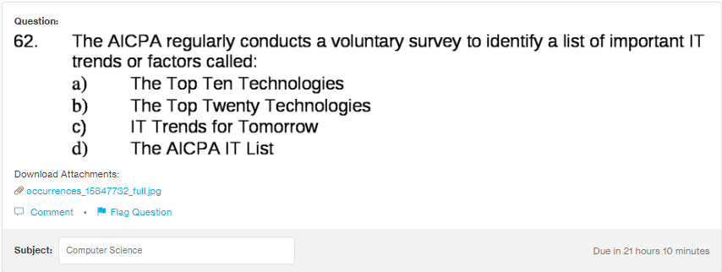
Answer:
The AICPA regularly conducts a voluntary survey to identify a list of important IT trends or factos called

explanation:

