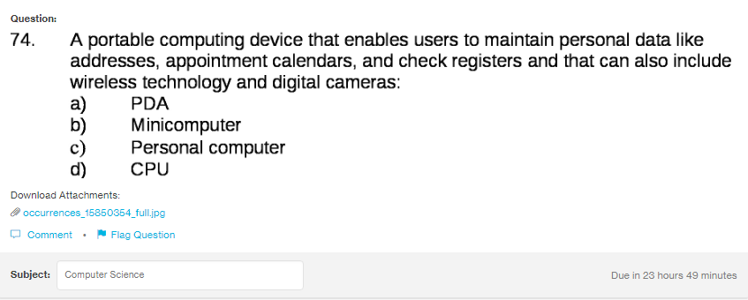

Answer:
a

Explanation:
PDA also known as personal digital assistant, are used mostly before 2010. They are the mini portable personal computer which may contain all the useful details such as registers, calenders and appointments. They are discontinued from 2010.

