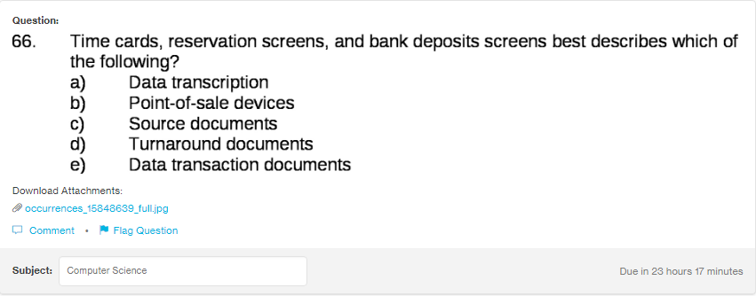

Answer:
c

Explanation:
Source document contains the original record of the transactions. For eg. The comapany’s monthy payrolls consist of time cards of the employee. Eariler source document were given on paper but now they are made electronic.

