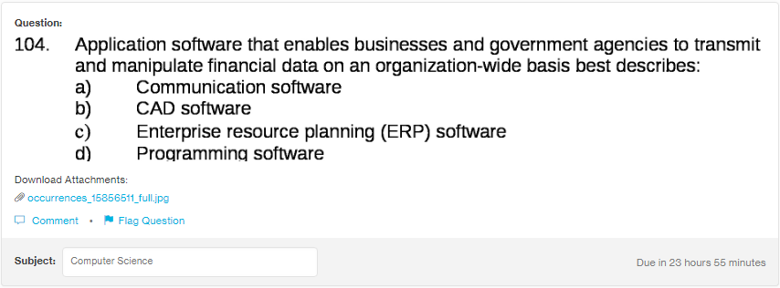
Answer:

Answer:
c

Explanation:
ERP software is widesly used to manage the data of the large organisation like university, government agencies and other big businesses to manage and change their data periodically.

Aansksks
skd12082781
iiiiii

