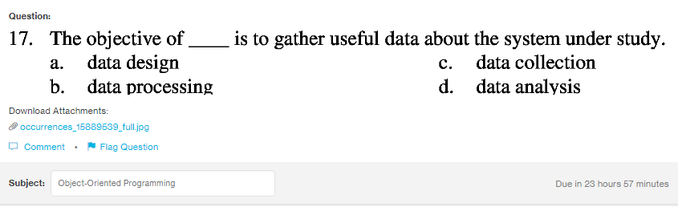
Answer:
c

Explanation:
The aim of the data collection is to gather all the important and useful data for study related to the research, answer possible outcomes and infer conclusions.

