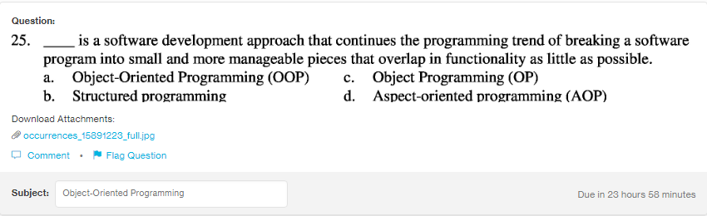
Answer:
a

Explanation:
In OOP’s the program is broken into various modules using he concept of class and objects. This separate modules then can be worked separately without the interference from other.

