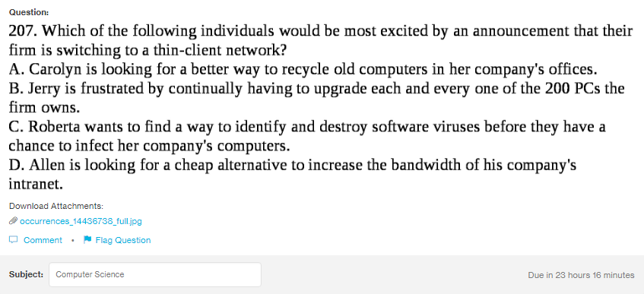
Answer:
Which of the following individuals would be most excited by an announcement that their firm is switching to a thin-client network?
A. Carolyn is looking for a better way to rectycle old computers in her company’s offices.
B. Jerry is frustrate by continually having to upgrade each and evvery one of the 200 Pcs the firm owns.

Explanation:

