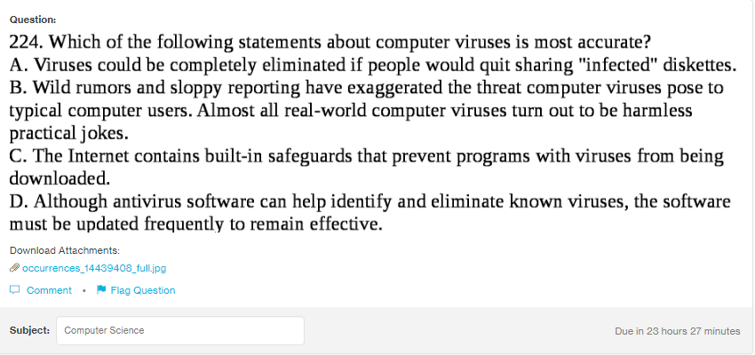
Answer:
d

Explanation:

For the complete proctection of the system through the antivirus, the software should always be continueally updated so as to fight the new viruses that may have crept in. Without the updation the system still gets prone to new viruses.

