**PRACTICAL: 11**

**Aim:**- Write programs in Java to use Wrapper class of each primitive data types

**Wrapper class:-** A Wrapper class is a class whose object wraps or contains a primitive data types. When we create an object to a wrapper class, it contains a field and in this field, we can store a primitive data types. In other words, we can wrap a primitive value into a wrapper class object. Need of Wrapper Classes.

**PROGRAM:**

public class Wrapper_7048

{

public static void main(String args[])

{

byte b=16;

short s=8;

int i=2;

long l=52;

char c='a';

Byte byteobj=b;

Short shortobj=s;

Integer intobj=i;

Long longobj=l;

Character charobj=c;

System.out.println("Print object values");

System.out.println("Byte object: "+byteobj);

System.out.println("Short object: "+shortobj);

System.out.println("Integer object: "+intobj);

System.out.println("Long object: "+longobj);

System.out.println("Character object: "+charobj);

byte bytevalue=byteobj;

short shortvalue=shortobj;

int intvalue=intobj;

long longvalue=longobj;

char charvalue=charobj;

System.out.println("Print primitive values");

System.out.println("Byte value: "+bytevalue);

System.out.println("Short value: "+shortvalue);

System.out.println("Int value: "+intvalue);

System.out.println("Long value: "+longvalue);

System.out.println("Char value: "+charvalue);

} }

**Output:**

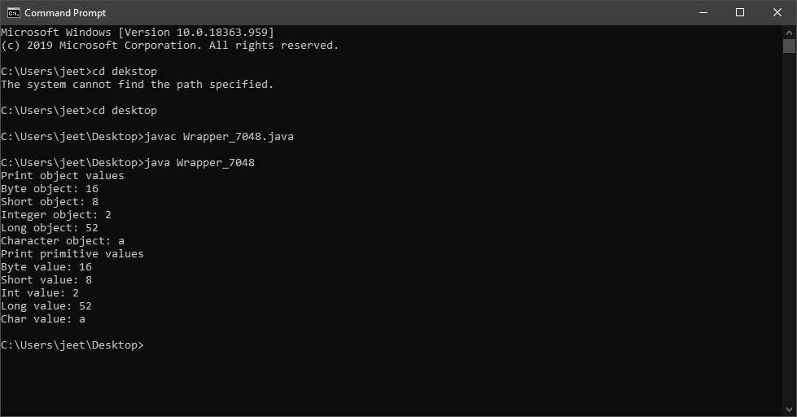

**PRACTICAL: 12**

**Aim:-** WAP which use the concepts of Garbage Collection in JAVA.

**Garbage Collection:-**Java garbage collection is the process by which Java programs

perform automatic memory management. Java programs compile to bytecode that

can be run on a Java Virtual Machine, or JVM for short. When Java programs run on

the JVM, objects are created on the heap, which is a portion of memory dedicated to

the program.

**PROGRAM:**

public class Garbage_7048

{

public void finalize()

{

System.out.println("garbage is collected");

}

public static void main(String args[])

{

Garbage_7048 s1=new Garbage_7048();

Garbage_7048 s2=new Garbage_7048();

s1=null;

s2=null;

System.gc();

}

}

**OUTPUT:**

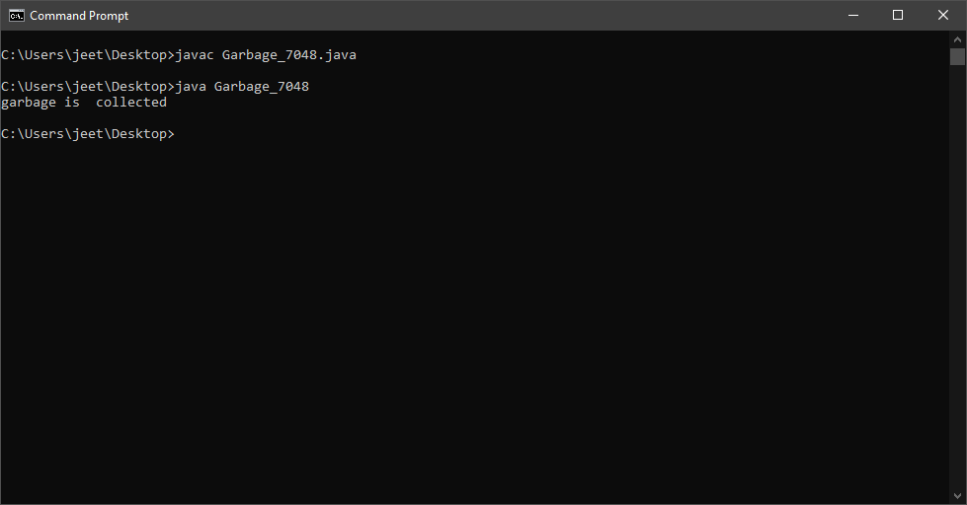

**PRACTICAL:13**

**AIM: Write a static block which will be executed before main( ) method in a class.**

**STATIC**: It Is used to initialize the static data member.

It is executed before the main method at the time of class loading. See the example.

**PROGRAM:**

# class p13_7048

# {

# static{

# System.out.println("this is static block");

# }

# public static void main(String[] args)

# {

# System.out.println("this is main block");

# }

# }

# OUTPUT:

# 