**PRACTICAL:14**

**AIM: Write a program in Java to demonstrate use of this keyword. Check whether this can access the private members of the class or not.**

**THIS keyword:**

* In java, this is a reference variable that used to refer current object.
* **Usage of java this keyword:**

1. this can be used to refer current class instance variable.
2. this can be used to invoke current class method (implicitly)

* this() can be used to invoke current class constructor.
* this can be passed as an argument in the method call.
* this can be passed as argument in the constructor call.
* this can be used to return the current class instance from the method.

**PROGRAM:**

class Std

{

private int rollno=101;

String name="Raj";

void display()

{

int rollno=105;

System.out.println("roll no. "+rollno);

System.out.println("private roll no. "+this.rollno);

System.out.println("name "+name);

}

}

class P14_7059

{

public static void main(String args[])

{

Std t1=new Std();

t1.display();

}

}

# OUTPUT:

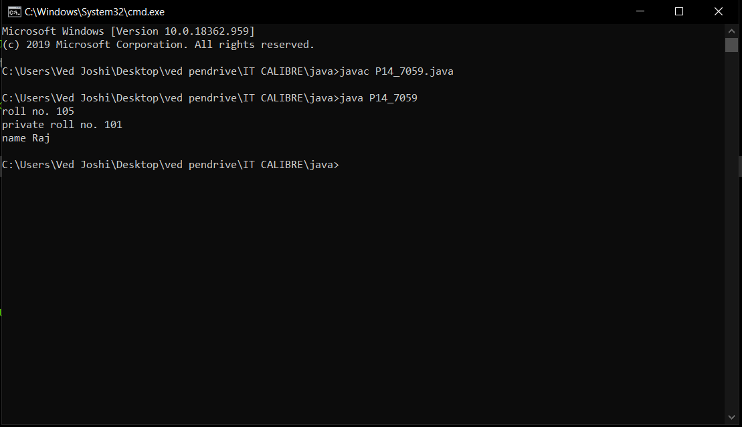s