**PRACTICAL:16**

**AIM:**Write a program in Java to demonstrate following types of inheritance.

# Single inheritance

# Multilevel inheritance

# Hierarchical inheritance.

# Inheritance:

# Inheritance in Java is a mechanism in which, one child class acquires all the properties and behaviors of a parent object.

# It is an important part of OOPs (Object Oriented programming system).

# Inheritance represents the IS-A relationship which is also known as a parent-child relationship.

# **SINGLE INHERITANCE:**

# Single Inheritance is the simple inheritance of all, When a class extends another class(Only one class) then we call it as Single inheritance.

# Class B extends only one class Class A.

# Here Class B will be the Sub class and Class A will be one and Super class.

**PROGRAM:**

class Parent

{

Parent()

{

System.out.println("this is parent");

}

}

class P16_7059 extends Parent

{

P16_7059()

{

System.out.println("this is child");

}

public static void main(String args[])

{

System.out.println("This is main");

P16_7059 c1=new P16_7059();

}

}

# OUTPUT:

# 

# **MULTILEVEL INHERITANCE:**

# In Multilevel Inheritance a derived class will be inheriting a parent class and as well as the derived class act as the parent class to other class.

# Class B inherits the property of Class A and again Class B act as a parent for Class C.

# In Short Class A parent for Class B and Class B parent for Class C.

**PROGRAM:**

class Grand

{

Grand()

{

System.out.println("this is Grand");

}

}

class Parent extends Grand

{

Parent()

{

System.out.println("this is parent");

}

}

class P16_7059 extends Parent

{

P16_7059()

{

System.out.println("this is child");

}

public static void main(String args[])

{

System.out.println("This is main");

P16_7059 c1=new P16_7059();

}

}

# OUTPUT:

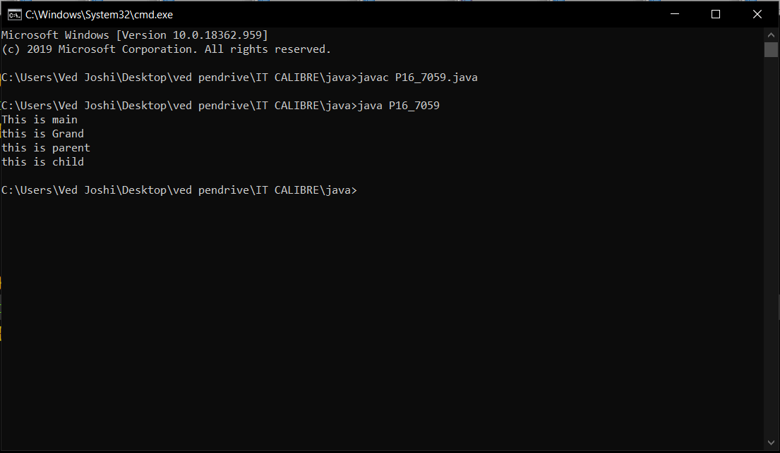

# HIERARCHICAL **INHERITANCE:**

# In Hierarchical inheritance one parent class will be inherited by many sub classes.

# Class A will be inherited by Class B, Class C and Class D.

# Class A will be acting as a parent class for Class B, Class C and Class D.

**PROGRAM:**

class Parent

{

Parent()

{

System.out.println("this is parent");

}

}

class P16_7059_1 extends Parent

{

P16_7059_1()

{

System.out.println("this is child-1");

}

}

class P16_7059 extends Parent

{

P16_7059()

{

System.out.println("this is child-2");

}

public static void main(String args[])

{

System.out.println("This is main");

P16_7059_1 c1=new P16_7059_1();

P16_7059 d1=new P16_7059();

}

}

# OUTPUT:

