**PRACTICAL:19**

**AIM:** **Write an application that illustrates method overriding in the same package and different packages. Also demonstrate accessibility rules in inside and outside packages.**

**Method Overriding:**

* If subclass (child class) has the same method as declared in the parent class, it is known as method overriding in Java.
* Method overriding is used to provide the specific implementation of a method which is already provided by its super class.
* Method overriding is used for runtime polymorphism.

**Rules for Java Method Overriding:**

* The method must have the same name as in the parent class.
* The method must have the same parameter as in the parent class.
* There must be an IS-A relationship (inheritance).

**PROGRAM(Same package):**

package First_package;

class A

{

void display()

{

System.out.println("This is Display method of A class");

}

}

class B extends A

{

void display()

{

System.out.println("This is Display method of B class");

}

}

public class P19_7059

{

public static void main(String args[])

{

B b1=new B();

b1.display();

}

}

**OUTPUT(Same package):**

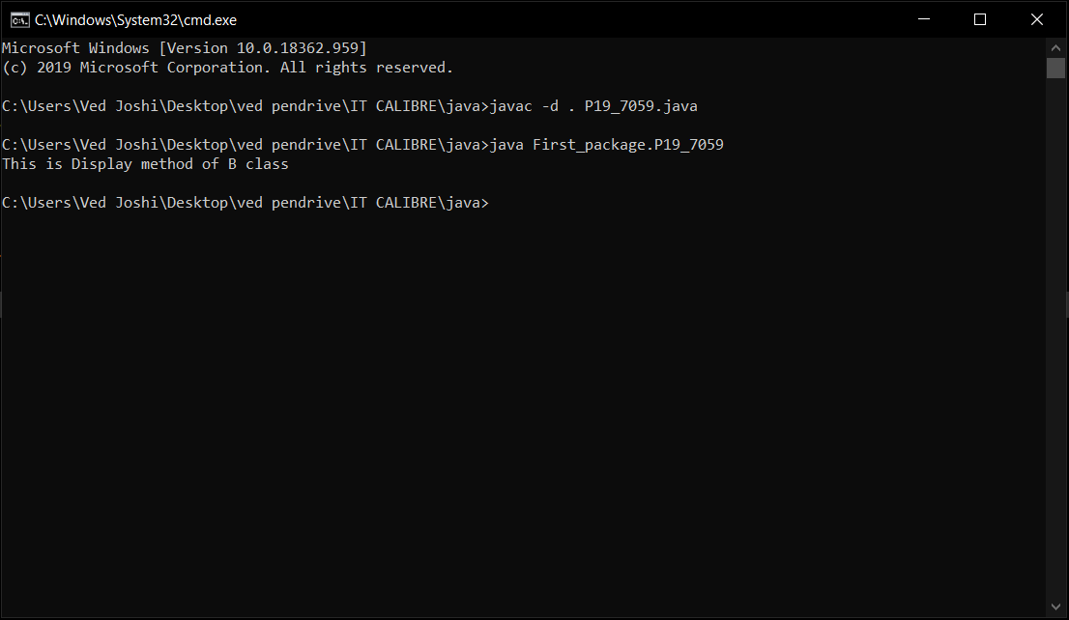

**PROGRAM(Different package):**

**File 1(B.java)**

package F_package;

public class B

{

public void display()

{

System.out.println("This is Display method of B class");

}

}

**File 2(P19_1_7059.java)**

package S_package;

import F_package.B;

public class P19_1_7059 extends B

{

public void display()

{

System.out.println("This is Display method of A class");

}

public static void main(String args[])

{

P19_1_7059 d1=new P19_1_7059();

B m1=new B();

d1.display();

m1.display();

}

}

**OUTPUT(Different package):**

