**PRACTICAL:4**

**AIM: Write a Java program to reverse the digits of a given number.**

# PROGRAM:

# import java.util.Scanner;

# class P4_7059

# {

# int n;

# int rev;

# void getElement()

# {

# Scanner sc=new Scanner(System.in);

# System.out.println("enter the number");

# n=sc.nextInt();

# }

# void reverse()

# {

# System.out.println("entered number : "+n);

# while(n != 0)

# {

# int digit = n % 10;

# rev = rev * 10 + digit;

# n /= 10;

# }

# System.out.println("Reverse of number : "+rev);

# }

# public static void main(String args[])

# {

# P4_7059 r=new P4_7059();

# r.getElement();

# r.reverse();

# }

# }

# OUTPUT:

# 

**PRACTICAL:5**

**AIM: Write a Java program to find factorial of a given number.**

**PROGRAM:**

# import java.util.Scanner;

# class P5_7059

# {

# void fact()

# {

# Scanner sc=new Scanner(System.in);

# int num;

# int factorial = 1;

# System.out.println("enter the limit to get factorial");

# num=sc.nextInt();

# for(int i=1;i<=num;++i)

# {

# factorial*=i;

# }

# System.out.println("Factorial is "+factorial);

# }

# 

# public static void main(String args[])

# {

# Fact f1=new Fact();

# f1.fact();

# }

# }

# OUTPUT:

# 

**PRACTICAL:6**

**AIM: Write a program to read five integer numbers from command line and display their sum and average.**

**PROGRAM:**

class P6_7059

{

public static void main(String args[])

{

int i;

int sum=0;

for(i=0;i<args.length;i++)

{

sum=sum+Integer.parseInt(args[i]);

}

System.out.println("sum : "+sum);

System.out.println("Average : "+sum/args.length);

}

}

# OUTPUT:

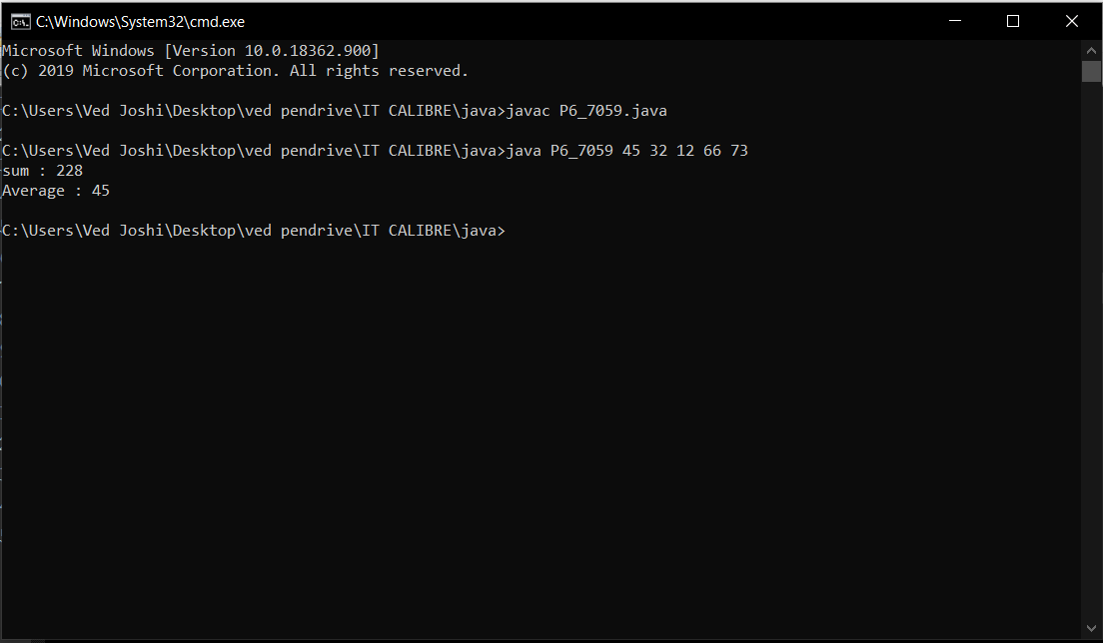

**PRACTICAL:7**

**AIM: Write a Java program to print Fibonacci series.**

**PROGRAM:**

import java.util.Scanner;

class P7_7059

{

public static void main(String args[])

{

Scanner sc=new Scanner(System.in);

int n,t1=0,t2=1,temp;

System.out.println("enter the length");

n=sc.nextInt();

System.out.println("Your Fibonacci Series : ");

for(int i=0;i<=n;i++)

{

System.out.println(""+t1);

temp=t1+t2;

t1=t2;

t2=temp;

}

}

}

# OUTPUT:

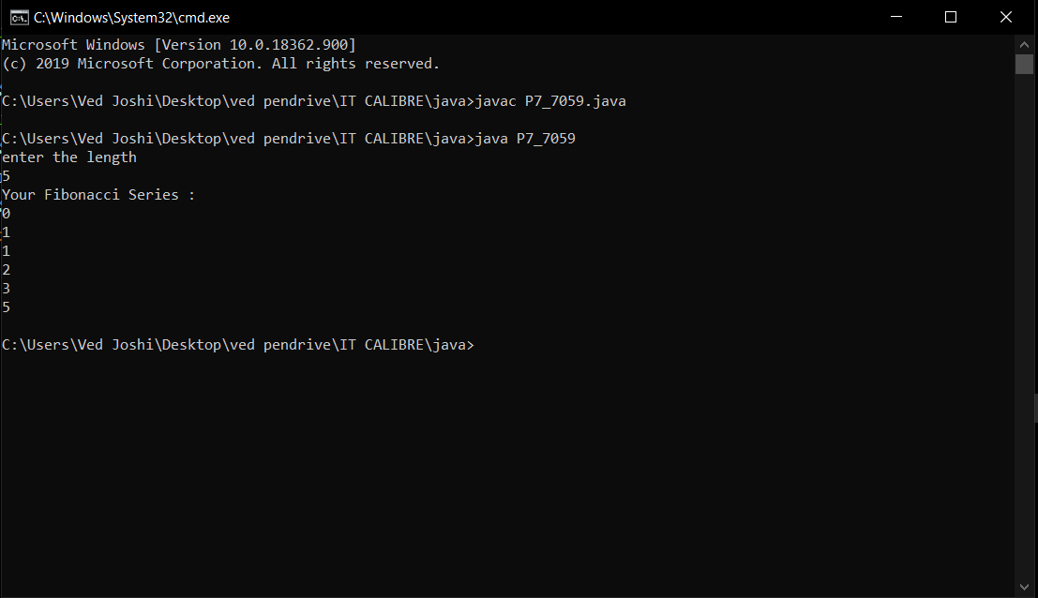

**PRACTICAL:8**

**AIM: Write a java program to sum of two dimensional matrix using array.**

**PROGRAM:**

import java.util.Scanner;

class P8_7059

{

public static void main(String args[])

{

Scanner sc=new Scanner(System.in);

int a[][]=new int[100][100];

int b[][]=new int[100][100];

int sum[][]=new int[100][100];

int row,col;

int i,j;

System.out.println("Enter the no of row : ");

row=sc.nextInt();

System.out.println("Enter the no of column : ");

col=sc.nextInt();

System.out.println("Enter the elements of 1st array : ");

for(i=0;i<row;++i)

{

for(j=0;j<col;++j)

{

System.out.println("enter array element "+(i+1)+(j+1));

a[i][j]=sc.nextInt();

}

}

System.out.println("Enter the elements of 2nd array : ");

for(i=0;i<row;++i)

{

for(j=0;j<col;++j)

{

System.out.println("enter array element "+(i+1)+(j+1));

b[i][j]=sc.nextInt();

}

}

for (i=0; i<row;++i)

{

for (j=0;j<col;++j)

{

sum[i][j] = a[i][j] + b[i][j];

}

}

System.out.println("Sum of two Matrix : ");

for(i=0;i<row;++i)

{

for(j=0;j<col;++j)

{

System.out.println(sum[i][j]);

}

}

}

}

# OUTPUT:

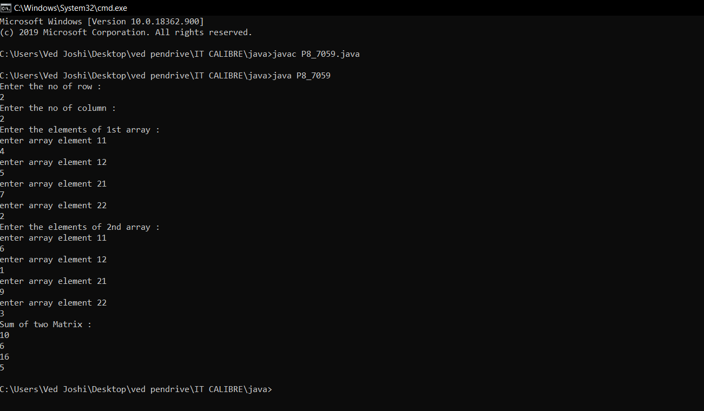

**PRACTICAL:9**

**AIM: Write a java program to sort of 5 numbers using array.**

**PROGRAM:**

import java.util.Scanner;

class P9_7059

{

public static void main(String args[])

{

int n,temp;

Scanner sc= new Scanner(System.in);

System.out.print("Enter array length:");

n = sc.nextInt();

int ar[] = new int[n];

System.out.println("Enter array elements:");

for(int i=0;i<n;i++)

{

ar[i]=sc.nextInt();

}

for(int i=0;i<n;i++)

{

for(int j=i+1;j<n;j++)

{

if(ar[i]>ar[j])

{

temp = ar[i];

ar[i] = ar[j];

ar[j] = temp;

}

}

}

System.out.print("Array Elements in Ascending Order: ");

for(int i=0;i<n-1;i++)

{

System.out.print(ar[i]+",");

}

System.out.println(ar[n-1]);

}

}

# OUTPUT:

