**PRACTICAL: Practice Practical**

**AIM:** **WAP of inheritance for below given diagram:**

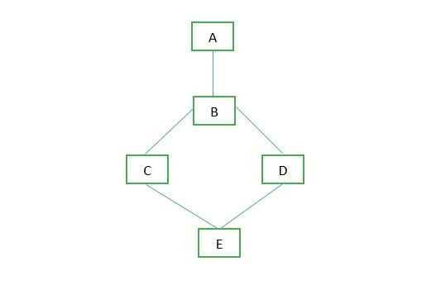

**PROGRAM:**

interface A

{

int i=10;

}

interface B extends A

{

int j=15;

}

interface C extends B

{

int k=20;

}

interface D extends B

{

int l=25;

}

class E implements D,C

{

public static void main(String args[])

{

E e=new E();

int m=30;

System.out.println(i);

System.out.println(j);

System.out.println(k);

System.out.println(l);

System.out.println(m);

}

}

**OUTPUT:**

