**INTRODUCTION**

**TO**

**DATA STRUCTURE**

**Topics To Be Discussed……………………….**

✓**Meaning of Data Structure**

✓**Classification of Data Structure**

# ✓Data Structure Operations

## DATA STRUCTURE

A data structure is a class of data that can be characterized by its organization and the operations that are defined on it.

### Data Structure = Organized Data + Allowed Operations

In other words, the organized collection of data is called data structure. A Data structure is a set of values along with the set of operations permitted on them.

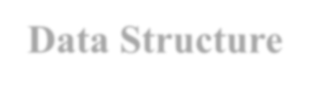

**Data Structure**

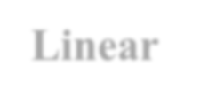

**Linear**

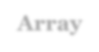

**Array**

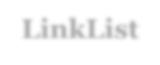

**LinkList**

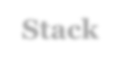

**Stack**

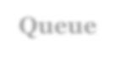

**Queue**

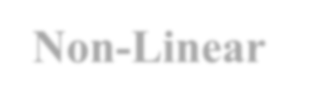

**Non**

**-**

**Linear**

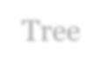

Tree

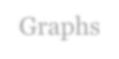

Graphs

## Classification of Data Structure

**There are various ways to classify data structure :**

* **Primitive and Non-Primitive Data Structure**
* **Linear and Non-Linear Data Structure**
* **Homogenous and Non-Homogeneous Data Structure**
* **Static and Dynamic Data Structure**

### Primitive and Non-Primitive Data Structure

The data structure that are atomic (indivisible) are called *primitive*.

Example are integer, real, Boolean and characters.

The data structure that are not atomic are called *non-primitive* or composite.

Example are records, array and string.

### Linear and Non- Linear Data Structure

In a linear data structure, the data items are arranged in a linear *sequence*.

Example is array.

In a non-Linear data structure, the data items *are not in a sequence.*

Example is tree.

#### Homogeneous and Non- Homogenous Data Structure

In Homogeneous Structure, *all the elements are of same type.*

Example is arrays.

In Non-homogeneous structure, the elements may or *may not be of same type.*

Example is records.

#### Static and Dynamic Data Structure

Static structures are ones whose sizes and structures, associated memory location are *fixed at compile time*.

Dynamic structures are ones which *expand(big) or decrease(small)* as required during the program execution and there associated memory location change.

#### Data Structure Operations

There are six basic operations that can be performed on data structure:-

1. Traversing
2. Searching
3. Sorting
4. Inserting
5. Deleting
6. Merging

##### (a) Traversing

Traversing means accessing and processing each element in the data structure exactly once.

This operation is used for *counting the number of elements, printing the contents of the elements* etc.

##### b) Searching

Searching is *finding* out the location of a given element from a set of numbers.

###### c) Sorting

Sorting is the process of arranging a list of elements in a *sequential order.*

The sequential order may be descending order or an ascending order according to the requirements of the data structure.

###### (d) Inserting

Inserting an element is *adding an element* in the data structure at any position. After insert operation the number of elements are increased by one.

###### e) Deleting

Deleting an element is *removing an element* in the data structure at any position. After deletion operation the number of elements are decreased by one.

###### (f) Merging

The process of *combining the elements of two data structures* into a single data structure is called merging.