

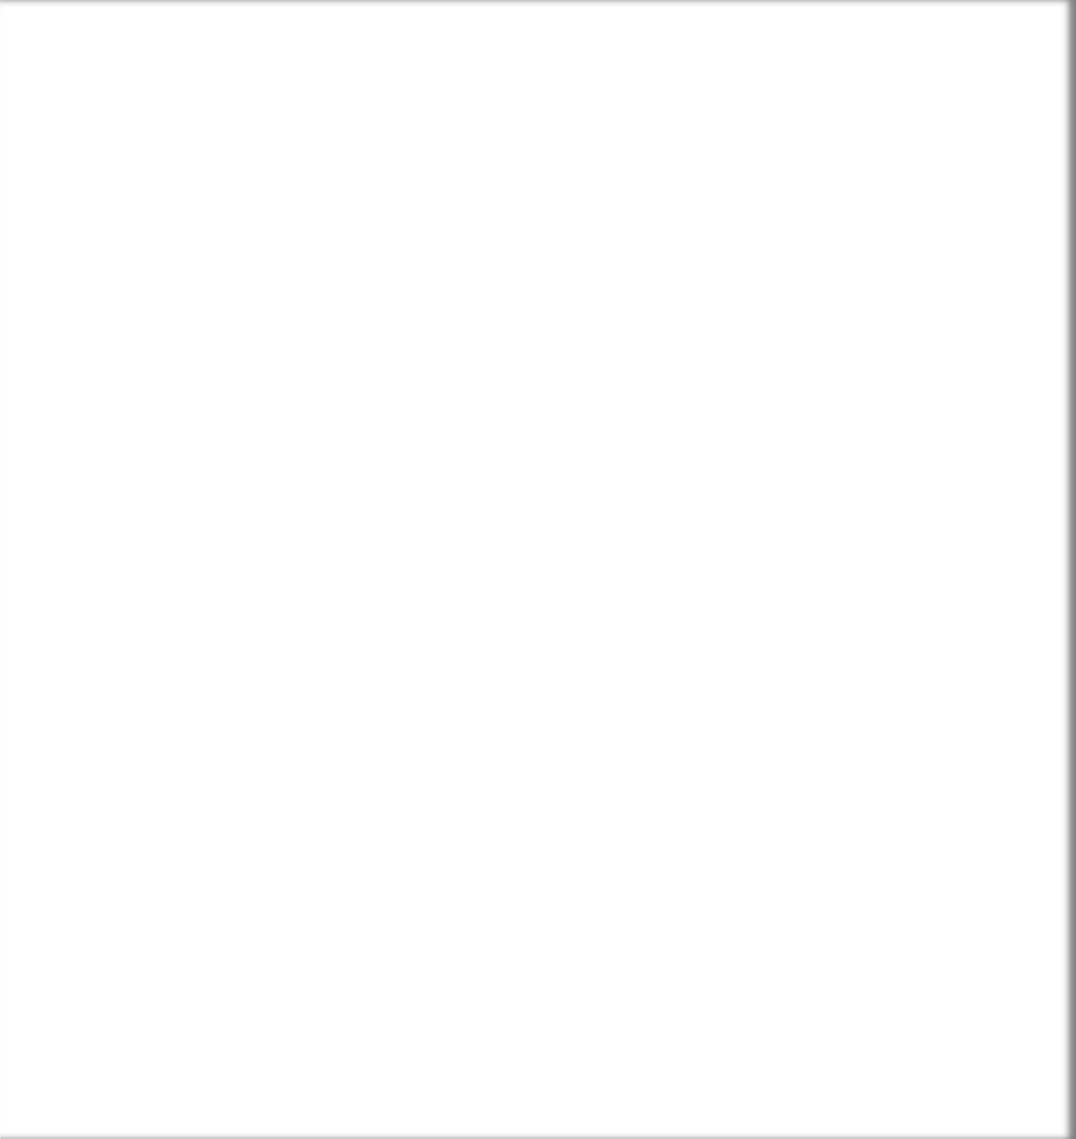

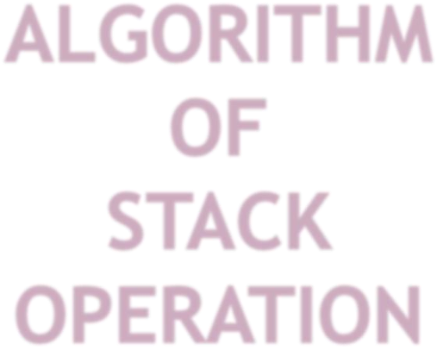


Step-1 [check for static overflow] if top >=size then o/p”stack is overflow” exit
Step-2 [increments the top values by one] top=top+1
Step-3 [perform insertion] stack[top]=data
Step-4 exit

Step-1 [check the stack is empty] if top = 0 then o/p”stack is under flow” exit
Step-2 [remove the top information] data=stack [top] top=top-1
Step-3 [return the format information of the stack]
Step-4 exit

Step-1 [check the stack is empty] if top-loc+1 < 0 then o/p”stack is overflow” exit
Step-2 [check max position of top] if loc > top o/p”the max position of top”,top
Step-3 if i == loc return (peep element)
Step-4 exit
Step-1 [check the stack is empty] if top = 0 then o/p”stack is under flow”
exit
Step-2 [Display values] repeat step-3 for i=top To i>=0
Step-3 print stack[i]
Step-4 exit

Step-1 [check the stack is empty] if top-loc+1 < 0 then
o/p”stack is empty”
exit
Step-2 [check max position of top] if loc > top o/p”the max position of top”,top
Step-3 [change the element]
if(loc == i)
(1)stack[top]=val
(2)top=loc
(3)return val
Step-4 exit




