
University of Dhaka
Department of Criminology
Professional Masters in Criminology and Criminal Justice
Course: MCCJ 525 – Cybercrimes and Security
Assignment: Assessing Security Features of Online Platforms
Locked or Leaked?
Assessing the Security Features of Facebook, Instagram, WhatsApp, Gmail and bKash
Submitted by:
Ahnaf Akif
Roll: 24
Submitted to:
Jannatul Hasan, BPM (Bar)
Additional DIG
Course Teacher, MCCJ 525
Department of Criminology, University of Dhaka
Date of Submission: 25 October 2026

Locked or Leaked? Assessing the Security Features of Five Online Platforms

1. Introduction
Social media usage and hacking rates have both increased many times over in the past decade. Every day we spend a massive amount of time scrolling and visiting social media accounts, which in turn increases our exposure and vulnerability to attackers. Losing a social media account to a hacker can cause more harm than losing a wallet. Almost 64 million Bangladeshis use Facebook (Statista, 2025). A 2024 study by the Cyber Crime Awareness Foundation (CCAF) found that account hacking was the most common cybercrime, affecting 21.65% of victims. About 59% of the victims were women, 78.78% were aged between 18 and 30, and only 12% went to the police (Dhaka Tribune, 2024). [Optional: one short sentence on mobile money (bKash) fraud.]
For this assignment, I examined five of the most commonly used online platforms: Facebook, Instagram, WhatsApp, Gmail and bKash. These were selected because of how frequently ordinary users use them every day. [Optional: one short reason for including bKash.] I checked each app on my own phone and cross-checked the features against their official help pages and news reports. An evaluation system was used to score the security features from 1 (weak) to 5 (strong) on five benchmarks: login protection, encryption by default, threat alerts, account recovery safety and privacy controls.

2. Existing Security Features

2.1 Facebook
Facebook’s protection features sit in Settings → Accounts Center → Password and security. For login protection, Facebook has an array of options. It includes two-factor authentication (2FA), which adds a second check after the password through an authenticator app, an SMS code or a physical security key. It also sends a login alert as a warning if someone logs in from an unfamiliar device. The “Where you’re logged in” feature shows every device and lets the user log out remotely. A Security Checkup feature gives a step-by-step guide through these settings. The newest feature of Facebook is passkeys, which let the user log in with a fingerprint or face scan instead of a password. Passkeys arrived in 2025 and were extended to Messenger in September 2025 (Meta, 2025).
Figure 1
Facebook → Accounts Center → Password and security
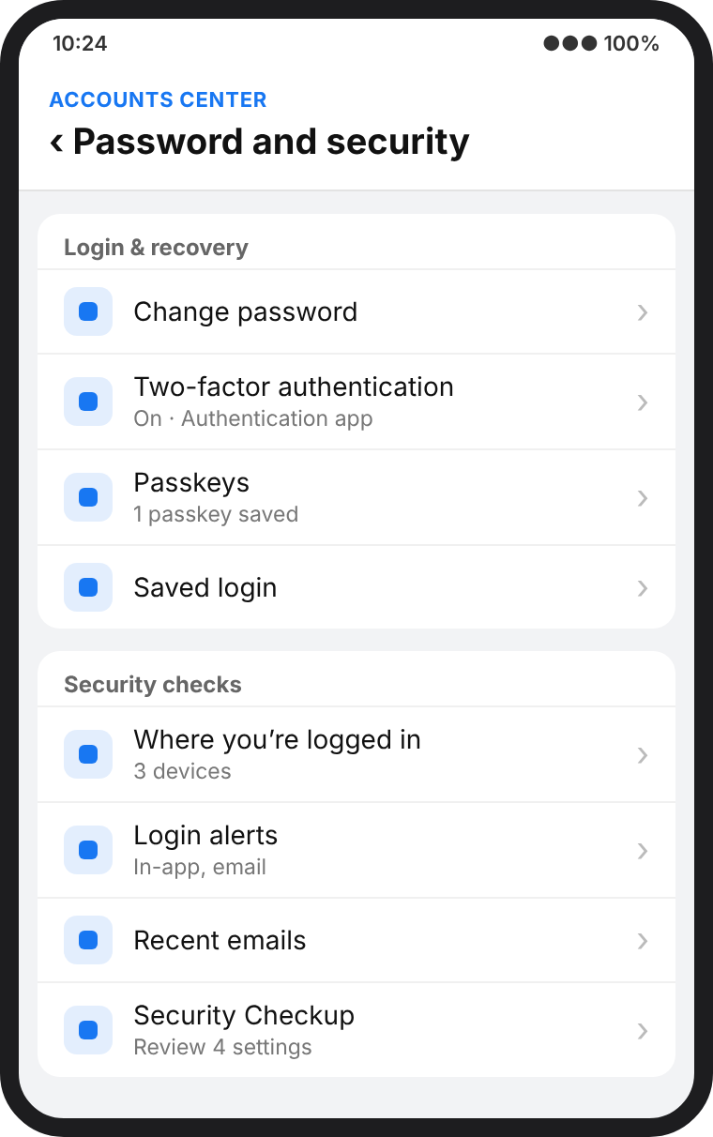
Note. Illustrative recreation of the settings screen, based on the app as of October 2026.

2.2 Instagram
Instagram shares the same Meta Accounts Center as Facebook, so its login protection features are the same. Instagram has a unique “Emails from Instagram” feature, which lists the real security emails Instagram has sent in the last 14 days. An email claiming to be from Instagram that is not on this list is likely a phishing email. It protects users from harassment through Restrict, Hidden Words and limits on message requests, which block abusive messages. Teen Accounts are private by default for users under 18. However, Meta removed its optional encrypted chats on 8 May 2026 (Euronews, 2026), which means Meta can access the content of private messages. Instagram is therefore vulnerable to sextortion and image-based blackmail, which often start in private messages.
Figure 2
Instagram → Settings → Accounts Center → Password and security
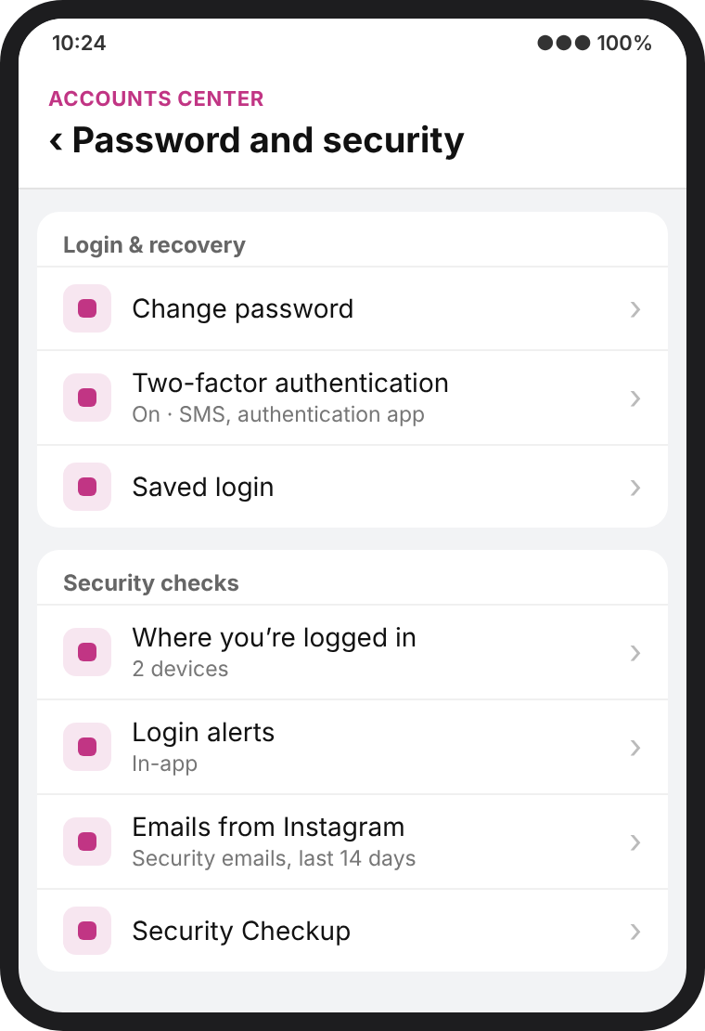
Note. Illustrative recreation of the settings screen, based on the app as of October 2026.

2.3 WhatsApp
WhatsApp encrypts every chat, call and status update end to end by default. It has extra login protection such as two-step verification, passkey login, chat lock, “Silence unknown callers” and IP protection in calls. Since October 2025, chat backups can be protected with a passkey instead of a 64-digit key (Help Net Security, 2025). In January 2026, it added Strict Account Settings, which locks everything to the safest options with one tap, blocking media from unknown senders and turning off link previews (WhatsApp, 2026). However, WhatsApp verifies a login by sending a code to the user’s phone number, and scammers exploit this. They request a code for the user’s number and then ask the user to send it back, claiming it was sent by mistake. If the user shares the code, the scammer can take over the account. A two-step PIN prevents this, but many users do not set one up.
Figure 3
WhatsApp → Settings → Account → Two-step verification / Privacy → Advanced
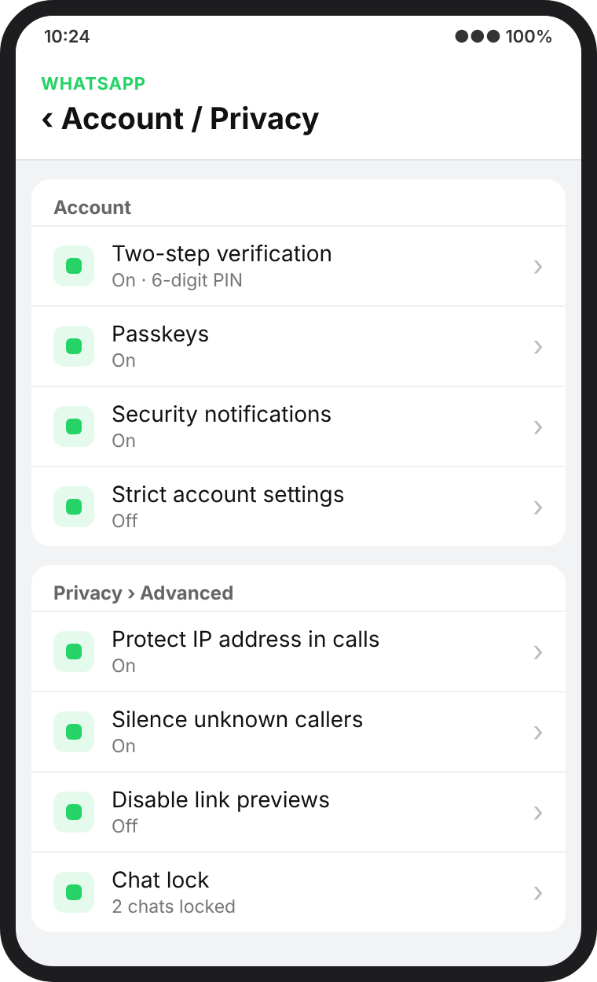
Note. Illustrative recreation of the settings screen, based on the app as of October 2026.

2.4 Gmail
Gmail’s protection is available in the Google Account (Settings → Security). Passkeys have been the default sign-in option since October 2023 (Google, 2023). Login protection also includes 2-Step Verification. Google also has an Advanced Protection Program for journalists and activists, which requires a passkey or a physical security key. According to Google, Gmail blocks more than 99.9% of phishing and malware attempts (Engadget, 2025). Suspicious emails also show a red warning banner. Gmail has a privacy tool called confidential mode, which sets an expiry date on an email and stops people from forwarding it. However, while emails are protected in transit, they are not end-to-end encrypted, unlike WhatsApp chats.
Figure 4
Google Account → Security → How you sign in to Google
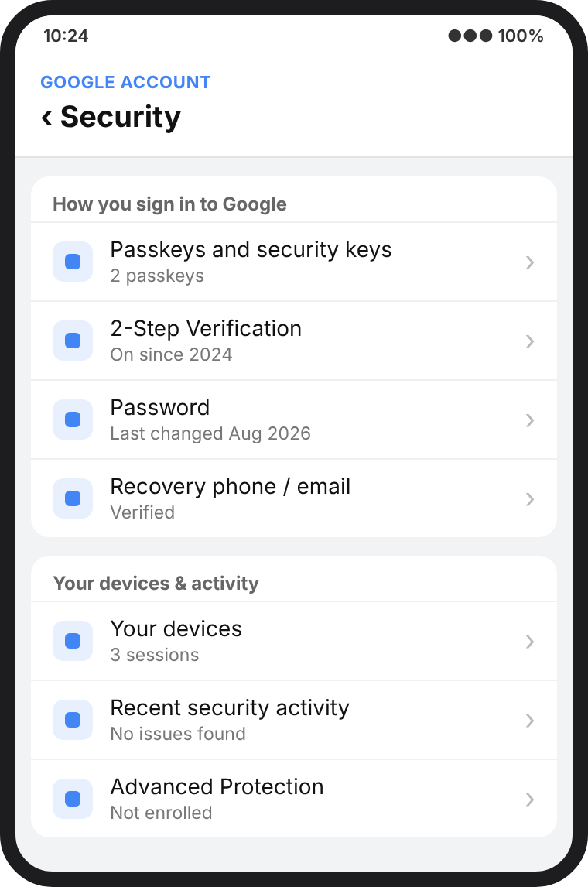
Note. Illustrative recreation of the settings screen, based on the app as of October 2026.

2.5 bKash
[Write your bKash paragraph here: its security features first, then its main weakness. Keep it to about 100 words.]
Figure 5
[bKash menu path, e.g., bKash app → … → …]
[ bKash screenshot will be added here ]

3. Additional Features Each Platform Should Add
Every platform has good security features. However, the strongest ones are mostly optional, hidden or designed for a global audience rather than for Bangladeshi users. Table 1 lists the features I propose.
Table 1
Proposed Additional Security Features
Platform | Proposed feature | Why it is needed
Facebook | A 48-hour delay before a new email, phone number or 2FA change takes effect, with alerts sent to the old contacts | Hackers and scammers change the email within minutes, so changes need to be delayed
Instagram | End-to-end encrypted DMs by default; blurring of explicit images | Sextortion often starts in DMs
WhatsApp | A Bangla warning whenever a code is requested; a mandatory two-step PIN for new accounts | Code-sharing scams are the main cause of account hijacking
Gmail | Optional end-to-end encryption; warnings for fake bKash, Nagad and bank emails | Email resets every other account, and phishing copies local brands
bKash | [Your proposed feature] | [Why it is needed]
Note. Proposals are the author’s own, based on the gaps identified in Section 2.
Strong security should be switched on automatically rather than left as an option for the user to activate. Most Bangladeshi users are unaware of these features, and a protection that is inactive by default fails to protect anyone because users rarely activate it.

4. Which Platform Is Most Secure?
Table 2
Security Scorecard of the Five Platforms (1 = weak, 5 = strong)
Criterion | Facebook | Instagram | WhatsApp | Gmail | bKash
Login protection | 4 | 4 | 4 | 5 | [ ]
Encryption by default | 3 | 1 | 5 | 3 | [ ]
Threat detection & alerts | 4 | 4 | 3 | 5 | [ ]
Recovery safety | 2 | 3 | 3 | 4 | [ ]
Privacy controls | 3 | 4 | 5 | 3 | [ ]
Total (out of 25) | 16 | 16 | 20 | 20 | [ ]
Note. Scores are the author’s assessment of the default and available settings as of October 2026.
WhatsApp and Gmail tie at 20 out of 25, but for an ordinary individual user I judge WhatsApp to be the most secure. Its strongest protection, end-to-end encryption, works from the moment the app is installed, with no action needed from the user. Gmail has the best account protection and phishing filters, and it deserves special care because it is the “master key”: whoever controls a person’s email can reset the passwords of almost everything else. Instagram’s retreat from encrypted messaging pulls it down. [Add one sentence on where bKash ranks and why. If bKash scores 20 or more, also change the first sentence.]
Still, no platform can protect a user who hands over a one-time code or reuses a weak password. The CCAF data shows that the typical victim is young and does not report the crime (Dhaka Tribune, 2024), which suggests that awareness matters as much as technology. In my view, the most secure account is simply the one whose owner has switched on 2FA or a passkey, checked their recovery details and learned to recognize a scam.

5. Conclusion
All five platforms offer serious security tools, but they differ in how much of that protection is on by default. WhatsApp leads for private communication and Gmail for account protection, while Instagram leaves the most content exposed. [Add one short point about bKash.] Platforms should make strong settings the default and speak to users in their own language; users, meanwhile, should spend five minutes turning on the protections that already exist.

References
[Add the bKash sources you cite here. Keep alphabetical order: bKash and BSS go before Dhaka Tribune.]
Dhaka Tribune. (2024, June 29). Cybercrime study: Social media hacking most prevalent. https://www.dhakatribune.com/bangladesh/crime/350507/cybercrime-study-social-media-hacking-most
Engadget. (2025, September 2). Google says reports of a major Gmail security issue are ‘entirely false’. https://www.engadget.com/google-says-reports-of-a-major-gmail-security-issue-are-entirely-false-224812292.html
Euronews. (2026, May 8). Instagram is dropping end-to-end encrypted chats: This is what is changing. https://www.euronews.com/next/2026/05/08/instagram-is-dropping-end-to-end-encrypted-chats-this-is-what-is-changing
Google. (2023, October 10). Passwordless by default: Make the switch to passkeys. The Keyword. https://blog.google/technology/safety-security/passkeys-default-google-accounts/
Help Net Security. (2025, October 30). WhatsApp now lets you secure chat backups with passkeys. https://www.helpnetsecurity.com/2025/10/30/whatsapp-secure-chat-backups-passkeys/
Meta. (2025, June 18). Introducing passkeys on Facebook for an easier sign-in (Updated September 23, 2025). Meta Newsroom. https://about.fb.com/news/2025/06/introducing-passkeys-facebook-easier-sign-in/
Statista. (2025). Countries with the most Facebook users as of October 2025. https://www.statista.com/statistics/268136/top-15-countries-based-on-number-of-facebook-users/
WhatsApp. (2026, January 27). WhatsApp’s latest privacy protection: Strict account settings. WhatsApp Blog. https://blog.whatsapp.com/whatsapps-latest-privacy-protection-strict-account-settings

