
University of Dhaka
Department of Criminology
Professional Masters in Criminology and Criminal Justice
Course: MCCJ 525 – Cybercrimes and Security
Assignment: Assessing Security Features of Online Platforms
Locked or Leaked?
Assessing the Security Features of Facebook, Instagram, WhatsApp, Gmail and bKash
Submitted by:
Ahnaf Akif
Roll: 24
Submitted to:
Jannatul Hasan, BPM (Bar)
Additional DIG
Course Teacher, MCCJ 525
Department of Criminology, University of Dhaka
Date of Submission: 25 October 2026

Locked or Leaked? Assessing the Security Features of Five Online Platforms

1. Introduction

Increased dependence on online platforms has made users vulnerable to abuse. Consequently, getting exploited on online platforms harms the victim more than getting robbed, as it damages both social image and money. In Bangladesh almost 64 million people use Facebook (Statista, 2025). In 2024, the Cyber Crime Awareness Foundation (CCAF) conducted a study which found that hacking was the most common form of cybercrime, affecting 21.65% of victims. Among them, 59% were women, 78.78% were aged between 18 and 30 and only 12% reported to the police (Dhaka Tribune, 2024).

For this assessment, I examined five most used online platforms: Facebook, Instagram, WhatsApp, Gmail and bKash. I used my own phone to check the security features of these platforms and cross-checked them against the platforms’ pages and websites. An evaluation system was used to score the security features from 1 (weak) to 5 (strong) on five benchmarks.

2. Existing Security Features

2.1 Facebook
Facebook’s two-factor authentication (2FA) adds an extra layer of authentication through an SMS code, an authenticator app or a physical security key. It also sends a login alert as a warning if someone logs in from an unfamiliar device. The “Where you’re logged in” feature shows every device and lets the user log out remotely. A Security Checkup feature gives a step-by-step guide through these settings. The newest feature of Facebook is passkeys, which let the user log in with a fingerprint or face scan instead of a password. Passkeys arrived in 2025 and were extended to Messenger in September 2025 (Meta, 2025).
Figure 1
Facebook → Settings & privacy → Accounts Center → Login and security
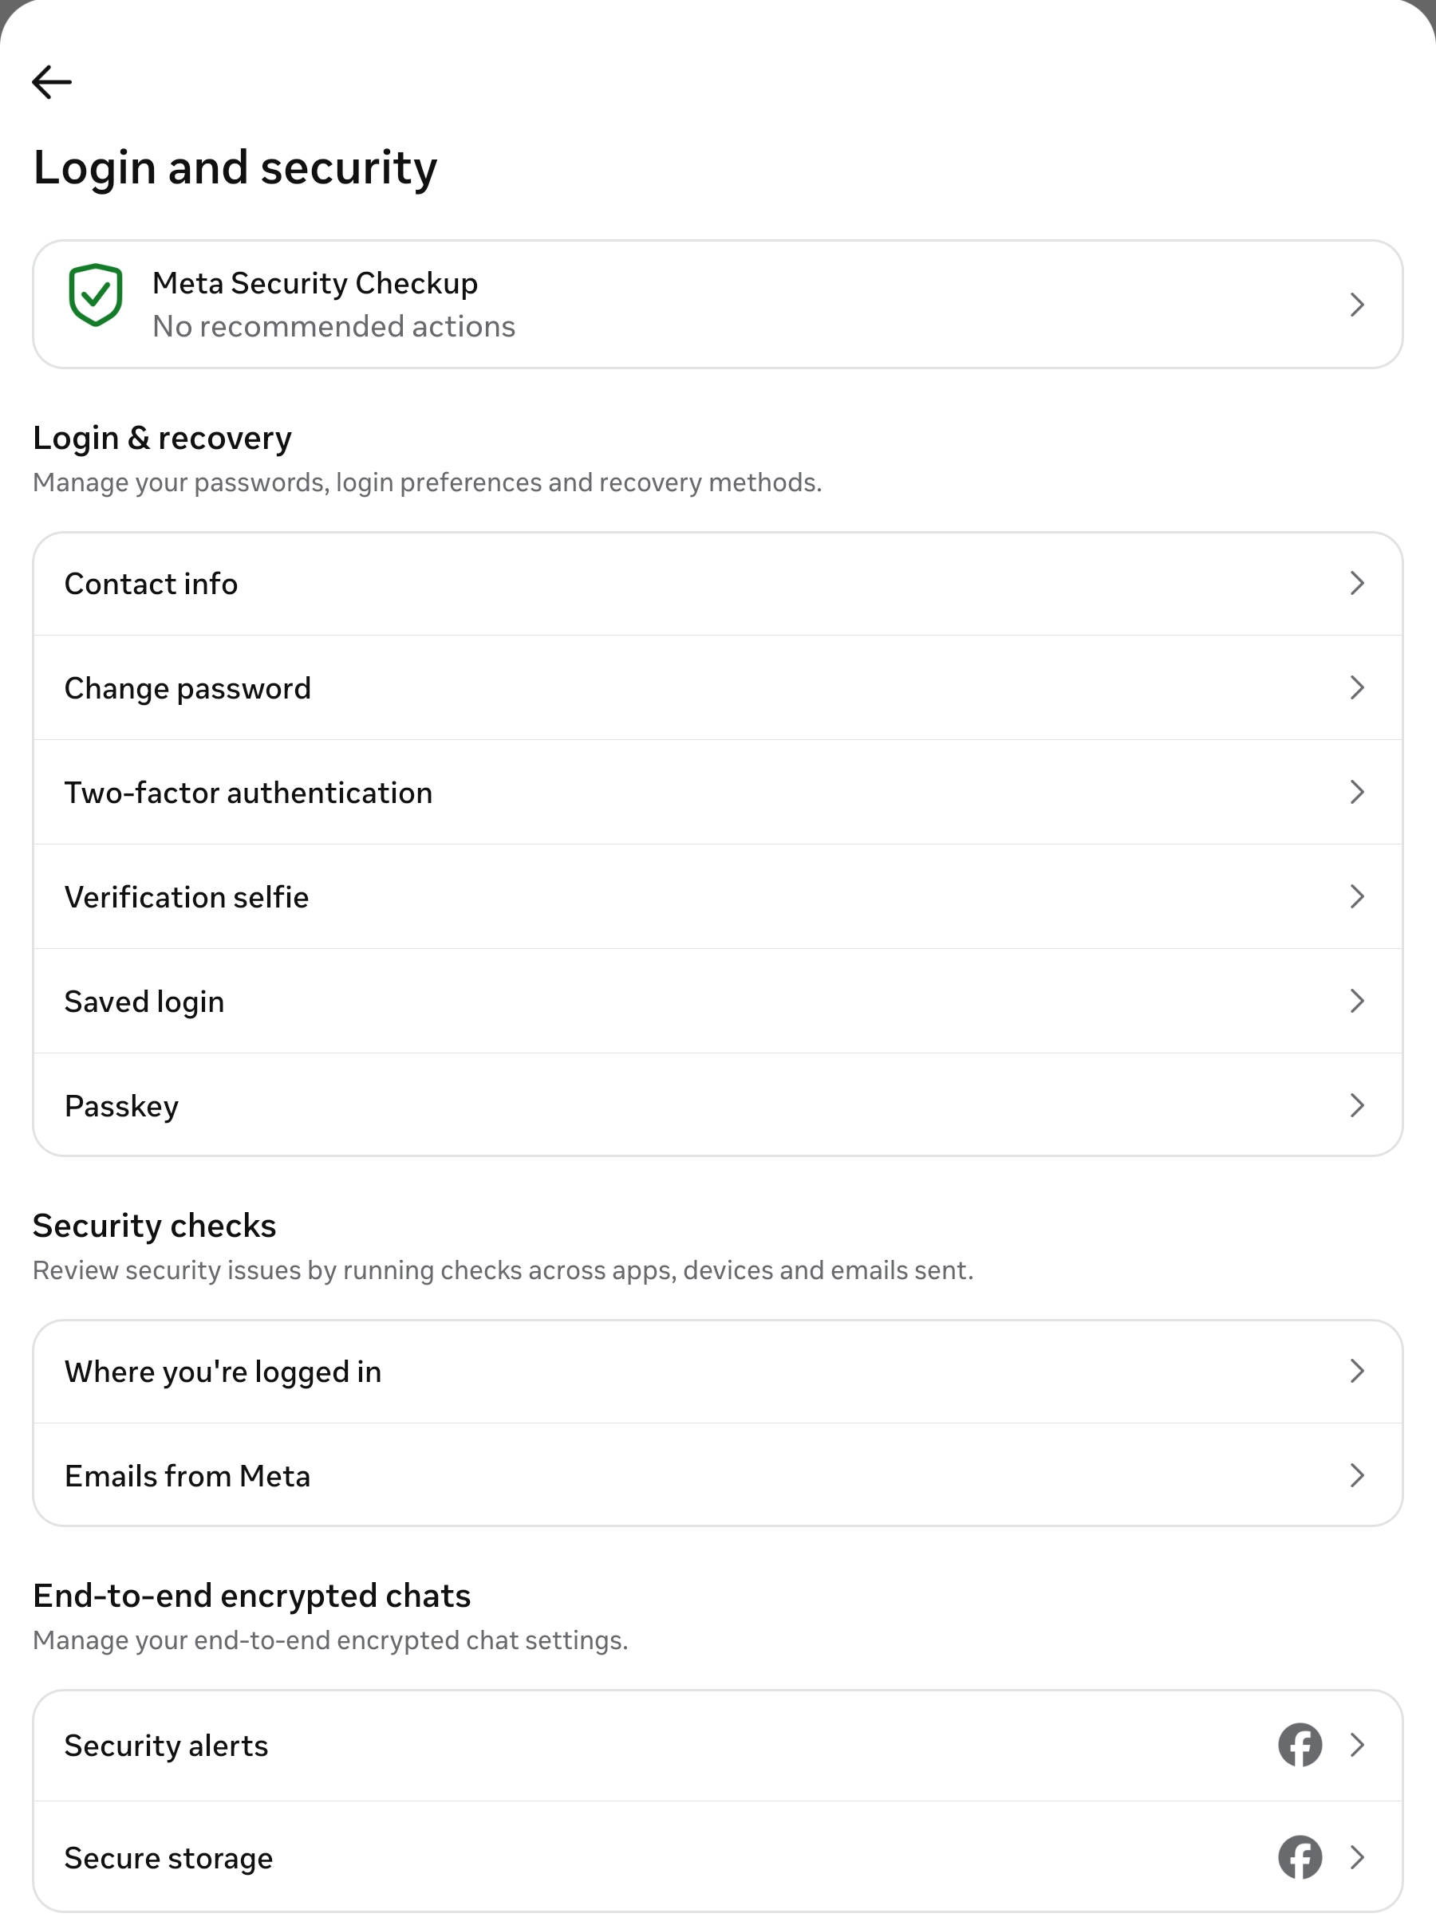
Note. Screenshot taken by the author on 25 October 2026.

2.2 Instagram
Instagram’s login protection features are the same as Facebook’s. Instagram has a unique “Emails from Instagram” feature, which lists the real security emails Instagram has sent in the last 14 days. It protects users from harassment through Restrict, Hidden Words and limits on message requests, which block abusive messages. Teen Accounts are private by default for users under 18. However, Meta removed its optional encrypted chats on 8 May 2026 (Euronews, 2026), which means Meta can access the content of private messages. Instagram is therefore vulnerable to sextortion and image-based blackmail, which often start in private messages.
Figure 2
Instagram → Profile → Menu → Accounts Center → Password and security
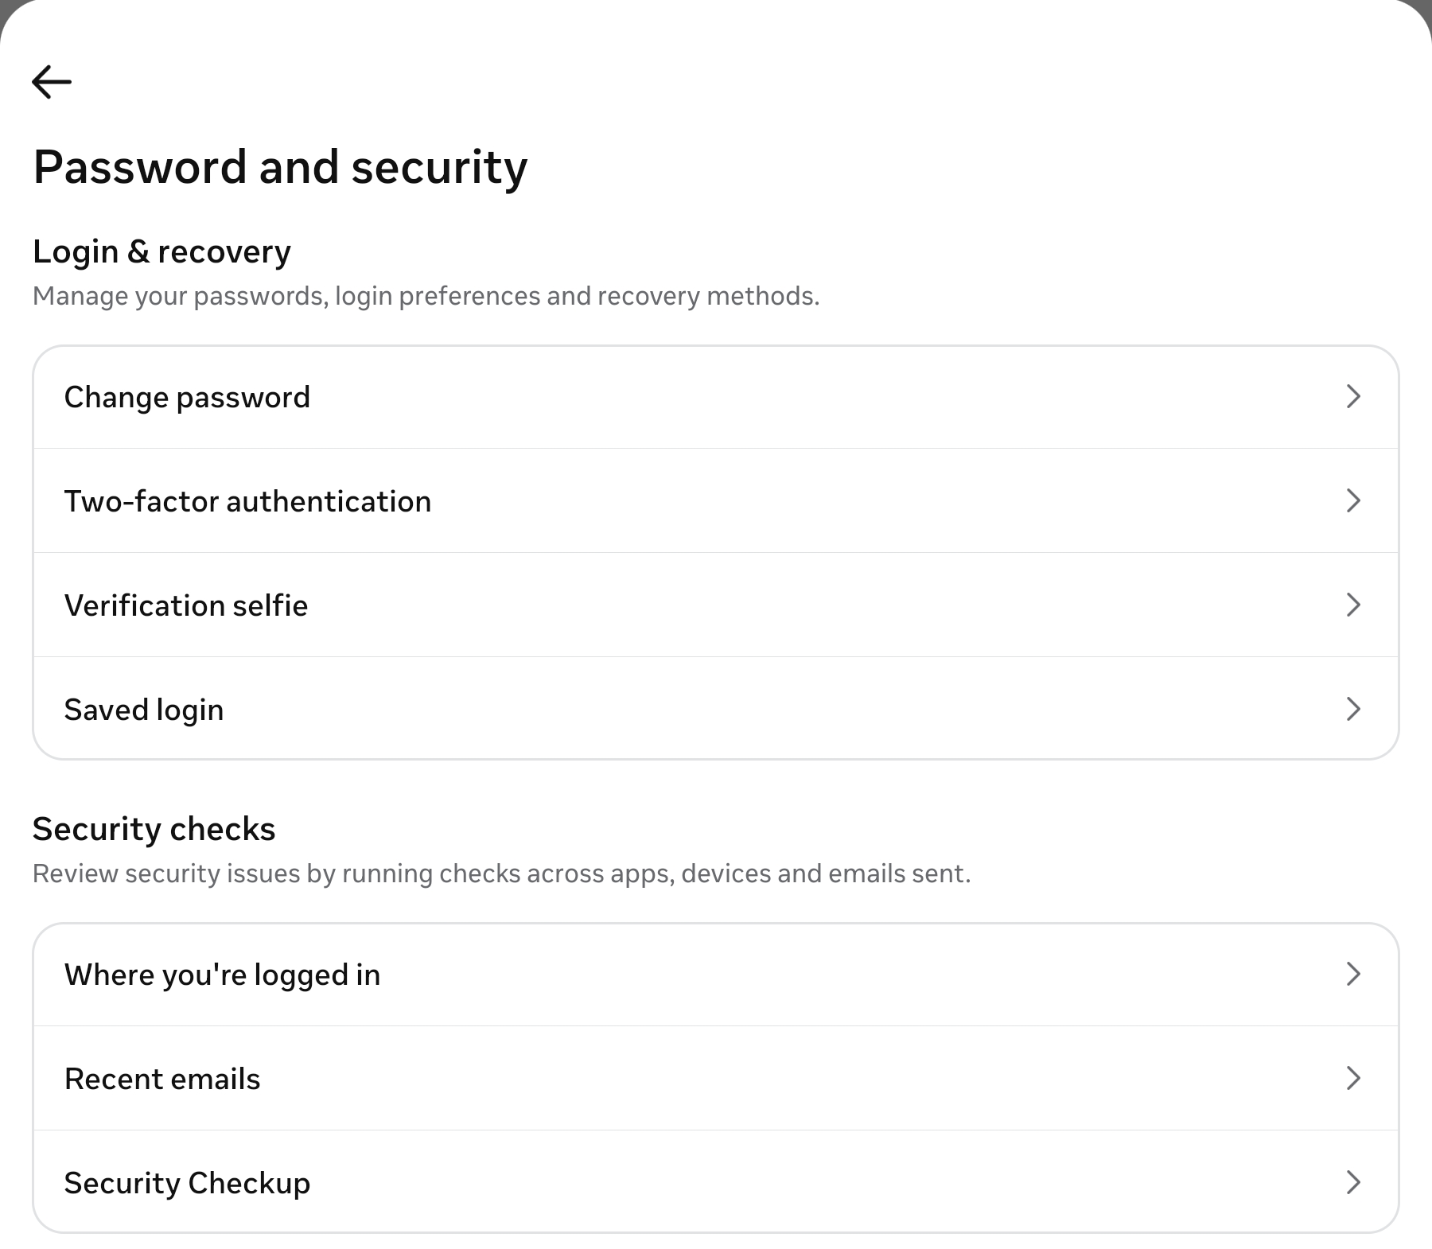
Note. Screenshot taken by the author on 25 October 2026.

2.3 WhatsApp
WhatsApp encrypts every chat, call and status update end to end by default. It has extra login protection such as two-step verification, passkey login, chat lock, “Silence unknown callers” and IP protection in calls. Since October 2025, chat backups can be protected with a passkey instead of a 64-digit key (Help Net Security, 2025). In January 2026, it added Strict Account Settings, which locks everything to the safest options with one tap (WhatsApp, 2026). However, WhatsApp verifies a login by sending a code to the user’s phone number, and scammers exploit this. If the user shares the code, the scammer can take over the account. A two-step PIN prevents this, but many users do not set one up.
Figure 3
WhatsApp → Settings → Privacy
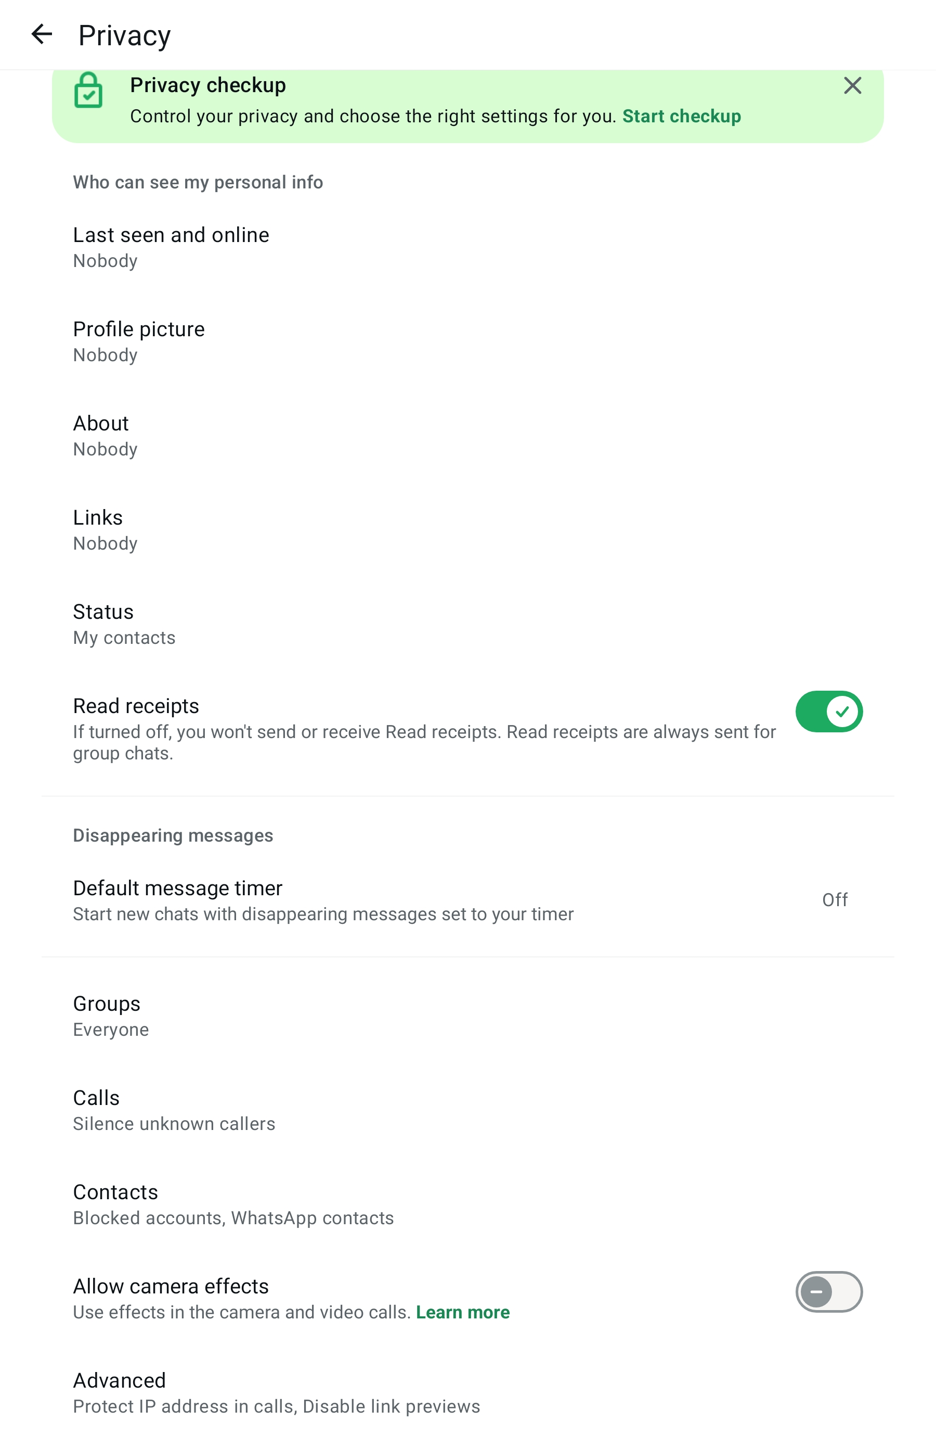
Note. Screenshot taken by the author on 25 October 2026.

2.4 Gmail
Passkeys have been the default sign-in option since October 2023 (Google, 2023). Login protection also includes 2-Step Verification. Google also has an Advanced Protection Program for journalists and activists, which requires a passkey or a physical security key. According to Google, Gmail blocks more than 99.9% of phishing and malware attempts (Engadget, 2025). Suspicious emails also show a red warning banner. Gmail has a privacy tool called confidential mode, which sets an expiry date on an email and stops people from forwarding it. However, while emails are protected in transit, they are not end-to-end encrypted, unlike WhatsApp chats.
Figure 4
Gmail → Profile picture → Manage your Google Account → Security and sign-in
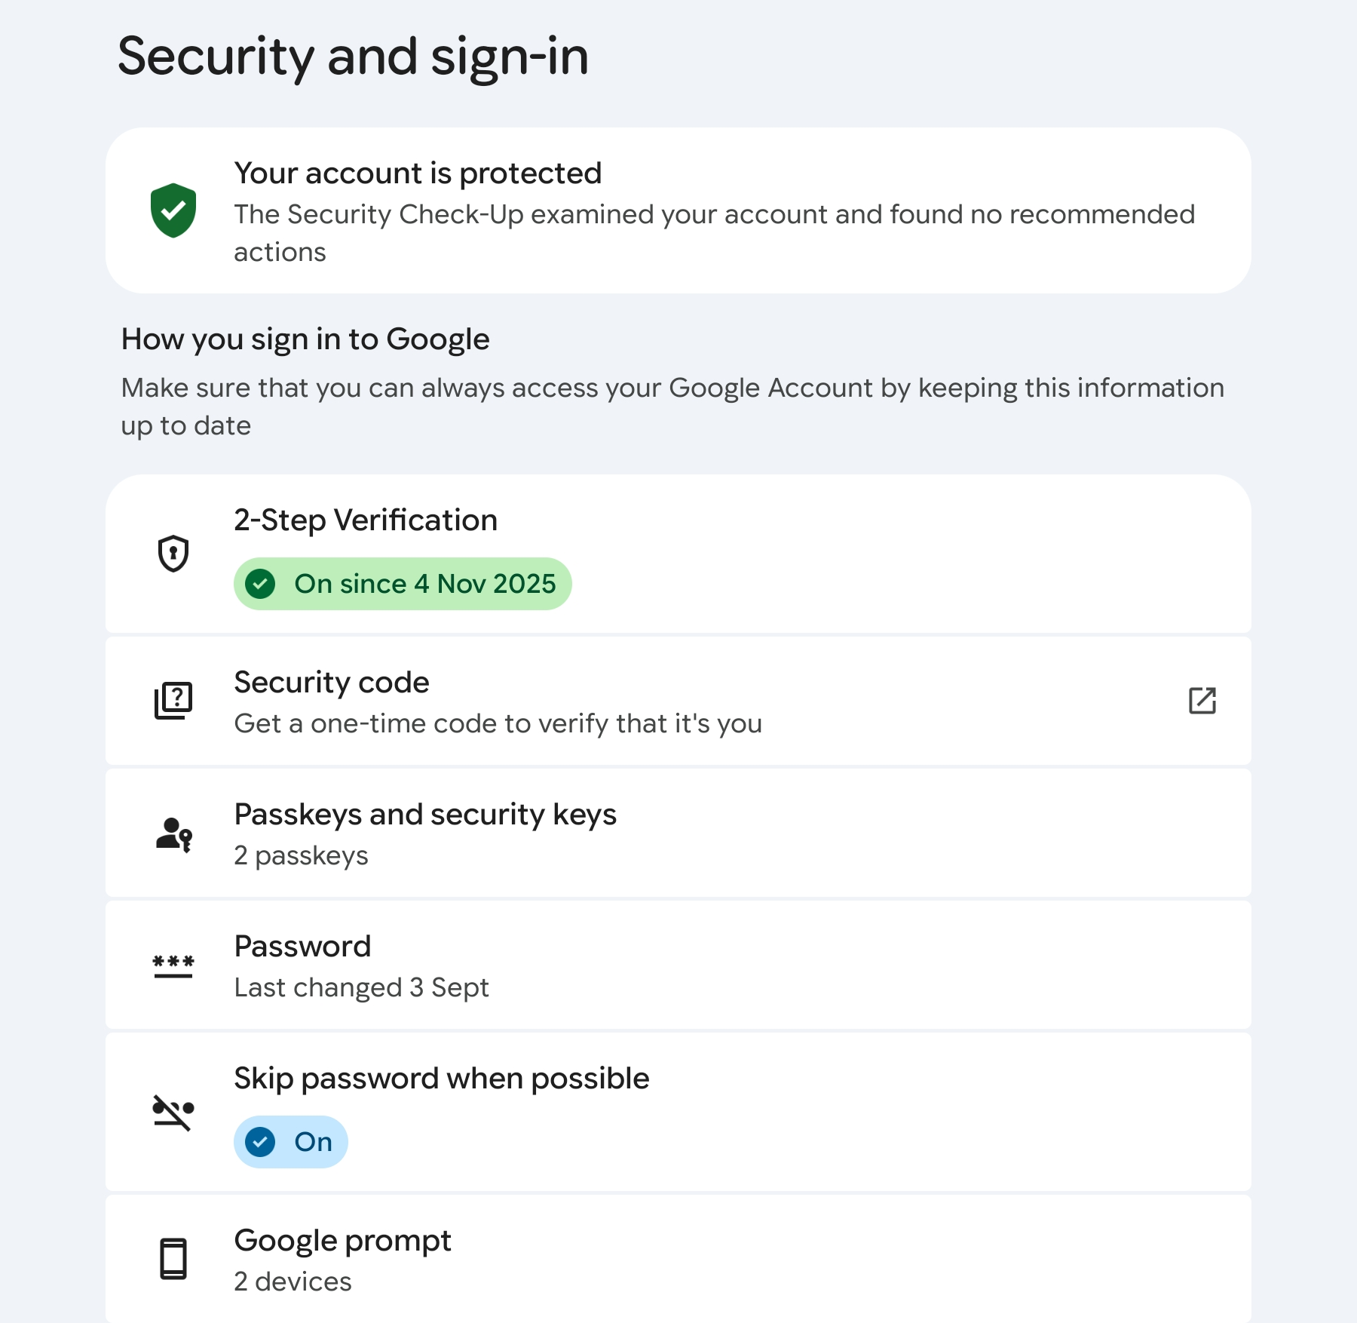
Note. Screenshot taken by the author on 25 October 2026; personal details have been cropped out.

2.5 bKash
bKash application verifies the first login with an OTP code and needs a PIN for every login and transaction. bKash introduced Face ID and fingerprint login in December 2023 (Bangladesh Sangbad Sangstha, 2023). The biggest weakness for bKash is the users. Scammers pretend to be an agent or a bKash official and trick users into reading out the OTP code. Scammers running these scams have been arrested by police (The Financial Express, 2020).
Figure 5
bKash app → My Profile → Touch/Face ID (top) and the Forgot PIN screen (bottom)
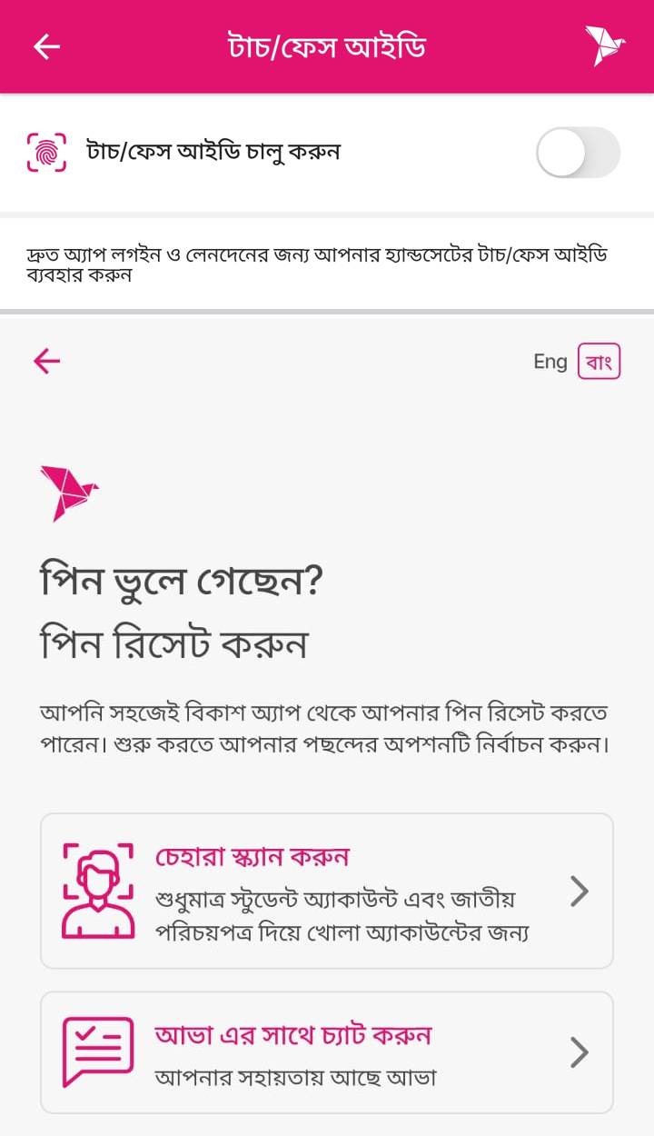
Note. Screenshots taken by the author on 25 October 2026; the app interface is in Bangla.

3. Additional Features Each Platform Should Add
The strongest ones are mostly optional, hidden or designed for a global audience rather than for Bangladeshi users. Table 1 lists the features I propose.
Table 1
Proposed Additional Security Features
Platform | Proposed feature | Why it is needed
Facebook | A waiting time of 48 hours before a new email is registered, a phone number added or 2FA changed | Hackers and scammers currently have the window to change email and phone number within seconds
Instagram | End to end encryption for DM and blurred images | Sextortion in DM
WhatsApp | A warning sign in Bangla for requested code and two step PIN for new accounts | Code sharing scams are more common
Gmail | Warning message for fake bKash, Nagad and bank email | Other accounts are reset by email and phishing scams are more
bKash | A separate warning sign for PIN reset code request and a short hold on transfer after a PIN reset code is sent | Scammers most commonly abuse the forgot PIN option to take hold of account and money transfer

The strongest protection features should be turned on by default to reduce scams and hacking incidents.

4. Which Platform Is Most Secure?
Table 2
Security Scorecard of the Five Platforms (1 = weak, 5 = strong)
Criterion | Facebook | Instagram | WhatsApp | Gmail | bKash
Login protection | 4 | 4 | 4 | 5 | 4
Encryption by default | 3 | 1 | 5 | 3 | 3
Threat detection & alerts | 4 | 4 | 3 | 5 | 3
Recovery safety | 2 | 3 | 3 | 4 | 2
Privacy controls | 3 | 4 | 5 | 3 | 3
Total (out of 25) | 16 | 16 | 20 | 20 | 15
Note. Scores are the writer’s assessment of the default and available settings as of October 2026.
WhatsApp and Gmail scored the highest (20 out of 25), while bKash scored the lowest (15 out of 25). Other platforms like Facebook and Instagram scored moderately (16 out of 25) due to their differences in strength and weakness.

5. Conclusion
All online platforms have security features, which vary with their design and user experience. However, some platforms have higher standards of security and encryption, while others have fewer. Overall, users are the weakest link in most scams, as scammers trick them into getting around the existing security features. The solution is for online platforms to assess the types of scams qualitatively and modify their security features accordingly.

References
Bangladesh Sangbad Sangstha. (2023, December 4). With ‘Face ID’, ‘fingerprint’ login bKash app is now more secure. https://www.bssnews.net/business/161466
Dhaka Tribune. (2024, June 29). Cybercrime study: Social media hacking most prevalent. https://www.dhakatribune.com/bangladesh/crime/350507/cybercrime-study-social-media-hacking-most
Engadget. (2025, September 2). Google says reports of a major Gmail security issue are ‘entirely false’. https://www.engadget.com/google-says-reports-of-a-major-gmail-security-issue-are-entirely-false-224812292.html
Euronews. (2026, May 8). Instagram is dropping end-to-end encrypted chats: This is what is changing. https://www.euronews.com/next/2026/05/08/instagram-is-dropping-end-to-end-encrypted-chats-this-is-what-is-changing
The Financial Express. (2020, December 24). Police arrest three fraud gang members in city. https://thefinancialexpress.com.bd/national/crime/police-arrest-three-fraud-gang-members-in-city-1608812154
Google. (2023, October 10). Passwordless by default: Make the switch to passkeys. The Keyword. https://blog.google/technology/safety-security/passkeys-default-google-accounts/
Help Net Security. (2025, October 30). WhatsApp now lets you secure chat backups with passkeys. https://www.helpnetsecurity.com/2025/10/30/whatsapp-secure-chat-backups-passkeys/
Meta. (2025, June 18). Introducing passkeys on Facebook for an easier sign-in (Updated September 23, 2025). Meta Newsroom. https://about.fb.com/news/2025/06/introducing-passkeys-facebook-easier-sign-in/
Statista. (2025). Countries with the most Facebook users as of October 2025. https://www.statista.com/statistics/268136/top-15-countries-based-on-number-of-facebook-users/
WhatsApp. (2026, January 27). WhatsApp’s latest privacy protection: Strict account settings. WhatsApp Blog. https://blog.whatsapp.com/whatsapps-latest-privacy-protection-strict-account-settings

