University of Dhaka
Department of Criminology
Professional Masters in Criminology and Criminal Justice (MCCJ)

Course: Research Methodology (MCCJ 521)
Individual Qualitative Research Report · Assignment (10 marks)

Justice Out of Reach: Lawyers' Accounts of Client-Side Barriers to Justice in Bangladesh
An individual qualitative research report based on semi-structured in-depth interviews
RESEARCH QUESTION 4
What challenges do lawyers face as they strive to pursue justice within legal institutions?

Submitted to  Sumaiya Iqbal  Course Teacher, Research Methodology (MCCJ 521)  Department of Criminology  University of Dhaka |  | Submitted by  Name: Md. Jubaer Islam Apon  Roll: 1  Session: 2025–2026  Programme: MCCJ, 2nd semester

Date of submission: November 2026 Word count: 2,236 (Sections 1–5)
DRAFT FOR GUIDANCE: the respondent answers, codes, counts and quotations in this version are illustrative placeholders (R1–R10), not real interview data. Conduct your own interviews, enter the real answers in data/study.json, update the bracketed [ ] details, and rebuild before submitting.

Contents
1. Introduction 3
2. Methodology 3
2.1 Research design 3
2.2 Sampling and participants 3
2.3 Data collection 4
2.4 Ethical considerations 5
2.5 Data analysis 5
2.6 Trustworthiness 5
3. Findings 6
3.1 "The cost of coming to court fifty times": litigation cost as time 8
3.2 Not knowing the law: legal literacy and the tout economy 9
3.3 Gendered barriers 9
3.4 Vulnerable clients and weak evidence 10
3.5 Delay as a cost multiplier 10
3.6 Bridging the gap: legal aid, ADR and referral networks 10
3.7 Coding paradigm model 11
4. Research limitations 12
5. Conclusion 13
References 14
Appendix A. Semi-structured interview questionnaire 15
Appendix B. Complete coding framework 16
Appendix C. Completed questionnaires 18

1. Introduction
Access to justice is usually measured from the supply side: the number of courts, judges and pending cases. Cappelletti and Garth (1978) argued that formal rights mean little unless ordinary people can actually use the institutions that enforce them. Galanter (1974) showed that legal systems tend to favour "repeat players" with resources over "one-shotters" who come to court once, often poor and inexperienced. Both insights fit Bangladesh closely. The state has created a statutory legal-aid system under the Legal Aid Act 2000, run through the National Legal Aid Services Organisation, district legal-aid offices and a national helpline (16430). Yet the people most in need of justice, such as day labourers, garment workers, rural landholders and women facing violence or abandonment, still face formidable barriers before they ever reach a judge.
Lawyers see these barriers at close range. They meet clients after a tout has taken their money, watch survivors abandon cases under pressure, and calculate whether a worker can afford to lose another day's wage for another court date. Their accounts therefore offer a practical view of how the justice system looks from the client's side of the counter.
This report responds to the research question: What challenges do lawyers face as they strive to pursue justice within legal institutions? It focuses on the challenge lawyers repeatedly described as the most frustrating: pursuing justice for clients who cannot easily afford, understand or safely use the legal system. Section 2 sets out the methodology. Section 3 presents themes from the interviews, supported by quotations and a coding paradigm model. Section 4 notes limitations, and Section 5 concludes.

2. Methodology

2.1 Research design
A qualitative design was adopted because the study is concerned with meanings, experiences and perceptions rather than frequencies (Creswell & Poth, 2018). The data were gathered through semi-structured in-depth interviews. This format keeps a common set of questions across respondents but allows the interviewer to probe individual stories in depth, which is essential when the subject matter involves clients' hardship (Kvale & Brinkmann, 2009).

2.2 Sampling and participants
As instructed, respondents were drawn from batchmates. Using purposive sampling, ten batchmates who are practising or apprenticing lawyers were selected, with deliberate variation across practice areas whose clients face different kinds of barriers: criminal, family, labour, land and legal-aid work. Three of the ten respondents are women, which allowed gendered experiences to be explored. All respondents are identified by codes (R1–R10). Their profile is given in Table 1 and Figure 1.
Table 1. Profile of respondents (pseudonymised)
ID | Gender | Years | Role | Main forum | Practice area
R1 | Male | 6 | Advocate | Dhaka Judge Court | Criminal
R2 | Female | 3 | Advocate | Family Court, Dhaka | Family
R3 | Male | 9 | Advocate | High Court Division | Writ / constitutional
R4 | Male | 2 | Junior advocate | District Court, Gazipur | Civil / land
R5 | Female | 5 | Advocate | Nari-o-Shishu Tribunal & CMM Court | Criminal (survivors)
R6 | Male | 12 | Advocate | District Court, Narayanganj | Land / civil
R7 | Male | 4 | Advocate | Labour Court, Dhaka | Labour / corporate
R8 | Male | 7 | Advocate | Dhaka Judge Court | Criminal defence / bail
R9 | Female | 1 | Junior advocate (legal-aid panel) | District Legal Aid Office | Mixed / legal aid
R10 | Male | 10 | Barrister / Advocate | High Court Division | Commercial / civil

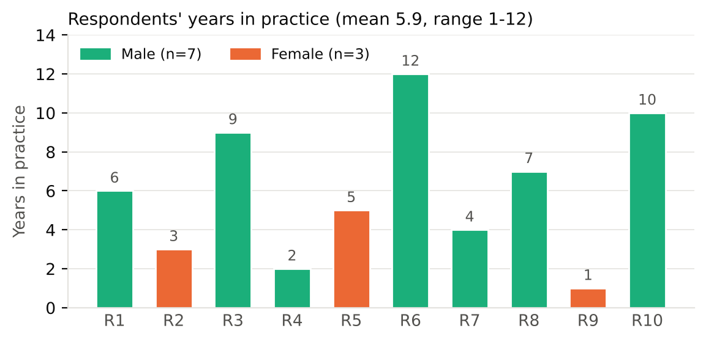
Figure 1. Respondents' years in practice, by gender

2.3 Data collection
A separate questionnaire of eleven open-ended questions, each with optional probes, was used (Appendix A). It was designed around the client's side of the justice system: Questions 3 to 8 asked about litigation costs, clients' understanding of the process, barriers faced by women, poor and rural clients, evidence and witness pressure, delay, and legal aid. The completed questionnaire for each respondent is attached in Appendix C. Interviews took place between [dates] in [mode], lasted around [duration] minutes, and were conducted in Bangla and/or English. Responses were recorded with permission, or written down in detail where recording was declined, and later transcribed and translated.

2.4 Ethical considerations
Informed verbal consent was obtained after explaining the study's purpose, the voluntary nature of participation and the right to withdraw. Respondents were asked not to name clients. Any case details that could identify a client were removed during transcription. Respondents' identities are known only to the researcher.

2.5 Data analysis
The transcripts were analysed through thematic analysis following Braun and Clarke's (2006) six phases (Table 2). Initial open codes were generated line by line. The codes were then related to one another through axial coding using Strauss and Corbin's (1998) coding paradigm, which asks what causes a phenomenon, in what context it occurs, what conditions intervene, how actors respond and with what consequences.
Table 2. Phases of thematic analysis as applied in this study
Phase (Braun & Clarke, 2006) | How it was applied in this study
1. Familiarisation | Transcripts were read several times alongside the recordings and notes, and initial impressions were noted in the margins.
2. Generating initial codes | Line-by-line open coding produced 29 initial codes across 194 coded segments (Appendix B).
3. Searching for themes | Related codes were clustered into candidate themes, and axial coding with the Strauss and Corbin coding paradigm was used to connect them.
4. Reviewing themes | Themes were checked against the coded extracts and the whole dataset using a respondent × theme framework matrix (Figure 3).
5. Defining and naming themes | Seven themes were defined and named, and a central phenomenon was identified for the paradigm model.
6. Producing the report | Vivid, representative quotations were selected and the analysis was related back to the research question and the literature.

2.6 Trustworthiness
To enhance credibility, emerging themes were discussed with a peer, and a summary was shared with two respondents for comment. A record of coding decisions was maintained (Lincoln & Guba, 1985). Being a batchmate of the respondents created trust, but I remained conscious that shared assumptions about "how courts work" could lead me to take answers at face value, so I used probes to ask for concrete examples.

3. Findings
The analysis produced 29 codes from 194 coded segments, grouped into seven themes (Figure 2). All seven appeared across the sample (Figure 3). Every respondent raised the client-side barriers in Theme 5. Litigation cost and lost income was mentioned by nine of the ten. This report concentrates on four interrelated themes: client access barriers (T5), investigation and evidence gaps as they affect vulnerable clients (T3), delay as a cost multiplier (T1), and the coping strategies and reforms through which lawyers try to bridge the gap (T7) (Table 3; Figure 4).
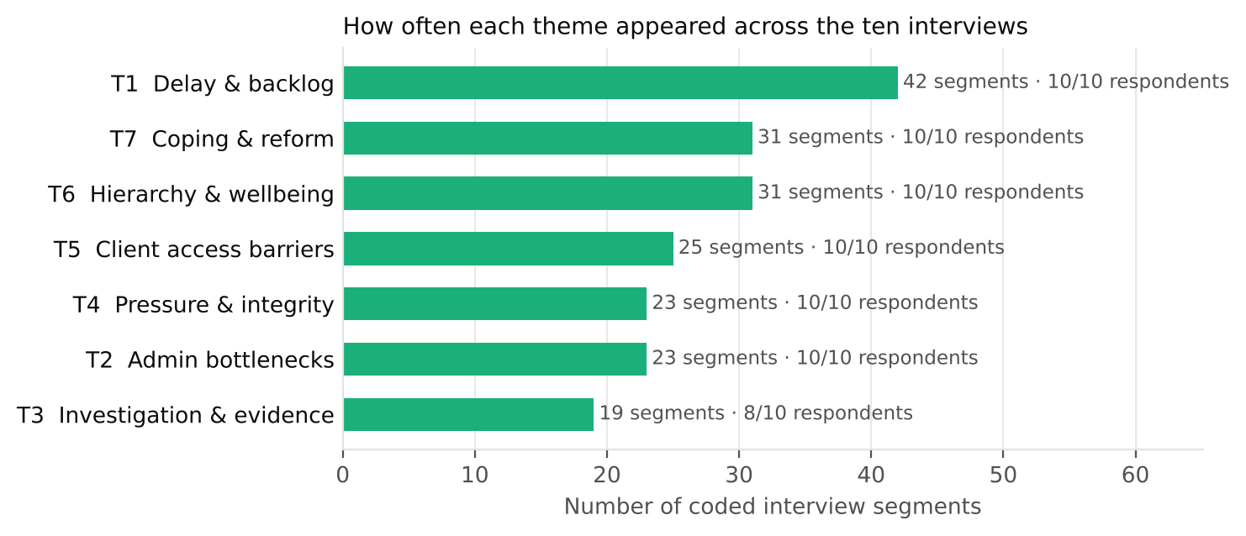
Figure 2. Coded segments per theme across all ten interviews
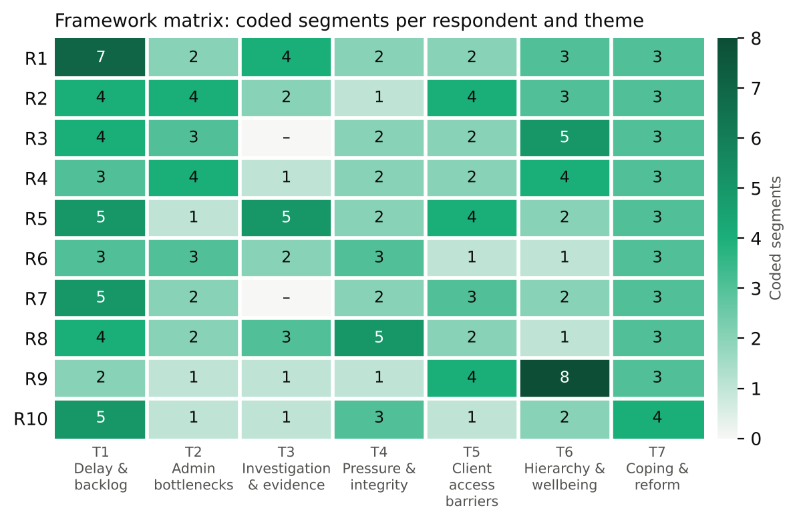
Figure 3. Framework matrix: number of coded segments per respondent and theme
Table 3. Coding framework for the focal themes: codes, categories and themes
Theme (selective coding) | Initial code (open coding) | n | Respondents
T5: Access-to-justice barriers for clients | c18 Litigation cost and lost income | 9/10 | R1, R2, R3, R4, R5, R6, R7, R8, R10
 | c19 Low legal literacy and exploitation by touts | 5/10 | R2, R4, R7, R8, R9
 | c20 Gender and social barriers for women clients | 2/10 | R2, R5
 | c21 Weak reach and quality of legal aid | 4/10 | R1, R3, R5, R9
T3: Weak investigation and evidentiary gaps | c10 Weak or biased police investigation | 5/10 | R1, R2, R5, R8, R9
 | c11 Delayed or flawed charge sheets | 3/10 | R1, R5, R8
 | c12 Witness intimidation / hostile witnesses | 4/10 | R2, R4, R5, R6
 | c13 Lack of forensic and digital-evidence support | 4/10 | R1, R5, R6, R10
T1: Institutional delay and case backlog | c01 Frequent adjournments / time petitions | 10/10 | R1, R2, R3, R4, R5, R6, R7, R8, R9, R10
 | c02 Case backlog and overloaded cause lists | 8/10 | R1, R3, R4, R5, R6, R7, R8, R10
 | c03 Shortage of judges and courts | 4/10 | R1, R6, R7, R10
 | c04 Witness non-appearance / summons not served | 4/10 | R1, R2, R5, R8
 | c05 Clients losing faith because of delay | 5/10 | R1, R2, R3, R5, R9
T7: Coping strategies and reform aspirations | c26 Persistent follow-up and personal networks | 7/10 | R1, R2, R3, R4, R5, R8, R9
 | c27 Mediation, conciliation and arbitration | 4/10 | R2, R6, R7, R10
 | c28 Digital tools (online cause list, virtual hearing) | 9/10 | R1, R3, R4, R5, R6, R7, R8, R9, R10
 | c29 Calls for structural reform | 10/10 | R1, R2, R3, R4, R5, R6, R7, R8, R9, R10

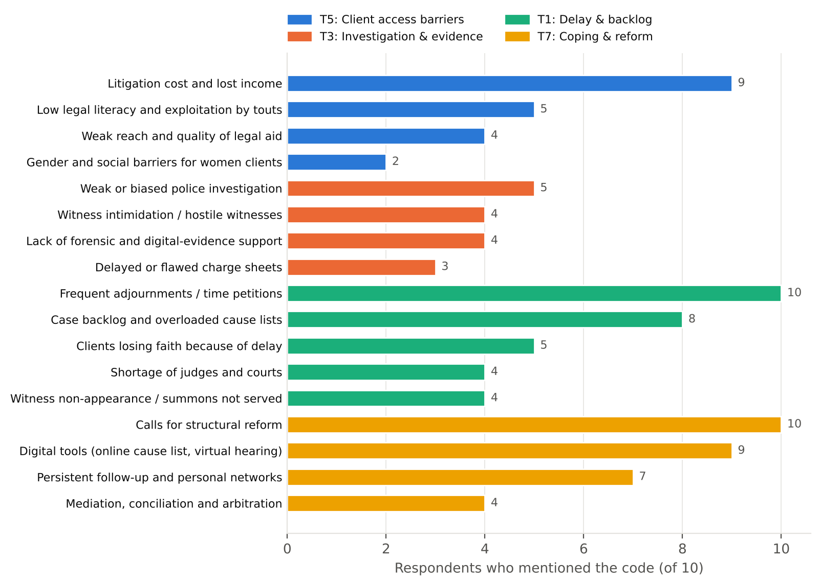
Figure 4. Number of respondents mentioning each code within the focal themes

3.1 "The cost of coming to court fifty times": litigation cost as time
Respondents agreed that the main cost of justice is not the lawyer's fee but the accumulated cost of repeated attendance: travel, lost wages and the cumulative toll of each date. One senior lawyer captured this in a single sentence:
“Litigation cost is not only fees. It is the cost of coming to court fifty times.” (R6, male, land / civil, 12 years in practice)
For workers and day labourers this cost is immediate and severe:
“Workers cannot leave work for court dates. Every date means losing a day's wage.” (R7, male, labour / corporate, 4 years in practice)
“Most of my clients are day labourers' families. They sell a cow or take a loan to pay for the case. Many do not even know legal aid exists.” (R1, male, criminal, 6 years in practice)
The higher courts were described as almost entirely out of reach for ordinary people, not least because rural litigants have to travel to and stay in Dhaka:
“Rural petitioners have to come to Dhaka and stay in hotels. A High Court case is beyond most ordinary people's means. Supreme Court legal aid exists, but few people know.” (R3, male, writ / constitutional, 9 years in practice)
These accounts closely match Galanter's (1974) "one-shotter". A client who must sell a cow to fund a case cannot outlast an opponent with resources, which is why respondents described the passage of time itself as a tool of the stronger party.

3.2 Not knowing the law: legal literacy and the tout economy
The second sub-theme concerns clients' limited understanding of legal language and procedure. Respondents described an informal economy of dalals (touts) who exploit this gap before a lawyer is even engaged:
“Villagers do not understand legal language. They sign documents without reading them. Many come to me after losing everything to a dalal.” (R4, male, civil / land, 2 years in practice)
“Clients' families are exploited by touts on the court premises before they even reach a lawyer.” (R8, male, criminal defence / bail, 7 years in practice)
In labour cases, literacy and documentation barriers make it hard even to establish the basic facts of a claim:
“The evidence is mostly documents, but workers have no appointment letters or payslips, so even proving employment is hard.” (R7, male, labour / corporate, 4 years in practice)
The newest respondent explained that inexperience on both sides of the lawyer-client relationship can compound the problem:
“Clients do not understand the process, and I do not yet have the experience to move through the system quickly.” (R9, female, mixed / legal aid, 1 year in practice)

3.3 Gendered barriers
The two respondents whose practice centres on women clients, in the family court and the Nari-o-Shishu tribunal, described in detail how gender shapes women clients' access to justice. Women often lack independent income, depend on male relatives to come to court, and face stigma:
“My clients are mostly women with no income of their own. They come with a brother or father and cannot speak freely. Many think the court is only for rich people.” (R2, female, family, 3 years in practice)
Courts themselves were described as physically unsafe for survivors:
“There is no private waiting space for survivors. They sit right next to the accused's family.” (R5, female, criminal (survivors), 5 years in practice)
Barriers also appear at the very first point of contact with the justice system, when a woman tries to report a crime to the police:
“In dowry or violence cases the medical certificate is late or weak. Police sometimes discourage women from filing and push them towards a 'compromise'.” (R2, female, family, 3 years in practice)

3.4 Vulnerable clients and weak evidence
Theme 3 shows that the investigation and evidence system works worst for those with least power. Respondents argued that poor clients' cases receive less investigative attention:
“Legal-aid cases often have poor investigation files. Nobody prioritises a poor man's case.” (R9, female, mixed / legal aid, 1 year in practice)
Where the opposing party is powerful, witness intimidation and pressure to compromise often decide the outcome:
“The pressure to compromise is huge. The accused side offers money or threatens the family. Sometimes the survivor turns hostile in the witness box.” (R5, female, criminal (survivors), 5 years in practice)
“Local influential people sometimes pressure my client to withdraw. Once a union parishad member came to the court premises to threaten her.” (R2, female, family, 3 years in practice)
In these accounts, intimidation, compromise pressure and weak investigation together form a barrier as real as cost. A client may afford the case and still lose it because the evidence cannot be safely produced.

3.5 Delay as a cost multiplier
Theme 1 (delay) was the densest theme in the dataset. From the client's perspective, respondents presented delay above all as something that multiplies every other barrier. Each adjournment adds cost, erodes trust and gives the stronger party more time to apply pressure:
“Poor clients come again and again just to hear 'next date'. Some simply stop coming.” (R9, female, mixed / legal aid, 1 year in practice)
“Execution is the problem. We get a maintenance decree but the husband does not pay, and execution takes another year. Women give up halfway.” (R2, female, family, 3 years in practice)
Five respondents explicitly linked delay to clients losing faith in the system. Among the poorest litigants, this often meant that cases were quietly abandoned.

3.6 Bridging the gap: legal aid, ADR and referral networks
Respondents described several ways of trying to close the gap between clients and courts. Legal aid was valued in principle but criticised for low awareness and weak incentives:
“Legal aid exists through the District Legal Aid Office, but people do not know about it. Panel lawyers' fees are very low, so motivation is low.” (R9, female, mixed / legal aid, 1 year in practice)
The national hotline was mentioned as one practical improvement in reaching clients:
“The national legal-aid hotline, 16430, helps clients reach us.” (R9, female, mixed / legal aid, 1 year in practice)
Alternative dispute resolution was widely used to spare clients the cost of long litigation:
“I try to negotiate settlements through conciliation. Quick money is often better than a slow judgment.” (R7, male, labour / corporate, 4 years in practice)
“I try reconciliation first, because the family court allows it before and after trial. I also connect clients with legal-aid NGOs.” (R2, female, family, 3 years in practice)
Lawyers working with survivors described a holistic role that went well beyond legal representation:
“I prepare the survivor before testimony and explain cross-examination. I coordinate with the one-stop crisis centres.” (R5, female, criminal (survivors), 5 years in practice)
Respondents' proposals for change focused on making existing protections effective:
“A victim and witness protection law. Without protection there is no evidence, and without evidence there is no justice.” (R5, female, criminal (survivors), 5 years in practice)
“Pay legal-aid lawyers properly and evaluate their work, so the quality improves.” (R9, female, mixed / legal aid, 1 year in practice)

3.7 Coding paradigm model
Figure 5 integrates these findings using Strauss and Corbin's (1998) coding paradigm. The central phenomenon is that justice is priced and distanced out of ordinary clients' reach. Its causal conditions are litigation cost and lost wages, low legal literacy and distance from courts. These operate in a context where delay multiplies costs, touts exploit clients on court premises and gendered social norms restrict women. Intervening conditions, namely weak awareness and low pay for legal aid, witness intimidation and poor investigation of poor clients' cases, deepen the exclusion. Lawyers respond with strategies of honest explanation, reconciliation and conciliation, referral to NGOs and crisis centres, and use of the legal-aid hotline. The consequences include abandoned cases, compromise under pressure, eroded public trust and calls for stronger legal aid and victim protection.
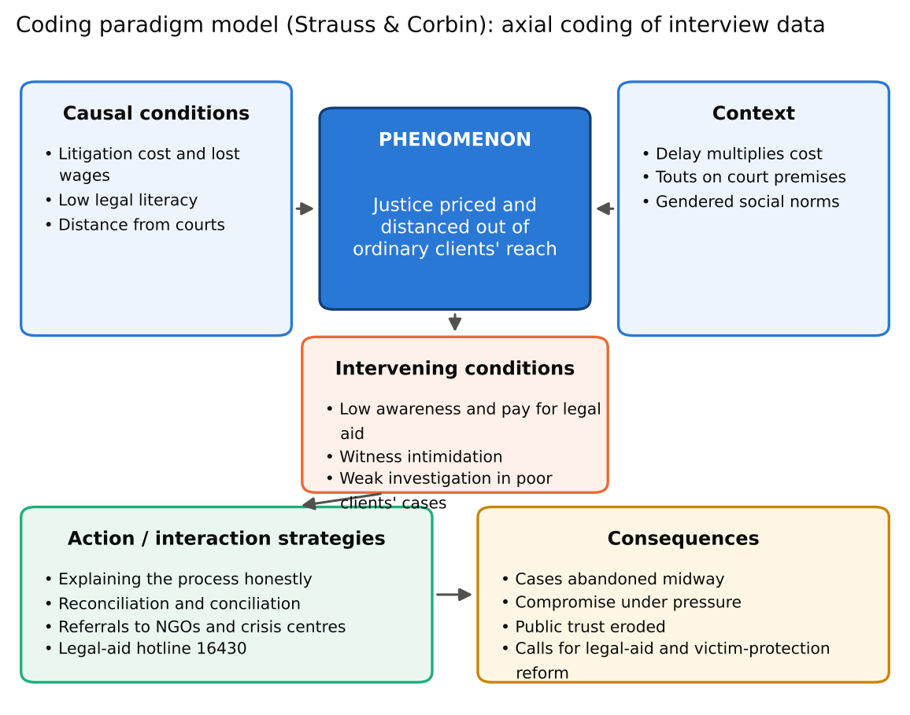
Figure 5. Coding paradigm model of client-side barriers to justice (after Strauss & Corbin, 1998)

4. Research limitations
This study has several limitations. The sample of ten batchmates is small and was selected for convenience and relevance, and most respondents practise in Dhaka and nearby districts. The findings therefore illuminate but cannot represent the experiences of lawyers across Bangladesh, particularly in remote areas where barriers may be even greater. Second, the study relies on lawyers' accounts of their clients. Clients themselves were not interviewed, so their perspectives are filtered through their lawyers' interpretations. Third, arranging interviews around court schedules was difficult, and some interviews were shorter or conducted remotely, which limited follow-up. Fourth, sensitive topics such as intimidation and informal payments may have been under-reported, both out of caution and because of my insider relationship with respondents. Fifth, translation between Bangla and English may have flattened some expressions. Finally, a single coder analysed the data. Peer debriefing helped, but interpretation inevitably reflects the researcher's perspective.

5. Conclusion
This study explored the challenges lawyers face in pursuing justice, with a focus on the barriers that stand between their clients and the courts. The interviews suggest that, for many Bangladeshis, the obstacle is not the absence of rights but the cost, complexity and risk of claiming them. Repeated court dates turn modest fees into crippling expense. Low legal literacy exposes clients to touts. Women face social and physical barriers at every stage. Weak investigation and witness intimidation mean that poor and vulnerable clients often cannot prove even strong cases. Delay ties these barriers together, multiplying each one. Lawyers respond creatively by explaining the process honestly, turning to mediation and conciliation, and connecting clients with NGOs, crisis centres and the legal-aid hotline. They are clear, however, that individual effort cannot substitute for institutional change. Their recommendations are to pay and evaluate legal-aid lawyers properly, enact victim and witness protection, enforce decrees quickly and bring services closer to clients. These point to a practical reform agenda for making justice reachable rather than merely available.

References
Braun, V., & Clarke, V. (2006). Using thematic analysis in psychology. Qualitative Research in Psychology, 3(2), 77–101.
Cappelletti, M., & Garth, B. (Eds.). (1978). Access to justice: Vol. 1. A world survey. Giuffrè / Sijthoff and Noordhoff.
Creswell, J. W., & Poth, C. N. (2018). Qualitative inquiry and research design: Choosing among five approaches (4th ed.). Sage.
Galanter, M. (1974). Why the "haves" come out ahead: Speculations on the limits of legal change. Law & Society Review, 9(1), 95–160.
Kvale, S., & Brinkmann, S. (2009). InterViews: Learning the craft of qualitative research interviewing (2nd ed.). Sage.
Lincoln, Y. S., & Guba, E. G. (1985). Naturalistic inquiry. Sage.
Strauss, A., & Corbin, J. (1998). Basics of qualitative research: Techniques and procedures for developing grounded theory (2nd ed.). Sage.
Legal Aid Act 2000; Women and Children Repression Prevention Act 2000; Bangladesh Labour Act 2006 (Bangladesh).

Appendix A. Semi-structured interview questionnaire
Opening: introduce the study, confirm consent and permission to record, and note the respondent's name, roll, batch, gender, years in practice and main court. The eleven core questions below were asked in every interview; probes were used where helpful.
- Could you introduce yourself and describe the kinds of clients you usually represent?
Probes: Where do most of your clients come from?
- What are the most common difficulties your clients face before and after they come to court?
Probes: Can you give an example?
- How do the costs of litigation (fees, travel, lost wages) affect your clients' ability to pursue their cases?
Probes: Have clients sold assets or borrowed money?
- How well do your clients understand the legal process, and how does this affect their case?
Probes: Have you met clients cheated by touts (dalals)?
- In your experience, do women, poor or rural clients face particular barriers? Please give an example.
Probes: What happens at the police station or in court?
- How do weak investigation, pressure on witnesses or lack of evidence affect clients who have little power or money?
Probes: Have clients been pressured to compromise?
- How does delay in the court process affect your clients' trust and their decision to continue?
Probes: Do clients stop coming?
- What has been your experience with government legal aid (District Legal Aid Office, NLASO, hotline 16430)?
Probes: Do clients know it exists? / How good is the service?
- What do you do as a lawyer to help clients overcome these barriers, for example explaining the process, mediation or referrals?
Probes: Which NGOs or services do you work with?
- How does working with disadvantaged clients affect you personally?
Probes: How do you cope?
- What changes would make justice more accessible for ordinary people?
Probes: Anything else you would like to add?
Closing: thank the respondent, ask whether there is anything they would like to add, and remind them of confidentiality and their right to withdraw.

Appendix B. Complete coding framework
Theme (selective coding) | Initial code (open coding) | n | Respondents
T1: Institutional delay and case backlog | c01 Frequent adjournments / time petitions | 10/10 | R1, R2, R3, R4, R5, R6, R7, R8, R9, R10
 | c02 Case backlog and overloaded cause lists | 8/10 | R1, R3, R4, R5, R6, R7, R8, R10
 | c03 Shortage of judges and courts | 4/10 | R1, R6, R7, R10
 | c04 Witness non-appearance / summons not served | 4/10 | R1, R2, R5, R8
 | c05 Clients losing faith because of delay | 5/10 | R1, R2, R3, R5, R9
T2: Procedural and administrative bottlenecks | c06 Informal 'speed money' to court staff | 7/10 | R1, R2, R3, R4, R6, R8, R9
 | c07 Missing or misplaced case records | 3/10 | R1, R4, R6
 | c08 Slow certified copies, orders and reports | 5/10 | R2, R3, R4, R7, R8
 | c09 Manual systems and poor court infrastructure | 7/10 | R2, R3, R4, R5, R6, R7, R10
T3: Weak investigation and evidentiary gaps | c10 Weak or biased police investigation | 5/10 | R1, R2, R5, R8, R9
 | c11 Delayed or flawed charge sheets | 3/10 | R1, R5, R8
 | c12 Witness intimidation / hostile witnesses | 4/10 | R2, R4, R5, R6
 | c13 Lack of forensic and digital-evidence support | 4/10 | R1, R5, R6, R10
T4: External pressure and integrity dilemmas | c14 Political influence on cases | 5/10 | R1, R3, R7, R8, R10
 | c15 Pressure or threats from influential parties | 8/10 | R1, R2, R4, R5, R6, R7, R8, R10
 | c16 Bar politics and partisan alignment | 5/10 | R3, R5, R6, R8, R10
 | c17 Ethical dilemmas over informal payments | 3/10 | R4, R6, R9
T5: Access-to-justice barriers for clients | c18 Litigation cost and lost income | 9/10 | R1, R2, R3, R4, R5, R6, R7, R8, R10
 | c19 Low legal literacy and exploitation by touts | 5/10 | R2, R4, R7, R8, R9
 | c20 Gender and social barriers for women clients | 2/10 | R2, R5
 | c21 Weak reach and quality of legal aid | 4/10 | R1, R3, R5, R9
T6: Professional hierarchy, insecurity and wellbeing | c22 Irregular income of junior lawyers | 5/10 | R2, R3, R4, R7, R9
 | c23 Senior gatekeeping and dependency | 6/10 | R1, R3, R4, R7, R9, R10
 | c24 Gender discrimination within the Bar | 3/10 | R2, R5, R9
 | c25 Stress, fear and burnout | 9/10 | R1, R2, R3, R4, R5, R6, R8, R9, R10
T7: Coping strategies and reform aspirations | c26 Persistent follow-up and personal networks | 7/10 | R1, R2, R3, R4, R5, R8, R9
 | c27 Mediation, conciliation and arbitration | 4/10 | R2, R6, R7, R10
 | c28 Digital tools (online cause list, virtual hearing) | 9/10 | R1, R3, R4, R5, R6, R7, R8, R9, R10
 | c29 Calls for structural reform | 10/10 | R1, R2, R3, R4, R5, R6, R7, R8, R9, R10

Appendix C. Completed questionnaires
This appendix contains the questionnaire completed for each of the ten respondents interviewed by Md. Jubaer Islam Apon. Names appear here for verification by the course teacher only; in the body of the report respondents are anonymised.

Questionnaire 1 of 10: Mohammad Mobarak Hosen
Respondent name | Mohammad Mobarak Hosen
Roll | 25
Session | 2025–2026 (MCCJ)
Gender / years in practice
Main court / practice area
Date, mode and duration
Interviewed by | Md. Jubaer Islam Apon (Roll 1)
Informed consent | ☐ Yes ☐ No

Q1. Could you introduce yourself and describe the kinds of clients you usually represent?
Response:
Q2. What are the most common difficulties your clients face before and after they come to court?
Response:
Q3. How do the costs of litigation (fees, travel, lost wages) affect your clients' ability to pursue their cases?
Response:
Q4. How well do your clients understand the legal process, and how does this affect their case?
Response:
Q5. In your experience, do women, poor or rural clients face particular barriers? Please give an example.
Response:
Q6. How do weak investigation, pressure on witnesses or lack of evidence affect clients who have little power or money?
Response:
Q7. How does delay in the court process affect your clients' trust and their decision to continue?
Response:
Q8. What has been your experience with government legal aid (District Legal Aid Office, NLASO, hotline 16430)?
Response:
Q9. What do you do as a lawyer to help clients overcome these barriers, for example explaining the process, mediation or referrals?
Response:
Q10. How does working with disadvantaged clients affect you personally?
Response:
Q11. What changes would make justice more accessible for ordinary people?
Response:

Questionnaire 2 of 10: Nafiul Hoque Kingshuk
Respondent name | Nafiul Hoque Kingshuk
Roll | 22
Session | 2025–2026 (MCCJ)
Gender / years in practice
Main court / practice area
Date, mode and duration
Interviewed by | Md. Jubaer Islam Apon (Roll 1)
Informed consent | ☐ Yes ☐ No

Q1. Could you introduce yourself and describe the kinds of clients you usually represent?
Response:
Q2. What are the most common difficulties your clients face before and after they come to court?
Response:
Q3. How do the costs of litigation (fees, travel, lost wages) affect your clients' ability to pursue their cases?
Response:
Q4. How well do your clients understand the legal process, and how does this affect their case?
Response:
Q5. In your experience, do women, poor or rural clients face particular barriers? Please give an example.
Response:
Q6. How do weak investigation, pressure on witnesses or lack of evidence affect clients who have little power or money?
Response:
Q7. How does delay in the court process affect your clients' trust and their decision to continue?
Response:
Q8. What has been your experience with government legal aid (District Legal Aid Office, NLASO, hotline 16430)?
Response:
Q9. What do you do as a lawyer to help clients overcome these barriers, for example explaining the process, mediation or referrals?
Response:
Q10. How does working with disadvantaged clients affect you personally?
Response:
Q11. What changes would make justice more accessible for ordinary people?
Response:

Questionnaire 3 of 10: Shams Bin Sharif Taj
Respondent name | Shams Bin Sharif Taj
Roll | 14
Session | 2025–2026 (MCCJ)
Gender / years in practice
Main court / practice area
Date, mode and duration
Interviewed by | Md. Jubaer Islam Apon (Roll 1)
Informed consent | ☐ Yes ☐ No

Q1. Could you introduce yourself and describe the kinds of clients you usually represent?
Response:
Q2. What are the most common difficulties your clients face before and after they come to court?
Response:
Q3. How do the costs of litigation (fees, travel, lost wages) affect your clients' ability to pursue their cases?
Response:
Q4. How well do your clients understand the legal process, and how does this affect their case?
Response:
Q5. In your experience, do women, poor or rural clients face particular barriers? Please give an example.
Response:
Q6. How do weak investigation, pressure on witnesses or lack of evidence affect clients who have little power or money?
Response:
Q7. How does delay in the court process affect your clients' trust and their decision to continue?
Response:
Q8. What has been your experience with government legal aid (District Legal Aid Office, NLASO, hotline 16430)?
Response:
Q9. What do you do as a lawyer to help clients overcome these barriers, for example explaining the process, mediation or referrals?
Response:
Q10. How does working with disadvantaged clients affect you personally?
Response:
Q11. What changes would make justice more accessible for ordinary people?
Response:

Questionnaire 4 of 10: Tashfia Ali
Respondent name | Tashfia Ali
Roll | 41
Session | 2025–2026 (MCCJ)
Gender / years in practice
Main court / practice area
Date, mode and duration
Interviewed by | Md. Jubaer Islam Apon (Roll 1)
Informed consent | ☐ Yes ☐ No

Q1. Could you introduce yourself and describe the kinds of clients you usually represent?
Response:
Q2. What are the most common difficulties your clients face before and after they come to court?
Response:
Q3. How do the costs of litigation (fees, travel, lost wages) affect your clients' ability to pursue their cases?
Response:
Q4. How well do your clients understand the legal process, and how does this affect their case?
Response:
Q5. In your experience, do women, poor or rural clients face particular barriers? Please give an example.
Response:
Q6. How do weak investigation, pressure on witnesses or lack of evidence affect clients who have little power or money?
Response:
Q7. How does delay in the court process affect your clients' trust and their decision to continue?
Response:
Q8. What has been your experience with government legal aid (District Legal Aid Office, NLASO, hotline 16430)?
Response:
Q9. What do you do as a lawyer to help clients overcome these barriers, for example explaining the process, mediation or referrals?
Response:
Q10. How does working with disadvantaged clients affect you personally?
Response:
Q11. What changes would make justice more accessible for ordinary people?
Response:

Questionnaire 5 of 10: Shohag
Respondent name | Shohag
Roll | [roll]
Session | 2025–2026 (MCCJ)
Gender / years in practice
Main court / practice area
Date, mode and duration
Interviewed by | Md. Jubaer Islam Apon (Roll 1)
Informed consent | ☐ Yes ☐ No

Q1. Could you introduce yourself and describe the kinds of clients you usually represent?
Response:
Q2. What are the most common difficulties your clients face before and after they come to court?
Response:
Q3. How do the costs of litigation (fees, travel, lost wages) affect your clients' ability to pursue their cases?
Response:
Q4. How well do your clients understand the legal process, and how does this affect their case?
Response:
Q5. In your experience, do women, poor or rural clients face particular barriers? Please give an example.
Response:
Q6. How do weak investigation, pressure on witnesses or lack of evidence affect clients who have little power or money?
Response:
Q7. How does delay in the court process affect your clients' trust and their decision to continue?
Response:
Q8. What has been your experience with government legal aid (District Legal Aid Office, NLASO, hotline 16430)?
Response:
Q9. What do you do as a lawyer to help clients overcome these barriers, for example explaining the process, mediation or referrals?
Response:
Q10. How does working with disadvantaged clients affect you personally?
Response:
Q11. What changes would make justice more accessible for ordinary people?
Response:

Questionnaire 6 of 10: Marzia Rahman
Respondent name | Marzia Rahman
Roll | 29
Session | 2025–2026 (MCCJ)
Gender / years in practice
Main court / practice area
Date, mode and duration
Interviewed by | Md. Jubaer Islam Apon (Roll 1)
Informed consent | ☐ Yes ☐ No

Q1. Could you introduce yourself and describe the kinds of clients you usually represent?
Response:
Q2. What are the most common difficulties your clients face before and after they come to court?
Response:
Q3. How do the costs of litigation (fees, travel, lost wages) affect your clients' ability to pursue their cases?
Response:
Q4. How well do your clients understand the legal process, and how does this affect their case?
Response:
Q5. In your experience, do women, poor or rural clients face particular barriers? Please give an example.
Response:
Q6. How do weak investigation, pressure on witnesses or lack of evidence affect clients who have little power or money?
Response:
Q7. How does delay in the court process affect your clients' trust and their decision to continue?
Response:
Q8. What has been your experience with government legal aid (District Legal Aid Office, NLASO, hotline 16430)?
Response:
Q9. What do you do as a lawyer to help clients overcome these barriers, for example explaining the process, mediation or referrals?
Response:
Q10. How does working with disadvantaged clients affect you personally?
Response:
Q11. What changes would make justice more accessible for ordinary people?
Response:

Questionnaire 7 of 10: Imran Mridha
Respondent name | Imran Mridha
Roll | 33
Session | 2025–2026 (MCCJ)
Gender / years in practice
Main court / practice area
Date, mode and duration
Interviewed by | Md. Jubaer Islam Apon (Roll 1)
Informed consent | ☐ Yes ☐ No

Q1. Could you introduce yourself and describe the kinds of clients you usually represent?
Response:
Q2. What are the most common difficulties your clients face before and after they come to court?
Response:
Q3. How do the costs of litigation (fees, travel, lost wages) affect your clients' ability to pursue their cases?
Response:
Q4. How well do your clients understand the legal process, and how does this affect their case?
Response:
Q5. In your experience, do women, poor or rural clients face particular barriers? Please give an example.
Response:
Q6. How do weak investigation, pressure on witnesses or lack of evidence affect clients who have little power or money?
Response:
Q7. How does delay in the court process affect your clients' trust and their decision to continue?
Response:
Q8. What has been your experience with government legal aid (District Legal Aid Office, NLASO, hotline 16430)?
Response:
Q9. What do you do as a lawyer to help clients overcome these barriers, for example explaining the process, mediation or referrals?
Response:
Q10. How does working with disadvantaged clients affect you personally?
Response:
Q11. What changes would make justice more accessible for ordinary people?
Response:

Questionnaire 8 of 10: Abdullah Al Mamun
Respondent name | Abdullah Al Mamun
Roll | 2
Session | 2025–2026 (MCCJ)
Gender / years in practice
Main court / practice area
Date, mode and duration
Interviewed by | Md. Jubaer Islam Apon (Roll 1)
Informed consent | ☐ Yes ☐ No

Q1. Could you introduce yourself and describe the kinds of clients you usually represent?
Response:
Q2. What are the most common difficulties your clients face before and after they come to court?
Response:
Q3. How do the costs of litigation (fees, travel, lost wages) affect your clients' ability to pursue their cases?
Response:
Q4. How well do your clients understand the legal process, and how does this affect their case?
Response:
Q5. In your experience, do women, poor or rural clients face particular barriers? Please give an example.
Response:
Q6. How do weak investigation, pressure on witnesses or lack of evidence affect clients who have little power or money?
Response:
Q7. How does delay in the court process affect your clients' trust and their decision to continue?
Response:
Q8. What has been your experience with government legal aid (District Legal Aid Office, NLASO, hotline 16430)?
Response:
Q9. What do you do as a lawyer to help clients overcome these barriers, for example explaining the process, mediation or referrals?
Response:
Q10. How does working with disadvantaged clients affect you personally?
Response:
Q11. What changes would make justice more accessible for ordinary people?
Response:

Questionnaire 9 of 10: Md. Akram Hossain Rifat
Respondent name | Md. Akram Hossain Rifat
Roll | 38
Session | 2025–2026 (MCCJ)
Gender / years in practice
Main court / practice area
Date, mode and duration
Interviewed by | Md. Jubaer Islam Apon (Roll 1)
Informed consent | ☐ Yes ☐ No

Q1. Could you introduce yourself and describe the kinds of clients you usually represent?
Response:
Q2. What are the most common difficulties your clients face before and after they come to court?
Response:
Q3. How do the costs of litigation (fees, travel, lost wages) affect your clients' ability to pursue their cases?
Response:
Q4. How well do your clients understand the legal process, and how does this affect their case?
Response:
Q5. In your experience, do women, poor or rural clients face particular barriers? Please give an example.
Response:
Q6. How do weak investigation, pressure on witnesses or lack of evidence affect clients who have little power or money?
Response:
Q7. How does delay in the court process affect your clients' trust and their decision to continue?
Response:
Q8. What has been your experience with government legal aid (District Legal Aid Office, NLASO, hotline 16430)?
Response:
Q9. What do you do as a lawyer to help clients overcome these barriers, for example explaining the process, mediation or referrals?
Response:
Q10. How does working with disadvantaged clients affect you personally?
Response:
Q11. What changes would make justice more accessible for ordinary people?
Response:

Questionnaire 10 of 10: Ahnaf Akif
Respondent name | Ahnaf Akif
Roll | 24
Session | 2025–2026 (MCCJ)
Gender / years in practice
Main court / practice area
Date, mode and duration
Interviewed by | Md. Jubaer Islam Apon (Roll 1)
Informed consent | ☐ Yes ☐ No

Q1. Could you introduce yourself and describe the kinds of clients you usually represent?
Response:
Q2. What are the most common difficulties your clients face before and after they come to court?
Response:
Q3. How do the costs of litigation (fees, travel, lost wages) affect your clients' ability to pursue their cases?
Response:
Q4. How well do your clients understand the legal process, and how does this affect their case?
Response:
Q5. In your experience, do women, poor or rural clients face particular barriers? Please give an example.
Response:
Q6. How do weak investigation, pressure on witnesses or lack of evidence affect clients who have little power or money?
Response:
Q7. How does delay in the court process affect your clients' trust and their decision to continue?
Response:
Q8. What has been your experience with government legal aid (District Legal Aid Office, NLASO, hotline 16430)?
Response:
Q9. What do you do as a lawyer to help clients overcome these barriers, for example explaining the process, mediation or referrals?
Response:
Q10. How does working with disadvantaged clients affect you personally?
Response:
Q11. What changes would make justice more accessible for ordinary people?
Response:

