University of Dhaka
Department of Criminology
Professional Masters in Criminology and Criminal Justice (MCCJ)

Course: Research Methodology (MCCJ 521)
Individual Qualitative Research Report · Assignment (10 marks)

Justice by Date: Institutional Delay and Procedural Obstruction as Challenges for Lawyers in Bangladesh
An individual qualitative research report based on semi-structured in-depth interviews
RESEARCH QUESTION 4
What challenges do lawyers face as they strive to pursue justice within legal institutions?

Submitted to  Sumaiya Iqbal  Course Teacher, Research Methodology (MCCJ 521)  Department of Criminology  University of Dhaka |  | Submitted by  Name: Minhaz Ahamed Khan Nabin  Roll: 27  Session: 2025–2026  Programme: MCCJ, 2nd semester

Date of submission: November 2026 Word count: 2,438 (Sections 1–5)
DRAFT FOR GUIDANCE: the respondent answers, codes, counts and quotations in this version are illustrative placeholders (R1–R10), not real interview data. Conduct your own interviews, enter the real answers in data/study.json, update the bracketed [ ] details, and rebuild before submitting.

Contents
1. Introduction 3
2. Methodology 3
2.1 Research design 3
2.2 Sampling and participants 3
2.3 Data collection 4
2.4 Ethical considerations 5
2.5 Data analysis 5
2.6 Trustworthiness and reflexivity 6
3. Findings 6
3.1 Theme 1: "Next date": delay as the defining experience 8
3.2 Theme 2: The file that does not move: administrative bottlenecks 9
3.3 Theme 3: Evidence that arrives late, or not at all 10
3.4 Theme 7: Working around the system 11
3.5 Coding paradigm model 11
3.6 Connections with the remaining themes 12
4. Research limitations 12
5. Conclusion 13
References 14
Appendix A. Semi-structured interview questionnaire 15
Appendix B. Complete coding framework 17
Appendix C. Completed questionnaires 19

1. Introduction
Bangladesh inherited a common-law legal system whose core procedural statutes, the Code of Civil Procedure 1908, the Code of Criminal Procedure 1898 and the Evidence Act 1872, were drafted for a colonial administration and a far smaller population. The judiciary was formally separated from the executive in 2007, following the Appellate Division's directions in Secretary, Ministry of Finance v. Masdar Hossain (2000). Separation has not, however, solved the problem that dominates public discussion of the courts: delay. Supreme Court figures widely reported in the national press put the number of pending cases above four million, handled by roughly two thousand subordinate-court judges for a population of more than 170 million.
Most debate on this backlog is statistical. Far less is known about how delay is experienced by the professionals who must work inside it. Lawyers sit at the junction between citizens and institutions: they file the papers, attend the dates, absorb the clients' frustration and, as this study shows, sometimes add to the delay themselves. Their accounts show how "justice delayed" happens in daily practice.
This report addresses the assigned research question: What challenges do lawyers face as they strive to pursue justice within legal institutions? It focuses on the institutional and procedural side of that question: delay, administrative bottlenecks and weak evidence, and the strategies lawyers use to work around them. Section 2 explains how the research was carried out. Section 3 presents the findings of a thematic analysis, supported by respondents' own words and by a coding paradigm model. Section 4 discusses limitations, and Section 5 concludes.

2. Methodology

2.1 Research design
The study used a qualitative, interpretivist design. The aim was not to measure how often delay occurs but to understand what it means to lawyers and how they respond to it, which calls for rich, first-person accounts (Creswell & Poth, 2018). Semi-structured in-depth interviews were chosen because they combine a consistent set of core questions with the flexibility to follow up unexpected points through probes (Kvale & Brinkmann, 2009).

2.2 Sampling and participants
Following the course instruction, respondents were recruited from among batchmates. Purposive sampling was used to select ten batchmates who are currently practising or apprenticing as lawyers. Variation was sought in years of experience, gender and forum of practice, from district courts and specialised tribunals to the High Court Division. Ten interviews is consistent with evidence that the main themes in a fairly homogeneous group tend to emerge within the first dozen interviews (Guest, Bunce & Johnson, 2006). To protect confidentiality, respondents are identified only as R1–R10. Table 1 and Figure 1 summarise their profile.
Table 1. Profile of respondents (pseudonymised)
ID | Gender | Years | Role | Main forum | Practice area
R1 | Male | 6 | Advocate | Dhaka Judge Court | Criminal
R2 | Female | 3 | Advocate | Family Court, Dhaka | Family
R3 | Male | 9 | Advocate | High Court Division | Writ / constitutional
R4 | Male | 2 | Junior advocate | District Court, Gazipur | Civil / land
R5 | Female | 5 | Advocate | Nari-o-Shishu Tribunal & CMM Court | Criminal (survivors)
R6 | Male | 12 | Advocate | District Court, Narayanganj | Land / civil
R7 | Male | 4 | Advocate | Labour Court, Dhaka | Labour / corporate
R8 | Male | 7 | Advocate | Dhaka Judge Court | Criminal defence / bail
R9 | Female | 1 | Junior advocate (legal-aid panel) | District Legal Aid Office | Mixed / legal aid
R10 | Male | 10 | Barrister / Advocate | High Court Division | Commercial / civil

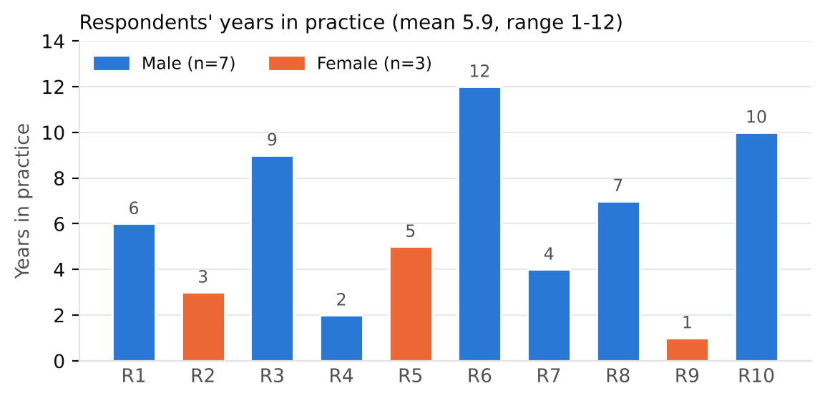
Figure 1. Respondents' years in practice, by gender

2.3 Data collection
A separate questionnaire of twelve open-ended questions with follow-up probes was developed from the research question (Appendix A). The questions moved from the respondent's practice background to the obstacles in a typical case, and then to specific institutional experiences: adjournments, backlog, court administration, investigation and evidence, and informal practices in court offices. They then turned to the effects of delay on clients and on the lawyer, and closed with coping strategies, digital initiatives and desired reforms. The completed questionnaire for each respondent is attached in Appendix C. Interviews were conducted in [mode: face-to-face / phone / online] between [dates], lasted approximately [duration] minutes and were held in Bangla, English or a mix, as the respondent preferred. With consent, interviews were audio-recorded or noted in detail, then transcribed and translated into English, keeping the respondents' original terms (e.g., peshkar, kharcha, dalal).

2.4 Ethical considerations
Each respondent was told the purpose of the study, that participation was voluntary, and that they could skip any question or withdraw at any time. Verbal informed consent was obtained before each interview. Because some questions touched on sensitive matters such as informal payments and political pressure, no names, case numbers or identifying details are reported, and recordings and notes were stored securely and used only for this assignment.

2.5 Data analysis
Transcripts were analysed using Braun and Clarke's (2006) six-phase thematic analysis, combined with Strauss and Corbin's (1998) coding paradigm at the axial-coding stage. Coding was done manually in a spreadsheet: each meaningful segment of an answer was assigned one or more codes, and the codes were then grouped into themes. Table 2 shows how each phase was applied.
Table 2. Phases of thematic analysis as applied in this study
Phase (Braun & Clarke, 2006) | How it was applied in this study
1. Familiarisation | Transcripts were read several times alongside the recordings and notes, and initial impressions were noted in the margins.
2. Generating initial codes | Line-by-line open coding produced 29 initial codes across 194 coded segments (Appendix B).
3. Searching for themes | Related codes were clustered into candidate themes, and axial coding with the Strauss and Corbin coding paradigm was used to connect them.
4. Reviewing themes | Themes were checked against the coded extracts and the whole dataset using a respondent × theme framework matrix (Figure 3).
5. Defining and naming themes | Seven themes were defined and named, and a central phenomenon was identified for the paradigm model.
6. Producing the report | Vivid, representative quotations were selected and the analysis was related back to the research question and the literature.

2.6 Trustworthiness and reflexivity
Credibility was strengthened by briefly checking interpretations with two respondents (member checking) and discussing the emerging codes with a classmate (peer debriefing). An audit trail of transcripts, code lists and the framework matrix was kept (Lincoln & Guba, 1985). As a practising lawyer and a batchmate of the respondents, I held an insider position. This made access and rapport easier, but it also risked my assuming shared meanings, so I deliberately probed terms that "everyone knows", such as time petition.

3. Findings
Open coding of the ten transcripts produced 29 codes across 194 coded segments, which were organised into seven themes. Figure 2 shows how often each theme appeared, and Figure 3 shows how the themes are spread across respondents. Institutional delay (T1) was by far the densest theme and appeared in every interview, which confirms that delay is the defining experience of legal practice for this sample. Because this report focuses on the institutional and procedural dimension, the discussion below concentrates on themes T1, T2, T3 and T7. Their codes are set out in Table 3 and Figure 4.
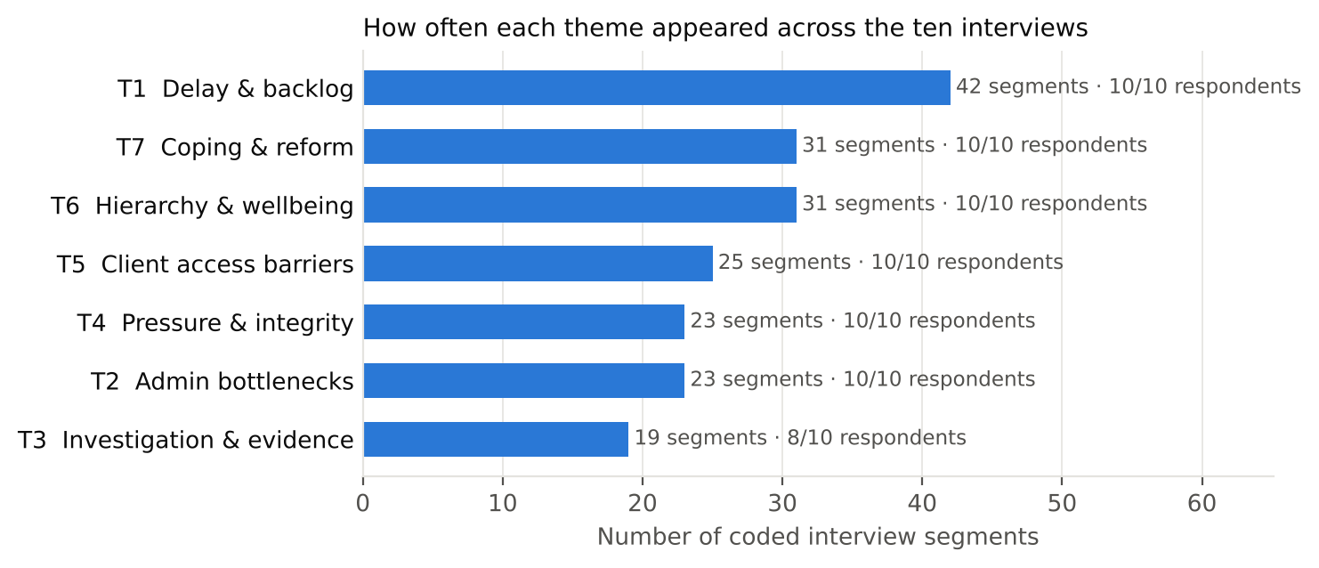
Figure 2. Coded segments per theme across all ten interviews
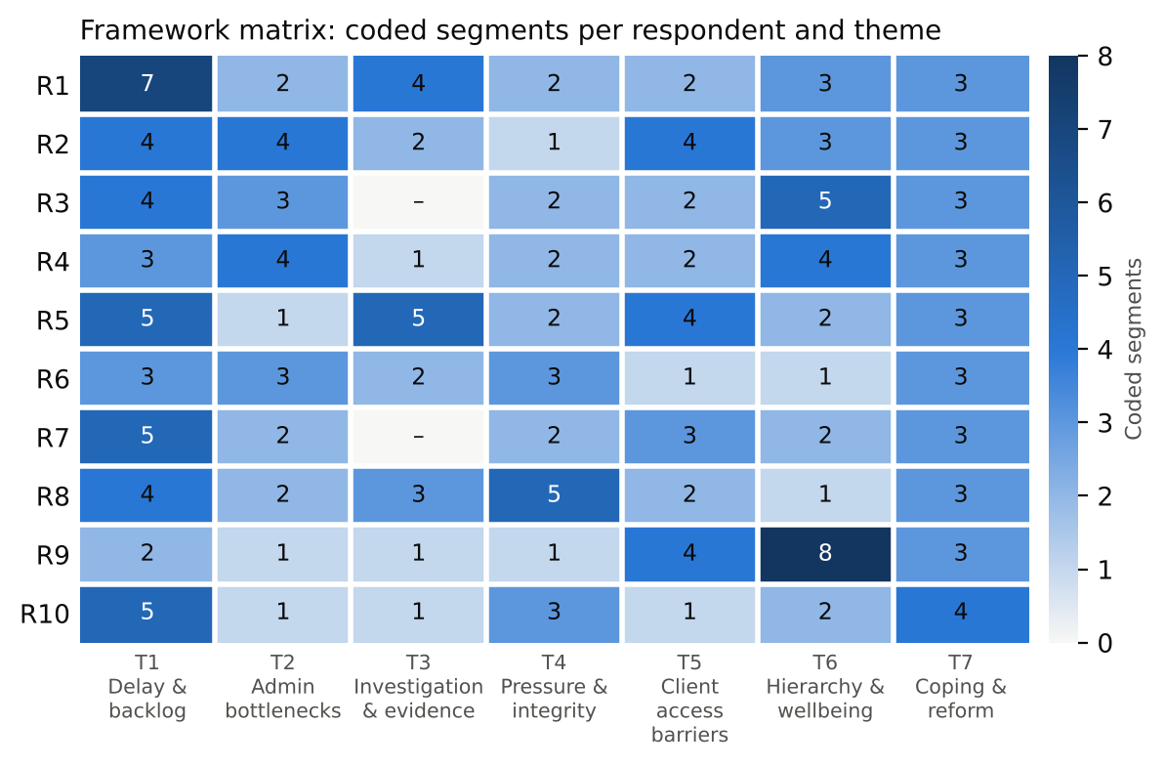
Figure 3. Framework matrix: number of coded segments per respondent and theme
Table 3. Coding framework for the focal themes: codes, categories and themes
Theme (selective coding) | Initial code (open coding) | n | Respondents
T1: Institutional delay and case backlog | c01 Frequent adjournments / time petitions | 10/10 | R1, R2, R3, R4, R5, R6, R7, R8, R9, R10
 | c02 Case backlog and overloaded cause lists | 8/10 | R1, R3, R4, R5, R6, R7, R8, R10
 | c03 Shortage of judges and courts | 4/10 | R1, R6, R7, R10
 | c04 Witness non-appearance / summons not served | 4/10 | R1, R2, R5, R8
 | c05 Clients losing faith because of delay | 5/10 | R1, R2, R3, R5, R9
T2: Procedural and administrative bottlenecks | c06 Informal 'speed money' to court staff | 7/10 | R1, R2, R3, R4, R6, R8, R9
 | c07 Missing or misplaced case records | 3/10 | R1, R4, R6
 | c08 Slow certified copies, orders and reports | 5/10 | R2, R3, R4, R7, R8
 | c09 Manual systems and poor court infrastructure | 7/10 | R2, R3, R4, R5, R6, R7, R10
T3: Weak investigation and evidentiary gaps | c10 Weak or biased police investigation | 5/10 | R1, R2, R5, R8, R9
 | c11 Delayed or flawed charge sheets | 3/10 | R1, R5, R8
 | c12 Witness intimidation / hostile witnesses | 4/10 | R2, R4, R5, R6
 | c13 Lack of forensic and digital-evidence support | 4/10 | R1, R5, R6, R10
T7: Coping strategies and reform aspirations | c26 Persistent follow-up and personal networks | 7/10 | R1, R2, R3, R4, R5, R8, R9
 | c27 Mediation, conciliation and arbitration | 4/10 | R2, R6, R7, R10
 | c28 Digital tools (online cause list, virtual hearing) | 9/10 | R1, R3, R4, R5, R6, R7, R8, R9, R10
 | c29 Calls for structural reform | 10/10 | R1, R2, R3, R4, R5, R6, R7, R8, R9, R10

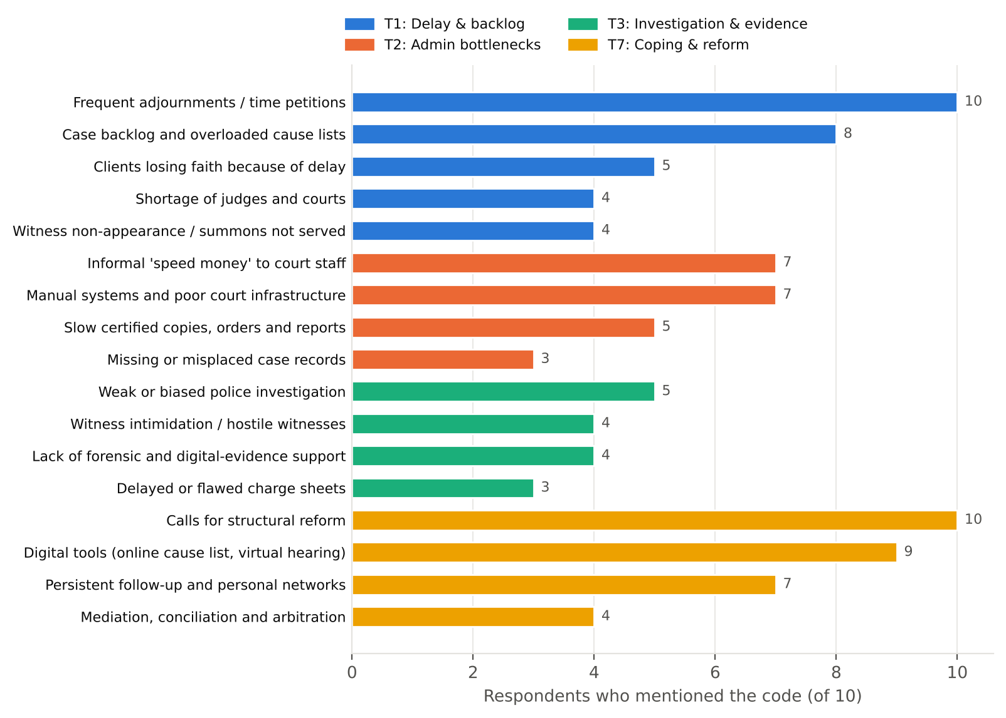
Figure 4. Number of respondents mentioning each code within the focal themes

3.1 Theme 1: "Next date": delay as the defining experience
Every respondent described delay as a major obstacle to justice. Frequent adjournments was mentioned by all ten respondents, and overloaded cause lists by eight. The most striking accounts quantified how little of a case's lifetime is spent actually hearing evidence:
“I have a murder case running since 2017. Out of maybe forty dates, evidence was taken on six. The rest were adjournments: either the prosecution witness was absent or the court had no time. One judge sometimes has more than a hundred matters on the cause list.” (R1, male, criminal, 6 years in practice)
Delay was described in every forum, from district civil courts to the High Court Division, where it changes what a remedy means in practice:
“After a rule is issued, the final hearing can take five to ten years. Meanwhile the petitioner may have retired or even died. Delay has made the interim order the real remedy.” (R3, male, writ / constitutional, 9 years in practice)
Statutory time limits offered little protection. A respondent appearing before the Nari-o-Shishu tribunal noted that the law's 180-day limit for trials "exists only on paper":
“The time limit exists only on paper. Prosecutors are overloaded, witnesses are not produced, and the date is shifted again.” (R5, female, criminal (survivors), 5 years in practice)
Respondents did not simply blame "the system". A senior land lawyer acknowledged that the profession helps sustain the adjournment culture, while also pointing to the impossible workload on the bench:
“Adjournment has become a culture. Lawyers file time petitions too; I will be honest, we are part of the problem. But judges also carry impossible workloads.” (R6, male, land / civil, 12 years in practice)
The human cost of delay ran through the data: clients lose faith, stop attending, or blame their lawyer. As R9 put it, poor clients "come again and again just to hear 'next date'". Delay therefore does more than postpone justice. It wears down the client's ability and willingness to pursue it at all.

3.2 Theme 2: The file that does not move: administrative bottlenecks
The second theme concerns the administrative machinery around the courtroom. Seven respondents described informal payments to court staff, and seven described manual, paper-based systems. Respondents presented the two as linked: when records are physical and processes are discretionary, the staff who control them gain informal power.
“Without giving the peshkar or the clerk something, your file does not move. Nobody calls it a bribe; they call it 'kharcha'. Twice my case records went missing on the hearing date.” (R1, male, criminal, 6 years in practice)
“Our record room is in a very bad state. Files are tied in bundles, sometimes damaged by water. Finding a file depends on the staff's goodwill.” (R6, male, land / civil, 12 years in practice)
In criminal matters these bottlenecks have direct consequences for liberty. A defence lawyer explained that even after bail is granted, the order must be physically pushed through the system:
“For a bail order to reach the jail you have to follow up at every desk. One day's delay means another night in jail for my client.” (R8, male, criminal defence / bail, 7 years in practice)
A respondent with international training saw the problem as one of institutional design rather than individual misconduct:
“The administrative culture is outdated: physical files, manual stamps, no integrated case-management system.” (R10, male, commercial / civil, 10 years in practice)
This theme suggests that much of what is counted as "judicial delay" in fact happens before and after the hearing, in filing, copying, listing and record-keeping. These are areas that procedural reform discussions often overlook.

3.3 Theme 3: Evidence that arrives late, or not at all
The third theme links courtroom delay to weaknesses in the investigation and evidence on which cases rely. Respondents in criminal practice were the most critical of police investigation:
“Police investigation is the weakest link. The charge sheet often just copies the FIR. There is no forensic report, or it comes after two years. As defence I sometimes benefit, but as a citizen I feel justice is lost.” (R1, male, criminal, 6 years in practice)
“Framing the charge alone takes years because the police report is late. Courts adjourn because the investigating officer has been transferred.” (R8, male, criminal defence / bail, 7 years in practice)
Late forensic and medical reports, transferred investigating officers and absent witnesses were each described as triggers for further adjournments, so this theme feeds directly back into Theme 1. Problems with evidence were not limited to criminal law. In commercial and land practice, respondents noted that courts struggle with forged documents and digital records:
“Digital evidence like emails and electronic transactions is still treated with suspicion, and courts lack technical expertise.” (R10, male, commercial / civil, 10 years in practice)
The recognition of digital records through the 2022 amendment of the Evidence Act was not, in respondents' experience, yet matched by technical capacity in the courts.

3.4 Theme 7: Working around the system
Despite these obstacles, respondents described an active repertoire of coping strategies. The most common was personal persistence, supported by relationships with staff and colleagues:
“I keep a personal diary of dates, I keep good relations with court staff, and I file applications for early hearing. Knowing people helps.” (R1, male, criminal, 6 years in practice)
“I keep my drafting very precise so the bench can grasp the point in the short time we get. I also rely on my senior's name to get listed.” (R3, male, writ / constitutional, 9 years in practice)
Others steered clients away from adjudication altogether, using court-annexed mediation under section 89A of the Code of Civil Procedure, conciliation or arbitration:
“I encourage settlement through mediation under section 89A of the Code of Civil Procedure. Many clients are relieved when it works.” (R6, male, land / civil, 12 years in practice)
Digital tools were widely welcomed, but respondents described their adoption as partial and fragile. Lawyers have built their own informal workarounds, such as WhatsApp groups that share cause lists. Several respondents noted that the virtual hearings permitted by the Use of Information Technology by Courts Act 2020 had largely stopped once the COVID-19 emergency ended:
“Virtual courts during COVID showed bail could be quick. The 2020 Act is still there, but it is hardly used now.” (R8, male, criminal defence / bail, 7 years in practice)
When asked for one change, all ten respondents proposed structural reform. Their proposals focused on capacity and case management:
“Strict case management: fixed timelines for each stage and a penalty for unnecessary adjournments.” (R6, male, land / civil, 12 years in practice)
“Digitise land records and connect them to the courts. Half the civil cases would disappear.” (R4, male, civil / land, 2 years in practice)

3.5 Coding paradigm model
To show how the themes relate to one another, the axial codes were organised using Strauss and Corbin's (1998) coding paradigm (Figure 5). The central phenomenon is protracted, procedurally obstructed litigation, which can be summarised as "justice by date". Its causal conditions are judicial under-capacity, an entrenched adjournment culture and weak, late evidence. It occurs in a context of overloaded cause lists, paper-based record rooms and multiple cases arising from a single dispute. Intervening conditions such as "speed money", dependency on seniors and uneven digitisation make the problem worse or, occasionally, ease it. Lawyers respond with strategies of persistence, precise drafting, mediation and informal digital workarounds. The consequences are clients who lose faith, prolonged pre-trial detention, frustrated and exhausted lawyers, and a clear professional demand for case-management reform.
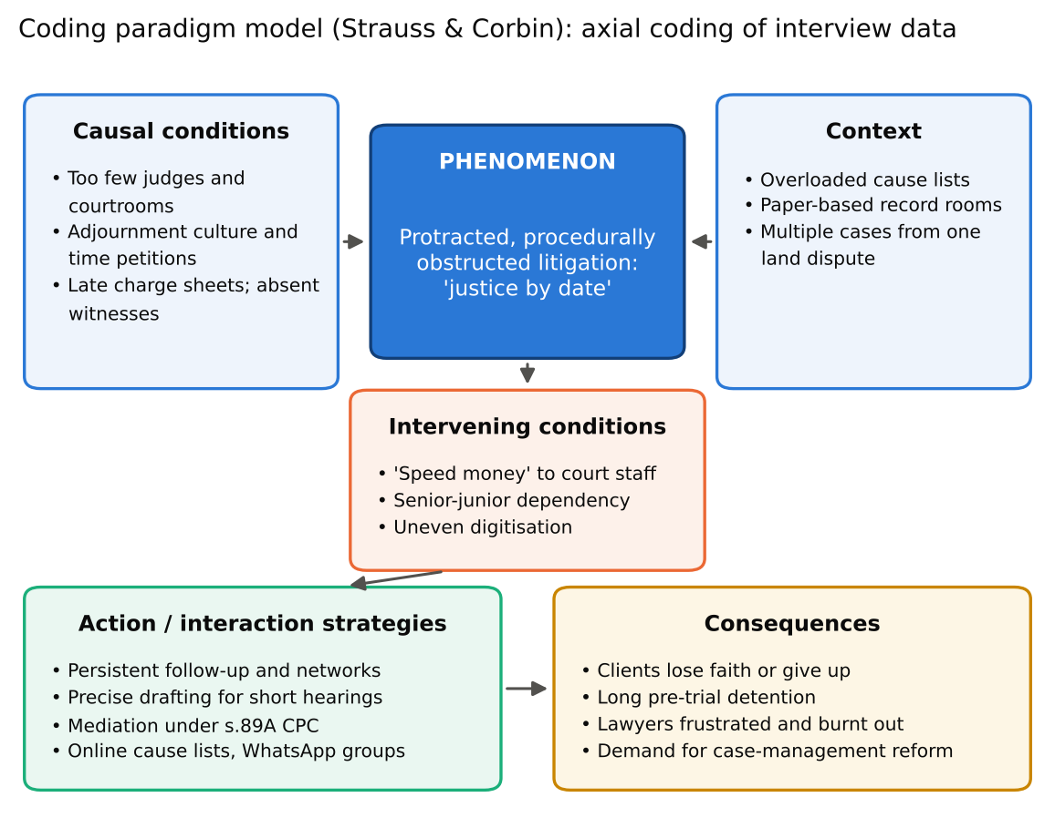
Figure 5. Coding paradigm model of institutional delay (after Strauss & Corbin, 1998)

3.6 Connections with the remaining themes
Although they are not the focus of this report, the other three themes show how institutional delay spreads outward. Delay multiplies litigation costs for poor clients (T5). It creates space for political and social pressure to influence outcomes (T4). It also weighs heavily on junior lawyers, whose income depends on cases that do not conclude (T6). As R6 summarised, "the cost of coming to court fifty times" is itself a barrier to justice.

4. Research limitations
Several limitations should be noted. First, the sample was small and drawn from batchmates through convenience and purposive selection, and most respondents practise in and around Dhaka. The findings therefore reflect the experiences of a particular group of relatively young, urban lawyers and cannot be generalised to the profession as a whole. Second, my insider position as a lawyer and classmate helped rapport but may have encouraged respondents to give answers they expected I would agree with, or to under-report sensitive issues such as informal payments. Third, scheduling interviews with practising lawyers was difficult. Court hours left limited time, so some interviews were shorter than planned or conducted by phone, which reduced the depth of probing. Fourth, translation from Bangla to English may have lost some nuance, although key local terms were kept. Finally, coding was carried out by a single researcher. Peer debriefing and an audit trail reduced, but did not eliminate, the risk of subjective interpretation.

5. Conclusion
This study asked what challenges lawyers face in pursuing justice within legal institutions, and it examined the institutional and procedural side of that question. The interviews show that delay is the defining experience of legal practice for these respondents. It is built from repeated adjournments, overloaded cause lists and too few judges, and it is reinforced by paper-based administration, informal payments to staff, and investigations and evidence that arrive late or not at all. Lawyers are not passive in the face of these problems. They chase files, draft for short hearings, push for mediation and build their own digital workarounds, and some openly admit that their own time petitions are part of the problem. The coding paradigm model shows a self-reinforcing cycle: weak capacity produces delay, delay creates space for informal practices, and those practices produce further delay. Respondents' proposals point to where the cycle could be broken: more judges and courts, enforceable timelines for each stage of a case, digitised and integrated records, and accountable investigation. Without such reforms, the respondents suggest, the courts will continue to deliver "justice by date" rather than justice on the merits.

References
Braun, V., & Clarke, V. (2006). Using thematic analysis in psychology. Qualitative Research in Psychology, 3(2), 77–101.
Creswell, J. W., & Poth, C. N. (2018). Qualitative inquiry and research design: Choosing among five approaches (4th ed.). Sage.
Guest, G., Bunce, A., & Johnson, L. (2006). How many interviews are enough? An experiment with data saturation and variability. Field Methods, 18(1), 59–82.
Kvale, S., & Brinkmann, S. (2009). InterViews: Learning the craft of qualitative research interviewing (2nd ed.). Sage.
Lincoln, Y. S., & Guba, E. G. (1985). Naturalistic inquiry. Sage.
Strauss, A., & Corbin, J. (1998). Basics of qualitative research: Techniques and procedures for developing grounded theory (2nd ed.). Sage.
Secretary, Ministry of Finance v. Md. Masdar Hossain (2000) 52 DLR (AD) 82.
Code of Civil Procedure 1908; Code of Criminal Procedure 1898; Evidence Act 1872 (as amended 2022); Use of Information Technology by Courts Act 2020 (Bangladesh).

Appendix A. Semi-structured interview questionnaire
Opening: introduce the study, confirm consent and permission to record, and note the respondent's name, roll, batch, gender, years in practice and main court. The twelve core questions below were asked in every interview; probes were used where helpful.
- Please tell me briefly about your legal practice: which courts you appear in and what kinds of cases you handle.
Probes: How long have you been in practice? / Why did you choose this area?
- In your experience, what are the main obstacles that prevent a case from reaching a just and timely conclusion?
Probes: Can you give a recent example?
- How often are your cases adjourned, and what are the usual reasons for adjournment?
Probes: Who usually asks for time? / How many dates does a typical matter take?
- How do the case backlog and the number of judges in your court affect your daily work?
Probes: How long is a typical cause list?
- Describe your experience with court administration: filing, cause lists, case records, certified copies and court staff.
Probes: What happens when a file cannot be found?
- How do police investigation, charge sheets, witnesses and forensic reports affect the progress of your cases?
Probes: Can you recall a case delayed by evidence problems?
- Have informal payments or unofficial practices in court offices affected how fast your cases move? How do you deal with this?
Probes: How do clients react?
- How does delay affect your clients: their costs, their trust and their willingness to continue?
Probes: Have clients abandoned cases?
- How do delay and procedural problems affect you personally and professionally?
Probes: Stress, income, motivation?
- What strategies do you use to move cases forward or avoid delay, such as follow-up, mediation or settlement?
Probes: Which works best?
- How useful have digital initiatives been, such as online cause lists, virtual hearings and e-filing?
Probes: What changed after COVID-19?
- What reforms would most reduce delay and procedural obstruction in our courts?
Probes: Who should lead them? / Anything else you would like to add?
Closing: thank the respondent, ask whether there is anything they would like to add, and remind them of confidentiality and their right to withdraw.

Appendix B. Complete coding framework
Theme (selective coding) | Initial code (open coding) | n | Respondents
T1: Institutional delay and case backlog | c01 Frequent adjournments / time petitions | 10/10 | R1, R2, R3, R4, R5, R6, R7, R8, R9, R10
 | c02 Case backlog and overloaded cause lists | 8/10 | R1, R3, R4, R5, R6, R7, R8, R10
 | c03 Shortage of judges and courts | 4/10 | R1, R6, R7, R10
 | c04 Witness non-appearance / summons not served | 4/10 | R1, R2, R5, R8
 | c05 Clients losing faith because of delay | 5/10 | R1, R2, R3, R5, R9
T2: Procedural and administrative bottlenecks | c06 Informal 'speed money' to court staff | 7/10 | R1, R2, R3, R4, R6, R8, R9
 | c07 Missing or misplaced case records | 3/10 | R1, R4, R6
 | c08 Slow certified copies, orders and reports | 5/10 | R2, R3, R4, R7, R8
 | c09 Manual systems and poor court infrastructure | 7/10 | R2, R3, R4, R5, R6, R7, R10
T3: Weak investigation and evidentiary gaps | c10 Weak or biased police investigation | 5/10 | R1, R2, R5, R8, R9
 | c11 Delayed or flawed charge sheets | 3/10 | R1, R5, R8
 | c12 Witness intimidation / hostile witnesses | 4/10 | R2, R4, R5, R6
 | c13 Lack of forensic and digital-evidence support | 4/10 | R1, R5, R6, R10
T4: External pressure and integrity dilemmas | c14 Political influence on cases | 5/10 | R1, R3, R7, R8, R10
 | c15 Pressure or threats from influential parties | 8/10 | R1, R2, R4, R5, R6, R7, R8, R10
 | c16 Bar politics and partisan alignment | 5/10 | R3, R5, R6, R8, R10
 | c17 Ethical dilemmas over informal payments | 3/10 | R4, R6, R9
T5: Access-to-justice barriers for clients | c18 Litigation cost and lost income | 9/10 | R1, R2, R3, R4, R5, R6, R7, R8, R10
 | c19 Low legal literacy and exploitation by touts | 5/10 | R2, R4, R7, R8, R9
 | c20 Gender and social barriers for women clients | 2/10 | R2, R5
 | c21 Weak reach and quality of legal aid | 4/10 | R1, R3, R5, R9
T6: Professional hierarchy, insecurity and wellbeing | c22 Irregular income of junior lawyers | 5/10 | R2, R3, R4, R7, R9
 | c23 Senior gatekeeping and dependency | 6/10 | R1, R3, R4, R7, R9, R10
 | c24 Gender discrimination within the Bar | 3/10 | R2, R5, R9
 | c25 Stress, fear and burnout | 9/10 | R1, R2, R3, R4, R5, R6, R8, R9, R10
T7: Coping strategies and reform aspirations | c26 Persistent follow-up and personal networks | 7/10 | R1, R2, R3, R4, R5, R8, R9
 | c27 Mediation, conciliation and arbitration | 4/10 | R2, R6, R7, R10
 | c28 Digital tools (online cause list, virtual hearing) | 9/10 | R1, R3, R4, R5, R6, R7, R8, R9, R10
 | c29 Calls for structural reform | 10/10 | R1, R2, R3, R4, R5, R6, R7, R8, R9, R10

Appendix C. Completed questionnaires
This appendix contains the questionnaire completed for each of the ten respondents interviewed by Minhaz Ahamed Khan Nabin. Names appear here for verification by the course teacher only; in the body of the report respondents are anonymised.

Questionnaire 1 of 10: Mohammad Mobarak Hosen
Respondent name | Mohammad Mobarak Hosen
Roll | 25
Session | 2025–2026 (MCCJ)
Gender / years in practice
Main court / practice area
Date, mode and duration
Interviewed by | Minhaz Ahamed Khan Nabin (Roll 27)
Informed consent | ☐ Yes ☐ No

Q1. Please tell me briefly about your legal practice: which courts you appear in and what kinds of cases you handle.
Response:
Q2. In your experience, what are the main obstacles that prevent a case from reaching a just and timely conclusion?
Response:
Q3. How often are your cases adjourned, and what are the usual reasons for adjournment?
Response:
Q4. How do the case backlog and the number of judges in your court affect your daily work?
Response:
Q5. Describe your experience with court administration: filing, cause lists, case records, certified copies and court staff.
Response:
Q6. How do police investigation, charge sheets, witnesses and forensic reports affect the progress of your cases?
Response:
Q7. Have informal payments or unofficial practices in court offices affected how fast your cases move? How do you deal with this?
Response:
Q8. How does delay affect your clients: their costs, their trust and their willingness to continue?
Response:
Q9. How do delay and procedural problems affect you personally and professionally?
Response:
Q10. What strategies do you use to move cases forward or avoid delay, such as follow-up, mediation or settlement?
Response:
Q11. How useful have digital initiatives been, such as online cause lists, virtual hearings and e-filing?
Response:
Q12. What reforms would most reduce delay and procedural obstruction in our courts?
Response:

Questionnaire 2 of 10: Nafiul Hoque Kingshuk
Respondent name | Nafiul Hoque Kingshuk
Roll | 22
Session | 2025–2026 (MCCJ)
Gender / years in practice
Main court / practice area
Date, mode and duration
Interviewed by | Minhaz Ahamed Khan Nabin (Roll 27)
Informed consent | ☐ Yes ☐ No

Q1. Please tell me briefly about your legal practice: which courts you appear in and what kinds of cases you handle.
Response:
Q2. In your experience, what are the main obstacles that prevent a case from reaching a just and timely conclusion?
Response:
Q3. How often are your cases adjourned, and what are the usual reasons for adjournment?
Response:
Q4. How do the case backlog and the number of judges in your court affect your daily work?
Response:
Q5. Describe your experience with court administration: filing, cause lists, case records, certified copies and court staff.
Response:
Q6. How do police investigation, charge sheets, witnesses and forensic reports affect the progress of your cases?
Response:
Q7. Have informal payments or unofficial practices in court offices affected how fast your cases move? How do you deal with this?
Response:
Q8. How does delay affect your clients: their costs, their trust and their willingness to continue?
Response:
Q9. How do delay and procedural problems affect you personally and professionally?
Response:
Q10. What strategies do you use to move cases forward or avoid delay, such as follow-up, mediation or settlement?
Response:
Q11. How useful have digital initiatives been, such as online cause lists, virtual hearings and e-filing?
Response:
Q12. What reforms would most reduce delay and procedural obstruction in our courts?
Response:

Questionnaire 3 of 10: Shams Bin Sharif Taj
Respondent name | Shams Bin Sharif Taj
Roll | 14
Session | 2025–2026 (MCCJ)
Gender / years in practice
Main court / practice area
Date, mode and duration
Interviewed by | Minhaz Ahamed Khan Nabin (Roll 27)
Informed consent | ☐ Yes ☐ No

Q1. Please tell me briefly about your legal practice: which courts you appear in and what kinds of cases you handle.
Response:
Q2. In your experience, what are the main obstacles that prevent a case from reaching a just and timely conclusion?
Response:
Q3. How often are your cases adjourned, and what are the usual reasons for adjournment?
Response:
Q4. How do the case backlog and the number of judges in your court affect your daily work?
Response:
Q5. Describe your experience with court administration: filing, cause lists, case records, certified copies and court staff.
Response:
Q6. How do police investigation, charge sheets, witnesses and forensic reports affect the progress of your cases?
Response:
Q7. Have informal payments or unofficial practices in court offices affected how fast your cases move? How do you deal with this?
Response:
Q8. How does delay affect your clients: their costs, their trust and their willingness to continue?
Response:
Q9. How do delay and procedural problems affect you personally and professionally?
Response:
Q10. What strategies do you use to move cases forward or avoid delay, such as follow-up, mediation or settlement?
Response:
Q11. How useful have digital initiatives been, such as online cause lists, virtual hearings and e-filing?
Response:
Q12. What reforms would most reduce delay and procedural obstruction in our courts?
Response:

Questionnaire 4 of 10: Tashfia Ali
Respondent name | Tashfia Ali
Roll | 41
Session | 2025–2026 (MCCJ)
Gender / years in practice
Main court / practice area
Date, mode and duration
Interviewed by | Minhaz Ahamed Khan Nabin (Roll 27)
Informed consent | ☐ Yes ☐ No

Q1. Please tell me briefly about your legal practice: which courts you appear in and what kinds of cases you handle.
Response:
Q2. In your experience, what are the main obstacles that prevent a case from reaching a just and timely conclusion?
Response:
Q3. How often are your cases adjourned, and what are the usual reasons for adjournment?
Response:
Q4. How do the case backlog and the number of judges in your court affect your daily work?
Response:
Q5. Describe your experience with court administration: filing, cause lists, case records, certified copies and court staff.
Response:
Q6. How do police investigation, charge sheets, witnesses and forensic reports affect the progress of your cases?
Response:
Q7. Have informal payments or unofficial practices in court offices affected how fast your cases move? How do you deal with this?
Response:
Q8. How does delay affect your clients: their costs, their trust and their willingness to continue?
Response:
Q9. How do delay and procedural problems affect you personally and professionally?
Response:
Q10. What strategies do you use to move cases forward or avoid delay, such as follow-up, mediation or settlement?
Response:
Q11. How useful have digital initiatives been, such as online cause lists, virtual hearings and e-filing?
Response:
Q12. What reforms would most reduce delay and procedural obstruction in our courts?
Response:

Questionnaire 5 of 10: Shohag
Respondent name | Shohag
Roll | [roll]
Session | 2025–2026 (MCCJ)
Gender / years in practice
Main court / practice area
Date, mode and duration
Interviewed by | Minhaz Ahamed Khan Nabin (Roll 27)
Informed consent | ☐ Yes ☐ No

Q1. Please tell me briefly about your legal practice: which courts you appear in and what kinds of cases you handle.
Response:
Q2. In your experience, what are the main obstacles that prevent a case from reaching a just and timely conclusion?
Response:
Q3. How often are your cases adjourned, and what are the usual reasons for adjournment?
Response:
Q4. How do the case backlog and the number of judges in your court affect your daily work?
Response:
Q5. Describe your experience with court administration: filing, cause lists, case records, certified copies and court staff.
Response:
Q6. How do police investigation, charge sheets, witnesses and forensic reports affect the progress of your cases?
Response:
Q7. Have informal payments or unofficial practices in court offices affected how fast your cases move? How do you deal with this?
Response:
Q8. How does delay affect your clients: their costs, their trust and their willingness to continue?
Response:
Q9. How do delay and procedural problems affect you personally and professionally?
Response:
Q10. What strategies do you use to move cases forward or avoid delay, such as follow-up, mediation or settlement?
Response:
Q11. How useful have digital initiatives been, such as online cause lists, virtual hearings and e-filing?
Response:
Q12. What reforms would most reduce delay and procedural obstruction in our courts?
Response:

Questionnaire 6 of 10: Marzia Rahman
Respondent name | Marzia Rahman
Roll | 29
Session | 2025–2026 (MCCJ)
Gender / years in practice
Main court / practice area
Date, mode and duration
Interviewed by | Minhaz Ahamed Khan Nabin (Roll 27)
Informed consent | ☐ Yes ☐ No

Q1. Please tell me briefly about your legal practice: which courts you appear in and what kinds of cases you handle.
Response:
Q2. In your experience, what are the main obstacles that prevent a case from reaching a just and timely conclusion?
Response:
Q3. How often are your cases adjourned, and what are the usual reasons for adjournment?
Response:
Q4. How do the case backlog and the number of judges in your court affect your daily work?
Response:
Q5. Describe your experience with court administration: filing, cause lists, case records, certified copies and court staff.
Response:
Q6. How do police investigation, charge sheets, witnesses and forensic reports affect the progress of your cases?
Response:
Q7. Have informal payments or unofficial practices in court offices affected how fast your cases move? How do you deal with this?
Response:
Q8. How does delay affect your clients: their costs, their trust and their willingness to continue?
Response:
Q9. How do delay and procedural problems affect you personally and professionally?
Response:
Q10. What strategies do you use to move cases forward or avoid delay, such as follow-up, mediation or settlement?
Response:
Q11. How useful have digital initiatives been, such as online cause lists, virtual hearings and e-filing?
Response:
Q12. What reforms would most reduce delay and procedural obstruction in our courts?
Response:

Questionnaire 7 of 10: Imran Mridha
Respondent name | Imran Mridha
Roll | 33
Session | 2025–2026 (MCCJ)
Gender / years in practice
Main court / practice area
Date, mode and duration
Interviewed by | Minhaz Ahamed Khan Nabin (Roll 27)
Informed consent | ☐ Yes ☐ No

Q1. Please tell me briefly about your legal practice: which courts you appear in and what kinds of cases you handle.
Response:
Q2. In your experience, what are the main obstacles that prevent a case from reaching a just and timely conclusion?
Response:
Q3. How often are your cases adjourned, and what are the usual reasons for adjournment?
Response:
Q4. How do the case backlog and the number of judges in your court affect your daily work?
Response:
Q5. Describe your experience with court administration: filing, cause lists, case records, certified copies and court staff.
Response:
Q6. How do police investigation, charge sheets, witnesses and forensic reports affect the progress of your cases?
Response:
Q7. Have informal payments or unofficial practices in court offices affected how fast your cases move? How do you deal with this?
Response:
Q8. How does delay affect your clients: their costs, their trust and their willingness to continue?
Response:
Q9. How do delay and procedural problems affect you personally and professionally?
Response:
Q10. What strategies do you use to move cases forward or avoid delay, such as follow-up, mediation or settlement?
Response:
Q11. How useful have digital initiatives been, such as online cause lists, virtual hearings and e-filing?
Response:
Q12. What reforms would most reduce delay and procedural obstruction in our courts?
Response:

Questionnaire 8 of 10: Abdullah Al Mamun
Respondent name | Abdullah Al Mamun
Roll | 2
Session | 2025–2026 (MCCJ)
Gender / years in practice
Main court / practice area
Date, mode and duration
Interviewed by | Minhaz Ahamed Khan Nabin (Roll 27)
Informed consent | ☐ Yes ☐ No

Q1. Please tell me briefly about your legal practice: which courts you appear in and what kinds of cases you handle.
Response:
Q2. In your experience, what are the main obstacles that prevent a case from reaching a just and timely conclusion?
Response:
Q3. How often are your cases adjourned, and what are the usual reasons for adjournment?
Response:
Q4. How do the case backlog and the number of judges in your court affect your daily work?
Response:
Q5. Describe your experience with court administration: filing, cause lists, case records, certified copies and court staff.
Response:
Q6. How do police investigation, charge sheets, witnesses and forensic reports affect the progress of your cases?
Response:
Q7. Have informal payments or unofficial practices in court offices affected how fast your cases move? How do you deal with this?
Response:
Q8. How does delay affect your clients: their costs, their trust and their willingness to continue?
Response:
Q9. How do delay and procedural problems affect you personally and professionally?
Response:
Q10. What strategies do you use to move cases forward or avoid delay, such as follow-up, mediation or settlement?
Response:
Q11. How useful have digital initiatives been, such as online cause lists, virtual hearings and e-filing?
Response:
Q12. What reforms would most reduce delay and procedural obstruction in our courts?
Response:

Questionnaire 9 of 10: Md. Akram Hossain Rifat
Respondent name | Md. Akram Hossain Rifat
Roll | 38
Session | 2025–2026 (MCCJ)
Gender / years in practice
Main court / practice area
Date, mode and duration
Interviewed by | Minhaz Ahamed Khan Nabin (Roll 27)
Informed consent | ☐ Yes ☐ No

Q1. Please tell me briefly about your legal practice: which courts you appear in and what kinds of cases you handle.
Response:
Q2. In your experience, what are the main obstacles that prevent a case from reaching a just and timely conclusion?
Response:
Q3. How often are your cases adjourned, and what are the usual reasons for adjournment?
Response:
Q4. How do the case backlog and the number of judges in your court affect your daily work?
Response:
Q5. Describe your experience with court administration: filing, cause lists, case records, certified copies and court staff.
Response:
Q6. How do police investigation, charge sheets, witnesses and forensic reports affect the progress of your cases?
Response:
Q7. Have informal payments or unofficial practices in court offices affected how fast your cases move? How do you deal with this?
Response:
Q8. How does delay affect your clients: their costs, their trust and their willingness to continue?
Response:
Q9. How do delay and procedural problems affect you personally and professionally?
Response:
Q10. What strategies do you use to move cases forward or avoid delay, such as follow-up, mediation or settlement?
Response:
Q11. How useful have digital initiatives been, such as online cause lists, virtual hearings and e-filing?
Response:
Q12. What reforms would most reduce delay and procedural obstruction in our courts?
Response:

Questionnaire 10 of 10: Ahnaf Akif
Respondent name | Ahnaf Akif
Roll | 24
Session | 2025–2026 (MCCJ)
Gender / years in practice
Main court / practice area
Date, mode and duration
Interviewed by | Minhaz Ahamed Khan Nabin (Roll 27)
Informed consent | ☐ Yes ☐ No

Q1. Please tell me briefly about your legal practice: which courts you appear in and what kinds of cases you handle.
Response:
Q2. In your experience, what are the main obstacles that prevent a case from reaching a just and timely conclusion?
Response:
Q3. How often are your cases adjourned, and what are the usual reasons for adjournment?
Response:
Q4. How do the case backlog and the number of judges in your court affect your daily work?
Response:
Q5. Describe your experience with court administration: filing, cause lists, case records, certified copies and court staff.
Response:
Q6. How do police investigation, charge sheets, witnesses and forensic reports affect the progress of your cases?
Response:
Q7. Have informal payments or unofficial practices in court offices affected how fast your cases move? How do you deal with this?
Response:
Q8. How does delay affect your clients: their costs, their trust and their willingness to continue?
Response:
Q9. How do delay and procedural problems affect you personally and professionally?
Response:
Q10. What strategies do you use to move cases forward or avoid delay, such as follow-up, mediation or settlement?
Response:
Q11. How useful have digital initiatives been, such as online cause lists, virtual hearings and e-filing?
Response:
Q12. What reforms would most reduce delay and procedural obstruction in our courts?
Response:

