[university / department]
[programme] · Batch [batch]

Course: Research Methodology ([course code])
Individual Qualitative Research Report · Assignment (10 marks)

Between Duty and Pressure: Integrity, Influence and Professional Strain among Lawyers in Bangladesh
An individual qualitative research report based on semi-structured in-depth interviews
RESEARCH QUESTION 4
What challenges do lawyers face as they strive to pursue justice within legal institutions?

Submitted to  Sumaiya Iqbal  [designation]  [university / department] |  | Submitted by  Name: Tanvir Ahmed Siddique  Roll: [roll]  Batch: [batch]  Programme: [programme]

Date of submission: [date of submission] Word count: 2,122 (Sections 1–5)
DRAFT FOR GUIDANCE: the respondent answers, codes, counts and quotations in this version are illustrative placeholders (R1–R10), not real interview data. Conduct your own interviews, enter the real answers in data/study.json, update the bracketed [ ] details, and rebuild before submitting.

Contents

Right-click the table of contents and choose “Update field” in Word if page numbers do not appear.

1. Introduction
Lawyers are officers of the court. Professional rules require them to act independently, honestly and in their client's lawful interest. Freidson (2001) describes professionalism as a "third logic", distinct from both the market and bureaucracy, that depends on practitioners being free to exercise judgement according to professional values. That freedom is not guaranteed. In Bangladesh, the legal profession works within an environment shaped by intense political competition, partisan Bar associations, a strongly hierarchical apprenticeship culture and court offices where discretion over files and dates rests with staff. Lipsky (1980) would call these staff "street-level bureaucrats".
Public debate on justice in Bangladesh tends to focus on backlog and delay. Far less attention is paid to the pressures on lawyers themselves: being asked to "manage" a case, being warned not to "push too hard", depending on a senior for income, or being treated differently because of one's gender. These pressures directly affect whether lawyers can pursue justice, and at what personal cost.
This report addresses the research question: What challenges do lawyers face as they strive to pursue justice within legal institutions? It focuses on the professional and ethical dimension of that question: external pressure and integrity dilemmas, the hierarchy and gender dynamics of the Bar, and their effects on lawyers' wellbeing. Section 2 describes the methodology. Section 3 presents the thematic findings with quotations and a coding paradigm model. Section 4 discusses limitations, and Section 5 concludes.

2. Methodology

2.1 Research design
The study followed a qualitative, interpretivist approach, appropriate for understanding how people make sense of sensitive experiences in their own terms (Creswell & Poth, 2018). Semi-structured in-depth interviews were used. They provide comparable data across respondents while leaving room to probe difficult topics gently and to follow respondents' own priorities (Kvale & Brinkmann, 2009).

2.2 Sampling and participants
Respondents were selected from among batchmates, as directed for this assignment. Purposive sampling identified ten batchmates who are practising or apprenticing as lawyers, varying in seniority (1 to 12 years), gender (three women) and forum (district courts, tribunals, the labour court and the High Court Division). This variation was important because pressure and hierarchy are experienced differently by juniors and seniors and by men and women. Respondents are referred to as R1–R10 (Table 1; Figure 1).
Table 1. Profile of respondents (pseudonymised)
ID | Gender | Years | Role | Main forum | Practice area
R1 | Male | 6 | Advocate | Dhaka Judge Court | Criminal
R2 | Female | 3 | Advocate | Family Court, Dhaka | Family
R3 | Male | 9 | Advocate | High Court Division | Writ / constitutional
R4 | Male | 2 | Junior advocate | District Court, Gazipur | Civil / land
R5 | Female | 5 | Advocate | Nari-o-Shishu Tribunal & CMM Court | Criminal (survivors)
R6 | Male | 12 | Advocate | District Court, Narayanganj | Land / civil
R7 | Male | 4 | Advocate | Labour Court, Dhaka | Labour / corporate
R8 | Male | 7 | Advocate | Dhaka Judge Court | Criminal defence / bail
R9 | Female | 1 | Junior advocate (legal-aid panel) | District Legal Aid Office | Mixed / legal aid
R10 | Male | 10 | Barrister / Advocate | High Court Division | Commercial / civil

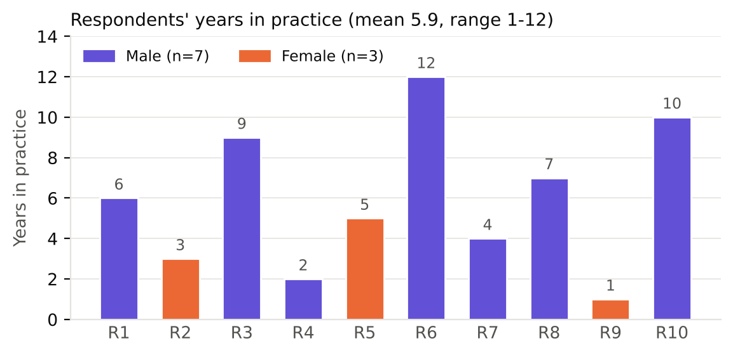
Figure 1. Respondents' years in practice, by gender

2.3 Data collection
A separate questionnaire of ten open-ended questions with probes was used (Appendix A). Questions 2 to 7 were central to this report: they asked about political and social pressure, informal payments, the senior-junior hierarchy, Bar politics, gender and personal impact. Because these topics are sensitive, the questionnaire opened with a general question about the respondent's path into law to build rapport, and phrased pressure questions as "experienced or witnessed" to reduce discomfort. The completed questionnaire for each respondent is attached in Appendix C. Interviews were held between [dates] by [mode], lasted roughly [duration] minutes, and were conducted in Bangla and English. They were recorded or noted with consent, then transcribed and translated.

2.4 Ethical considerations
Given the sensitivity of questions on political pressure and informal payments, particular care was taken. Respondents gave informed verbal consent, were reminded that they could decline any question, and were assured that no names, cases, courts or individuals would be identifiable in the report. Identifying details were removed at transcription, and data were stored securely for use in this assignment only.

2.5 Data analysis
Thematic analysis following Braun and Clarke's (2006) six phases was used (Table 2). Line-by-line open coding was followed by axial coding using Strauss and Corbin's (1998) coding paradigm, which connects categories by identifying the causal conditions, context, intervening conditions, action strategies and consequences surrounding a central phenomenon.
Table 2. Phases of thematic analysis as applied in this study
Phase (Braun & Clarke, 2006) | How it was applied in this study
1. Familiarisation | Transcripts were read several times alongside the recordings and notes, and initial impressions were noted in the margins.
2. Generating initial codes | Line-by-line open coding produced 29 initial codes across 194 coded segments (Appendix B).
3. Searching for themes | Related codes were clustered into candidate themes, and axial coding with the Strauss and Corbin coding paradigm was used to connect them.
4. Reviewing themes | Themes were checked against the coded extracts and the whole dataset using a respondent × theme framework matrix (Figure 3).
5. Defining and naming themes | Seven themes were defined and named, and a central phenomenon was identified for the paradigm model.
6. Producing the report | Vivid, representative quotations were selected and the analysis was related back to the research question and the literature.

2.6 Trustworthiness and reflexivity
A peer reviewed the coding framework, and two respondents were invited to comment on a summary of the findings. An audit trail of coding decisions was kept (Lincoln & Guba, 1985). As a batchmate, I benefited from trust, which was essential for respondents to speak about pressure and payments at all. I was also aware that friendship might lead respondents to soften criticism of colleagues, and that my own views on Bar politics could colour my interpretation. I therefore relied on respondents' own words wherever possible.

3. Findings
Coding generated 29 codes from 194 segments, organised into seven themes (Figures 2 and 3). External pressure and integrity (T4) appeared in every interview, and pressure or threats from influential parties was mentioned by eight respondents. Professional hierarchy, insecurity and wellbeing (T6) was among the densest themes, especially for junior and female respondents. This report focuses on T4, T6, the administrative practices that create ethical dilemmas (T2), and the strategies lawyers use to maintain integrity (T7) (Table 3; Figure 4).
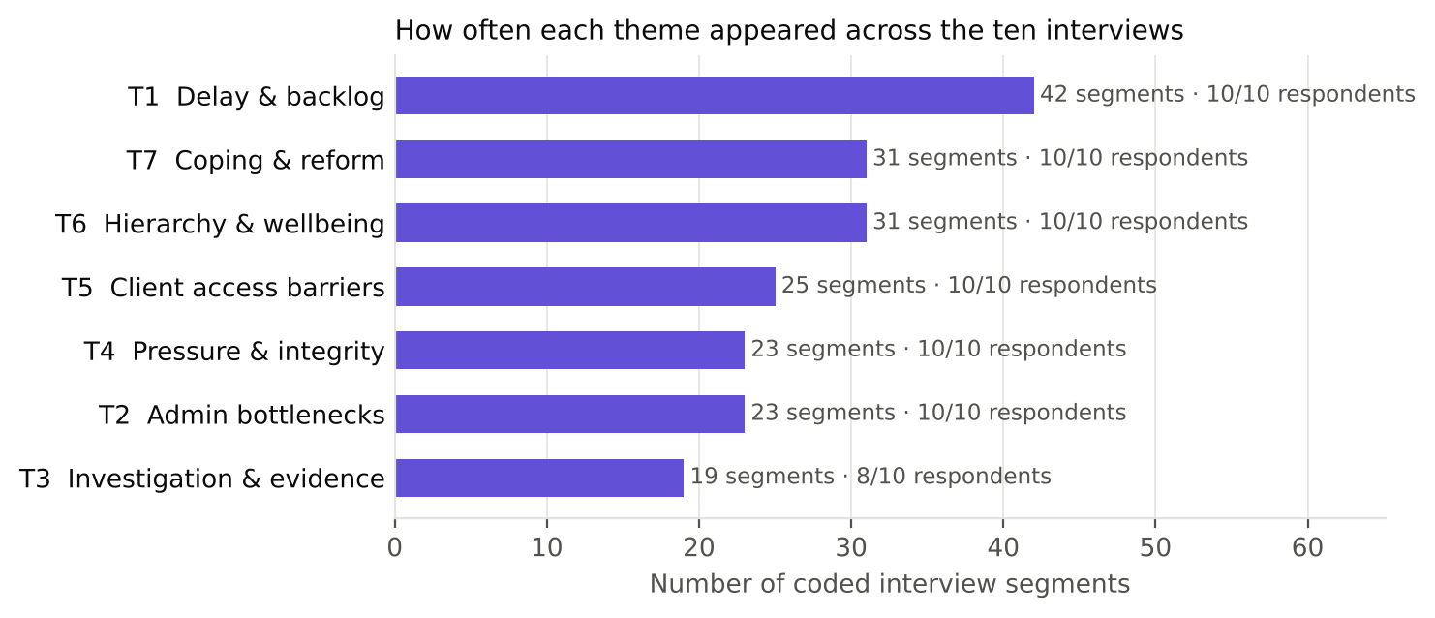
Figure 2. Coded segments per theme across all ten interviews
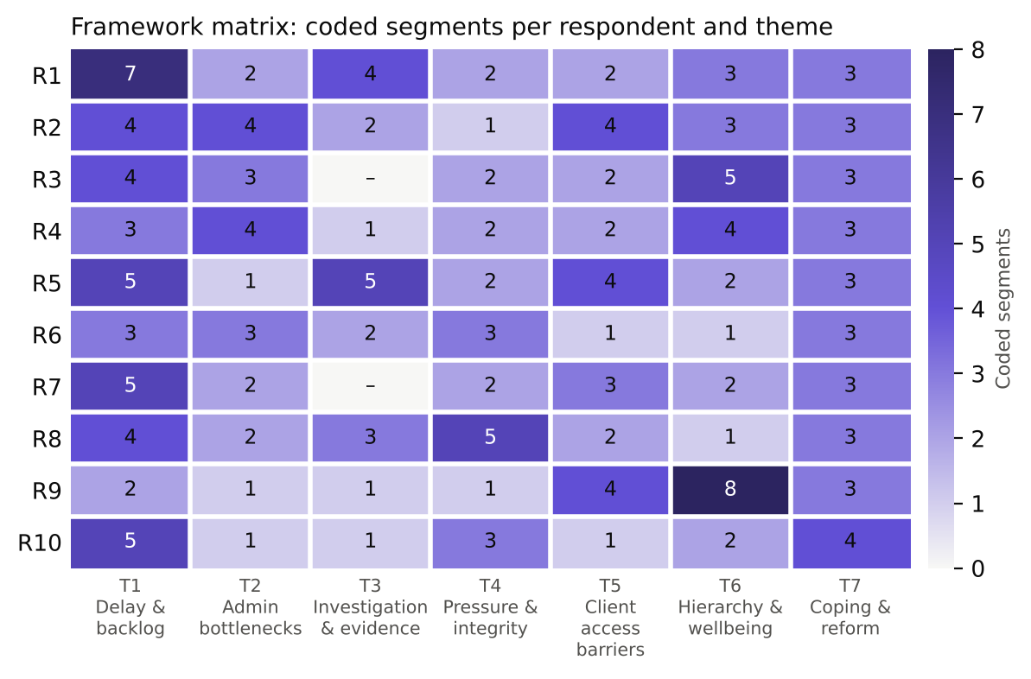
Figure 3. Framework matrix: number of coded segments per respondent and theme
Table 3. Coding framework for the focal themes: codes, categories and themes
Theme (selective coding) | Initial code (open coding) | n | Respondents
T4: External pressure and integrity dilemmas | c14 Political influence on cases | 5/10 | R1, R3, R7, R8, R10
 | c15 Pressure or threats from influential parties | 8/10 | R1, R2, R4, R5, R6, R7, R8, R10
 | c16 Bar politics and partisan alignment | 5/10 | R3, R5, R6, R8, R10
 | c17 Ethical dilemmas over informal payments | 3/10 | R4, R6, R9
T6: Professional hierarchy, insecurity and wellbeing | c22 Irregular income of junior lawyers | 5/10 | R2, R3, R4, R7, R9
 | c23 Senior gatekeeping and dependency | 6/10 | R1, R3, R4, R7, R9, R10
 | c24 Gender discrimination within the Bar | 3/10 | R2, R5, R9
 | c25 Stress, fear and burnout | 9/10 | R1, R2, R3, R4, R5, R6, R8, R9, R10
T2: Procedural and administrative bottlenecks | c06 Informal 'speed money' to court staff | 7/10 | R1, R2, R3, R4, R6, R8, R9
 | c07 Missing or misplaced case records | 3/10 | R1, R4, R6
 | c08 Slow certified copies, orders and reports | 5/10 | R2, R3, R4, R7, R8
 | c09 Manual systems and poor court infrastructure | 7/10 | R2, R3, R4, R5, R6, R7, R10
T7: Coping strategies and reform aspirations | c26 Persistent follow-up and personal networks | 7/10 | R1, R2, R3, R4, R5, R8, R9
 | c27 Mediation, conciliation and arbitration | 4/10 | R2, R6, R7, R10
 | c28 Digital tools (online cause list, virtual hearing) | 9/10 | R1, R3, R4, R5, R6, R7, R8, R9, R10
 | c29 Calls for structural reform | 10/10 | R1, R2, R3, R4, R5, R6, R7, R8, R9, R10

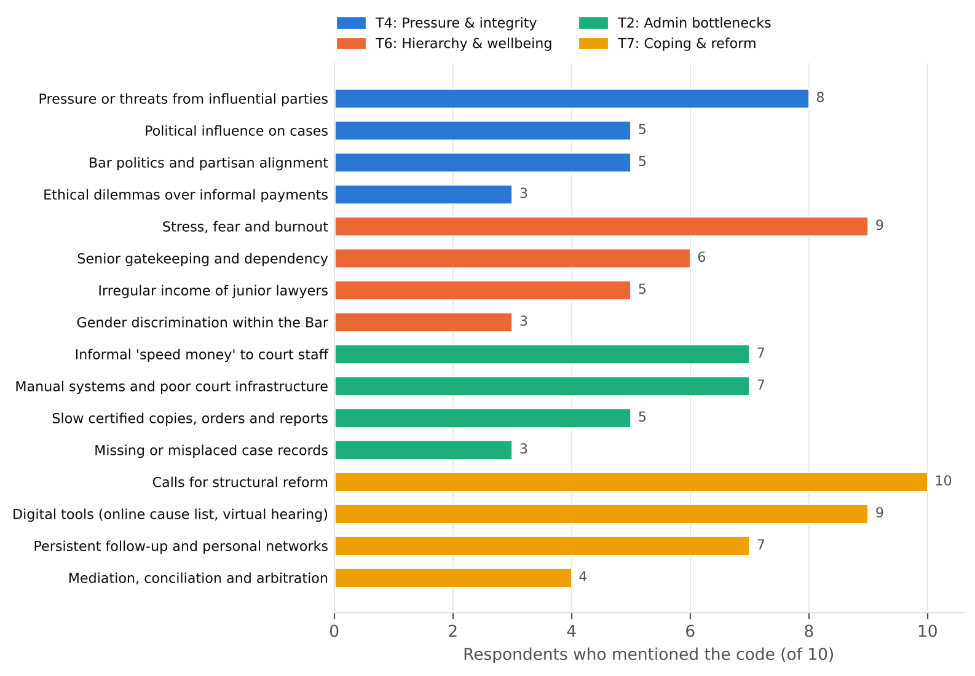
Figure 4. Number of respondents mentioning each code within the focal themes

3.1 "You can feel the pressure": political and social influence
Respondents seldom claimed to have direct proof of interference, but they described a pervasive sense that power shapes outcomes. In criminal practice, political affiliation was seen to affect bail:
“In politically sensitive cases you can feel the pressure. Bail becomes difficult when the accused is from the other side. A senior once told me not to 'push too hard'.” (R1, male, criminal, 6 years in practice)
“During political unrest, mass cases are filed and bail is almost impossible whatever the merits. I have received threats from both sides.” (R8, male, criminal defence / bail, 7 years in practice)
Respondents also linked influence to economic power, from factory owners to loan defaulters:
“Some factory owners are politically connected. Workers fear losing their jobs if they file, and some union leaders compromise.” (R7, male, labour / corporate, 4 years in practice)
“Influential defaulters have connections. You cannot prove it, but the pattern is visible.” (R10, male, commercial / civil, 10 years in practice)
R10's remark that "you cannot prove it, but the pattern is visible" sums up this theme. Influence works less through dramatic interventions than through hesitation, delay and an atmosphere in which lawyers learn what not to push.

3.2 "Kharcha": informal payments and the ethics of getting things done
The second sub-theme concerns informal payments in court offices (Theme 2), which respondents described as an ethical burden they must manage rather than an abstract form of corruption. Small payments are normalised through euphemism:
“Without giving the peshkar or the clerk something, your file does not move. Nobody calls it a bribe; they call it 'kharcha'. Twice my case records went missing on the hearing date.” (R1, male, criminal, 6 years in practice)
For juniors, the dilemma is personal and immediate:
“Staff ask for money for everything: finding a file, giving a date, even a photocopy. As a junior I feel ashamed telling the client he has to pay this.” (R4, male, civil / land, 2 years in practice)
Refusing to take part has a professional cost, because clients may simply move to a lawyer who promises results:
“I have refused cases where clients wanted me to 'manage' things. Clients sometimes leave because another lawyer promises to manage. That is the ethical dilemma.” (R6, male, land / civil, 12 years in practice)
These accounts reflect Lipsky's (1980) point that front-line discretion over everyday procedures can become a resource, and here it is one that lawyers must negotiate on behalf of their clients.

3.3 Hierarchy, gatekeeping and Bar politics
Theme 6 shows a profession organised around steep hierarchy. Juniors depend on seniors for briefs, income and even recognition at the bench:
“The hierarchy is strong. Juniors work for years under a senior for little or no pay. It is a guru-shishya culture.” (R3, male, writ / constitutional, 9 years in practice)
“I depend fully on my senior and get a small allowance. Without a senior, a new lawyer cannot get clients.” (R4, male, civil / land, 2 years in practice)
“Judges are mostly respectful, but junior lawyers are often ignored at the bench. The senior takes the brief and the junior does the running.” (R1, male, criminal, 6 years in practice)
Hierarchy also has a political dimension. Respondents described partisan Bar politics as affecting collegiality, access and opportunity:
“When a case involves powerful interests you sense the hesitation. Bar politics also matters: which panel you belong to can affect which briefs you receive and sometimes how you are treated.” (R3, male, writ / constitutional, 9 years in practice)
“With experience, relations with the bench become professional. But Bar elections divide lawyers along party lines, and that hurts collegiality.” (R6, male, land / civil, 12 years in practice)

3.4 Gendered professionalism
All three female respondents described gender-based discrimination from clients, colleagues and court staff, and the extra burden of proving competence:
“Some clients ask me, 'Is there no male lawyer?' Some senior colleagues make jokes. As a woman you have to prove twice that you are competent.” (R2, female, family, 3 years in practice)
“Some male colleagues think women lawyers are only suited to family matters. In the bar association women's voices are few.” (R5, female, criminal (survivors), 5 years in practice)
“Some seniors support you and some exploit you. Some male colleagues comment on my dress or ask why I am not married.” (R9, female, mixed / legal aid, 1 year in practice)
The consequences extend to who stays in the profession at all:
“I am learning, but I feel insecure about income. Many of my female classmates have left practice for jobs.” (R9, female, mixed / legal aid, 1 year in practice)

3.5 The personal toll
Stress, fear and burnout were mentioned by nine respondents, making them among the most widely shared codes. Respondents described moral fatigue at being blamed for a system they cannot control, the secondary trauma of working with survivors, and, in politically charged cases, fear for their own safety:
“I sleep less. Some days I have matters in four courts on four floors. Families call me at midnight. There is a moral tiredness when you know the system is the problem but people blame you.” (R1, male, criminal, 6 years in practice)
“Sometimes there is fear. I have been followed after a hearing, and my family worries.” (R8, male, criminal defence / bail, 7 years in practice)
“I carry the cases home. Secondary trauma is real, but nobody talks about it in our profession.” (R5, female, criminal (survivors), 5 years in practice)
For junior lawyers the toll was mainly financial and pushed some towards leaving the profession:
“The financial pressure is serious. My family asks when I will earn properly. Sometimes I think of taking a job instead.” (R4, male, civil / land, 2 years in practice)

3.6 Holding the line: strategies for maintaining integrity
Respondents described deliberate strategies to protect their integrity and their clients. These included creating a written record that is harder to manipulate:
“I document everything, keep copies, and file written applications so the record is clear. I also network with other defence lawyers.” (R8, male, criminal defence / bail, 7 years in practice)
and building wide networks rather than depending on a single patron:
“I read case law at night, and I ask questions of many seniors, not just one.” (R9, female, mixed / legal aid, 1 year in practice)
Their proposals for reform targeted institutional independence and accountability:
“A separate, independent secretariat for the judiciary, and a transparent listing system.” (R3, male, writ / constitutional, 9 years in practice)
“Separate criminal investigation from regular policing and make it accountable.” (R8, male, criminal defence / bail, 7 years in practice)

3.7 Coding paradigm model
Figure 5 integrates the findings using Strauss and Corbin's (1998) coding paradigm. The central phenomenon is that lawyers' professional autonomy and integrity are constrained by pressure. The causal conditions are political influence, pressure from influential parties and a culture of informal payments. These operate in a context of partisan Bar politics, a guru-shishya hierarchy and a male-dominated professional culture. Intervening conditions, namely juniors' income insecurity, reliance on a senior's name and weak accountability mechanisms, determine how strongly each lawyer feels these pressures. Lawyers respond with strategies of refusing to "manage" cases, documenting everything in writing, building peer networks and seeking many mentors rather than one. The consequences include ethical dilemmas and lost clients, fear, stress and burnout, attrition among juniors and women, and a clear demand for an independent judicial secretariat and transparent processes.
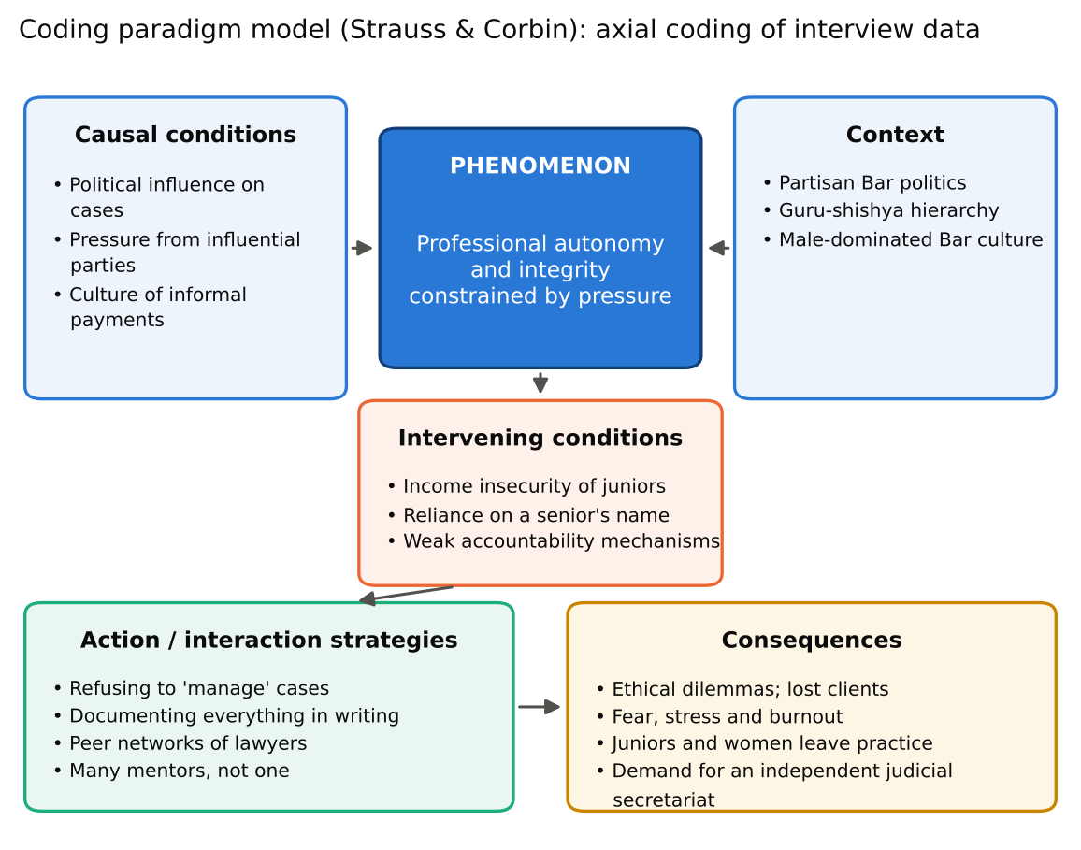
Figure 5. Coding paradigm model of pressure on professional integrity (after Strauss & Corbin, 1998)

4. Research limitations
The study has important limitations. First, it is based on ten batchmates selected purposively and for convenience, and most practise in the Dhaka region, so the findings cannot be generalised to all lawyers in Bangladesh. Second, the topics are highly sensitive. Respondents may have under-reported their own involvement in informal payments or political networks, and some spoke in general rather than personal terms. My insider relationship with respondents helped them speak openly, but it may also have encouraged socially desirable answers. Third, timing was difficult: interviews had to fit around court schedules, and some were shorter or conducted by phone, limiting deeper probing on sensitive points. Fourth, translation from Bangla may have lost some nuance and tone. Fifth, analysis was carried out by a single coder. A peer review of the coding framework reduced, but did not remove, the risk of interpretive bias.

5. Conclusion
This report examined the professional and ethical challenges lawyers face as they try to pursue justice within legal institutions. The interviews show that, alongside delay and poor infrastructure, lawyers have to navigate a web of pressure: political and economic influence that is rarely provable but widely felt, a normalised culture of informal payments that forces daily ethical choices, a steep and partly politicised hierarchy within the Bar, and gendered treatment that pushes women to prove themselves twice. These pressures carry real personal costs, including moral fatigue, fear, financial insecurity and, for some juniors and women, departure from the profession. Lawyers are not simply victims of these conditions. They refuse to "manage" cases, document their work, build peer networks and speak openly about reform. Their accounts suggest that protecting lawyers' professional autonomy, through an independent judicial secretariat, transparent listing, accountable investigation and fair conditions for junior and female lawyers, is itself a precondition for justice.

References
Braun, V., & Clarke, V. (2006). Using thematic analysis in psychology. Qualitative Research in Psychology, 3(2), 77–101.
Creswell, J. W., & Poth, C. N. (2018). Qualitative inquiry and research design: Choosing among five approaches (4th ed.). Sage.
Freidson, E. (2001). Professionalism, the third logic: On the practice of knowledge. University of Chicago Press.
Kvale, S., & Brinkmann, S. (2009). InterViews: Learning the craft of qualitative research interviewing (2nd ed.). Sage.
Lincoln, Y. S., & Guba, E. G. (1985). Naturalistic inquiry. Sage.
Lipsky, M. (1980). Street-level bureaucracy: Dilemmas of the individual in public services. Russell Sage Foundation.
Strauss, A., & Corbin, J. (1998). Basics of qualitative research: Techniques and procedures for developing grounded theory (2nd ed.). Sage.

Appendix A. Semi-structured interview questionnaire
Opening: introduce the study, confirm consent and permission to record, and note the respondent's name, roll, batch, gender, years in practice and main court. The ten core questions below were asked in every interview; probes were used where helpful.
- Please describe your path into the legal profession and what professional integrity means to you.
Probes: Has your view changed with experience?
- Have you experienced or witnessed political or social pressure affecting how a case was handled or decided? How did you respond?
Probes: How did it make you feel?
- How do informal payments or 'arrangements' in court offices affect your work, and what ethical dilemmas do they create?
Probes: Have you lost clients by refusing?
- How would you describe the relationship between junior and senior lawyers? Does this hierarchy affect your independence?
Probes: How are juniors paid?
- How does Bar association politics affect lawyers' work and professional relationships?
Probes: Does party alignment affect access or briefs?
- Does gender shape how lawyers are treated by clients, colleagues, court staff or the bench? Please share an example.
Probes: How do women lawyers respond?
- How do these pressures affect your income, stress, safety or motivation?
Probes: Have you ever felt unsafe?
- What strategies do you use to protect your integrity and your clients' interests?
Probes: Who do you turn to for support?
- Have you ever considered leaving practice, or seen colleagues leave? Why?
Probes: Who is most likely to leave?
- What institutional changes would best protect lawyers' independence and integrity?
Probes: Anything else you would like to add?
Closing: thank the respondent, ask whether there is anything they would like to add, and remind them of confidentiality and their right to withdraw.

Appendix B. Complete coding framework
Theme (selective coding) | Initial code (open coding) | n | Respondents
T1: Institutional delay and case backlog | c01 Frequent adjournments / time petitions | 10/10 | R1, R2, R3, R4, R5, R6, R7, R8, R9, R10
 | c02 Case backlog and overloaded cause lists | 8/10 | R1, R3, R4, R5, R6, R7, R8, R10
 | c03 Shortage of judges and courts | 4/10 | R1, R6, R7, R10
 | c04 Witness non-appearance / summons not served | 4/10 | R1, R2, R5, R8
 | c05 Clients losing faith because of delay | 5/10 | R1, R2, R3, R5, R9
T2: Procedural and administrative bottlenecks | c06 Informal 'speed money' to court staff | 7/10 | R1, R2, R3, R4, R6, R8, R9
 | c07 Missing or misplaced case records | 3/10 | R1, R4, R6
 | c08 Slow certified copies, orders and reports | 5/10 | R2, R3, R4, R7, R8
 | c09 Manual systems and poor court infrastructure | 7/10 | R2, R3, R4, R5, R6, R7, R10
T3: Weak investigation and evidentiary gaps | c10 Weak or biased police investigation | 5/10 | R1, R2, R5, R8, R9
 | c11 Delayed or flawed charge sheets | 3/10 | R1, R5, R8
 | c12 Witness intimidation / hostile witnesses | 4/10 | R2, R4, R5, R6
 | c13 Lack of forensic and digital-evidence support | 4/10 | R1, R5, R6, R10
T4: External pressure and integrity dilemmas | c14 Political influence on cases | 5/10 | R1, R3, R7, R8, R10
 | c15 Pressure or threats from influential parties | 8/10 | R1, R2, R4, R5, R6, R7, R8, R10
 | c16 Bar politics and partisan alignment | 5/10 | R3, R5, R6, R8, R10
 | c17 Ethical dilemmas over informal payments | 3/10 | R4, R6, R9
T5: Access-to-justice barriers for clients | c18 Litigation cost and lost income | 9/10 | R1, R2, R3, R4, R5, R6, R7, R8, R10
 | c19 Low legal literacy and exploitation by touts | 5/10 | R2, R4, R7, R8, R9
 | c20 Gender and social barriers for women clients | 2/10 | R2, R5
 | c21 Weak reach and quality of legal aid | 4/10 | R1, R3, R5, R9
T6: Professional hierarchy, insecurity and wellbeing | c22 Irregular income of junior lawyers | 5/10 | R2, R3, R4, R7, R9
 | c23 Senior gatekeeping and dependency | 6/10 | R1, R3, R4, R7, R9, R10
 | c24 Gender discrimination within the Bar | 3/10 | R2, R5, R9
 | c25 Stress, fear and burnout | 9/10 | R1, R2, R3, R4, R5, R6, R8, R9, R10
T7: Coping strategies and reform aspirations | c26 Persistent follow-up and personal networks | 7/10 | R1, R2, R3, R4, R5, R8, R9
 | c27 Mediation, conciliation and arbitration | 4/10 | R2, R6, R7, R10
 | c28 Digital tools (online cause list, virtual hearing) | 9/10 | R1, R3, R4, R5, R6, R7, R8, R9, R10
 | c29 Calls for structural reform | 10/10 | R1, R2, R3, R4, R5, R6, R7, R8, R9, R10

Appendix C. Completed questionnaires
This appendix contains the questionnaire completed for each of the ten respondents interviewed by Tanvir Ahmed Siddique. Names appear here for verification by the course teacher only; in the body of the report respondents are anonymised.

Questionnaire 1 of 10: Mobarak
Respondent name | Mobarak
Roll | [roll]
Batch | [batch]
Gender / years in practice
Main court / practice area
Date, mode and duration
Interviewed by | Tanvir Ahmed Siddique (Roll [roll], Batch [batch])
Informed consent | ☐ Yes ☐ No

Q1. Please describe your path into the legal profession and what professional integrity means to you.
Response:
Q2. Have you experienced or witnessed political or social pressure affecting how a case was handled or decided? How did you respond?
Response:
Q3. How do informal payments or 'arrangements' in court offices affect your work, and what ethical dilemmas do they create?
Response:
Q4. How would you describe the relationship between junior and senior lawyers? Does this hierarchy affect your independence?
Response:
Q5. How does Bar association politics affect lawyers' work and professional relationships?
Response:
Q6. Does gender shape how lawyers are treated by clients, colleagues, court staff or the bench? Please share an example.
Response:
Q7. How do these pressures affect your income, stress, safety or motivation?
Response:
Q8. What strategies do you use to protect your integrity and your clients' interests?
Response:
Q9. Have you ever considered leaving practice, or seen colleagues leave? Why?
Response:
Q10. What institutional changes would best protect lawyers' independence and integrity?
Response:

Questionnaire 2 of 10: Nafiul Haque Kingshuk
Respondent name | Nafiul Haque Kingshuk
Roll | [roll]
Batch | [batch]
Gender / years in practice
Main court / practice area
Date, mode and duration
Interviewed by | Tanvir Ahmed Siddique (Roll [roll], Batch [batch])
Informed consent | ☐ Yes ☐ No

Q1. Please describe your path into the legal profession and what professional integrity means to you.
Response:
Q2. Have you experienced or witnessed political or social pressure affecting how a case was handled or decided? How did you respond?
Response:
Q3. How do informal payments or 'arrangements' in court offices affect your work, and what ethical dilemmas do they create?
Response:
Q4. How would you describe the relationship between junior and senior lawyers? Does this hierarchy affect your independence?
Response:
Q5. How does Bar association politics affect lawyers' work and professional relationships?
Response:
Q6. Does gender shape how lawyers are treated by clients, colleagues, court staff or the bench? Please share an example.
Response:
Q7. How do these pressures affect your income, stress, safety or motivation?
Response:
Q8. What strategies do you use to protect your integrity and your clients' interests?
Response:
Q9. Have you ever considered leaving practice, or seen colleagues leave? Why?
Response:
Q10. What institutional changes would best protect lawyers' independence and integrity?
Response:

Questionnaire 3 of 10: Taj
Respondent name | Taj
Roll | [roll]
Batch | [batch]
Gender / years in practice
Main court / practice area
Date, mode and duration
Interviewed by | Tanvir Ahmed Siddique (Roll [roll], Batch [batch])
Informed consent | ☐ Yes ☐ No

Q1. Please describe your path into the legal profession and what professional integrity means to you.
Response:
Q2. Have you experienced or witnessed political or social pressure affecting how a case was handled or decided? How did you respond?
Response:
Q3. How do informal payments or 'arrangements' in court offices affect your work, and what ethical dilemmas do they create?
Response:
Q4. How would you describe the relationship between junior and senior lawyers? Does this hierarchy affect your independence?
Response:
Q5. How does Bar association politics affect lawyers' work and professional relationships?
Response:
Q6. Does gender shape how lawyers are treated by clients, colleagues, court staff or the bench? Please share an example.
Response:
Q7. How do these pressures affect your income, stress, safety or motivation?
Response:
Q8. What strategies do you use to protect your integrity and your clients' interests?
Response:
Q9. Have you ever considered leaving practice, or seen colleagues leave? Why?
Response:
Q10. What institutional changes would best protect lawyers' independence and integrity?
Response:

Questionnaire 4 of 10: Tashfia Ali
Respondent name | Tashfia Ali
Roll | [roll]
Batch | [batch]
Gender / years in practice
Main court / practice area
Date, mode and duration
Interviewed by | Tanvir Ahmed Siddique (Roll [roll], Batch [batch])
Informed consent | ☐ Yes ☐ No

Q1. Please describe your path into the legal profession and what professional integrity means to you.
Response:
Q2. Have you experienced or witnessed political or social pressure affecting how a case was handled or decided? How did you respond?
Response:
Q3. How do informal payments or 'arrangements' in court offices affect your work, and what ethical dilemmas do they create?
Response:
Q4. How would you describe the relationship between junior and senior lawyers? Does this hierarchy affect your independence?
Response:
Q5. How does Bar association politics affect lawyers' work and professional relationships?
Response:
Q6. Does gender shape how lawyers are treated by clients, colleagues, court staff or the bench? Please share an example.
Response:
Q7. How do these pressures affect your income, stress, safety or motivation?
Response:
Q8. What strategies do you use to protect your integrity and your clients' interests?
Response:
Q9. Have you ever considered leaving practice, or seen colleagues leave? Why?
Response:
Q10. What institutional changes would best protect lawyers' independence and integrity?
Response:

Questionnaire 5 of 10: Shohag
Respondent name | Shohag
Roll | [roll]
Batch | [batch]
Gender / years in practice
Main court / practice area
Date, mode and duration
Interviewed by | Tanvir Ahmed Siddique (Roll [roll], Batch [batch])
Informed consent | ☐ Yes ☐ No

Q1. Please describe your path into the legal profession and what professional integrity means to you.
Response:
Q2. Have you experienced or witnessed political or social pressure affecting how a case was handled or decided? How did you respond?
Response:
Q3. How do informal payments or 'arrangements' in court offices affect your work, and what ethical dilemmas do they create?
Response:
Q4. How would you describe the relationship between junior and senior lawyers? Does this hierarchy affect your independence?
Response:
Q5. How does Bar association politics affect lawyers' work and professional relationships?
Response:
Q6. Does gender shape how lawyers are treated by clients, colleagues, court staff or the bench? Please share an example.
Response:
Q7. How do these pressures affect your income, stress, safety or motivation?
Response:
Q8. What strategies do you use to protect your integrity and your clients' interests?
Response:
Q9. Have you ever considered leaving practice, or seen colleagues leave? Why?
Response:
Q10. What institutional changes would best protect lawyers' independence and integrity?
Response:

Questionnaire 6 of 10: Marzia Rahman
Respondent name | Marzia Rahman
Roll | [roll]
Batch | [batch]
Gender / years in practice
Main court / practice area
Date, mode and duration
Interviewed by | Tanvir Ahmed Siddique (Roll [roll], Batch [batch])
Informed consent | ☐ Yes ☐ No

Q1. Please describe your path into the legal profession and what professional integrity means to you.
Response:
Q2. Have you experienced or witnessed political or social pressure affecting how a case was handled or decided? How did you respond?
Response:
Q3. How do informal payments or 'arrangements' in court offices affect your work, and what ethical dilemmas do they create?
Response:
Q4. How would you describe the relationship between junior and senior lawyers? Does this hierarchy affect your independence?
Response:
Q5. How does Bar association politics affect lawyers' work and professional relationships?
Response:
Q6. Does gender shape how lawyers are treated by clients, colleagues, court staff or the bench? Please share an example.
Response:
Q7. How do these pressures affect your income, stress, safety or motivation?
Response:
Q8. What strategies do you use to protect your integrity and your clients' interests?
Response:
Q9. Have you ever considered leaving practice, or seen colleagues leave? Why?
Response:
Q10. What institutional changes would best protect lawyers' independence and integrity?
Response:

Questionnaire 7 of 10: Imran Mridha
Respondent name | Imran Mridha
Roll | [roll]
Batch | [batch]
Gender / years in practice
Main court / practice area
Date, mode and duration
Interviewed by | Tanvir Ahmed Siddique (Roll [roll], Batch [batch])
Informed consent | ☐ Yes ☐ No

Q1. Please describe your path into the legal profession and what professional integrity means to you.
Response:
Q2. Have you experienced or witnessed political or social pressure affecting how a case was handled or decided? How did you respond?
Response:
Q3. How do informal payments or 'arrangements' in court offices affect your work, and what ethical dilemmas do they create?
Response:
Q4. How would you describe the relationship between junior and senior lawyers? Does this hierarchy affect your independence?
Response:
Q5. How does Bar association politics affect lawyers' work and professional relationships?
Response:
Q6. Does gender shape how lawyers are treated by clients, colleagues, court staff or the bench? Please share an example.
Response:
Q7. How do these pressures affect your income, stress, safety or motivation?
Response:
Q8. What strategies do you use to protect your integrity and your clients' interests?
Response:
Q9. Have you ever considered leaving practice, or seen colleagues leave? Why?
Response:
Q10. What institutional changes would best protect lawyers' independence and integrity?
Response:

Questionnaire 8 of 10: Mamun
Respondent name | Mamun
Roll | 2
Batch | [batch]
Gender / years in practice
Main court / practice area
Date, mode and duration
Interviewed by | Tanvir Ahmed Siddique (Roll [roll], Batch [batch])
Informed consent | ☐ Yes ☐ No

Q1. Please describe your path into the legal profession and what professional integrity means to you.
Response:
Q2. Have you experienced or witnessed political or social pressure affecting how a case was handled or decided? How did you respond?
Response:
Q3. How do informal payments or 'arrangements' in court offices affect your work, and what ethical dilemmas do they create?
Response:
Q4. How would you describe the relationship between junior and senior lawyers? Does this hierarchy affect your independence?
Response:
Q5. How does Bar association politics affect lawyers' work and professional relationships?
Response:
Q6. Does gender shape how lawyers are treated by clients, colleagues, court staff or the bench? Please share an example.
Response:
Q7. How do these pressures affect your income, stress, safety or motivation?
Response:
Q8. What strategies do you use to protect your integrity and your clients' interests?
Response:
Q9. Have you ever considered leaving practice, or seen colleagues leave? Why?
Response:
Q10. What institutional changes would best protect lawyers' independence and integrity?
Response:

Questionnaire 9 of 10: Akram
Respondent name | Akram
Roll | 38
Batch | [batch]
Gender / years in practice
Main court / practice area
Date, mode and duration
Interviewed by | Tanvir Ahmed Siddique (Roll [roll], Batch [batch])
Informed consent | ☐ Yes ☐ No

Q1. Please describe your path into the legal profession and what professional integrity means to you.
Response:
Q2. Have you experienced or witnessed political or social pressure affecting how a case was handled or decided? How did you respond?
Response:
Q3. How do informal payments or 'arrangements' in court offices affect your work, and what ethical dilemmas do they create?
Response:
Q4. How would you describe the relationship between junior and senior lawyers? Does this hierarchy affect your independence?
Response:
Q5. How does Bar association politics affect lawyers' work and professional relationships?
Response:
Q6. Does gender shape how lawyers are treated by clients, colleagues, court staff or the bench? Please share an example.
Response:
Q7. How do these pressures affect your income, stress, safety or motivation?
Response:
Q8. What strategies do you use to protect your integrity and your clients' interests?
Response:
Q9. Have you ever considered leaving practice, or seen colleagues leave? Why?
Response:
Q10. What institutional changes would best protect lawyers' independence and integrity?
Response:

Questionnaire 10 of 10: [your name]
Respondent name | [your name]
Roll | [roll]
Batch | [batch]
Gender / years in practice
Main court / practice area
Date, mode and duration
Interviewed by | Tanvir Ahmed Siddique (Roll [roll], Batch [batch])
Informed consent | ☐ Yes ☐ No

Q1. Please describe your path into the legal profession and what professional integrity means to you.
Response:
Q2. Have you experienced or witnessed political or social pressure affecting how a case was handled or decided? How did you respond?
Response:
Q3. How do informal payments or 'arrangements' in court offices affect your work, and what ethical dilemmas do they create?
Response:
Q4. How would you describe the relationship between junior and senior lawyers? Does this hierarchy affect your independence?
Response:
Q5. How does Bar association politics affect lawyers' work and professional relationships?
Response:
Q6. Does gender shape how lawyers are treated by clients, colleagues, court staff or the bench? Please share an example.
Response:
Q7. How do these pressures affect your income, stress, safety or motivation?
Response:
Q8. What strategies do you use to protect your integrity and your clients' interests?
Response:
Q9. Have you ever considered leaving practice, or seen colleagues leave? Why?
Response:
Q10. What institutional changes would best protect lawyers' independence and integrity?
Response:

