

Shri Vile Parle Kelavani Mandal’s
Shri Bhagubhai Mafatlal Polytechnic and College of Engineering Vile Parle-( West), Mumbai-400056

PROJECT REPORT ON
FinAuditPro

Submitted in parallel Fulfilment of Requirements The Diploma in Information Technology
Name of Student: Aryan Yadav, Jeet Shah, Hitansh Jasani Roll No:T010, T013, T031 SAP No : 57508240011, 57508240016, 57508240035
Academic Year: 2026 Name of Department: INFORMATION TECHNOLOGY Year/Semester: 3rd Year / 5th Semester

THIS IS TO CERTIFY THAT
Shri/ Smt. / Kum: Aryan Yadav, Jeet Shah, Hitansh Jasani Exam Seat No.: Has Satisfactorily Completed his Project work and submitted.

Guide: Head of Dept. Principal
Date:

Shri Vile Parle Kelavani Mandal
Shri Bhagubhai Mafatlal Polytechnic and College of Engineering Vile Parle-( West), Mumbai-400056

PROJECT APPROVAL SHEET
THIS IS TO CERTIFY THAT

Shri/ Smt. / Kum: Aryan Yadav, Jeet Shah, Hitansh Jasani SAP No. 57508240011, 57508240016, 57508240035 has
Presented a Project Entitled FinAuditPro

In Partial Fulfilment of Diploma in Information Technology Same is Approved by:
- External Examiner
Name and Sign

- Internal Examiner
Name and Sign

Date:

Shri Vile Parle Kelavani Mandal
Shri Bhagubhai Mafatlal Polytechnic and College of Engineering Vile Parle-( West), Mumbai-400056

INFORMATION TECHNOLOGY DEPARTMENT

VISION
To create a learning environment that nurtures students and transform them into competent IT Diploma Graduates.

MISSION
M1: To impart technical and managerial skills for pursuing academic excellence through dynamic learning environment.

M2: To foster industry ready graduates by acquiring and utilizing latest technology. M3: To strengthen holistic development and Professionalism in the Diploma graduates.

PROGRAMME EDUCATIONAL OBJECTIVES

After successful completion of the program students will be able to:
PEO1: Imbibe core knowledge and utilise associated technologies to provide domain related solutions.

PEO2: Be capable of pursuing higher education and adapting to the rapid pace of technological advancements through strong professional competence.

PEO3: Develop a holistic personality equipped with leadership qualities, team skills and humane approach towards society.

PROGRAM SPECIFIC OUTCOMES

PSO1: Students will demonstrate fundamental knowledge in core domains of IT such as Software Development, Databases and Information Systems

PSO2: Students will acquire skills that can provide IT solutions in the field of Networking, IOT, Machine Learning and Cloud Computing.

Shri Vile Parle Kelavani Mandal
Shri Bhagubhai Mafatlal Polytechnic and College of Engineering Vile Parle-( West), Mumbai-400056

Table of Contents Abstract 6
Chapter 1 7 - 9
  - Introduction 7
  - Problem Statement 8
  - Proposed Solution 9
Chapter 2. 10 - 15
  - System Requirements 10
  - Tools and Technologies Used 11
  - Features 15
  - Gantt Chart. 15
Chapter 3 16 - 20
  - System Design 16
    - Flowchart 16
    - DFD Level 0. 17
    - DFD Level 1. 17
    - UMLUse Case Diagram 18
    - UML Activity Diagram 19
    - UML Component Diagram 20
    - Deployment Diagram 20
Chapter 4 21 - 56
  - Literature Review. 21
  - Source Code 23
  - Outputs 51
Chapter 5 57 - 61
  - Advantages 57
  - Future Scope 58
  - Limitations 59
  - Acknowledgement 60
  - Conclusion 61
  - References 61

Abstract

FinAuditPro is an intelligent audit-management platform developed to simplify and strengthen the complete financial audit process. It enables audit teams to manage clients, engagements, financial years, documents, working papers, risks, compliance requirements, findings, and reports through one secure portal [1]. The system supports document upload, validation, classification, OCR-based text extraction, table extraction, and evidence indexing, making audit information easier to organise, retrieve, and review [2], [3].

The platform uses a configurable rule engine to automate compliance checks, identify exceptions, and evaluate their severity [1]. Its AI-powered audit copilot, dashboards, KPIs (Key Performance Indicator), trend analysis, forecasting, and benchmarking features help auditors and managers derive useful insights from audit data [4], [5].

With workflow management, role-based access, audit trails, report generation, Excel/PDF export, digital signatures, and QR verification, FinAuditPro reduces manual effort, improves audit accuracy and transparency, and supports timely, reliable financial audits [1], [6], [7].

Chapter 1

Introduction

The traditional auditing processes face problems because of manual managing of client details, tasks, and document assignment. Documenting evidence and generating reports is not well automated. There is a lack of ability in offline AI-assisted report generation. This project is based on the industrial requirements for a highly secure local AI auditing application. The application will handle the creation of audit working papers, risk detection, and AI analysis of financial statements [1].

It will create an efficient workspace for the auditors and manage client portfolios for the same. Users will be able to use the application for querying local LLMs and generating compliance checklists. The application will generate quick, accurate risk estimation and everything will be stored in a local SQLite database, so it is secure and accessible anytime anywhere [2]. Ingesting, diagnosing, querying, and reporting are some of the tasks that will be sped up with the software. The incoming audit jobs will be scheduled and displayed for smooth completion.

The document portfolio, AI inference progress, and the track record of the firm, along with risk reporting and finances, this software will be able to handle all these things at once. The desktop application has various functionalities based on the auditing workflow. It generates working papers for the auditing process and exports them to PDF. It creates an efficient workspace for assigning tasks and monitoring the jobs registered. The application will have frontend using PySide6 [3]. The backend uses Python, FAISS [4], Ollama [5], and SQLite for database [2]. The principal purpose is to meet the needs of the industry such that it can significantly help the risk management and ensure strict data privacy.

Problem Statement

The traditional financial auditing industry faces problems like managing massive volumes of unstructured data, manual tracking of client records, and a high risk of errors in manual verification. The CRM and management of documents currently lack secure local processing. The need for an offline AI analysis tool is a requisite for establishing transparency and trust, enabling auditors to securely process sensitive financial data without uploading it to cloud servers [6]. They require an enterprise-grade portal which can provide actionable insights, automate risk detection, and drive their auditing decisions [1].

The software should generate quick, accurate working papers and reduce paperwork so there is no need to worry about losing information. Everything is to be stored in a local SQLite database giving auditors access anytime to review past or present information securely [2]. Everything should be automated to reduce the time taken for various regular audit operations. Ingesting, diagnosing, and reporting are some of the time-consuming tasks that are to be replaced with software. They expect the incoming audits to be scheduled to prevent overworking.

The document portfolios, risk progress, and the track record of the firm, along with compliance checklists, the auditing software should be able to handle all these things at once.

Proposed Solution

FinAuditPro- Our project will be able to handle document ingestion, AI-based financial queries, and track records of the audit processes, along with working paper generation. The software will manage the entire audit workflow with intelligent offline-first AI assistance. Automating the audit will provide efficiency, productivity, and absolute data privacy. It reduces the time taken for various regular auditing operations as everything will be streamlined.

So, auditors do not have to spend their time on manual data extraction instead focus entirely on providing the best financial assessment. This system will handle the creation of executive summaries, risk reports, and compliance lists using relevant information ingested by the RAG pipeline [7]. The local LLM integration is provided for establishing strict data security, enabling professionals to make informed, confident decisions on audit approvals without internet reliance [5].

Extracting, diagnosing, organizing, and generating reports will be automated. The incoming tasks will be scheduled to prevent overworking and resource clashing. Organizing documents and categorizing risks will be done by the system. This requirement could be catered using Python and SQLite [2] with frontend functionalities to elevate the need of workflow management for a financial audit firm. The offline nature of our portal would improve client trust by ensuring zero data leaks. Our application will be the interface between auditors and the raw financial ledgers, showing information securely and intuitively.

Chapter 2

System Requirements

- Python 3.14 (3.14.6)
- PySide6 (6.8.3)
- SQLite (Qt 6.8.8 LTS)
- Ollama (Offline AI Models) (0.32.0)
- Windows Terminal / PowerShell

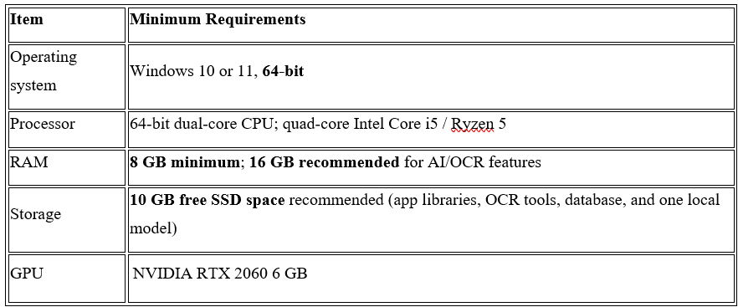

Tools and Technologies

Backend: Python (3.14.6)


Python is a high-level, interpreted, and general-purpose programming language known for its simple syntax and readability. It allows developers to write clear and efficient code with less complexity. Python is widely used in web development, automation, data analysis, artificial intelligence, and software development. In this project, Python 3.14.6 is used to implement the backend logic, process user requests, manage application functionality, and interact with the database.

Frontend: HTML5


HTML5 (HyperText Markup Language 5) is the standard markup language used to create and structure web pages. It provides various elements and tags to organize content, including headings, paragraphs, images, hyperlinks, tables, and forms. HTML5 also supports multimedia elements such as audio and video without requiring additional plugins. In this project, HTML5 is used to create the basic structure of the website and organize the content displayed to users

CSS3

CSS3 (Cascading Style Sheets Level 3) is a style sheet language used to enhance the appearance and layout of web pages. It controls the colors, fonts, spacing, borders, backgrounds, and positioning of different elements. CSS3 also supports animations, transitions, and responsive design, allowing websites to adapt to different screen sizes and devices. In this project, CSS3 is used to create an attractive, user-friendly, and well-organized interface that improves the overall visual presentation of the website.

JavaScript

JavaScript is a high-level programming language used to make web pages interactive and dynamic. It enables developers to add features such as button interactions, form validation, dropdown menus, animations, and dynamic content updates. JavaScript works alongside HTML5 and CSS3 to improve the functionality and usability of a website. In this project, JavaScript is used to handle user interactions, validate input data, respond to user actions, and provide a smoother and more engaging user experience.

Database: SQLite3



SQLite3 is a lightweight, serverless, and file-based relational database management system used to store and manage application data. It organizes information into tables consisting of rows and columns and supports SQL (Structured Query Language) for inserting, retrieving, updating, and deleting records. Unlike many other database systems, SQLite3 does not require a separate database server or complex configuration. In this project, SQLite3 is used to store and retrieve data efficiently, maintain organized records, and support the application's data management requirements..

Tools

Antigravity


Antigravity is an AI-powered development environment designed to assist software development through AI agents. It can help developers understand code, generate and modify program files, identify errors, and automate certain development tasks based on instructions.



Git&Github

Git is a free, open-source distributed version control system (VCS) created by Linus Torvalds in 2005. It runs locally on your machine to track history, changes, and snapshots in your code. GitHub is a cloud-based web hosting platform for Git repositories (owned by Microsoft) that adds a graphical interface and tools for online storage, teamwork, and code review

Figma


Figma is a interface design and prototyping tool used to create wireframes, user interface layouts, interactive prototypes, and design systems. It enables designers and developers to collaborate, share designs, and maintain consistent visual elements throughout an application.

Features
- Client and audit engagement management
- Complete offline operation for secure use without an internet connection
- Secure user authentication with role-based access control
- Audit planning, workflow tracking, and task management
- Document upload, OCR, classification, and evidence indexing
- Working-paper creation and audit evidence management
- Risk assessment, findings management, and compliance monitoring
- Configurable rule engine for automated audit checks and exception detection
- Ollama-based local AI Audit Copilot for document analysis and audit assistance
- Analytical dashboards and report generation with PDF/Excel export, digital signatures, QR verification, and audit trails

Gantt Chart

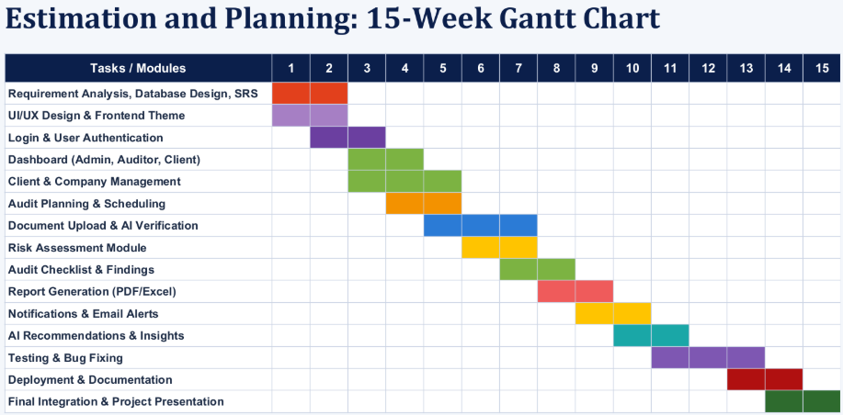
Figure 8. Gantt Chart

Chapter 3

SYSTEM DESIGN
    - Flowchart
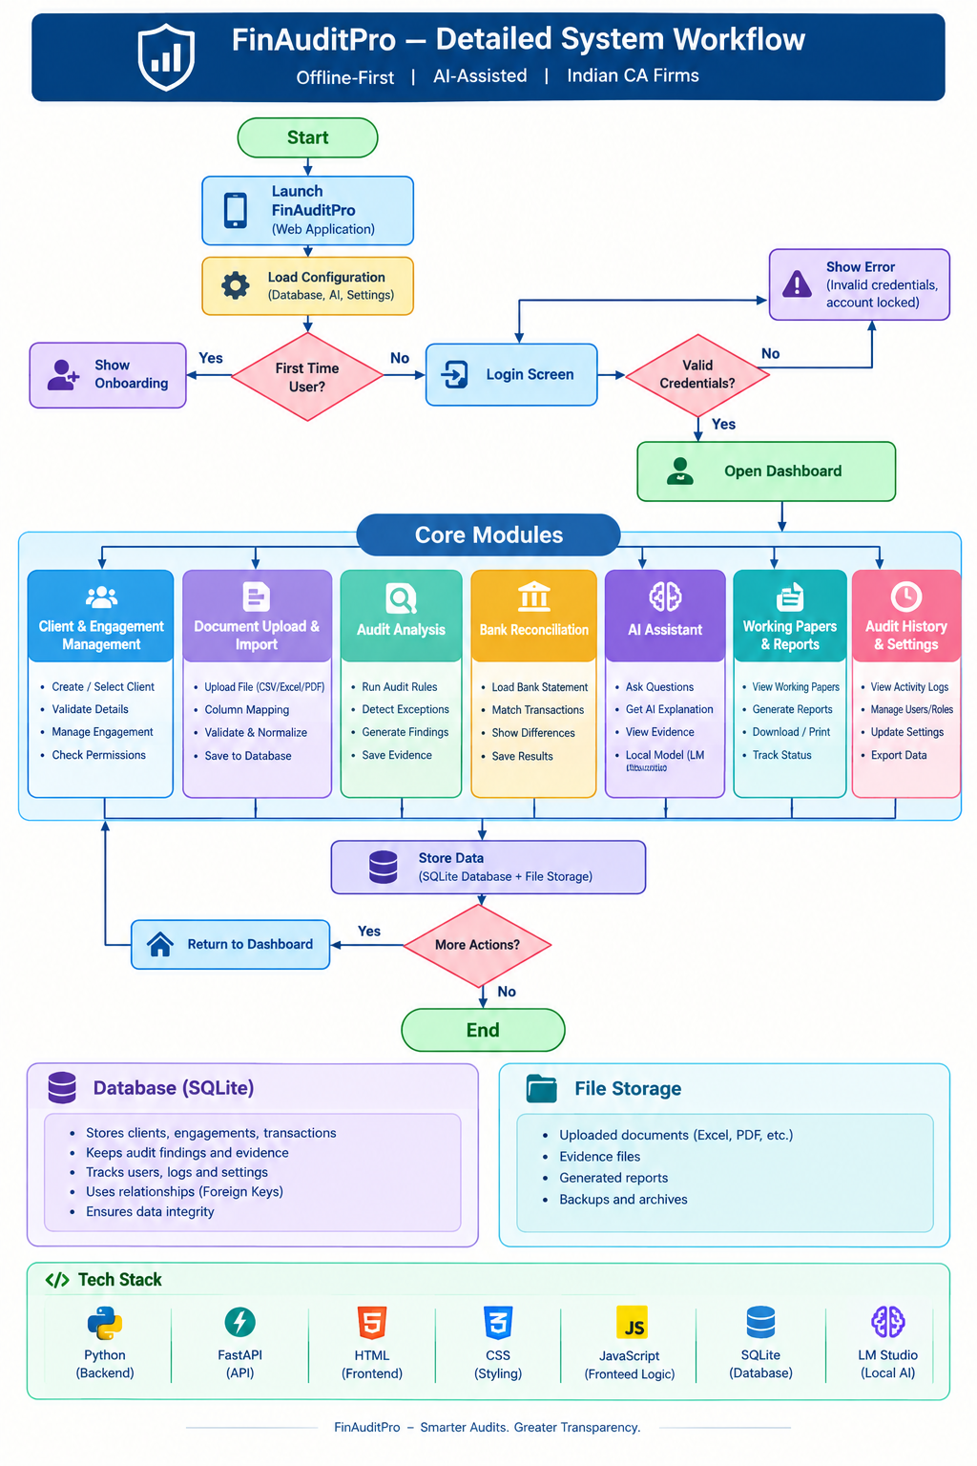

Figure 9. Flow Chart

    - DFD Level 0:
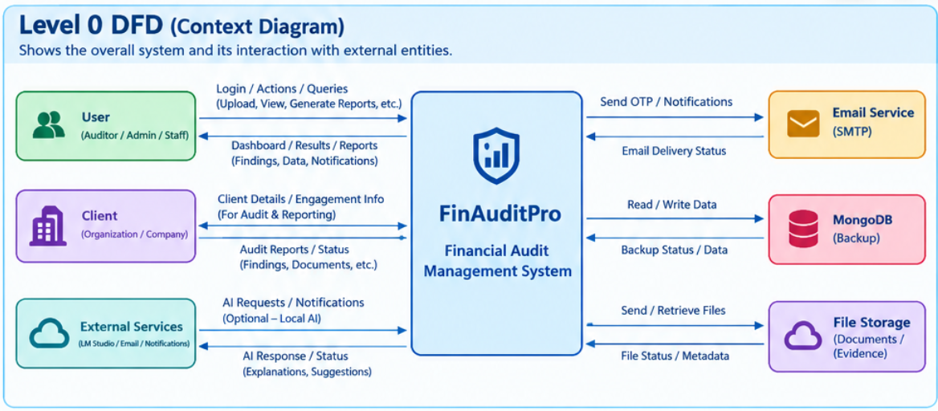

Figure 10. Level 0

    - DFD Level 1:
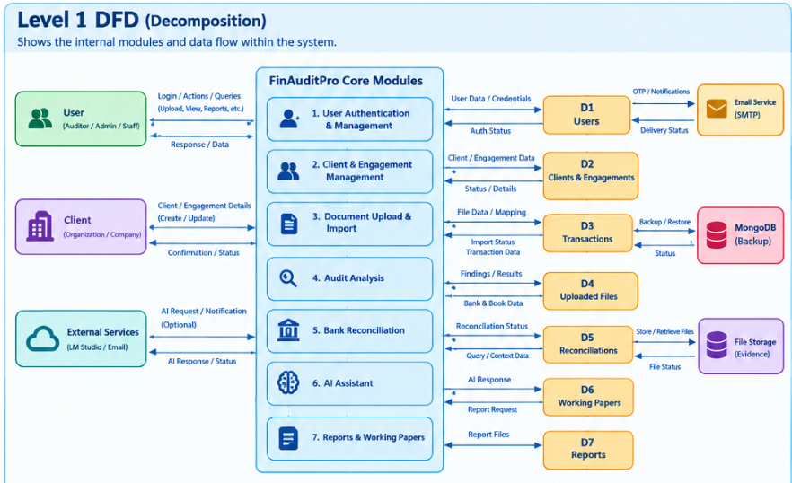

Figure 10. Level 1

    - Use Case Diagram
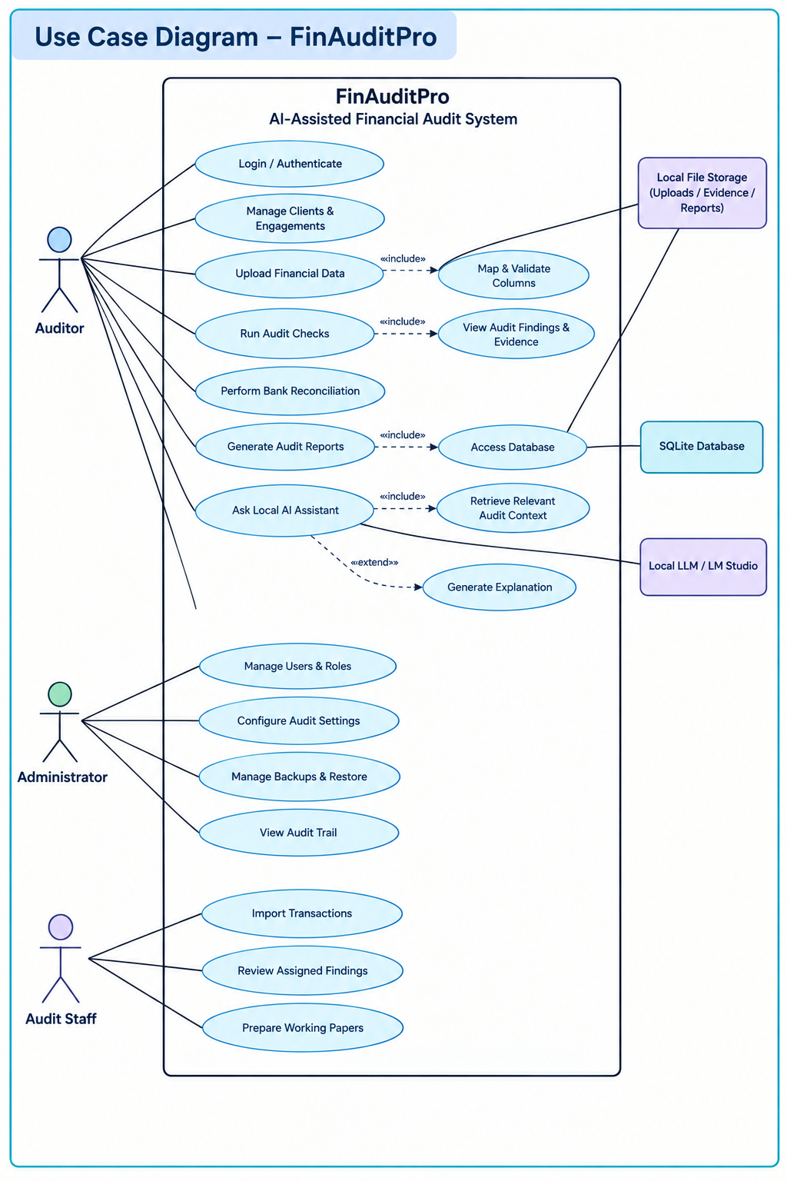
Figure 11. Use Case Diagram
    - UML Activity Diagram
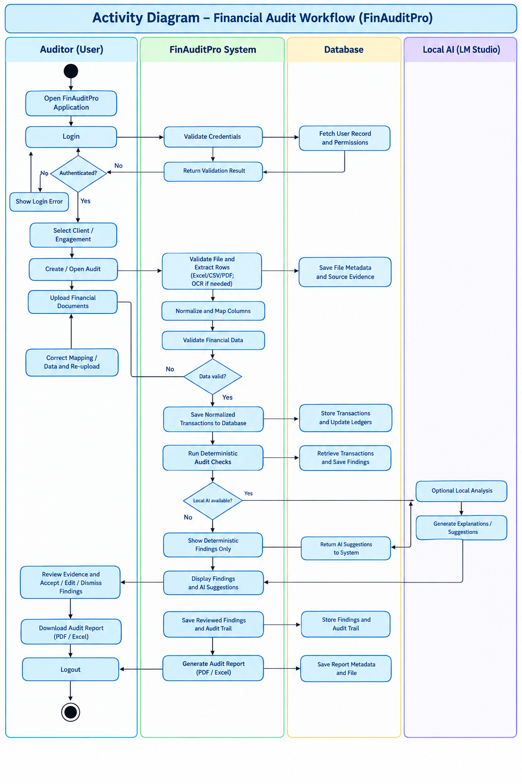
Figure 12. Activity Diagram

    - Component Diagram
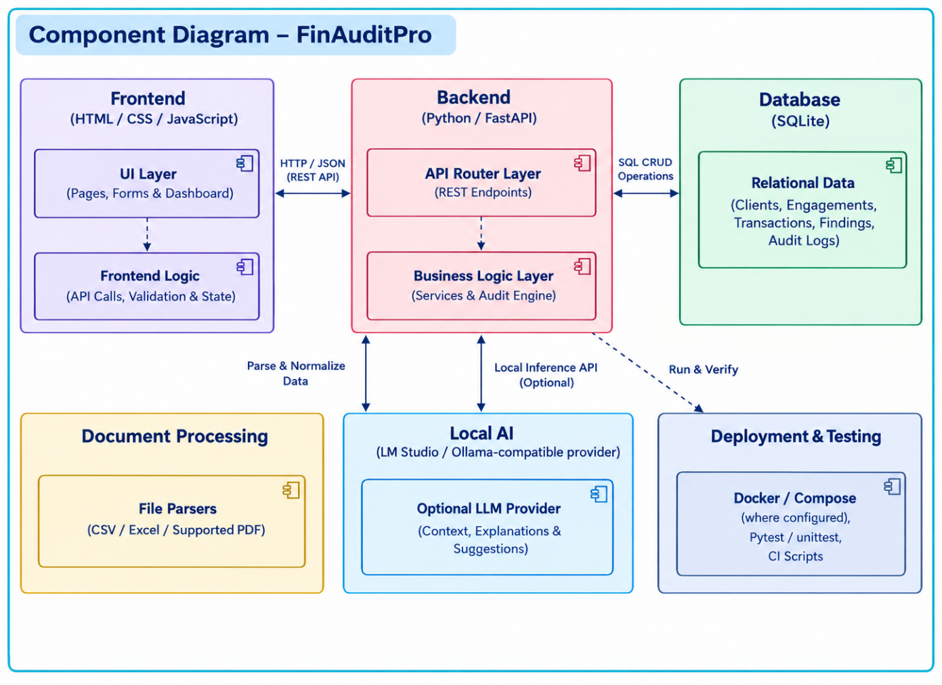
Figure 13. Component Diagram
    - Deployment Diagram

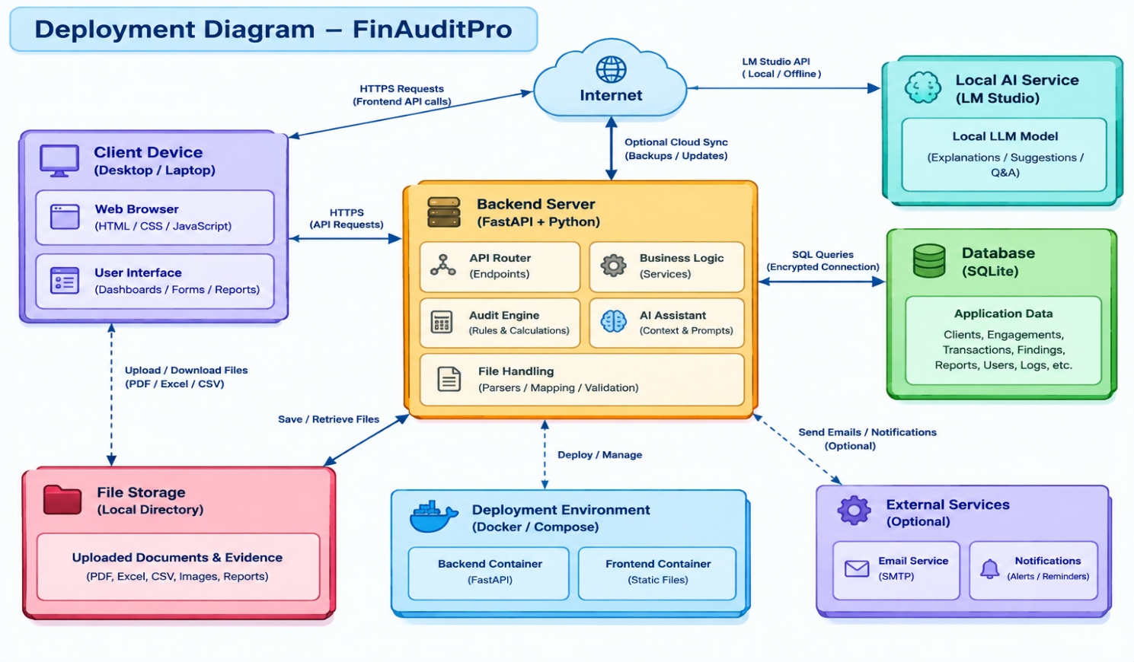

Figure 14. Deployment Diagram

Chapter 4

Literature Review
1. Study of Traditional Financial Auditing Practices
Traditional financial auditing involves manual ledger verification, spreadsheet analysis, voucher checking, bank reconciliation, and preparation of audit reports. These activities can be time-consuming when financial records are stored in different formats. Manual processing may also introduce inconsistencies and delays. FinAuditPro aims to simplify these workflows by providing a centralized platform for financial data management, automated checks, and audit findings.
2. Financial Data Processing and Database Management
Financial data is commonly maintained in CSV, Excel, and supported PDF formats. Different column names, date formats, and numerical representations create challenges during data processing. FinAuditPro uses Python-based parsing and normalization utilities to standardize supported financial records before analysis. SQLite provides structured storage for clients, engagements, transactions, uploaded files, and audit findings. This arrangement supports data retrieval and traceability between financial records and their associated audit activities.
3. Rule-Based Audit Automation
Rule-based auditing applies predefined conditions and calculations to identify potential financial discrepancies and compliance-related exceptions. FinAuditPro incorporates an audit-engine architecture designed to analyze transactions, identify unusual entries, and generate findings for review. Deterministic rules improve repeatability because the same inputs and rule configuration should produce consistent results. However, findings require verification against supporting documents, applicable regulations, and relevant exceptions before an auditor reaches a final conclusion.
4. Artificial Intelligence in Financial Auditing
Artificial intelligence can assist auditors by summarizing financial information, explaining potential discrepancies, and generating preliminary suggestions. FinAuditPro supports optional local AI integration through a compatible inference provider, such as LM Studio. The deterministic audit engine handles rule-based checks, while the AI component assists with explanations and natural-language interaction. Since language models can produce inaccurate or unsupported responses, AI-generated suggestions must be reviewed by the auditor and verified against the underlying financial evidence.
5. Security, Reconciliation, and Reporting
Financial auditing systems require appropriate authentication, role-based access control, reliable reconciliation, and structured reporting. FinAuditPro incorporates backend access controls and audit-related logging to support controlled access and activity traceability. Its reconciliation and reporting workflows are intended to help identify differences, organize findings, and prepare audit documentation. The reliability of these functions depends on correct implementation, data quality, appropriate security measures, and comprehensive testing.
6. Research Gap and Conclusion
Existing spreadsheet-based methods often require substantial manual effort, while general-purpose AI tools cannot independently guarantee accurate financial calculations or regulatory compliance. FinAuditPro aims to bring financial data processing, rule-based auditing, reconciliation, reporting, and optional local AI assistance into one application. Its objective is to improve workflow organization, reduce repetitive tasks, and support evidence-based audit reviews. The system's effectiveness must be established through functional testing, validation of financial rules, and verification of generated findings.

Source Code
Run.py (Entry point & server Launcher)

import os
import sys
# Auto-detect and seamlessly switch to project virtual environment if available
in_venv = getattr(sys, "base_prefix", sys.prefix) != sys.prefix or "VIRTUAL_ENV" in os.environ
if not in_venv:
project_root = os.path.dirname(os.path.abspath(__file__))
venv_python_unix = os.path.join(project_root, "venv", "bin", "python")
venv_python_win = os.path.join(project_root, "venv", "Scripts", "python.exe")
target_python = None
if os.path.exists(venv_python_unix):
target_python = venv_python_unix
elif os.path.exists(venv_python_win):
target_python = venv_python_win

if target_python and os.path.abspath(sys.executable) != os.path.abspath(target_python):
os.execv(target_python, [target_python] + sys.argv)

try:
import uvicorn
except ImportError:
print("\n" + "=" * 70)
print("❌ ERROR: Missing required dependencies (e.g. uvicorn, fastapi).")
print("Please activate your virtual environment or install dependencies:")
print(" source venv/bin/activate # macOS / Linux")
print(" .\\venv\\Scripts\\activate # Windows")
print(" pip install -r requirements.txt")
print("=" * 70 + "\n")
sys.exit(1)

import webbrowser
import threading
import time

def open_browser():
time.sleep(1.5)
webbrowser.open("http://127.0.0.1:8000")

if __name__ == "__main__":
print("==================================================================")
print(" FinAuditPro - AI-Assisted Auditing Software (Offline Edition) ")
print(" Standalone Desktop Server starting on http://127.0.0.1:8000 ")
print("==================================================================")
# Initialize database schema
from backend.app.database import init_db
init_db()
# Launch browser in separate thread
threading.Thread(target=open_browser, daemon=True).start()
# Run FastAPI server
uvicorn.run("backend.app.main:app", host="127.0.0.1", port=8000, reload=False)

Main.py (Backend Application Controller)

import os
from contextlib import asynccontextmanager
from fastapi import FastAPI
from fastapi.middleware.cors import CORSMiddleware
from fastapi.staticfiles import StaticFiles
from fastapi.responses import FileResponse

from backend.app.database import init_db
from backend.app.routers import (
auth, clients, engagements, import_data, data_cleaning, transactions,
trial_balance, financial_statements, yoy_comparison, reconciliation, gst_reconciliation,
duplicates_and_gaps, anomalies, audit_findings, assistant, checklist, working_papers,
reports, audit_trail, settings, ai_manager, evidence, jobs, system
)
@asynccontextmanager
async def lifespan(app: FastAPI):
# Initializes database tables, indexes, and immutable triggers
init_db()
yield

app = FastAPI(
title="FinAuditPro",
description="Standalone Offline-First AI-Assisted Auditing Application for Indian Chartered Accountants",
version="1.0.0",
lifespan=lifespan
)

# Enable CORS for local client connections with explicit safe origins
ALLOWED_ORIGINS = [
"http://localhost:8000",
"http://127.0.0.1:8000",
"http://localhost:3000",
"http://127.0.0.1:3000",
"http://localhost:5173",
"http://127.0.0.1:5173"
]
app.add_middleware(
CORSMiddleware,
allow_origins=ALLOWED_ORIGINS,
allow_credentials=True,
allow_methods=["GET", "POST", "PUT", "DELETE", "OPTIONS", "PATCH"],
allow_headers=["Authorization", "Content-Type", "Accept", "Origin", "X-Requested-With"],
)
# Include all API Routers
app.include_router(auth.router)
app.include_router(clients.router)
app.include_router(engagements.router)
app.include_router(import_data.router)
app.include_router(data_cleaning.router)
app.include_router(transactions.router)
app.include_router(trial_balance.router)
app.include_router(financial_statements.router)
app.include_router(yoy_comparison.router)
app.include_router(reconciliation.router)
app.include_router(gst_reconciliation.router)
app.include_router(duplicates_and_gaps.router)
app.include_router(anomalies.router)
app.include_router(audit_findings.router)
app.include_router(assistant.router)
app.include_router(checklist.router)
app.include_router(working_papers.router)
app.include_router(reports.router)
app.include_router(audit_trail.router)
app.include_router(settings.router)
app.include_router(ai_manager.router)
app.include_router(evidence.router)
app.include_router(jobs.router)
app.include_router(system.router)

FRONTEND_DIR = os.path.join(os.path.dirname(os.path.dirname(os.path.dirname(__file__))), "frontend")
if os.path.exists(FRONTEND_DIR):
app.mount("/static", StaticFiles(directory=FRONTEND_DIR), name="static")
@app.get("/")
def serve_index():
index_path = os.path.join(FRONTEND_DIR, "index.html")
if os.path.exists(index_path):
return FileResponse(index_path)
return {"message": "FinAuditPro Backend API is running locally.", "docs": "/docs"}

@app.get("/api/health")
def health_check():
return {
"status": "healthy"
}

deterministic.py

import re
from datetime import datetime
from typing import List, Dict, Any, Tuple

GSTIN_REGEX = r"^[0-9]{2}[A-Z]{5}[0-9]{4}[A-Z]{1}[1-9A-Z]{1}Z[0-9A-Z]{1}$"
PAN_REGEX = r"^[A-Z]{5}[0-9]{4}[A-Z]{1}$"

class DeterministicAuditEngine:
def __init__(self, transactions: List[Dict[str, Any]], financial_year: str = "2024-25"):
self.transactions = transactions
self.financial_year = financial_year
self.findings = []

def run_all_checks(self) -> List[Dict[str, Any]]:
self.findings = []
self.check_debit_credit_balance()
self.check_duplicates()
self.check_section_40a3_cash_payments()
self.check_section_269st_cash_receipts()
self.check_gstin_validity()
self.check_date_inconsistencies()
self.check_round_number_spikes()
self.check_missing_essential_metadata()
self.check_negative_balances()
self.check_high_value_unusual_narrations()
return self.findings

def check_debit_credit_balance(self):
"""Rule: Trial Balance and Transaction Debit must equal Credit."""
total_debit = sum(float(t.get('debit') or 0.0) for t in self.transactions)
total_credit = sum(float(t.get('credit') or 0.0) for t in self.transactions)
diff = round(abs(total_debit - total_credit), 2)

if diff > 0.01:
self.findings.append({
"finding_code": "DET-001",
"category": "Accounting Standard",
"severity": "CRITICAL",
"risk_score": 9.5,
"title": "Trial Balance Mismatch: Total Debits != Total Credits",
"description": f"The aggregate debits (₹{total_debit:,.2f}) and aggregate credits (₹{total_credit:,.2f}) do not balance, resulting in an unreconciled difference of ₹{diff:,.2f}.",
"affected_records": [t.get('id') for t in self.transactions[:10]],
"expected_value": f"Debits equal to Credits (Diff: ₹0.00)",
"actual_value": f"Debits: ₹{total_debit:,.2f}, Credits: ₹{total_credit:,.2f}",
"difference": f"₹{diff:,.2f}",
"reason": "Double-entry accounting equation violation. Unposted journal entries, missing one-sided entries, or manual ledger tampering.",
"evidence": {
"total_debit": total_debit,
"total_credit": total_credit,
"difference": diff,
"sample_records_count": len(self.transactions)
},
"rule_used": "Ind AS 1 / AS 1: Principle of Double-Entry Bookkeeping & Trial Balance Equality",
"engine_type": "DETERMINISTIC",
"ai_explanation": "In double-entry bookkeeping, every debit must have a corresponding credit. An imbalance of ₹" + f"{diff:,.2f}" + " indicates an incomplete ledger export, improper suspense account adjustment, or one-sided system corruption.",
"recommended_action": "Verify suspense accounts, extract full trial balance with opening adjustments, and re-check manual Journal Vouchers."
})

def check_duplicates(self):
"""Rule: Exact and near-duplicate transactions."""
seen_exact = {}
for t in self.transactions:
t_id = t.get('id')
amt = float(t.get('amount') or t.get('debit') or t.get('credit') or 0.0)
date = str(t.get('date') or '').strip()
party = str(t.get('party_name') or t.get('ledger') or '').strip().lower()
inv = str(t.get('invoice_no') or t.get('voucher_no') or '').strip().lower()

if amt > 0 and date and party:
key = (date, amt, party, inv)
if key in seen_exact:
prev_t = seen_exact[key]
self.findings.append({
"finding_code": "DET-DUP-01",
"category": "Exception",
"severity": "HIGH",
"risk_score": 8.0,
"title": f"Potential Duplicate Entry: ₹{amt:,.2f} for {party.title()}",
"description": f"Two or more transactions share identical Date ({date}), Party ({party.title()}), Amount (₹{amt:,.2f}), and Reference ({inv}).",
"affected_records": [prev_t.get('id'), t_id],
"expected_value": "Unique transaction per distinct economic event",
"actual_value": f"Duplicate entries found on {date}",
"difference": f"Duplicate amount: ₹{amt:,.2f}",
"reason": "Double booking of supplier invoice, repeated bank charge posting, or batch processing error.",
"evidence": {
"original_transaction_id": prev_t.get('id'),
"duplicate_transaction_id": t_id,
"voucher_original": prev_t.get('voucher_no'),
"voucher_duplicate": t.get('voucher_no'),
"amount": amt
},
"rule_used": "Deterministic Duplicate Key Hash Check (Date + Amount + Party + Invoice)",
"engine_type": "DETERMINISTIC",
"ai_explanation": "Identical entries recorded under the same voucher/invoice number create inflated expense or liability balances, leading to double payments or incorrect input tax credit claims.",
"recommended_action": "Inspect the original supporting invoice and bank statement to confirm whether this represents two genuine purchases or an unintentional double posting."
})
else:
seen_exact[key] = t

def check_section_40a3_cash_payments(self):
"""
Rule: Income Tax Act Section 40A(3) - Cash payments exceeding ₹10,000 per person per day.
Accounting Semantics:
- When the pure cash asset ledger ('Cash in hand', 'Petty Cash', 'Cash Account') is debited,
it represents cash being received (Receipt).
- When an expense or vendor ledger is debited (or transaction is a Payment), it represents an expenditure/payment.
"""
cash_keywords = ['cash', 'petty cash', 'cash in hand', 'bearer cheque']
cash_by_party_day = {}

for t in self.transactions:
ledger = str(t.get('ledger') or '').strip().lower()
desc = str(t.get('description') or '').strip().lower()
tx_type = str(t.get('transaction_type') or '').strip().lower()
voucher_type = str(t.get('voucher_type') or '').strip().lower()

is_pure_cash_asset = ledger in ['cash', 'petty cash', 'cash in hand', 'cash account'] or ledger.startswith('cash in hand') or ledger.startswith('petty cash')
is_cash_tx = is_pure_cash_asset or any(k in desc or k in tx_type or k in voucher_type or k in ledger for k in cash_keywords)

debit = float(t.get('debit') or 0.0)
credit = float(t.get('credit') or 0.0)
raw_amt = float(t.get('amount') or 0.0)

# Determine if this transaction is a payment / expenditure:
# Case 1: Pure cash asset ledger credited -> cash outflow / payment
# Case 2: Non-cash expense/vendor ledger debited with cash keyword in ledger/desc/type
is_payment = False
amount = 0.0

if is_pure_cash_asset:
if credit > 0:
is_payment = True
amount = credit
elif 'payment' in tx_type or 'payment' in voucher_type or 'paid' in desc or 'expense' in desc or 'purchase' in desc:
is_payment = True
amount = raw_amt if raw_amt > 0 else (debit if debit > 0 else 0.0)
else:
# Ledger is expense, vendor, or nominal account (e.g. 'Freight (Cash)', 'Office Rent')
if debit > 0 and ('receipt' not in tx_type and 'receipt' not in voucher_type and 'received' not in desc):
is_payment = True
amount = debit
elif 'payment' in tx_type or 'payment' in voucher_type or 'paid' in desc or 'expense' in desc:
is_payment = True
amount = debit if debit > 0 else raw_amt

# Pure receipts must never be classified as 40A(3) payments
if 'receipt' in tx_type or 'receipt' in voucher_type or 'received' in desc:
is_payment = False

if is_cash_tx and is_payment and amount > 0:
date = str(t.get('date') or '').split('T')[0]
party = str(t.get('party_name') or '').strip()
if not party or party.lower() in ['cash', 'cash account', 'cash in hand', 'petty cash']:
party = str(t.get('ledger') or 'Unknown Party').strip()
party = re.sub(r'\s*\(\s*cash\s*\)', '', party, flags=re.IGNORECASE).strip()

key = (date, party)
if key not in cash_by_party_day:
cash_by_party_day[key] = {"total": 0.0, "records": [], "vouchers": []}
cash_by_party_day[key]["total"] += amount
cash_by_party_day[key]["records"].append(t.get('id'))
cash_by_party_day[key]["vouchers"].append(t.get('voucher_no'))

for (date, party), data in cash_by_party_day.items():
if data["total"] > 10000.0 and party.lower() not in ['cash', 'petty cash', 'bank', 'cash account', 'cash in hand']:
self.findings.append({
"finding_code": "DET-TAX-40A3",
"category": "Statutory Compliance",
"severity": "CRITICAL" if data["total"] > 50000 else "HIGH",
"risk_score": 8.8,
"title": f"Section 40A(3) Breach: Aggregate Cash Payment of ₹{data['total']:,.2f} to {party}",
"description": f"Aggregate cash payments to '{party}' on {date} totaled ₹{data['total']:,.2f}, exceeding the statutory limit of ₹10,000 prescribed under Section 40A(3) of the Income Tax Act, 1961.",
"affected_records": data["records"],
"expected_value": "Payment via Account Payee Cheque / DD / ECS / prescribed electronic mode <= ₹10,000",
"actual_value": f"Total Cash Paid: ₹{data['total']:,.2f}",
"difference": f"Excess over limit: ₹{data['total'] - 10000:,.2f}",
"reason": "Direct cash disallowance under Section 40A(3) will result in 100% add-back of this expenditure to taxable business income in Form 3CD (Clause 21(d)).",
"evidence": {
"date": date,
"party": party,
"vouchers": data["vouchers"],
"total_cash": data["total"],
"records_count": len(data["records"])
},
"rule_used": "Income Tax Act, 1961 - Section 40A(3) read with Rule 6DD",
"engine_type": "DETERMINISTIC",
"ai_explanation": "Under Section 40A(3), where an assessee incurs any expenditure in respect of which a payment or aggregate of payments made to a person in a day exceeds ₹10,000 otherwise than by an account payee cheque or electronic clearing system, no deduction shall be allowed. This must be reported under Clause 21(d) of Tax Audit Report Form 3CD.",
"recommended_action": "Check whether the payment falls under any exemption listed under Rule 6DD (e.g. payments to cultivators, cottage industry, banking holidays). If not exempt, classify for 3CD tax audit disallowance."
})

def check_section_269st_cash_receipts(self):
"""
Rule: Income Tax Act Section 269ST - Cash receipts of ₹2,00,000 or more:
(a) In aggregate from a person in a day; or
(b) In respect of a single transaction; or
(c) In respect of transactions relating to one event or occasion from a person.
Penalty under Section 271DA equals 100% of sum received.
"""
# -------------------------------------------------------------------------
# Section 269ST Aggregation Categories:
# (a) in aggregate from a person in a day;
# (b) in respect of a single transaction (e.g. against the same invoice/voucher reference);
# (c) in respect of transactions relating to one event or occasion from a person (e.g. project, contract, event).
# -------------------------------------------------------------------------
receipts_by_person_day: Dict[Tuple[str, str], Dict[str, Any]] = {}
receipts_by_ref_trans: Dict[Tuple[str, str], Dict[str, Any]] = {}
cash_keywords = ['cash', 'petty cash', 'cash in hand']

for t in self.transactions:
credit = float(t.get('credit') or 0.0)
debit = float(t.get('debit') or 0.0)
raw_amt = float(t.get('amount') or 0.0)
ledger = str(t.get('ledger') or '').strip().lower()
desc = str(t.get('description') or '').strip().lower()
tx_type = str(t.get('transaction_type') or '').strip().lower()
voucher_type = str(t.get('voucher_type') or '').strip().lower()

is_pure_cash_asset = ledger in ['cash', 'petty cash', 'cash in hand', 'cash account'] or ledger.startswith('cash in hand') or ledger.startswith('petty cash')
is_cash_tx = is_pure_cash_asset or any(k in desc or k in tx_type or k in voucher_type or k in ledger for k in cash_keywords)

# Determine whether this is a cash receipt:
is_receipt = False
amount = 0.0

if is_pure_cash_asset:
if debit > 0:
is_receipt = True
amount = debit
elif 'receipt' in tx_type or 'receipt' in voucher_type or 'received' in desc:
is_receipt = True
amount = raw_amt if raw_amt > 0 else (credit if credit > 0 else 0.0)
else:
if credit > 0 and ('payment' not in tx_type and 'payment' not in voucher_type and 'expense' not in desc and 'purchase' not in desc):
is_receipt = True
amount = credit
elif 'receipt' in tx_type or 'receipt' in voucher_type or 'received' in desc:
is_receipt = True
amount = credit if credit > 0 else raw_amt

# Pure payments must never be classified as receipts
if 'payment' in tx_type or 'payment' in voucher_type or 'paid' in desc:
is_receipt = False

if not is_cash_tx or not is_receipt or amount <= 0:
continue

date = str(t.get('date') or '').split('T')[0]
party = str(t.get('party_name') or '').strip()
if not party or party.lower() in ['cash', 'cash account', 'cash in hand', 'petty cash']:
party = str(t.get('ledger') or 'Unknown Counterparty').strip()
party = re.sub(r'\s*\(\s*cash\s*\)', '', party, flags=re.IGNORECASE).strip()

vch = str(t.get('voucher_no') or t.get('id') or '—')
rec_id = t.get('id')

# Reference identification for single transaction / event across dates
inv_ref = str(t.get('invoice_no') or t.get('reference_no') or '').strip()
if not inv_ref:
# Check description for invoice / contract / bill / receipt / order / event reference pattern
match_ref = re.search(r'\b(?:INV|BILL|CONTR|EVENT|ORD|REF|ADV|REC|BOOKING)[-:\s#]*([A-Za-z0-9_-]+)\b', desc, re.IGNORECASE)
if match_ref:
inv_ref = match_ref.group(0).upper().replace(" ", "")
elif any(k in desc.lower() for k in ['booking', 'flat', 'plot', 'wedding', 'event', 'catering', 'annual function', 'conference', 'advance']):
# Event/occasion or ongoing transaction cluster detected in narration
for keyword in ['wedding', 'catering', 'conference', 'annual function', 'flat', 'plot', 'booking', 'advance']:
if keyword in desc.lower():
inv_ref = f"EVENT-{keyword.upper().replace(' ', '_')}"
break

# 1. Aggregate by person and day (Section 269ST(a))
day_key = (party, date)
if day_key not in receipts_by_person_day:
receipts_by_person_day[day_key] = {
"party": party,
"date": date,
"total_amount": 0.0,
"records": [],
"vouchers": []
}
receipts_by_person_day[day_key]["total_amount"] += amount
receipts_by_person_day[day_key]["records"].append(rec_id)
receipts_by_person_day[day_key]["vouchers"].append(vch)

# 2. Aggregate by person and transaction/event across different dates (Section 269ST(b) & (c))
if inv_ref:
ref_key = (party, inv_ref)
if ref_key not in receipts_by_ref_trans:
receipts_by_ref_trans[ref_key] = {
"party": party,
"ref": inv_ref,
"dates": set(),
"total_amount": 0.0,
"records": [],
"vouchers": []
}
receipts_by_ref_trans[ref_key]["total_amount"] += amount
receipts_by_ref_trans[ref_key]["records"].append(rec_id)
receipts_by_ref_trans[ref_key]["vouchers"].append(vch)
receipts_by_ref_trans[ref_key]["dates"].add(date)

emitted_record_sets: List[set] = []

# Evaluate condition (a): Person and Day
for (party, date), data in receipts_by_person_day.items():
tot = data["total_amount"]
if tot >= 200000.0 and party.lower() not in ['cash', 'cash account', 'cash in hand', 'bank']:
vch_list = data["vouchers"]
rec_list = data["records"]
rec_set = set(rec_list)
emitted_record_sets.append(rec_set)
is_split = len(rec_list) > 1
split_note = f" (aggregated across {len(rec_list)} split receipts on {date})" if is_split else ""

self.findings.append({
"finding_code": "DET-TAX-269ST",
"category": "Statutory Compliance",
"severity": "CRITICAL",
"risk_score": 9.5 if is_split else 9.2,
"title": f"Section 269ST Breach: Aggregate Cash Receipt of ₹{tot:,.2f} from {party}{split_note}",
"description": f"Aggregate cash receipts from '{party}' on {date} totaled ₹{tot:,.2f}{split_note}, violating Section 269ST(a) of the Income Tax Act, 1961 (threshold ₹2,00,000 per person per day).",
"affected_records": rec_list,
"expected_value": "Receipts >= ₹2,00,000 through banking channels / account payee modes",
"actual_value": f"Total Cash Received: ₹{tot:,.2f}",
"difference": f"₹{tot:,.2f}",
"reason": "Section 271DA levies an unavoidable penalty equal to 100% of the amount received in contravention of Section 269ST.",
"evidence": {
"date": date,
"party": party,
"vouchers": vch_list,
"amount": tot,
"split_receipts_count": len(rec_list),
"is_aggregated": is_split
},
"rule_used": "Income Tax Act, 1961 - Section 269ST & Penalty Section 271DA",
"engine_type": "DETERMINISTIC",
"ai_explanation": "Section 269ST prohibits receiving ₹2,00,000 or more in cash in aggregate from a person in a day, in respect of a single transaction, or relating to one event. A penalty equal to 100% of the sum received is leviable under Section 271DA.",
"recommended_action": "Seek immediate management explanation, inspect bank deposit slips, and document in working papers for reporting under Clause 31 of Tax Audit Report 3CD."
})
# Evaluate condition (b) & (c): Single Transaction or Event/Occasion across different dates
for (party, ref), data in receipts_by_ref_trans.items():
tot = data["total_amount"]
rec_list = data["records"]
rec_set = set(rec_list)

# Avoid duplicate reporting if already completely covered by a single-day breach
if any(rec_set.issubset(s) for s in emitted_record_sets):
continue

if tot >= 200000.0 and party.lower() not in ['cash', 'cash account', 'cash in hand', 'bank']:
emitted_record_sets.append(rec_set)
dates_str = ", ".join(sorted(data["dates"]))
vch_list = data["vouchers"]

self.findings.append({
"finding_code": "DET-TAX-269ST",
"category": "Statutory Compliance",
"severity": "CRITICAL",
"risk_score": 9.6,
"title": f"Section 269ST Breach: Aggregate Cash Receipt of ₹{tot:,.2f} for Transaction/Event '{ref}' across dates",
"description": f"Aggregate cash receipts from '{party}' relating to single transaction/event reference '{ref}' across dates ({dates_str}) totaled ₹{tot:,.2f}, violating Section 269ST(b)/(c) of the Income Tax Act, 1961 (threshold ₹2,00,000).",
"affected_records": rec_list,
"expected_value": "Receipts >= ₹2,00,000 through banking channels / account payee modes",
"actual_value": f"Total Cash Received: ₹{tot:,.2f}",
"difference": f"₹{tot:,.2f}",
"reason": "Section 271DA levies an unavoidable penalty equal to 100% of the amount received in contravention of Section 269ST (applies to receipts relating to a single transaction or event across multiple dates).",
"evidence": {
"party": party,
"reference": ref,
"dates": list(data["dates"]),
"vouchers": vch_list,
"amount": tot,
"split_receipts_count": len(rec_list),
"is_aggregated_across_dates": True
},
"rule_used": "Income Tax Act, 1961 - Section 269ST(b)/(c) & Penalty Section 271DA",
"engine_type": "DETERMINISTIC",
"ai_explanation": "Section 269ST(b) and (c) prohibit receiving ₹2,00,000 or more in cash in respect of a single transaction or relating to one event/occasion from a person, even if split across different dates. A penalty equal to 100% of the sum received is leviable under Section 271DA.",
"recommended_action": "Seek immediate management explanation, inspect related contract/invoice, and report under Clause 31 of Tax Audit Form 3CD."
})

def check_gstin_validity(self):
"""Rule: Validate 15-character GSTIN format on B2B invoices and taxable transactions."""
for t in self.transactions:
gstin = str(t.get('gstin') or '').strip()
amount = float(t.get('amount') or t.get('debit') or t.get('credit') or 0.0)

if gstin:
if not re.match(GSTIN_REGEX, gstin):
self.findings.append({
"finding_code": "DET-GST-001",
"category": "Statutory Compliance",
"severity": "HIGH",
"risk_score": 7.5,
"title": f"Invalid GSTIN Format: '{gstin}' on Transaction ₹{amount:,.2f}",
"description": f"The GSTIN '{gstin}' recorded for party '{t.get('party_name')}' does not comply with the standard 15-digit GST structure (2 State + 10 PAN + 1 Entity + 1 Z + 1 Check Digit).",
"affected_records": [t.get('id')],
"expected_value": "Valid 15-character alphanumeric GSTIN format",
"actual_value": gstin,
"difference": "Format Syntax Error",
"reason": "Invalid GSTIN will cause ITC disallowance during GSTR-2B/3B matching and portal validation failures.",
"evidence": {
"voucher": t.get('voucher_no'),
"party_name": t.get('party_name'),
"gstin_entered": gstin,
"amount": amount
},
"rule_used": "CGST Act 2017 - Section 22/25 & GSTIN Structuring Specification",
"engine_type": "DETERMINISTIC",
"ai_explanation": "Every valid Indian GSTIN consists of 15 alphanumeric characters. An invalid GSTIN implies either a clerical data entry error or an unregistered entity masquerading as a registered supplier, risking loss of Input Tax Credit.",
"recommended_action": "Obtain copy of supplier's GST Registration Certificate or verify active status on the GST Portal search tool."
})

def check_date_inconsistencies(self):
"""Rule: Payment date before invoice date or future dates."""
for t in self.transactions:
inv_date_str = t.get('invoice_date')
pay_date_str = t.get('payment_date') or t.get('date')

if inv_date_str and pay_date_str:
try:
inv_d = datetime.strptime(str(inv_date_str).split('T')[0], "%Y-%m-%d")
pay_d = datetime.strptime(str(pay_date_str).split('T')[0], "%Y-%m-%d")
if pay_d < inv_d:
self.findings.append({
"finding_code": "DET-DATE-001",
"category": "Exception",
"severity": "MEDIUM",
"risk_score": 6.5,
"title": f"Date Anomaly: Payment Date ({pay_date_str}) precedes Invoice Date ({inv_date_str})",
"description": f"Payment recorded on {pay_date_str} is chronologically earlier than the invoice creation date {inv_date_str} for party '{t.get('party_name')}'.",
"affected_records": [t.get('id')],
"expected_value": "Payment Date >= Invoice Date (or recorded as Advance)",
"actual_value": f"Invoice: {inv_date_str}, Payment: {pay_date_str}",
"difference": f"{(inv_d - pay_d).days} days prior",
"reason": "Incorrect backdating of payment voucher or lack of advance payment classification.",
"evidence": {
"voucher": t.get('voucher_no'),
"invoice_no": t.get('invoice_no'),
"invoice_date": inv_date_str,
"payment_date": pay_date_str
},
"rule_used": "Chronological Integrity & Accrual Principle Verification",
"engine_type": "DETERMINISTIC",
"ai_explanation": "A payment cannot extinguish an invoice liability before the invoice exists unless it is categorized as an 'Advance to Supplier' with appropriate GST reverse charge / tax deduction treatment.",
"recommended_action": "Verify if this was an advance payment or a typo in the voucher date."
})
except Exception:
pass

def check_round_number_spikes(self):
"""Rule: High-value round numbers (e.g. exactly ₹5,00,000, ₹10,00,000) on discretionary expense ledgers."""
suspicious_groups = ['consultancy', 'legal', 'advertisement', 'miscellaneous', 'repairs', 'commission', 'donations']
for t in self.transactions:
ledger = str(t.get('ledger') or '').lower()
amt = float(t.get('amount') or t.get('debit') or 0.0)

if any(k in ledger for k in suspicious_groups) and amt >= 100000.0:
if amt % 50000 == 0: # Exactly divisible by 50,000
self.findings.append({
"finding_code": "DET-ROUND-001",
"category": "Outlier / ML",
"severity": "MEDIUM",
"risk_score": 6.0,
"title": f"Unusual Round-Sum Expense: ₹{amt:,.2f} in '{t.get('ledger')}'",
"description": f"A perfectly round amount of ₹{amt:,.2f} posted to discretionary account '{t.get('ledger')}'.",
"affected_records": [t.get('id')],
"expected_value": "Itemized commercial invoice with exact tax / TDS deductions",
"actual_value": f"Exact round figure: ₹{amt:,.2f}",
"difference": "Round sum estimate indicator",
"reason": "Round-sum transactions in professional or miscellaneous fees often represent lump-sum provisions, unverified estimates, or non-arms-length payments.",
"evidence": {
"voucher": t.get('voucher_no'),
"party": t.get('party_name'),
"amount": amt,
"narration": t.get('description')
},
"rule_used": "Round Number Heuristic & Discretionary Expense Filter",
"engine_type": "DETERMINISTIC",
"ai_explanation": "Professional services, consultancy, and repairs typically carry GST (18%) and TDS (10% or 2% u/s 194J/194C), resulting in non-round net settlement amounts. A round figure warrants inspection of the underlying contract and tax deduction.",
"recommended_action": "Review contract/agreement, verify TDS deduction under Section 194J/194C, and check proof of service delivery."
})

def check_missing_essential_metadata(self):
"""Rule: Missing voucher number or description on high value items."""
for t in self.transactions:
amt = float(t.get('amount') or t.get('debit') or t.get('credit') or 0.0)
voucher = str(t.get('voucher_no') or '').strip()
desc = str(t.get('description') or '').strip()

if amt > 50000.0 and (not voucher or not desc):
self.findings.append({
"finding_code": "DET-META-001",
"category": "Missing Data",
"severity": "LOW",
"risk_score": 4.5,
"title": f"Missing Voucher/Narration on High-Value Entry (₹{amt:,.2f})",
"description": f"Transaction of ₹{amt:,.2f} in ledger '{t.get('ledger')}' lacks {'a Voucher Number' if not voucher else 'an audit Narration/Description'}.",
"affected_records": [t.get('id')],
"expected_value": "Mandatory Voucher Number and explanatory Narration",
"actual_value": f"Voucher: '{voucher or 'MISSING'}', Narration: '{desc or 'MISSING'}'",
"difference": "Missing mandatory audit trail field",
"reason": "Lack of adequate documentation and audit trail compliance under Companies (Accounts) Rules.",
"evidence": {
"date": t.get('date'),
"ledger": t.get('ledger'),
"amount": amt
},
"rule_used": "Companies Act 2013 - Section 128 (Books of Account & Audit Trail)",
"engine_type": "DETERMINISTIC",
"ai_explanation": "The Ministry of Corporate Affairs mandates that accounting software maintain an edit log and complete audit trail. Journal entries without proper voucher numbering or explanatory narration impair audit verification.",
"recommended_action": "Require client accounting team to update supporting voucher references and narrations."
})

def check_negative_balances(self):
"""Rule: Check for negative closing balance in Cash or Asset ledgers."""
for t in self.transactions:
cb = t.get('closing_balance')
ledger = str(t.get('ledger') or '').lower()
if cb is not None:
cb_val = float(cb)
if cb_val < -0.01 and ('cash' in ledger or 'bank' in ledger):
self.findings.append({
"finding_code": "DET-BAL-001",
"category": "Accounting Standard",
"severity": "HIGH",
"risk_score": 7.8,
"title": f"Negative Balance Detected in '{t.get('ledger')}': ₹{cb_val:,.2f}",
"description": f"Cash/Bank account cannot mathematically carry a negative balance without an approved bank overdraft / CC facility.",
"affected_records": [t.get('id')],
"expected_value": "Cash Balance >= ₹0.00",
"actual_value": f"Closing Balance: ₹{cb_val:,.2f}",
"difference": f"Negative ₹{abs(cb_val):,.2f}",
"reason": "Unrecorded cash receipts, backdated disbursements, or delayed deposit entry.",
"evidence": {
"date": t.get('date'),
"ledger": t.get('ledger'),
"closing_balance": cb_val
},
"rule_used": "Fundamental Accounting Principle - Asset Ledger Non-Negativity",
"engine_type": "DETERMINISTIC",
"ai_explanation": "Physical cash in hand cannot be negative. If this is a bank account, it must be reclassified under 'Current Liabilities - Bank Overdraft' on the Balance Sheet.",
"recommended_action": "Reconcile daily cash register and verify whether bank overdraft limit has been configured in the balance sheet grouping."
})

def check_high_value_unusual_narrations(self):
"""Rule: Identify suspicious or vague keywords in high-value transactions."""
vague_terms = ['adjustment', 'rectification', 'transfer', 'dummy', 'temp', 'misc', 'suspense', 'clearing', 'unknown']
for t in self.transactions:
amt = float(t.get('amount') or t.get('debit') or t.get('credit') or 0.0)
desc = str(t.get('description') or '').lower()
if amt >= 100000.0:
for term in vague_terms:
if term in desc:
self.findings.append({
"finding_code": "DET-NARR-001",
"category": "Exception",
"severity": "MEDIUM",
"risk_score": 6.8,
"title": f"High-Value Transaction with Vague Narration: '{term.upper()}' (₹{amt:,.2f})",
"description": f"Journal entry of ₹{amt:,.2f} contains non-descriptive term '{term}' in narration.",
"affected_records": [t.get('id')],
"expected_value": "Specific economic rationale and reference to underlying transaction document",
"actual_value": f"Narration: {t.get('description')}",
"difference": "Vague Narration",
"reason": "Vague narrations on large transfers often mask unapproved year-end adjustments or window dressing.",
"evidence": {
"date": t.get('date'),
"voucher": t.get('voucher_no'),
"ledger": t.get('ledger'),
"narration": t.get('description'),
"amount": amt
},
"rule_used": "Auditing Standard SA 240 - Auditor's Responsibilities Relating to Fraud in an Audit of Financial Statements",
"engine_type": "DETERMINISTIC",
"ai_explanation": "SA 240 requires auditors to test journal entries made at the end of a reporting period and entries with unusual descriptions or vague adjustments for management override of controls.",
"recommended_action": "Inspect approval authority and underlying documentary justification for this manual entry."
})
break

Database.py

import sqlite3
import os
import json
from datetime import datetime

def get_db_path() -> str:
return os.environ.get("FINAUDIT_DB_PATH", os.path.join(os.path.dirname(os.path.dirname(__file__)), "finauditpro.db"))

DB_PATH = get_db_path()

def refresh_db_path() -> str:
global DB_PATH
DB_PATH = get_db_path()
return DB_PATH

def _ensure_db_dir():
path = get_db_path()
db_dir = os.path.dirname(os.path.abspath(path))
if db_dir:
os.makedirs(db_dir, exist_ok=True)

def get_db_connection():
_ensure_db_dir()
path = refresh_db_path()
conn = sqlite3.connect(path, timeout=30.0, isolation_level=None)
conn.row_factory = sqlite3.Row
conn.execute("PRAGMA foreign_keys = ON")
conn.execute("PRAGMA journal_mode = WAL")
conn.execute("PRAGMA busy_timeout = 30000")
return conn

def init_db():
_ensure_db_dir()
refresh_db_path()
conn = get_db_connection()
try:
from backend.migrations.runner import apply_migrations

apply_migrations(conn)

required_tables = [
"users",
"clients",
"engagements",
"uploaded_files",
"transactions",
"audit_logs",
"audit_findings",
"app_settings",
]
missing_tables = []
for table_name in required_tables:
row = conn.execute(
"SELECT name FROM sqlite_master WHERE type = 'table' AND name = ?",
(table_name,),
).fetchone()
if row is None:
missing_tables.append(table_name)
if missing_tables:
raise RuntimeError(
"Database initialization incomplete; missing required tables: " + ", ".join(missing_tables)
)
except Exception:
try:
conn.rollback()
except Exception:
pass
conn.close()
raise

cursor = conn.cursor()

# Users
cursor.execute("""
CREATE TABLE IF NOT EXISTS users (
id INTEGER PRIMARY KEY AUTOINCREMENT,
username TEXT UNIQUE NOT NULL,
email TEXT UNIQUE NOT NULL,
full_name TEXT NOT NULL,
role TEXT NOT NULL DEFAULT 'Auditor', -- Admin, Auditor, Audit Staff
password_hash TEXT NOT NULL,
is_active INTEGER DEFAULT 1,
phone TEXT,
last_login TEXT,
token_version INTEGER DEFAULT 1,
created_at TEXT NOT NULL
)
""")

# Check and migrate columns if necessary
cursor.execute("PRAGMA table_info(users)")
user_columns = [col[1] for col in cursor.fetchall()]
if "last_login" not in user_columns:
cursor.execute("ALTER TABLE users ADD COLUMN last_login TEXT")
if "phone" not in user_columns:
cursor.execute("ALTER TABLE users ADD COLUMN phone TEXT")
if "token_version" not in user_columns:
cursor.execute("ALTER TABLE users ADD COLUMN token_version INTEGER DEFAULT 1")
if "designation" not in user_columns:
cursor.execute("ALTER TABLE users ADD COLUMN designation TEXT")
if "status" not in user_columns:
cursor.execute("ALTER TABLE users ADD COLUMN status TEXT DEFAULT 'ACTIVE'")
if "activation_token" not in user_columns:
cursor.execute("ALTER TABLE users ADD COLUMN activation_token TEXT")
if "activation_expires_at" not in user_columns:
cursor.execute("ALTER TABLE users ADD COLUMN activation_expires_at TEXT")

# Revoked / Blacklisted Tokens (for explicit logout)
cursor.execute("""
CREATE TABLE IF NOT EXISTS revoked_tokens (
jti TEXT PRIMARY KEY,
username TEXT,
revoked_at TEXT NOT NULL,
expires_at TEXT NOT NULL
)
""")

# Rate Limiting
cursor.execute("""
CREATE TABLE IF NOT EXISTS rate_limits (
key TEXT NOT NULL,
timestamp REAL NOT NULL
)
""")
cursor.execute("CREATE INDEX IF NOT EXISTS idx_rate_limits_key_ts ON rate_limits(key, timestamp)")

# Clients
cursor.execute("""
CREATE TABLE IF NOT EXISTS clients (
id INTEGER PRIMARY KEY AUTOINCREMENT,
name TEXT NOT NULL,
entity_type TEXT DEFAULT 'Private Limited Company',
pan TEXT,
gstin TEXT,
address TEXT,
contact_person TEXT,
email TEXT,
phone TEXT,
industry TEXT DEFAULT 'Manufacturing',
financial_year TEXT DEFAULT '2024-25',
notes TEXT,
created_at TEXT NOT NULL,
updated_at TEXT
)
""")

# Migrate clients table columns if missing
cursor.execute("PRAGMA table_info(clients)")
client_columns = [col[1] for col in cursor.fetchall()]
if "entity_type" not in client_columns:
cursor.execute("ALTER TABLE clients ADD COLUMN entity_type TEXT DEFAULT 'Private Limited Company'")
if "industry" not in client_columns:
cursor.execute("ALTER TABLE clients ADD COLUMN industry TEXT DEFAULT 'Manufacturing'")
if "notes" not in client_columns:
cursor.execute("ALTER TABLE clients ADD COLUMN notes TEXT")
if "financial_year" not in client_columns:
cursor.execute("ALTER TABLE clients ADD COLUMN financial_year TEXT DEFAULT '2024-25'")
if "updated_at" not in client_columns:
cursor.execute("ALTER TABLE clients ADD COLUMN updated_at TEXT")

# Engagements
cursor.execute("""
CREATE TABLE IF NOT EXISTS engagements (
id INTEGER PRIMARY KEY AUTOINCREMENT,
client_id INTEGER NOT NULL,
title TEXT NOT NULL,
audit_type TEXT NOT NULL DEFAULT 'Statutory Audit',
financial_year TEXT NOT NULL,
period_start TEXT,
period_end TEXT,
status TEXT DEFAULT 'In Progress', -- Draft, In Progress, Under Review, Completed, Archived
lead_auditor_id INTEGER,
assigned_staff_id INTEGER,
notes TEXT,
created_at TEXT NOT NULL,
updated_at TEXT,

FOREIGN KEY (client_id) REFERENCES clients (id) ON DELETE CASCADE,
FOREIGN KEY (lead_auditor_id) REFERENCES users (id) ON DELETE SET NULL,
FOREIGN KEY (assigned_staff_id) REFERENCES users (id) ON DELETE SET NULL
)
""")

# Migrate engagements table columns if missing
cursor.execute("PRAGMA table_info(engagements)")
eng_columns = [col[1] for col in cursor.fetchall()]
if "assigned_staff_id" not in eng_columns:
cursor.execute("ALTER TABLE engagements ADD COLUMN assigned_staff_id INTEGER")
if "notes" not in eng_columns:
cursor.execute("ALTER TABLE engagements ADD COLUMN notes TEXT")
if "materiality_threshold" not in eng_columns:
cursor.execute("ALTER TABLE engagements ADD COLUMN materiality_threshold REAL DEFAULT 50000.0")
if "updated_at" not in eng_columns:
cursor.execute("ALTER TABLE engagements ADD COLUMN updated_at TEXT")

# Uploaded Files
cursor.execute("""
CREATE TABLE IF NOT EXISTS uploaded_files (
id INTEGER PRIMARY KEY AUTOINCREMENT,
engagement_id INTEGER NOT NULL,
file_name TEXT NOT NULL,
file_type TEXT NOT NULL,
file_path TEXT NOT NULL,
source_type TEXT DEFAULT 'USER_UPLOAD', -- USER_UPLOAD, TEST_FIXTURE, SYSTEM_GENERATED
data_category TEXT DEFAULT 'General Ledger',
row_count INTEGER DEFAULT 0,
successful_rows INTEGER DEFAULT 0,
failed_rows INTEGER DEFAULT 0,
warning_count INTEGER DEFAULT 0,
mapping_json TEXT,
errors_json TEXT,
uploaded_by TEXT,
uploaded_at TEXT NOT NULL,
FOREIGN KEY (engagement_id) REFERENCES engagements (id) ON DELETE CASCADE
)
""")

# Migrate uploaded_files table columns if missing
cursor.execute("PRAGMA table_info(uploaded_files)")
up_cols = [col[1] for col in cursor.fetchall()]
if "source_type" not in up_cols:
cursor.execute("ALTER TABLE uploaded_files ADD COLUMN source_type TEXT DEFAULT 'USER_UPLOAD'")
if "data_category" not in up_cols:
cursor.execute("ALTER TABLE uploaded_files ADD COLUMN data_category TEXT DEFAULT 'General Ledger'")
if "successful_rows" not in up_cols:
cursor.execute("ALTER TABLE uploaded_files ADD COLUMN successful_rows INTEGER DEFAULT 0")
if "failed_rows" not in up_cols:
cursor.execute("ALTER TABLE uploaded_files ADD COLUMN failed_rows INTEGER DEFAULT 0")
if "warning_count" not in up_cols:
cursor.execute("ALTER TABLE uploaded_files ADD COLUMN warning_count INTEGER DEFAULT 0")
if "errors_json" not in up_cols:
cursor.execute("ALTER TABLE uploaded_files ADD COLUMN errors_json TEXT")

# Transactions
cursor.execute("""
CREATE TABLE IF NOT EXISTS transactions (
id INTEGER PRIMARY KEY AUTOINCREMENT,
engagement_id INTEGER NOT NULL,
file_id INTEGER,
date TEXT,
voucher_no TEXT,
invoice_no TEXT,
ledger TEXT,
account_group TEXT, -- Assets, Liabilities, Equity, Revenue, Expense
description TEXT,
debit REAL DEFAULT 0.0,
credit REAL DEFAULT 0.0,
amount REAL DEFAULT 0.0,
tax_amount REAL DEFAULT 0.0,
party_name TEXT,
gstin TEXT,
invoice_date TEXT,
payment_date TEXT,
reference_no TEXT,
bank_ref TEXT,
opening_balance REAL DEFAULT 0.0,
closing_balance REAL DEFAULT 0.0,
transaction_type TEXT,
original_row_json TEXT,
FOREIGN KEY (engagement_id) REFERENCES engagements (id) ON DELETE CASCADE,
FOREIGN KEY (file_id) REFERENCES uploaded_files (id) ON DELETE SET NULL
)
""")

# Migrate transactions table columns if missing
cursor.execute("PRAGMA table_info(transactions)")
tx_cols = [col[1] for col in cursor.fetchall()]
if "tax_amount" not in tx_cols:
cursor.execute("ALTER TABLE transactions ADD COLUMN tax_amount REAL DEFAULT 0.0")
if "original_row_json" not in tx_cols:
cursor.execute("ALTER TABLE transactions ADD COLUMN original_row_json TEXT")

# Ledgers
cursor.execute("""
CREATE TABLE IF NOT EXISTS ledgers (
id INTEGER PRIMARY KEY AUTOINCREMENT,
engagement_id INTEGER NOT NULL,
ledger_name TEXT NOT NULL,
account_group TEXT NOT NULL,
opening_balance REAL DEFAULT 0.0,
total_debit REAL DEFAULT 0.0,
total_credit REAL DEFAULT 0.0,
closing_balance REAL DEFAULT 0.0,
FOREIGN KEY (engagement_id) REFERENCES engagements (id) ON DELETE CASCADE,
UNIQUE(engagement_id, ledger_name)
)
""")

# Reconciliations
cursor.execute("""
CREATE TABLE IF NOT EXISTS reconciliations (
id INTEGER PRIMARY KEY AUTOINCREMENT,
engagement_id INTEGER NOT NULL,
recon_type TEXT NOT NULL, -- Bank BRS, GST 2B vs Books, Vendor Statement
title TEXT NOT NULL,
bank_account_name TEXT,
status TEXT DEFAULT 'Completed',
total_bank_tx INTEGER DEFAULT 0,
total_book_tx INTEGER DEFAULT 0,
matched_count INTEGER DEFAULT 0,
unmatched_bank_count INTEGER DEFAULT 0,
unmatched_book_count INTEGER DEFAULT 0,
amount_diff_count INTEGER DEFAULT 0,
manual_confirmed_count INTEGER DEFAULT 0,
unpresented_cheques_amount REAL DEFAULT 0.0,
outstanding_deposits_amount REAL DEFAULT 0.0,
bank_charges_amount REAL DEFAULT 0.0,
interest_credited_amount REAL DEFAULT 0.0,
book_balance REAL DEFAULT 0.0,
bank_balance REAL DEFAULT 0.0,
adjusted_bank_balance REAL DEFAULT 0.0,
net_unreconciled_difference REAL DEFAULT 0.0,
unreconciled_amount REAL DEFAULT 0.0,
summary_json TEXT,
created_at TEXT NOT NULL,
FOREIGN KEY (engagement_id) REFERENCES engagements (id) ON DELETE CASCADE
)
""")

# Migrate reconciliations table columns if missing
cursor.execute("PRAGMA table_info(reconciliations)")
recon_cols = [col[1] for col in cursor.fetchall()]
for col_name, col_type in [
("bank_account_name", "TEXT"),
("total_bank_tx", "INTEGER DEFAULT 0"),
("total_book_tx", "INTEGER DEFAULT 0"),
("unmatched_bank_count", "INTEGER DEFAULT 0"),
("unmatched_book_count", "INTEGER DEFAULT 0"),
("amount_diff_count", "INTEGER DEFAULT 0"),
("manual_confirmed_count", "INTEGER DEFAULT 0"),
("unpresented_cheques_amount", "REAL DEFAULT 0.0"),
("outstanding_deposits_amount", "REAL DEFAULT 0.0"),
("bank_charges_amount", "REAL DEFAULT 0.0"),
("interest_credited_amount", "REAL DEFAULT 0.0"),
("book_balance", "REAL DEFAULT 0.0"),
("bank_balance", "REAL DEFAULT 0.0"),
("adjusted_bank_balance", "REAL DEFAULT 0.0"),
("net_unreconciled_difference", "REAL DEFAULT 0.0"),
("summary_json", "TEXT")
]:
if col_name not in recon_cols:
cursor.execute(f"ALTER TABLE reconciliations ADD COLUMN {col_name} {col_type}")

# Reconciliation Items
cursor.execute("""
CREATE TABLE IF NOT EXISTS reconciliation_items (
id INTEGER PRIMARY KEY AUTOINCREMENT,
recon_id INTEGER NOT NULL,
bank_tx_id INTEGER,
book_tx_id INTEGER,
date_a TEXT,
date_b TEXT,
ref_a TEXT,
ref_b TEXT,
party_a TEXT,
party_b TEXT,
description_a TEXT,
description_b TEXT,
amount_a REAL DEFAULT 0.0,
amount_b REAL DEFAULT 0.0,
difference REAL DEFAULT 0.0,
date_diff_days INTEGER DEFAULT 0,
match_level TEXT DEFAULT 'UNMATCHED', -- EXACT MATCH, HIGH CONFIDENCE, POSSIBLE MATCH, UNMATCHED
match_score REAL DEFAULT 0.0,
match_reason TEXT,
item_type TEXT DEFAULT 'MATCHED', -- MATCHED, UNPRESENTED_CHEQUE, OUTSTANDING_DEPOSIT, BANK_CHARGES, INTEREST_CREDIT, UNRECORDED_BANK_ENTRY, UNRECORDED_BOOK_ENTRY, DUPLICATE_BOOK_ENTRY, DUPLICATE_BANK_ENTRY, AMOUNT_MISMATCH, UNKNOWN_ENTRY
status TEXT NOT NULL, -- Suggested, Confirmed, Rejected, Manual Matched, Unmatched
notes TEXT,
FOREIGN KEY (recon_id) REFERENCES reconciliations (id) ON DELETE CASCADE
)
""")

# Migrate reconciliation_items table columns if missing
cursor.execute("PRAGMA table_info(reconciliation_items)")
item_cols = [col[1] for col in cursor.fetchall()]
for col_name, col_type in [
("bank_tx_id", "INTEGER"),
("book_tx_id", "INTEGER"),
("description_a", "TEXT"),
("description_b", "TEXT"),
("date_diff_days", "INTEGER DEFAULT 0"),
("match_level", "TEXT DEFAULT 'UNMATCHED'"),
("match_score", "REAL DEFAULT 0.0"),
("match_reason", "TEXT"),
("item_type", "TEXT DEFAULT 'MATCHED'"),
("tax_a", "REAL DEFAULT 0.0"),
("tax_b", "REAL DEFAULT 0.0"),
("tax_difference", "REAL DEFAULT 0.0"),
("gstin_a", "TEXT"),
("gstin_b", "TEXT"),
("taxable_a", "REAL DEFAULT 0.0"),
("taxable_b", "REAL DEFAULT 0.0"),
("taxable_difference", "REAL DEFAULT 0.0"),
("cgst_a", "REAL DEFAULT 0.0"),
("cgst_b", "REAL DEFAULT 0.0"),
("cgst_difference", "REAL DEFAULT 0.0"),
("sgst_a", "REAL DEFAULT 0.0"),
("sgst_b", "REAL DEFAULT 0.0"),
("sgst_difference", "REAL DEFAULT 0.0"),
("igst_a", "REAL DEFAULT 0.0"),
("igst_b", "REAL DEFAULT 0.0"),
("igst_difference", "REAL DEFAULT 0.0"),
("match_category", "TEXT DEFAULT 'Mismatched'")
]:
if col_name not in item_cols:
cursor.execute(f"ALTER TABLE reconciliation_items ADD COLUMN {col_name} {col_type}")

# GST Configurable Rule Definitions
cursor.execute("""
CREATE TABLE IF NOT EXISTS gst_rule_configurations (
id INTEGER PRIMARY KEY AUTOINCREMENT,
rule_key TEXT UNIQUE NOT NULL,
category TEXT NOT NULL,
title TEXT NOT NULL,
description TEXT NOT NULL,
config_json TEXT NOT NULL,
is_active INTEGER DEFAULT 1,
version TEXT NOT NULL DEFAULT 'v1.0',
updated_by TEXT DEFAULT 'system',
updated_at TEXT NOT NULL
)
""")

# Audit Findings
cursor.execute("""
CREATE TABLE IF NOT EXISTS audit_findings (
id INTEGER PRIMARY KEY AUTOINCREMENT,
engagement_id INTEGER NOT NULL,
finding_code TEXT NOT NULL,
module TEXT DEFAULT 'General',
category TEXT NOT NULL, -- Statutory Compliance, Accounting Standard, Mathematical, Outlier / ML, Reconciliation, Missing Data, Variance Analysis
severity TEXT NOT NULL, -- LOW, MEDIUM, HIGH, CRITICAL
risk_score REAL DEFAULT 0.0,
title TEXT NOT NULL,
description TEXT NOT NULL,
affected_records_json TEXT,
expected_value TEXT,
actual_value TEXT,
difference TEXT,
reason TEXT,
evidence_json TEXT,
rule_used TEXT,
engine_type TEXT NOT NULL, -- DETERMINISTIC, STATISTICAL_ML, LOCAL_AI
risk_factors_json TEXT,
ai_explanation TEXT,
recommended_action TEXT,
status TEXT DEFAULT 'Open', -- Open, Under Review, Resolved, Waived
auditor_comment TEXT,
reviewed_at TEXT,
reviewed_by TEXT,
created_at TEXT NOT NULL,
FOREIGN KEY (engagement_id) REFERENCES engagements (id) ON DELETE CASCADE
)
""")

# Migrate audit_findings table columns if missing
cursor.execute("PRAGMA table_info(audit_findings)")
finding_cols = [col[1] for col in cursor.fetchall()]
for col_name, col_type in [
("module", "TEXT DEFAULT 'General'"),
("risk_factors_json", "TEXT"),
("reviewed_at", "TEXT"),
("reviewed_by", "TEXT")
]:
if col_name not in finding_cols:
cursor.execute(f"ALTER TABLE audit_findings ADD COLUMN {col_name} {col_type}")

# Audit Checklists
cursor.execute("""
CREATE TABLE IF NOT EXISTS audit_checklists (
id INTEGER PRIMARY KEY AUTOINCREMENT,
engagement_id INTEGER NOT NULL,
category TEXT NOT NULL,
item_code TEXT NOT NULL,
question TEXT NOT NULL,
guidance TEXT,
status TEXT DEFAULT 'Not Started', -- Not Started, In Progress, Completed, Not Applicable, Requires Review
assigned_staff TEXT,
evidence TEXT,
comment TEXT,
due_date TEXT,
completed_date TEXT,
auditor_remarks TEXT,
reference_wp TEXT,
checked_by TEXT,
checked_at TEXT,
is_custom INTEGER DEFAULT 0,
risk_finding_id INTEGER,
created_at TEXT,
FOREIGN KEY (engagement_id) REFERENCES engagements (id) ON DELETE CASCADE
)
""")

cursor.execute("PRAGMA table_info(audit_checklists)")
chk_columns = [col[1] for col in cursor.fetchall()]
for col_name, col_type in [
("assigned_staff", "TEXT"),
("evidence", "TEXT"),
("comment", "TEXT"),
("due_date", "TEXT"),
("completed_date", "TEXT"),
("is_custom", "INTEGER DEFAULT 0"),
("risk_finding_id", "INTEGER"),
("created_at", "TEXT")
]:
if col_name not in chk_columns:
cursor.execute(f"ALTER TABLE audit_checklists ADD COLUMN {col_name} {col_type}")

# Working Papers
cursor.execute("""
CREATE TABLE IF NOT EXISTS working_papers (
id INTEGER PRIMARY KEY AUTOINCREMENT,
engagement_id INTEGER NOT NULL,
wp_reference TEXT NOT NULL,
title TEXT NOT NULL,
area TEXT NOT NULL DEFAULT 'General',
category TEXT,
description TEXT,
evidence TEXT,
attached_files_json TEXT DEFAULT '[]',
prepared_by TEXT,
prepared_date TEXT,
reviewed_by TEXT,
review_date TEXT,
status TEXT DEFAULT 'Prepared', -- Prepared, Under Review, Reviewed, Needs Correction
notes TEXT,
reviewer_comments_json TEXT DEFAULT '[]',
linked_findings_json TEXT DEFAULT '[]',
linked_transactions_json TEXT DEFAULT '[]',
linked_checklists_json TEXT DEFAULT '[]',
created_at TEXT NOT NULL,
updated_at TEXT NOT NULL,
FOREIGN KEY (engagement_id) REFERENCES engagements (id) ON DELETE CASCADE
)
""")

# Migrate working_papers table columns if missing
cursor.execute("PRAGMA table_info(working_papers)")
wp_columns = [col[1] for col in cursor.fetchall()]
for col_name, col_type in [
("area", "TEXT DEFAULT 'General'"),
("evidence", "TEXT"),
("prepared_date", "TEXT"),
("review_date", "TEXT"),
("notes", "TEXT"),
("reviewer_comments_json", "TEXT DEFAULT '[]'"),
("linked_findings_json", "TEXT DEFAULT '[]'"),
("linked_transactions_json", "TEXT DEFAULT '[]'"),
("linked_checklists_json", "TEXT DEFAULT '[]'")
]:
if col_name not in wp_columns:
cursor.execute(f"ALTER TABLE working_papers ADD COLUMN {col_name} {col_type}")

# Standardize legacy working paper statuses & populate area if null
cursor.execute("UPDATE working_papers SET status = 'Prepared' WHERE status = 'Draft' OR status IS NULL OR status = ''")
cursor.execute("UPDATE working_papers SET status = 'Reviewed' WHERE status = 'Final'")
cursor.execute("UPDATE working_papers SET area = category WHERE (area IS NULL OR area = 'General' OR area = '') AND category IS NOT NULL AND category != ''")
cursor.execute("UPDATE working_papers SET attached_files_json = '[]' WHERE attached_files_json IS NULL OR attached_files_json = ''")
cursor.execute("UPDATE working_papers SET reviewer_comments_json = '[]' WHERE reviewer_comments_json IS NULL OR reviewer_comments_json = ''")
cursor.execute("UPDATE working_papers SET linked_findings_json = '[]' WHERE linked_findings_json IS NULL OR linked_findings_json = ''")
cursor.execute("UPDATE working_papers SET linked_transactions_json = '[]' WHERE linked_transactions_json IS NULL OR linked_transactions_json = ''")
cursor.execute("UPDATE working_papers SET linked_checklists_json = '[]' WHERE linked_checklists_json IS NULL OR linked_checklists_json = ''")

# Reports
cursor.execute("""
CREATE TABLE IF NOT EXISTS reports (
id INTEGER PRIMARY KEY AUTOINCREMENT,
engagement_id INTEGER NOT NULL,
report_title TEXT NOT NULL,
report_type TEXT NOT NULL,
generated_by TEXT,
file_path TEXT NOT NULL,
summary_json TEXT,
created_at TEXT NOT NULL,
FOREIGN KEY (engagement_id) REFERENCES engagements (id) ON DELETE CASCADE
)
""")

# Audit Logs (Append-Only Immutable System with Hash Chaining)
cursor.execute("""
CREATE TABLE IF NOT EXISTS audit_logs (
id INTEGER PRIMARY KEY AUTOINCREMENT,
timestamp TEXT NOT NULL,
user_id INTEGER,
username TEXT,
action TEXT NOT NULL,
module TEXT DEFAULT 'General',
record_id TEXT,
old_value TEXT,
new_value TEXT,
details TEXT,
engagement_id INTEGER,
ip_address TEXT,
entity_type TEXT,
entity_id INTEGER,
previous_hash TEXT,
entry_hash TEXT
)
""")

# Migrate audit_logs columns if missing
cursor.execute("PRAGMA table_info(audit_logs)")
audit_cols = [col[1] for col in cursor.fetchall()]
for col_name, col_type in [
("module", "TEXT"),
("record_id", "TEXT"),
("old_value", "TEXT"),
("new_value", "TEXT"),
("engagement_id", "INTEGER"),
("ip_address", "TEXT"),
("username", "TEXT"),
("user_id", "INTEGER"),
("previous_hash", "TEXT"),
("entry_hash", "TEXT")
]:
if col_name not in audit_cols:
cursor.execute(f"ALTER TABLE audit_logs ADD COLUMN {col_name} {col_type}")

# Enforce SQLite append-only immutability triggers
cursor.execute("""
CREATE TRIGGER IF NOT EXISTS trg_prevent_audit_log_update
BEFORE UPDATE ON audit_logs
BEGIN
SELECT RAISE(FAIL, 'Audit trail logs are immutable and cannot be modified.');
END;
""")
cursor.execute("""
CREATE TRIGGER IF NOT EXISTS trg_prevent_audit_log_delete
BEFORE DELETE ON audit_logs
BEGIN
SELECT RAISE(FAIL, 'Audit trail logs are immutable and cannot be deleted.');
END;
""")

# Financial Statement Auditor Explanations & Notes
cursor.execute("""
CREATE TABLE IF NOT EXISTS financial_statement_explanations (
id INTEGER PRIMARY KEY AUTOINCREMENT,
engagement_id INTEGER NOT NULL,
item_key TEXT NOT NULL,
financial_year TEXT NOT NULL,
explanation_category TEXT,
auditor_explanation TEXT NOT NULL,
review_status TEXT DEFAULT 'Reviewed', -- In Review, Reviewed, Flagged
updated_by TEXT DEFAULT 'admin',
updated_at TEXT NOT NULL,
FOREIGN KEY (engagement_id) REFERENCES engagements (id) ON DELETE CASCADE,
UNIQUE(engagement_id, item_key, financial_year)
)
""")

# App Settings
cursor.execute("""
CREATE TABLE IF NOT EXISTS app_settings (
key TEXT PRIMARY KEY,
value TEXT,
updated_at TEXT NOT NULL
)
""")

# Duplicate Group Reviews & Auditor Actions
cursor.execute("""
CREATE TABLE IF NOT EXISTS duplicate_group_reviews (
id INTEGER PRIMARY KEY AUTOINCREMENT,
engagement_id INTEGER NOT NULL,
group_code TEXT NOT NULL,
group_type TEXT NOT NULL,
primary_transaction_id INTEGER,
duplicate_transaction_id INTEGER,
similarity_pct REAL DEFAULT 100.0,
detection_reason TEXT,
status TEXT DEFAULT 'Unreviewed', -- Unreviewed, Confirmed Duplicate, Marked Valid, Ignored
auditor_comment TEXT,
reviewed_by TEXT,
reviewed_at TEXT,
created_at TEXT NOT NULL,
FOREIGN KEY (engagement_id) REFERENCES engagements (id) ON DELETE CASCADE,
UNIQUE(engagement_id, group_code, duplicate_transaction_id)
)
""")

# Missing Sequence Reviews & Auditor Explanations (Invoice, Voucher, Cheque Gaps)
cursor.execute("""
CREATE TABLE IF NOT EXISTS missing_sequence_reviews (
id INTEGER PRIMARY KEY AUTOINCREMENT,
engagement_id INTEGER NOT NULL,
sequence_type TEXT NOT NULL, -- INVOICE_GAP, VOUCHER_GAP, CHEQUE_GAP
series_prefix TEXT,
expected_from TEXT,
expected_to TEXT,
missing_count INTEGER DEFAULT 1,
missing_items_json TEXT,
severity TEXT DEFAULT 'MEDIUM',
status TEXT DEFAULT 'Open', -- Open, In Review, Documented / Valid Gap, Resolved
auditor_comment TEXT,
reviewed_by TEXT,
reviewed_at TEXT,
created_at TEXT NOT NULL,
FOREIGN KEY (engagement_id) REFERENCES engagements (id) ON DELETE CASCADE,
UNIQUE(engagement_id, sequence_type, series_prefix, expected_from, expected_to)
)
""")

# Data Cleaning & Normalization Transformation Logs
cursor.execute("""
CREATE TABLE IF NOT EXISTS data_cleaning_logs (
id INTEGER PRIMARY KEY AUTOINCREMENT,
engagement_id INTEGER NOT NULL,
file_id INTEGER,
transaction_id INTEGER,
row_number INTEGER,
field_name TEXT NOT NULL,
original_value TEXT,
normalized_value TEXT,
transformation_rule TEXT NOT NULL,
is_questionable INTEGER DEFAULT 0,
confidence_score REAL DEFAULT 1.0,
review_status TEXT DEFAULT 'Auto-Applied', -- Auto-Applied, Accepted, Overridden, Reverted
auditor_comment TEXT,
reviewed_by TEXT,
reviewed_at TEXT,
created_at TEXT NOT NULL,
FOREIGN KEY (engagement_id) REFERENCES engagements (id) ON DELETE CASCADE,
FOREIGN KEY (file_id) REFERENCES uploaded_files (id) ON DELETE CASCADE,
FOREIGN KEY (transaction_id) REFERENCES transactions (id) ON DELETE CASCADE
)
""")

# Anomaly Reviews & Auditor Actions
cursor.execute("""
CREATE TABLE IF NOT EXISTS anomaly_reviews (
id INTEGER PRIMARY KEY AUTOINCREMENT,
engagement_id INTEGER NOT NULL,
anomaly_id TEXT NOT NULL,
transaction_id INTEGER,
pattern_type TEXT,
level TEXT,
anomaly_score REAL DEFAULT 0.0,
severity TEXT DEFAULT 'MEDIUM',
status TEXT DEFAULT 'Open', -- Open, Confirmed Anomaly, Marked Normal, Ignored
auditor_comment TEXT,
ai_memo TEXT,
reviewed_by TEXT,
reviewed_at TEXT,
created_at TEXT NOT NULL,
FOREIGN KEY (engagement_id) REFERENCES engagements (id) ON DELETE CASCADE,
UNIQUE(engagement_id, anomaly_id)
)
""")
# YoY Financial Comparison Reviews & Auditor Comments
cursor.execute("""
CREATE TABLE IF NOT EXISTS yoy_comparison_reviews (
id INTEGER PRIMARY KEY AUTOINCREMENT,
engagement_id INTEGER NOT NULL,
item_key TEXT NOT NULL,
category TEXT NOT NULL, -- Executive Total, Major Ledger, Party Balance, Operational Metric
account_name TEXT NOT NULL,
status TEXT DEFAULT 'Unreviewed', -- Unreviewed, Reviewed, Flagged for Inquiry, Verified
auditor_comment TEXT,
ai_reason TEXT,
reviewed_by TEXT,
reviewed_at TEXT,
created_at TEXT NOT NULL,
FOREIGN KEY (engagement_id) REFERENCES engagements (id) ON DELETE CASCADE,
UNIQUE(engagement_id, item_key)
)
""")
# Performance & Scale Indexes (Flaw 35)
cursor.execute("CREATE INDEX IF NOT EXISTS idx_transactions_engagement ON transactions(engagement_id)")
cursor.execute("CREATE INDEX IF NOT EXISTS idx_transactions_engagement_date ON transactions(engagement_id, date, id)")
cursor.execute("CREATE INDEX IF NOT EXISTS idx_findings_engagement ON audit_findings(engagement_id)")
cursor.execute("CREATE INDEX IF NOT EXISTS idx_audit_logs_engagement ON audit_logs(engagement_id, id)")
cursor.execute("CREATE INDEX IF NOT EXISTS idx_working_papers_engagement ON working_papers(engagement_id)")
cursor.execute("CREATE INDEX IF NOT EXISTS idx_recon_items_recon ON reconciliation_items(recon_id)")
cursor.execute("CREATE INDEX IF NOT EXISTS idx_ledgers_eng ON ledgers(engagement_id)")
cursor.execute("CREATE INDEX IF NOT EXISTS idx_checklists_eng ON audit_checklists(engagement_id)")
cursor.execute("CREATE INDEX IF NOT EXISTS idx_cleaning_eng ON data_cleaning_logs(engagement_id)")
cursor.execute("CREATE INDEX IF NOT EXISTS idx_files_engagement ON uploaded_files(engagement_id)")
cursor.execute("CREATE INDEX IF NOT EXISTS idx_yoy_reviews_eng ON yoy_comparison_reviews(engagement_id)")

# Note: Production initialization creates no default credentials.
# Initial Administrator is created via /api/auth/initial-setup during first-run setup.
# Test credentials are seeded explicitly in test_data/seed.py or scripts/seed_test_data.py.

conn.commit()
conn.close()

if __name__ == "__main__":
init_db()
print("Database initialized successfully at:", get_db_path())

Auth.py

import hashlib
import os
import hmac
import jwt
from datetime import datetime, timedelta, timezone
from typing import List, Optional
from fastapi import HTTPException, Security, Depends, Request
from fastapi.security import HTTPBearer, HTTPAuthorizationCredentials
from backend.app.database import get_db_connection
import secrets

ALGORITHM = "HS256"

def get_session_timeout_minutes() -> int:
"""Reads configured session timeout from app_settings or defaults to 60 minutes."""
try:
conn = get_db_connection()
row = conn.execute("SELECT value FROM app_settings WHERE key = 'session_timeout_minutes'").fetchone()
conn.close()
if row and row["value"]:
return max(5, int(row["value"]))
except Exception:
pass
return 60

def get_jwt_secret() -> str:
"""Retrieves secret key from environment or persisted database settings (Refusing hardcoded fallbacks)."""
env_secret = os.environ.get("FINAUDIT_SECRET_KEY")
KNOWN_INSECURE_SECRETS = {
"c9d79e627e7813a37c8440ddc4d27f5a455c14243828a1c8f15499f1702d4e68",
"secret", "change_me", "default_secret", "admin123", "password"
}
if env_secret and env_secret.strip():
if env_secret.strip() in KNOWN_INSECURE_SECRETS:
raise RuntimeError("Insecure default or placeholder FINAUDIT_SECRET_KEY detected; refusing to start.")
return env_secret.strip()

try:
conn = get_db_connection()
conn.execute("CREATE TABLE IF NOT EXISTS app_settings (key TEXT PRIMARY KEY, value TEXT, updated_at TEXT)")
row = conn.execute("SELECT value FROM app_settings WHERE key = 'jwt_secret_key'").fetchone()
if row and row["value"]:
secret = row["value"]
conn.close()
return secret

new_secret = secrets.token_hex(32)
now_str = datetime.now(timezone.utc).isoformat()
conn.execute("INSERT OR REPLACE INTO app_settings (key, value, updated_at) VALUES ('jwt_secret_key', ?, ?)", (new_secret, now_str))
conn.commit()
conn.close()
return new_secret
except Exception as e:
raise RuntimeError("JWT secret is unavailable; refusing to start authentication.") from e

SECRET_KEY = get_jwt_secret()

security = HTTPBearer(auto_error=False)

JWT_ISSUER = "finauditpro"
JWT_AUDIENCE = "finauditpro-app"

def hash_password(password: str, salt: str = None) -> str:
"""Hashes password using PBKDF2-HMAC-SHA256 with 100,000 iterations and random salt."""
if not salt:
salt = os.urandom(16).hex()
hashed = hashlib.pbkdf2_hmac(
'sha256',
password.encode('utf-8'),
salt.encode('utf-8'),
100000
).hex()
return f"pbkdf2_sha256${salt}${hashed}"

def verify_password(plain_password: str, stored_hash: str) -> bool:
"""Verifies plain password against stored hash using PBKDF2."""
try:
if stored_hash.startswith("pbkdf2_sha256$"):
_, salt, hashed = stored_hash.split('$', 2)
check_hash = hashlib.pbkdf2_hmac(
'sha256',
plain_password.encode('utf-8'),
salt.encode('utf-8'),
100000
).hex()
return hmac.compare_digest(hashed, check_hash)
return False
except Exception:
return False

def create_access_token(data: dict, expires_delta: timedelta = None) -> str:
to_encode = data.copy()
now_utc = datetime.now(timezone.utc)
if expires_delta:
expire = now_utc + expires_delta
else:
timeout_mins = get_session_timeout_minutes()
expire = now_utc + timedelta(minutes=timeout_mins)

# Ensure token_version is included
if "token_version" not in to_encode:
try:
conn = get_db_connection()
user = conn.execute("SELECT token_version FROM users WHERE username = ?", (data.get("sub"),)).fetchone()
conn.close()
to_encode["token_version"] = user["token_version"] if user and user["token_version"] else 1
except Exception:
to_encode["token_version"] = 1

to_encode.update({
"exp": expire,
"iat": now_utc,
"iss": JWT_ISSUER,
"aud": JWT_AUDIENCE,
"jti": secrets.token_hex(16)
})
secret = get_jwt_secret()
encoded_jwt = jwt.encode(to_encode, secret, algorithm=ALGORITHM)
return encoded_jwt

def revoke_token_by_jti(jti: str, username: str, exp_timestamp: Optional[datetime] = None):
"""Adds a token's JTI to revoked_tokens table."""
conn = get_db_connection()
try:
now_str = datetime.now(timezone.utc).isoformat()
exp_str = exp_timestamp.isoformat() if exp_timestamp else (datetime.now(timezone.utc) + timedelta(days=1)).isoformat()
conn.execute("INSERT OR REPLACE INTO revoked_tokens (jti, username, revoked_at, expires_at) VALUES (?, ?, ?, ?)",
(jti, username, now_str, exp_str))
conn.commit()
except Exception:
pass
finally:
conn.close()

def invalidate_user_sessions(user_id: int):
"""Increments the user's token_version, instantly invalidating all previously issued JWTs."""
conn = get_db_connection()
try:
conn.execute("UPDATE users SET token_version = COALESCE(token_version, 1) + 1 WHERE id = ?", (user_id,))
conn.commit()
except Exception:
pass
finally:
conn.close()

def get_current_user(
credentials: Optional[HTTPAuthorizationCredentials] = Depends(security),
request: Request = None
) -> dict:
token = None
if credentials and credentials.credentials:
token = credentials.credentials
elif request and request.query_params.get("token"):
token = request.query_params.get("token")

if not token:
raise HTTPException(
status_code=401,
detail="Authentication required. Please provide a valid Bearer token.",
headers={"WWW-Authenticate": "Bearer"}
)

secret = get_jwt_secret()
try:
payload = jwt.decode(
token,
secret,
algorithms=[ALGORITHM],
issuer=JWT_ISSUER,
audience=JWT_AUDIENCE
)
username: str = payload.get("sub")
jti: str = payload.get("jti")
token_version: int = payload.get("token_version", 1)
if not username:
raise HTTPException(status_code=401, detail="Invalid authentication credentials")
except jwt.ExpiredSignatureError:
raise HTTPException(status_code=401, detail="Session expired. Please log in again.")
except jwt.PyJWTError:
raise HTTPException(status_code=401, detail="Invalid or malformed authentication token")

conn = get_db_connection()
try:
# Check if JTI was explicitly revoked (Flaw 27)
if jti:
revoked = conn.execute("SELECT 1 FROM revoked_tokens WHERE jti = ?", (jti,)).fetchone()
if revoked:
raise HTTPException(status_code=401, detail="Token has been revoked. Please log in again.")

user = conn.execute("SELECT * FROM users WHERE username = ?", (username,)).fetchone()
finally:
conn.close()

if user is None:
raise HTTPException(status_code=401, detail="User account not found")

user_dict = dict(user)
if not user_dict.get("is_active", 1) or user_dict.get("status") == "DISABLED":
raise HTTPException(status_code=403, detail="Account is disabled. Please contact your audit administrator.")

# Check token_version for password changes / admin resets (Flaws 28, 29)
current_version = user_dict.get("token_version", 1) or 1
if token_version < current_version:
raise HTTPException(status_code=401, detail="Session has been invalidated due to a password or role change. Please log in again.")

return user_dict

def normalize_role(role: Optional[str]) -> Optional[str]:
"""Normalizes user roles. Fails closed (returns None) on unknown or unexpected role values."""
if not role:
return None
r = role.strip().lower()
if r in ["admin", "administrator"]:
return "Admin"
elif r in ["auditor", "senior auditor", "manager", "senior audit manager"]:
return "Auditor"
elif r in ["audit staff", "staff", "assistant", "audit assistant"]:
return "Audit Staff"
return None

def require_role(allowed_roles: List[str]):
def role_checker(current_user: dict = Depends(get_current_user)):
user_role = normalize_role(current_user.get("role"))
normalized_allowed = [normalize_role(r) for r in allowed_roles if normalize_role(r) is not None]
if not user_role or user_role not in normalized_allowed:
raise HTTPException(
status_code=403,
detail=f"Access forbidden: Role '{current_user.get('role')}' is not authorized for this action."
)
return current_user
return role_checker

def require_engagement_access(
engagement_id: int,
current_user: dict = Depends(get_current_user)
) -> dict:
"""
Centralized Engagement Authorization (Flaw 11 & 20).
Verifies engagement exists and user has authorization to access/modify it.
- Admin and Auditor roles can access all engagements in the practice.
- Audit Staff can access engagements where they are assigned or created by them.
"""
if not engagement_id:
raise HTTPException(status_code=400, detail="Invalid engagement ID")

conn = get_db_connection()
eng = conn.execute("SELECT * FROM engagements WHERE id = ?", (engagement_id,)).fetchone()
conn.close()

if not eng:
raise HTTPException(status_code=404, detail=f"Engagement {engagement_id} not found")

eng_dict = dict(eng)
user_role = normalize_role(current_user.get("role"))

# Admin and Auditor roles have practice-wide engagement access
if user_role in ["Admin", "Auditor"]:
return eng_dict

# Audit Staff must be assigned to engagement
user_id = current_user.get("id")
if (eng_dict.get("assigned_staff_id") == user_id or
eng_dict.get("lead_auditor_id") == user_id):
return eng_dict

raise HTTPException(
status_code=403,
detail=f"Access forbidden: You do not have authorization for Engagement #{engagement_id}."
)

Schemas.py

import re
from pydantic import BaseModel, Field, field_validator, model_validator
from typing import Optional, List, Dict, Any, Literal

EMAIL_REGEX = r"^[\w\.-]+@[\w\.-]+\.\w+$"
DATE_REGEX = r"^\d{4}-\d{2}-\d{2}(?:[T ]\d{2}:\d{2}(?::\d{2})?)?$"
PAN_REGEX = r"^[A-Z]{5}[0-9]{4}[A-Z]{1}$"
GSTIN_REGEX = r"^[0-9]{2}[A-Z]{5}[0-9]{4}[A-Z]{1}[1-9A-Z]{1}Z[0-9A-Z]{1}$"

class UserLogin(BaseModel):
username: str
password: str

class UserCreate(BaseModel):
username: str = Field(..., min_length=3, max_length=50)
email: str
full_name: str = Field(..., min_length=2, max_length=100)
role: Literal["Admin", "Auditor", "Audit Staff"] = "Auditor"
password: str = Field(..., min_length=8)
phone: Optional[str] = None

@field_validator("email")
@classmethod
def validate_email(cls, v: str) -> str:
v = (v or "").strip()
if not re.match(EMAIL_REGEX, v):
raise ValueError("Invalid email format.")
return v

class UserUpdate(BaseModel):
full_name: Optional[str] = None
email: Optional[str] = None
role: Optional[Literal["Admin", "Auditor", "Audit Staff"]] = None
phone: Optional[str] = None

@field_validator("email")
@classmethod
def validate_email(cls, v: Optional[str]) -> Optional[str]:
if v is not None:
v = v.strip()
if not re.match(EMAIL_REGEX, v):
raise ValueError("Invalid email format.")
return v

class UserStatusUpdate(BaseModel):
is_active: bool

class ChangePasswordRequest(BaseModel):
old_password: str
new_password: str = Field(..., min_length=8)

class AdminResetPasswordRequest(BaseModel):
new_password: str = Field(..., min_length=8)

class InitialAdminCreate(BaseModel):
full_name: str = Field(..., min_length=2, max_length=100)
username: str = Field(..., min_length=3, max_length=50)
email: str
password: str = Field(..., min_length=10)
phone: Optional[str] = None
designation: Optional[str] = "Engagement Partner (FCA)"

@field_validator("email")
@classmethod
def validate_email(cls, v: str) -> str:
v = (v or "").strip()
if not re.match(EMAIL_REGEX, v):
raise ValueError("Invalid email format.")
return v

class FirmProfileSetup(BaseModel):
firm_name: str = Field(..., min_length=2, max_length=200)
address: Optional[str] = None
city: Optional[str] = None
state: Optional[str] = "Maharashtra"
country: Optional[str] = "India"
pin_code: Optional[str] = None
email: Optional[str] = None
phone: Optional[str] = None
website: Optional[str] = None
icai_reg_number: Optional[str] = None

class SecuritySetup(BaseModel):
session_timeout_minutes: int = Field(60, ge=5, le=480)
local_ai_mode: Literal["LOCAL_ONLY", "ALLOW_CONFIGURED"] = "LOCAL_ONLY"

class BackupSetup(BaseModel):
backup_location: Optional[str] = "backups"
auto_backup_enabled: bool = True
backup_retention_days: int = Field(30, ge=1, le=365)

class UserInviteCreate(BaseModel):
full_name: str = Field(..., min_length=2, max_length=100)
username: str = Field(..., min_length=3, max_length=50)
email: str
role: Literal["Admin", "Auditor", "Audit Staff"] = "Audit Staff"
phone: Optional[str] = None
designation: Optional[str] = "Audit Staff"

@field_validator("email")
@classmethod
def validate_email(cls, v: str) -> str:
v = (v or "").strip()
if not re.match(EMAIL_REGEX, v):
raise ValueError("Invalid email format.")
return v

class UserActivationSubmit(BaseModel):
activation_token: str
password: str = Field(..., min_length=8)
full_name: Optional[str] = None
phone: Optional[str] = None

class UserResponse(BaseModel):
id: int
username: str
email: str
full_name: str
role: str
is_active: int
created_at: str
last_login: Optional[str] = None
phone: Optional[str] = None
designation: Optional[str] = None
status: Optional[str] = "ACTIVE"
activation_token: Optional[str] = None

# --- CLIENT SCHEMAS ---
class ClientCreate(BaseModel):
name: str = Field(..., min_length=2, max_length=150)
entity_type: str = "Private Limited Company" # Proprietorship, Partnership, LLP, Private Limited Company, Public Limited Company, Trust, Society, NGO, Other
pan: Optional[str] = None
gstin: Optional[str] = None
address: Optional[str] = None
contact_person: Optional[str] = None
email: Optional[str] = None
phone: Optional[str] = None
industry: Optional[str] = "Manufacturing"
financial_year: Optional[str] = "2024-25"
notes: Optional[str] = None

@field_validator("email")
@classmethod
def validate_email(cls, v: Optional[str]) -> Optional[str]:
if v is not None and v.strip():
v = v.strip()
if not re.match(EMAIL_REGEX, v):
raise ValueError("Invalid email format.")
return v

class ClientUpdate(BaseModel):
name: Optional[str] = None
entity_type: Optional[str] = None
pan: Optional[str] = None
gstin: Optional[str] = None
address: Optional[str] = None
contact_person: Optional[str] = None
email: Optional[str] = None
phone: Optional[str] = None
industry: Optional[str] = None
financial_year: Optional[str] = None
notes: Optional[str] = None

@field_validator("email")
@classmethod
def validate_email(cls, v: Optional[str]) -> Optional[str]:
if v is not None and v.strip():
v = v.strip()
if not re.match(EMAIL_REGEX, v):
raise ValueError("Invalid email format.")
return v

# --- ENGAGEMENT SCHEMAS ---
class EngagementCreate(BaseModel):
client_id: int
title: str = Field(..., min_length=3, max_length=200)
audit_type: str = "Statutory Audit" # Statutory Audit, Internal Audit, Tax Audit, Review, Special Audit, Other
financial_year: str = "2024-25"
period_start: Optional[str] = None
period_end: Optional[str] = None
lead_auditor_id: Optional[int] = None
assigned_staff_id: Optional[int] = None
status: Optional[str] = "In Progress"
notes: Optional[str] = None

@field_validator("period_start", "period_end")
@classmethod
def validate_dates(cls, v: Optional[str]) -> Optional[str]:
if v is not None and v.strip():
v = v.strip()
if not re.match(DATE_REGEX, v):
raise ValueError("Date must be in YYYY-MM-DD format.")
return v

class EngagementUpdate(BaseModel):
title: Optional[str] = None
audit_type: Optional[str] = None
financial_year: Optional[str] = None
period_start: Optional[str] = None
period_end: Optional[str] = None
lead_auditor_id: Optional[int] = None
assigned_staff_id: Optional[int] = None
status: Optional[str] = None
notes: Optional[str] = None

@field_validator("period_start", "period_end")
@classmethod
def validate_dates(cls, v: Optional[str]) -> Optional[str]:
if v is not None and v.strip():
v = v.strip()
if not re.match(DATE_REGEX, v):
raise ValueError("Date must be in YYYY-MM-DD format.")
return v

class DuplicateEngagementRequest(BaseModel):
source_engagement_id: int
target_financial_year: str # e.g. "2025-26"
title: Optional[str] = None
copy_checklists: bool = True
copy_working_paper_templates: bool = True

class ColumnMappingRequest(BaseModel):
file_id: int
column_mapping: Dict[str, str]
data_category: Optional[str] = "General Ledger"

class ValidateMappingRequest(BaseModel):
file_id: int
column_mapping: Dict[str, str]
data_category: Optional[str] = "General Ledger"

class TransactionCreate(BaseModel):
date: Optional[str] = None
voucher_no: Optional[str] = None
invoice_no: Optional[str] = None
ledger: str
account_group: Optional[str] = "Expense"
description: Optional[str] = None
debit: float = Field(default=0.0, ge=0.0)
credit: float = Field(default=0.0, ge=0.0)
party_name: Optional[str] = None
gstin: Optional[str] = None
payment_date: Optional[str] = None

@field_validator("gstin")
@classmethod
def validate_gstin(cls, v: Optional[str]) -> Optional[str]:
if v is not None and v.strip():
v = v.strip().upper()
if not re.match(GSTIN_REGEX, v):
raise ValueError("Invalid Indian GSTIN format (Expected 15 characters).")
return v

@field_validator("date", "payment_date")
@classmethod
def validate_date(cls, v: Optional[str]) -> Optional[str]:
if v is not None and v.strip():
v = v.strip()
if not re.match(DATE_REGEX, v):
raise ValueError("Date must be in YYYY-MM-DD format.")
return v

@field_validator("debit", "credit")
@classmethod
def validate_amount(cls, v: float) -> float:
if v < 0:
raise ValueError("Transaction amounts cannot be negative.")
return round(float(v), 2)

@model_validator(mode="after")
def validate_accounting_entry(self):
if self.debit < 0 or self.credit < 0:
raise ValueError("Debit and credit amounts cannot be negative.")
return self

class FindingUpdate(BaseModel):
status: Optional[str] = None # Open, Under Review, Resolved, Waived
auditor_comment: Optional[str] = None
reviewed_by: Optional[str] = None

class FindingCreateCustom(BaseModel):
engagement_id: int
finding_code: Optional[str] = None
module: Optional[str] = "Manual Audit"
category: str = "General Audit"
severity: str = "MEDIUM" # LOW, MEDIUM, HIGH, CRITICAL
title: str
description: str
affected_records: Optional[List[int]] = []
expected_value: Optional[str] = None
actual_value: Optional[str] = None
difference: Optional[str] = None
rule_used: Optional[str] = "Manual Audit Observation"
recommended_action: Optional[str] = None
auditor_comment: Optional[str] = None

class ChecklistItemUpdate(BaseModel):
status: Optional[str] = None # Not Started, In Progress, Completed, Not Applicable, Requires Review
assigned_staff: Optional[str] = None
evidence: Optional[str] = None
comment: Optional[str] = None
auditor_remarks: Optional[str] = None
reference_wp: Optional[str] = None
due_date: Optional[str] = None
completed_date: Optional[str] = None

class ChecklistItemCreate(BaseModel):
category: str
question: str
item_code: Optional[str] = None
guidance: Optional[str] = None
status: Optional[str] = "Not Started"
assigned_staff: Optional[str] = None
due_date: Optional[str] = None
evidence: Optional[str] = None
comment: Optional[str] = None

class ChecklistGenerateRequest(BaseModel):
client_type: Optional[str] = None
audit_type: Optional[str] = None
financial_year: Optional[str] = None
selected_modules: Optional[List[str]] = []
regenerate: Optional[bool] = False

class WorkingPaperCreate(BaseModel):
wp_reference: str
title: str
area: Optional[str] = "General"
category: Optional[str] = None # Backwards compatibility
description: Optional[str] = None
evidence: Optional[str] = None
prepared_by: Optional[str] = None
prepared_date: Optional[str] = None
notes: Optional[str] = None
status: Optional[str] = "Prepared" # Prepared, Under Review, Reviewed, Needs Correction
linked_findings: Optional[List[int]] = []
linked_transactions: Optional[List[int]] = []
linked_checklists: Optional[List[int]] = []

class WorkingPaperUpdate(BaseModel):
wp_reference: Optional[str] = None
title: Optional[str] = None
area: Optional[str] = None
category: Optional[str] = None
description: Optional[str] = None
evidence: Optional[str] = None
prepared_by: Optional[str] = None
prepared_date: Optional[str] = None
reviewed_by: Optional[str] = None
review_date: Optional[str] = None
notes: Optional[str] = None
status: Optional[str] = None
linked_findings: Optional[List[int]] = None
linked_transactions: Optional[List[int]] = None
linked_checklists: Optional[List[int]] = None

class WorkingPaperStatusUpdate(BaseModel):
status: str # Prepared, Under Review, Reviewed, Needs Correction
reviewed_by: Optional[str] = None
review_date: Optional[str] = None
comment: Optional[str] = None

class WorkingPaperCommentCreate(BaseModel):
comment: str
author: Optional[str] = None

class WorkingPaperNotesUpdate(BaseModel):
notes: str

class WorkingPaperLinkUpdate(BaseModel):
link_type: str # "finding", "transaction", "checklist"
action: str # "link", "unlink"
item_id: int

class WorkingPaperDeleteRequest(BaseModel):
reason: Optional[str] = None

class GenerateReportRequest(BaseModel):
report_type: Optional[str] = "complete_audit_analysis"

class AssistantQuery(BaseModel):
engagement_id: int
query: str
finding_id: Optional[int] = None
transaction_id: Optional[int] = None
voucher_no: Optional[str] = None
context_type: Optional[str] = "general"

class ReconciliationRequest(BaseModel):
engagement_id: int
recon_type: str
title: str
file_a_id: int
file_b_id: int

class CleaningLogReviewRequest(BaseModel):
action: str # Accepted, Overridden, Reverted
custom_normalized_value: Optional[str] = None
auditor_comment: Optional[str] = None

class NormalizationPreviewRequest(BaseModel):
field_name: str # date, amount, debit, credit, party_name, ledger, gstin, invoice_no
raw_value: str

class AnomalyReviewRequest(BaseModel):
status: str # Open, Confirmed Anomaly, Marked Normal, Ignored
auditor_comment: Optional[str] = ""

class YoYCommentRequest(BaseModel):
item_key: str
category: str
account_name: str
status: Optional[str] = "Reviewed"
auditor_comment: str

class YoYExplainRequest(BaseModel):
item_key: str
threshold_pct: Optional[float] = 10.0

index.html(Frontend is developed in HTML)

<!DOCTYPE html>
<html lang="en">

<head>
<meta charset="UTF-8">
<meta name="viewport" content="width=device-width, initial-scale=1.0">
<title>FinAuditPro — Statutory Audit & Financial Verification Suite</title>
<link rel="stylesheet" href="/static/css/styles.css?v=2.0.0">
</head>

<body>
<!-- Fullscreen Modal Overlay for Splash / Wizard / Login / Diagnostic -->
<div id="login-screen-overlay" style="display: flex;"></div>

<div id="app-container">
<!-- Sidebar Navigation -->
<nav id="sidebar" role="navigation" aria-label="Main Navigation">
<div class="brand-header">
<div class="brand-icon" title="FinAuditPro">F</div>
<div style="flex: 1; min-width: 0;">
<div class="brand-title">FinAuditPro</div>
<div class="brand-subtitle" style="font-size: 10px; color: #94a3b8;">Standalone CA Suite</div>
</div>
<button id="sidebar-collapse-toggle" class="sidebar-toggle-btn" title="Toggle Sidebar Width"
aria-label="Toggle Sidebar">
<svg width="14" height="14" fill="none" stroke="currentColor" viewBox="0 0 24 24">
<path stroke-linecap="round" stroke-linejoin="round" stroke-width="2" d="M11 19l-7-7 7-7m8 14l-7-7 7-7">
</path>
</svg>
</button>
</div>

<div class="nav-section-title">Audit Management</div>
<div class="nav-list" role="tablist">
<button class="nav-item active" data-tab="dashboard" role="tab" aria-selected="true" tabindex="0">
<svg fill="none" stroke="currentColor" viewBox="0 0 24 24" aria-hidden="true">
<path stroke-linecap="round" stroke-linejoin="round" stroke-width="2"
d="M3 12l2-2m0 0l7-7 7 7M5 10v10a1 1 0 001 1h3m10-11l2 2m-2-2v10a1 1 0 01-1 1h-3m-6 0a1 1 0 001-1v-4a1 1 0 011-1h2a1 1 0 011 1v4a1 1 0 001 1m-6 0h6">
</path>
</svg>
<span class="nav-item-text">Dashboard</span>
</button>
<button class="nav-item" data-tab="clients" role="tab" aria-selected="false" tabindex="0">
<svg fill="none" stroke="currentColor" viewBox="0 0 24 24" aria-hidden="true">
<path stroke-linecap="round" stroke-linejoin="round" stroke-width="2"
d="M19 21V5a2 2 0 00-2-2H7a2 2 0 00-2 2v16m14 0h2m-2 0h-5m-9 0H3m2 0h5M9 7h1m-1 4h1m4-4h1m-1 4h1m-5 10v-5a1 1 0 011-1h2a1 1 0 011 1v5m-4 0h4">
</path>
</svg>
<span class="nav-item-text">Clients</span>
</button>
<button class="nav-item" data-tab="engagements" role="tab" aria-selected="false" tabindex="0">
<svg fill="none" stroke="currentColor" viewBox="0 0 24 24" aria-hidden="true">
<path stroke-linecap="round" stroke-linejoin="round" stroke-width="2"
d="M9 5H7a2 2 0 00-2 2v12a2 2 0 002 2h10a2 2 0 002-2V7a2 2 0 00-2-2h-2M9 5a2 2 0 002 2h2a2 2 0 002-2M9 5a2 2 0 012-2h2a2 2 0 012 2">
</path>
</svg>
<span class="nav-item-text">Engagements</span>
</button>
<button class="nav-item" data-tab="import" role="tab" aria-selected="false" tabindex="0">
<svg fill="none" stroke="currentColor" viewBox="0 0 24 24" aria-hidden="true">
<path stroke-linecap="round" stroke-linejoin="round" stroke-width="2"
d="M4 16v1a3 3 0 003 3h10a3 3 0 003-3v-1m-4-8l-4-4m0 0L8 8m4-4v12"></path>
</svg>
<span class="nav-item-text">Data Import</span>
</button>
<button class="nav-item" data-tab="cleaning_logs" role="tab" aria-selected="false" tabindex="0">
<svg fill="none" stroke="currentColor" viewBox="0 0 24 24" aria-hidden="true">
<path stroke-linecap="round" stroke-linejoin="round" stroke-width="2"
d="M19.428 15.428a2 2 0 00-1.022-.547l-2.387-.477a6 6 0 00-3.86.517l-.318.158a6 6 0 01-3.86.517L6.05 15.21a2 2 0 00-1.806.547M8 4h8l-1 1v5.172a2 2 0 00.586 1.414l5 5c1.26 1.26.367 3.414-1.415 3.414H4.828c-1.782 0-2.674-2.154-1.414-3.414l5-5A2 2 0 009 10.172V5L8 4z">
</path>
</svg>
<span class="nav-item-text">Data Cleaning Log</span>
</button>

<div class="nav-section-title">Core Accounting & Audit</div>
<button class="nav-item" data-tab="trial_balance" role="tab" aria-selected="false" tabindex="0">
<svg fill="none" stroke="currentColor" viewBox="0 0 24 24" aria-hidden="true">
<path stroke-linecap="round" stroke-linejoin="round" stroke-width="2"
d="M3 6l3 1m0 0l-3 9a5.002 5.002 0 006.001 0M6 7l3 9M6 7l6-2m6 2l3-1m-3 1l-3 9a5.002 5.002 0 006.001 0M18 7l3 9m-3-9l-6-2m0-2v2m0 16V5m0 16H9m3 0h3">
</path>
</svg>
<span class="nav-item-text">Trial Balance</span>
</button>
<button class="nav-item" data-tab="general_ledger" role="tab" aria-selected="false" tabindex="0">
<svg fill="none" stroke="currentColor" viewBox="0 0 24 24" aria-hidden="true">
<path stroke-linecap="round" stroke-linejoin="round" stroke-width="2"
d="M12 6.253v13m0-13C10.832 5.477 9.246 5 7.5 5S4.168 5.477 3 6.253v13C4.168 18.477 5.754 18 7.5 18s3.332.477 4.5 1.253m0-13C13.168 5.477 14.754 5 16.5 5c1.747 0 3.332.477 4.5 1.253v13C19.832 18.477 18.247 18 16.5 18c-1.746 0-3.332.477-4.5 1.253">
</path>
</svg>
<span class="nav-item-text">General Ledger</span>
</button>
<button class="nav-item" data-tab="reconciliation" role="tab" aria-selected="false" tabindex="0">
<svg fill="none" stroke="currentColor" viewBox="0 0 24 24" aria-hidden="true">
<path stroke-linecap="round" stroke-linejoin="round" stroke-width="2"
d="M8 7h12m0 0l-4-4m4 4l-4 4m0 6H4m0 0l4 4m-4-4l4-4"></path>
</svg>
<span class="nav-item-text">Reconciliation (BRS/2B)</span>
</button>
<button class="nav-item" data-tab="financial_statements" role="tab" aria-selected="false" tabindex="0">
<svg fill="none" stroke="currentColor" viewBox="0 0 24 24" aria-hidden="true">
<path stroke-linecap="round" stroke-linejoin="round" stroke-width="2"
d="M9 17v-2m3 2v-4m3 4v-6m2 10H7a2 2 0 01-2-2V5a2 2 0 012-2h5.586a1 1 0 01.707.293l5.414 5.414a1 1 0 01.293.707V19a2 2 0 01-2 2z">
</path>
</svg>
<span class="nav-item-text">Financial Statements</span>
</button>
<button class="nav-item" data-tab="yoy_comparison" role="tab" aria-selected="false" tabindex="0">
<svg fill="none" stroke="currentColor" viewBox="0 0 24 24" aria-hidden="true">
<path stroke-linecap="round" stroke-linejoin="round" stroke-width="2"
d="M7 12l3-3 3 3 4-4M8 21l4-4 4 4M3 4h18M4 4h16v12a1 1 0 01-1 1H5a1 1 0 01-1-1V4z"></path>
</svg>
<span class="nav-item-text">YoY Comparison</span>
</button>
<button class="nav-item" data-tab="duplicate_missing" role="tab" aria-selected="false" tabindex="0">
<svg fill="none" stroke="currentColor" viewBox="0 0 24 24" aria-hidden="true">
<path stroke-linecap="round" stroke-linejoin="round" stroke-width="2"
d="M8 16H6a2 2 0 01-2-2V6a2 2 0 012-2h8a2 2 0 012 2v2m-6 12h8a2 2 0 002-2v-8a2 2 0 00-2-2h-8a2 2 0 00-2 2v8a2 2 0 002 2z">
</path>
</svg>
<span class="nav-item-text">Duplicates & Sequence Gaps</span>
</button>

<div class="nav-section-title">Audit Intelligence</div>
<button class="nav-item" data-tab="anomaly_detection" role="tab" aria-selected="false" tabindex="0">
<svg fill="none" stroke="currentColor" viewBox="0 0 24 24" aria-hidden="true">
<path stroke-linecap="round" stroke-linejoin="round" stroke-width="2" d="M13 10V3L4 14h7v7l9-11h-7z"></path>
</svg>
<span class="nav-item-text">Anomaly Detection</span>
</button>
<button class="nav-item" data-tab="findings" role="tab" aria-selected="false" tabindex="0">
<svg fill="none" stroke="currentColor" viewBox="0 0 24 24" aria-hidden="true">
<path stroke-linecap="round" stroke-linejoin="round" stroke-width="2"
d="M12 9v2m0 4h.01m-6.938 4h13.856c1.54 0 2.502-1.667 1.732-3L13.732 4c-.77-1.333-2.694-1.333-3.464 0L3.34 16c-.77 1.333.192 3 1.732 3z">
</path>
</svg>
<span class="nav-item-text">Risk & Findings</span>
</button>
<button class="nav-item" data-tab="assistant" role="tab" aria-selected="false" tabindex="0">
<svg fill="none" stroke="currentColor" viewBox="0 0 24 24" aria-hidden="true">
<path stroke-linecap="round" stroke-linejoin="round" stroke-width="2"
d="M8 10h.01M12 10h.01M16 10h.01M9 16H5a2 2 0 01-2-2V6a2 2 0 012-2h14a2 2 0 012 2v8a2 2 0 01-2 2h-5l-5 5v-5z">
</path>
</svg>
<span class="nav-item-text">Audit Assistant</span>
</button>

<div class="nav-section-title">Compliance & Output</div>
<button class="nav-item" data-tab="checklist" role="tab" aria-selected="false" tabindex="0">
<svg fill="none" stroke="currentColor" viewBox="0 0 24 24" aria-hidden="true">
<path stroke-linecap="round" stroke-linejoin="round" stroke-width="2"
d="M9 12l2 2 4-4m6 2a9 9 0 11-18 0 9 9 0 0118 0z"></path>
</svg>
<span class="nav-item-text">Audit Checklist</span>
</button>
<button class="nav-item" data-tab="working_papers" role="tab" aria-selected="false" tabindex="0">
<svg fill="none" stroke="currentColor" viewBox="0 0 24 24" aria-hidden="true">
<path stroke-linecap="round" stroke-linejoin="round" stroke-width="2"
d="M5 19a2 2 0 01-2-2V7a2 2 0 012-2h4l2 2h4a2 2 0 012 2v1M5 19h14a2 2 0 002-2v-5a2 2 0 00-2-2H9a2 2 0 00-2 2v5a2 2 0 01-2 2z">
</path>
</svg>
<span class="nav-item-text">Working Papers</span>
</button>
<button class="nav-item" data-tab="reports" role="tab" aria-selected="false" tabindex="0">
<svg fill="none" stroke="currentColor" viewBox="0 0 24 24" aria-hidden="true">
<path stroke-linecap="round" stroke-linejoin="round" stroke-width="2"
d="M12 10v6m0 0l-3-3m3 3l3-3m2 8H7a2 2 0 01-2-2V5a2 2 0 012-2h5.586a1 1 0 01.707.293l5.414 5.414a1 1 0 01.293.707V19a2 2 0 01-2 2z">
</path>
</svg>
<span class="nav-item-text">Audit Reports (PDF)</span>
</button>
<button class="nav-item" data-tab="audit_trail" role="tab" aria-selected="false" tabindex="0">
<svg fill="none" stroke="currentColor" viewBox="0 0 24 24" aria-hidden="true">
<path stroke-linecap="round" stroke-linejoin="round" stroke-width="2"
d="M12 8v4l3 3m6-3a9 9 0 11-18 0 9 9 0 0118 0z"></path>
</svg>
<span class="nav-item-text">Audit Trail Log</span>
</button>

<div class="nav-section-title">Administration</div>
<button class="nav-item" id="nav-users-item" data-tab="users" role="tab" aria-selected="false" tabindex="0">
<svg fill="none" stroke="currentColor" viewBox="0 0 24 24" aria-hidden="true">
<path stroke-linecap="round" stroke-linejoin="round" stroke-width="2"
d="M12 4.354a4 4 0 110 5.292M15 21H3v-1a6 6 0 0112 0v1zm0 0h6v-1a6 6 0 00-9-5.197M13 7a4 4 0 11-8 0 4 4 0 018 0z">
</path>
</svg>
<span class="nav-item-text">User Management</span>
</button>
<button class="nav-item" data-tab="ai_manager" role="tab" aria-selected="false" tabindex="0">
<svg fill="none" stroke="currentColor" viewBox="0 0 24 24" aria-hidden="true">
<path stroke-linecap="round" stroke-linejoin="round" stroke-width="2"
d="M9.75 17L9 20l-1 1h8l-1-1-.75-3M3 13h18M5 17h14a2 2 0 002-2V5a2 2 0 00-2-2H5a2 2 0 00-2 2v10a2 2 0 002 2z">
</path>
</svg>
<span class="nav-item-text">Assistant Settings</span>
</button>
<button class="nav-item" data-tab="settings" role="tab" aria-selected="false" tabindex="0">
<svg fill="none" stroke="currentColor" viewBox="0 0 24 24" aria-hidden="true">
<path stroke-linecap="round" stroke-linejoin="round" stroke-width="2"
d="M10.325 4.317c.426-1.756 2.924-1.756 3.35 0a1.724 1.724 0 002.573 1.066c1.543-.94 3.31.826 2.37 2.37a1.724 1.724 0 001.065 2.572c1.756.426 1.756 2.924 0 3.35a1.724 1.724 0 00-1.066 2.573c.94 1.543-.826 3.31-2.37 2.37a1.724 1.724 0 00-2.572 1.065c-.426 1.756-2.924 1.756-3.35 0a1.724 1.724 0 00-2.573-1.066c-1.543.94-3.31-.826-2.37-2.37a1.724 1.724 0 00-1.065-2.572c-1.756-.426-1.756-2.924 0-3.35a1.724 1.724 0 001.066-2.573c-.94-1.543.826-3.31 2.37-2.37.996.608 2.296.07 2.572-1.065z">
</path>
<path stroke-linecap="round" stroke-linejoin="round" stroke-width="2" d="M15 12a3 3 0 11-6 0 3 3 0 016 0z">
</path>
</svg>
<span class="nav-item-text">Settings & Backup</span>
</button>
</div>

<div class="sidebar-footer">
<span class="offline-pill"><span class="offline-dot"></span> <span class="sidebar-footer-text">100%
OFFLINE</span></span>
<span class="sidebar-footer-text">Local SQLite</span>
</div>
</nav>

<!-- Mobile Sidebar Backdrop -->
<div id="mobile-sidebar-backdrop"
style="display: none; position: fixed; inset: 0; background: rgba(15,23,42,0.6); z-index: 90;"
onclick="toggleMobileSidebar(false)"></div>

<!-- Main Content Wrapper -->
<div id="main-wrapper">
<!-- Top Application Header -->
<header id="top-bar">
<button id="mobile-sidebar-toggle" aria-label="Toggle navigation menu" onclick="toggleMobileSidebar()">
<svg width="20" height="20" fill="none" stroke="currentColor" viewBox="0 0 24 24">
<path stroke-linecap="round" stroke-linejoin="round" stroke-width="2" d="M4 6h16M4 12h16M4 18h16"></path>
</svg>
</button>

<div class="engagement-selector-box">
<span class="engagement-label">Active Engagement:</span>
<select id="engagement-select" class="engagement-select" aria-label="Select Active Audit Engagement">
<option value="">No Active Engagement</option>
</select>
</div>

<button id="global-search-btn" class="global-search-trigger" onclick="openGlobalSearchModal()"
title="Global Search across transactions, findings & working papers (⌘K)">
<svg width="15" height="15" fill="none" stroke="currentColor" viewBox="0 0 24 24">
<path stroke-linecap="round" stroke-linejoin="round" stroke-width="2"
d="M21 21l-6-6m2-5a7 7 0 11-14 0 7 7 0 0114 0z"></path>
</svg>
<span>Search audit data...</span>
<kbd>⌘K</kbd>
</button>

<div class="top-bar-actions" style="display: flex; align-items: center; gap: 14px; margin-left: auto;">
<!-- Restrained Status Indicator -->
<div id="top-offline-badge" class="top-offline-pill" onclick="navigateTo('ai_manager')"
title="Local standalone environment — click to configure assistant settings">
<span class="offline-dot" aria-hidden="true"></span>
<span class="status-label">Offline</span>
<span class="status-divider" aria-hidden="true">|</span>
<span id="top-ai-status-text">Local Model: Checking...</span>
</div>

<div class="user-profile-menu-wrap">
<div class="user-profile-badge" id="top-user-badge" tabindex="0" role="button" aria-haspopup="true"
aria-expanded="false" aria-label="User profile menu">
<div class="user-avatar admin" id="top-user-avatar">CA</div>
<span id="top-user-name">Loading User...</span>
<span id="top-user-role-badge"></span>
<svg width="10" height="10" fill="none" stroke="currentColor" viewBox="0 0 24 24" aria-hidden="true"
style="color: #64748b;">
<path stroke-linecap="round" stroke-linejoin="round" stroke-width="2" d="M19 9l-7 7-7-7"></path>
</svg>
</div>

<!-- Profile Dropdown -->
<div class="user-dropdown-menu" id="user-dropdown-menu" role="menu">
<div class="user-dropdown-item" role="menuitem" tabindex="0" onclick="openChangePasswordModal()">
<svg width="15" height="15" fill="none" stroke="currentColor" viewBox="0 0 24 24" aria-hidden="true">
<path stroke-linecap="round" stroke-linejoin="round" stroke-width="2"
d="M12 15v2m-6 4h12a2 2 0 002-2v-6a2 2 0 00-2-2H6a2 2 0 00-2 2v6a2 2 0 002 2zm10-10V7a4 4 0 00-8 0v4h8z">
</path>
</svg>
<span>Change Password</span>
</div>
<div class="user-dropdown-item" role="menuitem" tabindex="0" onclick="navigateTo('ai_manager')">
<svg width="15" height="15" fill="none" stroke="currentColor" viewBox="0 0 24 24" aria-hidden="true">
<path stroke-linecap="round" stroke-linejoin="round" stroke-width="2"
d="M10.325 4.317c.426-1.756 2.924-1.756 3.35 0a1.724 1.724 0 002.573 1.066c1.543-.94 3.31.826 2.37 2.37a1.724 1.724 0 001.065 2.572c1.756.426 1.756 2.924 0 3.35a1.724 1.724 0 00-1.066 2.573c.94 1.543-.826 3.31-2.37 2.37a1.724 1.724 0 00-2.572 1.065c-.426 1.756-2.924 1.756-3.35 0a1.724 1.724 0 00-2.573-1.066c-1.543.94-3.31-.826-2.37-2.37a1.724 1.724 0 00-1.065-2.572c-1.756-.426-1.756-2.924 0-3.35a1.724 1.724 0 001.066-2.573c-.94-1.543.826-3.31 2.37-2.37.996.608 2.296.07 2.572-1.065z">
</path>
<path stroke-linecap="round" stroke-linejoin="round" stroke-width="2"
d="M15 12a3 3 0 11-6 0 3 3 0 016 0z"></path>
</svg>
<span>Assistant Settings</span>
</div>
<div class="user-dropdown-item danger" role="menuitem" tabindex="0" onclick="handleLogout()">
<svg width="15" height="15" fill="none" stroke="currentColor" viewBox="0 0 24 24" aria-hidden="true">
<path stroke-linecap="round" stroke-linejoin="round" stroke-width="2"
d="M17 16l4-4m0 0l-4-4m4 4H7m6 4v1a3 3 0 01-3 3H6a3 3 0 01-3-3V7a3 3 0 013-3h4a3 3 0 013 3v1">
</path>
</svg>
<span>Sign Out</span>
</div>
</div>
</div>
</div>
</header>

<!-- View Container -->
<main id="content-container" role="main" aria-live="polite">
<!-- Rendered dynamically by app.js -->
</main>
</div>
</div>

<!-- Slide-out Evidence Drawer -->
<div id="drawer-overlay" onclick="closeDrawer()"></div>
<aside id="evidence-drawer" role="dialog" aria-modal="true" aria-label="Audit Evidence Details">
<div class="drawer-header">
<h3 id="drawer-title" style="font-size: 14px; font-weight: 700; color: #0f172a;">Audit Evidence</h3>
<button id="drawer-close-btn" class="btn btn-sm btn-secondary" aria-label="Close drawer"
style="border: none; padding: 4px; display: inline-flex; align-items: center; justify-content: center;">
<svg width="14" height="14" fill="none" stroke="currentColor" viewBox="0 0 24 24" aria-hidden="true">
<path stroke-linecap="round" stroke-linejoin="round" stroke-width="2" d="M6 18L18 6M6 6l12 12"></path>
</svg>
</button>
</div>
<div class="drawer-body" id="drawer-content">
<!-- Populated dynamically -->
</div>
</aside>

<!-- Global Modal & Notification Containers -->
<div id="notification-toast-container" class="toast-container" aria-live="polite" aria-atomic="true"></div>
<div id="fin-confirm-container"></div>
<div id="global-search-container"></div>

<script src="/static/js/api.js?v=2.0.0"></script>
<script src="/static/js/app.js?v=2.0.0"></script>
</body>
</html>

Outputs

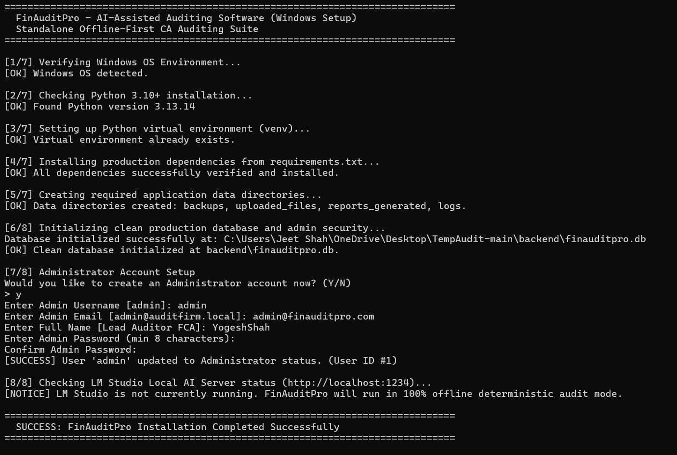

When clicked on “start” Batch file

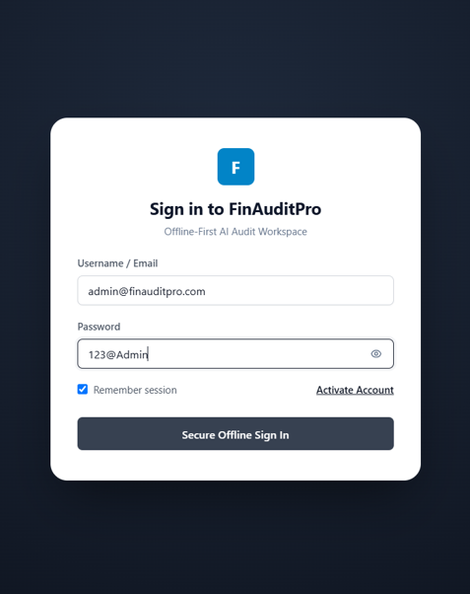

Login page

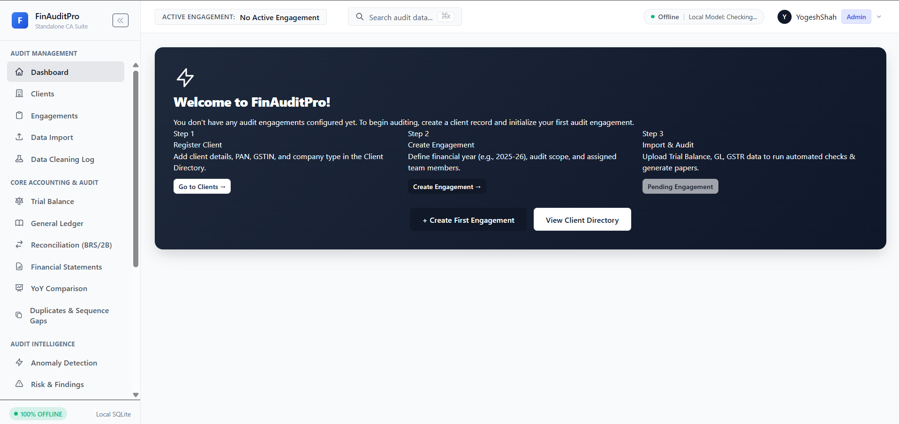

Dashboard

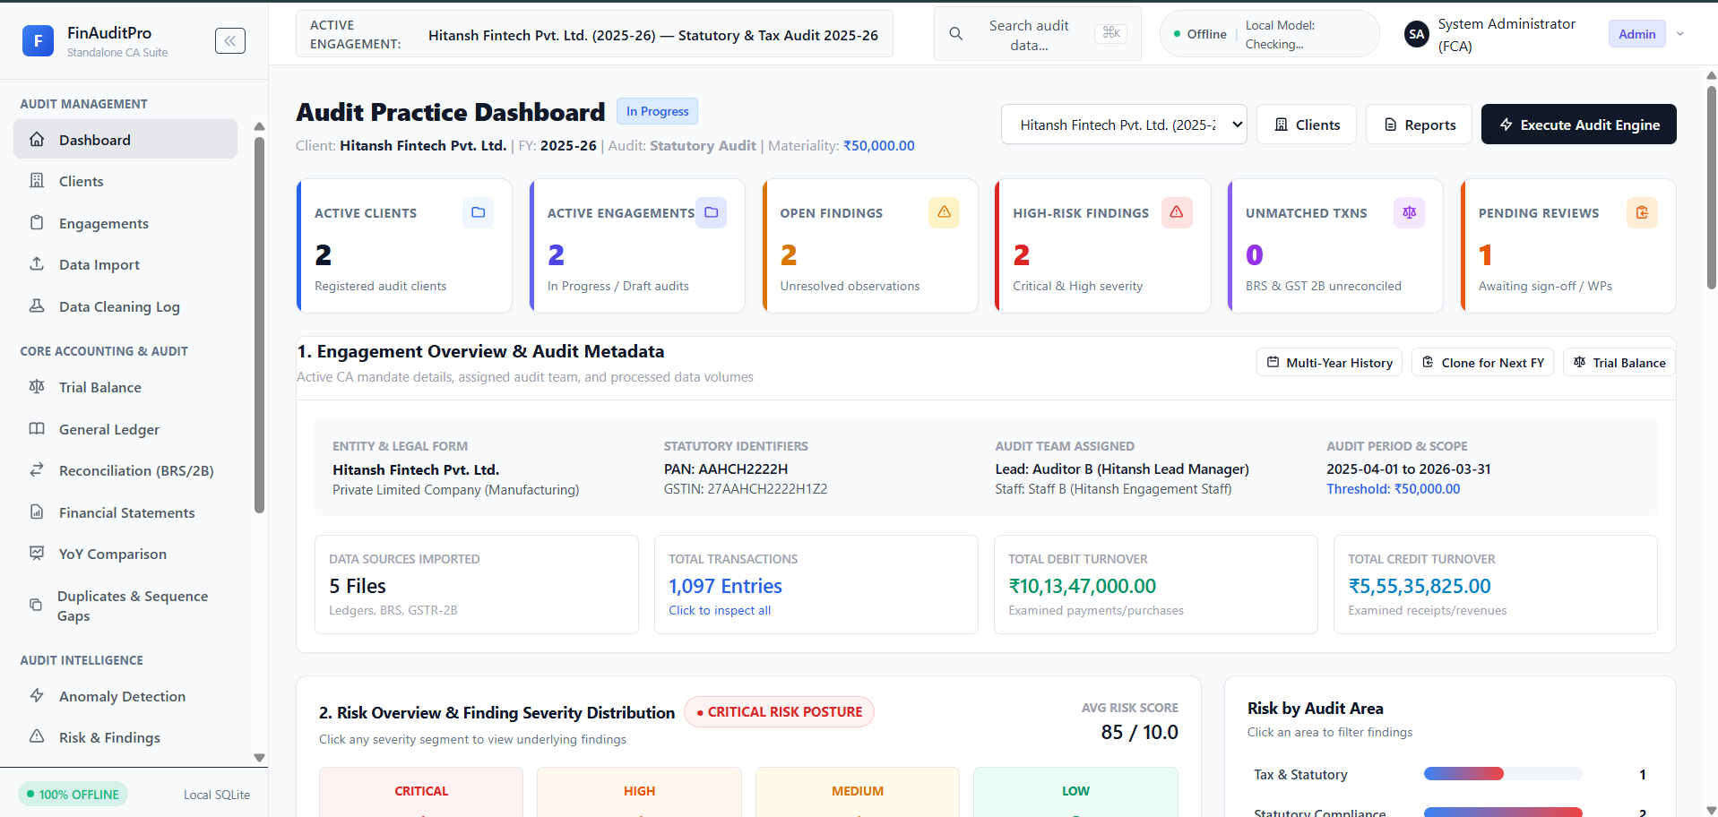

Dashboard when account is being added

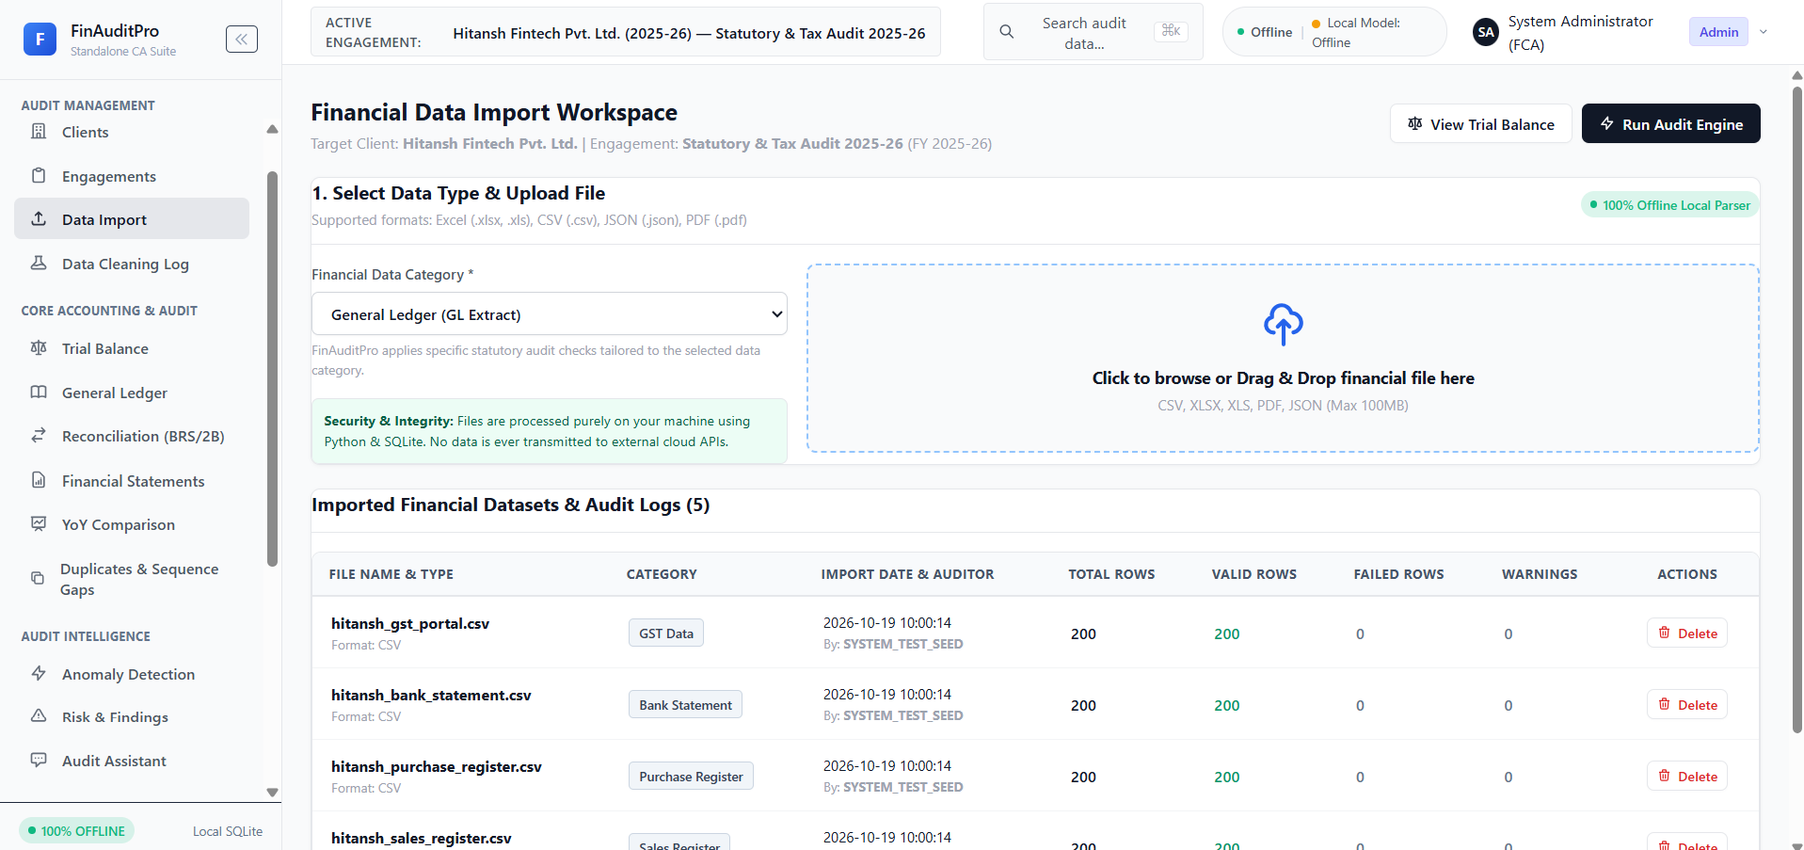

Data import page

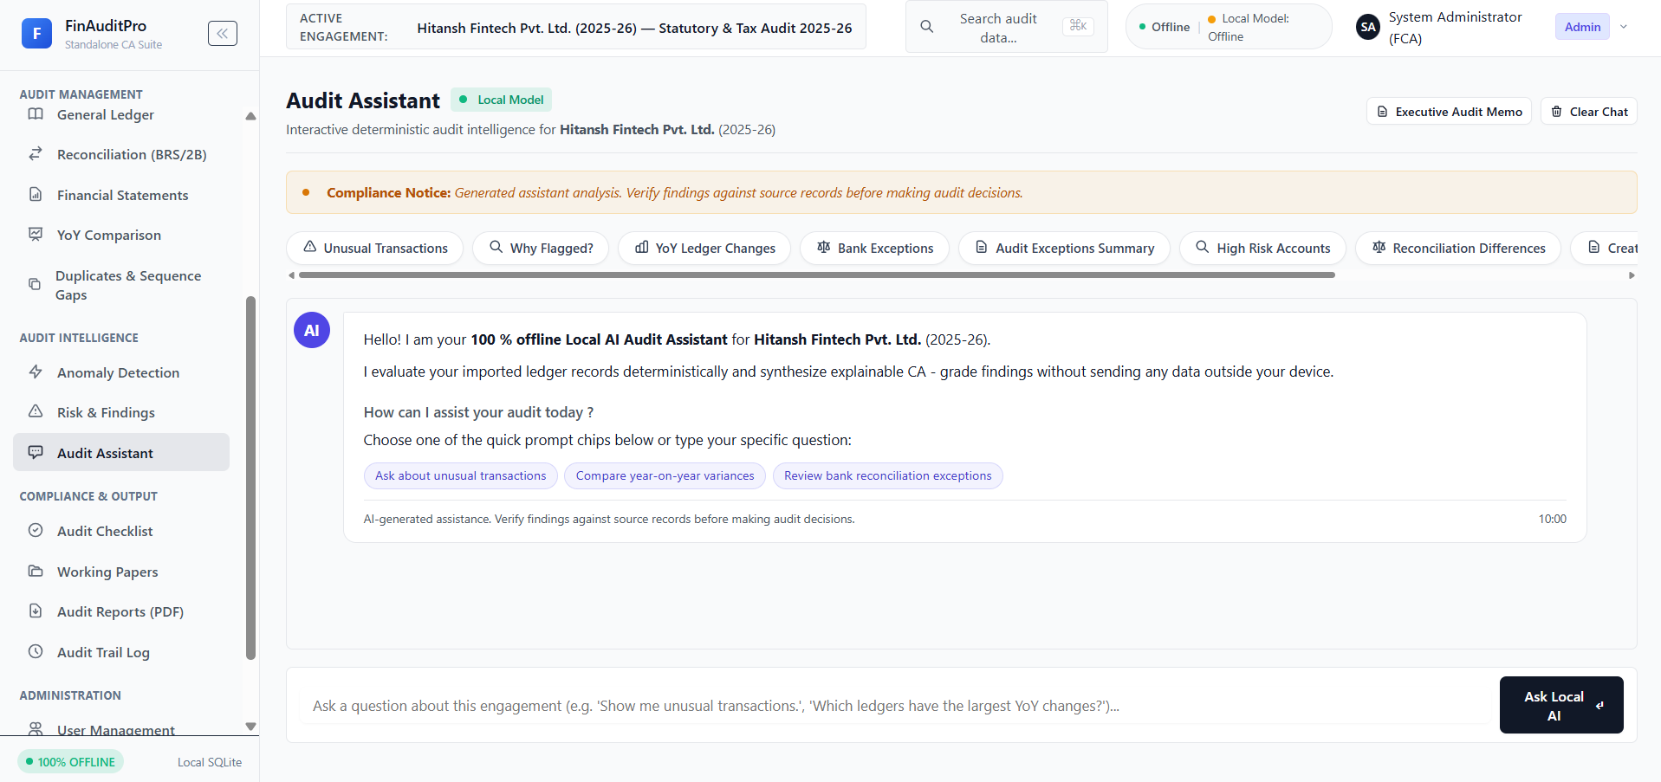

Audit assistant(copilot for FinAuditPro)

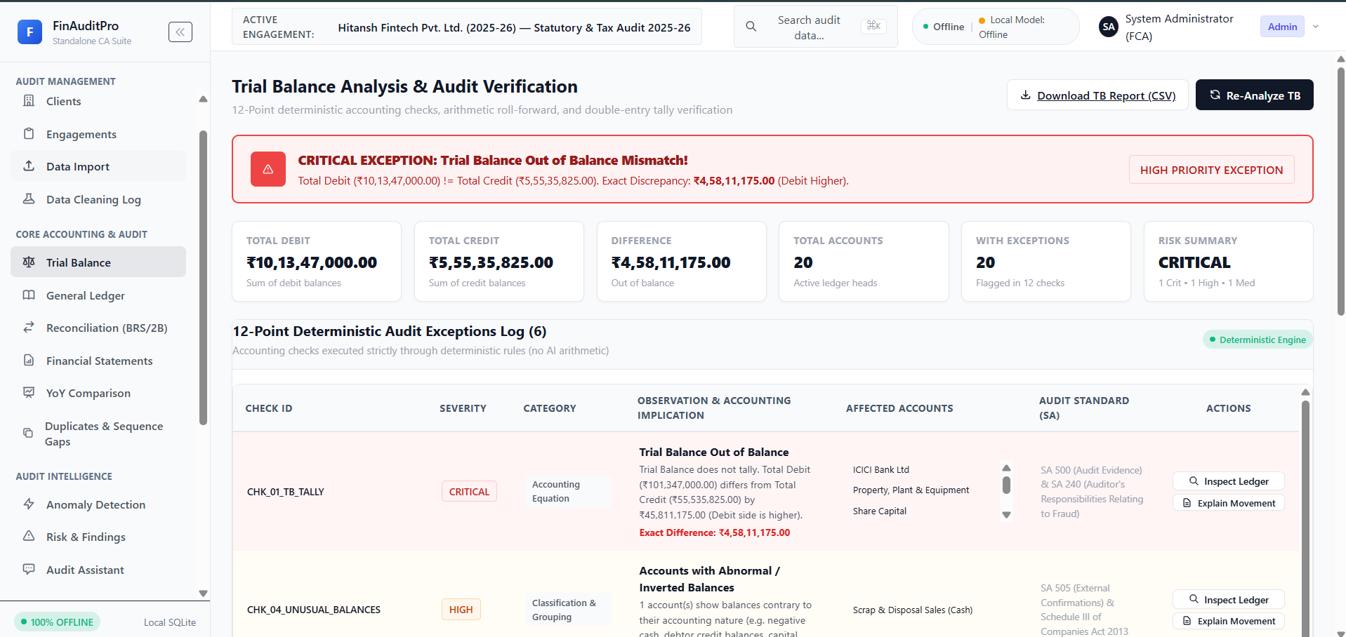

Trial Balance page

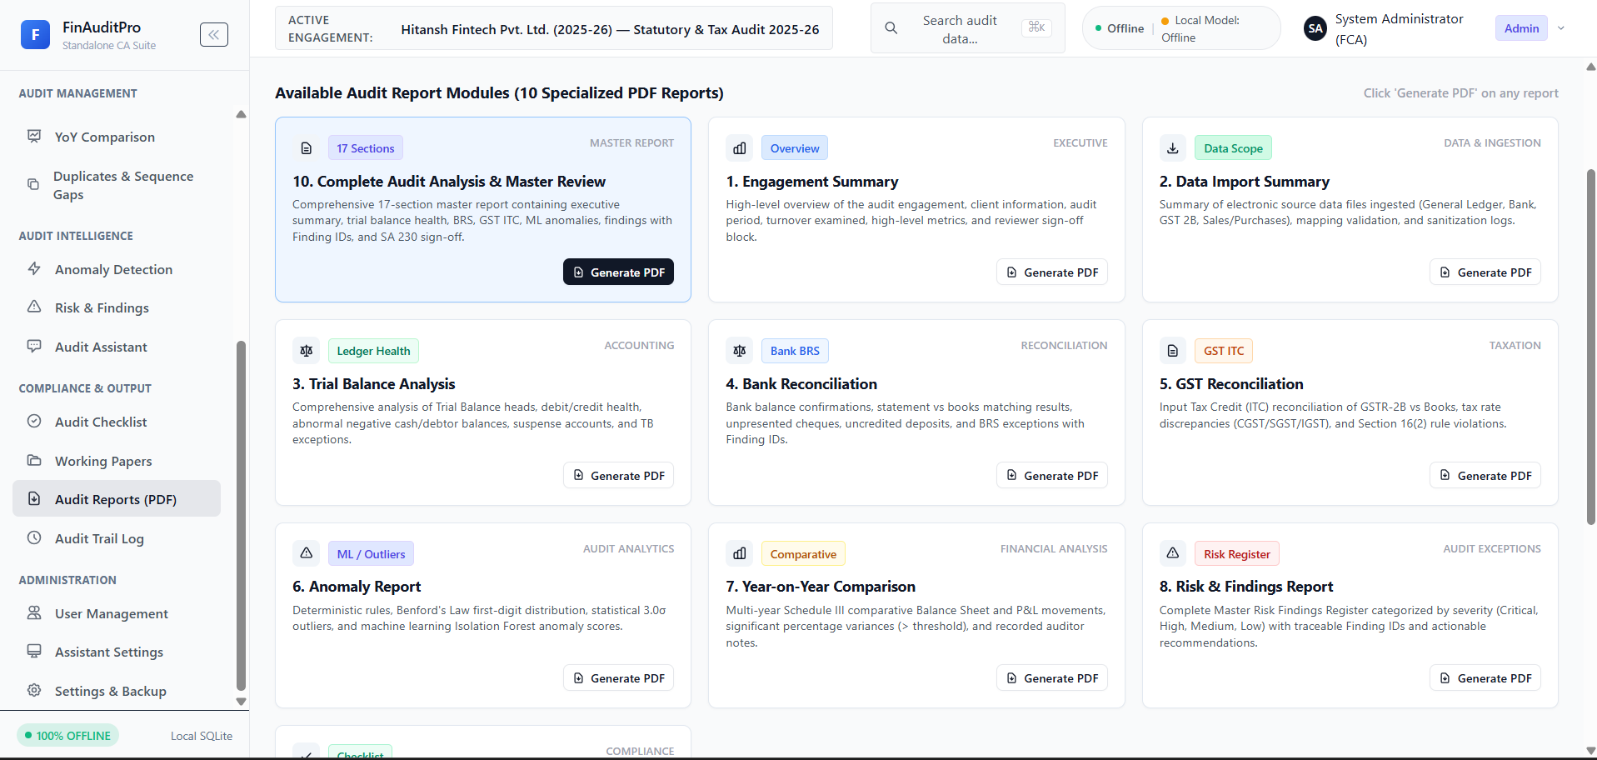

Report Generator page

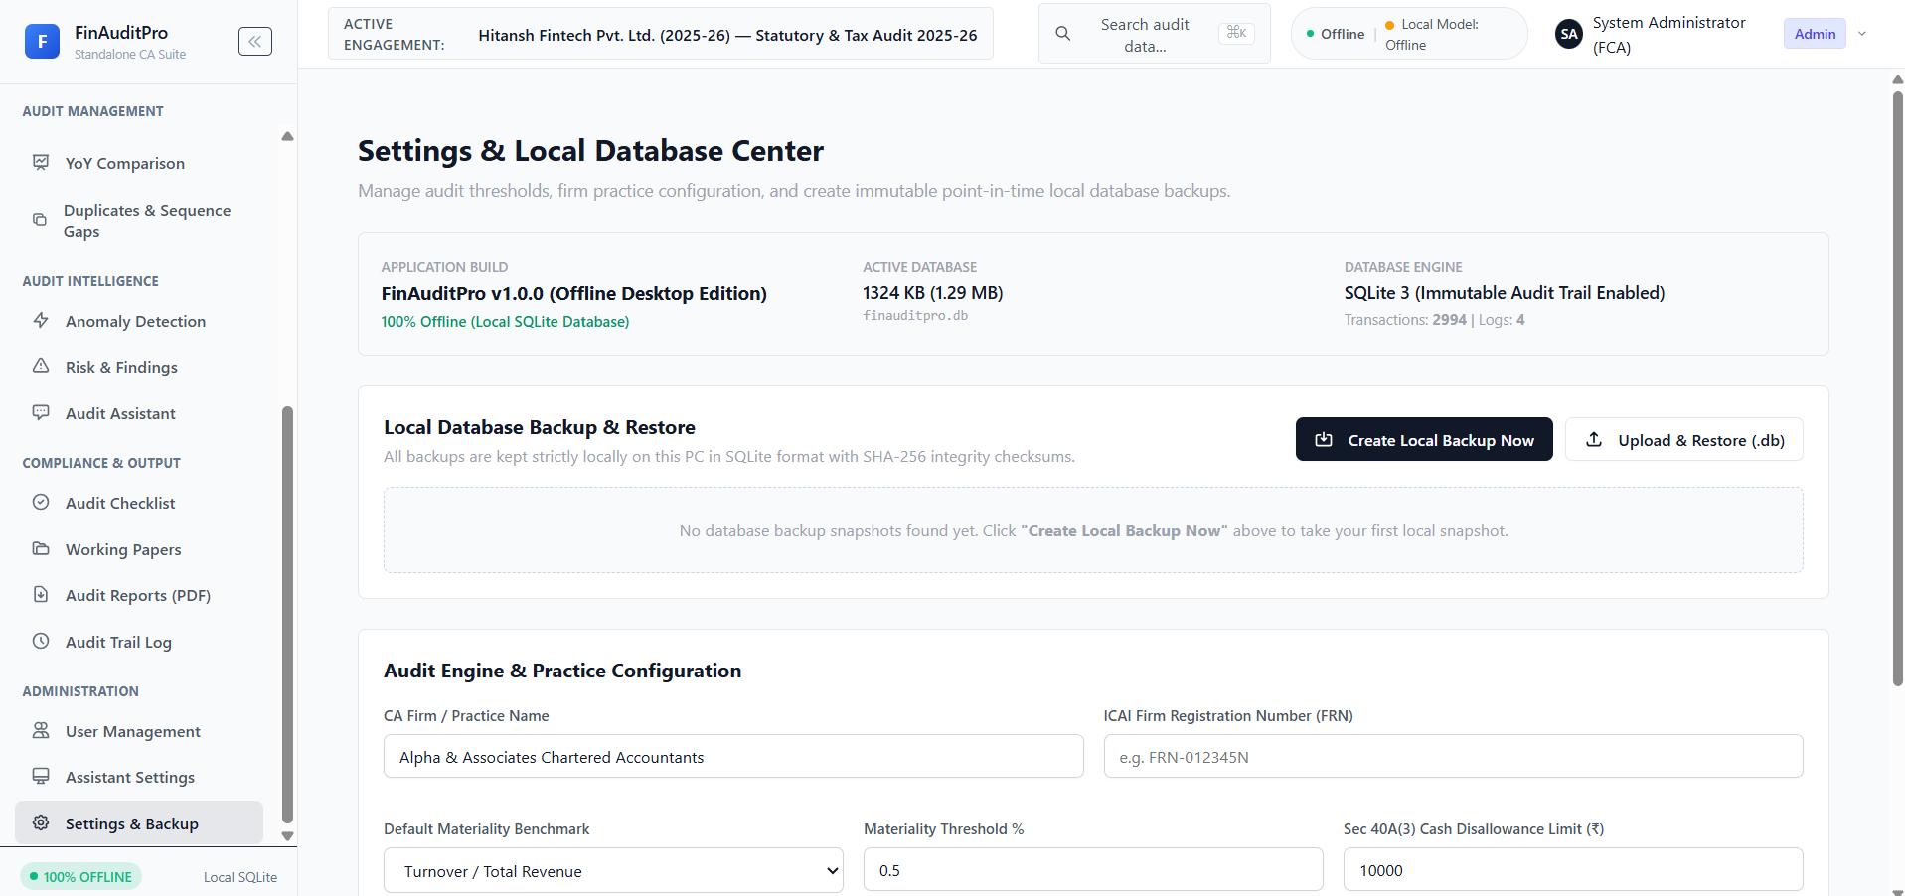

Settings and Backup Page

Chapter 5

Advantages
1. Centralized Audit Engagement Management: FinAuditPro brings client details, financial-year information, audit activities, and engagement records into one organized workspace. This helps CA firms manage audit-related information more consistently and reduces the need to track each engagement across separate files and tools.
2. Structured Evidence Organization: The system helps organize ledgers, invoices, statements, and other supporting documents with their related audit activities. This makes it easier for auditors to locate relevant evidence during verification and review.
3. Automated Audit Checks and Reconciliations: FinAuditPro can apply configured rules and checks to imported financial data to identify unusual items, mismatches, and potential exceptions. This can help auditors focus their attention on transactions that may need closer examination.
4. AI-Assisted Evidence Review: The AI Evidence Assistant can help users query or summarize evidence and prepare draft responses with references. This may reduce time spent on routine document review, while keeping the auditor responsible for validating the output against the source material.
5. Reviewable Findings and Working Papers: The platform supports the recording and review of audit findings, decisions, and working papers. This gives the audit team a clearer view of how an exception was identified, reviewed, and resolved.
6. Report Generation and Audit Trail: FinAuditPro can bring together findings and engagement activity to support report preparation and maintain an activity history. This helps teams trace key actions and review the status of audit work.
7. Local-First Data Handling: The project is designed to process evidence and AI prompts locally on the auditor’s machine. This can help firms retain greater control over sensitive client information, subject to the security settings and backup practices used in the deployment.
8. Improved Audit Workflow Visibility: By connecting evidence import, audit checks, review, and report preparation in one workflow, FinAuditPro can help CA firms monitor engagement progress and identify work that is pending review or sign-off.

Future Scope
The FinAuditPro project provides a foundation for improving audit workflows through organized evidence handling, configured audit checks, AI-assisted review, and report preparation.
The following enhancements could expand its capabilities in future versions:
Integration with Accounting and ERP Systems: Connecting FinAuditPro with commonly used accounting, ERP, banking, and tax platforms could reduce manual data import and help auditors work with more current and consistent financial information.
Advanced Document Intelligence: Enhancing document processing with improved OCR and machine learning could support more accurate extraction from scanned invoices, bank statements, handwritten records, and varied document formats.
Customizable Audit Programs: Allowing firms to configure audit checklists, thresholds, and procedures by industry, client type, and engagement could make the system more adaptable to different audit requirements.
Risk-Based Audit Analytics: Adding trend analysis, anomaly detection, and risk scoring could help auditors prioritize transactions and accounts that may require additional review. Such indicators should remain explainable and subject to professional assessment.
Collaborative Review and Approval: Introducing secure role-based access, reviewer comments, task assignment, and approval workflows could support coordination between audit team members while maintaining a clear record of review decisions.
Enhanced Report and Workpaper Templates: Providing customizable templates for audit reports, working papers, and evidence summaries could help firms produce consistent documentation aligned with their internal processes and applicable requirements.
Secure Backup and Recovery: Adding encrypted backup, restore, and version history features could help protect engagement data against device failure, accidental deletion, or corruption while preserving the local-first design.
Scalability for Larger Engagements: Improving performance for high transaction volumes, large evidence libraries, and multiple concurrent engagements could make FinAuditPro suitable for larger firms and more complex audits.
These enhancements would require careful development and validation. FinAuditPro should continue to support the auditor’s work while leaving professional judgments, verification, and final conclusions with the responsible audit team.

Limitations

FinAuditPro supports audit planning, evidence review, and workpaper preparation, but its results depend on the completeness and accuracy of the information provided. Missing, inconsistent, or incorrectly classified ledgers, invoices, statements, and supporting documents may lead to incomplete analysis or misleading exceptions. The system’s automated checks also depend on the rules and thresholds configured by the firm; incomplete or outdated rules may overlook relevant issues or flag transactions that do not represent genuine risks.
FinAuditPro does not replace the professional judgment or approval of a Chartered Accountant or audit team. Its AI Evidence Assistant may produce incomplete or inaccurate summaries, particularly when documents are unclear or difficult to interpret. Extracted information and AI-generated outputs must therefore be checked against the original evidence before they are used in audit workpapers or reports.
The system may not integrate directly with every accounting, ERP, banking, tax, or regulatory platform, so some information may need to be imported or reviewed manually. Document extraction can also be less reliable for scanned, low-resolution, handwritten, or inconsistently formatted records. As a local-first system, FinAuditPro’s availability depends on the auditor’s device, storage, security controls, and backup arrangements. Local processing alone does not guarantee data security; access controls, encryption, secure backups, and software updates must also be maintained.
The system’s performance with large transaction volumes, many concurrent engagements, or extensive supporting documents requires validation in real audit environments. FinAuditPro does not determine whether an audit is legally compliant and does not replace applicable auditing standards, regulatory guidance, firm policies, or professional review. Users remain responsible for ensuring that their audit work meets the relevant requirements.

Acknowledgment

I would like to express my sincere and heartfelt gratitude to Mr. M.Z. Shaikh, Principal of Shri Bhagubhai Mafatlal Polytechnic and College of Engineering, and
Mrs. Neeta Kadukar, Vice Principal and Head of the Department of Information Technology, for providing us with the opportunity and resources to undertake this project titled “FinAuditPro”. Their continuous encouragement, academic support, and commitment to student excellence have been a great source of motivation throughout this journey.
I extend my deepest appreciation to my project mentor, Mr. Abhijit Dongaonkar, for his invaluable guidance, insightful feedback, and unwavering support during every stage of the project. His expertise and constructive suggestions played a vital role in helping us refine our ideas, overcome technical challenges, and achieve our objectives successfully.
I am also grateful to all the faculty members of the Department of Information Technology for imparting the technical knowledge and professional skills that greatly contributed to the successful completion of this project. Their teaching and mentorship have laid a strong foundation for our learning and development.
Lastly, I would like to acknowledge that this project was completed entirely by me and my team with dedication, collaboration, and consistent effort. The experience of working on this project has been both enriching and rewarding, allowing us to apply our classroom learning to real-world problem-solving.

5.5 Conclusion

The desktop application is highly helpful for financial auditing firms throughout the process of analyzing and generating reports. It organizes the audit records and improves the efficiency of the workplace. The application can aid the functioning of the firm by reducing the time taken in manual data extraction.

It increases professional productivity through numerous AI-driven services and a user-friendly interface.

Features for proving transparency, data privacy, and accurate risk detection, sanctioning auditors to form educated, assured choices on financial approvals are provided for higher expertise, which increases loyalty and retention that helps in growing business.

It is essential to use technology to become productive, more organized, and more efficient in auditing, but more importantly, to ensure absolute data security.

5.6 References
[1] International Auditing and Assurance Standards Board (IAASB), “ISA 315 (Revised 2019): Identifying and Assessing the Risks of Material Misstatement,” 2019. Available: https://www.iaasb.org/publications/isa-315-revised-2019-identifying-and-assessing-risks-material-misstatement
[2] SQLite, “About SQLite.” Available: https://www.sqlite.org/about.html
[3] Qt for Python, “PySide6 Documentation.” Available: https://doc.qt.io/qtforpython-6/
[4] M. Douze et al., “The Faiss Library,” arXiv:2401.08281, 2024. Available: https://arxiv.org/abs/2401.08281
[5] Ollama, “Ollama Documentation.” Available: https://docs.ollama.com/
[6] P. Mell and T. Grance, “The NIST Definition of Cloud Computing,” NIST Special Publication 800-145, National Institute of Standards and Technology, 2011. Available: https://doi.org/10.6028/NIST.SP.800-145
[7] P. Lewis et al., “Retrieval-Augmented Generation for Knowledge-Intensive NLP Tasks,” Advances in Neural Information Processing Systems, vol. 33, 2020. Available: https://arxiv.org/abs/2005.11401
[8] Adobe, “What Is OCR (Optical Character Recognition)?” Available: https://www.adobe.com/acrobat/resources/what-is-ocr.html
[9] National Institute of Standards and Technology (NIST), “Artificial Intelligence Risk Management Framework (AI RMF 1.0),” NIST AI 100-1, 2023. Available: https://doi.org/10.6028/NIST.AI.100-1
[10] Microsoft, “What Is Business Intelligence?” Available: https://www.microsoft.com/en-us/power-platform/products/power-bi/topics/business-intelligence/what-is-business-intelligence
[11] National Institute of Standards and Technology (NIST), “Digital Signature Standard (DSS),” FIPS PUB 186-5, 2023. Available: https://doi.org/10.6028/NIST.FIPS.186-5
[12] National Institute of Standards and Technology (NIST), “Security and Privacy Controls for Information Systems and Organizations,” NIST SP 800-53 Rev. 5, 2020. Available: https://doi.org/10.6028/NIST.SP.800-53r5

