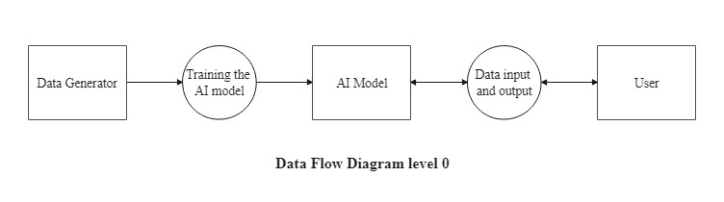

DFD Level 0 diagram

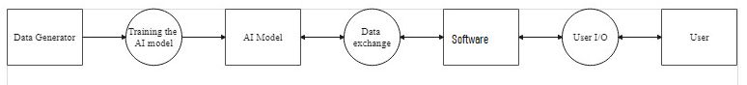

DFD Level 1 Diagram

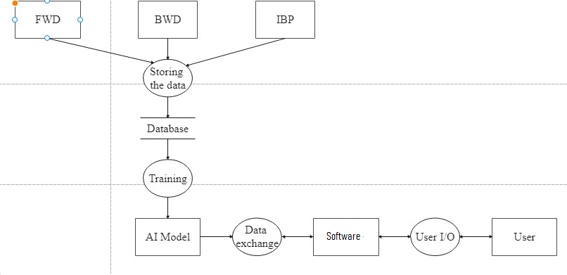

DFD Level 2 Diagram

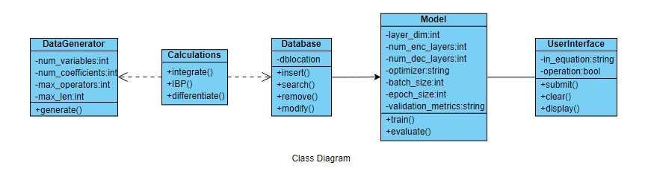

Class Diagram