1. Create a zoo.py file first. Define the hours() function, which prints the string 'Open 9-5 daily'. Then, use the interactive interpreter to import the zoo module and call its hours() function.

**Answer:**

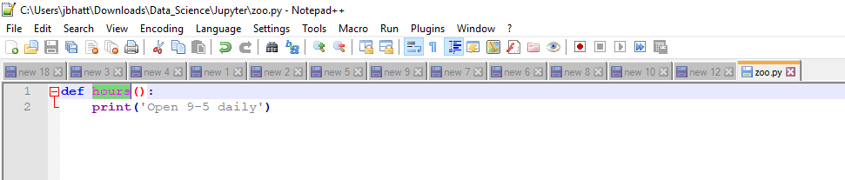

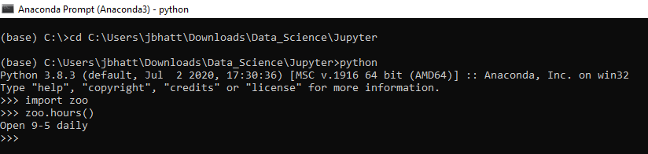

2. In the interactive interpreter, import the zoo module as menagerie and call its hours() function.

**Answer:**

**>>> import zoo as menagerie**

**>>> menagerie.hours()**

**Open 9-5 daily**

3. Using the interpreter, explicitly import and call the hours() function from zoo.

**Answer:**

**>>> from zoo import hours**

**>>> hours()**

**Open 9-5 daily**

4. Import the hours() function as info and call it.

**Answer:**

**>>> from zoo import hours as info**

**>>> info()**

**Open 9-5 daily**

5. Create a plain dictionary with the key-value pairs 'a': 1, 'b': 2, and 'c': 3, and print it out.

**Answer:**

**dict1 = {'a': 1, 'b': 2,'c': 3}**

**for key , value in dict1.items():**

**print(key , value)**

6.Make an OrderedDict called fancy from the same pairs listed in 5 and print it. Did it print in the same order as plain?

**Answer:**

**from collections import OrderedDict**

**fancy = OrderedDict()**

**fancy['a'] = 1**

**fancy['b'] = 2**

**fancy['c'] = 3**

**for key , value in fancy.items():**

**print(key , value)**

7. Make a default dictionary called dict_of_lists and pass it the argument list. Make the list dict_of_lists['a'] and append the value 'something for a' to it in one assignment. Print dict_of_lists['a'].

**Answer:**

**dict_of_lists = {'a' : [1,2,3,'jeet'] }**

**dict_of_lists['a'].append('something for a')**

**print(dict_of_lists)**