**billy383-**03/15/2017

I'm in!

**dilgenfritz-**03/15/2017

Sweet

**Jeetendra_Khadka-**03/15/2017

**March 17, 2017**

**dilgenfritz-**Last Friday at 10:36 AM

Okay. So after some consideration I think it's best if we stick with visual studio 2015. I've already spoken to a couple of you and you agreed. 2017 gets rid of project.json plus we should all already have everything up to date on 2015

Plus it saves you a lot of download time

Which brings me to my next point.

In 2015 you cannot right click and exclude from project.

The work around for this is to go into project.json and under buildOptions add this.

[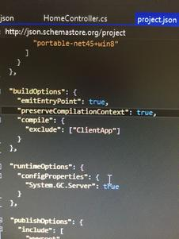](https://cdn.discordapp.com/attachments/291738978292596757/292320983392452608/image.jpg)

**billy383-**Last Friday at 11:27 AM

That sounds good. I haven't set up anything for VS 2017 yet, so that'll save me the trouble there.

**March 22, 2017**

**dilgenfritz-**Today at 8:51 AM

Alright. Slight change of plans. This message is for those of you who were not in class. We talked to the envoc guys and it was VERY HEAVILY recommended to use VS 2017. So that's what we are going to do. I have pushed a project to the repo but it's bare bones.

We are planning to meet on Thursday to really dive into this just let me know your availability.

Speaking of which I am going to upload a folder to the repo labeled "correspondence" any email traffic you generate with anyone about this project please push it to that folder.

Also billy has an excel spreadsheet for a schedule I would like us all to fill out. I will also be copying this discord conversation to said folder from time to time just for reference.