Jenkins Automation for back end

[Agile and DevOps (FSE_Oct_2022_C5_CFSEZG551)](https://bits-pilani.instructure.com/courses/2061)

FSE Oct 2022 (Cohort 3)

**By**:

PRASAD, JEETENDRA

(2021cfse032@wilp.bits-pilani.ac.in)

1. My git repo: <https://github.com/jeetendraprasad/PilaniDevOpBackendCode.git> (url: <https://github.com/jeetendraprasad/PilaniDevOpBackendCode>) 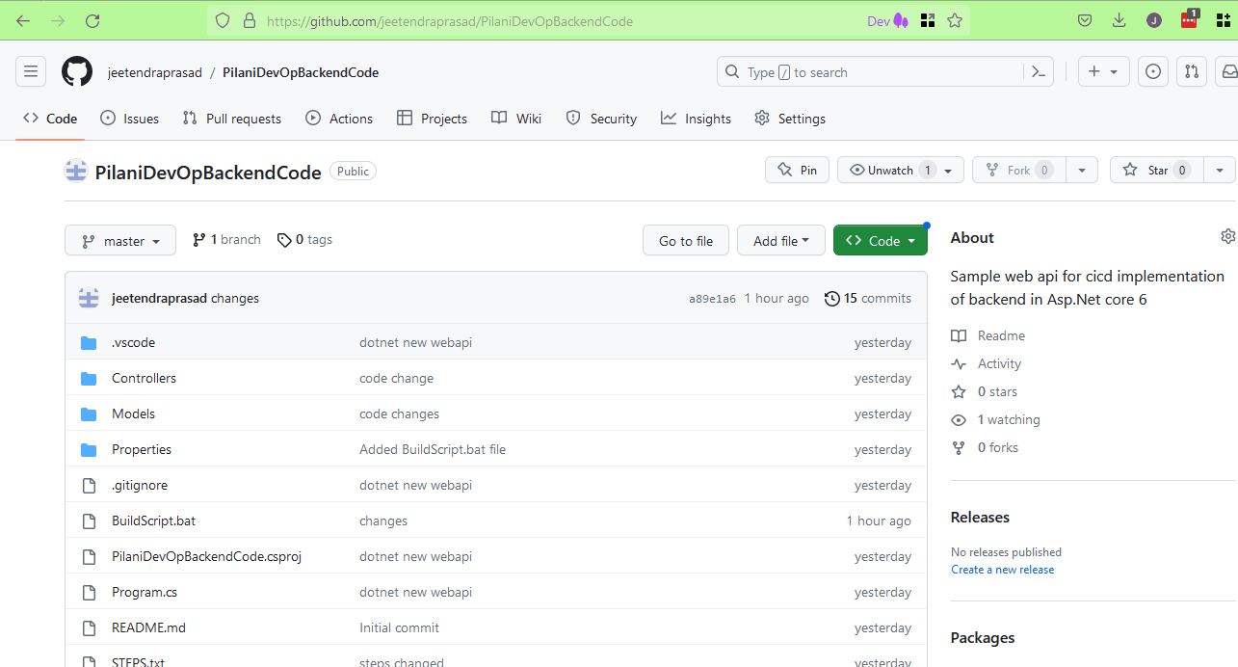
2. This is my back-end project developed in Asp.Net core 6 Web Api in C# in ‘VS code’ editor. The reference project is <https://learn.microsoft.com/en-us/aspnet/core/tutorials/first-web-api?view=aspnetcore-6.0&tabs=visual-studio-code>. I also added .\PilaniDevOpBackendCode\Properties\PublishProfiles\IISProfile.pubxml for IIS deployment. I have also created a build batch file named ‘BuildScript.bat’ which contains build steps for Jenkins. Explanation of this file comes later.
3. I also have the local repo at my local system at folder Q:\HOMEPATH\github\PilaniDevOpBackendCode. This is seen in explorer as 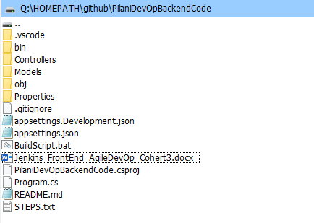
4. To build and run my local development environment I use following commands: -

dotnet build

dotnet run

Then in browser I can see my output in url <https://localhost:7281/user> as 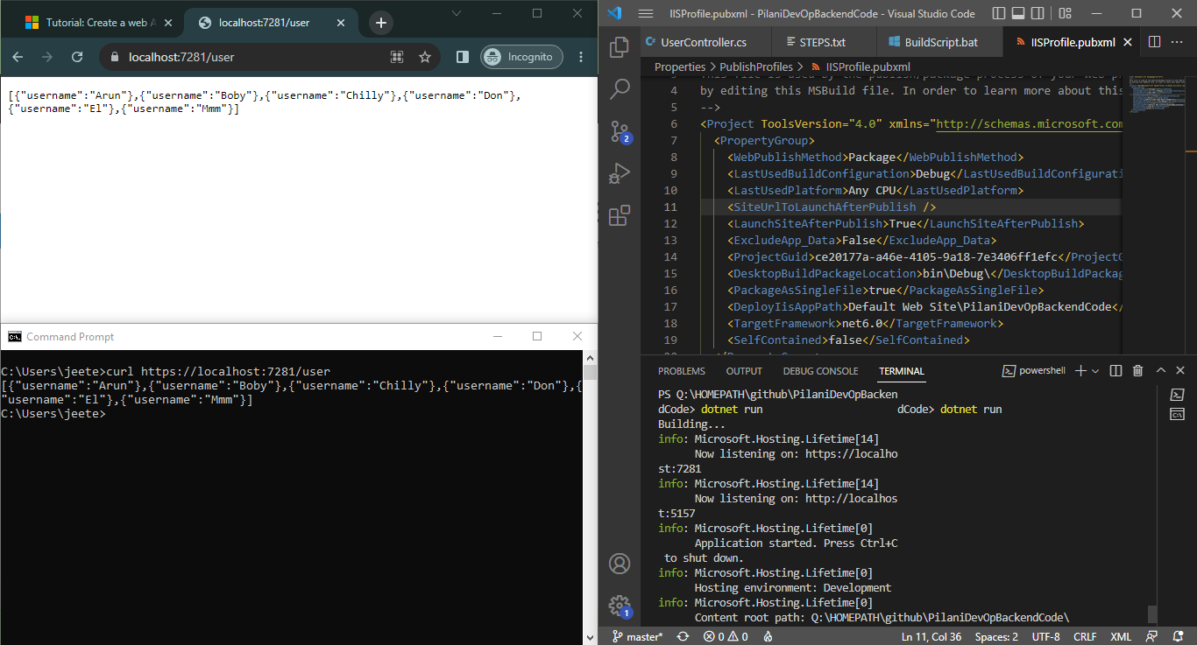. I can also do “curl <https://localhost:7281/user>”.

1. I have also set up a remote windows system **as a server** with info ( username@hostname ) as development@192.168.87.1. I have passwordless ssh login enabled between these two systems. So, I will use scp to copy files to the server. And do deployment as: -

ssh development@192.168.87.1 “batch file commands here”.

Also, on server I have to: -

1. enable IIS.
2. Install dotnet 6 runtime with hosting bundle (from <https://dotnet.microsoft.com/en-us/download/dotnet/thank-you/runtime-aspnetcore-6.0.19-windows-x64-installer>)
3. Install ‘Web Deploy 3’ (from <https://www.microsoft.com/en-us/download/details.aspx?id=43717>)
4. Install DotNet 6 LTS SDK
5. Jenkins setup: All default plug-ins are installed. No other change required.
6. Now I do Jenkins new Job for backend CICD. The name of job is ‘PilaniDevOpBackendCode’ which looks as:- 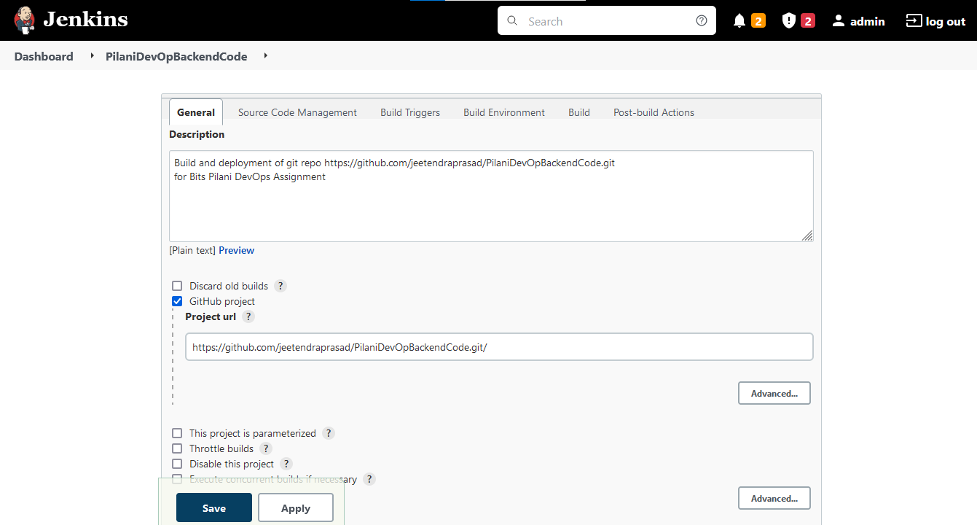 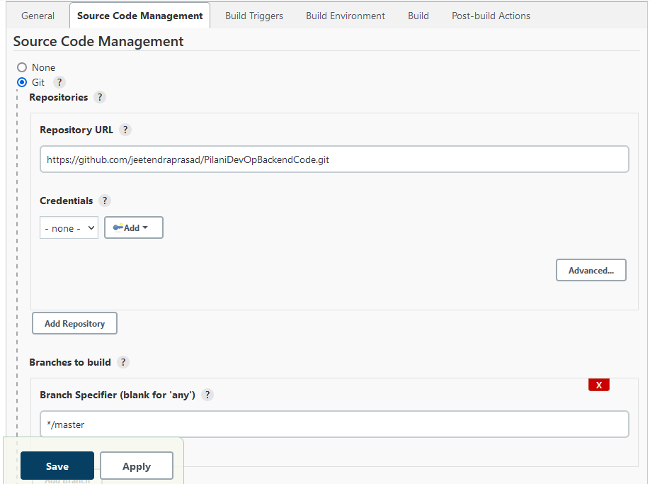 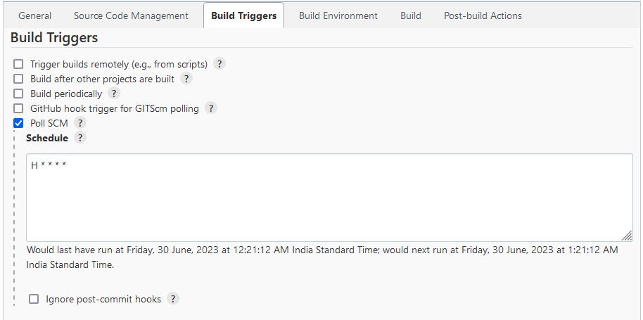 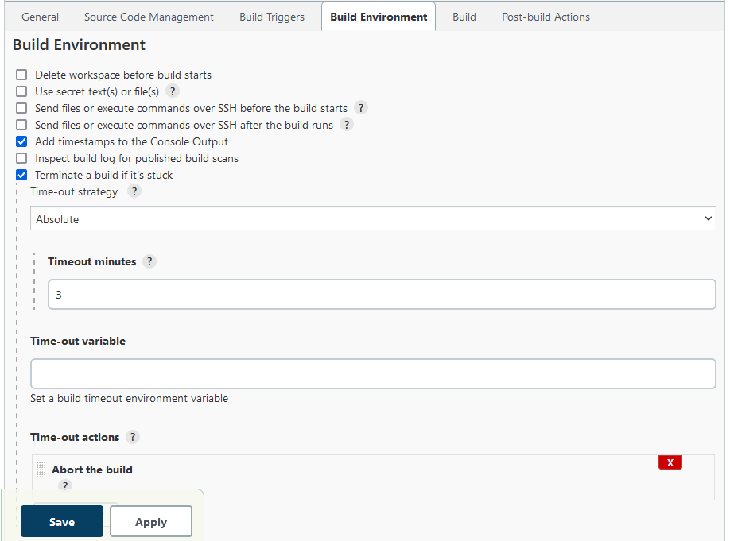 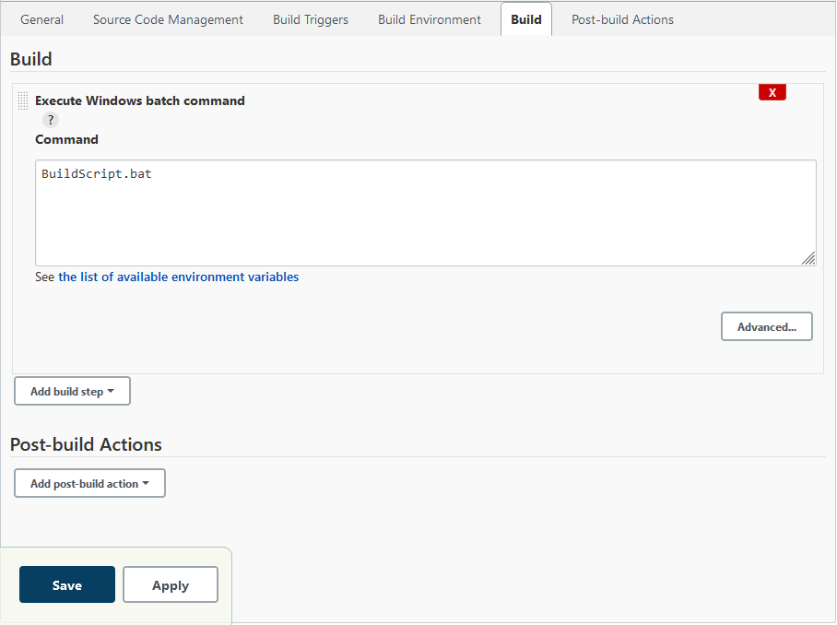. Note Polling time is kept as 1 hour.
7. IMP: There is a file ‘BuildScript.bat’ which is run by Jenkins do build and automatic deployment on server. This deployment is done by copying file to server using scp command and then deployment on server using ssh command.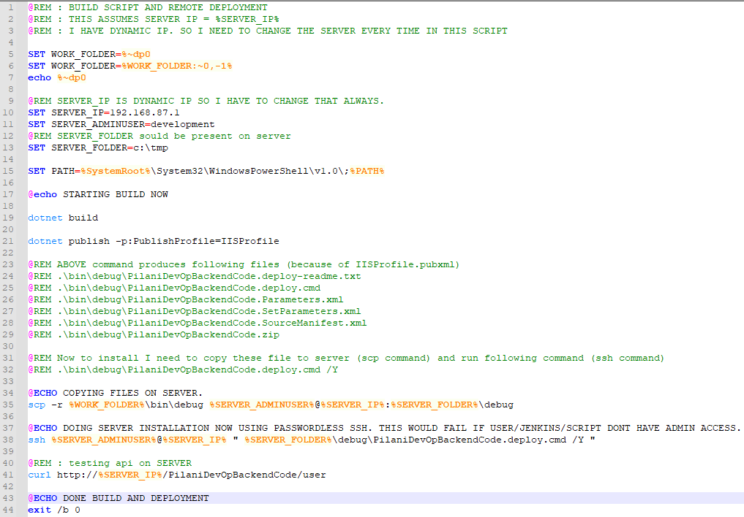
8. Now I do code change and add my commit in my local branch.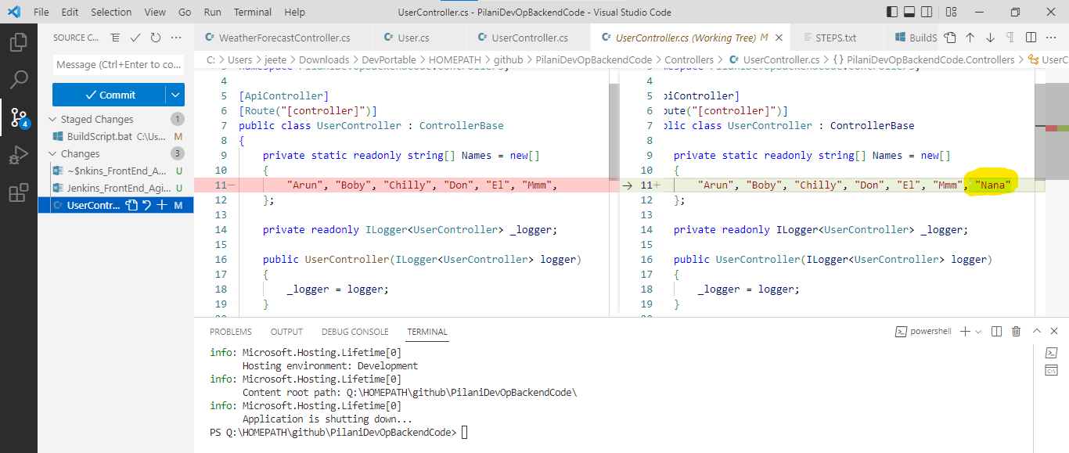. Followed by push to origin (github) 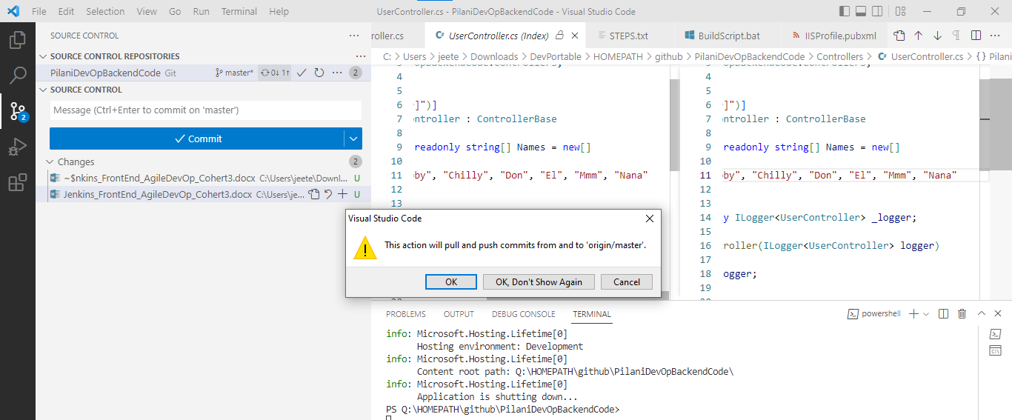. On github we can see this change as 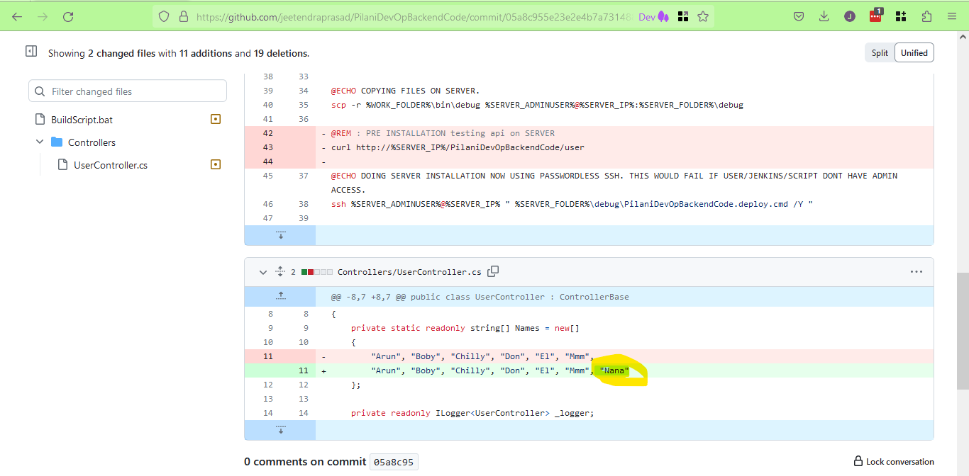
9. Now we will do ‘Build Now’ for Jenkins job. (Also note that on server there is no website).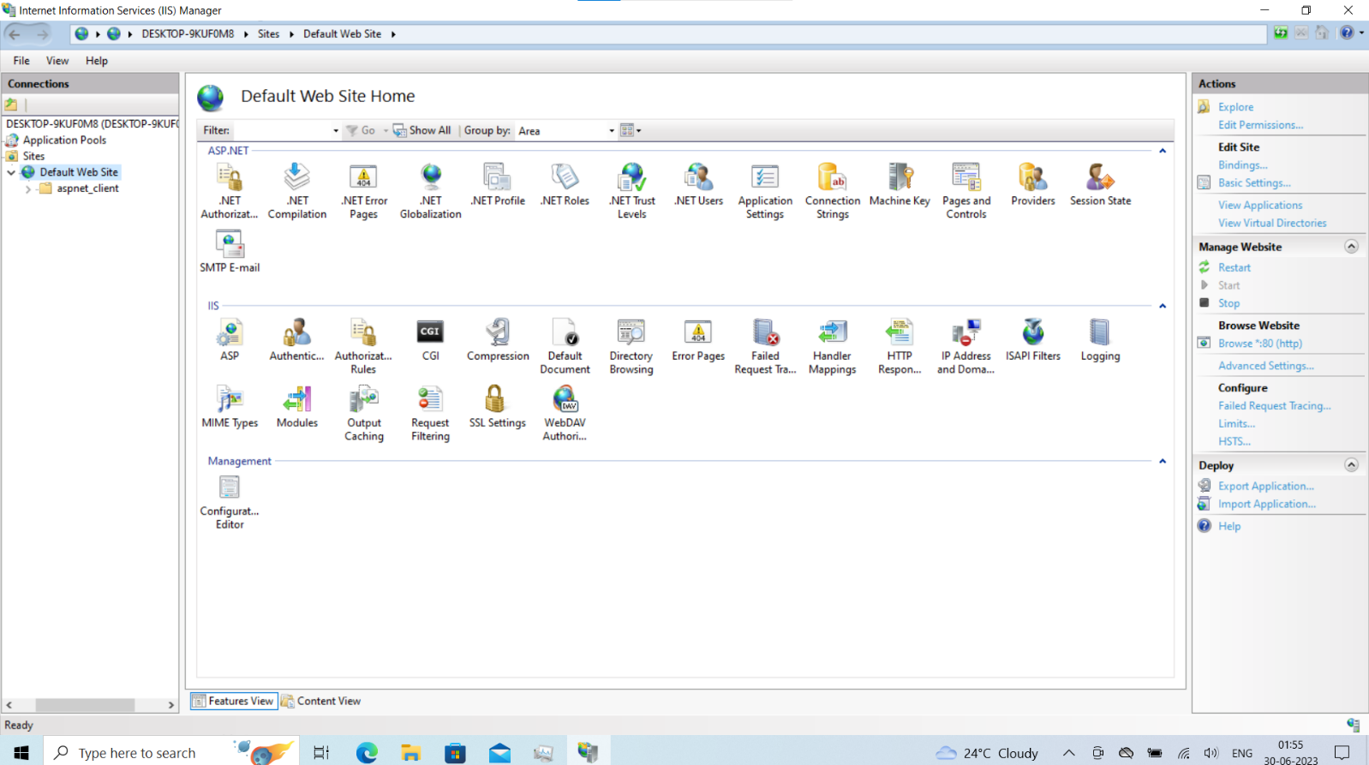
10. I press ‘Build Now’ and this triggers build. 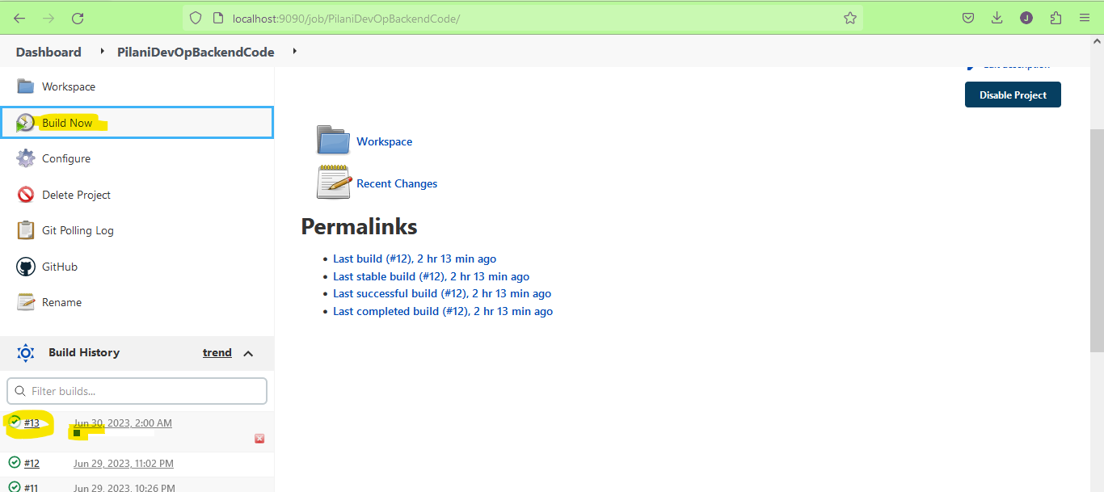. Note: I can also wait for 1 hour (git scm poll time is 1hr).
11. My build is successful 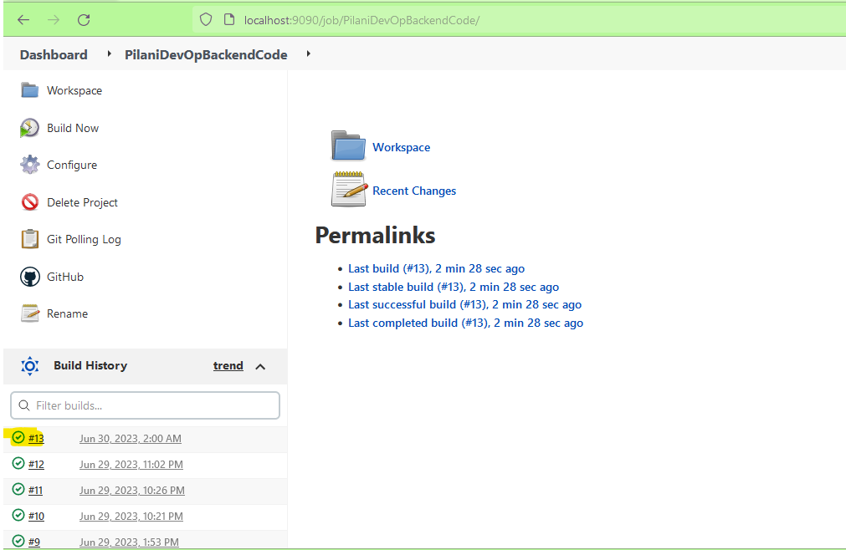 with logs as: -

Started by user admin

Running as SYSTEM

Building in workspace Q:\HOMEPATH\JENKINS_HOME\workspace\PilaniDevOpBackendCode

The recommended git tool is: NONE

No credentials specified

> git.exe rev-parse --resolve-git-dir Q:\HOMEPATH\JENKINS_HOME\workspace\PilaniDevOpBackendCode\.git # timeout=10

Fetching changes from the remote Git repository

> git.exe config remote.origin.url https://github.com/jeetendraprasad/PilaniDevOpBackendCode.git # timeout=10

Fetching upstream changes from https://github.com/jeetendraprasad/PilaniDevOpBackendCode.git

> git.exe --version # timeout=10

> git --version # 'git version 2.35.1.windows.2'

> git.exe fetch --tags --force --progress -- https://github.com/jeetendraprasad/PilaniDevOpBackendCode.git +refs/heads/*:refs/remotes/origin/* # timeout=10

> git.exe rev-parse "refs/remotes/origin/master^{commit}" # timeout=10

Checking out Revision 05a8c955e23e2e4b7a731488066ba3d9520a3ea9 (refs/remotes/origin/master)

> git.exe config core.sparsecheckout # timeout=10

> git.exe checkout -f 05a8c955e23e2e4b7a731488066ba3d9520a3ea9 # timeout=10

Commit message: "Name list changed."

> git.exe rev-list --no-walk a89e1a649275091a60a6214a55400a6a573c16c7 # timeout=10

[PilaniDevOpBackendCode] $ cmd /c call Q:\USERPROFILE\TEMP\jenkins12258169650717589002.bat

Q:\HOMEPATH\JENKINS_HOME\workspace\PilaniDevOpBackendCode>BuildScript.bat

Q:\HOMEPATH\JENKINS_HOME\workspace\PilaniDevOpBackendCode>SET WORK_FOLDER=Q:\HOMEPATH\JENKINS_HOME\workspace\PilaniDevOpBackendCode\

Q:\HOMEPATH\JENKINS_HOME\workspace\PilaniDevOpBackendCode>SET WORK_FOLDER=Q:\HOMEPATH\JENKINS_HOME\workspace\PilaniDevOpBackendCode

Q:\HOMEPATH\JENKINS_HOME\workspace\PilaniDevOpBackendCode>echo Q:\HOMEPATH\JENKINS_HOME\workspace\PilaniDevOpBackendCode\

Q:\HOMEPATH\JENKINS_HOME\workspace\PilaniDevOpBackendCode\

Q:\HOMEPATH\JENKINS_HOME\workspace\PilaniDevOpBackendCode>SET SERVER_IP=192.168.87.1

Q:\HOMEPATH\JENKINS_HOME\workspace\PilaniDevOpBackendCode>SET SERVER_ADMINUSER=development

Q:\HOMEPATH\JENKINS_HOME\workspace\PilaniDevOpBackendCode>SET SERVER_FOLDER=c:\tmp

Q:\HOMEPATH\JENKINS_HOME\workspace\PilaniDevOpBackendCode>SET PATH=C:\Windows\System32\WindowsPowerShell\v1.0\;Q:\Softwares\Perl\perl\site\bin;Q:\Softwares\Perl\perl\bin;Q:\Softwares\Perl\c\bin;Q:\Softwares\PostgresSQL\pgsql\bin\;Q:\Softwares\Pwsh7\;Q:\Softwares\EclipseJava\eclipse\;Q:\Softwares\Jenkins\;Q:\Softwares\OpenJDK\jdk-11.0.15+10\bin\;Q:\Softwares\VSCode\;Q:\Softwares\WinMerge\WinMerge\;Q:\Softwares\SourceTree\;Q:\Softwares\Python_Pypy\pypy3.9-v7.3.9-win64;Q:\Softwares\Python_Pypy\pypy3.9-v7.3.9-win64\Scripts;Q:\Softwares\NodeJS\node-v16.13.2-win-x64\;Q:\Softwares\FreeCommander\;Q:\Softwares\PortableGit\bin\;Q:\Softwares\NotepadPP\;C:\Windows\system32;C:\Windows;C:\Windows\System32\Wbem;C:\Windows\System32\WindowsPowerShell\v1.0\;C:\Windows\System32\OpenSSH\;C:\Program Files\dotnet\;C:\Users\jeete\AppData\Local\Microsoft\WindowsApps;C:\Users\jeete\.dotnet\tools

STARTING BUILD NOW

Q:\HOMEPATH\JENKINS_HOME\workspace\PilaniDevOpBackendCode>dotnet build

MSBuild version 17.3.2+561848881 for .NET

Determining projects to restore...

All projects are up-to-date for restore.

PilaniDevOpBackendCode -> Q:\HOMEPATH\JENKINS_HOME\workspace\PilaniDevOpBackendCode\bin\Debug\net6.0\PilaniDevOpBackendCode.dll

Build succeeded.

0 Warning(s)

0 Error(s)

Time Elapsed 00:00:12.97

Q:\HOMEPATH\JENKINS_HOME\workspace\PilaniDevOpBackendCode>dotnet publish -p:PublishProfile=IISProfile

MSBuild version 17.3.2+561848881 for .NET

Determining projects to restore...

All projects are up-to-date for restore.

PilaniDevOpBackendCode -> Q:\HOMEPATH\JENKINS_HOME\workspace\PilaniDevOpBackendCode\bin\Debug\net6.0\PilaniDevOpBackendCode.dll

PilaniDevOpBackendCode -> Q:\HOMEPATH\JENKINS_HOME\workspace\PilaniDevOpBackendCode\bin\Debug\net6.0\publish\

Info: Updating file (Q:\HOMEPATH\JENKINS_HOME\workspace\PilaniDevOpBackendCode\bin\Debug\net6.0\publish\PilaniDevOpBackendCode.dll).

Info: Updating file (Q:\HOMEPATH\JENKINS_HOME\workspace\PilaniDevOpBackendCode\bin\Debug\net6.0\publish\PilaniDevOpBackendCode.exe).

Info: Updating file (Q:\HOMEPATH\JENKINS_HOME\workspace\PilaniDevOpBackendCode\bin\Debug\net6.0\publish\PilaniDevOpBackendCode.pdb).

Info: Updating file (Q:\HOMEPATH\JENKINS_HOME\workspace\PilaniDevOpBackendCode\bin\Debug\net6.0\publish\web.config).

Total changes: 4 (0 added, 0 deleted, 4 updated, 0 parameters changed, 179758 bytes copied)

Package "PilaniDevOpBackendCode.zip" is successfully created as single file at the following location:

file:///Q:/HOMEPATH/JENKINS_HOME/workspace/PilaniDevOpBackendCode/bin/Debug

To get the instructions on how to deploy the web package please visit the following link:

http://go.microsoft.com/fwlink/?LinkId=124618

COPYING FILES ON SERVER.

Q:\HOMEPATH\JENKINS_HOME\workspace\PilaniDevOpBackendCode>scp -r Q:\HOMEPATH\JENKINS_HOME\workspace\PilaniDevOpBackendCode\bin\debug development@192.168.87.1:c:\tmp\debug

DOING SERVER INSTALLATION NOW USING PASSWORDLESS SSH. THIS WOULD FAIL IF USER/JENKINS/SCRIPT DONT HAVE ADMIN ACCESS.

Q:\HOMEPATH\JENKINS_HOME\workspace\PilaniDevOpBackendCode>ssh development@192.168.87.1 " c:\tmp\debug\PilaniDevOpBackendCode.deploy.cmd /Y "

SetParameters from:

"c:\tmp\debug\PilaniDevOpBackendCode.SetParameters.xml"

You can change IIS Application Name, Physical path, connectionString

or other deploy parameters in the above file.

-------------------------------------------------------

Start executing msdeploy.exe

-------------------------------------------------------

"C:\Program Files\IIS\Microsoft Web Deploy V3\msdeploy.exe" -source:package='c:\tmp\debug\PilaniDevOpBackendCode.zip' -dest:auto,includeAcls="False" -verb:sync -disableLink:AppPoolExtension -disableLink:ContentExtension -disableLink:CertificateExtension -setParamFile:"c:\tmp\debug\PilaniDevOpBackendCode.SetParameters.xml"

Info: Creating application (Default Web Site\PilaniDevOpBackendCode)

Info: Adding virtual path (Default Web Site\PilaniDevOpBackendCode)

Info: Adding directory (Default Web Site\PilaniDevOpBackendCode).

Info: Adding file (Default Web Site\PilaniDevOpBackendCode\appsettings.Development.json).

Info: Adding file (Default Web Site\PilaniDevOpBackendCode\appsettings.json).

Info: Adding file (Default Web Site\PilaniDevOpBackendCode\Microsoft.OpenApi.dll).

Info: Adding file (Default Web Site\PilaniDevOpBackendCode\PilaniDevOpBackendCode.deps.json).

Info: Adding file (Default Web Site\PilaniDevOpBackendCode\PilaniDevOpBackendCode.dll).

Info: Adding file (Default Web Site\PilaniDevOpBackendCode\PilaniDevOpBackendCode.exe).

Info: Adding file (Default Web Site\PilaniDevOpBackendCode\PilaniDevOpBackendCode.pdb).

Info: Adding file (Default Web Site\PilaniDevOpBackendCode\PilaniDevOpBackendCode.runtimeconfig.json).

Info: Adding file (Default Web Site\PilaniDevOpBackendCode\Swashbuckle.AspNetCore.Swagger.dll).

Info: Adding file (Default Web Site\PilaniDevOpBackendCode\Swashbuckle.AspNetCore.SwaggerGen.dll).

Info: Adding file (Default Web Site\PilaniDevOpBackendCode\Swashbuckle.AspNetCore.SwaggerUI.dll).

Info: Adding file (Default Web Site\PilaniDevOpBackendCode\web.config).

Total changes: 15 (14 added, 0 deleted, 1 updated, 0 parameters changed, 3723939 bytes copied)

Q:\HOMEPATH\JENKINS_HOME\workspace\PilaniDevOpBackendCode>**curl** http://192.168.87.1/PilaniDevOpBackendCode/user

% Total % Received % Xferd Average Speed Time Time Time Current

Dload Upload Total Spent Left Speed

0 0 0 0 0 0 0 0 --:--:-- --:--:-- --:--:-- 0

0 0 0 0 0 0 0 0 --:--:-- 0:00:01 --:--:-- 0

100 119 0 119 0 0 93 0 --:--:-- 0:00:01 --:--:-- 93

[{"username":"Arun"},{"username":"Boby"},{"username":"Chilly"},{"username":"Don"},{"username":"El"},{"username":"Mmm"}]DONE BUILD AND DEPLOYMENT

Q:\HOMEPATH\JENKINS_HOME\workspace\PilaniDevOpBackendCode>exit /b 0

Finished: SUCCESS

1. Now on server we can see that website is deployed as:- 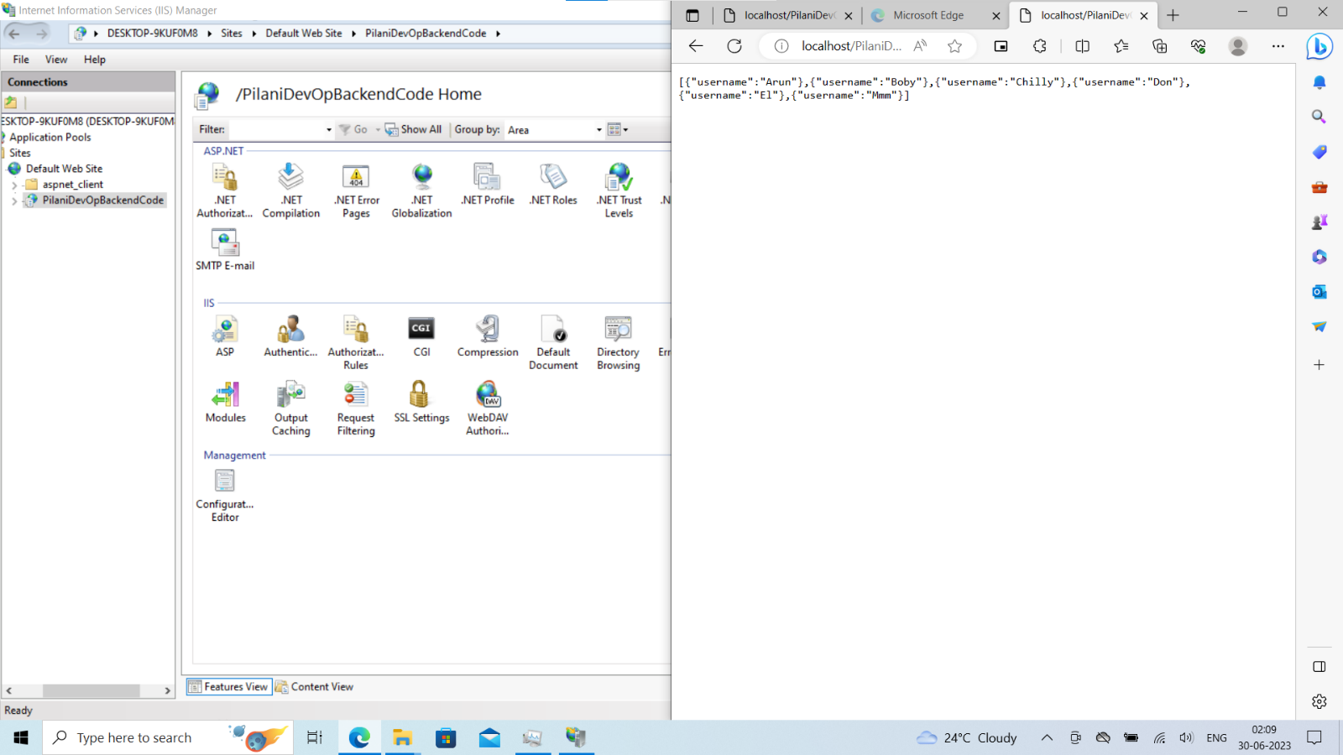 and we can test that by using following command:-

curl http://192.168.87.1/PilaniDevOpBackendCode/user 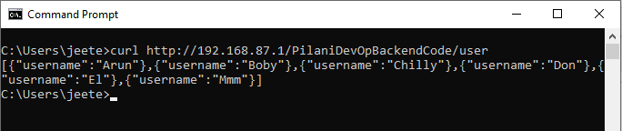

Result : We completed backend code Jenkins CICD automation.