Jenkins Automation for front end

[Agile and DevOps (FSE_Oct_2022_C5_CFSEZG551)](https://bits-pilani.instructure.com/courses/2061)

FSE Oct 2022 (Cohort 3)

1. My git repo: <https://github.com/jeetendraprasad/RatingApp_Client.git> 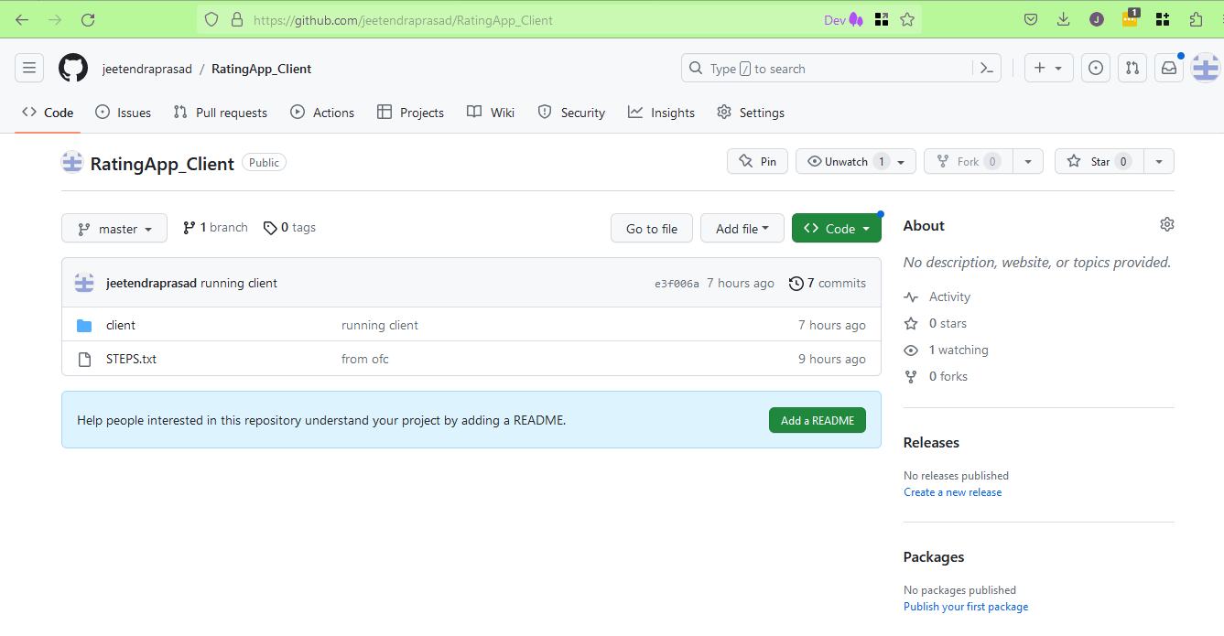 This is my front-end project.
2. I also have the local repo at my local system at folder Q:\HOMEPATH\github\RatingApp_Client\client. This is seen in explorer as 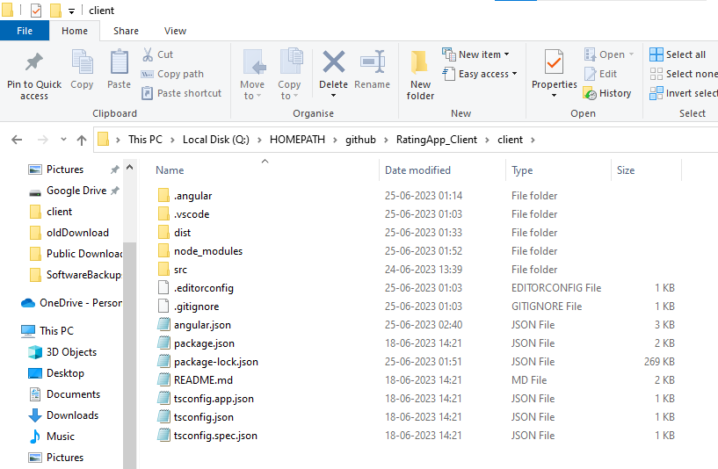
3. I have also set up a remote windows system **as a server** with ip as username@hostname as development@192.168.x.y. We have passwordless ssh login enabled between these two systems. So we will use scp to copy files to the server.
4. When I do local run as ‘ng serve’ this runs in browser at url <https://localhost:4200/> as 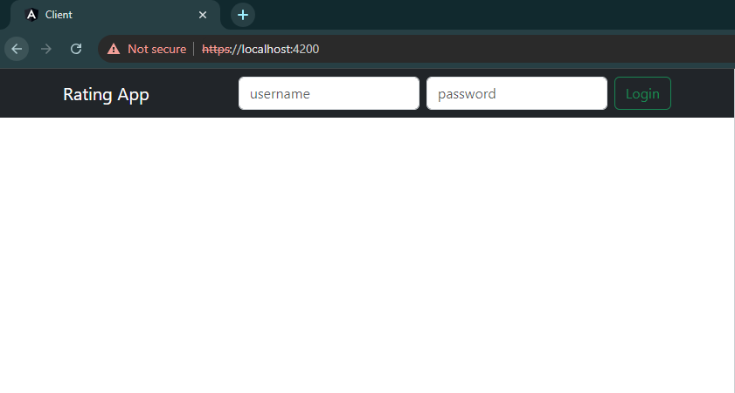
5. Now we create new job for front end with steps:
   1. WIP
6. WIP