ANIL NEERUKONDA INSTITUTE OF TECHNOLOGY AND

SCIENCES
Department of Computer Science and Engineering(AI&ML)

LAB RECORD
FULL STACK WEB DEVELOPMENT LAB
Name : JAMI VISHNUPRIYA
Registration No. : A24126552143

INDEX
S.No. | Description of the Experiment | CO | Week | Date / Sign
1 | Design Static Webpage using HTML Components | CO1 | 1
2 | Design Webpage using HTML5 & CSS3 | CO1 | 1
3 | Write a program using JavaScript (arrays, functions) | CO1 | 2
4 | Develop Dynamic Webpage using JavaScript | CO1 | 2
5 | Implement Modules in NodeJS | CO2 | 3
6 | Develop mini application using Express and NodeJS | CO2 | 3
7 | Create a Functional component and class component using React | CO3 | 4
8 | Implement http methods using JSON server | CO3 | 4
9 | Develop CRUD operations using  MongoDB | CO4 | 5
10 | Develop Main Project using Express, React and MongoDB/MySql | CO4 | 5

EXPERIMENT 1

Design Static Webpage using HTML Components
Course Outcome: CO1

Aim
To design a static webpage that uses the common HTML components: headings, paragraphs, text formatting, images, links, lists, tables and forms.

Question
Design a static web page for a department that contains navigation links, formatted text, an image, ordered/unordered/definition lists, a timetable table and a contact form.
Software / Tools Required
VS Code (or any text editor), Google Chrome / any web browser

Procedure
- Create a folder exp-01-static-html and open it in VS Code.
- Create index.html with the HTML5 document skeleton (DOCTYPE, html, head, body).
- Add headings, paragraphs, formatting tags (b, i, u, mark, sub, sup), blockquote and pre.
- Add the logo image (logo.svg) using the img tag and anchor links using the a tag.
- Add ul, ol and dl lists, then a table using thead, tbody, th, td and colspan.
- Add a form with text, email, radio, checkbox, select, textarea, submit and reset controls.
- Open index.html in the browser and verify every component.

Program

File: index.html
<!DOCTYPE html>
<html lang="en">
<head>
<meta charset="UTF-8">
<meta name="viewport" content="width=device-width, initial-scale=1.0"> <title>Experiment 1 - Static Webpage using HTML Components</title>
</head>
<body bgcolor="#f5f7fa">

<h1 align="center">Department of Computer Science and Engineering</h1> <h3 align="center"><i>Static Webpage using HTML Components</i></h3>
<hr>

<!-- Navigation links -->
<p align="center">
<a href="#about">About</a> |
<a href="#courses">Courses</a> |
<a href="#timetable">Timetable</a> |
<a href="#contact">Contact</a> |
<a href="https://www.w3.org/html/" target="_blank">HTML Spec</a>
</p>
<hr>

<!-- Headings, paragraphs and text formatting -->

<h2 id="about">About the Department</h2>
<p> The department offers <b>B.Tech</b> in <i>Computer Science and Engineering</i>.
Students learn <u>programming</u>, <mark>web technologies</mark>, databases and H<sub>2</sub>O-level basics of networking. Famous equation: E = mc<sup>2</sup>.
</p>
<blockquote>"Programs must be written for people to read." &mdash; Harold
Abelson</blockquote>
<pre>
function hello() {
console.log("Hello, HTML!");
}
</pre>

<!-- Image -->
<h2>Campus Logo</h2>
<img src="logo.svg" alt="Department logo" width="160" height="160">

<!-- Lists -->
<h2 id="courses">Courses Offered</h2>
<h4>Unordered list</h4>
<ul>
<li>Programming in C</li>
<li>Data Structures</li>
<li>Database Management Systems</li>
</ul>
<h4>Ordered list</h4>
<ol>
<li>HTML</li>
<li>CSS</li>
<li>JavaScript</li>
</ol>
<h4>Definition list</h4>
<dl>
<dt>HTML</dt><dd>HyperText Markup Language</dd>
<dt>CSS</dt><dd>Cascading Style Sheets</dd>
</dl>

<!-- Table -->
<h2 id="timetable">Class Timetable</h2>
<table border="1" cellpadding="8" cellspacing="0" width="80%">
<caption><b>Weekly Timetable</b></caption>
<thead bgcolor="#cfe2ff">
<tr><th>Day</th><th>9:00 - 10:00</th><th>10:00 - 11:00</th><th>11:15 - 12:15</th></tr>
</thead>
<tbody>
<tr><td>Monday</td><td>FS</td><td>DBMS</td><td>ML</td></tr>
<tr><td>Tuesday</td><td>ML</td><td>FS Lab</td><td colspan="1">FS Lab</td></tr>
<tr><td>Wednesday</td><td>DBMS</td><td>OOSE</td><td>FS</td></tr>
</tbody>
</table>

<!-- Form -->
<h2 id="contact">Contact Form</h2>
<form action="#" method="post">
<p><label for="name">Name:</label> <input type="text" id="name" name="name" placeholder="Enter your name"></p>
<p><label for="email">Email:</label> <input type="email" id="email" name="email" placeholder="you@example.com"></p>
<p>Gender:
<input type="radio" name="g" value="m" checked> Male
<input type="radio" name="g" value="f"> Female
</p> <p>Interests:
<input type="checkbox" checked> Web
<input type="checkbox"> AI
<input type="checkbox"> Cloud
</p>
<p><label for="year">Year:</label>
<select id="year" name="year">
<option>First</option><option>Second</option><option selected>Third</option><option>Fourth</option>
</select>
</p>
<p><label for="msg">Message:</label><br>
<textarea id="msg" rows="3" cols="40">Hello!</textarea></p>
<p><input type="submit" value="Submit"> <input type="reset" value="Reset"></p>
</form>

<hr>
<p align="center"><small>&copy; 2026 Department of CSE</small></p>
</body>
</html>

File: logo.svg
<svg xmlns="http://www.w3.org/2000/svg" viewBox="0 0 160 160" width="160" height="160">
<circle cx="80" cy="80" r="76" fill="#1e3a8a"/>
<circle cx="80" cy="80" r="62" fill="none" stroke="#fbbf24" stroke-width="4"/>
<text x="80" y="92" font-family="Georgia, serif" font-size="38" font-weight="bold" fill="#ffffff" text-anchor="middle">CSE</text>
<text x="80" y="118" font-family="Georgia, serif" font-size="12" fill="#fbbf24" textanchor="middle">DEPARTMENT</text> </svg>
How to Run
Open index.html in a browser.

Output (Screenshots)
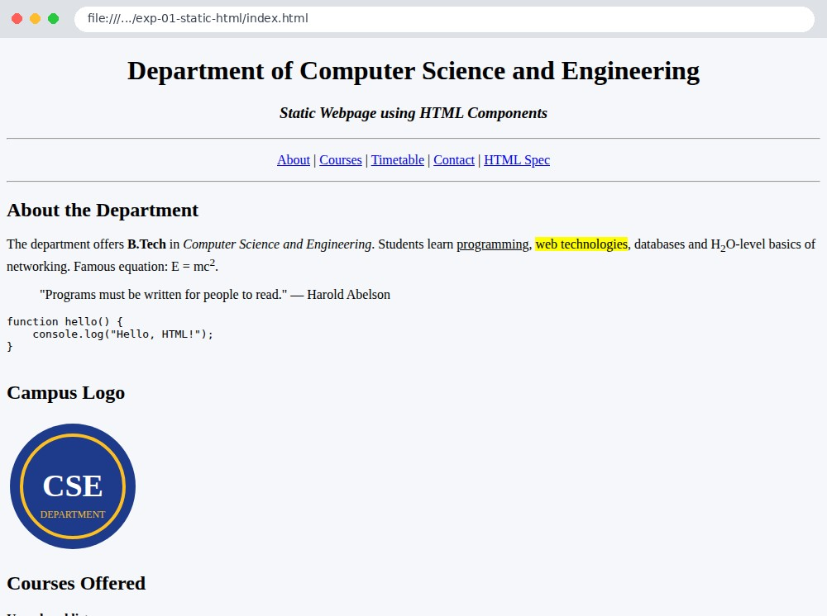
Fig 1.1 Top of the page - headings, formatted text, image and lists
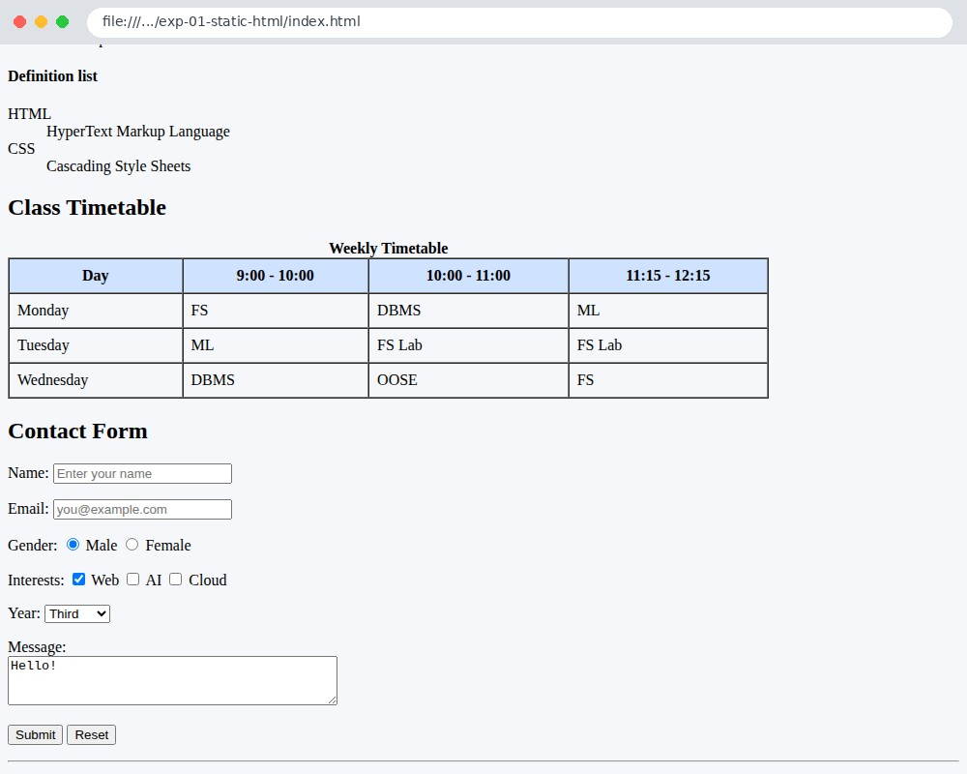
Fig 1.2 Lower part of the page - table and form

Result
A static webpage using the major HTML components was designed and displayed successfully in the browser.

EXPERIMENT 2

Design Webpage using HTML5 & CSS3
Course Outcome: CO1

Aim
To design a responsive webpage using HTML5 semantic elements and CSS3 features such as flexbox, grid, gradients, transitions and media queries.

Question
Create a responsive landing page using semantic tags (header, nav, main, section, article, aside, footer) styled with an external CSS3 stylesheet that uses variables, flexbox, grid, gradients, hover transitions and a media query for mobile screens.
Software / Tools Required
VS Code, Google Chrome (with Developer Tools device toolbar)

Procedure
- Create index.html using HTML5 semantic elements.
- Create style.css and link it using the link tag.
- Define colour variables in :root and apply a CSS reset.
- Style the header navigation and cards using flexbox; the gallery using CSS grid.
- Add linear-gradient hero section, box-shadow, border-radius and :hover transitions.
- Add an @media (max-width: 600px) block for small screens.
- Open the page on desktop width and in mobile view to test responsiveness.

Program

File: index.html
<!DOCTYPE html>
<html lang="en">
<head>
<meta charset="UTF-8">
<meta name="viewport" content="width=device-width, initial-scale=1.0">
<title>Experiment 2 - HTML5 and CSS3</title>
<link rel="stylesheet" href="style.css">
</head>
<body>
<header class="site-header">
<h1>TechVerse</h1>
<nav>
<a href="#features">Features</a>
<a href="#gallery">Gallery</a>
<a href="#signup">Sign Up</a>
</nav>
</header>

<main>
<section class="hero">
<h2>Learn Full Stack Development</h2>
<p>HTML5 semantic tags + CSS3 flexbox, grid, gradients, transitions and media queries.</p>
<a class="btn" href="#signup">Get Started</a>
</section>

<section id="features">
<h2>Features</h2>
<div class="cards">
<article class="card"><h3>Semantic HTML5</h3><p>header, nav, main, section, article, aside, footer.</p></article>
<article class="card"><h3>Responsive Layout</h3><p>Flexbox, CSS Grid and media queries adapt to any screen.</p></article>
<article class="card"><h3>CSS3 Effects</h3><p>Gradients, shadows, rounded corners, transitions, transforms.</p></article>
</div>
</section>

<section id="gallery">
<h2>Gallery (CSS Grid)</h2>
<div class="grid">
<div class="tile t1">HTML</div>
<div class="tile t2">CSS</div>
<div class="tile t3">JS</div>
<div class="tile t4">Node</div>
<div class="tile t5">React</div>
<div class="tile t6">Mongo</div>
</div>
</section>

<section id="signup">
<h2>Sign Up</h2>
<form class="form">
<input type="text" placeholder="Full name" required>
<input type="email" placeholder="Email" required>
<input type="date">
<input type="range" min="0" max="10" value="6">
<button type="submit">Register</button>
</form>
</section>
</main>

<aside class="note">HTML5 &amp; CSS3 demo page</aside>
<footer><p>&copy; 2026 TechVerse &middot; Built with HTML5 &amp; CSS3</p></footer>
</body>
</html>

File: style.css
:root { --primary: #4f46e5; --accent: #06b6d4; --dark: #111827; --light: #f3f4f6; }
* { box-sizing: border-box; margin: 0; padding: 0; }
body { font-family: "Segoe UI", Arial, sans-serif; background: var(--light); color: var(-dark); line-height: 1.6; }

/* Header + flexbox nav */
.site-header { display: flex; justify-content: space-between; align-items: center; padding: 16px 40px; background: var(--dark); color: #fff; }
.site-header nav a { color: #e5e7eb; text-decoration: none; margin-left: 24px; transition: color .3s; }
.site-header nav a:hover { color: var(--accent); }

/* Hero: gradient background */
.hero { text-align: center; padding: 80px 20px; color: #fff;
background: linear-gradient(135deg, var(--primary), var(--accent)); }
.hero h2 { font-size: 2.4rem; margin-bottom: 12px; }
.btn { display: inline-block; margin-top: 20px; padding: 12px 28px; border-radius: 30px; background: #fff; color: var(--primary); font-weight: 600; text-decoration: none; transition: transform .3s, box-shadow .3s; }
.btn:hover { transform: translateY(-4px) scale(1.05); box-shadow: 0 10px 20px rgba(0,0,0,.25); }
section { padding: 40px; }
section > h2 { text-align: center; margin-bottom: 24px; }

/* Cards: flexbox */
.cards { display: flex; gap: 24px; flex-wrap: wrap; justify-content: center; } .card { flex: 1 1 250px; max-width: 320px; background: #fff; padding: 24px; border-radius:
14px; box-shadow: 0 4px 14px rgba(0,0,0,.1); border-top: 5px solid var(--primary); transition: transform .3s; }
.card:hover { transform: translateY(-8px); }

/* Gallery: CSS grid */
.grid { display: grid; grid-template-columns: repeat(3, 1fr); gap: 16px; max-width: 800px; margin: auto; } .tile { height: 110px; display: flex; align-items: center; justify-content: center; color: #fff; font-size: 1.4rem; font-weight: 700; border-radius: 12px; transition: transform .3s; }
.tile:hover { transform: rotate(-3deg) scale(1.06); }
.t1 { background: #e44d26; } .t2 { background: #264de4; } .t3 { background: #f0a500; } .t4 { background: #3c873a; } .t5 { background: #0ea5e9; } .t6 { background: #10b981; }

/* Form */
.form { max-width: 420px; margin: auto; display: flex; flex-direction: column; gap: 14px; }
.form input { padding: 12px; border: 2px solid #d1d5db; border-radius: 8px; font-size: 1rem; transition: border-color .3s; }
.form input:focus { outline: none; border-color: var(--primary); }
.form button { padding: 12px; border: none; border-radius: 8px; background: var(--primary); color: #fff; font-size: 1rem; cursor: pointer; transition: background .3s; }
.form button:hover { background: #3730a3; }

.note { position: fixed; right: 16px; bottom: 60px; background: #fef3c7; padding: 8px 14px; border-radius: 8px; font-size: .85rem; box-shadow: 0 2px 8px rgba(0,0,0,.15); } footer { background: var(--dark); color: #9ca3af; text-align: center; padding: 18px; }

/* Responsive: media query */
@media (max-width: 600px) {
.site-header { flex-direction: column; gap: 8px; padding: 14px; }
.site-header nav a { margin: 0 10px; }
.hero h2 { font-size: 1.6rem; }
.grid { grid-template-columns: repeat(2, 1fr); } section { padding: 24px 16px; }
}
How to Run
Open index.html in a browser.

Output (Screenshots)
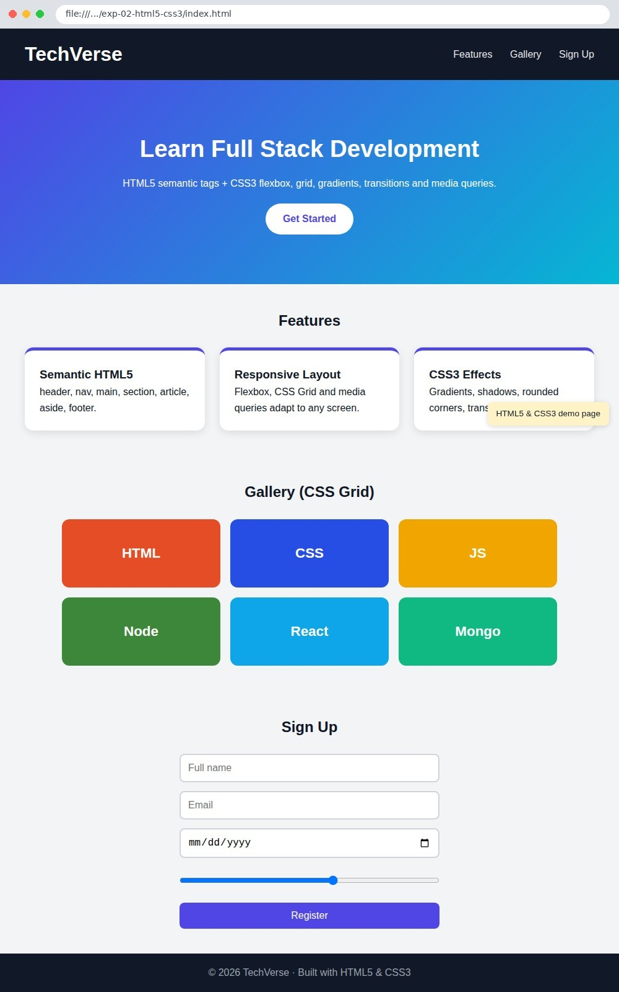
Fig 2.1 Desktop view of the page
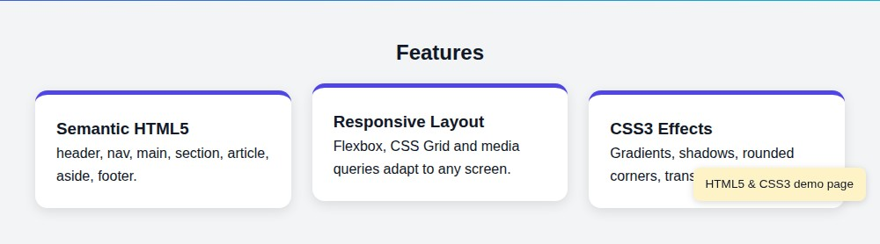
Fig 2.2 Hover effect (card lifts on mouse-over)
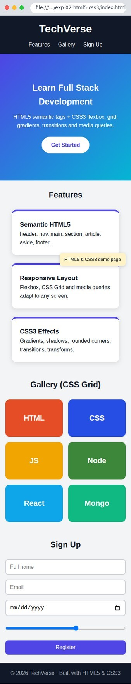
Fig 2.3 Mobile view (390 px) after the media query is applied
Result
A responsive webpage was designed using HTML5 semantic tags and CSS3 features.

EXPERIMENT 3

Write a program using JavaScript (arrays, functions) Course Outcome: CO1
Aim
To write JavaScript programs that demonstrate arrays and functions.

Question
- Write a JavaScript program to perform array operations: add/remove elements, search, slice, splice, sort, map, filter, reduce and 2D arrays.
- Write a JavaScript program to demonstrate function declarations, expressions, arrow functions, default/rest parameters, recursion, callbacks and closures.
Software / Tools Required
Node.js (to run the JavaScript files), VS Code

Procedure
- Create arrays.js and write the array operations and higher-order array methods.
- Create functions.js and write the different kinds of functions.
- Run each program in the terminal using node arrays.js and node functions.js.
- Observe and record the output.

Program

File: arrays.js
// Experiment 3(a): Arrays in JavaScript const fruits = ["apple", "banana", "cherry"]; console.log("Original array :", fruits);

fruits.push("mango"); // add at end fruits.unshift("kiwi"); // add at start console.log("After push/unshift :", fruits);

fruits.pop(); // remove from end fruits.shift(); // remove from start console.log("After pop/shift :", fruits);

fruits.splice(1, 0, "grape"); // insert at index 1 console.log("After splice insert :", fruits);
console.log("Index of cherry :", fruits.indexOf("cherry")); console.log("Includes banana? :", fruits.includes("banana")); console.log("slice(1, 3) :", fruits.slice(1, 3)); console.log("join with ' | ' :", fruits.join(" | ")); console.log("reverse :", [...fruits].reverse()); console.log("sorted :", [...fruits].sort());

const marks = [78, 92, 45, 67, 88, 34, 59]; console.log("\nMarks :", marks);
console.log("map (+5 grace) :", marks.map(m => m + 5)); console.log("filter (passed >=50):", marks.filter(m => m >= 50)); console.log("reduce (sum) :", marks.reduce((s, m) => s + m, 0));
console.log("Highest / Lowest :", Math.max(...marks), "/", Math.min(...marks)); console.log("find (first > 80) :", marks.find(m => m > 80));
console.log("every >= 30? :", marks.every(m => m >= 30)); console.log("some > 90? :", marks.some(m => m > 90)); marks.forEach((m, i) => console.log(` Student ${i + 1}: ${m} -> ${m >= 50 ? "Pass" :
"Fail"}`));

const matrix = [[1, 2, 3], [4, 5, 6], [7, 8, 9]]; console.log("\n2D array :", matrix);
console.log("Diagonal :", matrix.map((row, i) => row[i])); console.log("Flattened :", matrix.flat());

File: functions.js
// Experiment 3(b): Functions in JavaScript

// 1. Function declaration
function add(a, b) { return a + b; }

// 2. Function expression
const multiply = function (a, b) { return a * b; };

// 3. Arrow function const square = n => n * n;

// 4. Default and rest parameters
function greet(name = "Guest") { return `Hello, ${name}!`; }
function sumAll(...nums) { return nums.reduce((s, n) => s + n, 0); }

// 5. Recursion
function factorial(n) { return n <= 1 ? 1 : n * factorial(n - 1); }
function fibonacci(n) { return n < 2 ? n : fibonacci(n - 1) + fibonacci(n - 2); }

// 6. Higher-order function / callback
function applyToArray(arr, fn) { return arr.map(fn); }

// 7. Closure
function makeCounter() { let count = 0;
return { inc: () => ++count, dec: () => --count, value: () => count };
}

// 8. Prime check using array of functions
const isPrime = n => { if (n < 2) return false; for (let i = 2; i * i <= n; i++) if (n % i
=== 0) return false; return true; };

console.log("add(5, 3) =", add(5, 3)); console.log("multiply(4, 6) =", multiply(4, 6)); console.log("square(9) =", square(9)); console.log("greet() =", greet()); console.log("greet('Jeetesh') =", greet("Jeetesh")); console.log("sumAll(1,2,3,4,5) =", sumAll(1, 2, 3, 4, 5)); console.log("factorial(6) =", factorial(6));
console.log("fibonacci(0..10) =", Array.from({ length: 11 }, (_, i) => fibonacci(i))); console.log("applyToArray(square) =", applyToArray([1, 2, 3, 4], square)); const c = makeCounter(); c.inc(); c.inc(); c.inc(); c.dec(); console.log("closure counter value =", c.value());
console.log("primes up to 30 =", Array.from({ length: 30 }, (_, i) => i +
1).filter(isPrime));
How to Run node arrays.js and node functions.js

Output (Screenshots)
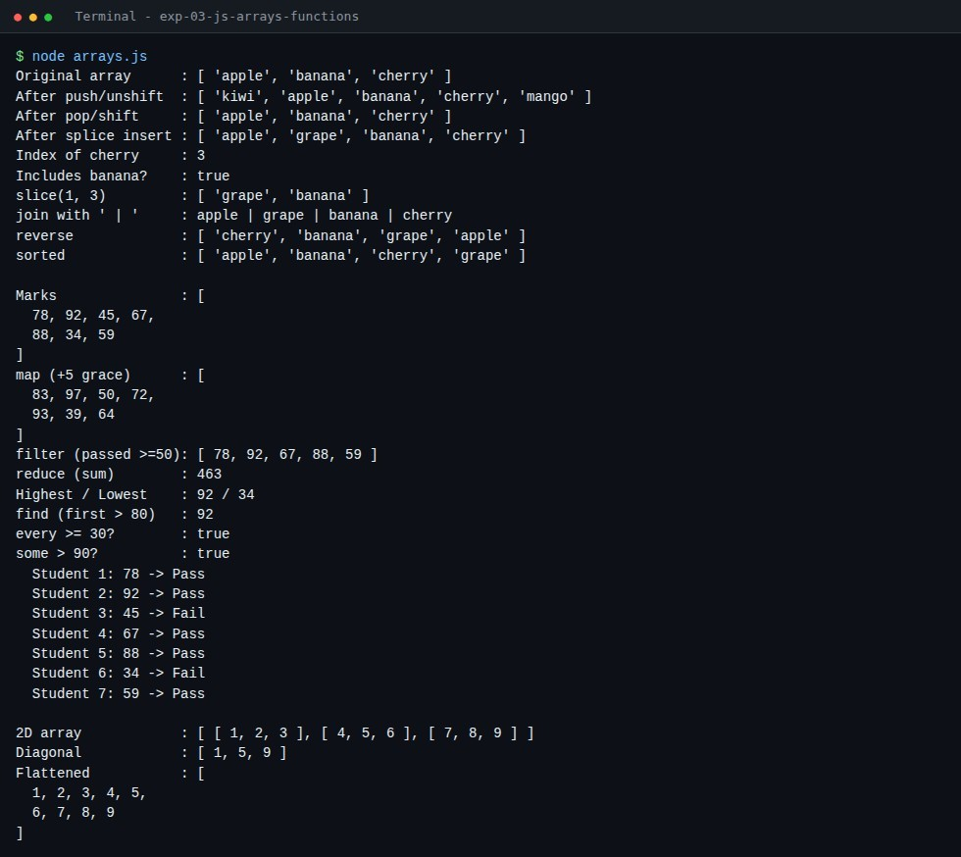

Fig 3.1 Output of arrays.js
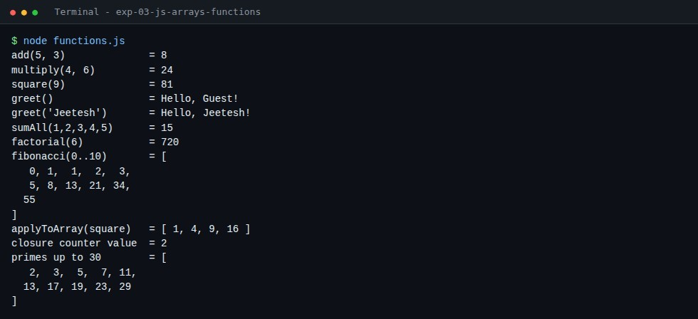
Fig 3.2 Output of functions.js
Result
JavaScript programs using arrays and functions were written and executed successfully.

EXPERIMENT 4

Develop Dynamic Webpage using JavaScript
Course Outcome: CO1

Aim
To develop a dynamic webpage using JavaScript with DOM manipulation, event handling and form validation.

Question
Develop a dynamic webpage that shows a live clock, validates a registration form, manages a to-do list (add, mark complete, delete) and toggles dark mode / random colour using JavaScript events.
Software / Tools Required
VS Code, Google Chrome

Procedure
- Create index.html with the form, to-do section and event section.
- Create style.css for layout and the dark-mode theme.
- Create script.js: update the clock using setInterval.
- Add the submit event listener to validate name, email (regular expression) and password.
- Create list items dynamically using createElement, appendChild, classList and remove().
- Add click events for dark mode and random colour.
- Open index.html and test each feature.

Program

File: index.html
<!DOCTYPE html>
<html lang="en">
<head>
<meta charset="UTF-8">
<meta name="viewport" content="width=device-width, initial-scale=1.0">
<title>Experiment 4 - Dynamic Webpage using JavaScript</title>
<link rel="stylesheet" href="style.css">
</head>
<body>
<div class="container">
<h1>Dynamic Webpage</h1>
<p class="clock" id="clock"></p>

<!-- 1. Registration form with validation -->
<section class="panel">
<h2>1. Form Validation</h2>
<form id="regForm" novalidate>
<input type="text" id="name" placeholder="Name (min 3 letters)">
<input type="email" id="email" placeholder="Email">
<input type="password" id="password" placeholder="Password (min 6 chars)">
<button type="submit">Register</button>
<p id="formMsg" class="msg"></p>
</form>
</section>

<!-- 2. Dynamic to-do list (DOM manipulation) -->
<section class="panel">
<h2>2. To-Do List (DOM manipulation)</h2>
<div class="row">
<input type="text" id="taskInput" placeholder="Add a task...">
<button id="addBtn">Add</button>
</div>
<ul id="taskList"></ul>
<p id="count" class="msg"></p>
</section>

<!-- 3. Event handling -->
<section class="panel">
<h2>3. Event Handling</h2>
<button id="themeBtn">Toggle Dark Mode</button>
<button id="colorBtn">Random Colour</button>
<div id="box" class="box">Click the buttons!</div>
</section>
</div>
<script src="script.js"></script>
</body>
</html>

File: style.css
* { box-sizing: border-box; } body { font-family: "Segoe UI", Arial, sans-serif; background: #eef2ff; margin: 0; padding:
30px; transition: background .3s, color .3s; } body.dark { background: #111827; color: #e5e7eb; }
.container { max-width: 640px; margin: auto; } h1 { text-align: center; margin-bottom: 4px; }
.clock { text-align: center; font-size: 1.1rem; color: #4f46e5; margin-top: 0; } body.dark .clock { color: #a5b4fc; }
.panel { background: #fff; border-radius: 12px; padding: 20px; margin: 18px 0; box-shadow: 0
3px 10px rgba(0,0,0,.1); }
body.dark .panel { background: #1f2937; } input { width: 100%; padding: 10px; margin: 6px 0; border: 2px solid #d1d5db; border-radius:
8px; font-size: 1rem; }
input.error { border-color: #dc2626; } input.ok { border-color: #16a34a; } button { padding: 10px 18px; border: 0; border-radius: 8px; background: #4f46e5; color:
#fff; cursor: pointer; font-size: .95rem; margin-top: 6px; } button:hover { background: #3730a3; }
.row { display: flex; gap: 8px; } .row button { margin-top: 6px; } ul { list-style: none; padding: 0; }
li { display: flex; justify-content: space-between; align-items: center; padding: 10px; border-bottom: 1px solid #e5e7eb; }
li.done span { text-decoration: line-through; color: #9ca3af; } li span { cursor: pointer; flex: 1; }
li button { background: #dc2626; padding: 4px 10px; margin: 0; }
.msg { font-size: .9rem; min-height: 1.2em; }
.msg.err { color: #dc2626; } .msg.good { color: #16a34a; } .box { margin-top: 14px; padding: 30px; text-align: center; border-radius: 10px; background:
#e0e7ff; color: #111827; font-weight: 600; transition: background .4s; }

File: script.js
// ---------- Live clock ---------const clock = document.getElementById("clock");
function updateClock() { clock.textContent = "Current time: " + new
Date().toLocaleTimeString(); }
updateClock(); setInterval(updateClock, 1000);

// ---------- 1. Form validation ----------

const form = document.getElementById("regForm"); const formMsg = document.getElementById("formMsg");
function mark(input, valid) { input.className = valid ? "ok" : "error"; return valid; }

form.addEventListener("submit", function (e) {
e.preventDefault();
const name = document.getElementById("name"); const email = document.getElementById("email"); const pass = document.getElementById("password"); const v1 = mark(name, name.value.trim().length >= 3);
const v2 = mark(email, /^[^\s@]+@[^\s@]+\.[^\s@]+$/.test(email.value)); const v3 = mark(pass, pass.value.length >= 6); if (v1 && v2 && v3) {
formMsg.className = "msg good";
formMsg.textContent = `Registration successful. Welcome, ${name.value.trim()}!`;
} else {
formMsg.className = "msg err";
formMsg.textContent = "Please correct the highlighted fields.";
}
});

// ---------- 2. To-do list ----------
const taskInput = document.getElementById("taskInput"); const taskList = document.getElementById("taskList"); const count = document.getElementById("count");

function updateCount() {
const total = taskList.children.length;
const done = taskList.querySelectorAll("li.done").length;
count.textContent = total ? `${done} of ${total} tasks completed` : "No tasks yet.";
}
function addTask() {
const text = taskInput.value.trim(); if (!text) return;
const li = document.createElement("li"); const span = document.createElement("span"); span.textContent = text;
span.addEventListener("click", () => { li.classList.toggle("done"); updateCount(); }); const del = document.createElement("button"); del.textContent = "Delete";
del.addEventListener("click", () => { li.remove(); updateCount(); }); li.append(span, del); taskList.appendChild(li); taskInput.value = ""; updateCount();
}
document.getElementById("addBtn").addEventListener("click", addTask);
taskInput.addEventListener("keydown", e => { if (e.key === "Enter") addTask(); }); updateCount();

// ---------- 3. Event handling ---------const box = document.getElementById("box");
document.getElementById("themeBtn").addEventListener("click", () => { document.body.classList.toggle("dark");
box.textContent = document.body.classList.contains("dark") ? "Dark mode ON" : "Dark mode
OFF";
});
document.getElementById("colorBtn").addEventListener("click", () => {
const c = "#" + Math.floor(Math.random() * 0xffffff).toString(16).padStart(6, "0"); box.style.background = c;
box.textContent = "Background colour: " + c;
});
How to Run
Open index.html in a browser.

Output (Screenshots)
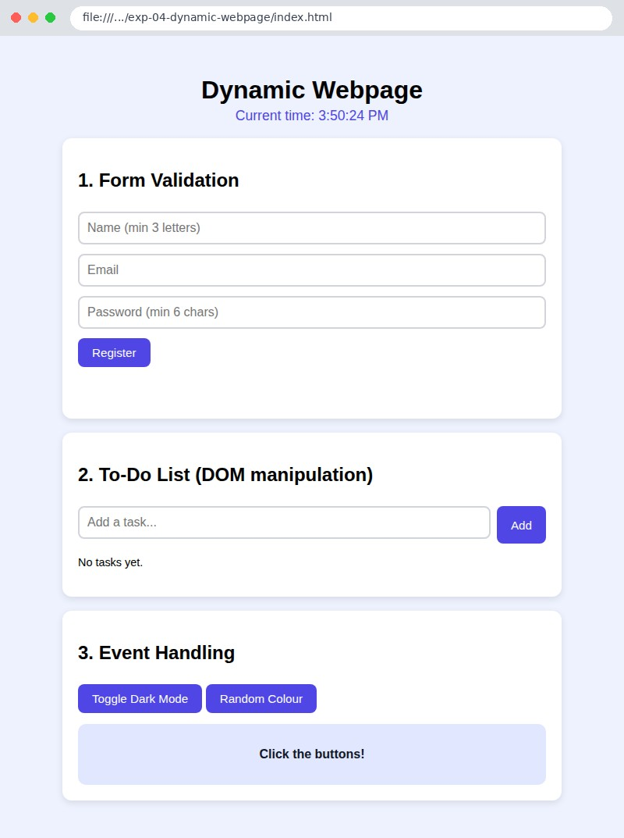
Fig 4.1 Initial page with live clock
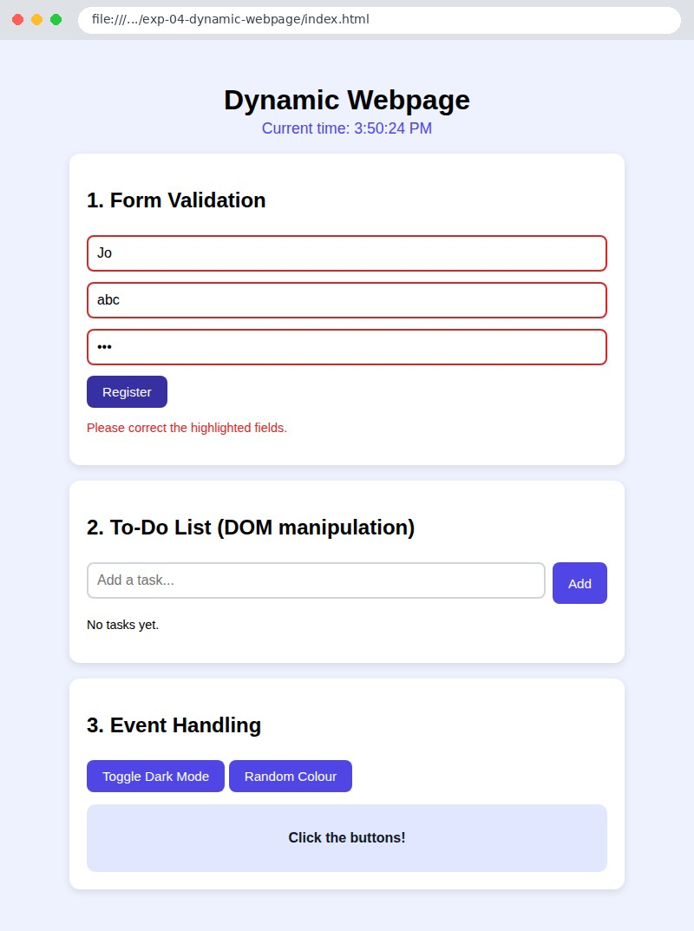

Fig 4.2 Form validation errors (invalid fields highlighted in red)
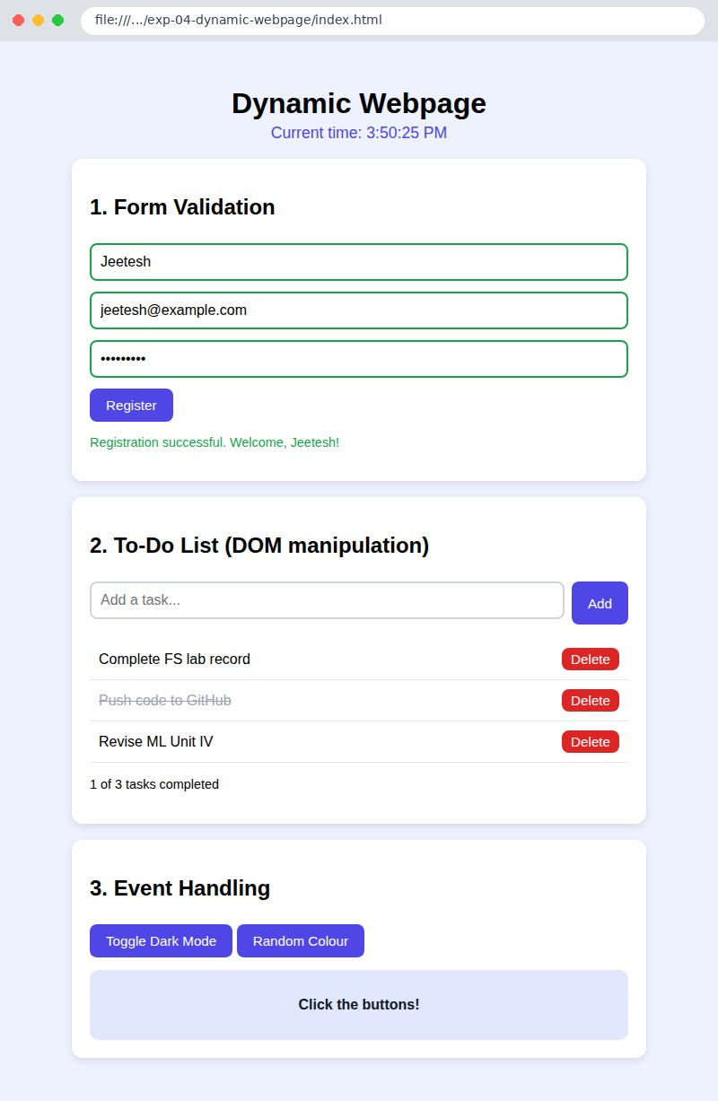

Fig 4.3 Successful registration and to-do list (one task completed)
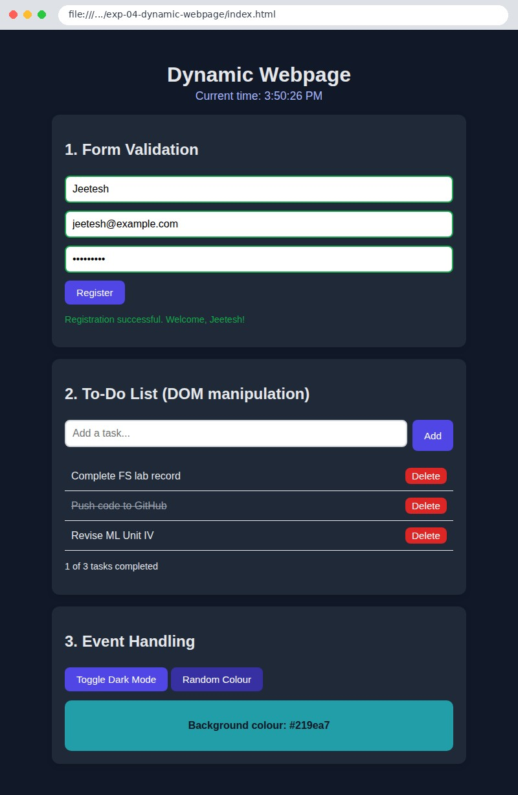
Fig 4.4 Dark mode and random colour events

Result
A dynamic webpage was developed using JavaScript DOM manipulation, events and validation.

EXPERIMENT 5

Implement Modules in NodeJS
Course Outcome: CO2

Aim
To implement user-defined and built-in modules in Node.js using CommonJS and ES modules.

Question
Create user-defined modules (functions, class, EventEmitter) and use them in a main program along with the core modules path, os, fs and events. Also create an ES module with named and default exports.
Software / Tools Required
Node.js (v18 or above), VS Code

Procedure
- Create the folder exp-05-nodejs-modules and run npm init -y (or create package.json).
- Create modules/calculator.js, greeter.js, Student.js and logger.js using module.exports / exports.
- Create app.js and import the modules using require().
- Use the core modules path, os, fs and events in app.js.
- Create modules/geometry.mjs (export) and app.mjs (import) for ES modules.
- Run node app.js and node app.mjs.

Program

File: modules/calculator.js
// CommonJS module: exports an object of functions using module.exports const add = (a, b) => a + b; const subtract = (a, b) => a - b; const multiply = (a, b) => a * b; const divide = (a, b) => {
if (b === 0) throw new Error("Division by zero is not allowed"); return a / b;
};

module.exports = { add, subtract, multiply, divide };

File: modules/greeter.js
// CommonJS module: using the exports shortcut exports.sayHello = function (name) {
return `Hello, ${name}! Welcome to Node.js modules.`;
};
exports.sayBye = function (name) { return `Goodbye, ${name}!`;
};

File: modules/Student.js
// CommonJS module: exporting a class class Student {
constructor(name, roll, marks) {
this.name = name; this.roll = roll; this.marks = marks;
} average() {
return this.marks.reduce((s, m) => s + m, 0) / this.marks.length;
} grade() {
const avg = this.average();
return avg >= 80 ? "A" : avg >= 60 ? "B" : avg >= 40 ? "C" : "F";
}
}
module.exports = Student;

File: modules/logger.js
// Module that extends the core 'events' module (EventEmitter) const EventEmitter = require("events");

class Logger extends EventEmitter { log(message) {
console.log("[LOG]", message);
this.emit("logged", { message, time: new Date().toISOString() });
}
}
module.exports = Logger;

File: app.js
// Experiment 5: Implementing Modules in Node.js (CommonJS)

// 1. User-defined modules
const calc = require("./modules/calculator");
const { sayHello, sayBye } = require("./modules/greeter"); const Student = require("./modules/Student"); const Logger = require("./modules/logger");

// 2. Core (built-in) modules const path = require("path"); const os = require("os"); const fs = require("fs");

console.log("========== 1. User-defined modules =========="); console.log("add(10, 5) =", calc.add(10, 5)); console.log("subtract(10, 5) =", calc.subtract(10, 5)); console.log("multiply(10, 5) =", calc.multiply(10, 5)); console.log("divide(10, 5) =", calc.divide(10, 5));
try { calc.divide(1, 0); } catch (e) { console.log("divide(1, 0) -> Error:", e.message); }
console.log(sayHello("Jeetesh")); console.log(sayBye("Jeetesh"));

const s = new Student("Ravi", "21A91A05", [78, 85, 90, 66]);
console.log(`Student ${s.name} (${s.roll}) average = ${s.average()}, grade = ${s.grade()}`);

console.log("\n========== 2. Core module: path =========="); const file = "/home/user/projects/app/index.html"; console.log("basename :", path.basename(file)); console.log("dirname :", path.dirname(file)); console.log("extname :", path.extname(file));
console.log("join :", path.join("folder", "sub", "file.txt"));

console.log("\n========== 3. Core module: os =========="); console.log("Platform :", os.platform()); console.log("CPU cores:", os.cpus().length);
console.log("Total RAM:", (os.totalmem() / 1024 ** 3).toFixed(1), "GB");

console.log("\n========== 4. Core module: fs =========="); const out = path.join(__dirname, "output.txt"); fs.writeFileSync(out, "Hello from the fs module!\n"); fs.appendFileSync(out, "This line was appended.\n");
console.log("File content:\n" + fs.readFileSync(out, "utf8").trim()); console.log("File exists :", fs.existsSync(out)); fs.unlinkSync(out);
console.log("File deleted :", !fs.existsSync(out));

console.log("\n========== 5. Core module: events =========="); const logger = new Logger();
logger.on("logged", (data) => console.log("Event received ->", data.message)); logger.log("Node.js modules experiment completed");

File: modules/geometry.mjs
// ES module: named exports + default export export const PI = 3.14159;
export const circleArea = (r) => PI * r * r; export const rectArea = (l, b) => l * b; export default function greeting() {
return "Hello from an ES module (default export)!";
}

File: app.mjs
// ES Module version (import / export)
import { PI, circleArea, rectArea } from "./modules/geometry.mjs"; import defaultGreeting from "./modules/geometry.mjs"; import { readFileSync } from "node:fs";

console.log("PI =", PI);
console.log("circleArea(5)=", circleArea(5).toFixed(2)); console.log("rectArea(4,6)=", rectArea(4, 6)); console.log(defaultGreeting());
console.log("Reading package.json using ES import:", JSON.parse(readFileSync("./package.json")).name);
How to Run node app.js and node app.mjs

Output (Screenshots)
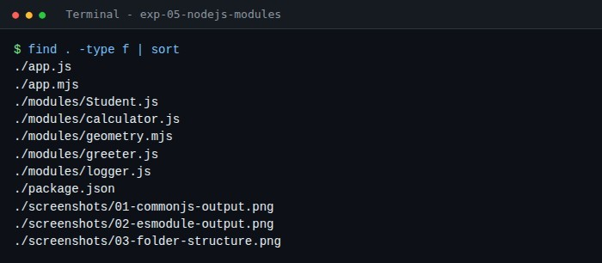
Fig 5.1 Project folder structure
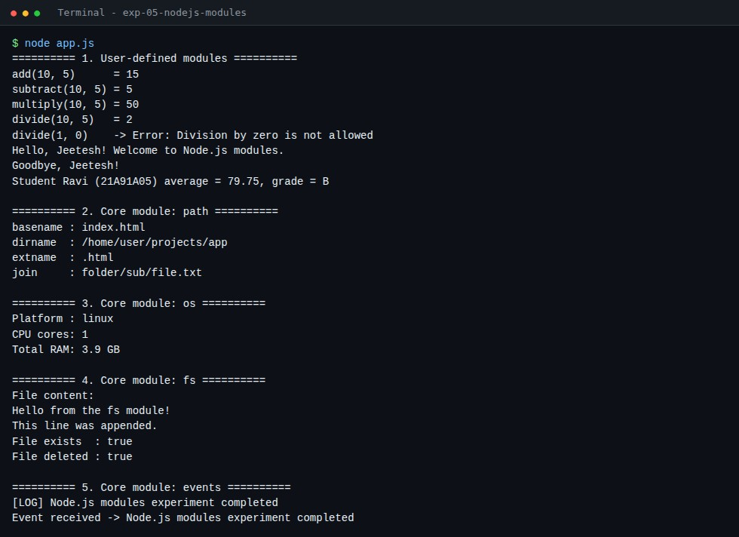

Fig 5.2 Output of app.js (CommonJS modules and core modules)
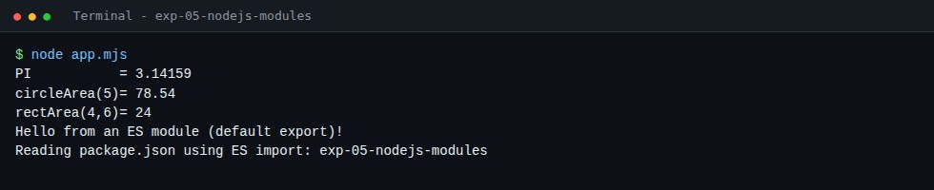
Fig 5.3 Output of app.mjs (ES modules)
Result
User-defined and core modules were implemented and executed successfully in Node.js.

EXPERIMENT 6

Develop mini application using Express and NodeJS Course Outcome: CO2

Aim
To develop a mini web application (Student Directory) using Express.js and Node.js with routing, middleware and a REST API.

Question
Develop a Student Directory application using Express that serves a static HTML front end and a REST API supporting GET (all, by id, filter), POST, PUT and DELETE with custom logger middleware and a 404 handler.
Software / Tools Required
Node.js, npm, Express, VS Code, Google Chrome

Procedure
- Create the folder and run npm init -y, then npm install express.
- Create server.js and add middleware: express.json(), express.urlencoded(), express.static() and a custom logger.
- Define the routes GET /api/students, GET /api/students/:id, POST, PUT and DELETE.
- Add a 404 handler and app.listen().
- Create public/index.html which calls the API using fetch().
- Start the server with npm start and open http://localhost:3000.
- Test the API with the browser and curl.

Program

File: package.json
{
"name": "exp-06-express-mini-app",
"version": "1.0.0",
"description": "Experiment 6 - Mini application using Express and Node.js",
"main": "server.js",
"scripts": { "start": "node server.js" },
"dependencies": { "express": "^4.19.2" },
"license": "ISC"
}

File: server.js
// Experiment 6: Mini application using Express and Node.js
// A small "Student Directory" with REST API + HTML front end. const express = require("express"); const path = require("path"); const app = express();
const PORT = process.env.PORT || 3000;

// ---------- Middleware ----------
app.use(express.json()); // parse JSON bodies app.use(express.urlencoded({ extended: true })); // parse form bodies app.use(express.static(path.join(__dirname, "public"))); // serve static files
app.use((req, res, next) => { // custom logger middleware console.log(`${new Date().toLocaleTimeString()} ${req.method} ${req.url}`); next();
});

// ---------- In-memory data ---------let students = [
{ id: 1, name: "Ravi Kumar", branch: "CSE", year: 3 },
{ id: 2, name: "Sneha Reddy", branch: "ECE", year: 2 }, { id: 3, name: "Arjun Varma", branch: "IT", year: 4 },
];
let nextId = 4;

// ---------- Routes ----------
app.get("/api/about", (req, res) => res.send("Student Directory API built with
Express.js"));

// READ all (with optional ?branch= filter) app.get("/api/students", (req, res) => { const { branch } = req.query; res.json(branch ? students.filter(s => s.branch.toLowerCase() === branch.toLowerCase()) : students);
});

// READ one (route parameter)
app.get("/api/students/:id", (req, res) => {
const s = students.find(x => x.id === Number(req.params.id));
s ? res.json(s) : res.status(404).json({ error: "Student not found" });
});

// CREATE (JSON or HTML form)
app.post("/api/students", (req, res) => { const { name, branch, year } = req.body;
if (!name || !branch || !year) return res.status(400).json({ error: "name, branch and year are required" });
const student = { id: nextId++, name, branch, year: Number(year) }; students.push(student); res.status(201).json(student);
});

// UPDATE
app.put("/api/students/:id", (req, res) => {
const s = students.find(x => x.id === Number(req.params.id)); if (!s) return res.status(404).json({ error: "Student not found" });
Object.assign(s, req.body, { id: s.id }); res.json(s);
});

// DELETE
app.delete("/api/students/:id", (req, res) => { const before = students.length;
students = students.filter(x => x.id !== Number(req.params.id)); before === students.length ? res.status(404).json({ error: "Student not found" }) : res.json({ message: "Deleted" });
});

// 404 handler
app.use((req, res) => res.status(404).send("404 - Page not found"));

app.listen(PORT, () => console.log(`Server running at http://localhost:${PORT}`));

File: public/index.html
<!DOCTYPE html>
<html lang="en">
<head>

<meta charset="UTF-8">
<title>Student Directory - Express App</title>
<style>
body { font-family: "Segoe UI", Arial, sans-serif; background: #f0fdf4; margin: 0; padding: 30px; }
.wrap { max-width: 720px; margin: auto; } h1 { color: #166534; text-align: center; }
.card { background: #fff; border-radius: 12px; padding: 20px; margin: 16px 0; boxshadow: 0 3px 10px rgba(0,0,0,.1); }
input, select { padding: 9px; margin: 4px 4px 4px 0; border: 2px solid #d1d5db; borderradius: 8px; font-size: 1rem; } button { padding: 9px 18px; background: #16a34a; color: #fff; border: 0; border-radius:
8px; cursor: pointer; font-size: 1rem; }
table { width: 100%; border-collapse: collapse; margin-top: 10px; } th, td { padding: 10px; text-align: left; border-bottom: 1px solid #e5e7eb; } th { background: #dcfce7; }
td button { background: #dc2626; padding: 4px 10px; }
</style>
</head>
<body>
<div class="wrap">
<h1>Student Directory</h1>
<div class="card">
<h3>Add Student</h3>
<input id="name" placeholder="Name">
<select
id="branch"><option>CSE</option><option>ECE</option><option>IT</option><option>EEE</ option></select>
<input id="year" type="number" min="1" max="4" placeholder="Year" style="width:80px">
<button onclick="addStudent()">Add</button>
</div>
<div class="card">
<h3>Students <small id="total"></small></h3>
<table>
<thead><tr><th>ID</th><th>Name</th><th>Branch</th><th>Year</th><th></th></tr></ thead>
<tbody id="rows"></tbody>
</table>
</div>
</div>
<script>
async function load() {
const res = await fetch("/api/students"); const data = await res.json();
document.getElementById("total").textContent = `(${data.length})`; document.getElementById("rows").innerHTML = data.map(s =>
`<tr><td>${s.id}</td><td>${s.name}</td><td>${s.branch}</td><td>${s.year}</td> <td><button onclick="del(${s.id})">Delete</button></td></tr>`).join("");
}
async function addStudent() {
const nameInput = document.getElementById("name"); const branchInput = document.getElementById("branch"); const yearInput = document.getElementById("year");
const body = { name: nameInput.value, branch: branchInput.value, year: yearInput.value }; await fetch("/api/students", { method: "POST", headers: { "Content-Type":
"application/json" }, body: JSON.stringify(body) }); nameInput.value = ""; yearInput.value = ""; load();
}
async function del(id) { await fetch("/api/students/" + id, { method: "DELETE" }); load(); } load(); </script>
</body>
</html>
How to Run npm install then npm start (open http://localhost:3000)

Output (Screenshots)
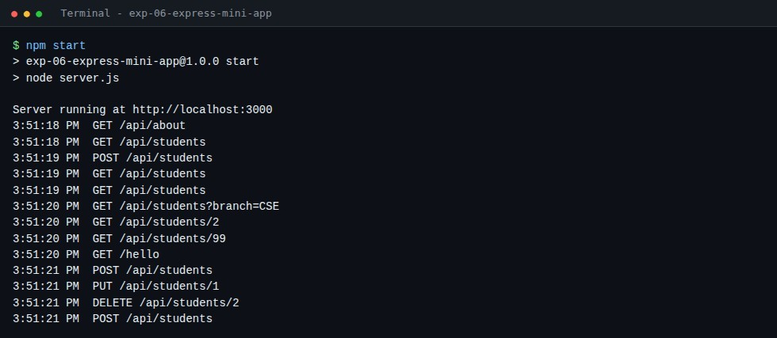
Fig 6.1 Server start-up and request log from the middleware
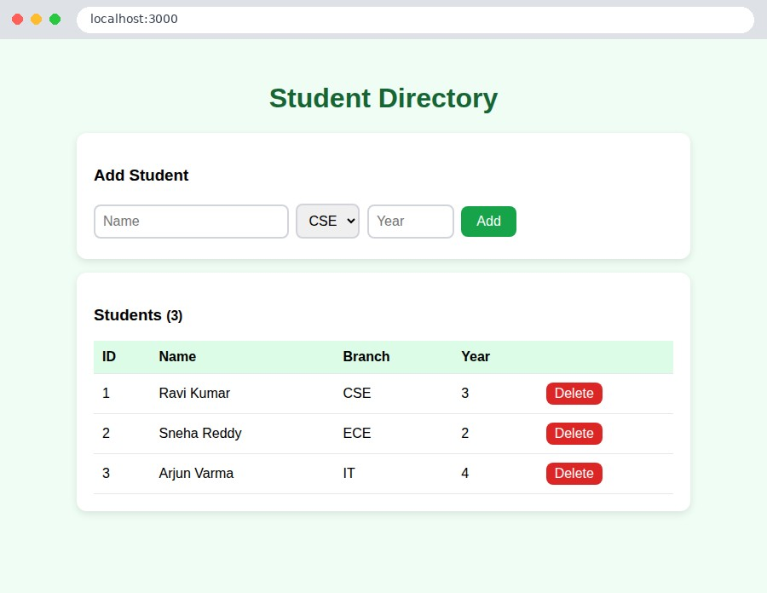

Fig 6.2 Student Directory front end
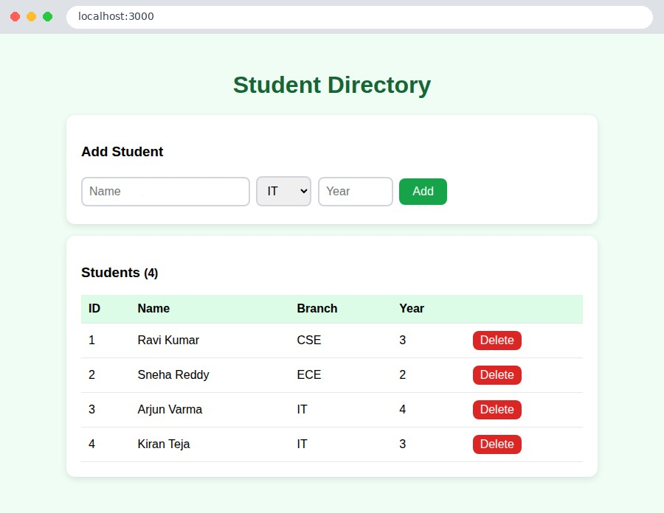

Fig 6.3 After adding a student (POST)
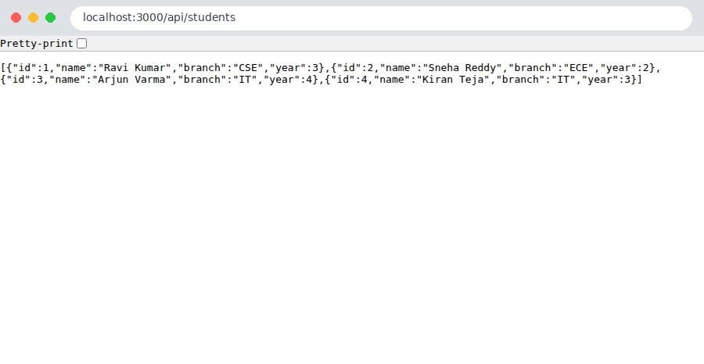

Fig 6.4 GET /api/students
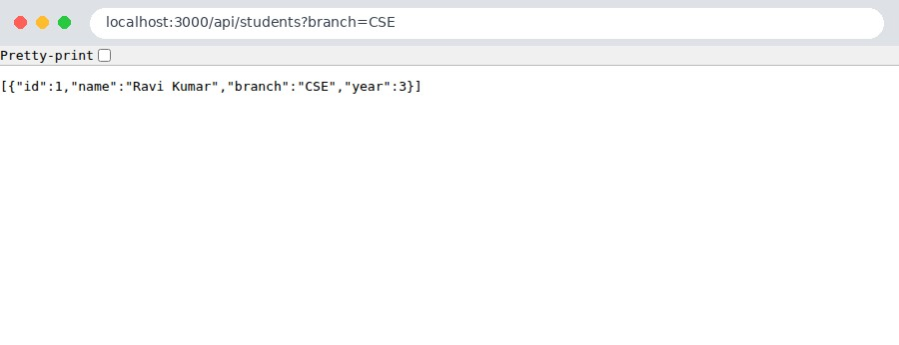

Fig 6.5 GET /api/students?branch=CSE (query string)
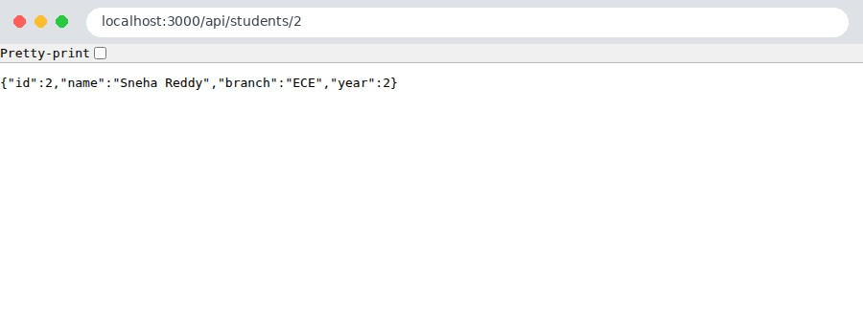

Fig 6.6 GET /api/students/2 (route parameter)
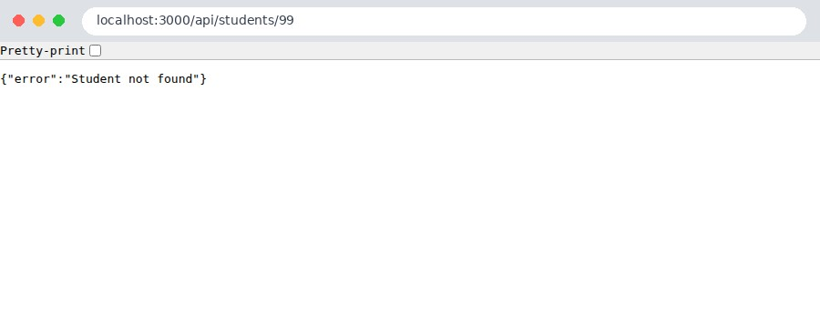

Fig 6.7 GET /api/students/99 - 404 JSON error
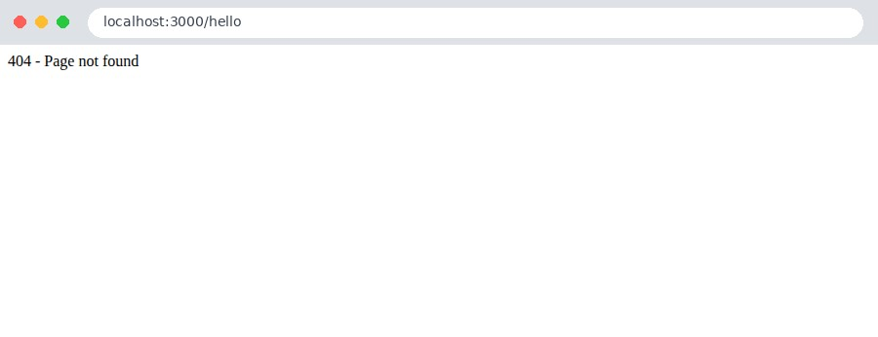

Fig 6.8 Unknown route - 404 handler
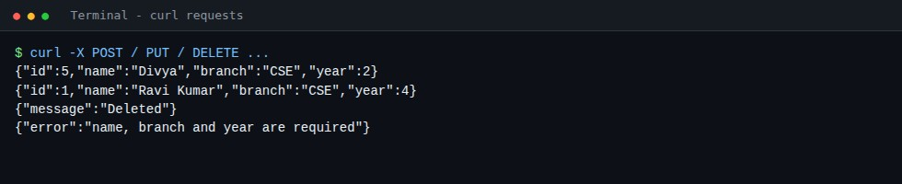
Fig 6.9 POST, PUT, DELETE and validation error tested with curl

Result
A mini application using Express and Node.js with routing, middleware and REST API was developed and tested.

EXPERIMENT 7

Create a Functional component and class component using React Course Outcome: CO3
Aim
To create functional and class components in React and use state and props.

Question
Create a React application (Vite) containing (a) a functional component with the useState hook, (b) a class component with this.state and this.setState, and (c) a reusable functional component that receives props.
Software / Tools Required
Node.js, npm, Vite, React 18, VS Code, Google Chrome

Procedure
- Create a Vite React project (npm create vite@latest) or use the provided package.json and run npm install.
- Create components/FunctionalCounter.jsx using the useState hook.
- Create components/ClassCounter.jsx extending React.Component with state, setState and event handlers.
- Create components/Profile.jsx that receives name, role and skills as props.
- Use all components in App.jsx and render App in main.jsx.
- Run npm run dev and open http://localhost:5173.

Program

File: src/main.jsx
import React from "react";
import ReactDOM from "react-dom/client"; import App from "./App.jsx"; import "./styles.css";

ReactDOM.createRoot(document.getElementById("root")).render(<App />);

File: src/App.jsx
import FunctionalCounter from "./components/FunctionalCounter.jsx"; import ClassCounter from "./components/ClassCounter.jsx"; import Profile from "./components/Profile.jsx";

export default function App() { return (
<div className="app">
<h1>React: Functional and Class Components</h1>
<div className="grid">
<section className="box">
<h2>Functional Component</h2>
<p className="tag">uses the useState hook</p>
<FunctionalCounter initial={0} />
</section>
<section className="box">
<h2>Class Component</h2>
<p className="tag">uses this.state and this.setState</p>
<ClassCounter initial={0} />
</section>
</div>
<section className="box">
<h2>Props - Reusable Profile Cards</h2>
<div className="grid">
<Profile name="Ravi Kumar" role="Frontend Developer" skills={["HTML", "CSS",
"React"]} />
<Profile name="Sneha Reddy" role="Backend Developer" skills={["Node", "Express",
"MongoDB"]} />
</div>
</section>
</div>
);
}

File: src/components/FunctionalCounter.jsx
import { useState } from "react";

// Functional component with state (useState hook) function FunctionalCounter({ initial }) { const [count, setCount] = useState(initial);

return (
<div className="counter">
<h3>Count: {count}</h3>
<button onClick={() => setCount(count + 1)}>Increment</button>
<button onClick={() => setCount(count - 1)}>Decrement</button>
<button className="reset" onClick={() => setCount(initial)}>Reset</button>
</div>
);
}
export default FunctionalCounter;

File: src/components/ClassCounter.jsx
import React, { Component } from "react";

// Class component with state (this.state / this.setState) class ClassCounter extends Component { constructor(props) { super(props);
this.state = { count: props.initial }; this.increment = this.increment.bind(this);
}

increment() {
this.setState({ count: this.state.count + 1 });
}

decrement = () => this.setState({ count: this.state.count - 1 });

reset = () => this.setState({ count: this.props.initial });

render() { return (
<div className="counter">
<h3>Count: {this.state.count}</h3>
<button onClick={this.increment}>Increment</button>
<button onClick={this.decrement}>Decrement</button>
<button className="reset" onClick={this.reset}>Reset</button>
</div>
);
}
}
export default ClassCounter;

File: src/components/Profile.jsx
// Functional component receiving props function Profile({ name, role, skills }) { return (
<div className="profile">
<div className="avatar">{name.charAt(0)}</div>
<h3>{name}</h3>
<p>{role}</p>
<ul>
{skills.map((s) => (
<li key={s}>{s}</li>
))}
</ul>
</div>
);
}
export default Profile;

File: src/styles.css
* { box-sizing: border-box; }
body { margin: 0; font-family: "Segoe UI", Arial, sans-serif; background: #f5f3ff; }
.app { max-width: 820px; margin: auto; padding: 30px 20px; } h1 { text-align: center; color: #5b21b6; }
.grid { display: grid; grid-template-columns: repeat(auto-fit, minmax(280px, 1fr)); gap:
18px; }
.box { background: #fff; border-radius: 14px; padding: 20px; margin: 18px 0; box-shadow: 0
3px 12px rgba(0,0,0,.1); }
.box h2 { margin: 0 0 4px; color: #4c1d95; }
.tag { margin: 0 0 12px; color: #7c3aed; font-size: .9rem; }
.counter { text-align: center; }
.counter h3 { font-size: 1.8rem; margin: 10px 0; }
button { padding: 8px 14px; margin: 3px; border: 0; border-radius: 8px; background: #7c3aed; color: #fff; cursor: pointer; font-size: .95rem; }
button:hover { background: #5b21b6; } button.reset { background: #6b7280; }
.profile { text-align: center; background: #faf5ff; padding: 16px; border-radius: 12px; }
.avatar { width: 56px; height: 56px; line-height: 56px; margin: auto; border-radius: 50%; background: #7c3aed; color: #fff; font-size: 1.5rem; font-weight: 700; }
.profile ul { list-style: none; padding: 0; display: flex; gap: 6px; justify-content: center; }
.profile li { background: #ede9fe; color: #5b21b6; padding: 3px 10px; border-radius: 20px; font-size: .85rem; }
How to Run npm install then npm run dev (open http://localhost:5173)

Output (Screenshots)
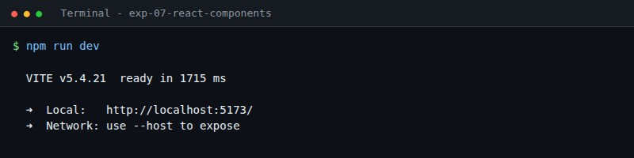

Fig 7.1 Vite development server running
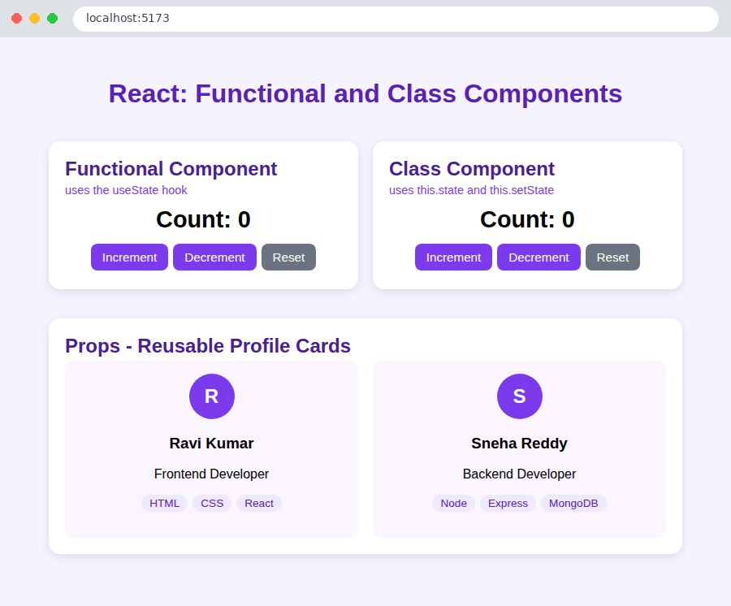

Fig 7.2 Initial output - both components at 0
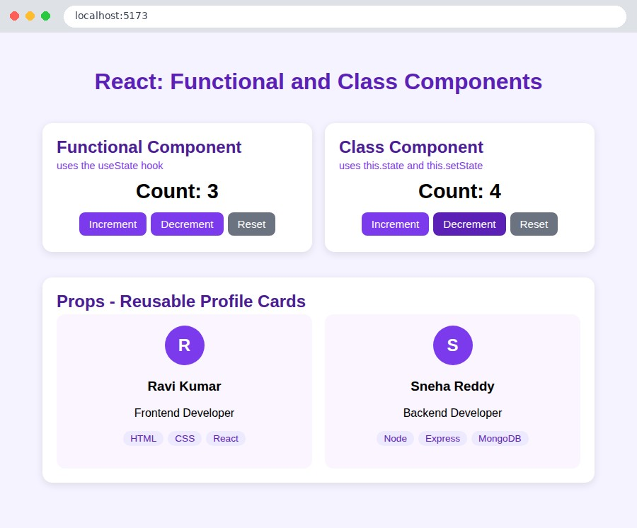
Fig 7.3 After clicking: functional counter = 3, class counter = 4

Result
Functional and class components were created in React and the output was verified in the browser.

EXPERIMENT 8

Implement http methods using JSON server
Course Outcome: CO3

Aim
To implement the HTTP methods GET, POST, PUT, PATCH and DELETE using JSON Server as a fake REST API.

Question
Create a db.json file with students and courses, start JSON Server and perform GET, POST, PUT, PATCH and DELETE operations using curl and a JavaScript fetch() client page.
Software / Tools Required
Node.js, npm, json-server 0.17, curl, VS Code, Google Chrome

Procedure
- Create db.json with the collections students and courses.
- Install JSON Server: npm install json-server@0.17.4 (or npm install in the folder).
- Start it using npx json-server --watch db.json --port 3001.
- Test every method with curl (GET, POST, PUT, PATCH, DELETE and a filter query).
- Create index.html with buttons that call the API using fetch().
- Open index.html, click each button and observe the status code and response.

Program

File: db.json
{
"students": [
{ "id": 1, "name": "Ravi Kumar", "branch": "CSE", "cgpa": 8.4 },
{ "id": 2, "name": "Sneha Reddy", "branch": "ECE", "cgpa": 9.1 }, { "id": 3, "name": "Arjun Varma", "branch": "IT", "cgpa": 7.6 }
],
"courses": [
{ "id": 1, "title": "Full Stack Development", "credits": 3 },
{ "id": 2, "title": "Machine Learning", "credits": 3 }
]
}

File: index.html
<!DOCTYPE html>
<html lang="en">
<head>
<meta charset="UTF-8">
<title>JSON Server - HTTP Methods</title>
<style>
body { font-family: "Segoe UI", Arial, sans-serif; background: #fff7ed; margin: 0; padding: 30px; }
.wrap { max-width: 760px; margin: auto; } h1 { text-align: center; color: #9a3412; }
.bar { display: flex; gap: 8px; flex-wrap: wrap; justify-content: center; margin: 16px
0; } button { padding: 10px 18px; border: 0; border-radius: 8px; color: #fff; font-weight:
600; cursor: pointer; }
.get { background: #2563eb; } .post { background: #16a34a; } .put { background: #d97706;
}
.patch { background: #7c3aed; } .delete { background: #dc2626; }
pre { background: #1f2937; color: #a7f3d0; padding: 16px; border-radius: 10px; minheight: 160px; overflow: auto; }
#status { font-weight: 700; text-align: center; }
</style>
</head>
<body>
<div class="wrap">
<h1>HTTP Methods with JSON Server</h1>
<div class="bar">
<button class="get" onclick="run('GET')">GET</button>
<button class="post" onclick="run('POST')">POST</button>
<button class="put" onclick="run('PUT')">PUT</button>
<button class="patch" onclick="run('PATCH')">PATCH</button> <button class="delete" onclick="run('DELETE')">DELETE</button>
</div>
<p id="status">Click a method to send a request to http://localhost:3001/students</p>
<pre id="out">Response will appear here...</pre>
</div>
<script>
const BASE = "http://localhost:3001/students"; const headers = { "Content-Type": "application/json" }; let lastId = null; async function run(method) {
let url = BASE, options = { method, headers }; if (method === "POST") options.body = JSON.stringify({ name: "Kiran Teja", branch:
"CSE", cgpa: 8.0 });
if (method === "PUT") { url += "/1"; options.body = JSON.stringify({ name: "Ravi
Kumar", branch: "CSE", cgpa: 9.0 }); }
if (method === "PATCH") { url += "/2"; options.body = JSON.stringify({ cgpa: 9.5 }); } if (method === "DELETE") { url += "/3"; } const res = await fetch(url, options); const text = await res.text();
document.getElementById("status").textContent = `${method} ${url} -> ${res.status} $
{res.statusText}`;
document.getElementById("out").textContent = text ? JSON.stringify(JSON.parse(text), null, 2) : "(empty response body)";
}
</script>
</body>
</html>

File: package.json
{
"name": "exp-08-json-server-http",
"version": "1.0.0",
"description": "Experiment 8 - Implement HTTP methods using JSON Server",
"scripts": { "start": "json-server --watch db.json --port 3001" },
"devDependencies": { "json-server": "^0.17.4" },
"license": "ISC"
}

How to Run
npm install then npm start (API at http://localhost:3001) and open index.html

Output (Screenshots)
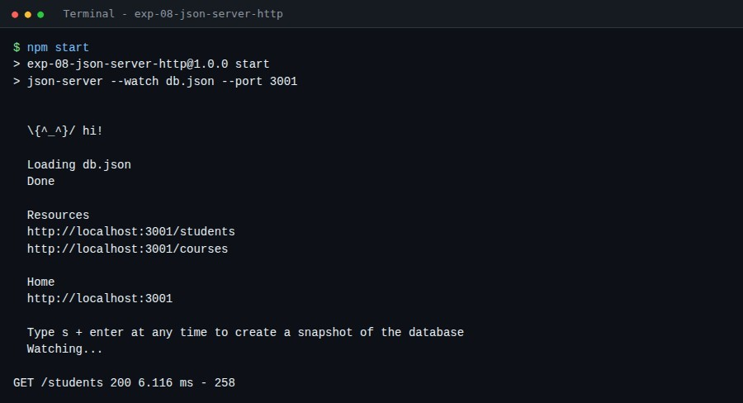
Fig 8.1 JSON Server started
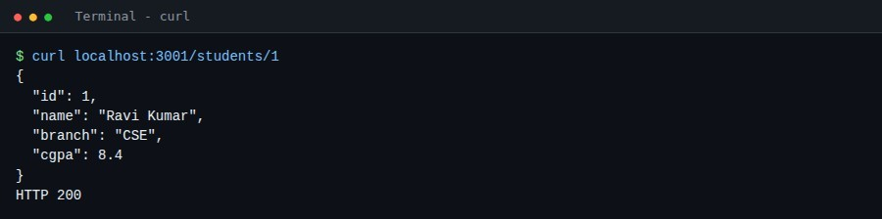
Fig 8.2 GET /students/1 - 200
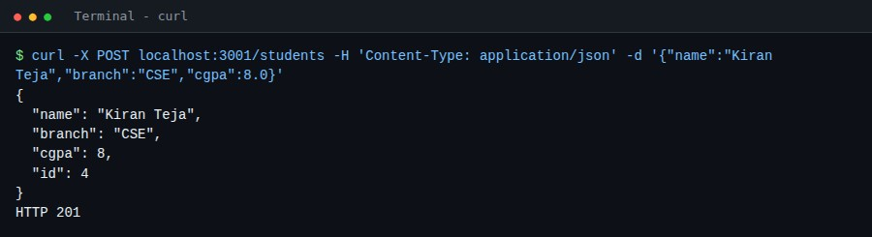
Fig 8.3 POST /students - 201 Created
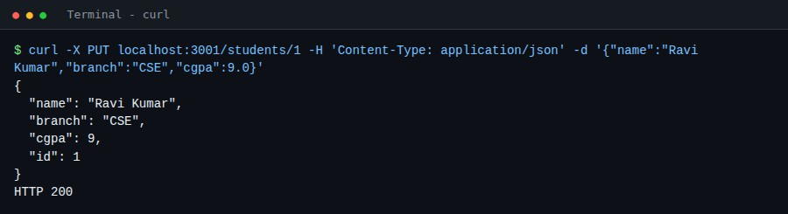
Fig 8.4 PUT /students/1 - full update
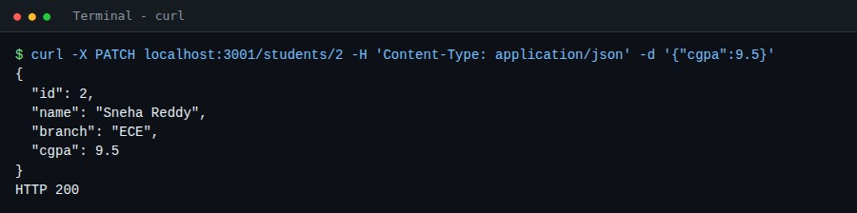

Fig 8.5 PATCH /students/2 - partial update
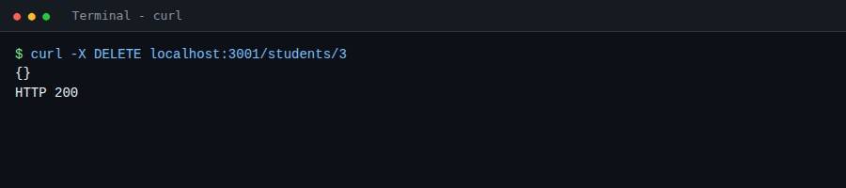

Fig 8.6 DELETE /students/3
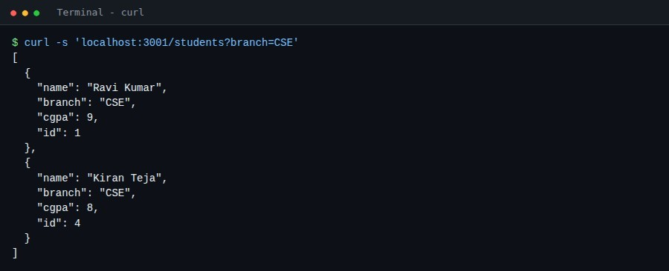

Fig 8.7 GET /students?branch=CSE - filtering
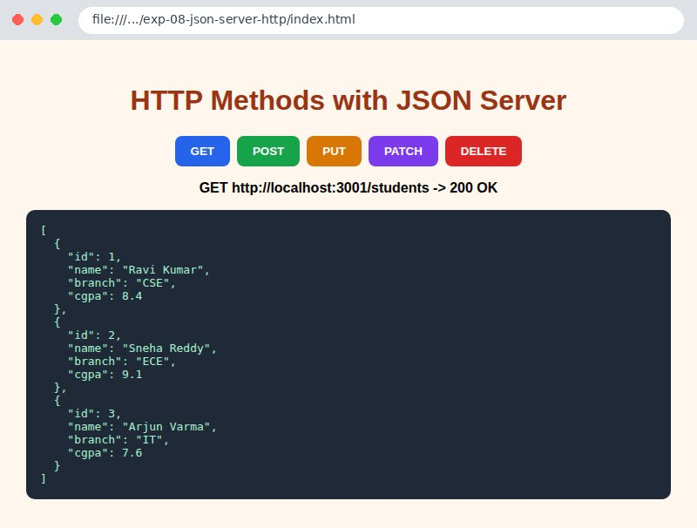

Fig 8.8 Client page - GET
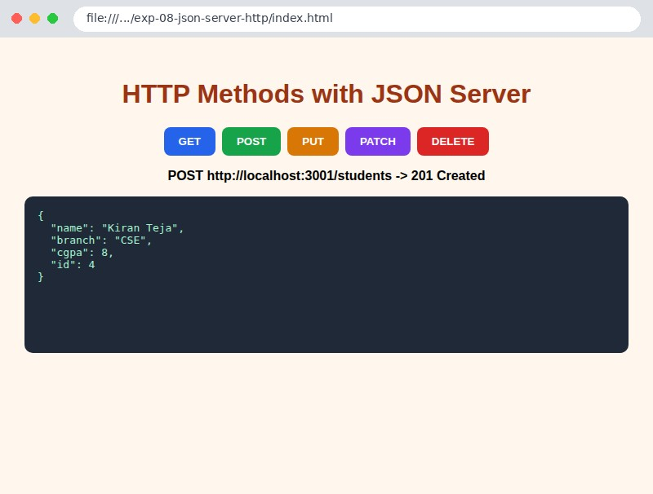

Fig 8.9 Client page - POST
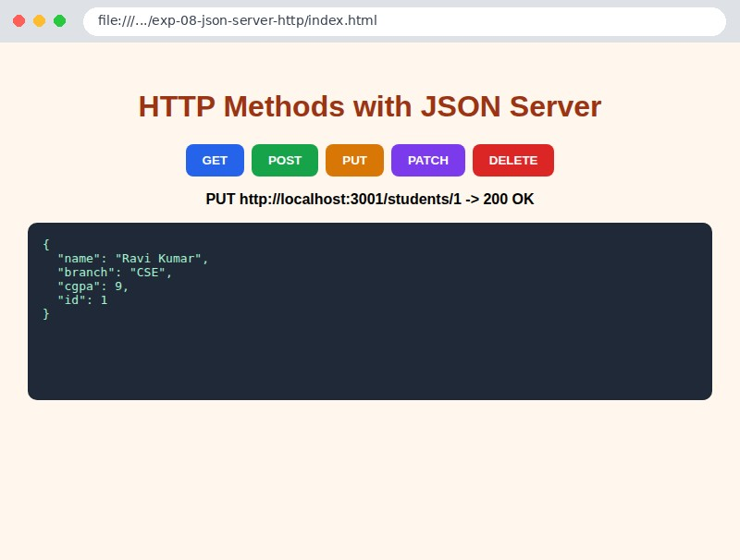

Fig 8.10 Client page - PUT
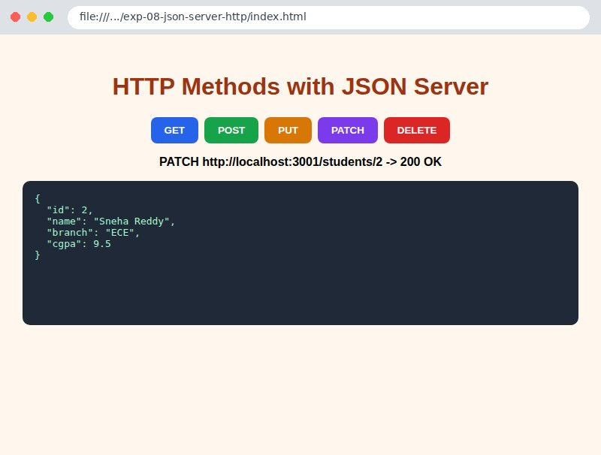

Fig 8.11 Client page - PATCH
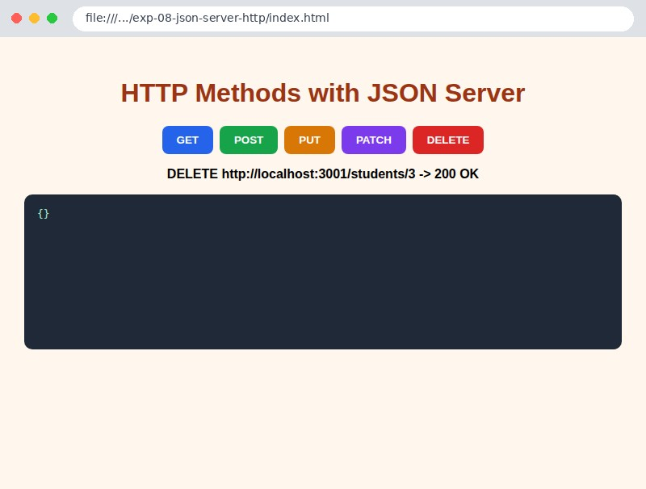

Fig 8.12 Client page - DELETE
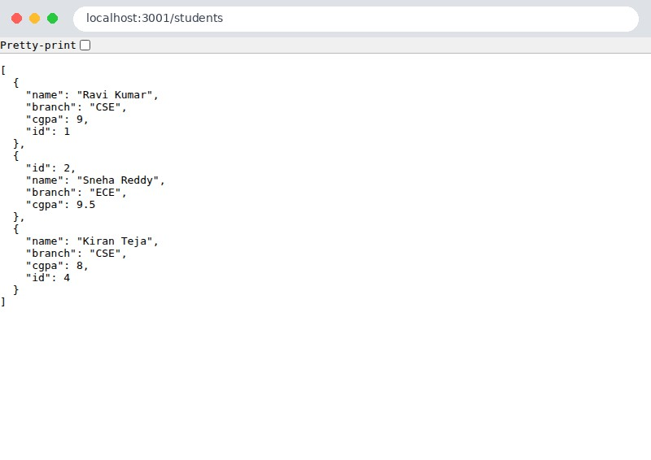
Fig 8.13 Final data at http://localhost:3001/students

Result
HTTP methods GET, POST, PUT, PATCH and DELETE were implemented using JSON Server.

EXPERIMENT 9

Develop CRUD operations using MongoDB
Course Outcome: CO4

Aim
To perform Create, Read, Update and Delete (CRUD) operations on a MongoDB database using Node.js.

Question
Write a Node.js program using the MongoDB driver to insert, query (filter, sort, limit, count), update ($set, $inc) and delete documents in a students collection. Also write the equivalent mongosh commands.
Software / Tools Required
MongoDB Community Server, Node.js, mongodb npm driver, mongosh, VS Code

Procedure
- Install and start MongoDB (mongod). The default port is 27017.
- Create the folder and run npm install mongodb.
- Create crud.js: connect using MongoClient.connect() and select the college database and students collection.
- CREATE using insertOne and insertMany.
- READ using find, findOne, filters ($gt), sort, limit and countDocuments.
- UPDATE using updateOne with $set and updateMany with $inc.
- DELETE using deleteOne and deleteMany, then close the connection.
- Run node crud.js and note the output.

Program

File: crud.js
// Experiment 9: CRUD operations using MongoDB (Node.js native driver)
// Make sure MongoDB is running locally: mongod (default port 27017) const { MongoClient } = require("mongodb");

const url = process.env.MONGO_URL || "mongodb://127.0.0.1:27017"; const dbName = "college";

async function main() {
const client = await MongoClient.connect(url); console.log("Connected to MongoDB server");
const students = client.db(dbName).collection("students");
await students.deleteMany({}); // start with an empty collection

// ---------------- CREATE --------------- console.log("\n--- CREATE ---"); const one = await students.insertOne({ name: "Ravi Kumar", branch: "CSE", year: 3, cgpa:
8.4 });
console.log("insertOne -> insertedId:", one.insertedId); const many = await students.insertMany([
{ name: "Sneha Reddy", branch: "ECE", year: 2, cgpa: 9.1 },
{ name: "Arjun Varma", branch: "IT", year: 4, cgpa: 7.6 },
{ name: "Meena Devi", branch: "CSE", year: 3, cgpa: 8.8 }, { name: "Kiran Teja", branch: "CSE", year: 2, cgpa: 6.9 },
]);
console.log("insertMany -> insertedCount:", many.insertedCount);

// ---------------- READ --------------- console.log("\n--- READ ---"); console.log("All students:");
console.table((await students.find({}, { projection: { _id: 0 } }).toArray())); console.log("findOne({ name: 'Sneha Reddy' }):");
const sneha = await students.findOne({ name: "Sneha Reddy" }, { projection: { _id: 0 } }); console.log(sneha);
console.log("CSE students with cgpa > 8:"); console.table(await students.find({ branch: "CSE", cgpa: { $gt: 8 } }, { projection:
{ _id: 0 } }).toArray());
console.log("Sorted by cgpa (descending), top 3:");
console.table(await students.find({}, { projection: { _id: 0, name: 1, cgpa: 1 } }).sort({ cgpa: -1 }).limit(3).toArray()); console.log("countDocuments({ branch: 'CSE' }) =", await students.countDocuments({ branch:
"CSE" }));

// ---------------- UPDATE --------------- console.log("\n--- UPDATE ---");
const u1 = await students.updateOne({ name: "Ravi Kumar" }, { $set: { cgpa: 9.0 } }); console.log("updateOne -> matched:", u1.matchedCount, " modified:", u1.modifiedCount); const u2 = await students.updateMany({ branch: "CSE" }, { $inc: { year: 1 } }); console.log("updateMany -> matched:", u2.matchedCount, " modified:", u2.modifiedCount); console.table(await students.find({ branch: "CSE" }, { projection: { _id:
0 } }).toArray());

// ---------------- DELETE --------------- console.log("\n--- DELETE ---");
const d1 = await students.deleteOne({ name: "Arjun Varma" }); console.log("deleteOne -> deletedCount:", d1.deletedCount); const d2 = await students.deleteMany({ cgpa: { $lt: 7 } });
console.log("deleteMany (cgpa < 7) -> deletedCount:", d2.deletedCount); console.log("Remaining documents:");
console.table(await students.find({}, { projection: { _id: 0 } }).toArray());

await client.close();
console.log("Connection closed");
}
main().catch(console.error);

File: mongosh-commands.js
// Same CRUD operations in the MongoDB shell (mongosh) use college

// CREATE
db.students.insertOne({ name: "Ravi Kumar", branch: "CSE", year: 3, cgpa: 8.4 }) db.students.insertMany([
{ name: "Sneha Reddy", branch: "ECE", year: 2, cgpa: 9.1 }, { name: "Arjun Varma", branch: "IT", year: 4, cgpa: 7.6 }
])

// READ
db.students.find()
db.students.findOne({ name: "Sneha Reddy" }) db.students.find({ branch: "CSE", cgpa: { $gt: 8 } }) db.students.find().sort({ cgpa: -1 }).limit(3)

// UPDATE
db.students.updateOne({ name: "Ravi Kumar" }, { $set: { cgpa: 9.0 } }) db.students.updateMany({ branch: "CSE" }, { $inc: { year: 1 } })

// DELETE
db.students.deleteOne({ name: "Arjun Varma" }) db.students.deleteMany({ cgpa: { $lt: 7 } })
How to Run npm install then node crud.js (MongoDB must be running)

Output (Screenshots)
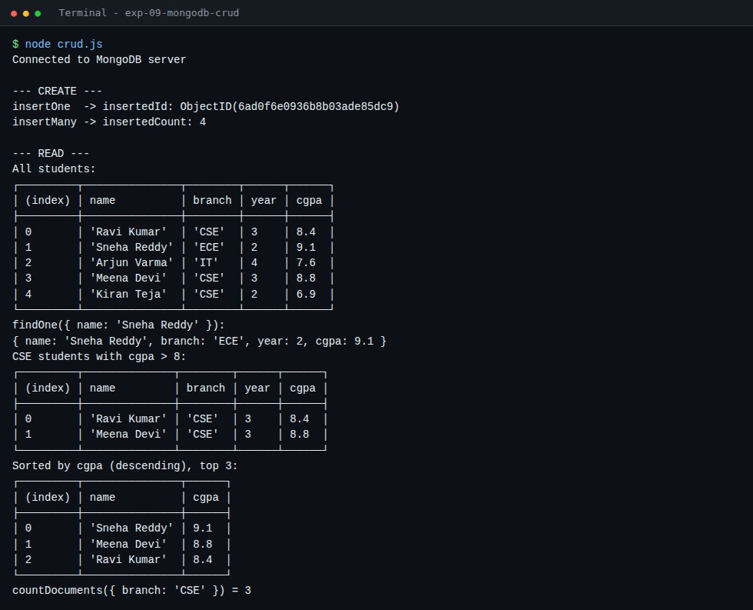

Fig 9.1 CREATE and READ operations
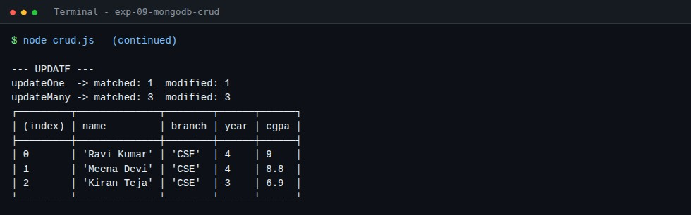

Fig 9.2 UPDATE operations
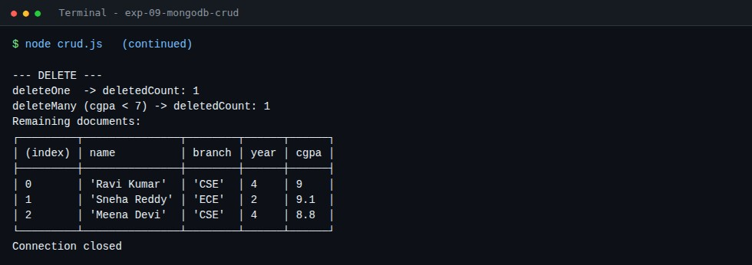
Fig 9.3 DELETE operations
Result
CRUD operations were performed successfully on MongoDB using Node.js.

EXPERIMENT 10

Develop Main Project using Express, React and MongoDB/MySql Course Outcome: CO4

Aim
To develop a full-stack Student Management System using Express (back end), React (front end) and MongoDB (database).

Question
Develop a full-stack MERN-style application that stores student records in MongoDB, exposes a REST API with Express and provides a React user interface to add, view, edit, delete and search students with summary statistics.
Software / Tools Required
Node.js, Express, React (Vite), MongoDB, mongodb driver, cors, VS Code, Google Chrome

Procedure
- Create folders server/ and client/.
- Server: npm install express mongodb cors. Create db.js (database connection), routes/students.js (CRUD routes) and server.js.
- Client: create a Vite React app. Create api.js (fetch helpers), App.jsx (state and layout), StudentForm.jsx and StudentTable.jsx.
- Start MongoDB, then start the server (npm start, port 5000).
- Start the client (npm run dev, port 5173) and open it in the browser.
- Test add, edit, search and delete operations from the UI.

Program

File: server/db.js
const { MongoClient } = require("mongodb");

const url = process.env.MONGO_URL || "mongodb://127.0.0.1:27017"; let collection;

async function connect() {
const client = await MongoClient.connect(url);
collection = client.db("student_management").collection("students"); console.log("MongoDB connected"); return collection;
}
const students = () => collection;

module.exports = { connect, students };

File: server/routes/students.js
const express = require("express"); const { ObjectId } = require("mongodb"); const { students } = require("../db");

const router = express.Router();

// READ all (optional ?search=)
router.get("/", async (req, res) => { const { search } = req.query;
const filter = search ? { name: { $regex: search, $options: "i" } } : {}; res.json(await students().find(filter).sort({ name: 1 }).toArray());
});

// CREATE
router.post("/", async (req, res) => {
const { name, rollNo, branch, cgpa } = req.body;
if (!name || !rollNo || !branch) return res.status(400).json({ error: "name, rollNo and branch are required" });
const doc = { name, rollNo, branch, cgpa: Number(cgpa) || 0 }; const result = await students().insertOne(doc);
res.status(201).json({ ...doc, _id: result.insertedId });
});

// UPDATE
router.put("/:id", async (req, res) => { const { name, rollNo, branch, cgpa } = req.body; await students().updateOne(
{ _id: new ObjectId(req.params.id) },
{ $set: { name, rollNo, branch, cgpa: Number(cgpa) || 0 } }
);
res.json({ message: "Updated" });
});

// DELETE
router.delete("/:id", async (req, res) => {
await students().deleteOne({ _id: new ObjectId(req.params.id) }); res.json({ message: "Deleted" });
});

module.exports = router;

File: server/server.js
const express = require("express"); const cors = require("cors"); const { connect } = require("./db");
const studentRoutes = require("./routes/students");

const app = express(); app.use(cors()); app.use(express.json());
app.use("/api/students", studentRoutes);
app.get("/", (req, res) => res.send("Student Management API is running"));

const PORT = process.env.PORT || 5000; connect()
.then(() => app.listen(PORT, () => console.log(`Server running on http://localhost:$
{PORT}`)))
.catch((err) => { console.error("MongoDB connection failed:", err.message); process.exit(1); });

File: client/src/api.js
const BASE = "http://localhost:5000/api/students"; const json = { "Content-Type": "application/json" };

export const getStudents = (search = "") => fetch(`${BASE}?search=$ {encodeURIComponent(search)}`).then((r) => r.json()); export const addStudent = (s) => fetch(BASE, { method: "POST", headers: json, body: JSON.stringify(s) }).then((r) => r.json()); export const updateStudent = (id, s) => fetch(`${BASE}/${id}`, { method: "PUT", headers: json, body: JSON.stringify(s) });
export const deleteStudent = (id) => fetch(`${BASE}/${id}`, { method: "DELETE" });

File: client/src/App.jsx
import { useEffect, useState } from "react";
import { getStudents, addStudent, updateStudent, deleteStudent } from "./api.js"; import StudentForm from "./StudentForm.jsx"; import StudentTable from "./StudentTable.jsx";

export default function App() {
const [students, setStudents] = useState([]); const [editing, setEditing] = useState(null); const [search, setSearch] = useState("");

const load = async () => setStudents(await getStudents(search)); useEffect(() => { load(); }, [search]);

const save = async (data) => {
if (editing) await updateStudent(editing._id, data); else await addStudent(data); setEditing(null); load();
};
const remove = async (id) => { await deleteStudent(id); load(); };

const avg = students.length ? (students.reduce((s, x) => s + x.cgpa, 0) / students.length).toFixed(2) : "0.00";

return (
<div className="app">
<h1>Student Management System</h1>
<p className="sub">Express + React + MongoDB</p>
<div className="stats">
<div><b>{students.length}</b><span>Students</span></div>
<div><b>{avg}</b><span>Average CGPA</span></div>
</div>
<StudentForm onSave={save} editing={editing} onCancel={() => setEditing(null)} />
<div className="card">
<input className="search" placeholder="Search by name..." value={search} onChange={(e) => setSearch(e.target.value)} />
<StudentTable students={students} onEdit={setEditing} onDelete={remove} />
</div>
</div>
);
}

File: client/src/StudentForm.jsx
import { useEffect, useState } from "react";

const empty = { name: "", rollNo: "", branch: "CSE", cgpa: "" };

export default function StudentForm({ onSave, editing, onCancel }) { const [form, setForm] = useState(empty);
useEffect(() => { setForm(editing || empty); }, [editing]);

const change = (e) => setForm({ ...form, [e.target.name]: e.target.value }); const submit = (e) => { e.preventDefault(); onSave(form); setForm(empty); };

return (
<form className="card form" onSubmit={submit}>
<h3>{editing ? "Edit Student" : "Add Student"}</h3>
<input name="name" placeholder="Name" value={form.name} onChange={change} required />
<input name="rollNo" placeholder="Roll No" value={form.rollNo} onChange={change} required />
<select name="branch" value={form.branch} onChange={change}>
<option>CSE</option><option>ECE</option><option>IT</option><option>EEE</ option><option>MECH</option>
</select>
<input name="cgpa" type="number" step="0.01" min="0" max="10" placeholder="CGPA" value={form.cgpa} onChange={change} />
<button type="submit">{editing ? "Update" : "Add"}</button>
{editing && <button type="button" className="grey" onClick={onCancel}>Cancel</button>}
</form>
);
}

File: client/src/StudentTable.jsx
export default function StudentTable({ students, onEdit, onDelete }) { if (!students.length) return <p>No students found.</p>; return ( <table>
<thead>
<tr><th>Roll No</th><th>Name</th><th>Branch</th><th>CGPA</th><th>Actions</th></tr>
</thead>
<tbody>
{students.map((s) => (
<tr key={s._id}>
<td>{s.rollNo}</td><td>{s.name}</td><td>{s.branch}</td><td>{s.cgpa}</td>
<td>
<button onClick={() => onEdit(s)}>Edit</button>{" "}
<button className="red" onClick={() => onDelete(s._id)}>Delete</button>
</td>
</tr>
))}
</tbody>
</table>
);
}

How to Run
cd server && npm install && npm start | cd client && npm install && npm run dev Output (Screenshots)
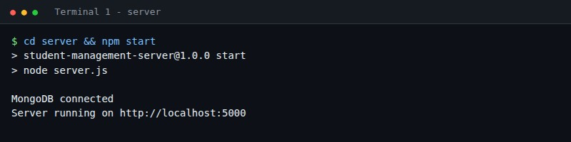

Fig 10.1 Back-end server running (Terminal 1)
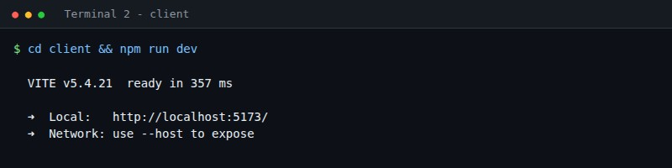

Fig 10.2 React client running (Terminal 2)
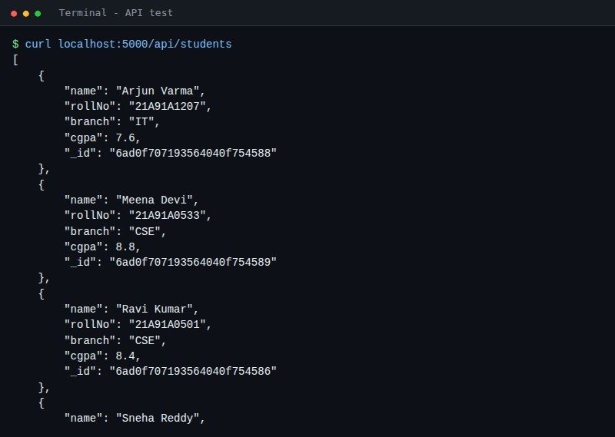

Fig 10.3 REST API response from the Express server
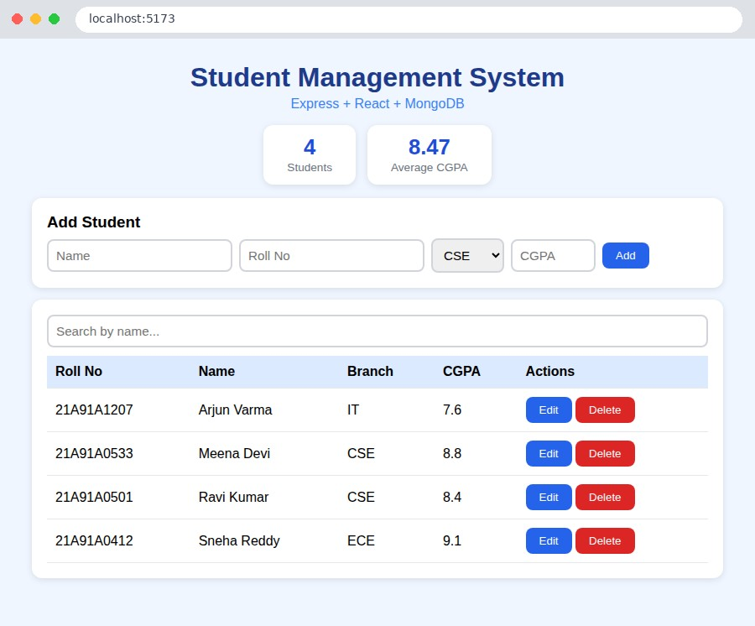

Fig 10.4 Student list loaded from MongoDB
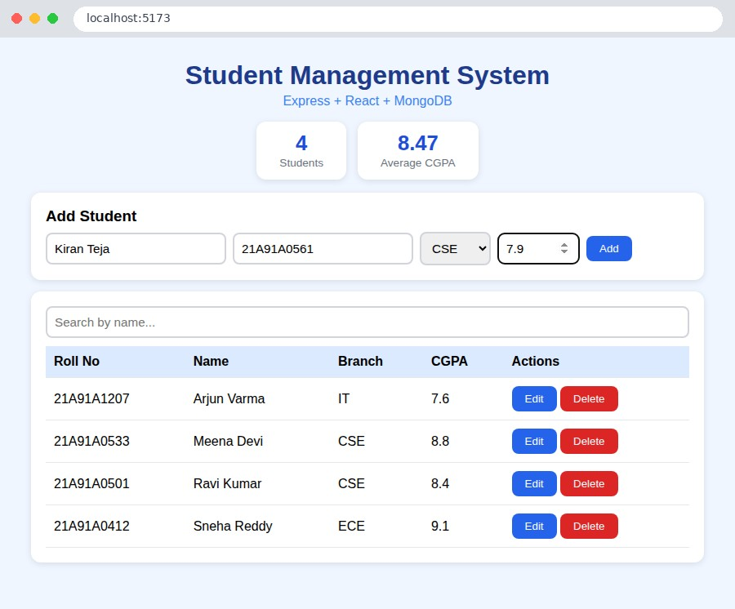

Fig 10.5 Add Student form filled
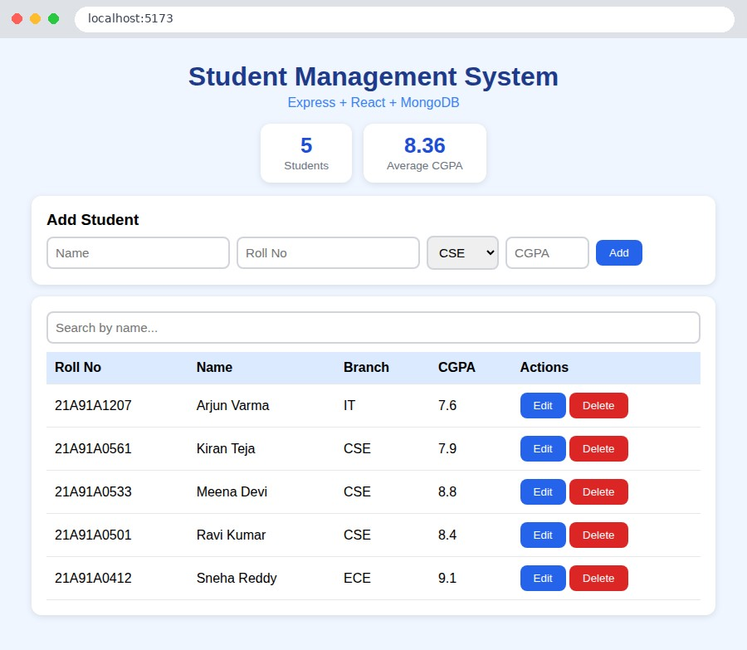

Fig 10.6 After adding the student
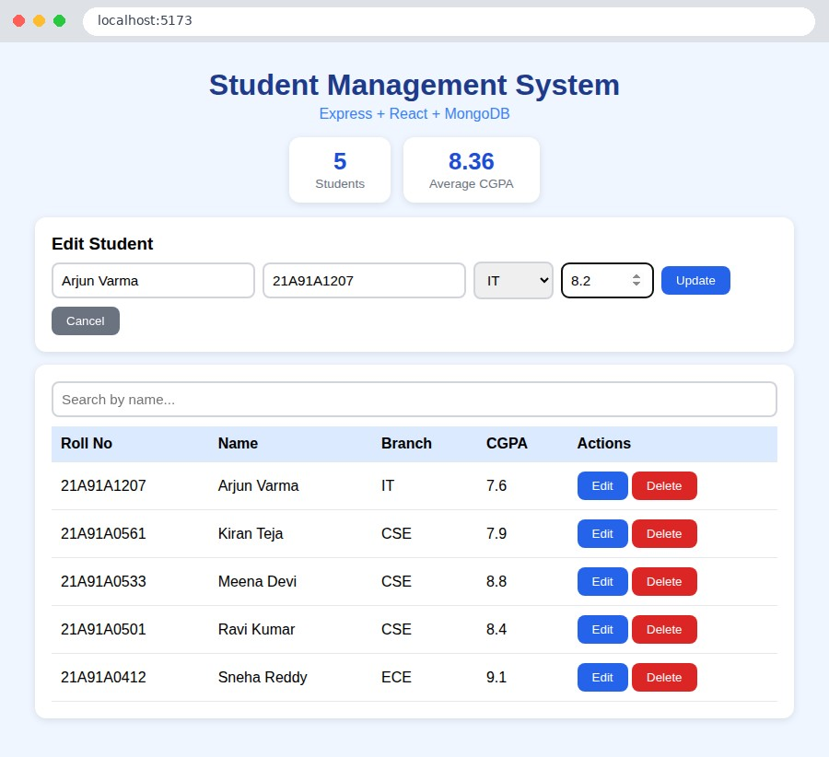

Fig 10.7 Edit mode (CGPA being changed)
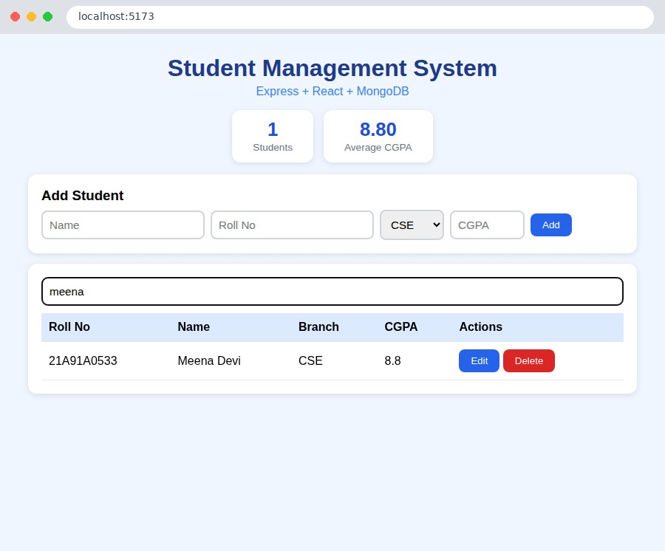

Fig 10.8 Search by name
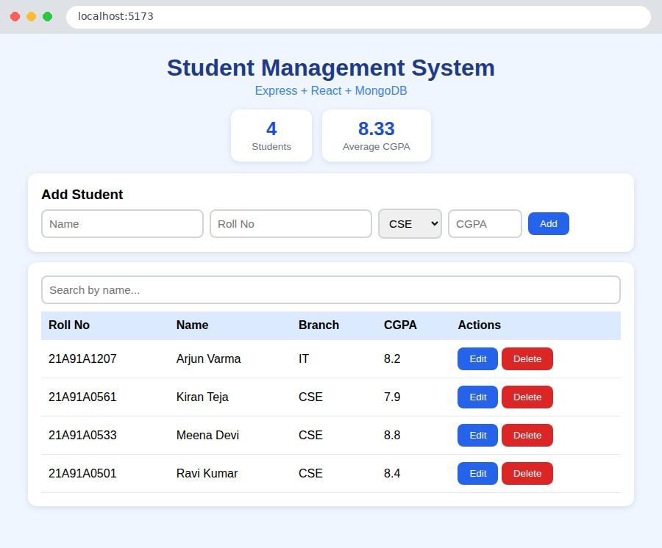
Fig 10.9 After update and delete - statistics updated

Result
A full-stack Student Management System using Express, React and MongoDB was developed and tested.

