Conversational Commerce Chatbot – BRD & Architecture Document

1. Business Requirements Document (BRD)

1.1 Project Overview
This project aims to develop a reusable, AI-powered conversational chatbot that can perform end-to-end product purchases on behalf of customers across multiple retailers' websites.
The chatbot will serve as a multi-tenant platform, allowing different retailers to integrate it into their websites while customizing its behavior and branding.

1.2 Objectives
- Create a scalable chatbot engine capable of understanding shopping-related intents and automating purchase flows.
- Support multiple retailers through standardized APIs and plug-in adapters.
- Enable natural, human-like conversations that guide customers through discovery, selection, and checkout.
- Maintain security and compliance standards, especially around authentication and payments.

1.3 Scope
In Scope:
- Chatbot conversation flow for browsing, adding to cart, and purchasing.
- Integration with multiple retailer systems (Shopify, WooCommerce, custom APIs).
- Retailer admin portal for configuration and analytics.
- Embeddable frontend widget for deployment on websites.
Out of Scope (for MVP):
- Voice-based interactions.
- Direct payment handling (delegated to retailer systems).
- Cross-retailer cart or global checkout.

1.4 Key Stakeholders
- Product Owner
- Technical Architect
- Backend Developers
- Frontend Developers
- Retailer Partners / Integrators
- QA Engineers
- Security / Compliance Officer

1.5 Business Goals
- Increase conversion rates for online retailers via conversational commerce.
- Reduce cart abandonment by simplifying the purchase journey.
- Provide a seamless, personalized, and human-like shopping experience.
- Create a scalable SaaS platform that can serve multiple businesses.

2. System Architecture Document

2.1 High-Level Architecture Overview
The system consists of a modular architecture supporting multiple retailer integrations. The chatbot interacts with a core backend (LLM engine) that communicates with retailer APIs through a standardized adapter layer.
Architecture Layers:
1. User Interface Layer – Chat widget (React/Web Component) embedded on retailer websites.
2. Bot Engine Layer – Handles conversation logic, context, and LLM orchestration.
3. Integration Layer – Retailer-specific adapters connecting to external e-commerce APIs.
4. Data Layer – Stores sessions, product metadata, and configurations.
5. Admin Dashboard – Allows retailers to customize their chatbot and monitor analytics.

2.2 Component Overview
- **Frontend Widget:** A lightweight, embeddable JavaScript chat widget allowing user interaction.
- **Bot Engine:** Core service that handles message routing, intent detection, and function calling.
- **Retailer Adapter Framework:** Standardized interface layer enabling integration with various platforms.
- **Admin Dashboard:** Web interface for retailer onboarding, configuration, and monitoring.
- **Data Storage:** PostgreSQL for persistent data; Redis for session management; Vector DB for semantic search.

2.3 Technology Stack
| Layer | Technology |
|-------|-------------|
| Chat Engine | Python (FastAPI) or Node.js (Express/NestJS) |
| LLM | OpenAI GPT-4 / GPT-5 |
| Database | PostgreSQL + Redis |
| Vector DB (optional) | Pinecone / Weaviate |
| Retailer APIs | REST / GraphQL Adapters |
| Frontend | React + Web Components |
| Authentication | OAuth 2.0 / JWT |
| Hosting | AWS / GCP / Vercel |

2.4 Data Flow
1. User interacts with chat widget on retailer website.
2. Widget sends message to Bot Engine via API or WebSocket.
3. Bot Engine uses LLM to parse intent and extract parameters.
4. Retailer Adapter executes relevant API calls (get products, add to cart, checkout).
5. Response returned to Bot Engine → formatted as natural chat message → displayed to user.

2.5 Security Considerations
- Use HTTPS and signed JWTs for all communications.
- Enforce per-tenant API isolation and authentication.
- Never store raw payment details; delegate transactions to retailer’s backend.
- Add audit logs and rate limiting to prevent abuse.

2.6 Scalability and Multi-Tenancy
Each retailer operates as an isolated tenant with their own configurations, API keys, and chatbot personality. Multi-tenancy is achieved through scoped data models and tenant-based middleware that filters data access by retailer ID.

2.7 Future Enhancements
- Add support for voice-based shopping assistants.
- Integrate advanced personalization via recommendation models.
- Enable analytics dashboards with conversational insights.
- Support omnichannel presence (e.g., WhatsApp, Instagram DM).

3. System Architecture Diagrams

3.1 High-Level Architecture
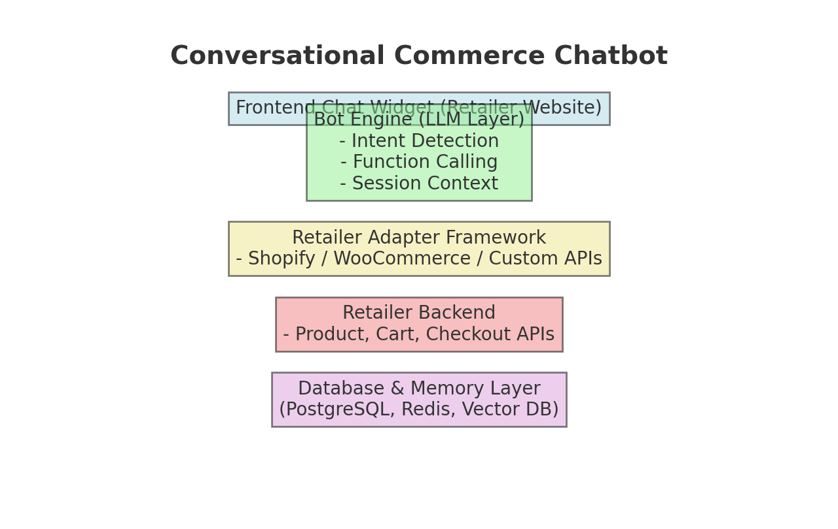
Figure 1: High-level architecture showing chatbot layers from user interface to retailer backend.

3.2 Data Flow
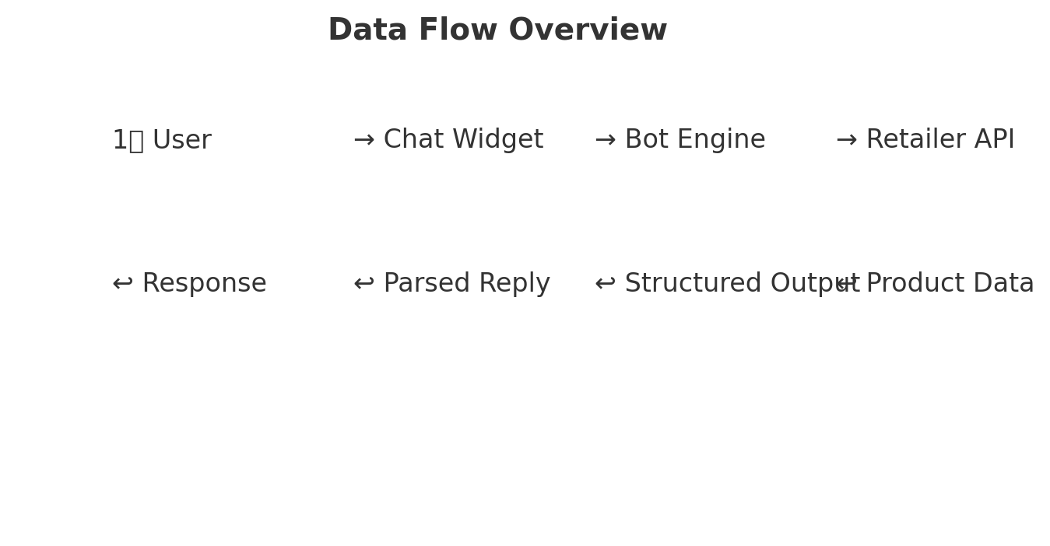
Figure 2: Data flow illustrating message exchange between user, chatbot, and retailer systems.

