* + **Assignment-1**

• Install Power BI Desktop and share the final screenshot of the report view page which appears when power desktop starts.

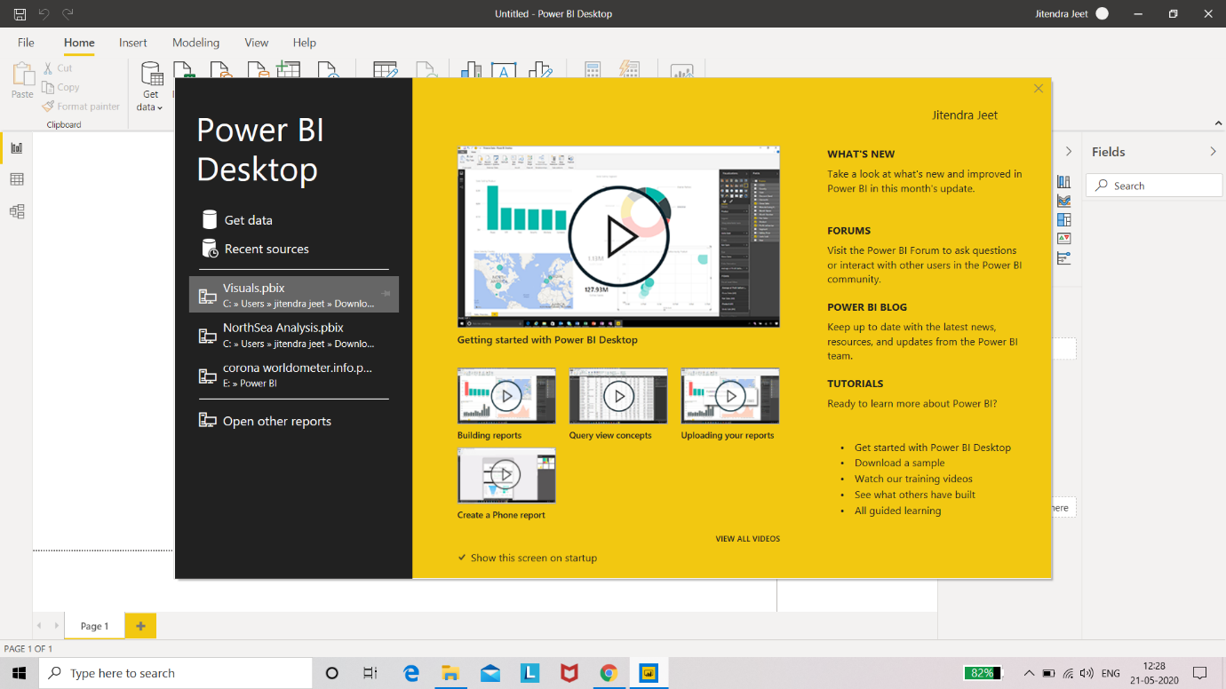

• Prepare a document and with the following screenshot

-Report View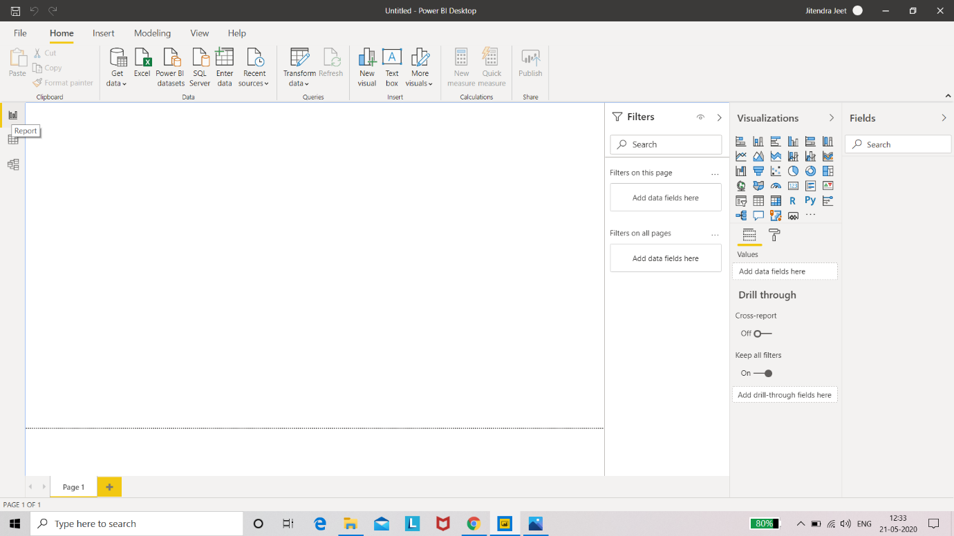- The above image is the screenshot of Report View In the Power BI Desktop

- It is mainly used for the the visualization part of the data when we load a dataset

- we can make any visualization here which is available in Power BI and visualization like Table, bar chat, pie chart, gauge chart, map etc.

- In Report view we can make any type of visualization but make sure that we should prepare such type of visualizations only through which we can achieve some meaningful information according to our dataset

− Data View

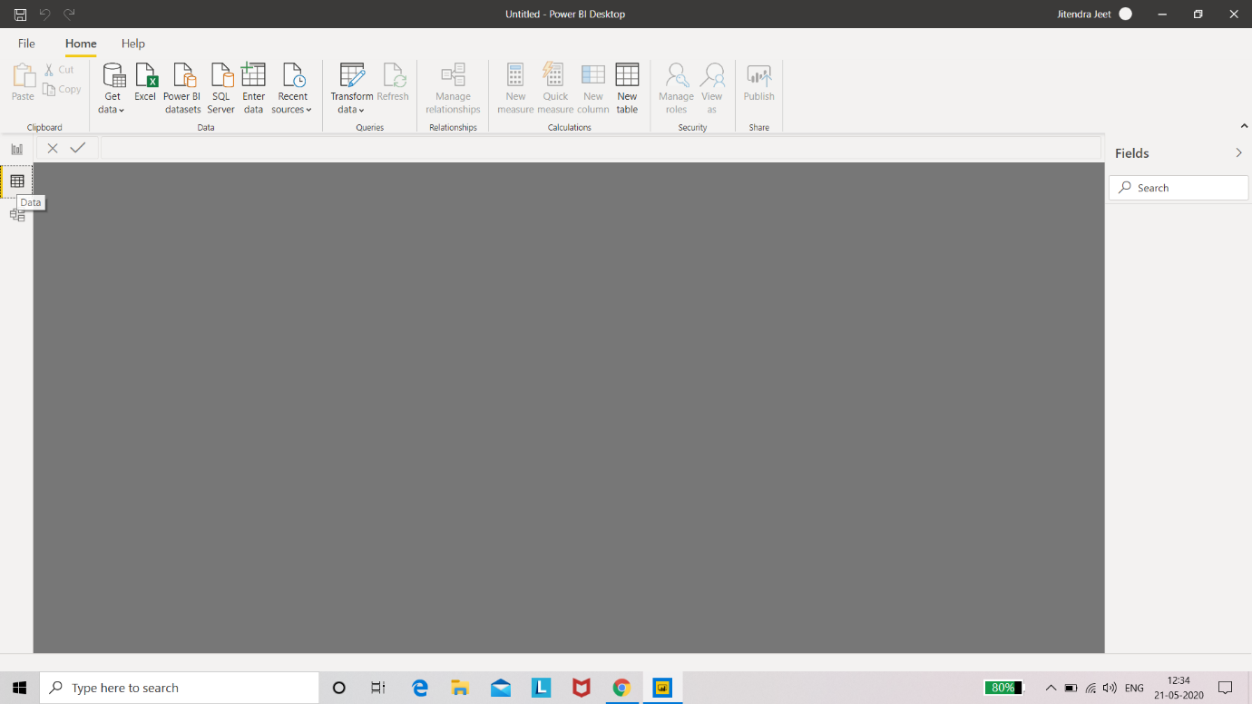-The above figure show the screenshot of Data View

- Data view helps us to inspect, explore and understand the data through Power BI Desktop model, here we can looking at our data after it has been loaded into the Power BI Desktop

-here we can see the dataset on which we are currently working and we can make some changes in our dataset here also by clicking on the column which is shown throw columns tools

- we can make any changes which is available on the data view tools like New columns, Manage Relationship, Data Group, short by columns etc.

-When we're modelling our data, sometimes we want to see what's actually in a table or column without creating a visual on the report canvas.

we might want to see right down to the row level. This ability is especially useful when we're creating measures and calculated columns, or we need to identify a data type or data category.

− Model View

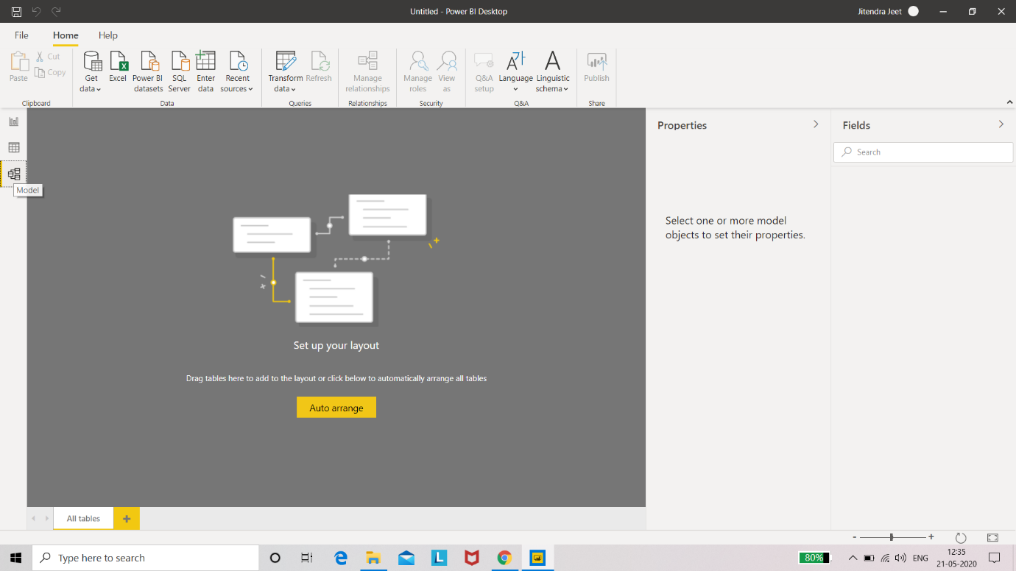

-Model view show all the table, columns and the relationship in the model , can connect the table through any common columns which is available among the tables

- It is mainly used when our model has complex relationship between many tables and through it, we can see the relationship easily

-we can add relation here and we can also edit the connected table according to the relationship, we can double click on relationship and can edit relationship

− Power Query Editor 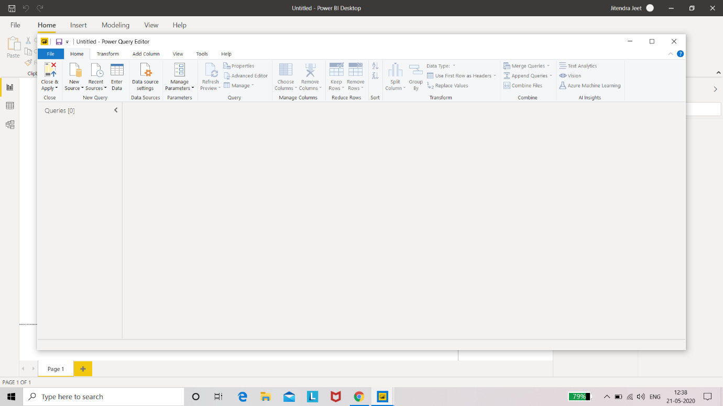

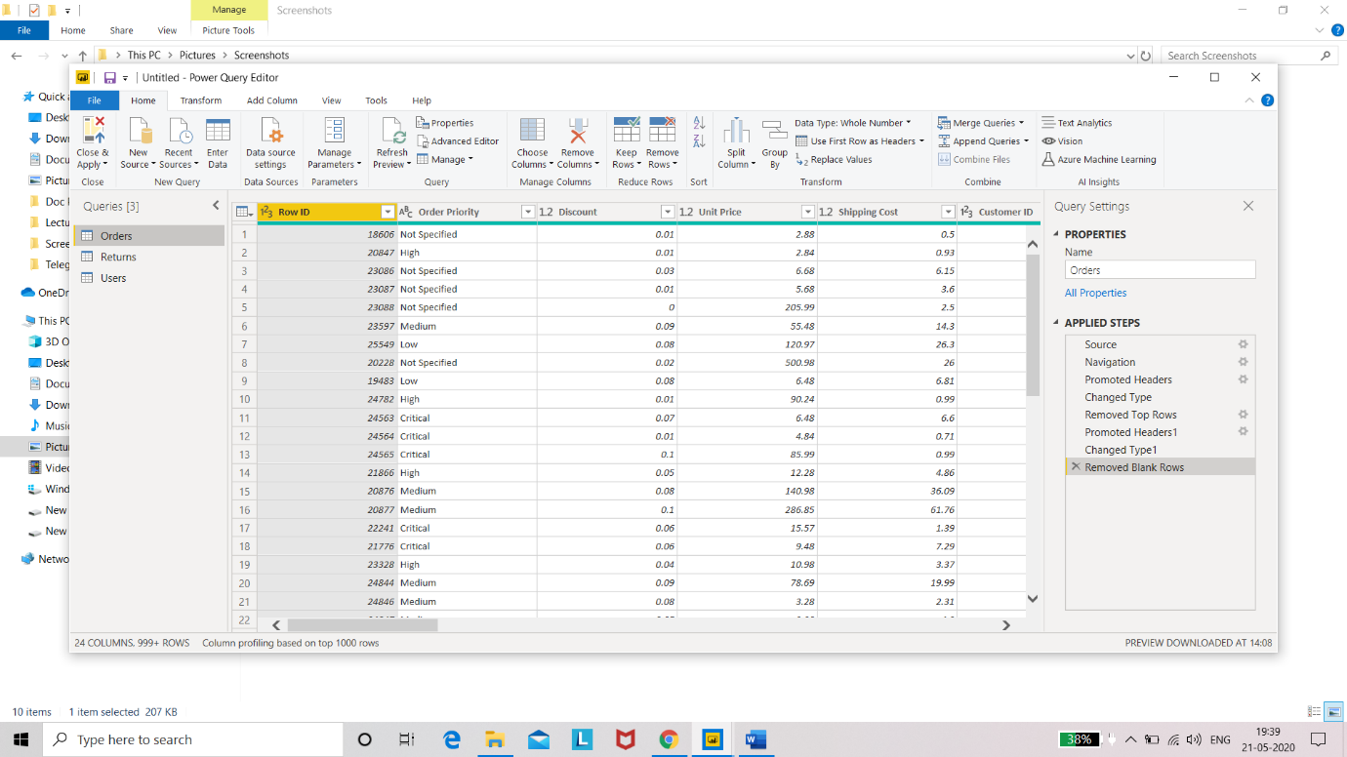

-The Power Query Editor is also known as “The Heart of Power BI Desktop”

-To Launch Power Query Editor, select Transform Data from the home tab of the Power BI Desktop

-With no data connections, Power Query Editor appears as a blank pane, ready for data.

-Once a query is loaded, Power Query Editor view becomes more interesting.

-we can manage all type of editing option of power bi through the power query editor, here we can remove the blank rows, errors, missing rows by clicking the ‘remove row’ option from the power query editor home option and here we can manage the row level header and columns also

After completing the whole editing option, we have to select the ‘choose and apply option’ for the apply the whole records which is done by the power query editor.

− Advance Editor

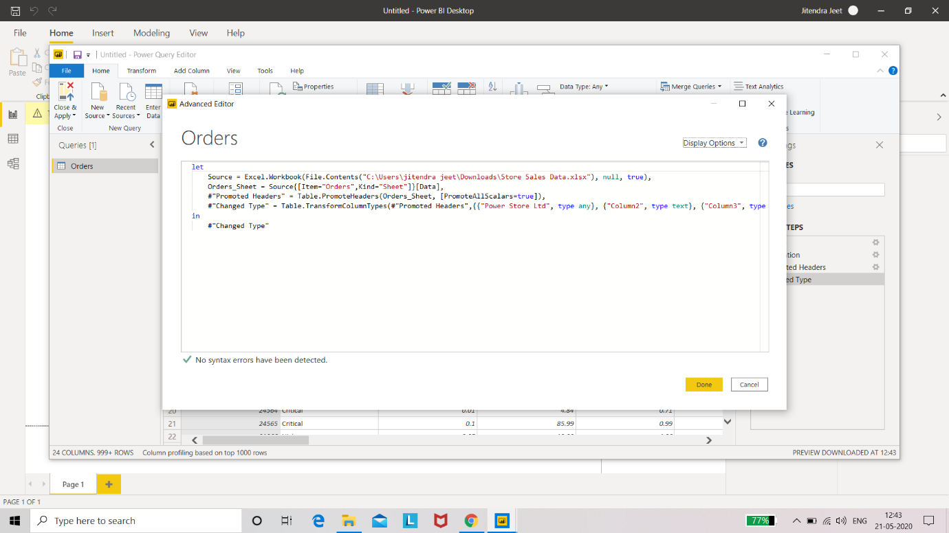

-To launch the advanced editor, select transform data from the home menu, then select Advanced Editor from the power query editor. A window appears, showing the existing query code. we can directly edit the code in the Advanced Editor window.

-Through the advanced editor we can make changes in our existing code also by editing the code and we can see the changes after applying that

• Prepare a document with details of the following along with their price

-Power BI comes in three level

Power BI Desktop

Power BI Pro

Power BI Premium

* + Power BI Desktop: (Free Available)

-It is the basic level of Power BI which is used by all for the visualization

-It is free of cost available for the use in market for the visualizations tool designed and owned by Microsoft.

- Power BI Desktop is a free application you install on your local computer that lets you connect to, transform, and visualize your data. With Power BI Desktop, you can connect to multiple different sources of data, and combine them (often called modeling) into a data model. This data model lets you build visuals, and collections of visuals you can share as reports, with other people inside your organization. Most users who work on business intelligence projects use Power BI Desktop to create reports, and then use the Power BI service to share their reports with others.

-Connect to data

-Transform and clean that data, to create a data model

-Create visuals, such as charts or graphs, that provide visual representations of the data

-Create reports that are collections of visuals, on one or more report pages

-Share reports with others by using the Power BI service

-it can used the data upto 1GB for Visualization

* + Power BI Pro(Cost: $9.99 per month)

-It is the paid tool of visualization provided by the Microsoft and advanced BI tools

-it can used the data upto 1GB for Visualization

-Self-service and modern BI in the cloud

-Collaboration, published, sharing and ad-hoc analysis

-Fully managed by Microsoft

* Power BI Premium(Cost: $4995 per annum)

-It is the most advanced and very secured tool by Microsoft and it is acostly and advanced verson tool used for organisation and indivisuals also.

-it can used the data upto 10GB for Visualization

-Enterprise BI, big data analytics, cloud on-premises reporting

-Advanced administration and deployment controls

-Dedicated cloud compute and storage resources

-Allow any user to consume Power BI content