Fake News Detection Using Machine Learning

Jeet John Gomes
BSc. Statistics 3rd Year
at
St. Xavier’s (Autonomous) Kolkata

Mentor Name: Dr. Dipasree Pal

Period of Internship: 18th May 2026 – 31st July 2026

Report submitted to: IDEAS – Institute of Data Engineering, Analytics and Science Foundation, ISI Kolkata

Abstract :-

This project aims to build a fake news detection system using classical machine learning techniques. The dataset used is the Fake and Real News Dataset from Kaggle, consisting of 44,898 news articles labeled as real or fake. After removing duplicate articles, the final dataset contained 38,646 articles. The text data was preprocessed by combining title and text, removing URLs, punctuation, numbers and extra whitespace.

TF-IDF Vectorization was used to convert text into numerical features, keeping the top 5,000 most important words. Three machine learning models were trained and compared — Logistic Regression, Naive Bayes and Decision Tree. All three models were evaluated across seven different train-test splits — 80/20, 75/25, 70/30, 65/35, 60/40, 55/45 and 50/50. Decision Tree achieved the highest accuracy of 99.32% while Logistic Regression was the most consistent model with 99% precision across all splits.

The project demonstrates that classical machine learning techniques combined with proper text preprocessing are highly effective for fake news detection.

Introduction :-

In today's digital age, the rapid spread of misinformation and fake news has become one of the most significant challenges facing society. With the rise of social media platforms and online news sources, false information can spread to millions of people within minutes, influencing public opinion, political decisions and social behaviour. The ability to automatically detect fake news has therefore become an important problem in the field of Natural Language Processing and Machine Learning.

This project addresses the problem of fake news detection using classical machine learning techniques. Given a news article, the goal is to automatically classify it as either real or fake based on its text content. We approach this as a binary text classification problem, where the input is the text of a news article and the output is a label of 0 (fake) or 1 (real).

The dataset used in this project is the Fake and Real News Dataset from Kaggle, created by Clement Bisaillon. It consists of two files — True.csv containing real news articles collected from Reuters, and Fake.csv containing fake news articles collected from various unreliable sources that were flagged during the 2016 US election period. The combined dataset contains 44,898 articles across six categories — politicsNews, worldnews, News, politics, left-news and Government News.

The core technology used in this project is TF-IDF (Term Frequency — Inverse Document Frequency) Vectorization combined with classical machine learning classifiers. TF-IDF is a well established statistical technique that converts raw text into numerical features by measuring how important each word is within a specific article relative to the entire dataset. This numerical representation is then fed into machine learning models that learn to distinguish patterns associated with fake news from those associated with real news.

Three machine learning models were trained, evaluated and compared in this project — Logistic Regression, Naive Bayes and Decision Tree Classifier. These models were chosen because they are statistically grounded, computationally efficient and interpretable, making them well suited to a project based on a background in Python and statistics.

The project was completed as part of the IDEAS TIH Summer Internship 2026 at the Indian Statistical Institute, Kolkata. The entire codebase was developed in Python using Google Colab, with libraries including pandas, scikit-learn and matplotlib.

Training Topics Covered During the Internship

As part of the IDEAS TIH Summer Internship 2026 program,
the following topics were covered during the online
training sessions in the first two weeks before the
project work began:

Week 1 (Section 2):
- Introduction to Data Science and Internship Overview
- Basic Statistics for Data Science
- Data Visualization
- Introduction to GitHub and Cloud Computing
- Data Science Application Development using Streamlit

Week 2 (Section 2):
- Machine Learning 1
- Machine Learning 2
- LLM Fundamentals
- Communication Skills
- Deep Learning 1
- Deep Learning 2
- Computer Vision Overview
- Agentic AI
- System View of Data Science
- Reinforcement Learning

These training sessions provided the theoretical
foundation required to undertake the fake news
detection project, covering key concepts in
statistics, machine learning and data science
that were directly applied throughout the project.

Project Objective :-

The objectives of this project are as follows:

1. To build an automated fake news detection system that can classify a given news article as real or fake based on its text content using classical machine learning techniques.

2. To apply text preprocessing techniques including duplicate removal, URL removal, punctuation removal, number removal and whitespace cleaning to prepare raw news article text for machine learning.

3. To implement TF-IDF Vectorization as a statistical technique to convert preprocessed text into meaningful numerical features that machine learning models can learn from.

4. To train and compare three machine learning models — Logistic Regression, Naive Bayes and Decision Tree Classifier — on the same dataset and evaluate their performance using standard metrics including accuracy, precision, recall and F1 score.

5. To assess the stability and consistency of each model by evaluating performance across seven different train-test splits (80/20 down to 50/50) and identify which model generalizes best and at what point each model starts to fail.

Methodology:-

The methodology followed in this project covers the complete end-to-end pipeline from data collection to model evaluation. The entire project was developed in Python using Google Colab as the development environment.

Tools and Libraries Used
● Python: Primary programming language
● Google Colab: Cloud-based development environment
● pandas: For data loading and manipulation
● numpy: For numerical operations
● scikit-learn: For TF-IDF Vectorization, model training and evaluation
● matplotlib: For data visualizations and graphs
● seaborn: For confusion matrix heatmaps
● Kaggle API: For direct dataset download into Google Colab
● GitHub: For storing and sharing the project code

Dataset
The dataset used is the Fake and Real News Dataset from Kaggle (created by Clement Bisaillon), consisting of two CSV files:
● True.csv: Contains 21,417 real news articles collected from Reuters
● Fake.csv: Contains 23,481 fake news articles from unreliable sources flagged during the 2016 US election period
The dataset contains 5 columns — title, text, subject, date and label. The combined dataset before cleaning contained 44,898 articles.

Data Preprocessing
The following preprocessing steps were applied to the dataset in order:
● Step 1 — Combining Datasets: Both files merged into one dataframe of 44,898 articles. Labels assigned — 1 for real, 0 for fake.
● Step 2 — Removing Duplicates: 6,252 duplicate articles removed based on the text column, reducing the dataset to 38,646 articles. Notably 6,027 duplicates were from fake news vs only 225 from real news, suggesting fake news is more commonly copy-pasted across sources.
● Step 3 — Combining Title and Text: Title and text columns merged into a single content column.
● Step 4 — Lowercasing: All text converted to lowercase for consistency.
● Step 5 — Removing URLs: Web links starting with http or www removed using regex.
● Step 6 — Removing Punctuation: Punctuation marks removed using regex pattern [^\w\s].
● Step 7 — Removing Numbers: All digits removed as they rarely help generalize patterns.
● Step 8 — Removing Extra Whitespace: Multiple consecutive spaces collapsed into single spaces.
● Step 9 — Resetting Index: Index reset after duplicate removal to maintain sequential numbering.
● Step 10 — Shuffling: Dataset randomly shuffled with random_state=42 for reproducibility.
Note: Stopword removal was handled by TfidfVectorizer using stop_words='english' rather than manually during preprocessing.

Exploratory Data Analysis
● Label Distribution: After cleaning — 21,192 real and 17,454 fake articles. Dataset is reasonably balanced.
● Article Length Analysis: Distribution of article lengths compared between real and fake news.
● Category Analysis: Dataset dominated by political content — politicsNews (29%) and politics (16.6%) together account for nearly 46% of all articles.
● Before vs After Cleaning: Dataset reduced from 44,898 to 38,646 articles after duplicate removal.

Train-Test Split
The cleaned dataset was split into training and testing sets before applying TF-IDF Vectorization to avoid data leakage. Seven different splits were tested:
● 80/20: 30,916 training, 7,730 test articles
● 75/25: 28,984 training, 9,662 test articles
● 70/30: 27,052 training, 11,594 test articles
● 65/35: 25,119 training, 13,527 test articles
● 60/40: 23,187 training, 15,459 test articles
● 55/45: 21,255 training, 17,391 test articles
● 50/50: 19,323 training, 19,323 test articles
All splits used random_state=42 to ensure reproducibility across experiments

TF-IDF Vectorization
TF-IDF (Term Frequency — Inverse Document Frequency) Vectorization was used to convert preprocessed text into numerical features. TF-IDF assigns a score to each word based on how often it appears in a specific article (TF) balanced against how rare it is across all articles (IDF). The TfidfVectorizer was configured with max_features=5000 and stop_words='english'. The vectorizer was fitted only on training data (fit_transform) and applied to test data using transform only, preventing data leakage.

Machine Learning Models
Three models were trained and compared:
● Logistic Regression: A statistical classification algorithm that calculates the probability of an article being real or fake using a weighted sum of TF-IDF features passed through a sigmoid function.
● Naive Bayes (MultinomialNB): A probabilistic classifier based on Bayes Theorem, specifically designed for text classification with TF-IDF features. Assumes all words are statistically independent.
● Decision Tree Classifier: Makes predictions by asking yes/no questions about TF-IDF word scores, building a flowchart of decisions during training. Uses random_state=42 for reproducibility.

Model Evaluation Metrics
● Accuracy: Overall percentage of correct predictions
● Precision: Of all articles predicted as fake, what percentage were actually fake
● Recall: Of all actually fake articles, what percentage did the model correctly identify
● F1 Score: Harmonic mean of precision and recall
● Confusion Matrix: Table showing True Positives, True Negatives, False Positives and False Negatives

]

Project Workflow
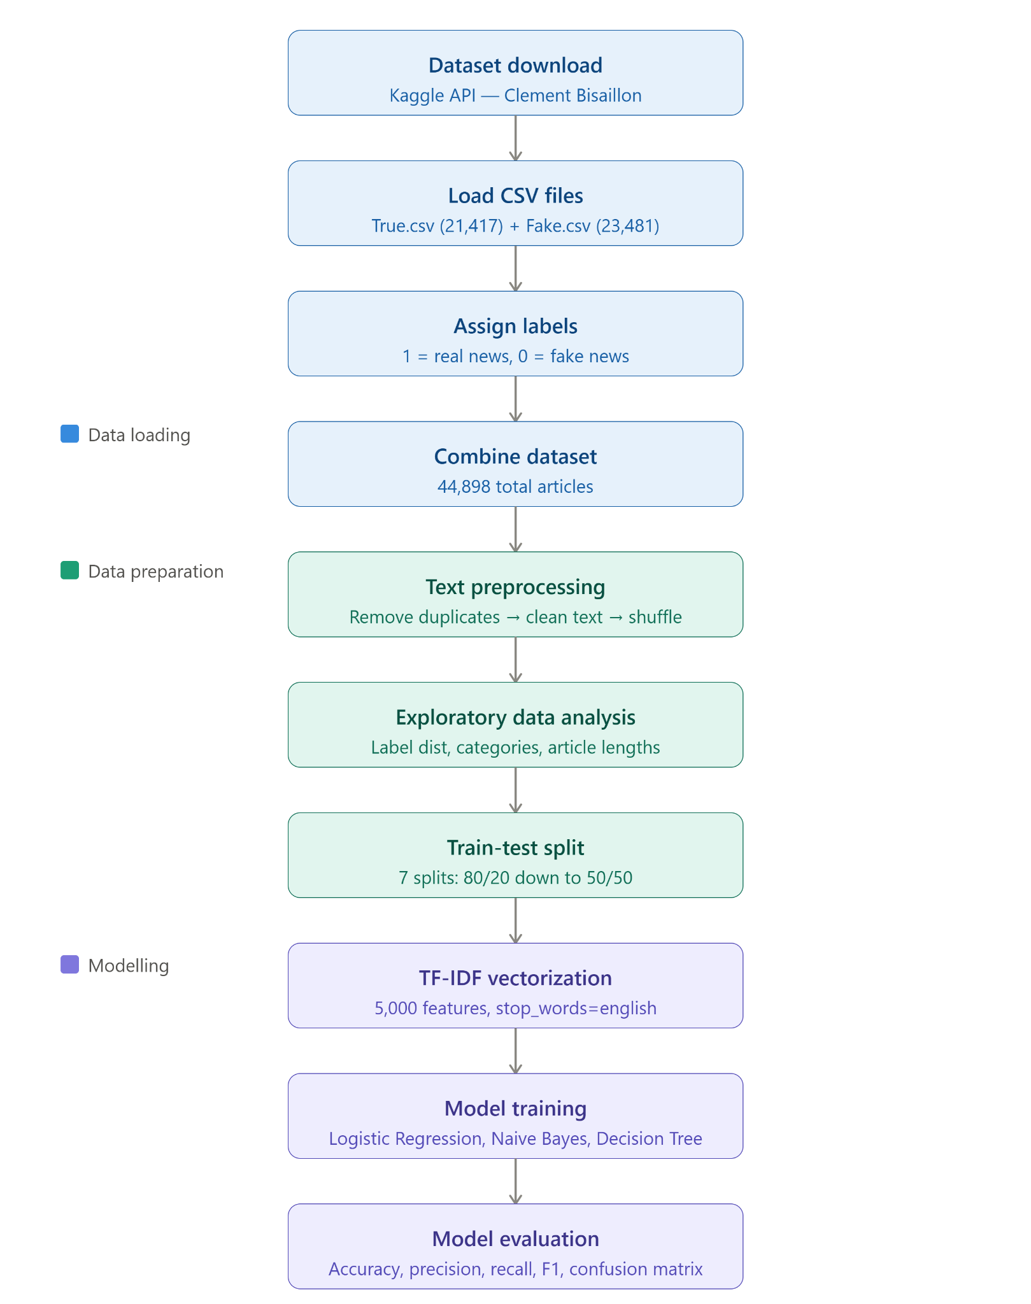

Data Analysis and Results:-

Dataset Statistics After Preprocessing
Metric | Value
Total articles before cleaning | 44,898
Duplicate articles removed | 6,252
Total articles after cleaning | 38,646
Real news articles | 21,192
Fake news articles | 17,454
Number of features (TF-IDF) | 5,000

Figure 1 — Distribution of Real vs Fake News Articles (Bar Chart)
The bar chart below shows the label distribution after preprocessing. The dataset is reasonably balanced between real and fake news articles, reducing the risk of model bias towards either class.

Real news: 21,192 articles, Fake news: 17,454 articles. Total: 38,646 articles.

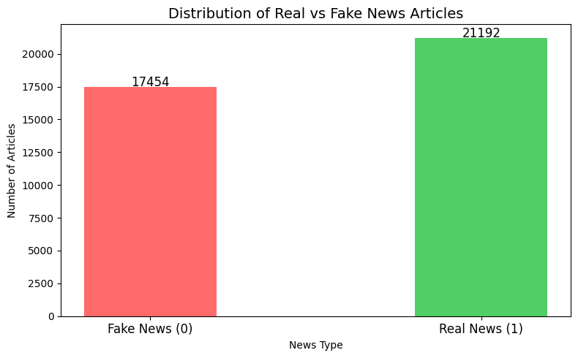
Category Distribution

Category | Percentage
politicsNews | 29.0%
worldnews | 25.8%
News | 23.4%
politics | 16.6%
US_News | 2.0%
left-news | 1.3%
Government News | 1.2%

Figure 2 — Proportion of News Categories (Pie Chart)

Proportion of News Categories in the dataset after preprocessing. The dataset is heavily dominated by political content — politicsNews (29%) and politics (16.6%) together account for 45.6% of all articles.
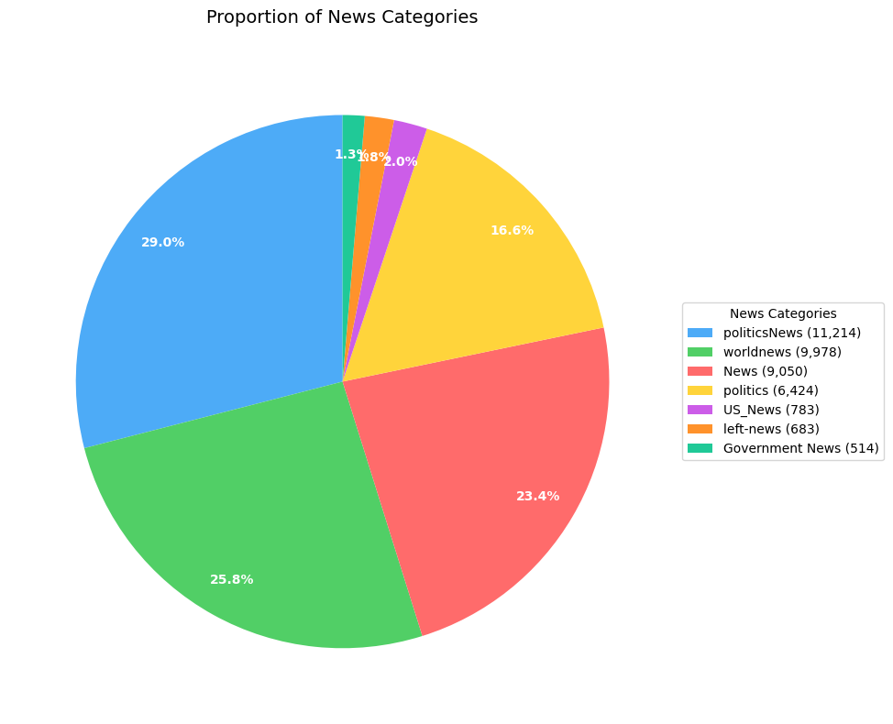

Model Performance Across All Splits
All three models were evaluated across seven train-test splits from 80/20 to 50/50. The table below shows the complete results:

Split | Model | Accuracy (%) | Precision (%)
80/20 | Logistic Regression | 98.93% | 99%
80/20 | Naive Bayes | 94.46% | 94%
80/20 | Decision Tree | 99.29% | 99%
75/25 | Logistic Regression | 98.87% | 99%
75/25 | Naive Bayes | 94.35% | 94%
75/25 | Decision Tree | 99.25% | 99%
70/30 | Logistic Regression | 98.82% | 99%
70/30 | Naive Bayes | 94.29% | 94%
70/30 | Decision Tree | 99.30% | 99%
65/35 | Logistic Regression | 98.81% | 99%
65/35 | Naive Bayes | 94.17% | 94%
65/35 | Decision Tree | 99.32% | 99%
60/40 | Logistic Regression | 98.81% | 99%
60/40 | Naive Bayes | 94.17% | 94%
60/40 | Decision Tree | 99.32% | 99%
55/45 | Logistic Regression | 98.71% | 99%
55/45 | Naive Bayes | 94.04% | 94%
55/45 | Decision Tree | 99.34% | 99%
50/50 | Logistic Regression | 98.62% | 99%
50/50 | Naive Bayes | 93.86% | 93%
50/50 | Decision Tree | 99.34% | 99%

Individual Model Analysis:

Logistic Regression
Logistic Regression showed the most gradual and consistent decline of all three models. From 80/20 to 50/50, accuracy dropped by only 0.31% — from 98.93% to 98.62%. Precision remained fixed at 99% across every single split without exception. This extremely stable behavior demonstrates that Logistic Regression generalizes very well and does not depend heavily on the amount of training data.

Naive Bayes
Naive Bayes was the weakest and most affected model by reduced training data. Accuracy dropped by 0.60% from 80/20 to 50/50 — the largest drop of the three models. More significantly, at the 50/50 split its precision dropped from 94% to 93% — the only model to show a precision reduction across all tested splits. This is the closest thing to a breaking signal observed in this experiment. The independence assumption of Naive Bayes means it needs more training examples to build reliable probability estimates.

Decision Tree
Decision Tree was the most surprising result. Not only did it never drop in accuracy — it actually marginally improved as training data was reduced, going from 99.29% at 80/20 to 99.34% at 50/50. Precision remained fixed at 99% throughout every single split. This consistent high performance suggests that TF-IDF features provide extremely clean and strong decision boundaries for the tree to split on, even with limited training data.

Breaking Point Analysis

The key finding of the extended split experiment is that none of the three models truly failed or broke down even at the most extreme 50/50 split. All three models continued to perform well even when training and test data were exactly equal in size (19,323 articles each). However important differences in breaking tendency were observed:

Model | Total Accuracy Drop | Precision Drop | Breaking Tendency
Logistic Regression | 0.31% | None | Most stable — very gradual decline
Naive Bayes | 0.60% | 94% → 93% at 50/50 | First to show signs of breaking
Decision Tree | ~0% (slight increase) | None | No breaking point found

If splits were pushed beyond 50/50, Naive Bayes would likely be the first model to break, followed by Logistic Regression. Decision Tree showed no signs of breaking within the tested range.

80/20 Split — Detailed Evaluation

The following table shows the detailed classification report for each model at the standard 80/20 split:

Model | Class | Precision | Recall | F1 Score | Support
Logistic Regression | Fake News | 0.99 | 0.98 | 0.99 | 3,494
Logistic Regression | Real News | 0.99 | 1.00 | 0.99 | 4,236
Naive Bayes | Fake News | 0.94 | 0.94 | 0.94 | 3,494
Naive Bayes | Real News | 0.95 | 0.95 | 0.95 | 4,236
Decision Tree | Fake News | 0.99 | 0.99 | 0.99 | 3,494
Decision Tree | Real News | 0.99 | 0.99 | 0.99 | 4,236

The following confusion matrices compare how each model performed on the 7,730 test articles at the 80/20 split. Each matrix has four cells:

- Top Left: Fake articles correctly predicted as
Fake (True Positive)
- Top Right: Fake articles wrongly predicted as
Real (False Negative)
- Bottom Left: Real articles wrongly predicted as
Fake (False Positive)
- Bottom Right: Real articles correctly predicted
as Real (True Negative)

Darker cells indicate higher counts. Ideally the diagonal cells (top left and bottom right) should be the darkest, indicating most articles were correctly classified. The off-diagonal cells representing errors should be as light as possible.

Logistic Regression Confusion Matrix (80/20 Split) The confusion matrix below shows the prediction breakdown for Logistic Regression on 7,730 test articles. The model correctly identified 3,431 fake news articles and 4,216 real news articles. It made only 83 total errors — 63 real articles were wrongly flagged as fake and 20 fake articles were missed and classified as real. The strong diagonal values confirm that the model is highly accurate and well balanced between both classes.

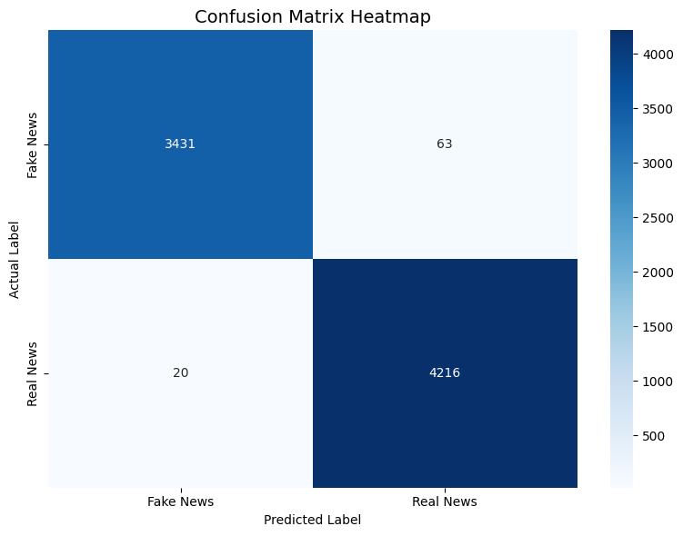

Figure 3: Confusion Matrix — Logistic Regression (80/20 Split).
Accuracy: 98.93%

Naive Bayes Confusion Matrix (80/20 Split) The confusion matrix below shows the prediction breakdown for Naive Bayes on 7,730 test articles. The model correctly identified 3,278 fake articles and 4,024 real articles. However it made 428 total errors — significantly more than the other two models. 216 real articles were wrongly flagged as fake and 212 fake articles were missed. This higher error count reflects the limitation of Naive Bayes independence assumption, which assumes all words are statistically independent of each other — an assumption that does not fully hold in real language, reducing its overall accuracy to 94.46%.

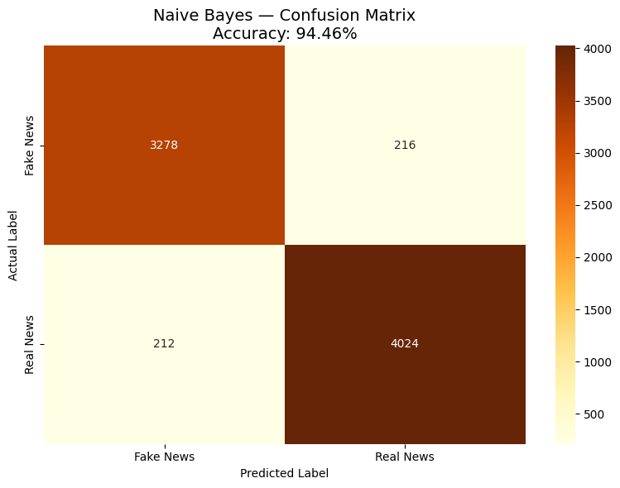

Figure 4: Confusion Matrix — Naive Bayes (80/20 Split).
Accuracy: 94.46%
Decision Tree Confusion Matrix (80/20 Split) The confusion matrix below shows the prediction breakdown for the Decision Tree on 7,730 test articles. The model correctly identified 3,463 fake articles and 4,212 real articles — the highest correct classification counts of all three models. It made only 55 total errors — the fewest of all three models — with 31 real articles wrongly flagged as fake and 24 fake articles missed. This outstanding performance confirms that TF-IDF features provide extremely strong and clean decision boundaries for tree-based classification.

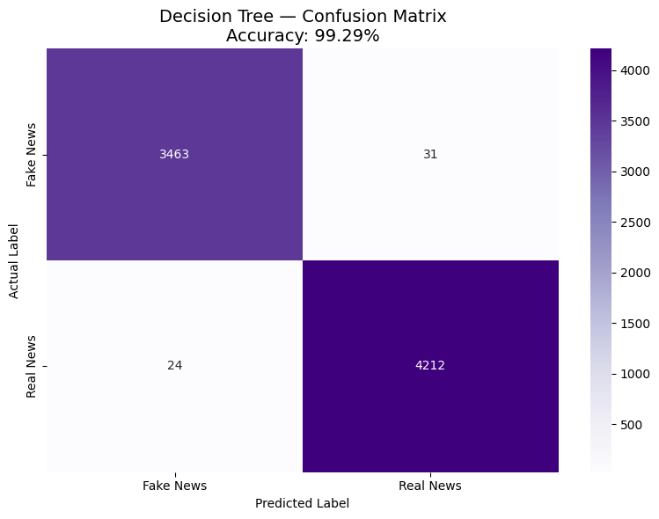

Figure 5: Confusion Matrix — Decision Tree (80/20 Split). Accuracy: 99.29%

Summary Comparison:

Logistic Regression: 83 total errors out of 7,730
Naive Bayes: 428 total errors out of 7,730
Decision Tree: 55 total errors out of 7,730

Decision Tree made the fewest mistakes overall,
followed closely by Logistic Regression. Naive
Bayes made significantly more errors than both
other models, consistent with its lower overall
accuracy of 94.46% compared to 98.93% and 99.29%
for Logistic Regression and Decision Tree
respectively.

Conclusion:-
This project successfully built a fake news detection system using classical machine learning techniques, achieving outstanding results across all evaluated models and splits.
The most significant finding of this project is that none of the three models showed a true breaking point across seven train-test splits from 80/20 to 50/50. All three models maintained strong performance even with only 50% training data, demonstrating that TF-IDF features are extremely informative for this dataset and that the preprocessing pipeline was highly effective.

Among the three models, Decision Tree achieved the highest accuracy (99.34%) and showed the most remarkable stability — its accuracy actually marginally improved as training data was reduced. Logistic Regression was the most consistent model, maintaining 99% precision across all seven splits with only a 0.31% accuracy drop. Naive Bayes was the most affected by reduced training data, showing the only precision drop observed across all splits (94% to 93% at 50/50), suggesting it would be the first to fail if splits were pushed beyond 50/50.

For real-world deployment, Logistic Regression is recommended as the primary model due to its combination of high accuracy (98.62-98.93%), perfect precision consistency and high interpretability — the learned word weights can be directly examined to understand what linguistic patterns the model uses to distinguish fake from real news.

An interesting insight from the data analysis is that fake news articles contained significantly more duplicates (6,027) compared to real news (225), which aligns with the real-world phenomenon of fake news being copy-pasted and redistributed across multiple unreliable sources. Additionally the dataset is dominated by political news (politicsNews and politics account for 45.6% of articles), reflecting the context in which it was originally collected — the 2016 US election period.

Future work could include testing the models with even smaller training splits (40/60, 30/70) to definitively find the breaking point of each model, exploring deep learning approaches like BERT for comparison, extending the dataset to include more diverse categories such as sports, health and entertainment news, and building a real-time web application for fake news detection using the trained model.

Appendices:-

Appendix A — GitHub Repository
All project code, visualizations and results are available at:
https://github.com/jeetjohngomes77-svg/fake-news-detection/tree/main

Appendix B — References
● Clement Bisaillon — Fake and Real News Dataset, Kaggle. https://www.kaggle.com/datasets/clmentbisaillon/fake-and-real-news-dataset
● Scikit-learn Documentation — TfidfVectorizer, LogisticRegression, MultinomialNB, DecisionTreeClassifier. https://scikit-learn.org/stable/
● Pandas Documentation. https://pandas.pydata.org/docs/
● Matplotlib Documentation. https://matplotlib.org/stable/
● IDEAS TIH Summer Internship 2026 — Program Materials, Indian Statistical Institute Kolkata. https://www.ideas-tih.org

Appendix C — Google Colab Notebook
The complete Google Colab notebook with all code, outputs and visualizations is available at:
https://colab.research.google.com/drive/16gVu2iorxy6yjm5DqRjE37C3g17YKmj5?usp=sharing

Appendix D — Dataset Information

Item | Details
Dataset Name | Fake and Real News Dataset
Source | Kaggle — Clement Bisaillon
Real News Source | Reuters News Agency
Fake News Source | Various unreliable sources (2016 US election)
Total Articles (before cleaning) | 44,898
Total Articles (after cleaning) | 38,646
Number of Columns | 5 (title, text, subject, date, label)
Number of Categories | 6
Label 0 | Fake News
Label 1 | Real News

