

**[CPSC-501-11]-OOP with Design Patterns-2019FA**

Group Project Report

Elevator Simulation

Group-3

Name of Group Members:

Jeet Trivedi (1098918)

Shubham Kashikar ()

Teja Sai Inala (1097928)

UML Diagram of Elevator Simulation

Structural Diagram: Class Diagram

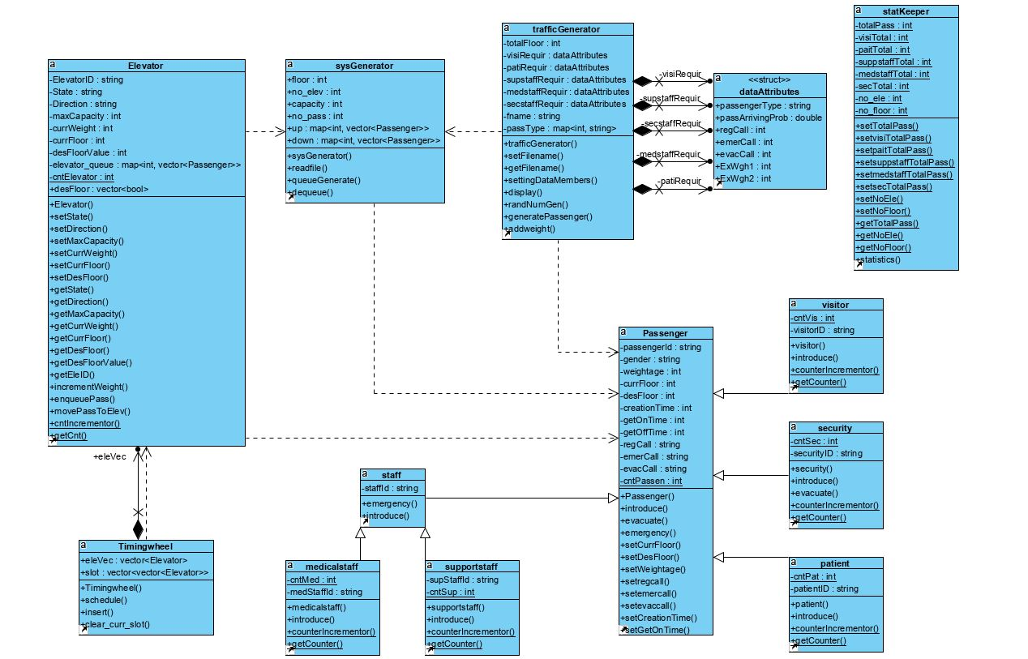

Behavioral Diagram: State Diagram

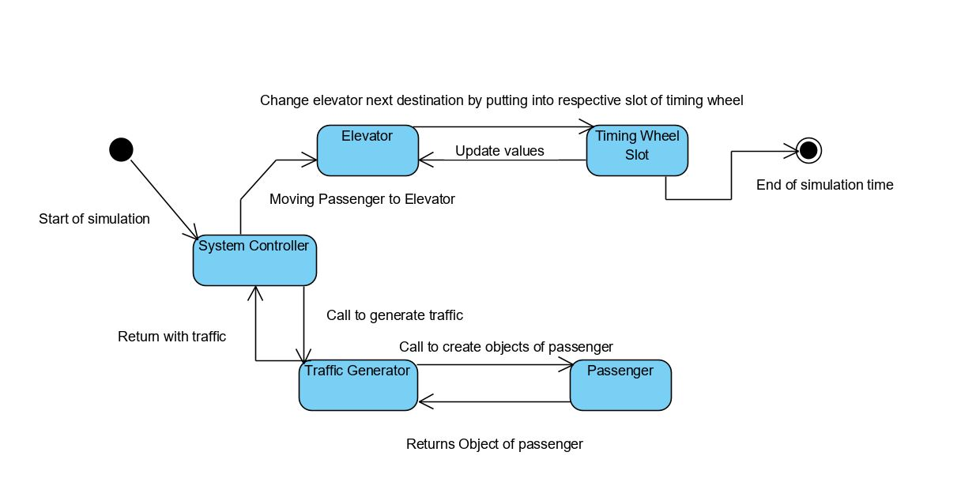

Final Code



Screenshot of Output