import pandas as pd import numpy as np import matplotlib. pyplot as plt from sklearn.model_selection import train_test_split from sklearn. linear_model import LinearRegression from sklearn. metrics import mean_squared_error, r2_score import time

# Load the data from the CSV file file_path = ' / content/ test . '

try :

data = pd . read_csv(file_path) print("Data Loaded Successfully: " ) print(data) except FileNotFoundError:

print(f"Error: The file {file_path} was not found. ") exit ( )

 Prepare the data

X = 'Vehicle_Count' ]] # Features y = data[ ' Light_Duration ' ] # Target variable

 Split the data into training and testing sets

X_train, X_test, y_train, y_test = train_test_sp1it(X, y, test_size=e.2, random_state=42)

 Create a linear regression model model = LinearRegression()

# Train the model model. fit (X_train, y_train)

# Make predictions predictions = model . predict (X_test)

# Evaluate the model mse = mean_squared_error(y_test, predictions) r2_score(y_test, predictions)

print("\nMode1 Evaluation: ") print(f"Mean Squared Error: {mse: .2f}")

# Score: {r2: .2f}")

# Visualize the results plt.scatter(X_test, y_test, color= 'blue' , label='Actua1 Data' ) plt. scatter (X_test, predictions, color= ' red' , label= ' Predictions plt. plot (X_test, predictions, color= ' green ' linewidth=2, label= 'Regression Line' ) plt.title( 'Vehicle Count vs Light Duration' ) plt.xlabel( 'Vehicle Count' ) plt.ylabel( ' Light Duration' ) plt. legend() PIt. show()

# Function to predict light duration based on vehicle count def predict_light_duration (vehicle_count) : if vehicle count < e:

raise ValueError("Vehic1e count cannot be negative. return model.  [vehicle_count] ] ) ) [ e ]

# Function to simulate traffic light control def traffic_light_control (vehicle_count) :

predicted_duration = predict_light_duration (vehicle_count) print(f"\nPredicted Light Duration for {vehicle_count} vehicles: {predicted_duration: .2f} seconds")

# Simulate the traffic light timing print("Traffic Light will be GREEN for { : .2f} seconds. " . format(predicted_duration)) time. sleep(predicted_duration) # Simulate the duration of the green light print("Traffic Light will turn RED now. ")

# Example usage try :

vehicle count_input - 30 # Example vehicle count traffic_light_control (vehicle_count_input) except ValueError as e: print(f"Error:

Data Loaded Successfully:

Vehicle_Count Light_Duration

 e  le

25 3e

30 35

35 40

40

50 55

Model Evaluation:

mean Squared Error: e.ee RA2 Score: I.ee

Vehicle Count vs Light Duration

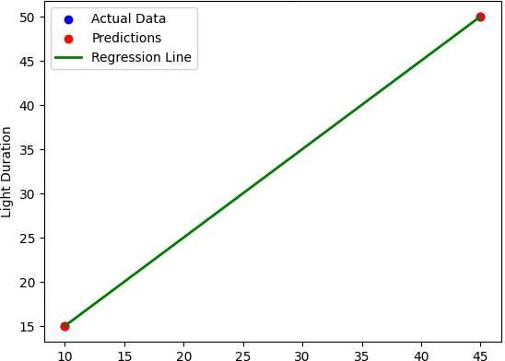

10

15

20

25

30

35

Vehicle Count

/usr/local/lib/ python3.11 'dist-packages/sklearn/utils/val idation. py: 2739 : userWarning: X does not have valid feature names, but LinearRE warnings. warn (

Predicted Light Duration for 3B vehicles: 35 .ee seconds Traffic Light will be GREEN for 35 .ee seconds. Traffic Light will turn RED now.