IT481 Capstone/Cornerstone Project Report on
AI based Intelligent Framework for 3DCP Layer
Deformation Monitoring and Shrinkage Prediction
Submitted in partial fulfilment of the requirements for the degree of
by
BACHELOR of Technology in INFORMATION TECHNOLOGY
Sagar Hiremath (Roll No. 241IT067)
And
BACHELOR of Technology in ARTIFICIAL INTELLIGENCE
Jeetu Kumar (Roll No. 241AI018)

Under the guidance of
Dr. Sowmya Kamath S

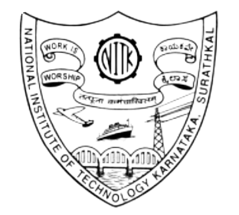
DEPARTMENT OF INFORMATION TECHNOLOGY
NATIONAL INSTITUTE OF TECHNOLOGY KARNATAKA
SURATHKAL, MANGALORE - 575025

DECLARATION
We hereby declare that the IT481 Capstone/Cornerstone Project Report entitled “AI based Intelligent Framework for 3DCP Layer Deformation Monitoring and Shrinkage Prediction”, which is being submitted to National Institute of Technology Karnataka, Surathkal, for the award of Degree of Bachelor of Technology in Information technology, and Bachelor of Technology in Artificial Intelligence, is a bona fide report of the work carried out by us. The material contained in this Report has not been submitted to any University or Institution for the award of any degree.

Name of the Students with Signature.

- Sagar Hiremath (Roll No. 241IT067)

- Jeetu Kumar (Roll no. 241AI018)

Department of Information Technology
Place: NITK, Surathkal
Date: 06/11/2025

CERTIFICATE
This is to certify that the Major Project Work entitled “AI based Intelligent Framework for 3DCP Layer Deformation Monitoring and Shrinkage Prediction” submitted by

Name of the Students (Registration Number)

- Sagar hiremath (Roll No. 241IT067)
- Jeetu Kumar (Roll No. 241AI018)

is the record of the work carried out by him/her/them, is accepted as the B.Tech Capstone/Cornerstone project work report submission in partial fulfilment of the requirement for the award of the degree of Bachelor of Technology in Information Technology(Sagar Hiremath) and Bachelor of Technology in Artificial Intelligence(Jeetu Kumar) in the Department of Information Technology, NITK Surathkal.

Signature of Capstone/Cornerstone Project Guide with date
Dr. Sowmya Kamath S
Associate Professor
Department of Information Technology
NITK Surathkal-575025

