PROJECT REPORT
Mountain Gazelle Optimization-Based Joint Hyperparameter Tuning of Neural-XGBoost for Disaster Prediction

Based on the Neural-XGBoost disaster prediction framework and the proposed MGO-based optimization extension

Prepared as a project report

1. Abstract
Accurate disaster prediction is important for preparedness, resource allocation, and emergency response. The Neural-XGBoost (N-XGB) framework considered in this project combines a neural network (NN) for high-level feature extraction with XGBoost for multi-class classification of wildfire, flood, and earthquake events. The original study reports 5,091 disaster records and 45 input features and uses data preprocessing, median/mode imputation, feature scaling, SMOTE-based class balancing, neural feature extraction, and XGBoost classification. Its XGBoost hyperparameters are selected using an exhaustive grid search, while the neural-network training settings are not jointly tuned. This project proposes replacing that fixed search stage with Mountain Gazelle Optimization (MGO), a population-based metaheuristic search method, and extending the search to jointly tune selected NN and XGBoost hyperparameters. The first objective is to reproduce the baseline N-XGB pipeline. In the current implementation, the baseline has been successfully executed, but its measured performance differs from the reference paper, motivating careful verification of the experimental setup before MGO optimization. The balanced experiment achieves 90.82% accuracy and a macro ROC-AUC of 0.91964 for N-XGB, while standalone XGBoost achieves 95.82% accuracy and a macro ROC-AUC of 0.96965.

2. Introduction
Natural disasters such as wildfires, floods, and earthquakes can produce large social, economic, and infrastructure losses. Machine learning can support disaster management by learning patterns from historical disaster records and predicting the most likely disaster category for a new observation. The reference Neural-XGBoost study addresses this as a multi-class classification problem and combines deep feature extraction with gradient-boosted trees.
The N-XGB architecture first preprocesses the disaster records, then passes the processed data through a fully connected neural network to obtain a lower-dimensional feature representation H. XGBoost uses H as its input and performs the final classification. SMOTE is applied to the training data to reduce the effect of class imbalance. The paper reports an overall accuracy of 94.8% and an average F1-score of 0.95, with class-specific F1-scores of 0.96 for wildfire, 0.93 for flood, and 0.96 for earthquake. These values provide a strong baseline for the present project.
The central modification proposed in this project is the joint selection of hyperparameters for both stages of the hybrid model: the neural-network feature extractor and the XGBoost classifier.

3. Literature Survey

3.1 Traditional machine learning for disaster prediction
Traditional methods such as decision trees, Random Forest, Support Vector Machines (SVM), logistic regression, and k-nearest neighbors have been widely used for structured disaster data. The reference study notes that these approaches can struggle when relationships among meteorological, geological, spatial, temporal, and socio-economic variables become strongly nonlinear. The paper also identifies class imbalance as a major issue, because flood events can be much more numerous than wildfire and earthquake records.

3.2 Deep learning based approaches
Deep learning models such as convolutional neural networks, recurrent neural networks, and long short-term memory networks can automatically learn high-level representations. They are especially useful for imagery and sequential information. However, the reference paper highlights practical challenges including computational requirements, data scarcity, and limited interpretability. The N-XGB approach uses a relatively compact neural network for feature extraction and delegates final classification to XGBoost.

3.3 Hybrid deep learning and XGBoost approaches
Hybrid architectures combine the representation-learning ability of neural networks with the tabular-data strength of boosted trees. The reference paper reviews CNN-XGBoost and LSTM-XGBoost combinations and argues that a hybrid NN + XGBoost formulation is suitable for heterogeneous disaster records. The resulting N-XGB model uses neural embeddings as XGBoost inputs and reports stronger classification performance than the baseline machine-learning models considered in the paper.

3.4 Imbalance and missing-data handling
The disaster dataset contains substantial missing information, including large amounts of missing geographic and financial data. The paper uses median imputation for numerical variables and mode imputation for categorical variables, followed by label encoding and standardization. SMOTE is then applied only to the training set to generate synthetic minority-class samples and produce a more balanced training distribution.

3.5 Hyperparameter optimization and the project gap
The reference model tunes three XGBoost hyperparameters using an exhaustive grid search. The sensitivity analysis in the paper shows that learning rate, maximum tree depth, and number of estimators affect classification performance. The paper also states that automated tuning methods such as Bayesian optimization are a future research direction. This project instead investigates Mountain Gazelle Optimization (MGO) and extends the search to jointly tune selected NN and XGBoost hyperparameters.
Study/Approach | Main idea | Limitation / gap relevant to this project
Random Forest / SVM / Logistic Regression | Classical supervised classification | Less effective for complex nonlinear interactions and imbalance in the target setting
CNN / RNN / LSTM | Automatic deep feature learning | Higher computational cost and data requirements; reduced interpretability
CNN-XGBoost / LSTM-XGBoost | Hybrid feature learning + boosted trees | Dependence on suitable input modality and larger labeled datasets in some settings
Original N-XGB | NN feature extraction + SMOTE + XGBoost | Uses fixed grid search for a small hyperparameter space
Proposed MGO-N-XGB | Adaptive metaheuristic hyperparameter search | Project extension; performance must be validated experimentally

4. Motivation
The motivation for this project comes from the fact that the N-XGB architecture and its hyperparameter-search strategy are separate design choices. The reference model already reports strong performance, but its XGBoost tuning examines only a small predefined grid, while the NN settings are fixed rather than jointly optimized. A configuration that performs better but falls outside the tested grid values will not be evaluated by grid search. In addition, expanding the number of hyperparameters or candidate values can rapidly increase the number of exhaustive combinations.
MGO provides an outer optimization layer that searches for a strong joint configuration of NN and XGBoost hyperparameters. A candidate solution is not a new classifier; it is one complete set of training settings. For each candidate, the underlying NN and XGBoost training procedures remain unchanged. MGO only determines which hyperparameter configuration is used for the next model evaluation.

5. Problem Statement
The N-XGB model's fixed, exhaustive grid-search strategy is limited to a small set of predefined XGBoost hyperparameter values and does not jointly tune the neural-network settings. An efficient optimization approach is therefore needed to search the joint NN-XGBoost hyperparameter space and identify configurations that can improve validation performance without an unnecessarily large exhaustive search.

6. Objectives
1. Reproduce the baseline Neural-XGBoost (N-XGB) disaster classification model described in the reference paper.
2. Implement Mountain Gazelle Optimization (MGO) as an outer-loop optimizer that jointly tunes selected neural-network and XGBoost hyperparameters.
3. Define a fitness function based on validation performance, with macro-F1 as the primary optimization metric so that wildfire, flood, and earthquake classes are considered jointly.
4. Compare the MGO-optimized N-XGB model against the baseline grid-search N-XGB model using accuracy, class-wise F1, macro-F1, ROC-AUC, confusion matrices, and computational cost.
5. Analyze whether joint MGO tuning identifies a stronger N-XGB configuration without an excessive increase in model-evaluation cost.

7. Methodology

7.1 Dataset and preprocessing
The reference study uses the CRED EM-DAT disaster database with 5,091 records and 45 raw input features, focusing on three disaster categories: wildfire, flood, and earthquake. In the present implementation, additional identifier and taxonomy fields that can trivially reveal the target are excluded before model training. The preprocessing pipeline includes median imputation for missing numerical values, mode imputation for missing categorical values, label encoding for categorical variables, and StandardScaler-based normalization. The data are then partitioned for learning and evaluation, and SMOTE is applied only to the training data so that minority disaster classes are represented more adequately.
Stage | Operation | Purpose
1 | Filter target classes | Keep wildfire, flood, and earthquake records
2 | Median/mode imputation | Handle missing numerical and categorical entries
3 | Label encoding | Convert categorical inputs into numerical form
4 | StandardScaler | Put numerical variables on a comparable scale
5 | Train/test partition and SMOTE on training data | Balance the training set without changing the held-out evaluation data

7.2 Neural feature extraction
The preprocessed input D' is passed through a fully connected neural network with ReLU activation and dropout regularization. The network maps the original input into a lower-dimensional embedding H:
H = f_NN(D')
The extracted representation H is then used as the feature matrix for XGBoost. In the proposed project, the NN training procedure is still the same model described in the reference paper, but its selected hyperparameters become part of the outer MGO search. Thus, the NN architecture is not replaced; only its training settings are selected adaptively.

7.3 XGBoost classification
XGBoost performs the final multi-class classification using the extracted feature vectors. The reference paper expresses its training objective as minimizing the sample loss plus a regularization term:
min_w Σ_i ℓ(y_i, f(h_i; w)) + Ω(f)
Here, w represents the learned tree parameters, l is the classification loss, h_i is the extracted feature vector, and Omega(f) controls model complexity. This internal optimization is performed by XGBoost itself. It is not replaced by MGO; MGO operates at a higher level by selecting the hyperparameters that define how the NN and XGBoost are trained.

7.4 Baseline grid-search tuning
The reference paper searches learning rate (α), maximum tree depth (d), and number of estimators (n) using the values shown below. The current project implementation also uses a 27-combination grid, but its learning-rate values are 0.01, 0.10, and 0.20. This difference is one reason the current implementation should be treated as an implementation-specific baseline rather than an exact reproduction of the published experiment.
Hyperparameter | Reference paper values
Learning rate (α) | 0.01, 0.05, 0.10
Maximum depth (d) | 5, 7, 9
Number of estimators (n) | 100, 200, 300
Current implementation learning rate | 0.01, 0.10, 0.20

This produces 27 combinations. Each combination is trained and evaluated, and the best-performing configuration is retained.

7.5 Proposed MGO-based optimization
The proposed method adds an outer optimization problem above the original N-XGB training process. Let theta denote one complete candidate hyperparameter vector containing selected NN and XGBoost settings. MGO seeks the candidate that maximizes the chosen validation fitness:
In the notation used here, MGO does not directly optimize the internal XGBoost tree parameters w. It searches the outer hyperparameter vector theta, and each candidate fitness evaluation trains the NN and XGBoost using that theta before measuring validation macro-F1.
θ* = argmax_θ F(θ)
For this project, the joint search vector is defined conceptually as theta = [lr_NN, dropout, batch_size, epochs, hidden_1, hidden_2, hidden_3, alpha, max_depth, n_estimators, subsample, colsample_bytree, gamma, min_child_weight]. Continuous variables are searched within specified bounds, while discrete/integer variables such as batch size, epochs, hidden-layer sizes, tree depth, and estimator count must be mapped or rounded to valid values before model training. The final bounds and encoding used in the implementation should be reported explicitly for reproducibility.
Each candidate theta is evaluated by running the complete N-XGB pipeline: the NN is built and trained using theta_NN; its extracted representation H is generated; SMOTE is applied to the training data according to the reference workflow; XGBoost is trained using theta_XGB; and the complete model is evaluated on validation data. The resulting validation macro-F1 is returned to MGO as the fitness value.
The primary fitness function is defined as the macro-F1 score of the complete N-XGB pipeline on validation data:

7.6 Optimization workflow
Step 1: Initialize a population of candidate joint NN + XGBoost hyperparameter vectors within predefined bounds.
Step 2: For each candidate, train the NN with its candidate settings, generate H, train XGBoost with its candidate settings, and compute the validation fitness.
Step 3: Rank the complete NN + XGBoost configurations and identify the current best solution.
Step 4: Update the population using the MGO movement mechanisms.
Step 5: Repeat evaluation and updating for the chosen number of iterations.
Step 6: Return the best complete NN + XGBoost hyperparameter vector encountered across all iterations.
Step 7: Retrain and evaluate the final N-XGB model using the selected joint configuration on the prescribed train/test protocol.

7.7 First objective implementation: baseline reproduction
The first project objective is to reproduce the original N-XGB model before introducing MGO. The reproduction follows the reference paper's preprocessing, neural feature extraction, training-data balancing with SMOTE, XGBoost classification, and evaluation sequence. The paper reports Python 3.9 on Windows 11, an Intel Core i9 processor, 32 GB RAM, and an NVIDIA GPU; the NN is reported with batch size 64, learning rate 0.001, and 50 epochs, while the XGBoost hyperparameters are tuned with GridSearchCV. These reported settings are used as reproduction targets, not as independently measured project results.

8. First Objective Implementation Results
The baseline N-XGB pipeline has now been implemented and evaluated using the updated experimental outputs. The current implementation includes both balanced (SMOTE on training data) and imbalanced (raw training data) experiments, with 5-fold StratifiedKFold GridSearchCV for the downstream classifiers. The test set remains untouched during classifier tuning. The results below supersede the earlier placeholder/reference-only result values.

8.1 Implementation Status
The implementation reproduces the intended baseline workflow: EM-DAT preprocessing, separate neural feature extraction for the balanced and imbalanced training sets, downstream model tuning, and evaluation on a held-out test set. The current implementation-specific results are reported below rather than using the reference paper's published 94.8% N-XGB accuracy as though it were independently reproduced.

8.2 Balanced Experiment Results
SMOTE is applied only to the training data. The held-out test set contains 1,602 observations and retains the original class distribution. The updated confusion matrices compare Logistic Regression, SVM, Random Forest, k-NN, and N-XGB.
Model | Accuracy | Macro ROC-AUC
Logistic Regression | 73.16% | 0.88009
SVM | 81.46% | 0.90270
Random Forest | 92.57% | 0.95843
k-NN | 79.46% | 0.83879
N-XGB (Hybrid) | 89.64% | 0.91082
For N-XGB, the measured weighted F1-score is 0.89843 and the macro ROC-AUC is 0.91082. The model correctly classifies 201/212 wildfire cases, 1,198/1,286 flood cases, and 37/104 earthquake cases. The dominant error is the misclassification of earthquake cases as flood events.
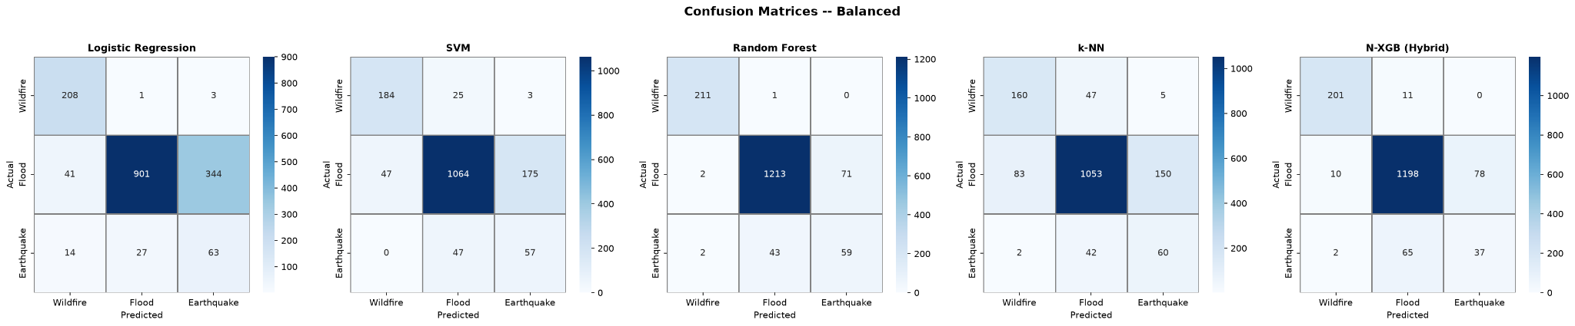
Figure 1. Confusion matrices for the balanced experiment.
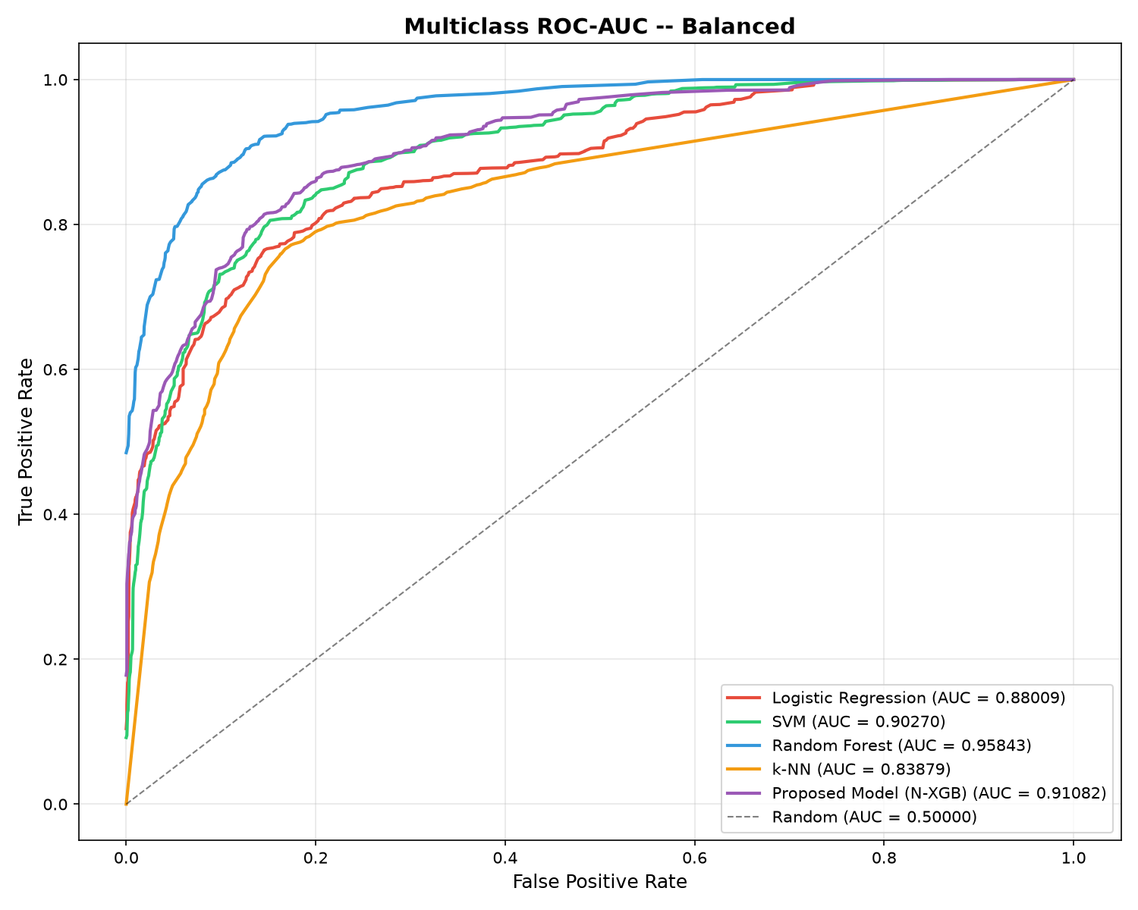
Figure 2. Multiclass ROC-AUC comparison on the balanced experiment.
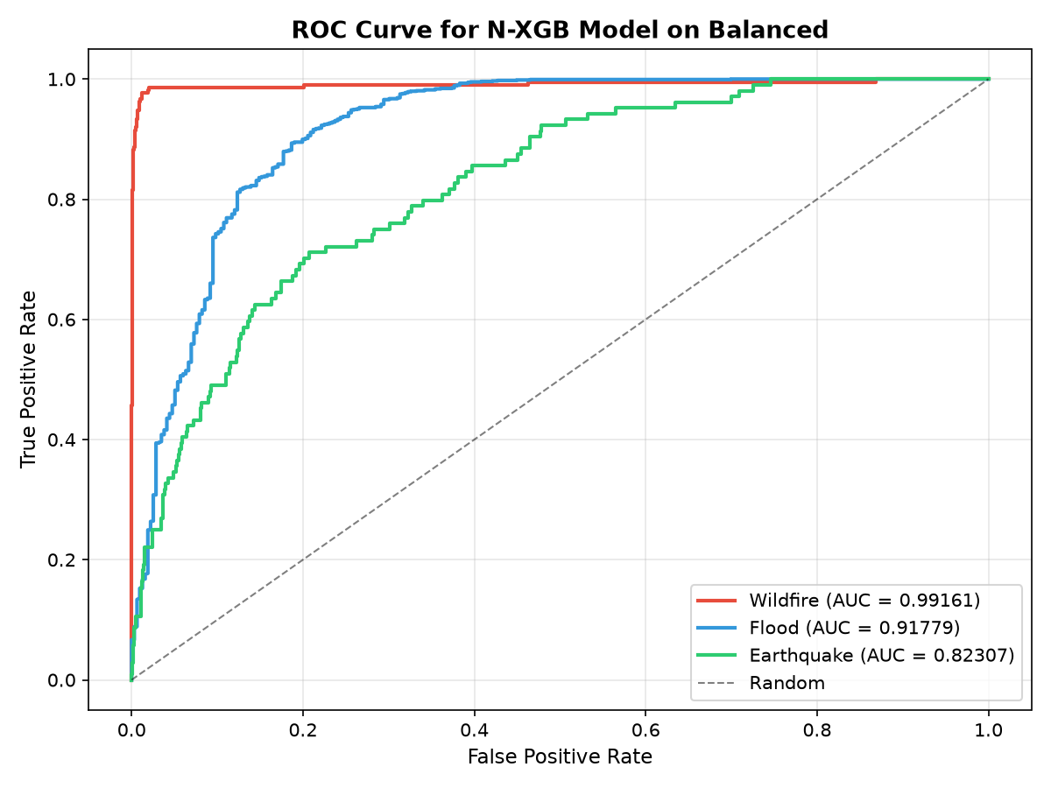
Figure 3. Class-wise ROC curves for N-XGB on the balanced experiment.
The class-wise N-XGB ROC-AUC values are 0.99161 for wildfire, 0.91779 for flood, and 0.82307 for earthquake. This confirms that earthquake discrimination is the weakest part of the hybrid model, consistent with the confusion matrix.

8.3 Imbalanced Experiment Results
The imbalanced experiment uses the raw training distribution without SMOTE. The same 1,602-observation test set is used for evaluation.
Model | Accuracy | Macro ROC-AUC
Logistic Regression | 88.39% | 0.87072
SVM | 89.14% | 0.83327
Random Forest | 94.57% | 0.96251
k-NN | 85.27% | 0.81448
N-XGB (Hybrid) | 91.57% | 0.91535
For N-XGB, the measured weighted F1-score is 0.90469 and the macro ROC-AUC is 0.91535. The N-XGB confusion matrix shows 194/212 wildfire cases, 1,251/1,286 flood cases, and 22/104 earthquake cases correctly classified. Earthquake recognition remains the major weakness, with most earthquake errors being predicted as flood.
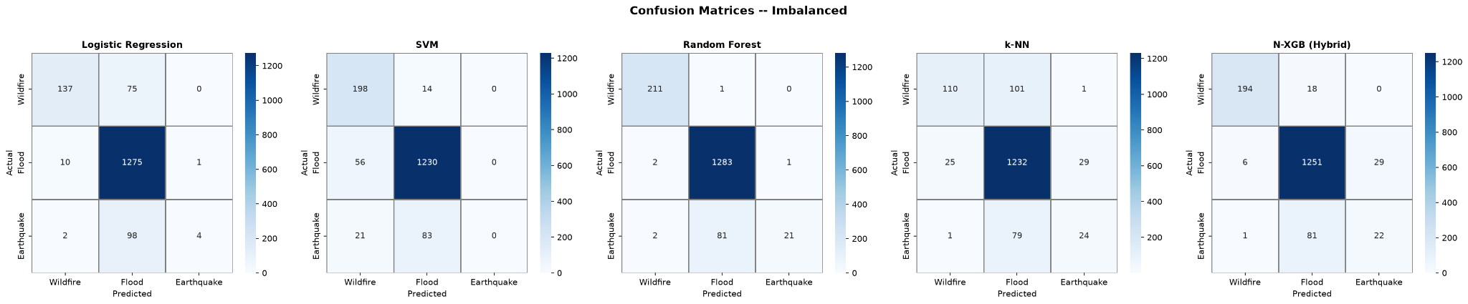
Figure 4. Confusion matrices for the imbalanced experiment.
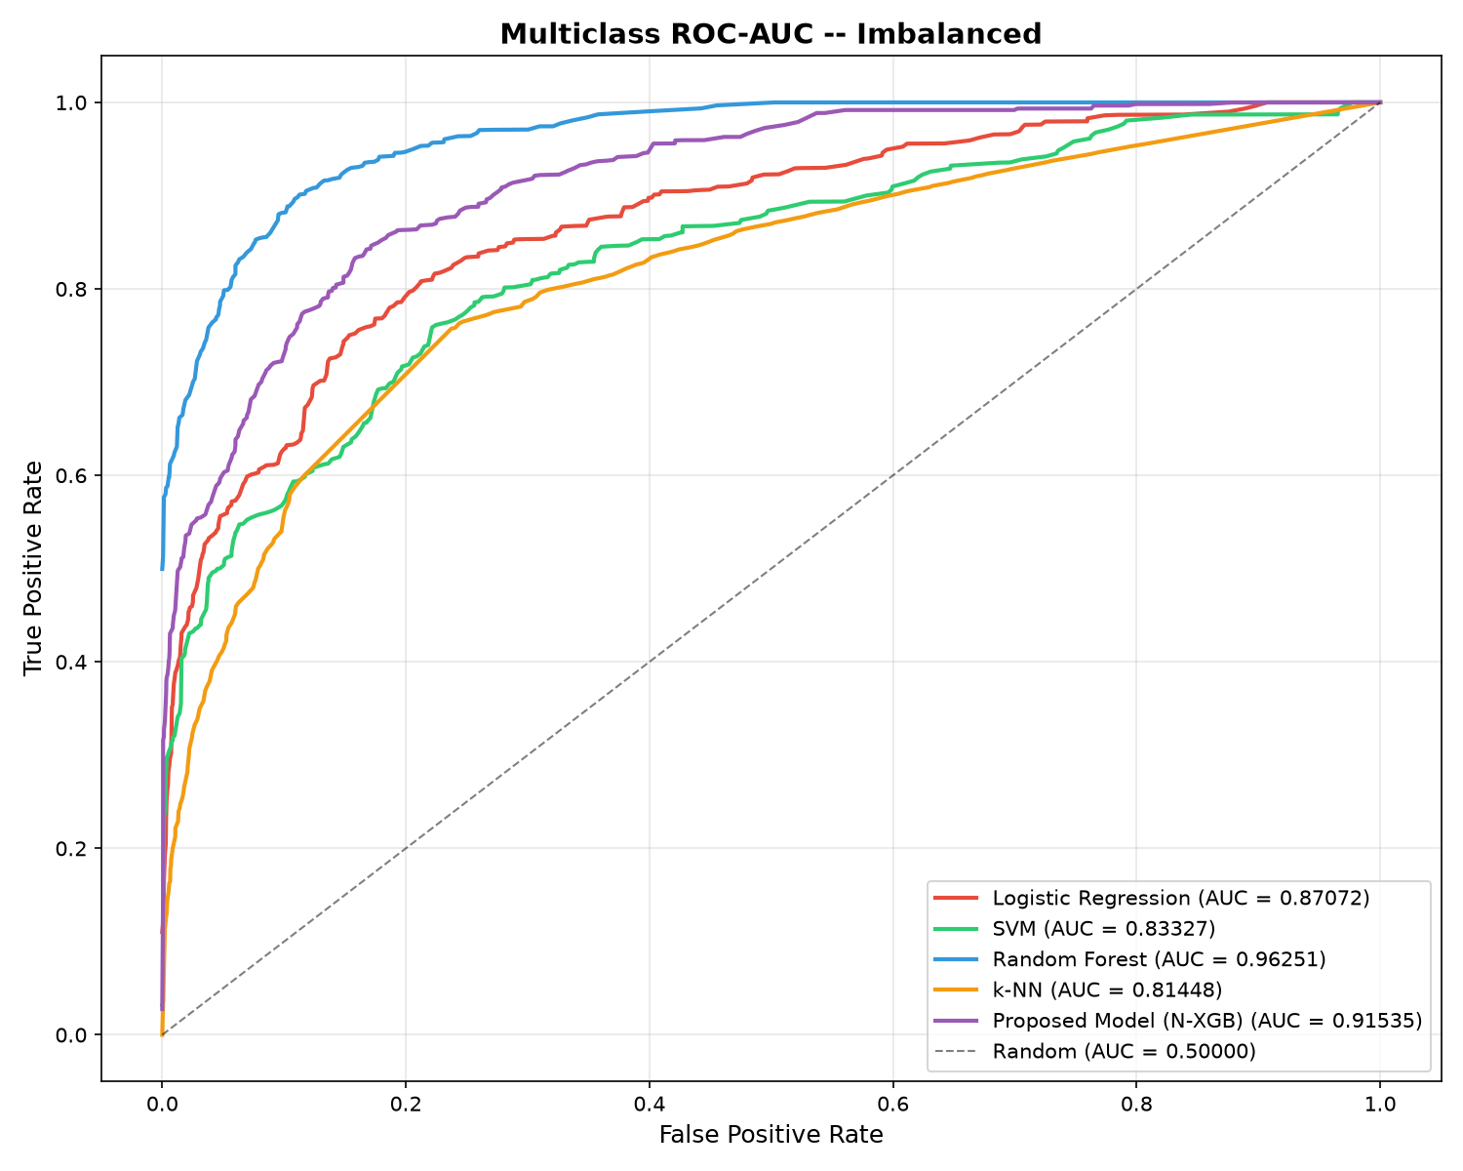
Figure 5. Multiclass ROC-AUC comparison on the imbalanced experiment.
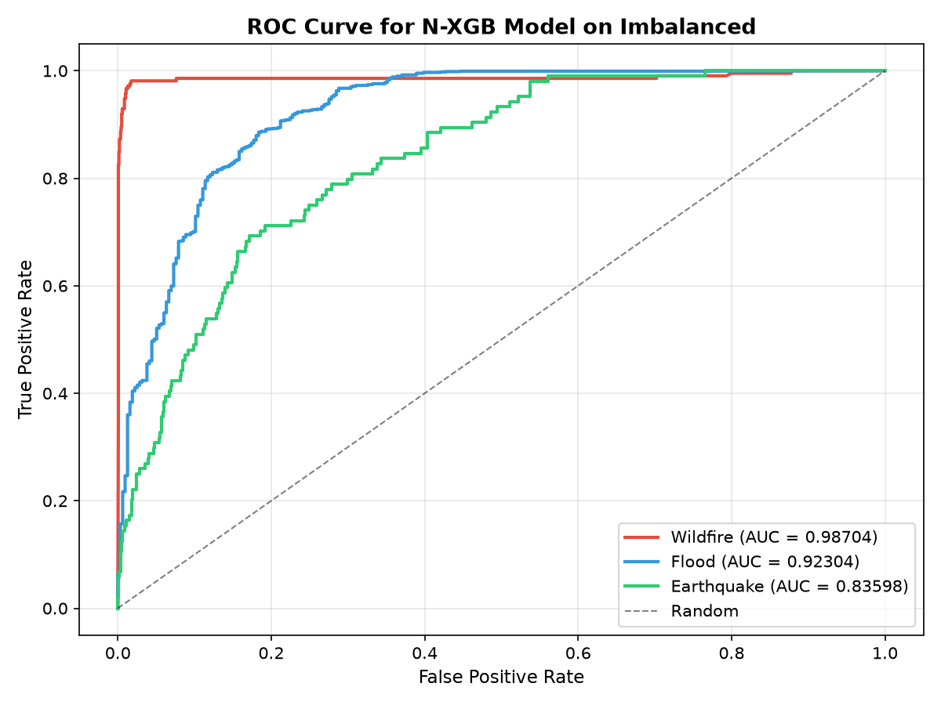
Figure 6. Class-wise ROC curves for N-XGB on the imbalanced experiment.
The class-wise N-XGB ROC-AUC values are 0.98704 for wildfire, 0.92304 for flood, and 0.83598 for earthquake. Although the imbalanced experiment retains the original class proportions, N-XGB still shows substantially weaker separation for earthquakes than for the other two disaster classes.

8.4 Interpretation and Implications for the Project
The updated implementation does not reproduce the reference paper's reported 94.8% N-XGB accuracy. In the current baseline, Random Forest is the strongest classifier by test accuracy in the imbalanced experiment (94.57%) and by macro ROC-AUC in both experiments (0.95843 balanced; 0.96251 imbalanced). N-XGB achieves 89.64% balanced accuracy and 91.57% imbalanced accuracy, with macro ROC-AUC values of 0.91082 and 0.91535, respectively.
These results establish the implementation-specific baseline for the MGO stage. The principal weakness to monitor during optimization is earthquake classification, particularly the tendency to classify earthquake observations as floods. MGO will therefore be evaluated using validation performance of the complete NN + XGBoost pipeline, with macro-F1 as the primary fitness metric, while the test set remains isolated for the final comparison.
Implementation verification note: the current code fits numerical imputers and categorical encoders before the train/test split, while StandardScaler and SMOTE are correctly restricted to training data. For the final reported MGO experiments, imputation and categorical encoding should be moved inside the training split (or implemented in a leakage-safe pipeline) before the final model comparison.

8.5 Baseline-to-MGO Comparison
Aspect | Current Baseline N-XGB | Proposed N-XGB + MGO
Hyperparameter search | GridSearchCV for selected XGBoost parameters | MGO jointly searches selected NN + XGBoost parameters
Search space | 27 fixed XGBoost combinations | Joint continuous/discrete search space
Primary fitness | Weighted-F1 CV score in current baseline | Validation macro-F1 of complete N-XGB pipeline
Model architecture | NN + XGBoost | Same NN + XGBoost architecture
SMOTE | Training data only | Same training-data procedure
Balanced accuracy | 89.64% (N-XGB) | To be measured after MGO
Balanced macro ROC-AUC | 0.91082 (N-XGB) | To be measured after MGO
Imbalanced accuracy | 91.57% (N-XGB) | To be measured after MGO
Imbalanced macro ROC-AUC | 0.91535 (N-XGB) | To be measured after MGO

9. References
M. A. Saleem, A. Javeed, W. Benjapolakul, W. Srisiri, S. Chaitusaney, and P. Kaewplung, “Neural-XGBoost: A Hybrid Approach for Disaster Prediction and Management Using Machine Learning,” IEEE Access, vol. 13, 2025, DOI: 10.1109/ACCESS.2025.3569499.
T. Chen and C. Guestrin, “XGBoost: A Scalable Tree Boosting System,” Proceedings of the 22nd ACM SIGKDD International Conference on Knowledge Discovery and Data Mining, 2016, pp. 785-794.
N. V. Chawla, K. W. Bowyer, L. O. Hall, and W. P. Kegelmeyer, “SMOTE: Synthetic Minority Over-sampling Technique,” Journal of Artificial Intelligence Research, vol. 16, pp. 321-357, 2002.

Source note: This report was drafted from the uploaded Neural-XGBoost paper, the project discussion, the implementation code, and the measured model outputs supplied for this project. Published results are used as reference targets where appropriate; the confusion matrices and ROC-AUC values in Section 8 are from the current implementation.

