COGNIZANT

Week- Hands on
Assignments

GIT

GIT
GITLAB-https://gitlab.com/officiallalithkumar-group/gitdemo
Question-1(Git lab configuration using Git bash)

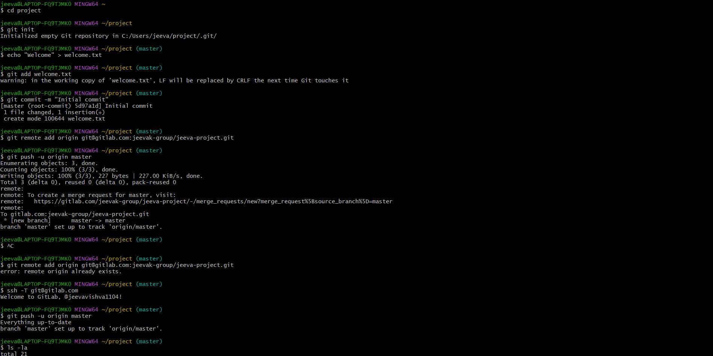

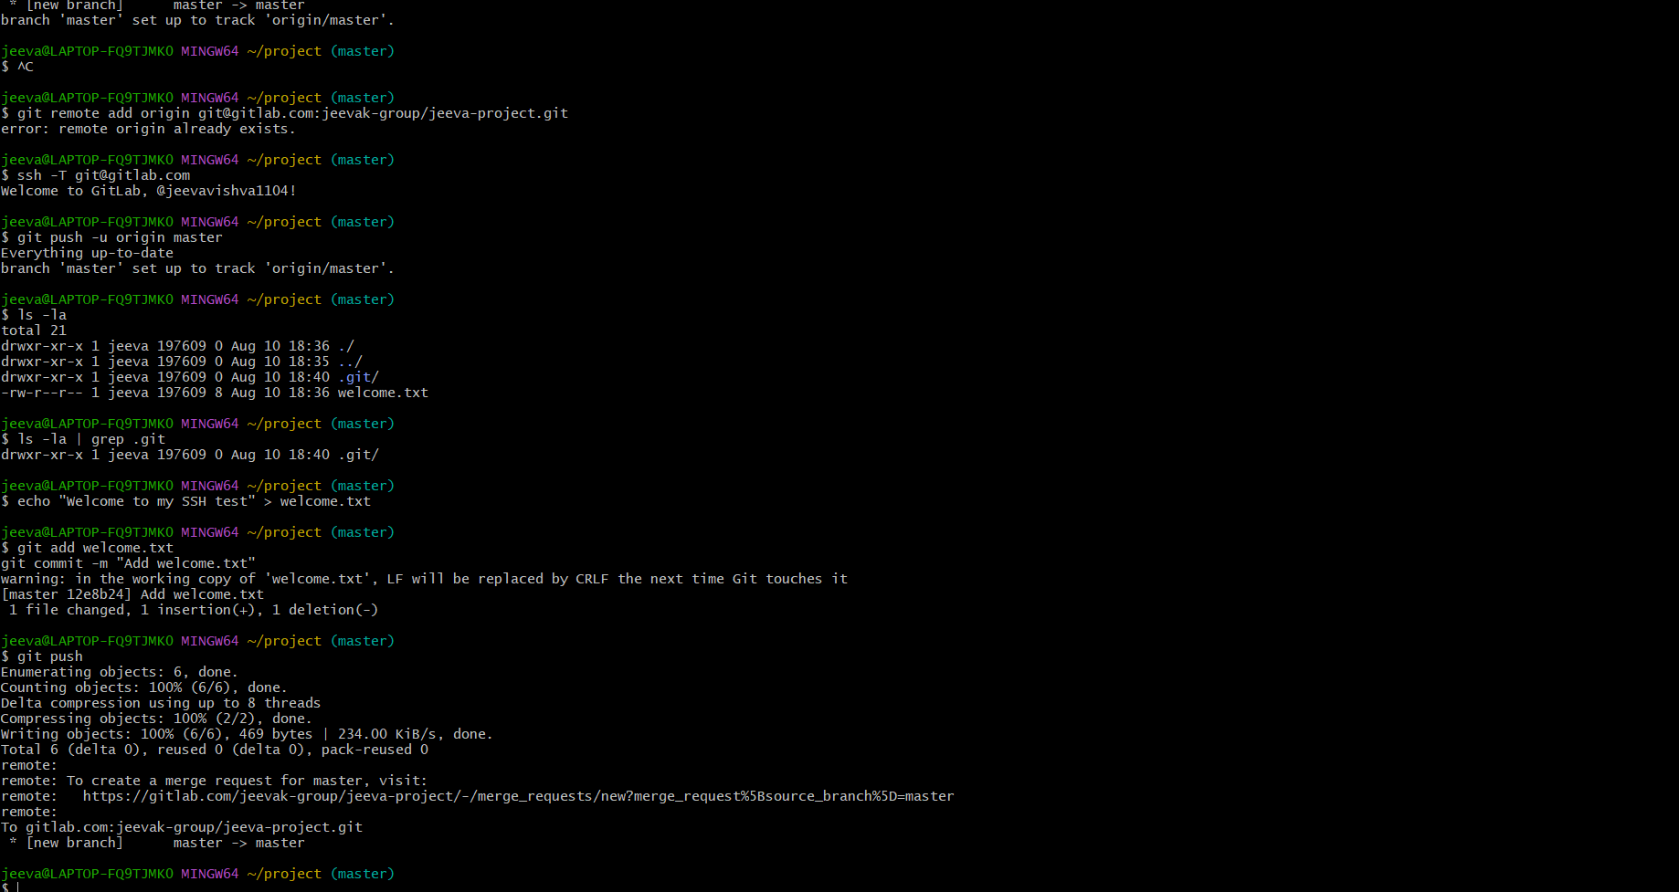

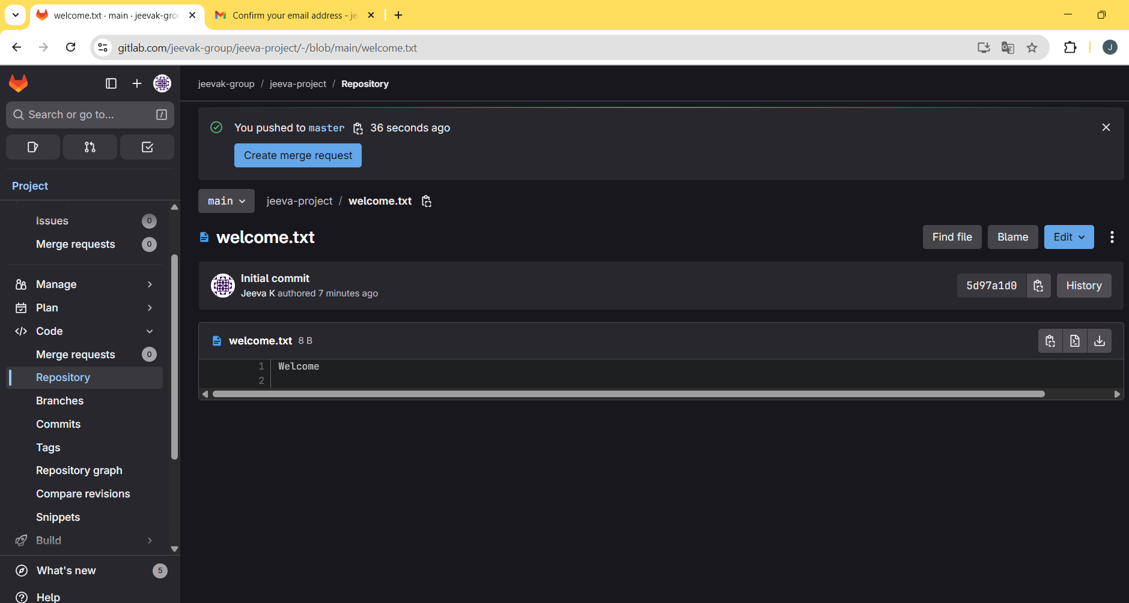

Question-2(Create a “.log” file and a log folder in the working directory of Git)

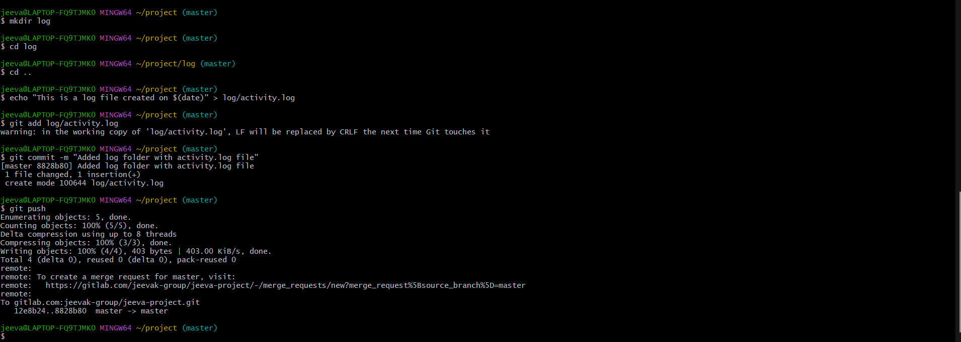

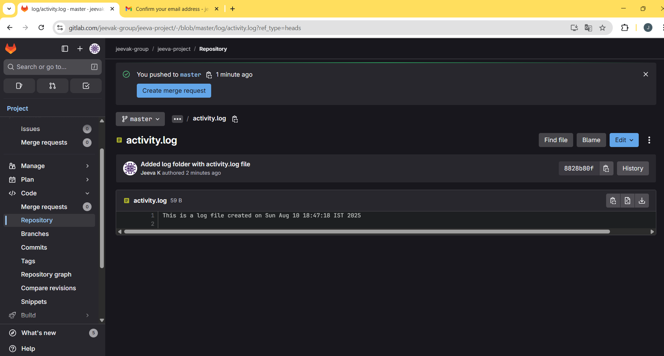

Question-3(Git Branching and Merging)

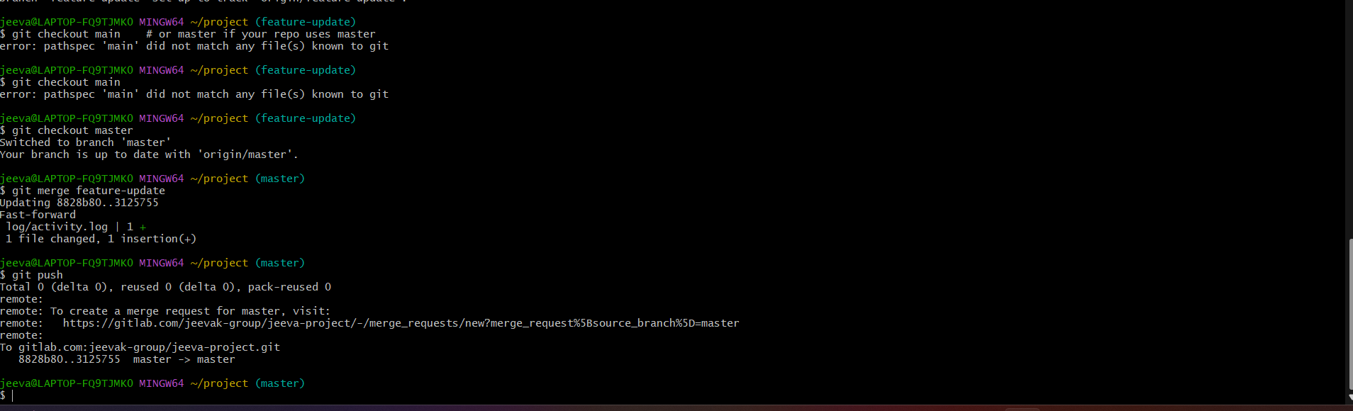

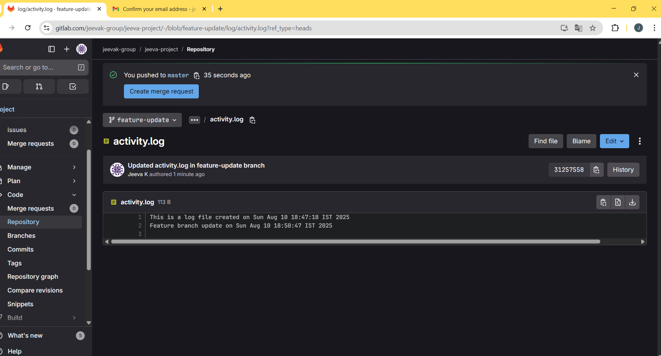

Question-4(Implement conflict resolution when multiple users are updating the trunk (or master))

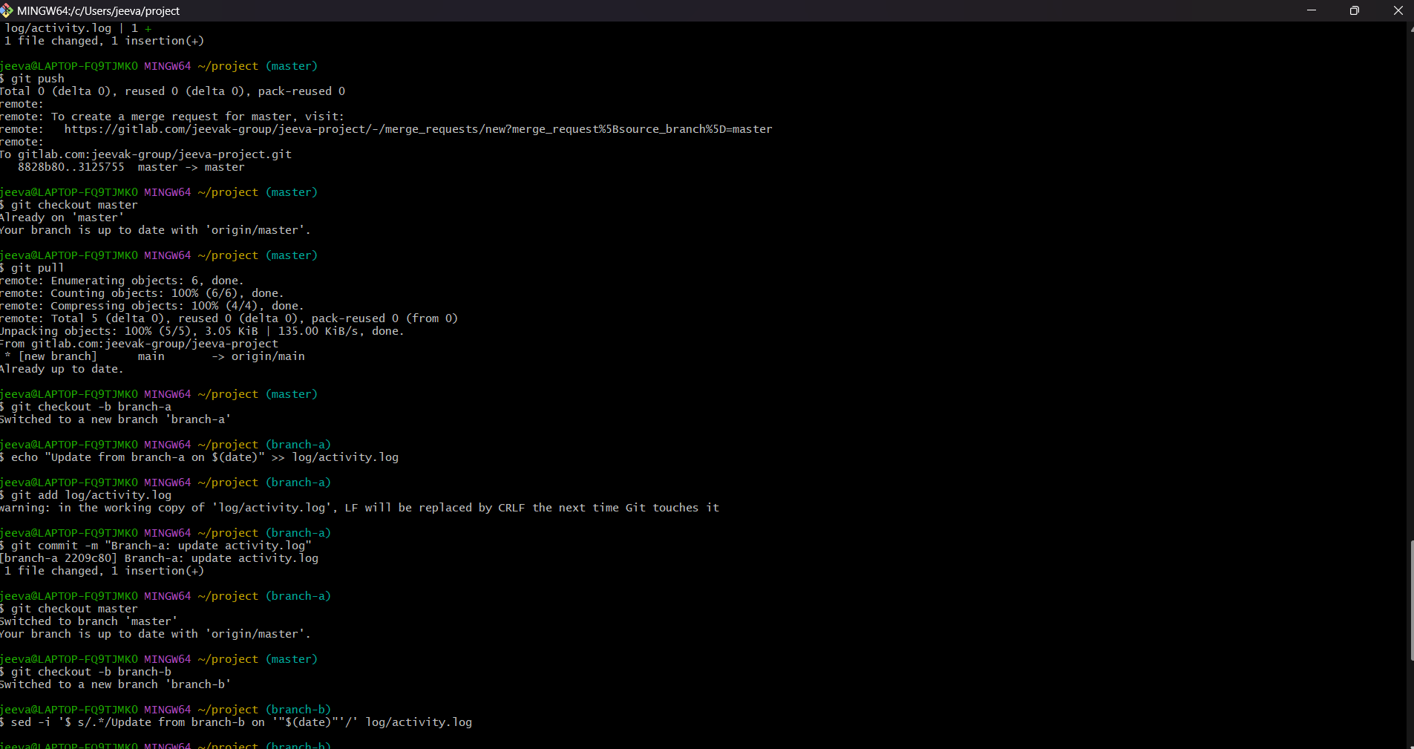

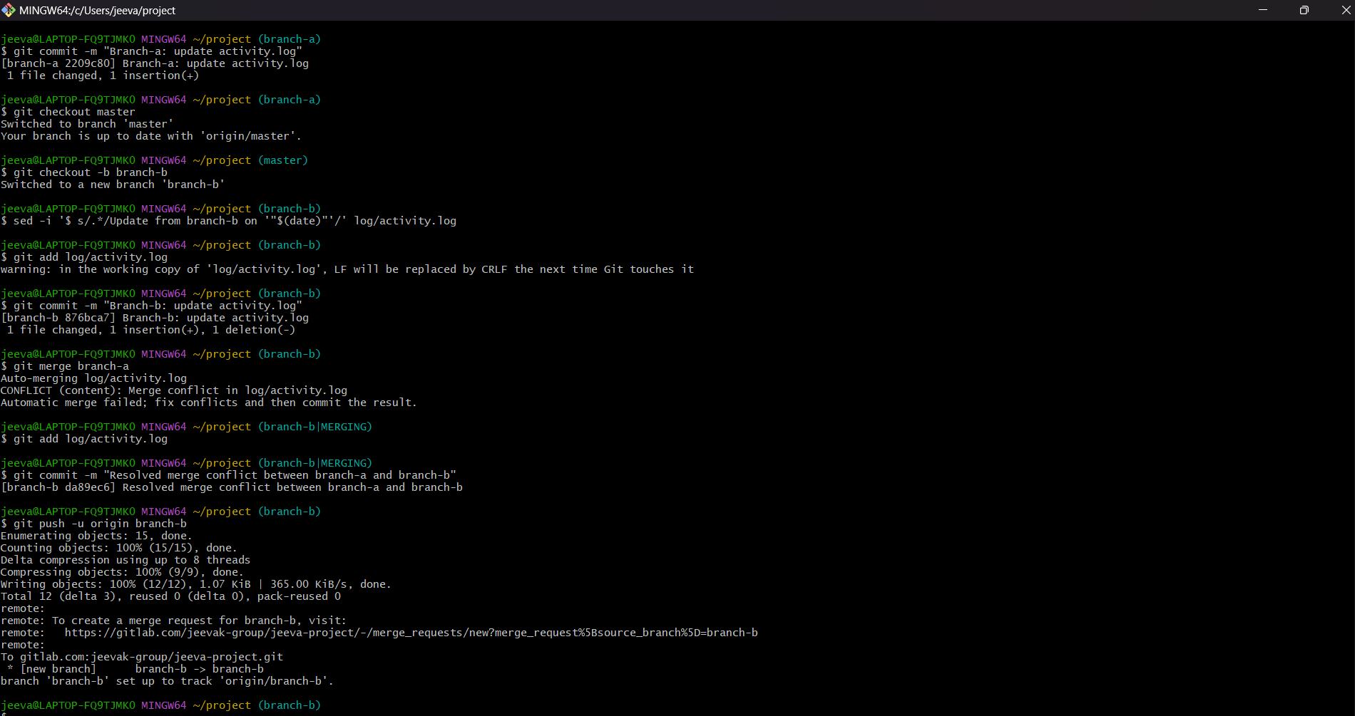

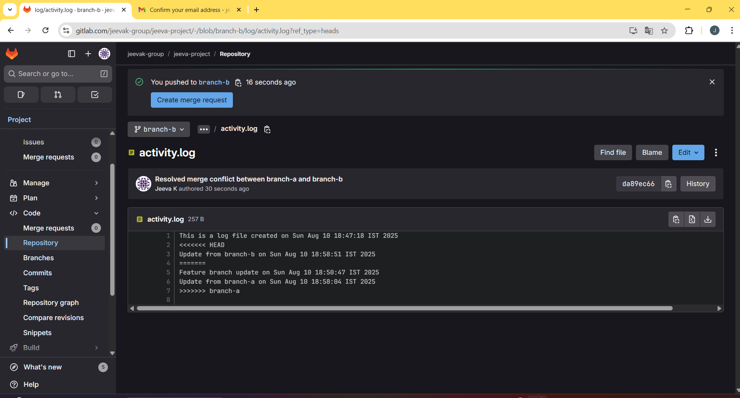

Question-5(Execute steps involving clean up and push back to remote Git)

