DESIGN AND DEVELOPMENT OF LOW POWER AND AREA EFFICIENT DESIGN FOR VLSI CIRCUITS

V.Kamalkumar  Department of Electrical and Electronics Engineering, KPR Institute of Engineering and Technology, Coimbatore, Tamilnadu, India,kamalskcet@gmail.com | R.Lal Raja Singh  Department of Electrical and Electronics Engineering, KIT-Kalaignar Karunanidhi Institute of Technology, Coimbatore, Tamilnadu, India

ABSTRACT
The term Very Large-Scale Integration (VLSI) refers to an Integrated Circuit (IC) type that uses countless transistor connections on a small chip. Arithmetic Logic Unit (ALU) design is crucial for both low power consumption and excellent performance as the ALU is a crucial component for mathematical and computational activities. Leakage power uses up a considerable amount of the overall energy as process technologies develop from one generation to the next. In both standby and active modes, there are many techniques to reduce leakage power. Input Vector Control (IVC), a non-process technology approach that relies on the transistor stacking effect, is one such technique. In standby mode, it reduces leakage power. A search technique called the Gravitational Search Technique (GSA) is used to find the Minimum Leakage Vector (MLV). Using the PSPICE tool and several test circuits, 16-bit and 32-bit ALUs are developed in this research. Verilog HDL is used for the coding, and the Xilinx vivado platform is used for simulation and synthesising these coded designs. Comparative study has demonstrated that GSA outperforms Genetic Algorithm in terms of iterations and low leakage power.

Keywords: GA, IVC, MLV AND ALU

1. INTRODUCTION
The VLSI architectural design includes a branch for network security, a section for semiconductors, a part for silicon implementation systems, and semiconductor foundries from across the world. The most current expansion and advancements in low power VLSI are examined in this research because they have an impact on many manufacturing procedures and innovations, such as transistor count, processor shrinkage, voltage scaling, timer gating, and fuzzy logic control. The manufacturing implementation of this restricted VLSI is in charge of concerns like transistor size, process shrinkage, voltage scaling, clock gating, and others; as a result, VLSI power loss is a well-known problem. Additionally, this study aims to demonstrate and highlight recent developments and forthcoming trends in low-power VLSI innovation. VLSI is used in many different electrical applications.Transistor count reduction and transistor logic control are the techniques that are used the most often to reduce the power consumption of VLSI circuits. Only very few circumstances call for the use of routing and optimization-based control techniques. In a manner similar to this, the performance of all recommended techniques is compared to that of the traditional CMOS process. In certain cases, methods for route regulating and optimisation are employed to control transistor logics. A drowsy keeper method was found by adding extra transistors to hold the previous transistor's logic state. These methods increase the VLSI circuit's available area while minimising power use. The demand for space and heat dissipation must be balanced against a plan for using less power, however, in a successful VLSI circuit design [1]–[5].
In order to accommodate new architectural features, more transistors are being added to existing VLSI chips, which raises the likelihood of extremely high power consumption in a die. However, people are increasingly looking for lightweight, portable devices with extended battery life, such as smartphones and tablet computers. As a result, low power dissipation in VLSI circuits has become a crucial design factor. With the global energy crisis as the primary concern, manufacturers cannot afford to accept excessive power loss from a single chip. Increased power dissipation may cause the components to unnecessarily heat up, reducing their reliability, performance, and lifetime. Low power VLSI circuit techniques are necessary as a consequence. Today's world needs ways to successfully restrict the waste of vast quantities of power from the circuits in order to keep up with the constantly growing demands for more and more functionality on a single die. The following sections [6] through [10] cover the many strategies employed by business to reduce power dissipation as well as how power leaks from VLSI circuits.

VLSI has received a considerable lot of attention since it is a rapidly developing and highly efficient computer technology. VLSI has been employed in a wide range of applications across many sectors, including transistor chip resizing, mobile phones, and computer systems. A number of techniques were used to resolve the difficult issues with embedded schemes and the operations of electronic components. The "Knowledge Dissemination and Evolution" graphic that was included in this article explained how different methodologies utilised by practitioners turned into practising artefacts. The many cMos and nMos variations were discussed by a receiving community. The MPC experiences [11]–[15] provided instructions on how to apply the experiment methodology and computer connection architecture. A table on this page includes the many VLSI design outputs and results, as well as the various outcomes based on the cooperative development of the multi-level cluster of systems. Many research and works in the field of VLSI design, as well as current work in knowledge engineering, have been covered. VLSI design is complex, making it challenging to solve, and infrastructure, size, and societal considerations may all have an impact on VLSI design techniques. Provide knowledge engineering that allows knowledge transformation in the field of extremely large-scale integration, to name just one last thing. Clock gating, one of the most popular and commonly used techniques, is a highly efficient way to reduce leakage power into the loop and also shows that, in a graphical representation, a change in threshold voltage is directly proportionate to a change in delay and leakage current. Clustered voltage scaling is the second most prevalent technique for reducing leakage power [16]–[17].

II. PROPOSED METHOD
Analogue and digital signals are combined on a single semiconductor device. Using analogue and mixed signal integrated circuits while designing integrated circuits is crucial. It is often used as a conduit for messages travelling between the digital and physical worlds. Analogue circuitry elements are considered to need critical design because of their tremendous intricacy and apparent size1. Due to the miniaturisation of circuit design, which lays a strong focus on the development of system on chip (SOC), the impacts of nanoscale components are also largely prominent. Analogue and mixed mode systems' productivity and performance are impacted by scaling issues, an exponential growth in complexity brought on by the consequences of rising demand and miniaturisation, as well as scaling constraints. Figure 1 illustrates how decreasing the pace at which existing CPUs use energy might lengthen the lifespan of semiconductor parts and batteries, especially in portable devices. As VLSI technology has advanced, digital and analogue circuits have shrunk to the nanoscale range, exponentially increasing power consumption, sub-threshold leakage current, and threshold voltage. The problem of power consumption has grown more significant because of the complexity of the design and the density of the structures3. An precise approach to power modelling is also required to address the issues with nanoscale processing technology. Figure 2 illustrates how Input Vector Control (IVC) is used to achieve reduced power consumption, which is shown to be a better solution. Several modelling strategies are covered in this paper. Because of its independence from other technological factors and foundation in the impact of transistor stacking, IVC is widely recommended.
Implementing the IVC approach demonstrates that there is no performance overhead and the circuit is in a minimal leakage state. Another method to reduce energy use is to determine a Minimum leaking Vector (MLV), which denotes the leaking state with the least amount among the test inputs5. Utilising multiplexers, it may be moved into the test circuit to reduce the power consumption during the idle state. The appropriate input vector selection and the fusion of various test circuits, which are evaluated using a look-up table, may help reduce leakage power. Figure 3 illustrates how a variety of machine learning optimisation techniques have been used to decrease leakage power and have been effective in addressing a range of size and power consumption challenges.

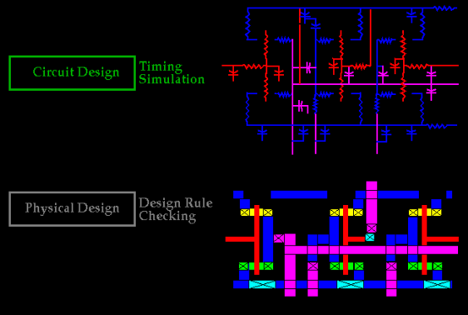
Figure.1. Model Design of the Proposed Method

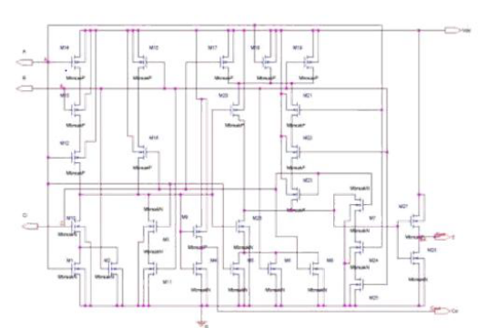
Figure.2. Schematic Structure of the Proposed Model
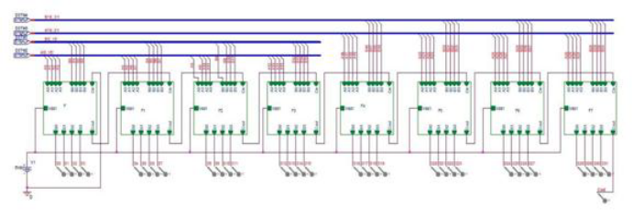
Figure.3. Schematic Structure of the Model

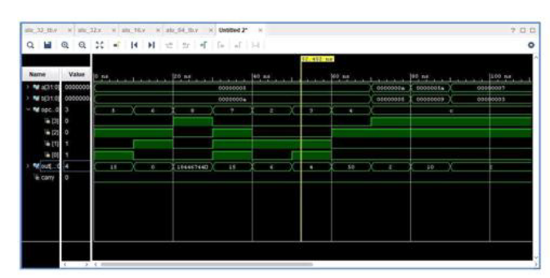

Figure.4. Xilinx Output of the Proposed Model

VLSI circuits are able to do the most challenging mathematical operations by packing more transistors and logic circuits onto a microchip. VLSI microchips are used in both simple calculators and the most complex neural network-based applications. The frequent and intensive operations as a consequence raise the power need of such circuits. Because of the increased power demand, the microchips produce more heat than usual. Every day, a number of operational logics are being created in order to lower the power consumption of VLSI circuits. An overview of current methods utilised in the research to lessen the power consumption of VLSI devices shows that the transistor reduction technique is the one that is most often employed for power conservation. But in order to show how well an approach works, it must be measured against the performance of previously created designs. A considerable performance gap between real-world experiments and simulations was also discovered, as illustrated in Figure 4. The practical research' findings deviate a little from the simulation setup's unfavourable side. In the past, area, performance, cost, and reliability were the primary considerations of the VLSI designer, with consideration of power sometimes only being of minor importance. Despite a recent trend towards change, thoughts regarding area and speed still carry more weight than those concerning power. Several factors have had an impact on this trend. It's possible that the class of personal computing devices (portable desktops, audio- and video-based multimedia products), as well as wireless communications systems (personal digital assistants and personal communicators), that demand high-speed computation and complex functionality with low power consumption, have been the main driving forces behind this development.In many applications, average power consumption is an important design factor. Figure 5 illustrates how high-end product producers are under a lot of pressure to reduce their energy use. Modern performance-optimized microprocessors may waste up to 15-30 W at clock frequencies between 100 and 200 MHz [20]! Future predictions suggest that the power consumption of a 10 cm2 microprocessor operating at 500 MHz (a conservative estimate for the next ten years) will be about 300 W. Such devices cost a lot to package and cool.
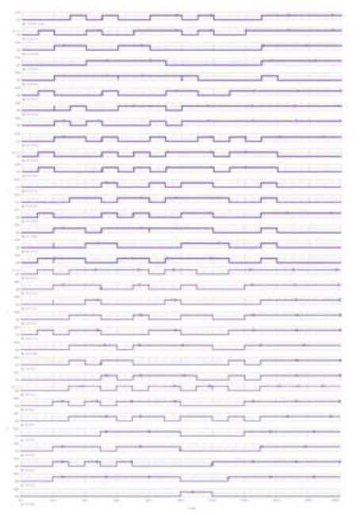

Figure.5. Output of the Proposed Model

As chip power consumption rises, more expensive packaging and cooling techniques are needed because the packaging is where core power consumption must be dissipated. Reduced power consumption in high performance systems thus has a definite financial benefit. The problem of dependability exists in addition to the one of cost. High temperature tends to worsen a number of silicon failure causes, and high power systems often run hot. A component's failure rate generally doubles for every 10 °C rise in operational temperature. Peak power, or the maximum amount of power that can be dissipated, is an important design consideration in this case because it establishes the thermal and electrical design boundaries, affects the cost, size, and weight of the system, specifies the battery type, the packaging of components and systems, and the heat sinks that should be used, as well as making the problems with resistive and inductive voltage drop worse. So it is crucial to keep the peak power under control. Furthermore, the integration of more transistors on a single chip or on a module made up of multiple chips is becoming constrained by excessive power consumption. The ensuing heat will make it impossible to compact and operate VLSI circuits and systems efficiently unless power consumption is drastically lowered.

III. CONCLUSION
In building digital circuits, the arithmetic and logical unit plays a key role, and selecting the best design strategy may reduce power consumption. This paper proposes a heuristic approach to reduce the leakage power in ALU circuits based on gravitational search algorithms. Throughout the design phase, combinations of 16 and 32 bit ALU input test are considered to get the optimal MLV. The research reveals that the GSA algorithm produces better results for the ideal test function with the least amount of leakage power and the fewest repeats. It is then proved via a comparative study that the results are superior than those of the Genetic Algorithm, proving the effectiveness of the design. To get the best MLV in the future, the current technique may be extended to a 64 bit input vector set.

REFERENCES
[1] P. Verma, R. A. Mishra, “Leakage power and delay analysis of LECTOR based CMOS circuits”, Int’l conf. on computer & communication technology ICCCT 2011.
[2] H. Narender and R. Nagarajan, “LECTOR: A technique for leakage reduction in CMOS circuits”, IEEE trans. on VLSI systems, vol. 12, no. 2, Feb. 2004.
[3] L. Wei, Z. Chen, M. Johnson, and K. Roy, “Design and optmization of low voltage high performance dual threshold CMOS circuits,” in Proc. 35th DAC, 1998, pp. 489–492.
[4] M. C. Johnson, D. Somasekhar, L. Y. Chiou, and K. Roy, “Leakage control with efficient use of transistor stacks in single threshold CMOS,” IEEE Trans. VLSI Syst., vol. 10, pp. 1–5, Feb. 2002.
[5] B. S. Deepaksubramanyan, A. Nunez, “Analysis of subthreshold leakage reduction in CMOS digital circuits,” in Proc. 13th NASA VLSI Symp.,June 2007.
[6] Q. Wang and S. Vrudhula, “Static power optimization of deep sub-micron CMOS circuits for dual VT technology,” in Proc. ICCAD, Apr. 1998, pp. 490–496.
[7] M. D. Powell, S. H. Yang, B. Falsafi, K. Roy, and T. N. Vijaykumar, “Gated-Vdd: A ciruit technique to reduce leakage in deep submicron cache memories,” in Proc. IEEE ISLPED, 2000, pp. 90-95.
[8] S. H. Kim and V. J. Mooney, “Sleepy Keeper: a new approach to low-leakage power VLSI design,” IFIP, pp. 367-372, 2006.
[9]. J.M. Cheng and M. Pedram “Energy Minimization using Multi Supply Voltage”, IEEE Transaction on VLSI System, Vol. 5, No. 4, pp. 1-8, December 1992.
[10] Manoj Kumar 1, Sandeep K. Arya 2, and Sujata Pandey , “Low power CMOS full adder design with body biasing approach”, journal integrated circuits and system, 2011.
[11] P. Sreenivasulu, P. khadar khan, Dr. K. Srinivasa Rao & Dr. A. VinayaBabu (July 2013)” Power Scaling in CMOS Circuits by Dual Threshold Voltage Technique” International Journal of Engineering and Innovative Technology (IJEIT) Volume 3, Issue 1.
[12] S. Narendra, S. Borkar, V. De, Antoniadis& A. Chandrakasan, (August 2001), ‘Scaling of Stack effect and its Application for Leakage Reduction,” in proceedings of the International Symposium on Low Power Electronics and Design, pp.195-200.
[13] Narender Hanchate & N. Ranganathan, (2004),’A New Technique for Leakage Reduction in CMOS Circuits using Self-Controlled Stacked Transistors”, Proceedings of the 17th International Conference on VLSI Design (VLSID”04) IEEE.
[14] S.Kannadhasan and R.Nagarajan, Design of a Low-Cost 1-20 GHz E-Shaped Antenna for Wireless Applications, Second International Conference on Future Learning Aspects of Mechanical Engineering (FLAME 2020), Amity University, Noida, 5-7 August 2020, Proceedings Published in Lecture Notes in Mechanical Engineering, Title: Advances in Interdisciplinary Engineering, doi No: https://doi.org/10.1007/978-981-15-9956-9_14
[15] V.Sri Sai Harsha & Aparna, ( September 2015,) “Sub-Threshold Leakage Current Reduction Techniques In VLSI Circuits -A Survey”, Int. Journal of Engineering Research and Applications. 5, Issue 9, (Part - 1) pp.28-32.
[16] Pillai, P., & Shin, K. G. (Dec. 2001). Real-Time dynamic voltage scaling for low-power embedded operating systems. Proceedings of the Eighteenth ACM Symposium on Operating Systems Principles.
[17] Tawfik, S. A. (May 2009). Low power and high speed multi threshold voltage interface circuits. IEEE Transactions on Very Large Scale Integration (VLSI) Systems, 17(5).

