EXPT NO: 6 | IMPLEMENTATION OF LSTM FOR SENTIMENT ANALYSIS
DATE: 30-09-2026 | IMPLEMENTATION OF LSTM FOR SENTIMENT ANALYSIS
Name: Jeevaa Roll No: 24BAD047 Department: AI & DS

PRE-LAB QUESTIONS (PROVIDE BRIEF ANSWERS TO THE FOLLOWING QUESTIONS)

- What is the purpose of Long Short-Term Memory (LSTM) networks in NLP?
Ans: LSTM is a special type of RNN that can learn and remember long-term dependencies in sequential data. In NLP it helps the model understand the order and context of words in a sentence, so it is used for tasks such as sentiment analysis, text classification and translation.
- Why is LSTM preferred over a Simple RNN for processing long text sequences?
Ans: A Simple RNN suffers from the vanishing gradient problem and forgets information from the early words of a long text. LSTM uses a memory cell and gates (forget, input and output) to keep important information for a long time, so it works better for long text sequences.
- What is sentiment analysis? Give two real-world applications.
Ans: Sentiment analysis is the process of finding whether a given text expresses a positive, negative or neutral opinion. Applications: (i) analysing customer reviews of products or movies, (ii) monitoring public opinion on social media.
- Explain the role of tokenization and padding in text preprocessing.
Ans: Tokenization splits the text into words (tokens) and converts each token into an integer number using a vocabulary. Padding adds zeros (or cuts the text) so that all sequences have the same length, which is needed to give the data to the model in batches.
- What is word embedding? Why is it useful for sentiment analysis?
Ans: A word embedding is a dense vector of numbers that represents a word, where words with similar meanings have similar vectors. It is useful for sentiment analysis because the model can understand similarity between words (for example, good and great) using a small vector instead of a large one-hot vector.

AIM
To implement a Long Short-Term Memory (LSTM) network for sentiment analysis by performing text preprocessing, tokenization, sequence generation, and embedding using NLP libraries, and classify text into sentiment categories.

SOFTWARE REQUIREMENTS
- Python
- TensorFlow / Keras
- Google Colab
- GitHub
- NumPy
- Pandas
- Matplotlib
- NLP libraries – NLTK / spaCy
- Scikit-learn

OBJECTIVES
Students will be able to:
- Understand the architecture and working of LSTM networks.
- Perform text preprocessing techniques for sentiment analysis.
- Tokenize and convert textual data into numerical sequences.
- Generate word embeddings for textual data.
- Build and train an LSTM model for sentiment classification.
- Evaluate the performance of the trained LSTM model.
- Analyze the effect of preprocessing and embedding on sentiment classification.

PROCEDURE
PART A: DATASET PREPARATION AND TEXT PREPROCESSING
- Perform the following tasks:
- Load a sentiment analysis dataset such as the IMDB Movie Reviews dataset.
- Explore the dataset and examine sample positive and negative reviews.
- Check the number of samples and sentiment class distribution.
- Perform text preprocessing using NLP libraries.
- Convert text to lowercase.
- Remove unnecessary punctuation and special characters.
- Remove stop words, if required.
- Tokenize the reviews into words/tokens.
- Convert the tokens into numerical sequences using a tokenizer.
- Build a vocabulary from the training reviews.
- Apply sequence padding to obtain equal-length input sequences.
- Encode sentiment labels into numerical form.
- Split the prepared dataset into training and testing/validation datasets.
Screenshots of Code and Output:
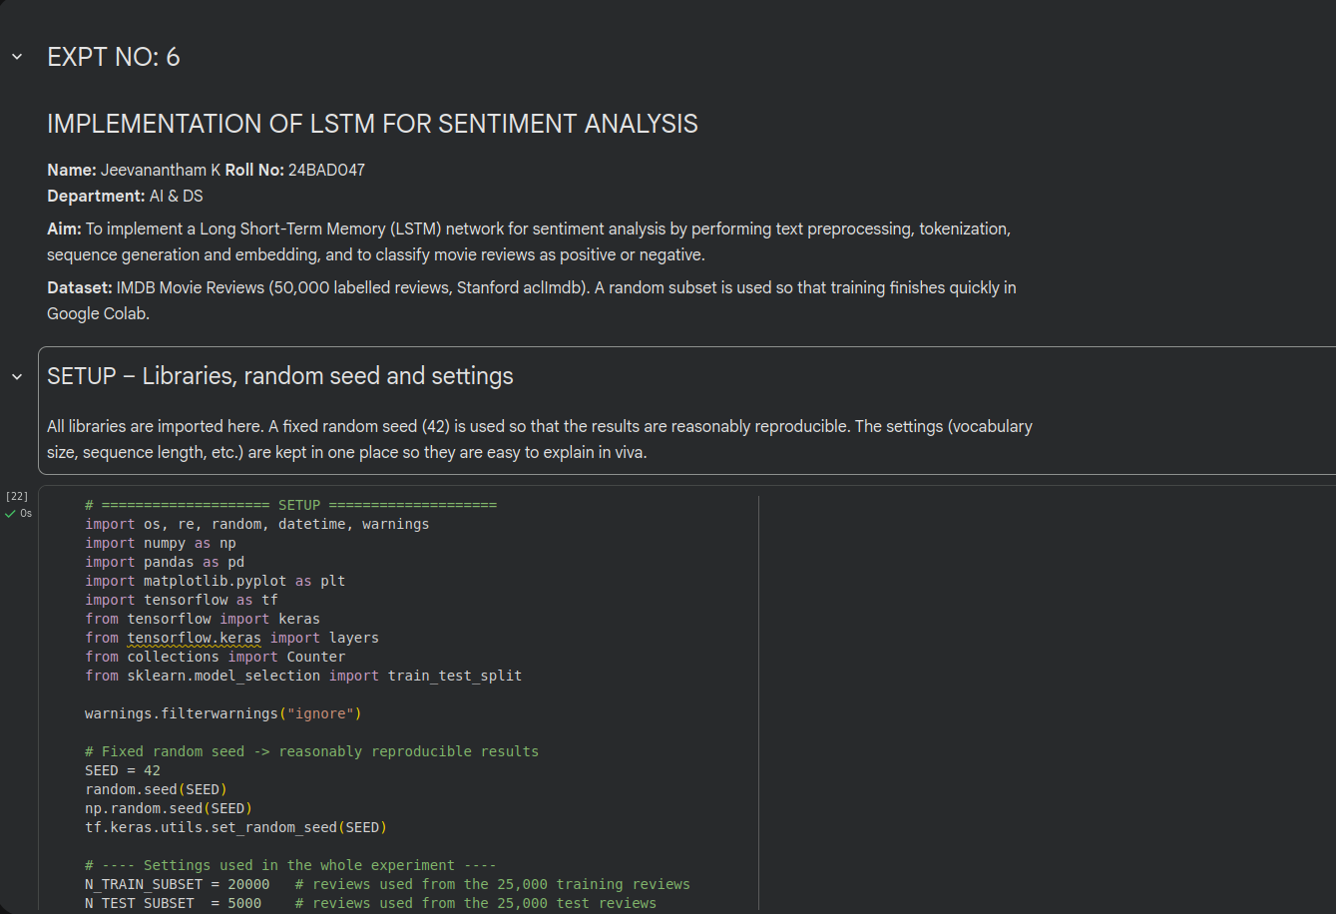
Fig. A1: Importing libraries and setting parameters (code)
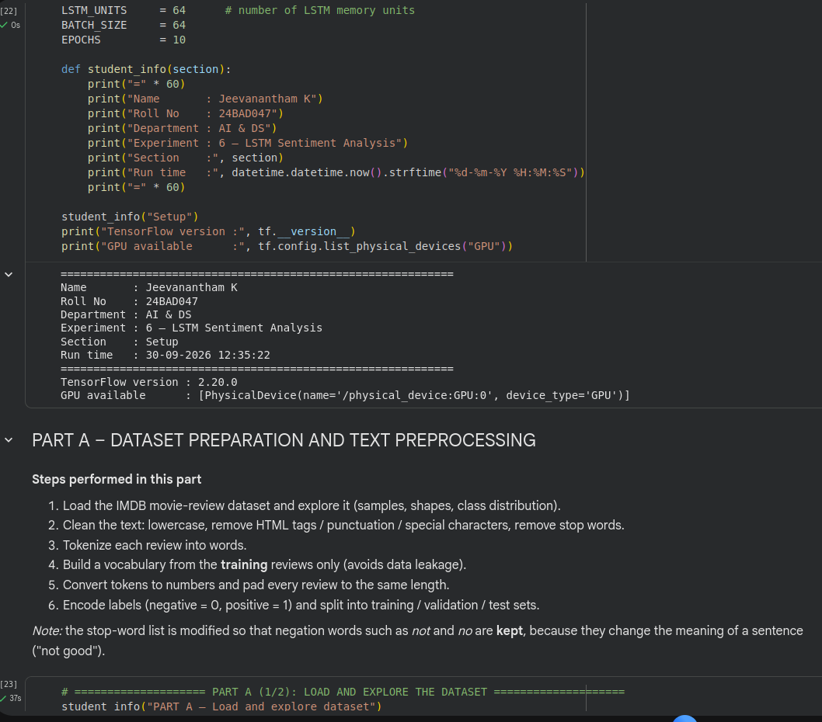
Fig. A2: Setup output and start of dataset loading
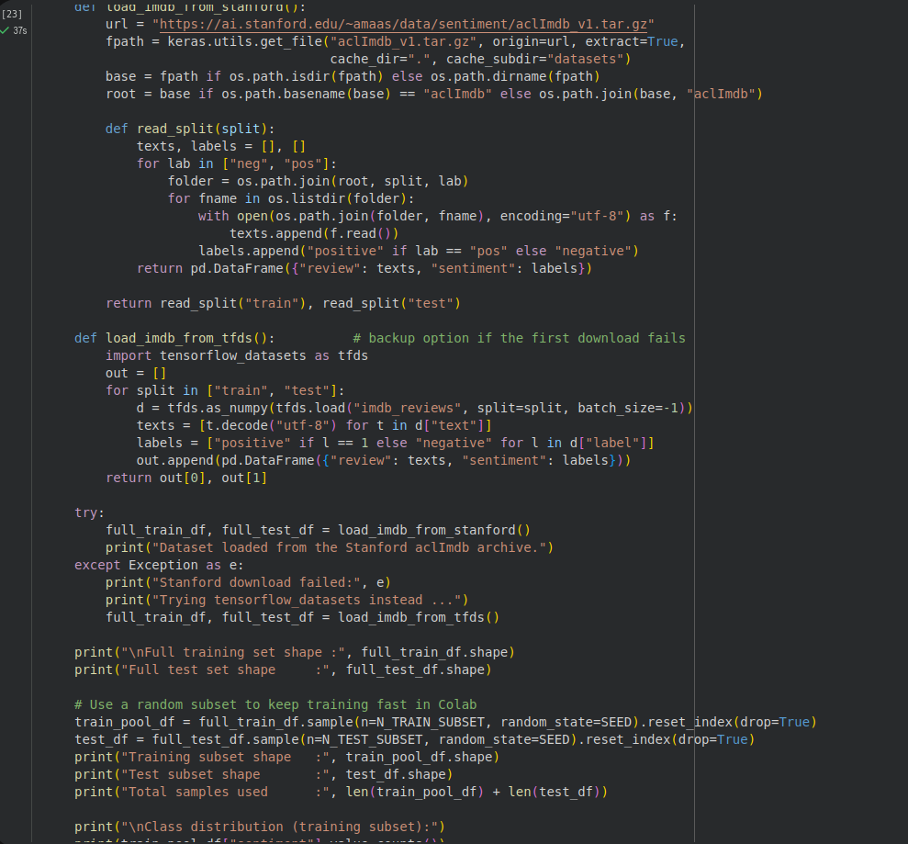
Fig. A3: Loading the IMDB dataset (code)
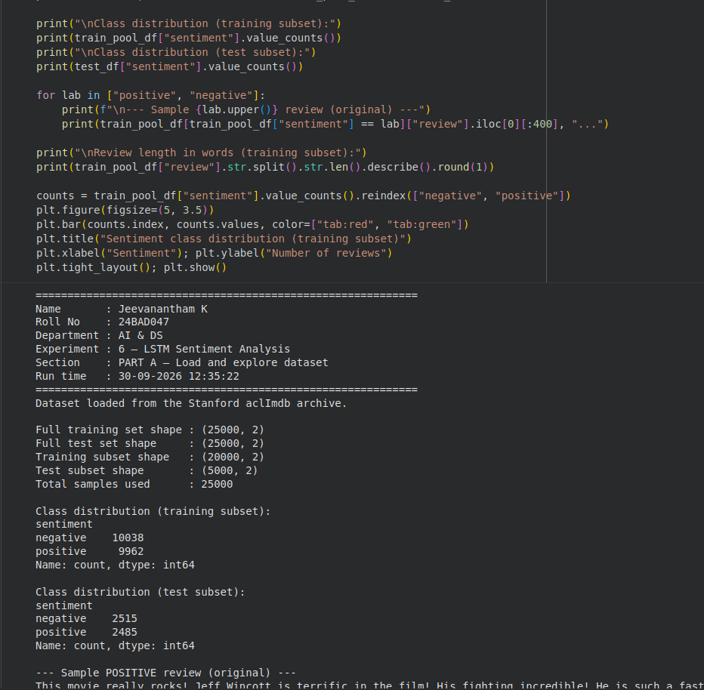
Fig. A4: Dataset exploration code and output
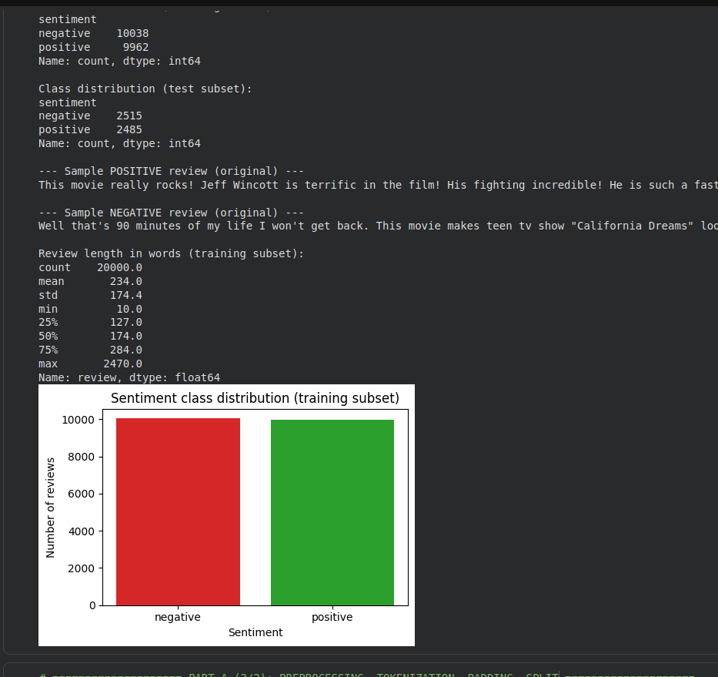
Fig. A5: Sample reviews, review length statistics and class distribution plot
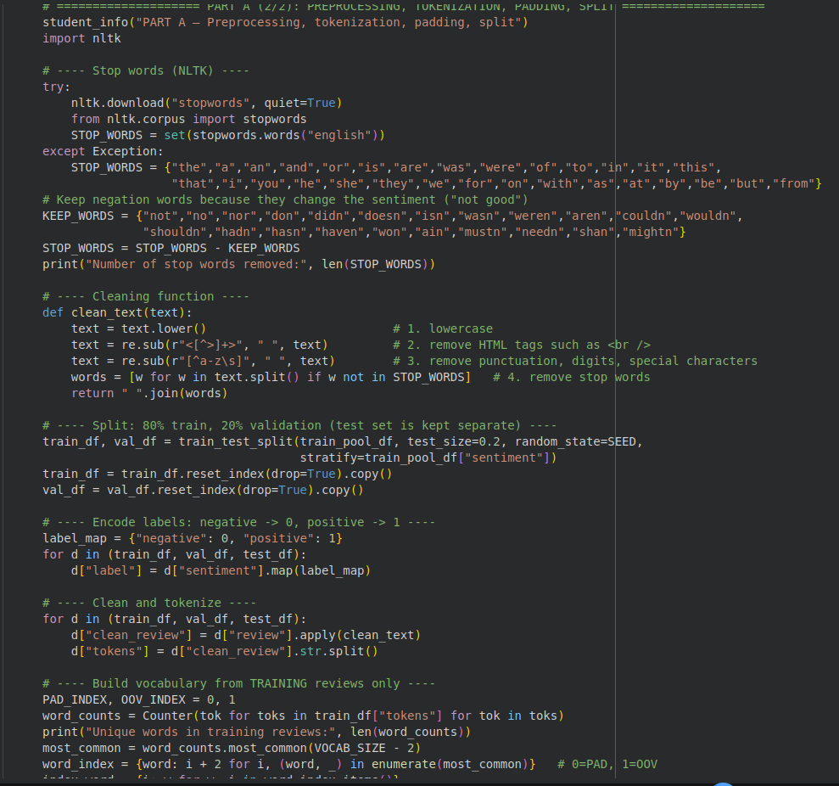
Fig. A6: Text cleaning, label encoding, tokenization and train/validation split (code)
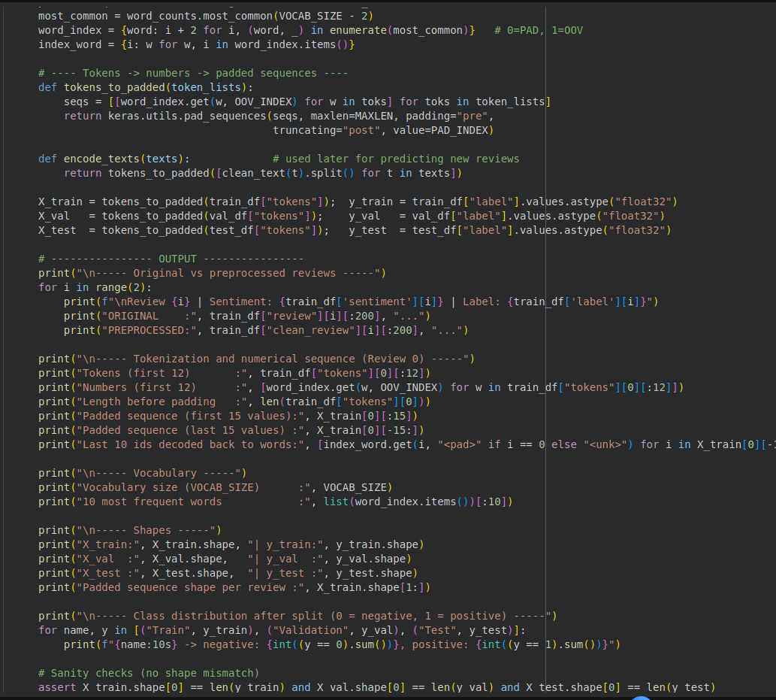
Fig. A7: Vocabulary building, padding and printing of results (code)
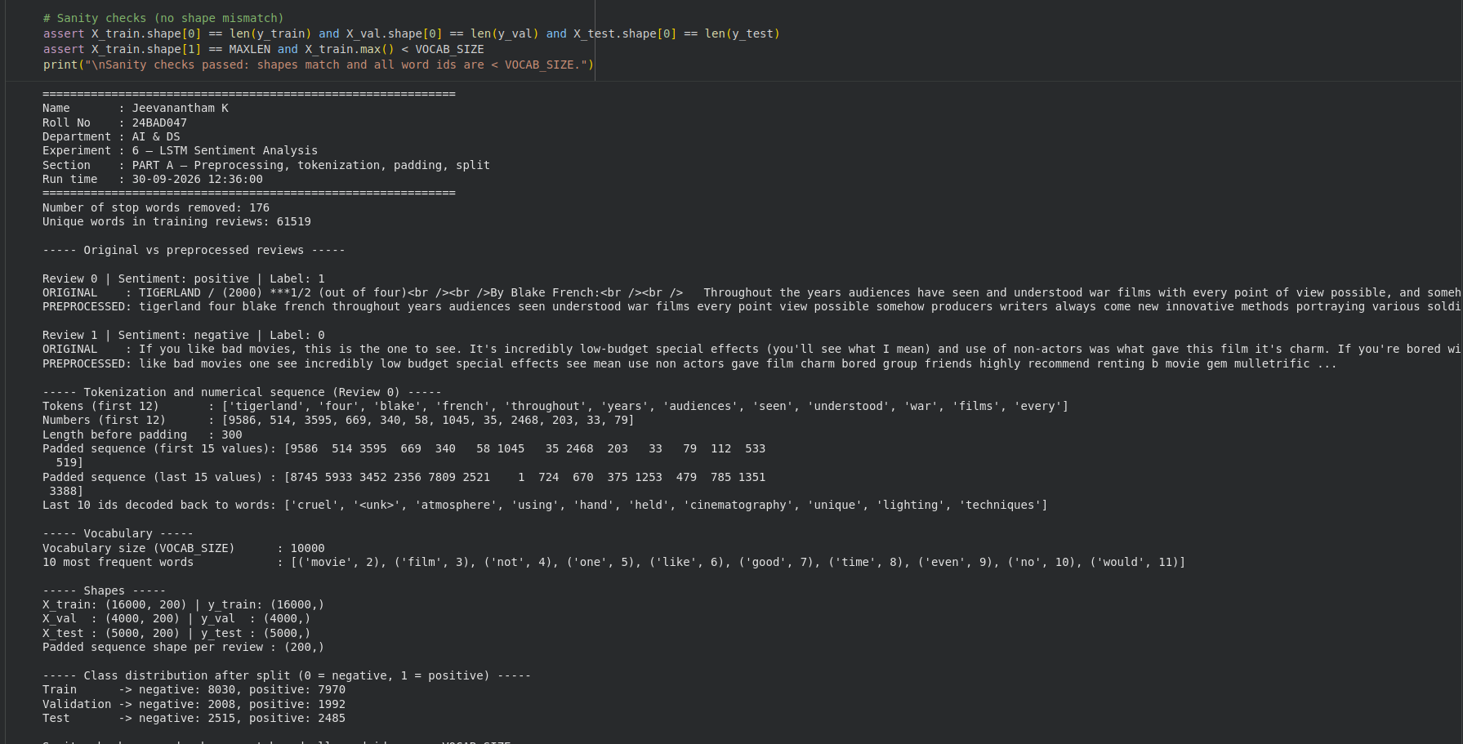
Fig. A8: Output of preprocessing, tokenization, padding and data split

PART B: EMBEDDING GENERATION
Perform the following tasks:
- Generate numerical representations of the pre-processed text.
- Create an Embedding layer using Keras/TensorFlow.
- Define the vocabulary size and embedding dimension.
- Convert tokenized sequences into dense vector representations.
- Display the shape of the generated embedding representation.
- Analyze how words are represented in the embedding space.
Screenshots of Code and Output:
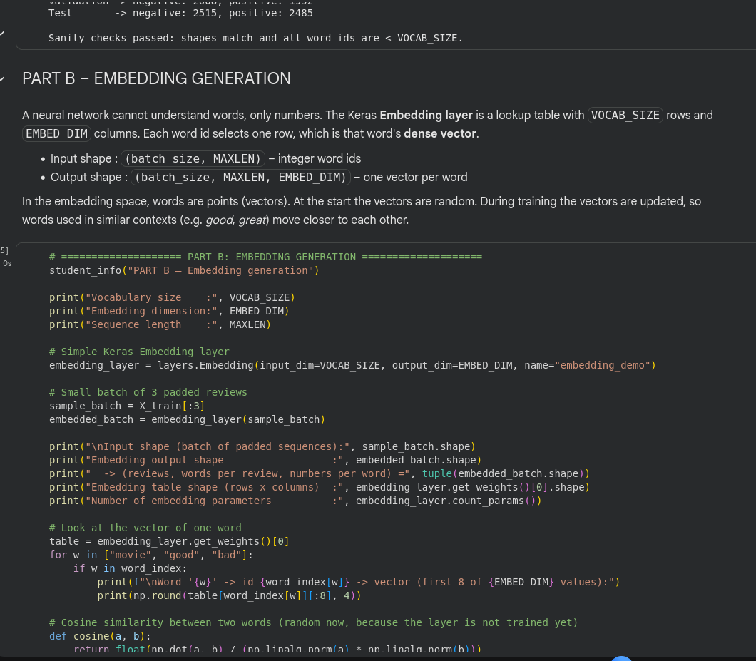
Fig. B1: Embedding generation explanation and code
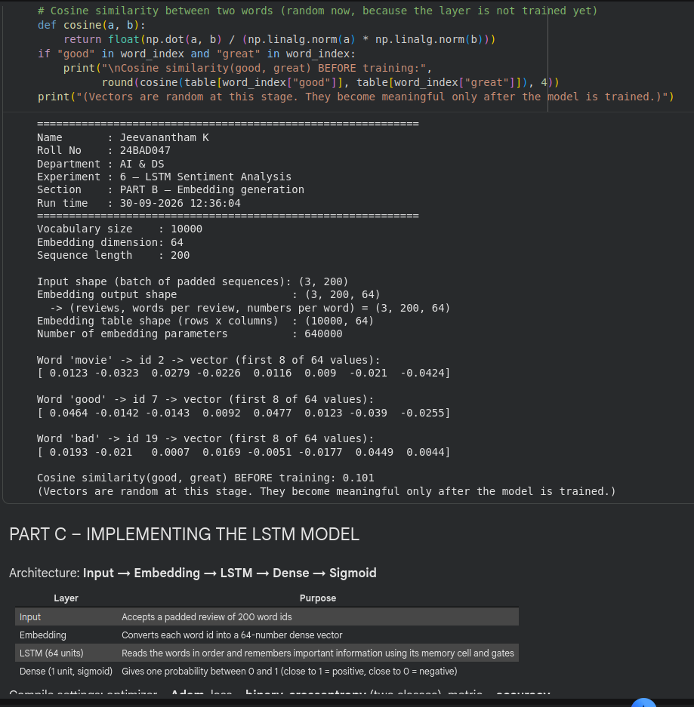
Fig. B2: Embedding code (continued) and output with embedding shapes

PART C: IMPLEMENTING THE LSTM MODEL
Perform the following tasks:
- Create an input layer for the padded text sequences.
- Add an Embedding layer to generate dense word representations.
- Add an LSTM layer to learn sequential dependencies in the reviews.
- Add a Dense output layer with an appropriate activation function for sentiment classification.
- Compile the model using:
  - Appropriate optimizer
  - Binary cross-entropy loss
  - Accuracy as the evaluation metric
- Display the model architecture and summary.
Screenshots of Code and Output:
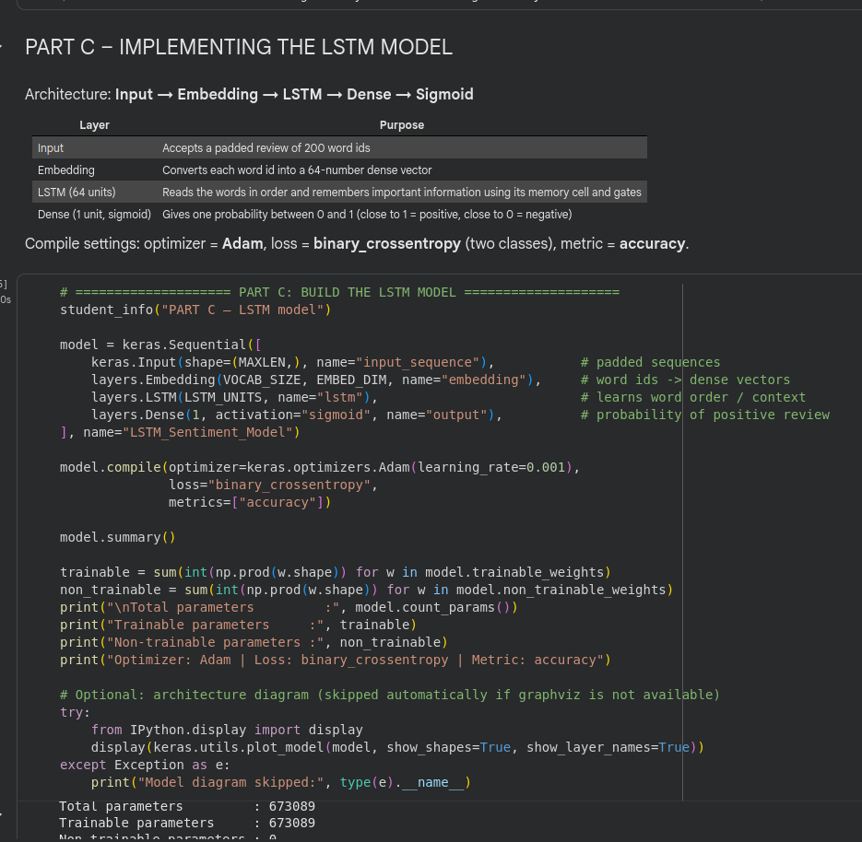
Fig. C1: Building and compiling the LSTM model (code) and parameter count
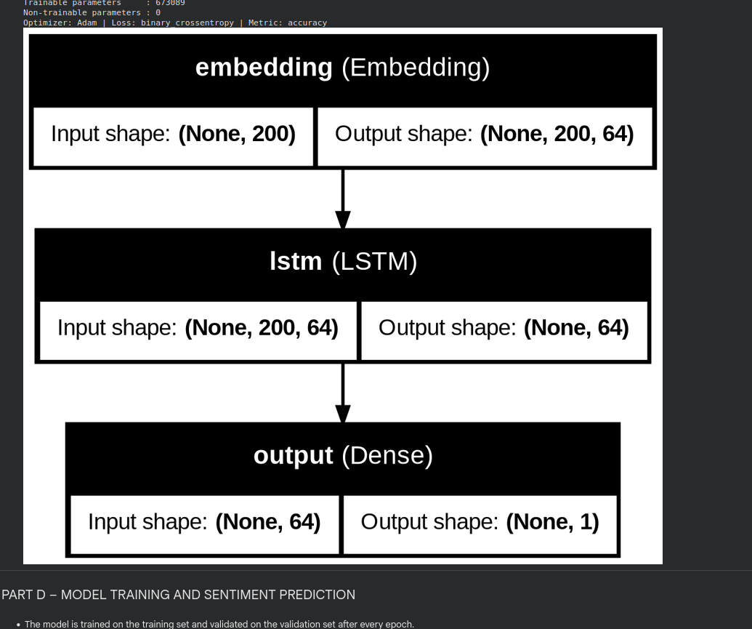
Fig. C2: Model architecture diagram

PART D: MODEL TRAINING AND SENTIMENT PREDICTION
Perform the following tasks:
- Train the LSTM model using the prepared training dataset.
- Validate the model using the validation dataset.
- Record:
  - Training accuracy
  - Validation accuracy
  - Training loss
  - Validation loss
- Visualize:
  - Accuracy vs. Epoch
  - Loss vs. Epoch
- Evaluate the trained model using the test dataset.
- Predict the sentiment of sample reviews.
- Compare the predicted sentiment with the actual sentiment.
- Calculate appropriate evaluation metrics such as:
  - Accuracy
  - Precision
  - Recall
  - F1-score
  - Confusion matrix
Screenshots of Code and Output:
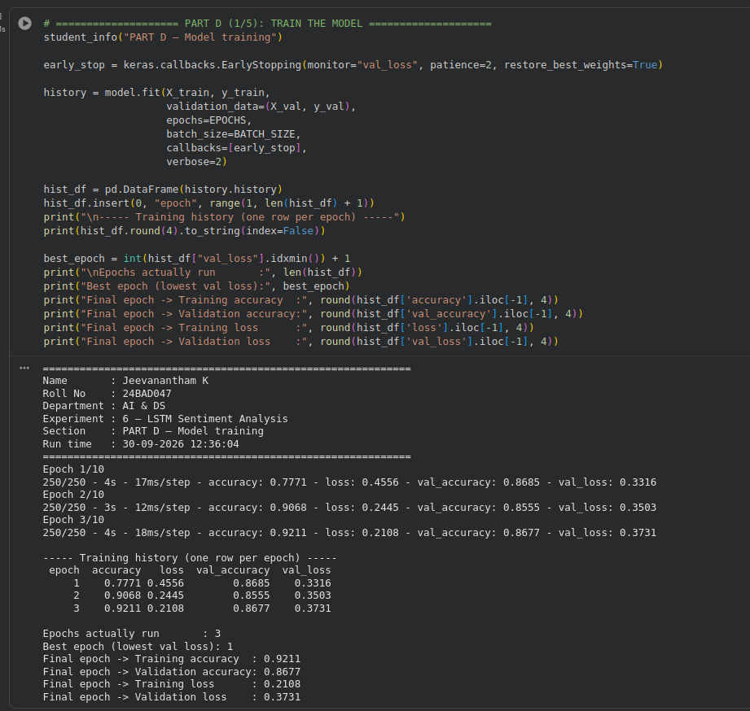
Fig. D1: Model training code and output
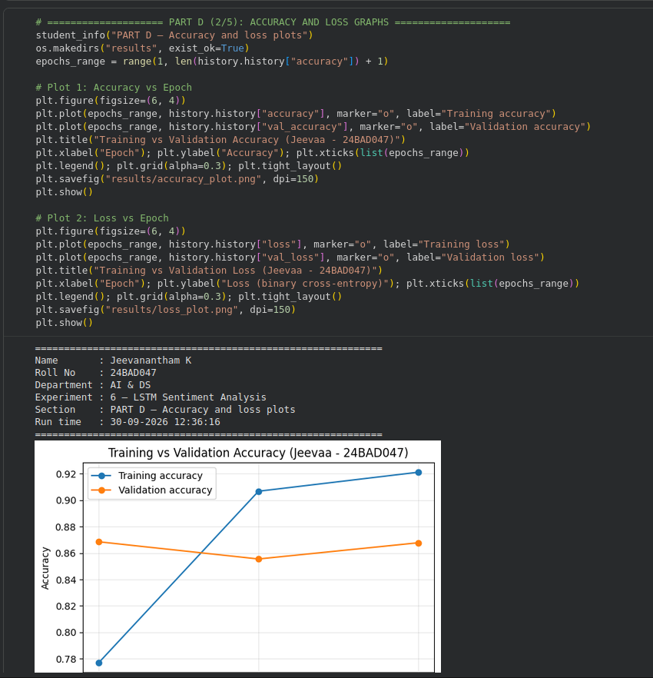
Fig. D2: Accuracy vs. epoch plot (code and output)
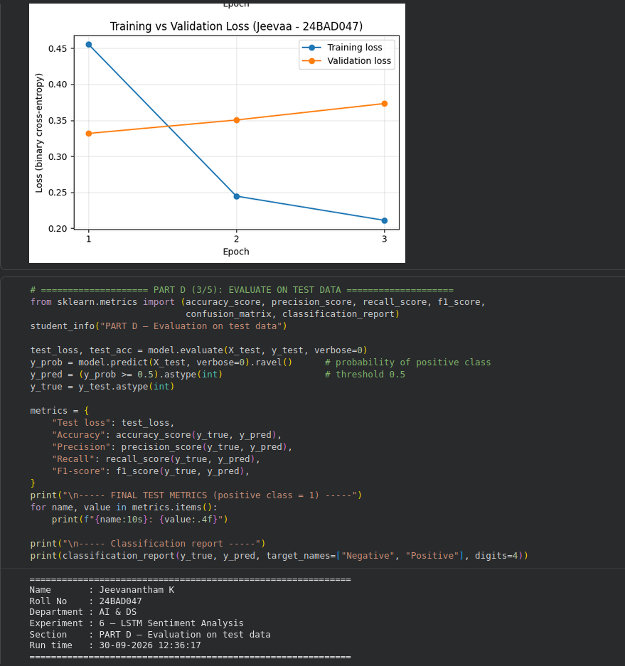
Fig. D3: Loss vs. epoch plot and test-data evaluation code
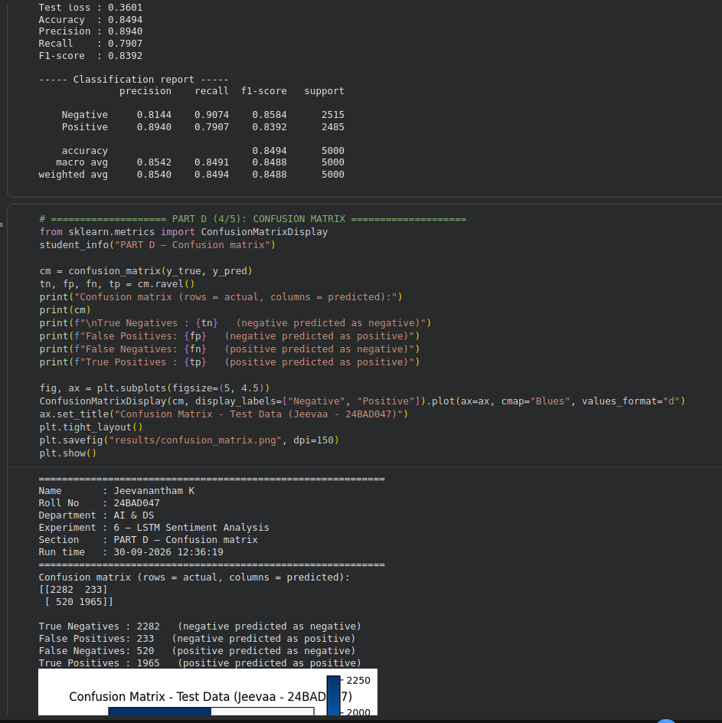
Fig. D4: Test metrics, classification report and confusion matrix code
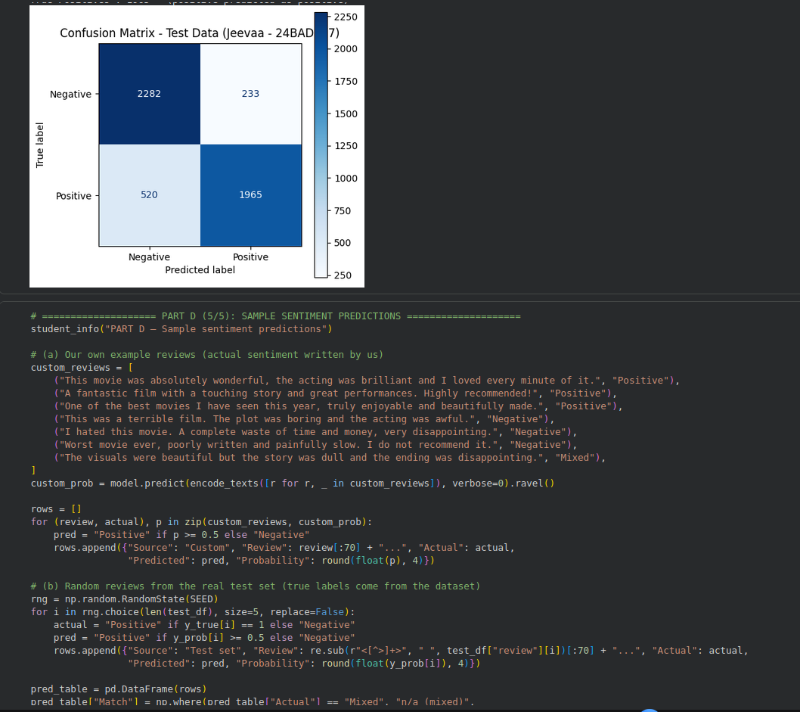
Fig. D5: Confusion matrix output and sample prediction code
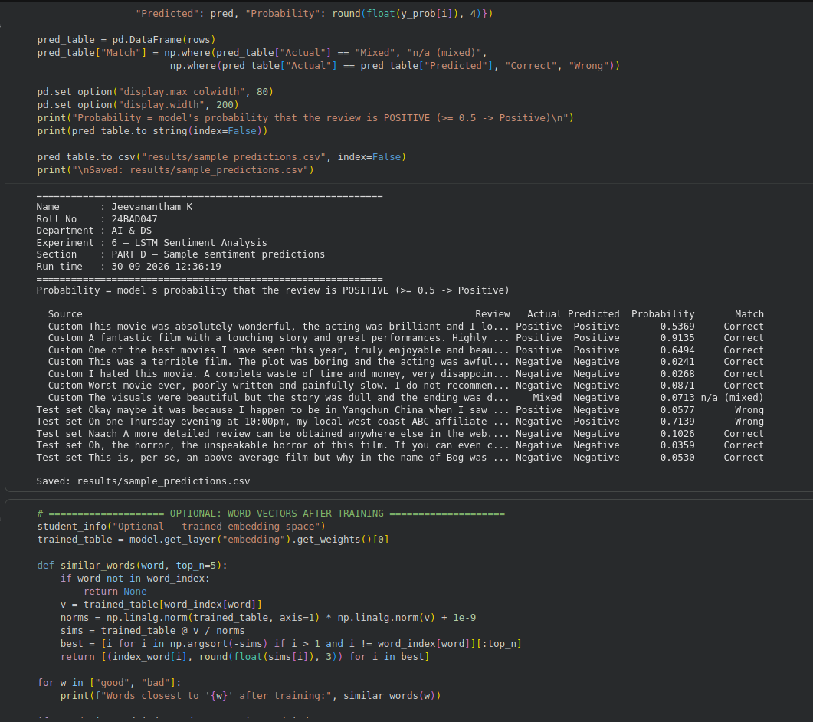
Fig. D6: Sample sentiment predictions (code and output)
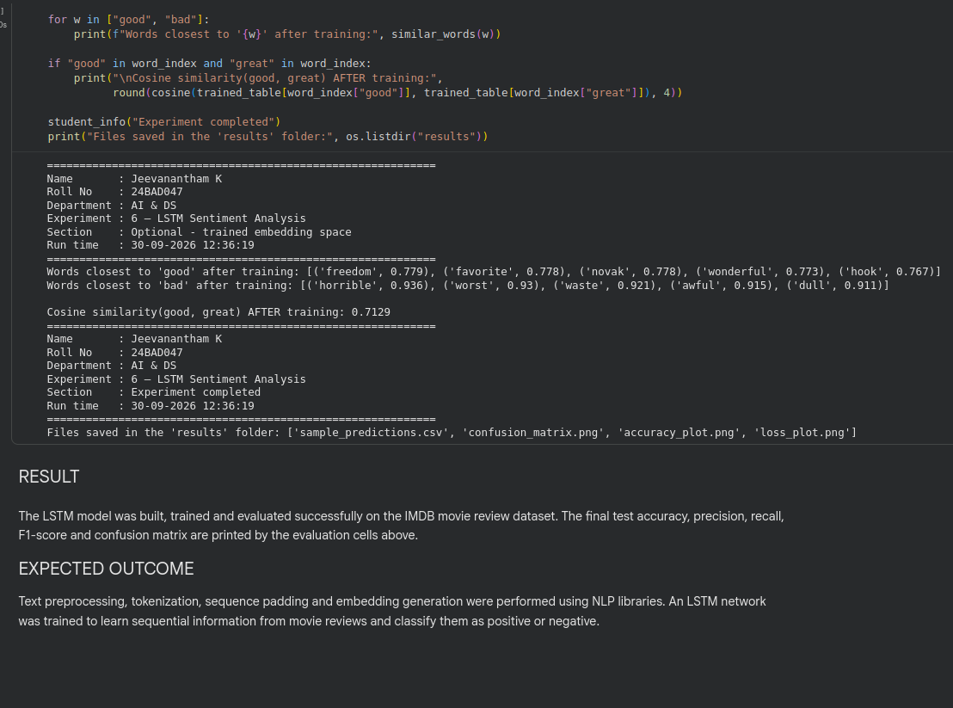
Fig. D7: Trained embedding space output

RESULT
The LSTM model was built, trained and evaluated on the IMDB movie reviews dataset. The results obtained from the screenshots above are given below.
1. Dataset and model details
Description | Value
Training subset used (from 25,000 reviews) | 20,000 reviews
Training / Validation split | 16,000 / 4,000 reviews
Test subset used | 5,000 reviews
Vocabulary size | 10000
Sequence length (after padding) | 200
Embedding dimension | 64
Model layers | Embedding, LSTM (64 units), Dense (sigmoid)
Total trainable parameters | 673089
Optimizer / Loss / Metric | Adam / binary cross-entropy / accuracy
2. Training and validation (final epoch)
Description | Value
Epochs run (early stopping) | 3
Best epoch (lowest validation loss) | 1
Training accuracy | 0.9211
Validation accuracy | 0.8677
Training loss | 0.2108
Validation loss | 0.3731
3. Test data evaluation
Description | Value
Test loss | 0.3601
Accuracy | 0.8494
Precision (positive class) | 0.8940
Recall (positive class) | 0.7907
F1-score (positive class) | 0.8392
4. Confusion matrix (test data)
Description | Value
True Negatives (negative predicted as negative) | 2282
False Positives (negative predicted as positive) | 233
False Negatives (positive predicted as negative) | 520
True Positives (positive predicted as positive) | 1965
5. Observations
Sample predictions: all 6 custom positive/negative reviews were predicted correctly, and 3 out of the 5 random test reviews were predicted correctly. The mixed custom review was predicted as Negative.
Embedding: the cosine similarity between the words "good" and "great" increased from 0.101 (before training) to 0.7129 (after training), showing that the embedding learned meaningful word relationships.
Thus, the LSTM model was successfully implemented for sentiment analysis and classified movie reviews as positive or negative with a test accuracy of 0.8494.

EXPECTED OUTCOME
Students will understand how LSTM networks learn sequential information from textual data and apply them to sentiment classification. Students will learn to perform text preprocessing, tokenization, sequence padding, and embedding generation using NLP libraries. They will build and train an LSTM model and evaluate its ability to classify reviews into positive and negative sentiments.

POST-LAB QUESTIONS (PROVIDE BRIEF ANSWERS TO THE FOLLOWING QUESTIONS)

- What is the role of the memory cell in an LSTM?
Ans: The memory cell stores information over many time steps. The gates decide what information to forget, what new information to add and what to output, so the memory cell acts as the long-term memory of the LSTM.
- How does an LSTM overcome the vanishing gradient problem of a Simple RNN?
Ans: In an LSTM, the cell state is updated by addition and controlled by gates, so the gradient can flow through many time steps without becoming very small. In a Simple RNN the gradient is multiplied again and again and shrinks towards zero (vanishing gradient).
- What is the purpose of the Embedding layer in the sentiment analysis model?
Ans: The Embedding layer converts the integer word ids into dense vectors (vocabulary size 10000, embedding dimension 64 in this experiment). These vectors are learned during training and give meaningful numerical input to the LSTM layer.
- How does padding affect the input to an LSTM network?
Ans: Padding makes all reviews the same length (200 words here) so that they can be processed in batches. Shorter reviews are filled with zeros (padding value) and longer reviews are truncated, so some information may be lost.
- What happens when the LSTM model is trained for too many epochs?
Ans: When the model is trained for too many epochs it overfits: the training accuracy keeps increasing but the validation loss increases and validation accuracy stops improving, so the model performs poorly on new data. Early stopping is used to avoid this.
- Why are precision, recall, and F1-score useful in addition to accuracy?
Ans: Accuracy alone can be misleading, especially when the classes are imbalanced or when different errors matter. Precision shows how many predicted positives are correct, recall shows how many actual positives are found, and F1-score is the balance of both.
- Give one limitation of using LSTM for sentiment analysis.
Ans: LSTM reads the words one by one, so training is slow and cannot be done in parallel. It also performs worse than Transformer models (such as BERT) on very long texts.

SUGGESTIONS FOR DATASETS
- IMDB Movie Reviews – https://ai.stanford.edu/~amaas/data/sentiment/
- SST-2 (Stanford Sentiment Treebank) – https://huggingface.co/datasets/stanfordnlp/sst2
- Twitter Sentiment Analysis – https://www.kaggle.com/c/twitter-sentiment-analysis
- Stanford Sentiment Treebank (SST) – https://huggingface.co/datasets/stanfordnlp/sst
- Amazon Product Reviews – https://huggingface.co/datasets/amazon_polarity
- Yelp Polarity Reviews – https://huggingface.co/datasets/fancyzhx/yelp_polarity

ASSESSMENT
Description | Max Marks | Marks Awarded
Pre Lab Exercise | 5
In Lab Exercise | 10
Post Lab Exercise | 5
Viva | 10
Total | 30
Faculty Signature

GitHub Repository:
[PASTE MY GITHUB LINK HERE]

