EXPT NO: 7 | GENERATE SYNTHETIC IMAGES USING A GENERATIVE ADVERSARIAL NETWORK (GAN)
DATE: 05-10-2026

PRE-LAB QUESTIONS (PROVIDE BRIEF ANSWERS TO THE FOLLOWING QUESTIONS)

- What is a Generative Adversarial Network (GAN)?
Ans: A Generative Adversarial Network (GAN) is a deep learning model made of two neural networks, a Generator and a Discriminator, that are trained together in competition with each other. The Generator creates fake (synthetic) data from random noise, and the Discriminator tries to decide whether the data is real or fake. It was introduced by Ian Goodfellow in 2014, and after training the Generator can produce new data that looks very similar to the real data.
- What are the roles of the Generator and Discriminator in a GAN?
Ans: The Generator takes a random noise vector as input and converts it into a synthetic image that tries to look like a real image from the dataset. The Discriminator is a binary classifier that takes an image (real or generated) and gives the probability that the image is real. The Generator tries to fool the Discriminator, while the Discriminator tries to catch the fake images.
- Why are GANs used for synthetic image generation?
Ans: GANs learn the distribution of the training images without needing labels, so they can generate new, sharp and realistic images that were never in the dataset. They are useful when real data is limited, costly or private, for example in data augmentation, image super-resolution, image-to-image translation and face generation.
- What is the difference between real images and synthetic images?
Ans: Real images are actual samples collected from the real world, such as scanned handwritten digits in the MNIST dataset. Synthetic images are artificially created by a trained model (the Generator) from random noise. They imitate the look of real images but are not original samples, and they may contain small distortions or artifacts, especially in early training.
- Explain the concept of adversarial training in GANs.
Ans: In adversarial training the Generator and Discriminator are trained against each other like a two-player minimax game. The Discriminator is trained to correctly separate real images from generated ones, and the Generator is trained to produce images that the Discriminator classifies as real. As the Discriminator improves, it gives better feedback to the Generator, so the generated images become more realistic until the Discriminator can no longer tell them apart (output close to 0.5).

AIM
To implement a Generative Adversarial Network (GAN) for generating synthetic images by training a Generator and Discriminator on an image dataset and evaluating the quality of the generated images.

SOFTWARE REQUIREMENTS
- Python
- TensorFlow / Keras
- Google Colab
- GitHub
- NumPy
- Matplotlib
- Pandas

OBJECTIVES
Students will be able to:
- Understand the architecture and working of Generative Adversarial Networks.
- Understand the roles of the Generator and Discriminator.
- Prepare and preprocess an image dataset for GAN training.
- Build a Generator network for synthetic image generation.
- Build a Discriminator network for distinguishing real and generated images.
- Train a GAN using adversarial learning.
- Generate synthetic images using the trained Generator.
- Visualize and analyze the quality of generated images.

PROCEDURE
PART A: DATASET PREPARATION AND IMAGE PREPROCESSING
Perform the following tasks:
- Load an image dataset such as the MNIST handwritten digit dataset.
- Explore the dataset and examine sample images.
- Check the number of images and image dimensions.
- Display sample images from the dataset.
- Normalize the pixel values to the range [-1, 1].
- Reshape the images into the required input format.
- Prepare the dataset for batch-wise training.
- Create a data pipeline using appropriate TensorFlow/Keras utilities.

Screenshot of Code
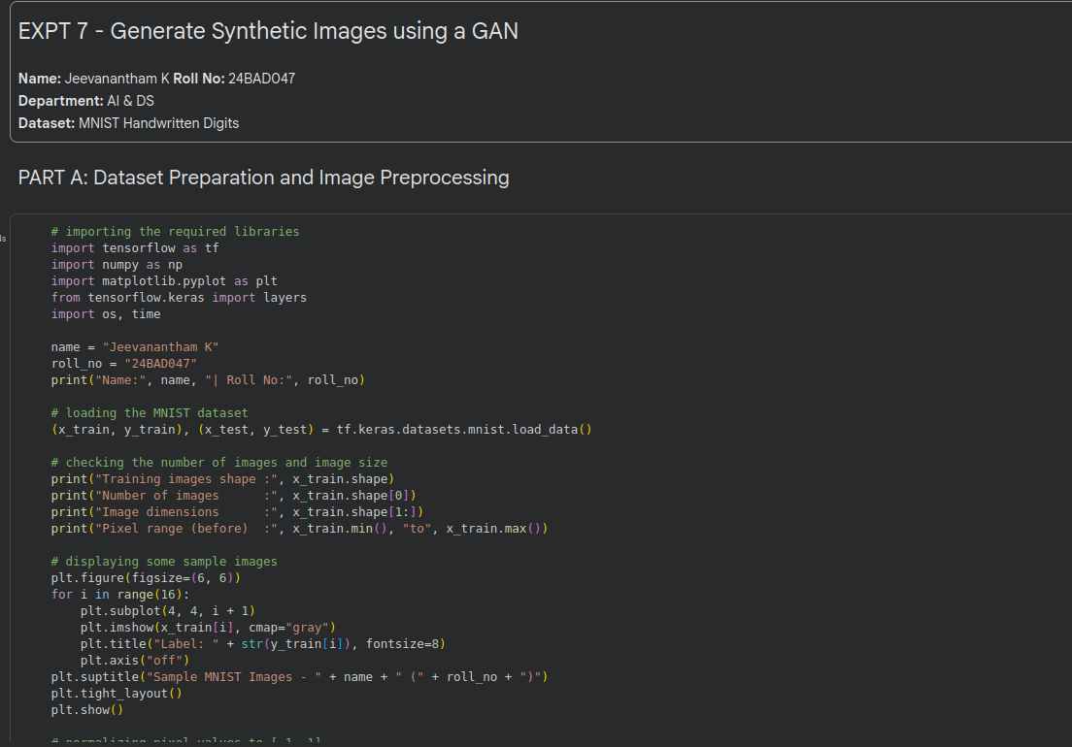
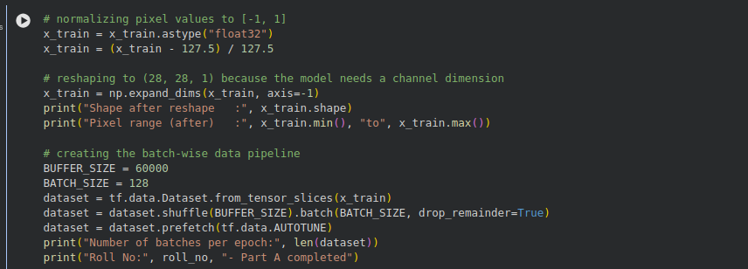
Screenshot of Output
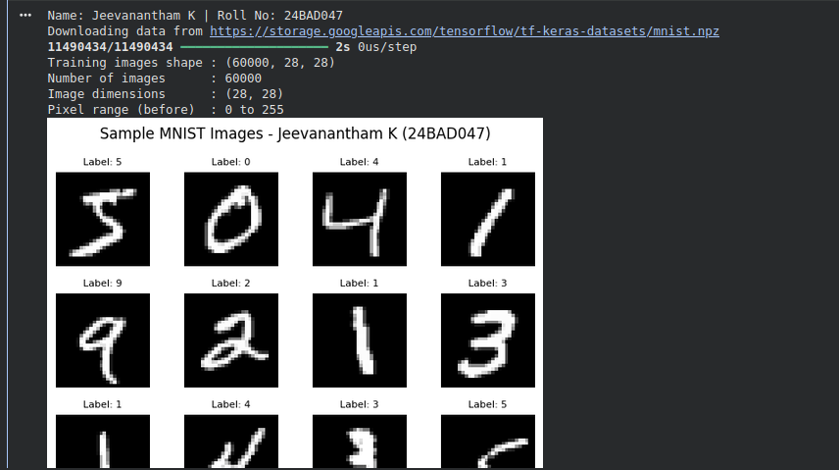
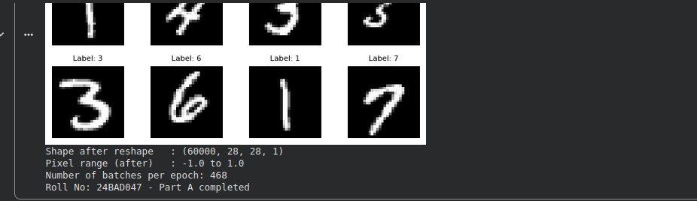

PART B: IMPLEMENTING THE GENERATOR
Perform the following tasks:
- Define a random noise vector as the input to the Generator.
- Create the Generator using appropriate neural network layers.
- Use Dense and convolutional/transposed convolutional layers to generate images.
- Apply appropriate activation functions.
- Generate an image from a random noise vector.
- Display the generated image before GAN training.
- Display the Generator model architecture and summary.

Screenshot of Code
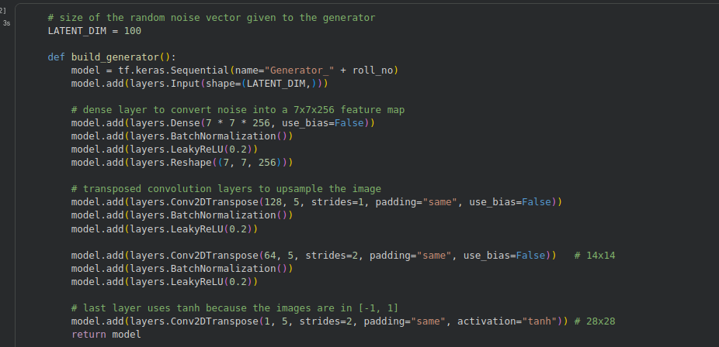
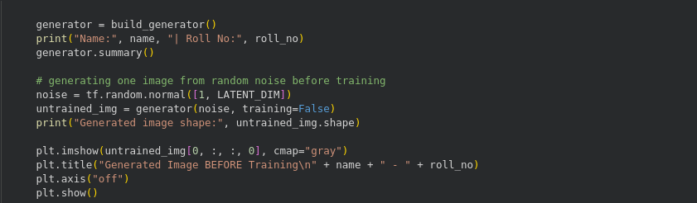
Screenshot of Output
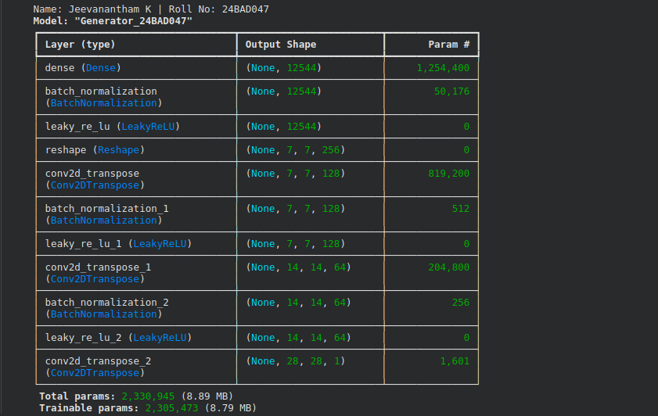
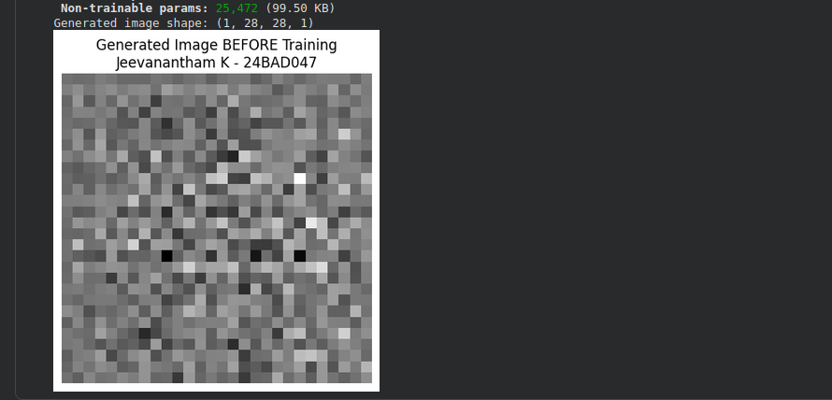

PART C: IMPLEMENTING THE DISCRIMINATOR AND GAN MODEL
Perform the following tasks:
- Create a Discriminator network to classify images as real or generated.
- Add convolutional layers to extract image features.
- Add appropriate activation functions.
- Add a final output layer for binary classification.
- Compile the Discriminator using:
  - Appropriate optimizer
  - Binary cross-entropy loss
- Combine the Generator and Discriminator to form the GAN.
- Display the Generator and Discriminator model summaries.

Screenshot of Code
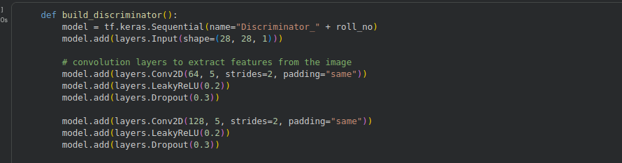
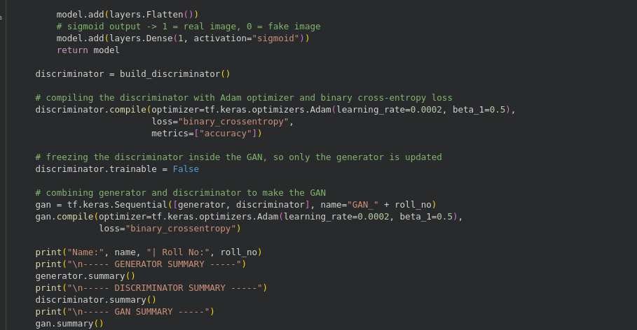
Screenshot of Output
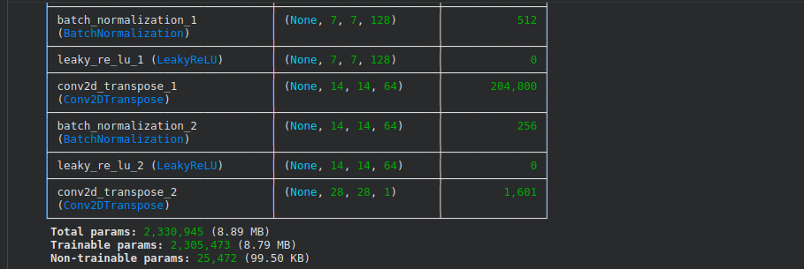
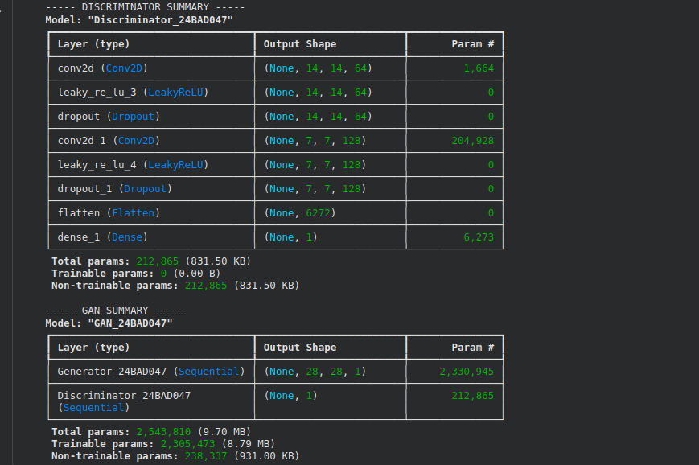

PART D: GAN TRAINING AND SYNTHETIC IMAGE GENERATION
Perform the following tasks:
- Initialize the Generator with random noise.
- Train the Discriminator using:
  - Real images from the dataset.
  - Synthetic images generated by the Generator.
- Train the Generator through the combined GAN model.
- Record:
  - Generator loss
  - Discriminator loss
- Repeat the training process for the specified number of epochs.
- Generate synthetic images at regular training intervals.
- Visualize generated images at different stages of training.
- Compare the generated images with real images.
- Analyze the quality and diversity of the generated images.
- Save the final generated images.

Screenshot of Code
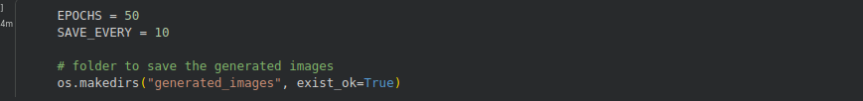
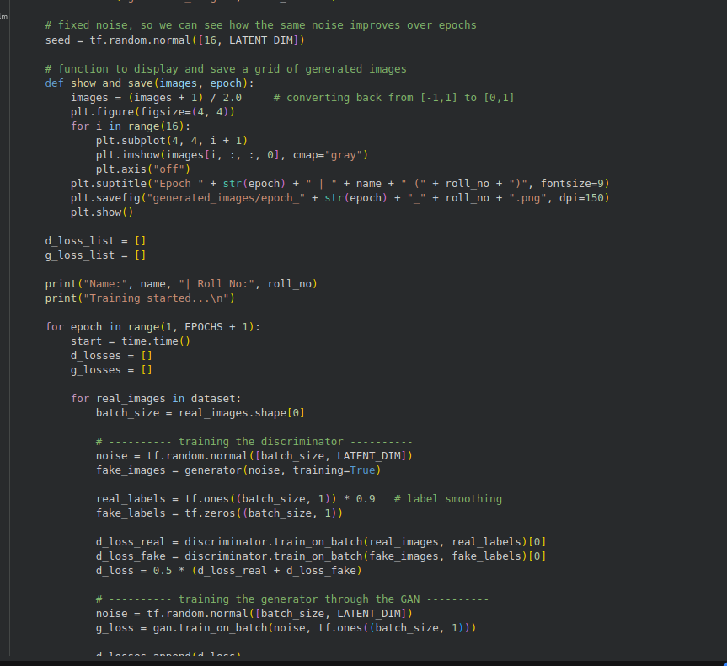
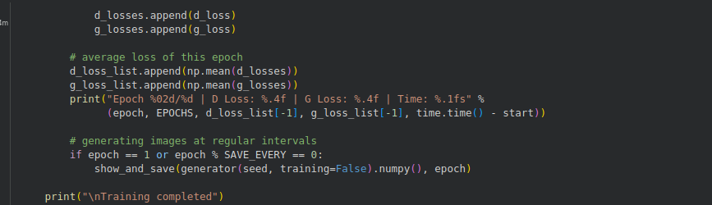
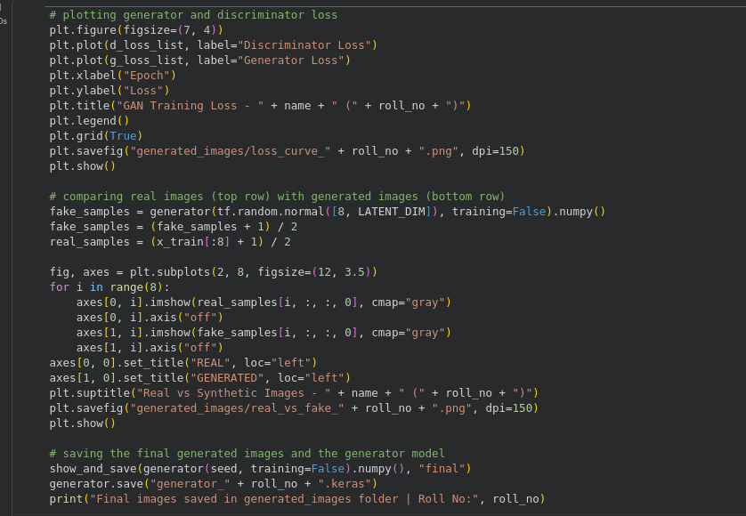
Screenshot of Output
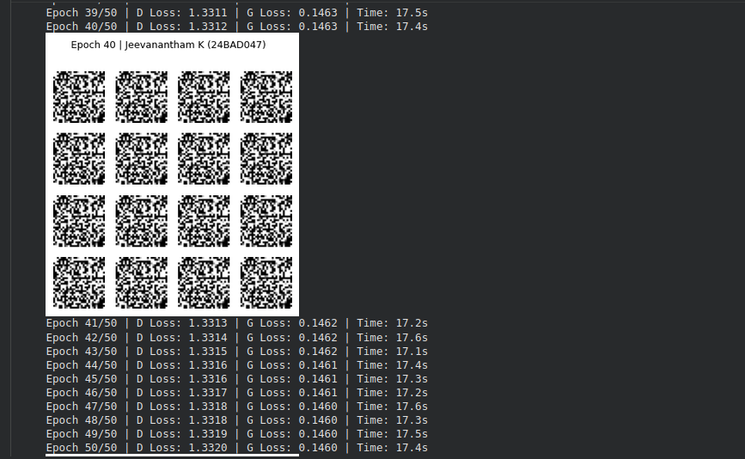
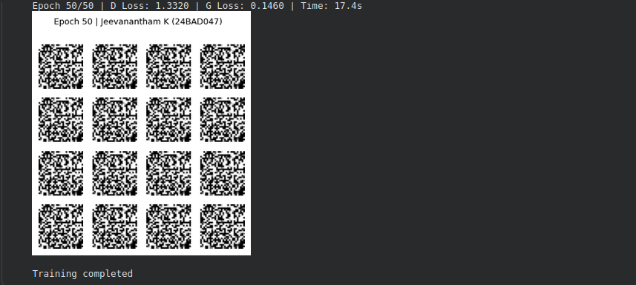
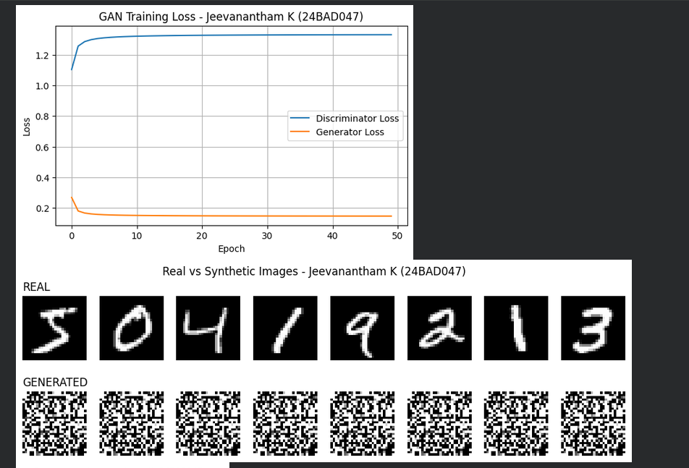
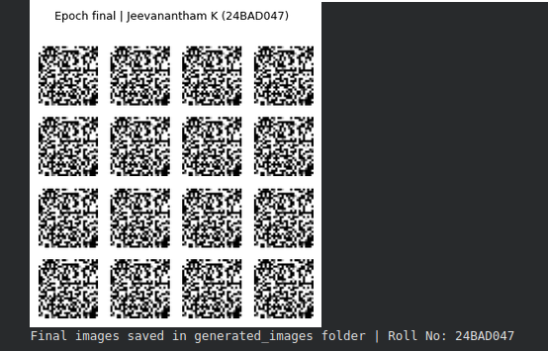

EXPECTED OUTCOME
Students will understand the architecture and working of Generative Adversarial Networks (GANs) and the interaction between the Generator and Discriminator during adversarial training. Students will learn to preprocess image data, build and train GAN models, and generate synthetic images. They will evaluate the generated images by visually comparing them with real images and analyzing the improvement in image quality during training.

POST-LAB QUESTIONS (PROVIDE BRIEF ANSWERS TO THE FOLLOWING QUESTIONS)

- What is the role of the Generator in a GAN?
Ans: The Generator takes a random noise vector and transforms it into a synthetic image. Its goal is to produce images that look so real that the Discriminator classifies them as real. It never sees the real images directly and learns only from the Discriminator's feedback.
- What is the role of the Discriminator in a GAN?
Ans: The Discriminator is a binary classifier that checks whether an input image is real (from the dataset) or fake (produced by the Generator). It outputs a probability between 0 and 1 and is trained with binary cross-entropy loss. Its feedback is what teaches the Generator to improve.
- Why is random noise used as input to the Generator?
Ans: Random noise acts as the source of randomness (the latent space) for the Generator. Because different noise vectors are mapped to different images, the Generator can create a new and varied image each time. Without noise it would produce the same fixed output every time.
- What happens when the Discriminator becomes too strong during GAN training?
Ans: If the Discriminator becomes too strong, it classifies the generated images as fake with very high confidence, so the Generator loss becomes large and the gradients passed to the Generator become very small (vanishing gradients). The Generator then stops learning and the image quality does not improve. Techniques such as label smoothing, dropout in the Discriminator and a balanced learning rate help to avoid this.
- What is meant by mode collapse in GANs?
Ans: Mode collapse is a failure case in which the Generator produces only a few types of images (or even the same image) for different noise inputs, instead of covering all the variety present in the real data. For example, in MNIST the Generator may produce only the digit 1. It happens when the Generator finds a few samples that easily fool the Discriminator.
- How does the Generator improve the quality of generated images during training?
Ans: The Generator gets gradient feedback from the Discriminator through the combined GAN model. In each step its weights are updated so that the Discriminator is more likely to label its images as real. Over many epochs the output improves from random noise to blurry shapes and finally to clear digit-like images.
- Mention one real-world application of GANs.
Ans: One real-world application of GANs is generating synthetic medical images (such as X-ray or MRI images) for data augmentation, which helps train diagnosis models when real patient data is limited.
- What is the difference between GAN training and conventional neural network training?
Ans: In conventional neural network training, a single network minimizes a fixed loss function against fixed labels, and the loss steadily decreases until convergence. In GAN training, two networks with opposite objectives are trained together, so each network's target keeps changing as the other one improves. This makes training unstable and needs a careful balance between the two networks, and the loss values alone do not show the image quality, so the generated images must be checked visually.

SUGGESTIONS FOR DATASETS
- MNIST Handwritten Digits – https://www.tensorflow.org/datasets/catalog/mnist
- Fashion-MNIST – https://www.tensorflow.org/datasets/catalog/fashion_mnist
- CIFAR-10 – https://www.tensorflow.org/datasets/catalog/cifar10
- CelebA – https://www.tensorflow.org/datasets/catalog/celeb_a
- Oxford-IIIT Pet Dataset – https://www.tensorflow.org/datasets/catalog/oxford_iiit_pet

ASSESSMENT
Description | Max Marks | Marks Awarded
Pre Lab Exercise | 5
In Lab Exercise | 10
Post Lab Exercise | 5
Viva | 10
Total | 30
Faculty Signature

