EXPT NO: 8 | TRAIN A SIMPLE AUTOENCODER FOR DIMENSIONALITY REDUCTION AND FEATURE LEARNING
DATE: 30-10-2026 | NAME: Jeevanantham K ROLL NO: 24BAD047

PRE-LAB QUESTIONS
- What is an autoencoder? An autoencoder is an unsupervised (self-supervised) neural network that learns to compress its input into a compact code and then reconstruct the original input from that code.
- What are the roles of the encoder and decoder in an autoencoder? The encoder maps the input to a lower-dimensional latent vector, and the decoder reconstructs the original input from that latent vector.
- What is dimensionality reduction? It is the process of representing data with fewer features while preserving as much useful information as possible (e.g., 784 → 32).
- What is meant by latent representation or latent space? The latent representation is the compressed bottleneck vector produced by the encoder. The space of all such vectors is the latent space, which captures the essential features of the data.
- Why is reconstruction loss used when training an autoencoder? It measures how close the reconstructed output is to the original input (e.g., MSE or binary cross-entropy). Minimising it forces the network to retain the most informative features in the latent code.
AIM
To implement and train a simple autoencoder using the MNIST dataset, learn a lower-dimensional representation of the input data, and evaluate the model by reconstructing the input samples and visualizing their latent representations.
SOFTWARE REQUIREMENTS
- Python
- TensorFlow / Keras
- Google Colab
- GitHub
- NumPy, Matplotlib
- scikit-learn (PCA and t-SNE)
OBJECTIVES
- Understand the architecture and working of autoencoders.
- Differentiate between the encoder, latent representation, and decoder.
- Prepare and preprocess a dataset for autoencoder training.
- Build and train an autoencoder using reconstruction loss.
- Perform dimensionality reduction and extract latent features.
- Visualize original and reconstructed samples and evaluate reconstruction performance.
PROCEDURE (CODE AND OUTPUT SCREENSHOTS)
Dataset used: MNIST handwritten digits (60,000 training and 10,000 testing images, 28 × 28 grayscale). Every code cell prints the student name / roll number 24BAD047.
PART A: DATASET PREPARATION AND PREPROCESSING
- Loaded MNIST using TensorFlow/Keras and checked the training/testing shapes: (60000, 28, 28) and (10000, 28, 28).
- Displayed sample images and normalized pixel values to [0, 1].
- Flattened each 28 × 28 image into a 784-dimensional vector; the input images are used as both input and target.
Screenshot of Code and Output – Setup, loading data and sample images
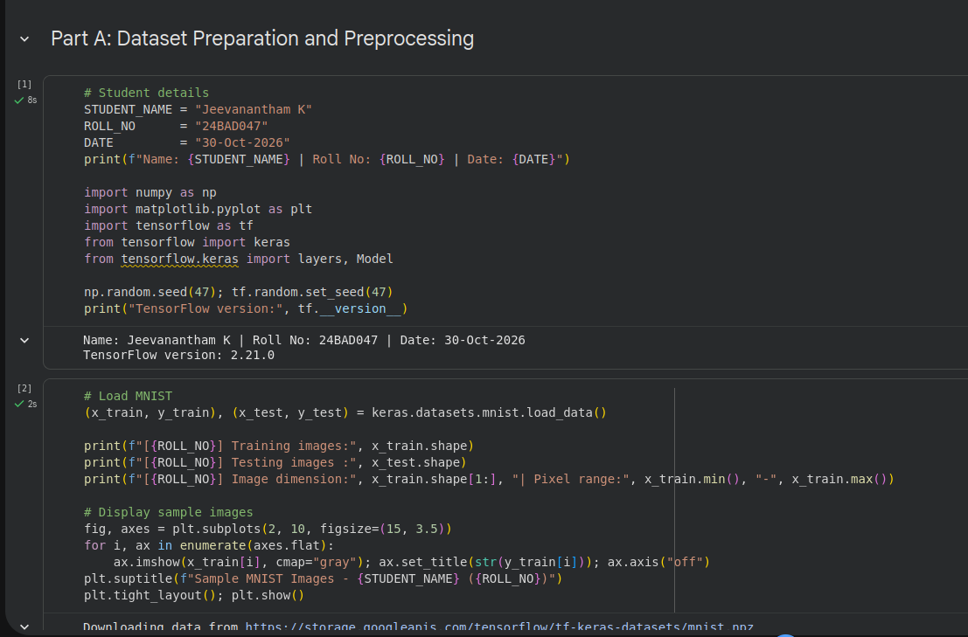
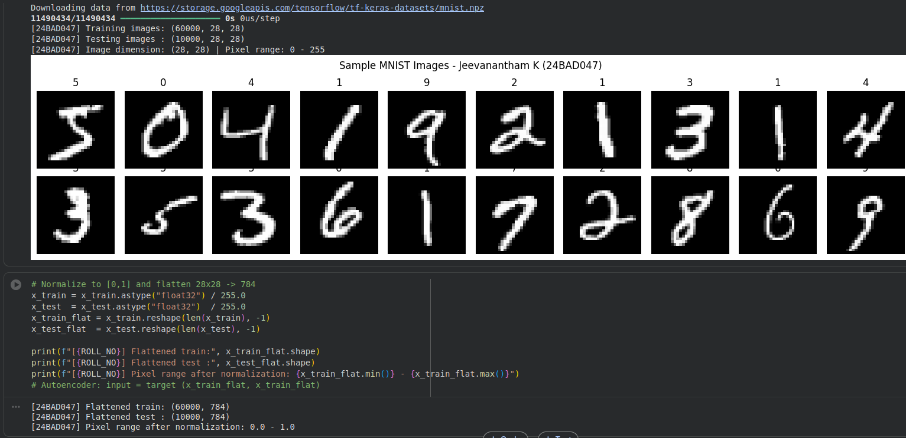
PART B: IMPLEMENTING THE ENCODER AND DECODER
- Encoder: 784 → 128 (ReLU) → 64 (ReLU) → 32 (latent, ReLU).
- Decoder: 32 → 64 (ReLU) → 128 (ReLU) → 784 (Sigmoid).
- Encoder and decoder were combined into a single autoencoder (total 222,384 parameters).
Screenshot of Code and Output – Model definition and summaries
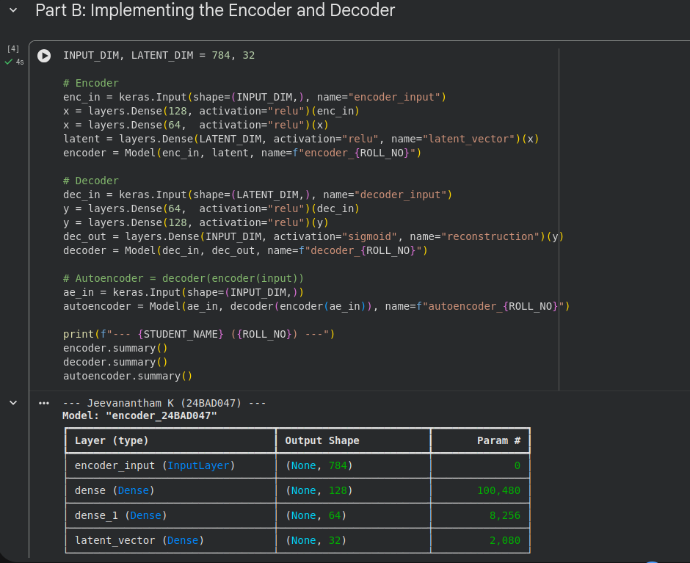
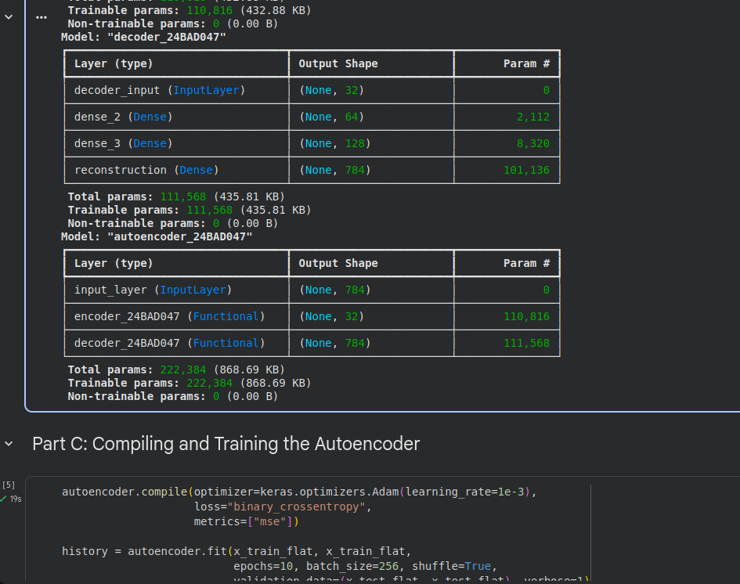
PART C: COMPILING AND TRAINING THE AUTOENCODER
- Compiled with the Adam optimizer (learning rate 1e-3) and binary cross-entropy loss; MSE tracked as a metric.
- Trained for 10 epochs with batch size 256, using the test set for validation.
- Training loss fell from 0.2397 to 0.1009 and validation loss from 0.1615 to 0.0989 (validation MSE 0.0122).
Screenshot of Code and Output – Compile and train
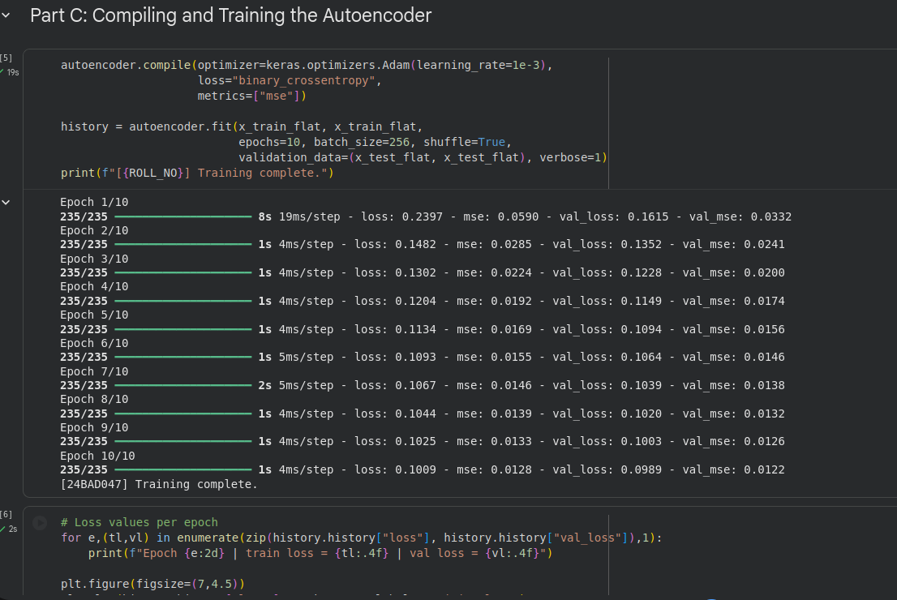
Screenshot of Code and Output – Loss per epoch
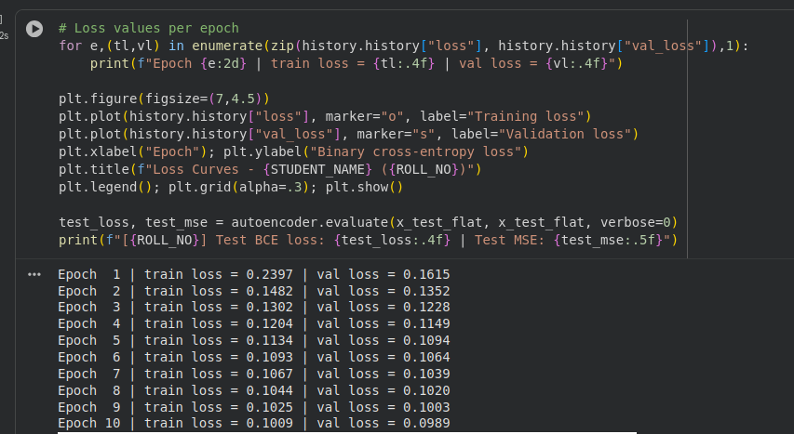
Screenshot of Output – Training and validation loss curves
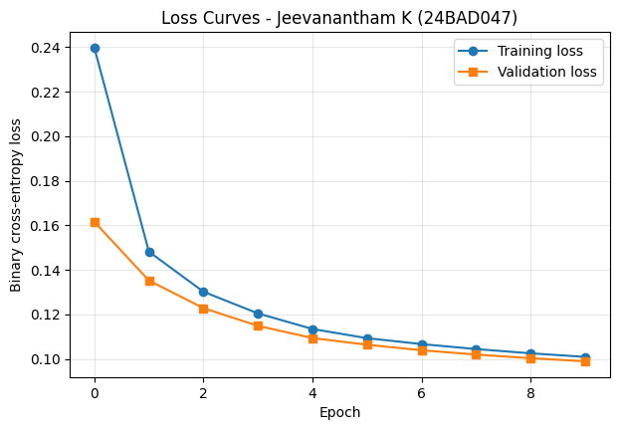
PART D: DIMENSIONALITY REDUCTION, FEATURE LEARNING AND RECONSTRUCTION
- The trained encoder converted test images from 784 to 32 dimensions (24.5× compression).
- The decoder reconstructed the images from the latent vectors, shown side by side with the originals.
- PCA and t-SNE were used to visualize the latent features in two dimensions; models and reconstructed images were saved.
Screenshot of Code and Output – Latent vectors and reconstruction
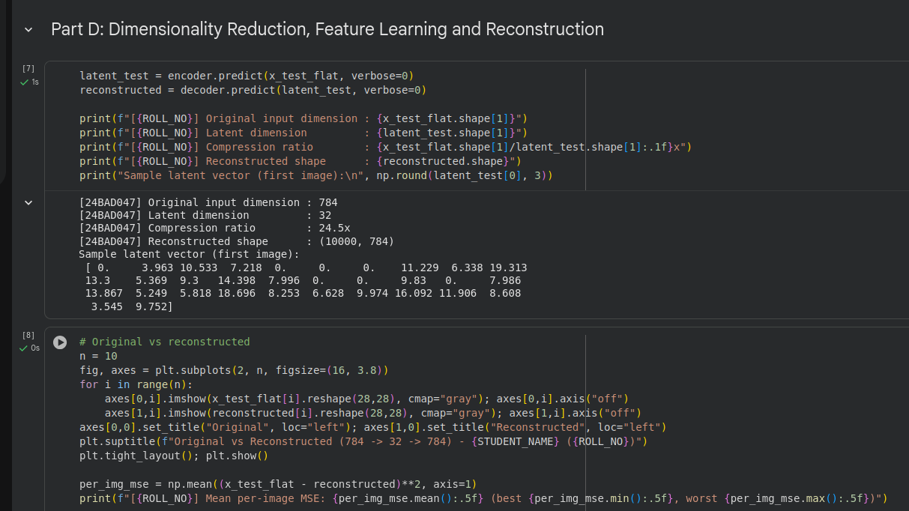
Screenshot of Output – Original vs reconstructed images
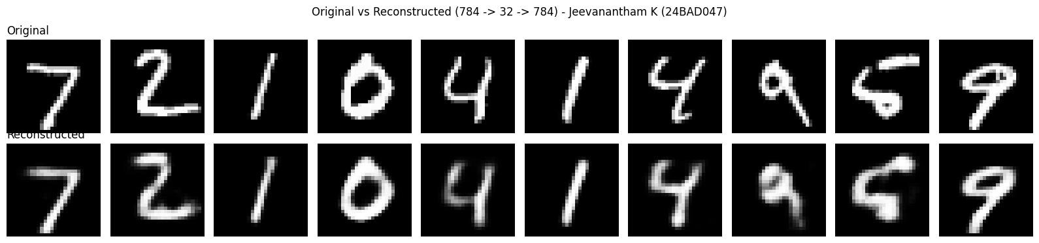
Screenshot of Code – PCA and t-SNE
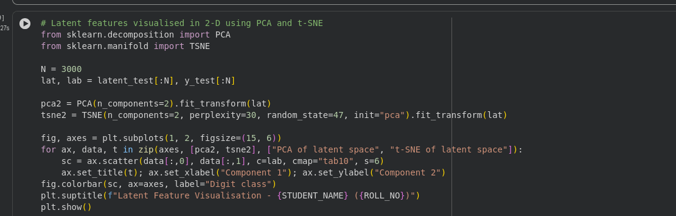
Screenshot of Output – Latent space visualization (PCA and t-SNE)
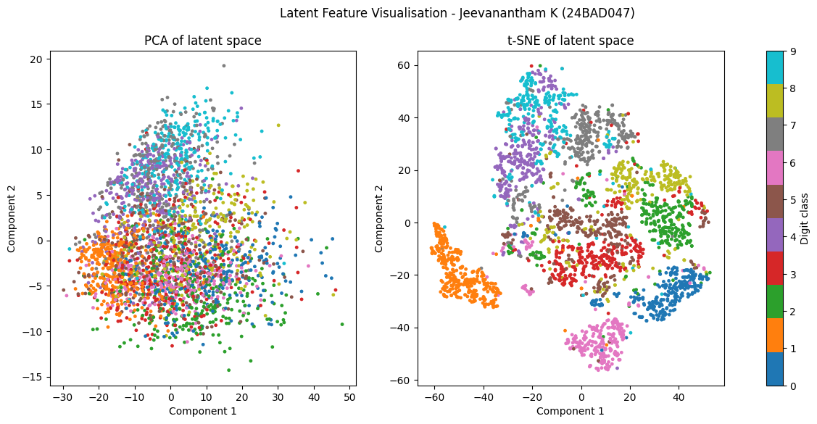
Screenshot of Code and Output – Saving models and reconstructed images
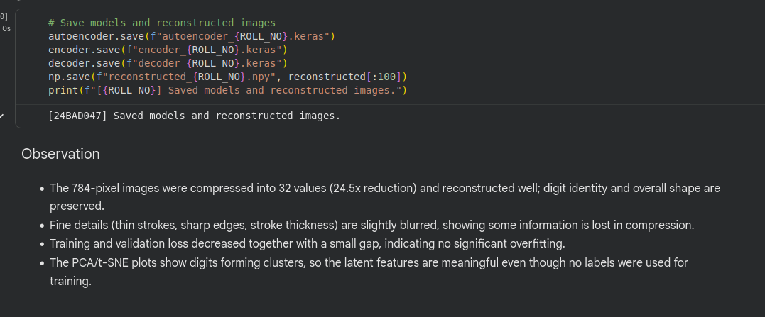
Observation
- The 784-pixel images were compressed into 32 values and reconstructed well; digit identity and overall shape are preserved.
- Fine details such as thin strokes and sharp edges are blurred, and a few digits (e.g., some 4s and 9s) are slightly distorted, showing that some information is lost in compression.
- Training and validation loss decreased together with almost no gap, indicating no significant overfitting.
- The t-SNE plot shows digits forming distinct clusters (PCA overlaps more), so the latent features are meaningful even though no labels were used for training.
EXPECTED OUTCOME
The simple autoencoder was successfully trained. It compressed 784-dimensional inputs into a 32-dimensional latent representation, reconstructed the images with low reconstruction loss, and produced latent features that separate digit classes.
POST-LAB QUESTIONS
- What is the main purpose of an autoencoder? To learn a compact representation of data (dimensionality reduction and feature learning) by reconstructing its own input.
- How do the encoder and decoder differ? The encoder compresses the input into the latent vector (784 → 32), while the decoder expands the latent vector back to the original size (32 → 784).
- What is a latent representation? The low-dimensional bottleneck vector that holds the most important features of the input.
- How does an autoencoder perform dimensionality reduction? The bottleneck layer has far fewer units than the input, so the network must keep only the most informative features; the encoder output is the reduced representation.
- Why are the input images also used as target outputs during training? An autoencoder is self-supervised: its goal is to reproduce the input, so no separate labels are needed and the input itself is the ground truth.
- What does reconstruction loss measure? The difference between the original input and the reconstructed output (e.g., MSE or binary cross-entropy); a lower loss means better reconstruction.
- What may happen if the latent dimension is too small? Too much information is lost (underfitting), giving blurry or inaccurate reconstructions and poor features.
- Mention one real-world application of autoencoders. Image denoising, anomaly/fraud detection, image compression, or feature extraction for downstream models.
ASSESSMENT
Description | Max Marks | Marks Awarded
Pre Lab Exercise | 5
In Lab Exercise | 10
Post Lab Exercise | 5
Viva | 10
Total | 30
Faculty Signature

