EXPT NO: 10 | BUILDING A SIMPLE LLM CHATBOT USING STREAMLIT/GRADIO
DATE: 12/10/2026 | BUILDING A SIMPLE LLM CHATBOT USING STREAMLIT/GRADIO

PRE-LAB QUESTIONS (PROVIDE BRIEF ANSWERS TO THE FOLLOWING QUESTIONS)

- What is a Large Language Model (LLM)?
Ans: A neural network trained on huge amounts of text to predict the next token, which lets it understand and generate human-like language (summarise, answer, translate, write code).
- What is the role of the Transformer architecture in modern LLMs?
Ans: The Transformer uses self-attention so that every token can weigh every other token in the context. This captures long-range meaning and allows parallel training; it is the backbone of GPT, Llama, Qwen, etc.
- What is a prompt, and how does it influence an LLM's response?
Ans: The prompt is the input text or instructions given to the model. Its wording, context, examples and role/system message steer the tone, format and accuracy of the response.
- What is the difference between a chatbot and a conventional rule-based program?
Ans: A rule-based program follows fixed if-else rules and only handles anticipated inputs. An LLM chatbot generalises from training data and handles open-ended language, but can be wrong or unpredictable.
- What are Streamlit and Gradio used for?
Ans: Python libraries that turn scripts/models into interactive web apps (text boxes, chat UI, buttons) with very little code, and make it easy to share or deploy them.
AIM
To build a simple chatbot or AI application using a Transformer-based Large Language Model (LLM), process user prompts, generate responses, and deploy the application using Streamlit or Gradio.

SOFTWARE REQUIREMENTS
- Python
- Google Colab / Jupyter Notebook / Local Python environment
- Hugging Face Transformers
- PyTorch (or another supported model backend)
- Streamlit or Gradio
- GitHub (for version control and submission)
- A web browser
- An LLM API key, if using a hosted model API

OBJECTIVES
Students will be able to:
- Understand the basic working of Transformer-based LLMs.
- Select and load a suitable pretrained language model or connect to a hosted LLM API.
- Accept user input through a prompt-based interface.
- Generate and display responses from the selected model.
- Build a simple chatbot interface using Streamlit or Gradio.
- Maintain conversation history where supported.
- Test the chatbot with different prompts and evaluate the relevance of its responses.
- Run and demonstrate the deployed application.

PROCEDURE
PART A: ENVIRONMENT SETUP AND MODEL SELECTION
Perform the following tasks:
- Create a Python notebook or project folder.
- Install the required libraries, such as transformers, torch, and either Streamlit or Gradio.
- Choose a suitable pretrained instruction-following or conversational model or select a hosted LLM API.
- Read the model documentation and check its hardware, memory, access, and usage requirements.
- Load the model and tokenizer or configure the API client and store the API key securely as an environment variable.
- Test the setup with one simple input prompt.
SCREENSHOT OF CODE:
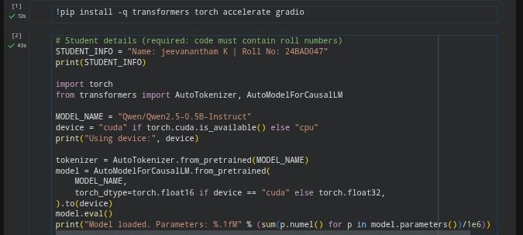
SCREENSHOT OF OUTPUT:
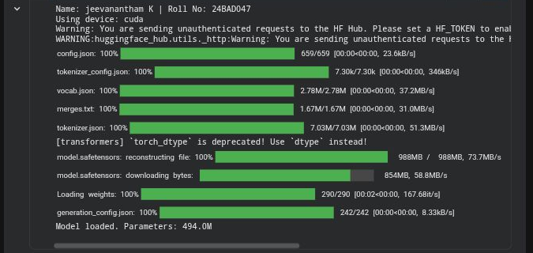
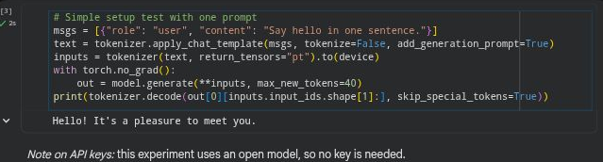
PART B: PROMPT HANDLING AND RESPONSE GENERATION
Perform the following tasks:
- Define a function that accepts a user message as input.
- Prepare the prompt in the format required by the selected model or API.
- Pass the prompt to the model and generate a response using suitable generation settings.
- Decode and display the generated response clearly.
- Handle empty input and basic runtime or API errors.
- Test the function using at least five different prompts and record the responses.
SCREENSHOT OF CODE:
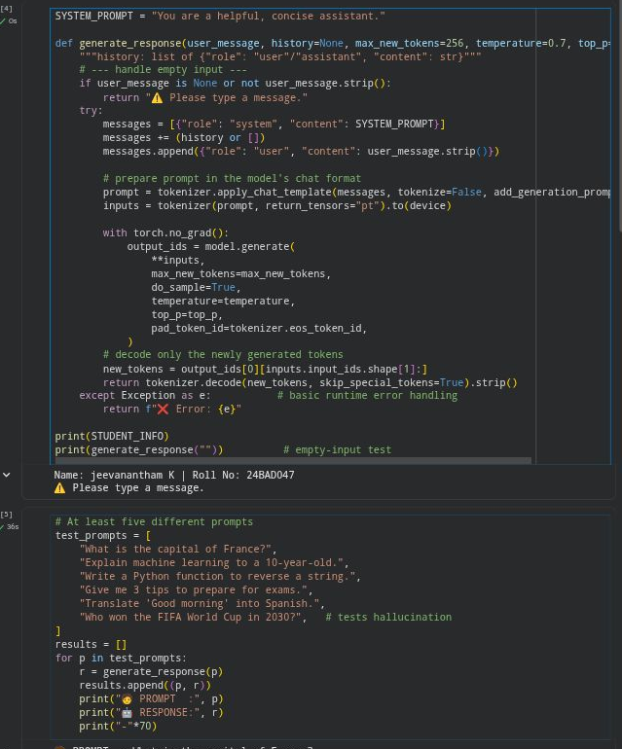
SCREENSHOT OF OUTPUT:
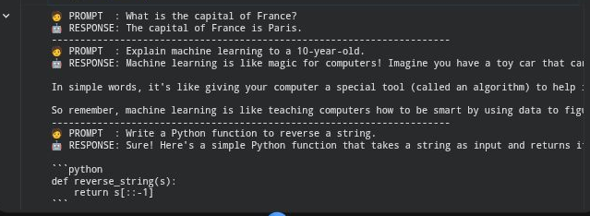
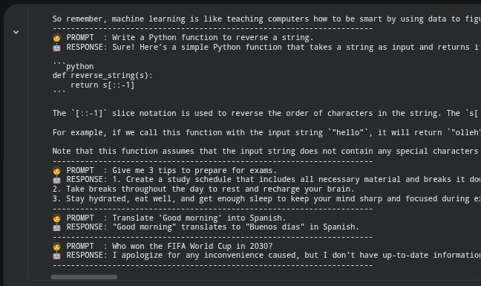

PART C: BUILDING THE CHATBOT INTERFACE
Perform the following tasks:
- Choose either Streamlit or Gradio to create the user interface.
- Add a text box or chat input for entering user messages.
- Display the user message and the model-generated response in the interface.
- Maintain conversation history if supported by the selected model and interface.
- Add a clear-chat or reset option if appropriate.
- Run the application locally and test the interaction from a web browser.
SCREENSHOT OF CODE:
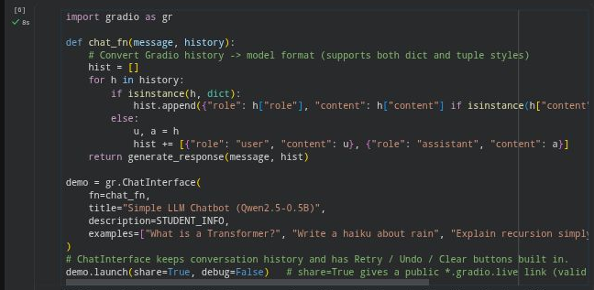
SCREENSHOT OF OUTPUT:
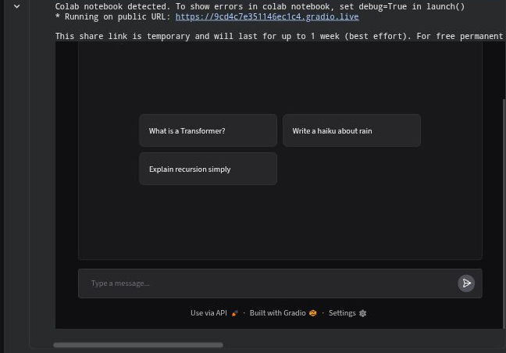

PART D: TESTING AND DEPLOYMENT
Perform the following tasks:
- Test the chatbot with factual, conversational, and task-oriented prompts.
- Check whether the responses are relevant, readable, and consistent with the prompts.
- Identify any incorrect, biased, or unsafe responses and note the limitations.
- Deploy the application using an available hosting option supported by Streamlit or Gradio or demonstrate it locally if deployment access is unavailable.
- Do not upload API keys or other secrets to GitHub; use environment variables or the hosting platform's secrets settings.
- Save the source code, requirements file, screenshots of the interface, and sample outputs.
- Include the GitHub repository link and the application link, if publicly deployed, in the submission.
SCREENSHOT OF CODE:
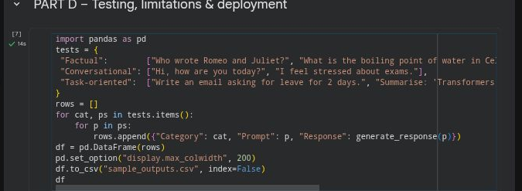
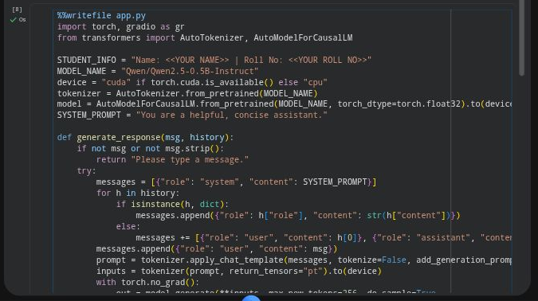
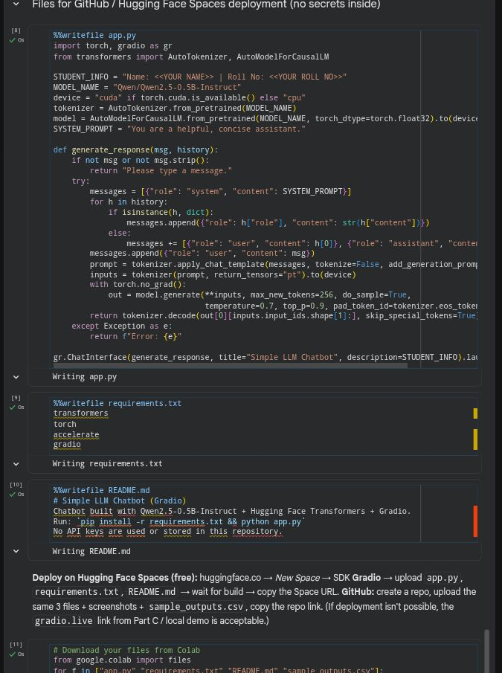
SCREENSHOT OF OUTPUT:
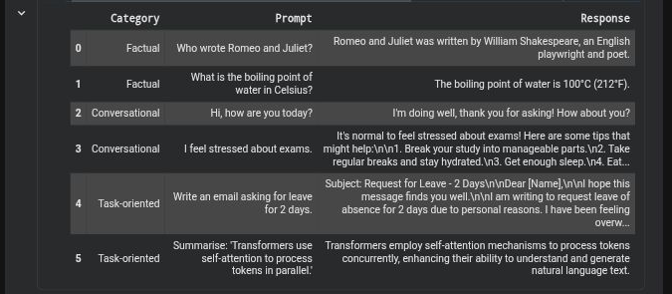
OBSERVATIONS AND LIMITATIONS:
Check | Observation
Relevance / readability | Responses were mostly relevant, short and readable for factual and task-oriented prompts.
Incorrect output | The small 0.5B model can hallucinate (e.g. the "World Cup 2030" prompt) and may make factual or arithmetic mistakes.
Bias / safety | Small models may reflect training-data bias and can produce unsafe text if pushed; there is no strong safety filtering.
Latency | Slower on CPU; fast on a T4 GPU.
Other | Limited context length, no live knowledge, and responses may be inconsistent between runs (sampling).

DEPLOYMENT:
The chatbot was run and demonstrated through the Gradio public share link (gradio.live) generated in Part C, as shown in the Part C screenshot. The source code (app.py), requirements.txt, README.md and sample_outputs.csv were saved and downloaded for upload to GitHub / Hugging Face Spaces. No API keys or secrets are used or stored anywhere, since the experiment uses an open model (Qwen2.5-0.5B-Instruct).

EXPECTED OUTCOME
Students will understand the basic use of Transformer-based LLMs for prompt-based text generation and chatbot development. They will build a working chatbot interface using Streamlit or Gradio, test its responses with different prompts, and run or deploy the application. Students will also identify limitations such as inaccurate responses, model-access requirements, latency, and responsible handling of user inputs and API credentials.

POST-LAB QUESTIONS (PROVIDE BRIEF ANSWERS TO THE FOLLOWING QUESTIONS)

- What is the function of a tokenizer in an LLM application?
Ans: A tokenizer splits text into tokens and maps them to integer IDs the model understands, and converts the output IDs back into text.
- How does a Transformer-based LLM generate a response to a prompt?
Ans: The prompt is tokenised, embedded and passed through Transformer layers with self-attention. The model outputs a probability distribution for the next token, one token is chosen (greedy/sampling) and appended, and this repeats until an end token or the length limit is reached.
- What is the purpose of Streamlit or Gradio in this experiment?
Ans: They provide a quick web UI (chat box, buttons, history) so users can interact with the model in a browser without writing HTML/JS, and make the app easy to demo and deploy.
- Why should an API key be stored securely and not committed to GitHub?
Ans: A leaked key lets others use your account, causing cost, quota abuse and data exposure. GitHub repositories are often public or scraped, so keys must be kept in environment variables or secrets managers.
- What is conversation history, and how can it improve a chatbot?
Ans: It is the earlier user/assistant turns sent along with each new prompt. It gives context, so follow-up questions such as "Where was he born?" are understood and replies stay coherent.
- Mention two limitations of LLM-based chatbots.
Ans: (i) Hallucination: it can give confident but wrong answers. (ii) Bias/safety issues, limited context window, latency/compute cost and no real-time knowledge.
- How can you test whether a chatbot's responses are relevant?
Ans: Test with varied prompts (factual, conversational, task-oriented), compare against known answers, check consistency across runs, have human raters score relevance/readability, or use metrics such as ROUGE/BERTScore on reference answers.
- What is the difference between running an application locally and deploying it online?
Ans: Running locally means the app runs on your own machine (localhost) and only you can access it. Deploying hosts it on a server (e.g. Hugging Face Spaces) with a public URL, available to anyone, always on, with its own resources and secrets management.

SUGGESTIONS FOR DATASETS
- Hugging Face Transformers documentation – https://huggingface.co/docs/transformers/index
- Hugging Face conversational / text-generation models – https://huggingface.co/models?pipeline_tag=text-generation
- Streamlit documentation – https://docs.streamlit.io/
- Gradio documentation – https://www.gradio.app/docs

ASSESSMENT
Description | Max Marks | Marks Awarded
Pre Lab Exercise | 5
In Lab Exercise | 10
Post Lab Exercise | 5
Viva | 10
Total | 30
Faculty Signature

