EXPT NO: 9 | TEXT CLASSIFICATION AND TEXT GENERATION USING TRANSFORMERS  NAME: Jeevanantham K ROLL NO: 24BAD047
DATE: 01-11-2026

PRE-LAB QUESTIONS (PROVIDE BRIEF ANSWERS TO THE FOLLOWING QUESTIONS)

- What is a Transformer model in Natural Language Processing (NLP)?
Ans: A Transformer is a neural network architecture based on the self-attention mechanism. It processes all tokens of a sequence in parallel and learns how strongly each token relates to every other token, producing context-aware representations. It is built from encoder and/or decoder stacks (multi-head attention, feed-forward layers, residual connections, layer normalisation, positional encodings) and replaced RNN/LSTM models because it trains faster and captures long-range dependencies better.
- What is BERT, and how is it used for text classification?
Ans: BERT (Bidirectional Encoder Representations from Transformers) is an encoder-only Transformer pretrained on large corpora with Masked Language Modelling and Next Sentence Prediction, so it understands context from both directions. For classification the input starts with a [CLS] token; the final hidden state of [CLS] is passed to a linear layer that outputs class probabilities.
- What is fine-tuning in the context of pretrained language models?
Ans: Fine-tuning is continuing the training of a pretrained model on a smaller, task-specific labelled dataset, usually with a small learning rate, so its general language knowledge is adapted to the target task. It needs far less data and compute than training from scratch.
- What is the difference between text classification and text generation?
Ans: Text classification maps an input text to one label from a fixed set of classes (e.g. positive or negative). Text generation produces new text token by token (e.g. a summary or translation); its output is open-ended and of variable length.
- What is a sequence-to-sequence model, and how is it used in text generation?
Ans: A sequence-to-sequence model has an encoder that converts the input sequence into contextual representations and a decoder that generates the output sequence autoregressively while attending to the encoder output. Examples are T5 and BART; they are used for summarization, translation, question answering and paraphrasing.
AIM
To implement text classification by fine-tuning a pretrained BERT model and develop a simple sequence-to-sequence text generation application using Transformer models.

SOFTWARE REQUIREMENTS
- Python
- Google Colab
- Hugging Face Transformers
- Hugging Face Datasets
- PyTorch
- NumPy
- Pandas
- Matplotlib
Dataset used: IMDb Movie Reviews (stanfordnlp/imdb), 25,000 train and 25,000 test reviews with binary sentiment labels; a random subset of 4,000 training and 1,000 testing reviews was used. Models: BERT Base Uncased (google-bert/bert-base-uncased) for classification and T5-small (google-t5/t5-small) for sequence-to-sequence generation.

OBJECTIVES
Students will be able to:
- Understand the architecture and working of Transformer models in NLP.
- Understand the concepts of text classification and text generation.
- Load and preprocess text datasets for NLP applications.
- Fine-tune a pretrained BERT model for text classification.
- Evaluate the classification model using appropriate performance metrics.
- Implement a sequence-to-sequence application using a pretrained Transformer model.
- Generate text using the model's text generation capabilities.
- Analyze and compare the outputs produced by the Transformer models.

PROCEDURE
PART A: DATASET PREPARATION AND TEXT PREPROCESSING
Perform the following tasks:
- Load a text dataset such as the IMDb movie review dataset.
- Explore the dataset and examine sample text entries and their labels.
- Check the number of samples and the distribution of class labels.
- Separate the dataset into training and testing sets or use the predefined splits.
- Load a pretrained tokenizer corresponding to the BERT model.
- Tokenize the text using the tokenizer.
- Apply padding and truncation to maintain consistent input lengths.
- Convert the tokenized data into the required format for model training.
- Prepare the dataset for batch-wise processing.
A1. Library installation — Code
A2. Student details and device setup — Code
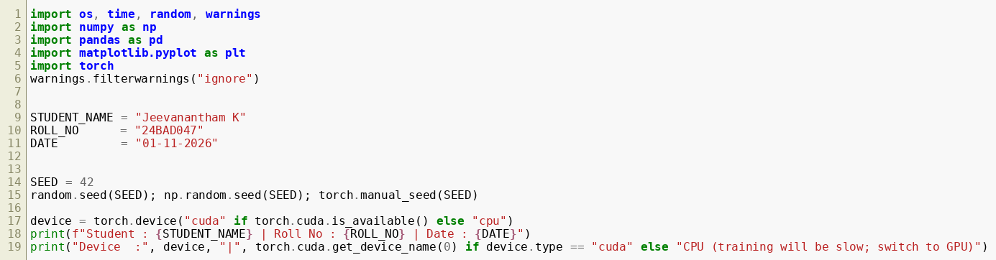
A2. Student details and device setup — Output
A3. Dataset loading — Code
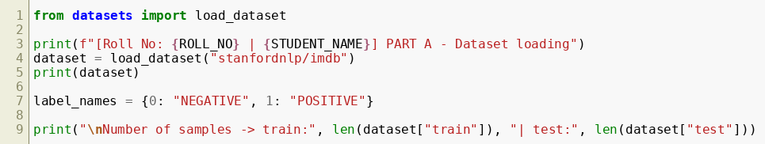
A3. Dataset loading — Output
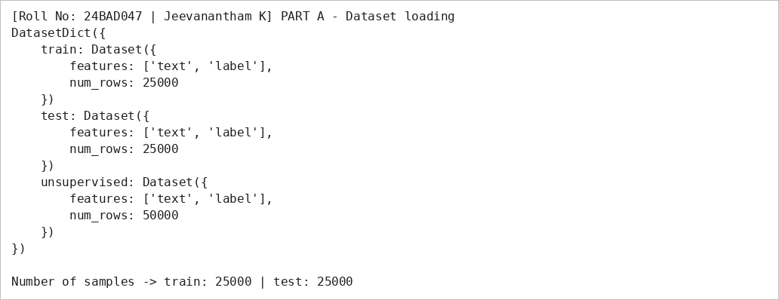
A4. Sample entries and labels — Code
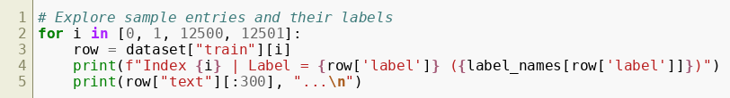
A4. Sample entries and labels — Output
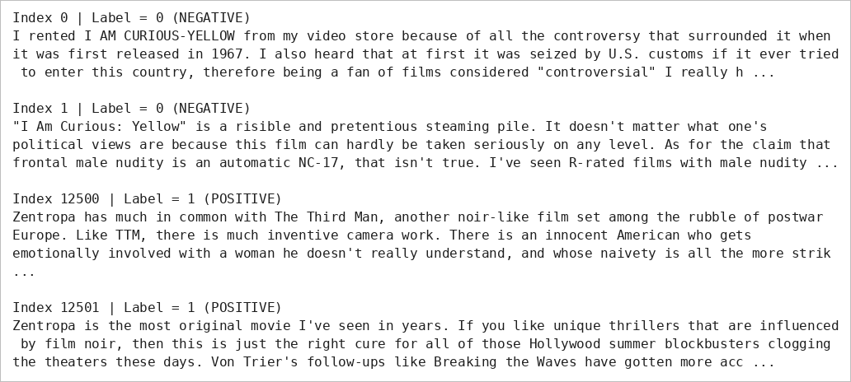
A5. Class distribution and review length — Code
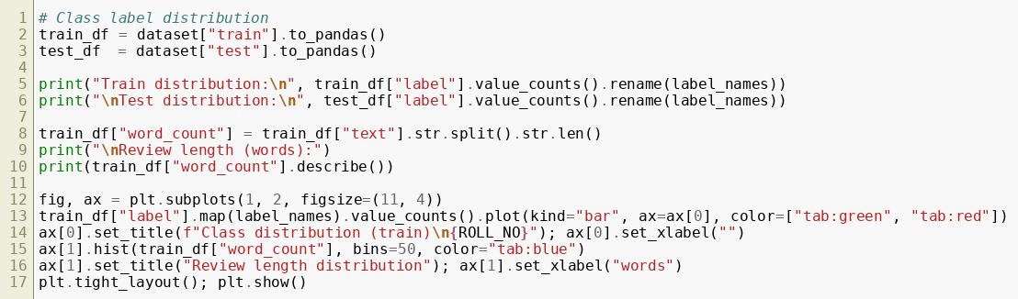
A5. Class distribution and review length — Output
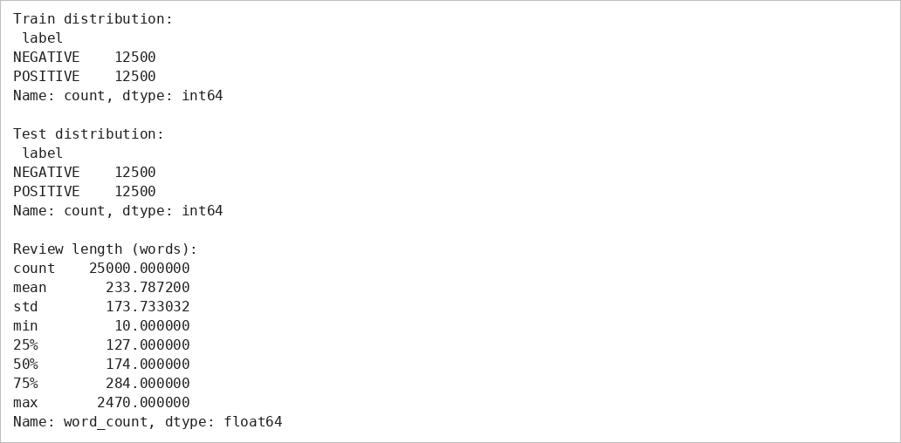
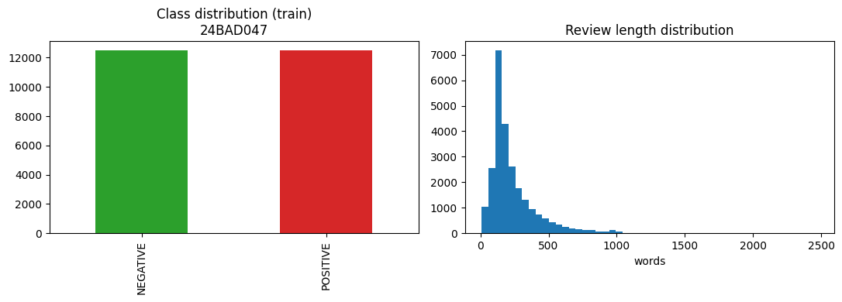
A6. Train and test subset — Code
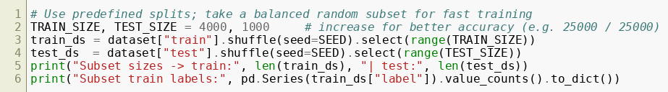
A6. Train and test subset — Output
A7. Tokenizer — Code
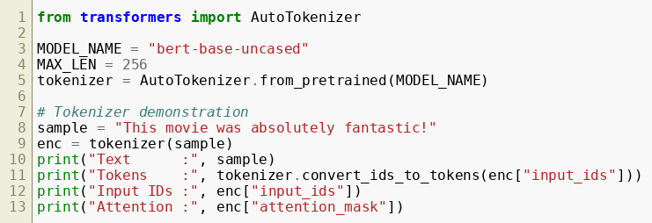
A7. Tokenizer — Output
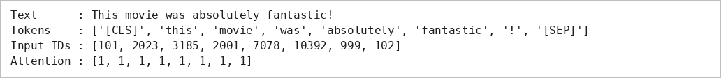
A8. Tokenization with padding and truncation — Code
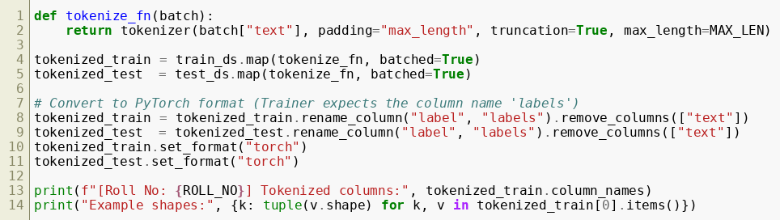
A8. Tokenization with padding and truncation — Output
A9. Batch-wise processing — Code
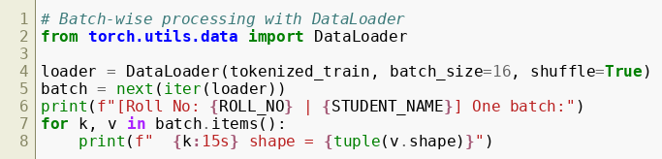
A9. Batch-wise processing — Output
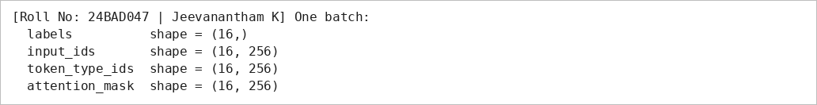
PART B: FINE-TUNING BERT FOR TEXT CLASSIFICATION
Perform the following tasks:
- Load a pretrained BERT model for sequence classification.
- Configure the model for the required number of classes.
- Prepare the tokenized training and testing datasets.
- Define the training parameters, including learning rate, batch size, and number of epochs.
- Fine-tune the BERT model using the training dataset.
- Evaluate the trained model using the testing dataset.
- Calculate appropriate performance metrics, such as accuracy, precision, recall, and F1-score.
- Test the model using new text inputs.
- Display the predicted class labels and corresponding evaluation results.
- Save the fine-tuned model and tokenizer.
B1. Model loading — Code
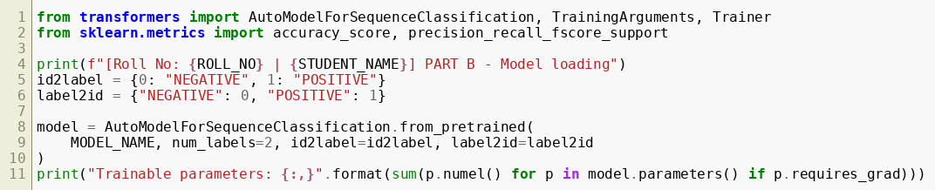
B1. Model loading — Output
B2. Metrics and training parameters — Code
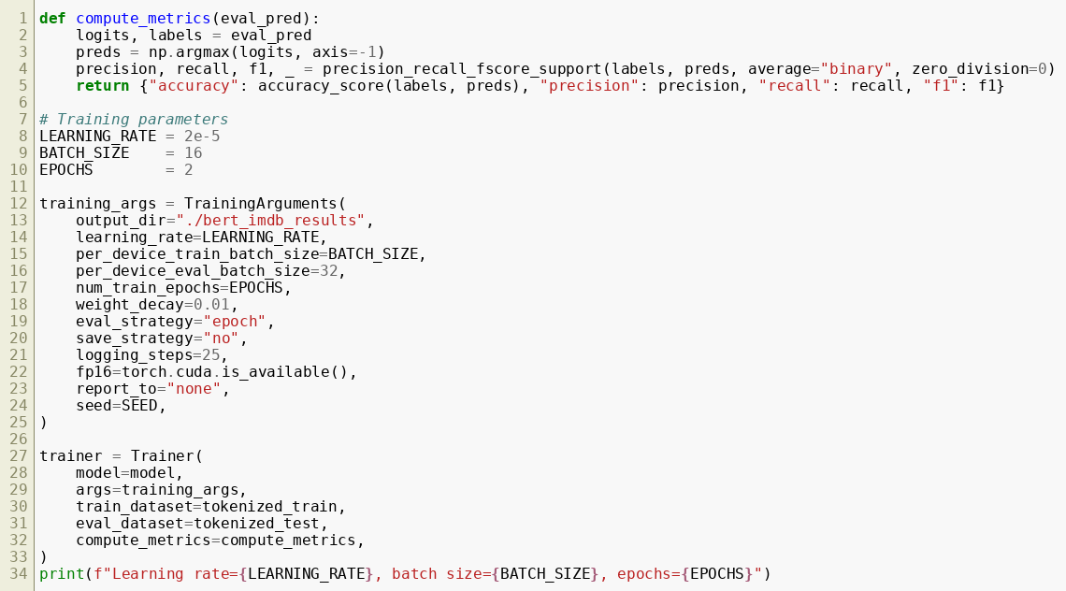
B2. Metrics and training parameters — Output
B3. Fine-tuning — Code
B3. Fine-tuning — Output
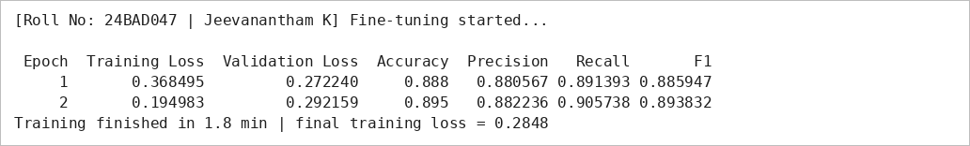
B4. Training loss curve — Code
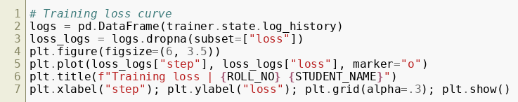
B4. Training loss curve — Output
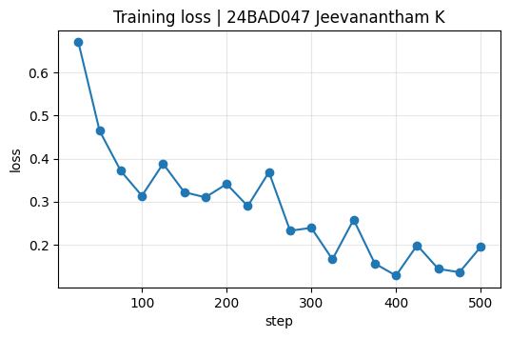
B5. Evaluation on test set — Code
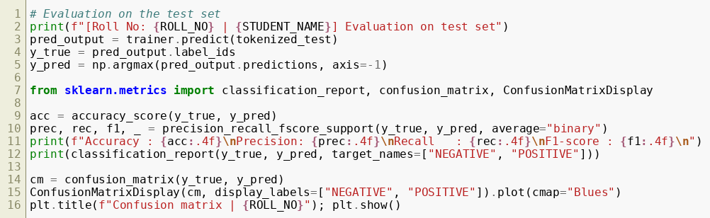
B5. Evaluation on test set — Output
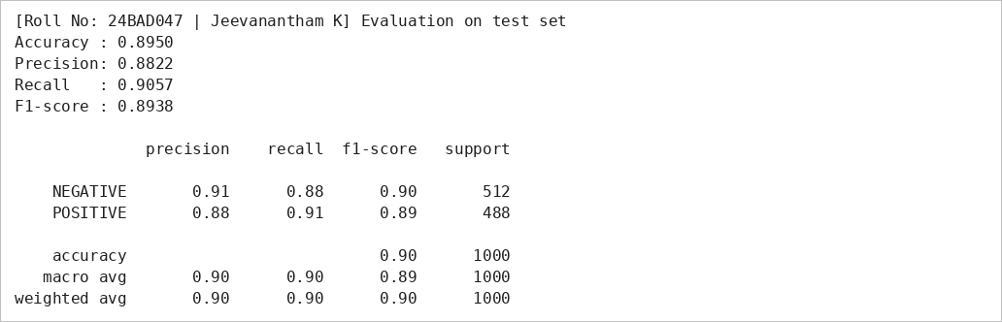
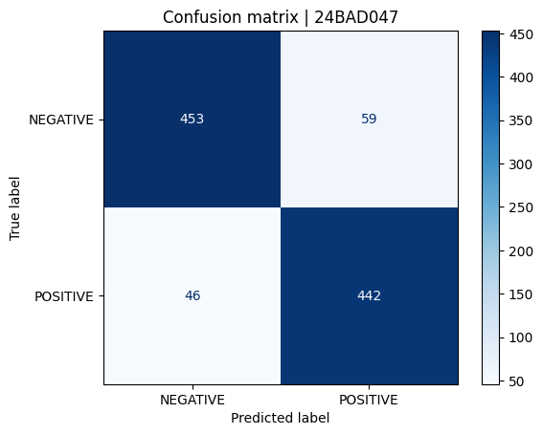
B6. Predictions on new text — Code
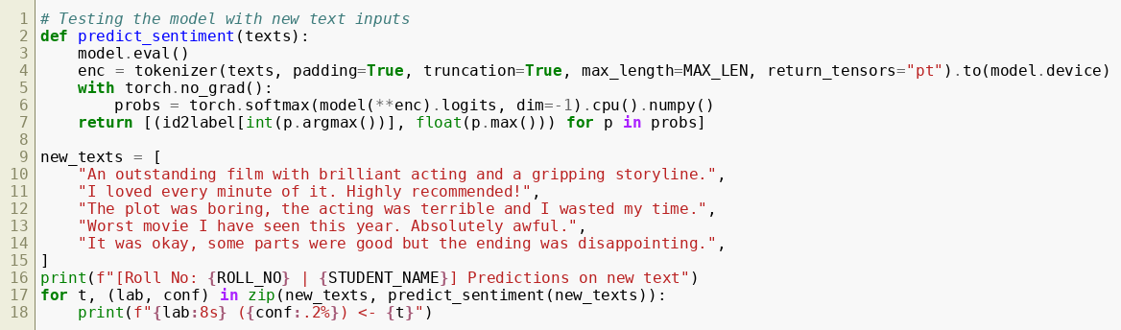
B6. Predictions on new text — Output
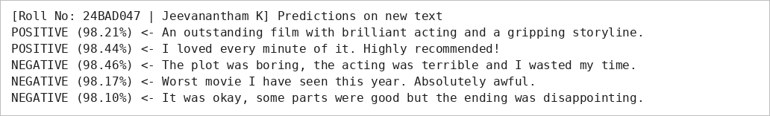
B7. Saving the model and tokenizer — Code
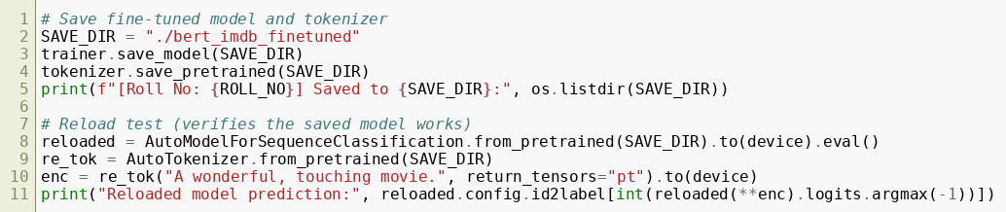
B7. Saving the model and tokenizer — Output

PART C: IMPLEMENTING A SEQUENCE-TO-SEQUENCE APPLICATION USING TRANSFORMERS
Perform the following tasks:
- Load a pretrained sequence-to-sequence Transformer model, such as T5-small.
- Load the corresponding tokenizer.
- Prepare a sample text input for the selected text generation task.
- Preprocess the input according to the model's requirements.
- Generate output text using the pretrained model.
- Apply appropriate generation parameters, such as maximum output length and beam search, where applicable.
- Display the input text and the generated output.
- Experiment with different input texts and generation settings.
- Observe how changes in the input and generation parameters affect the output.
- Save the generated outputs for further analysis.
C1. Loading T5-small — Code
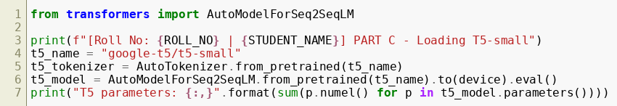
C1. Loading T5-small — Output
C2. Generation function and summarization — Code
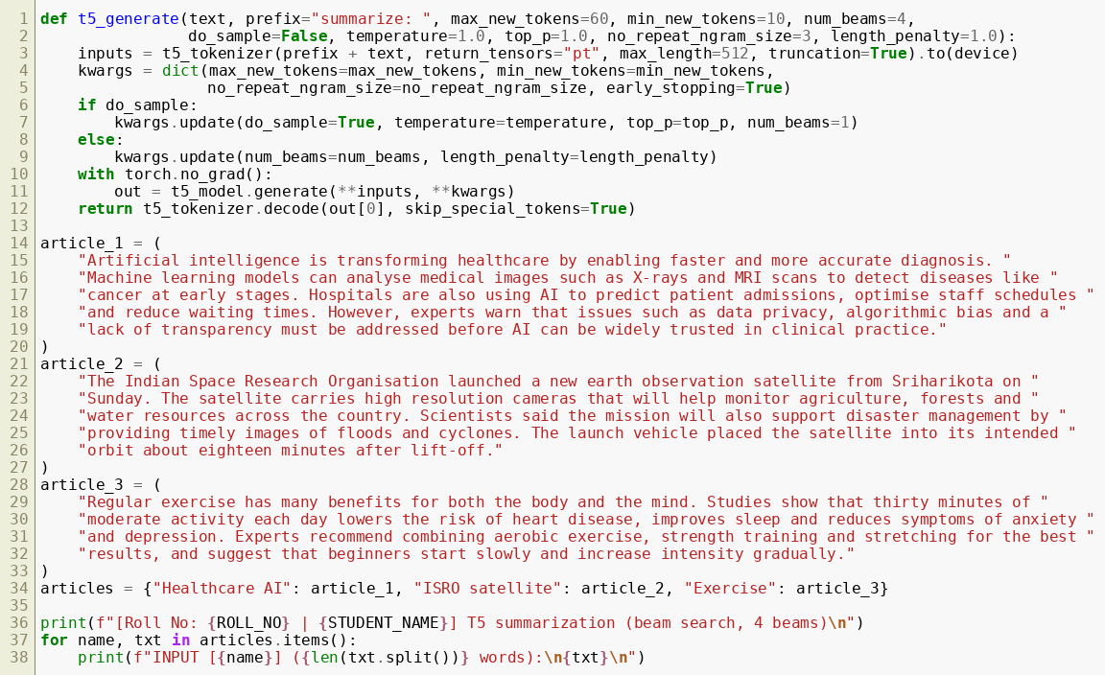
C2. Generation function and summarization — Output
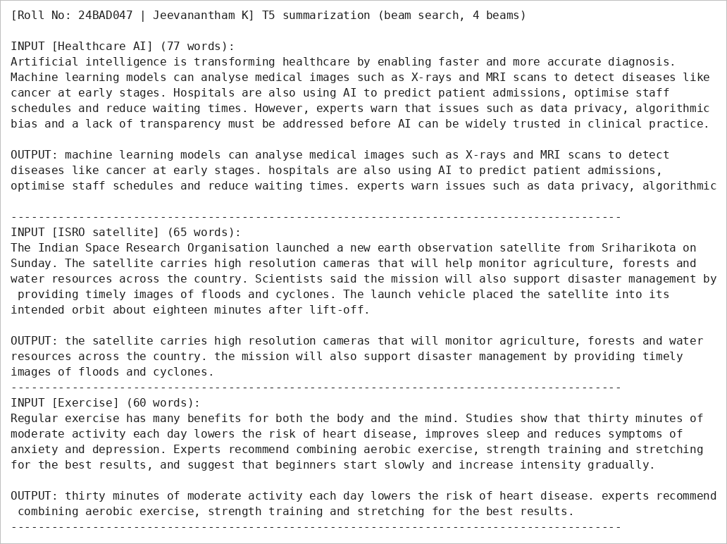
C3. Effect of generation parameters — Code
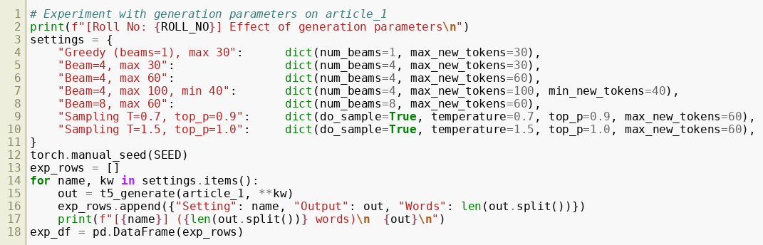
C3. Effect of generation parameters — Output
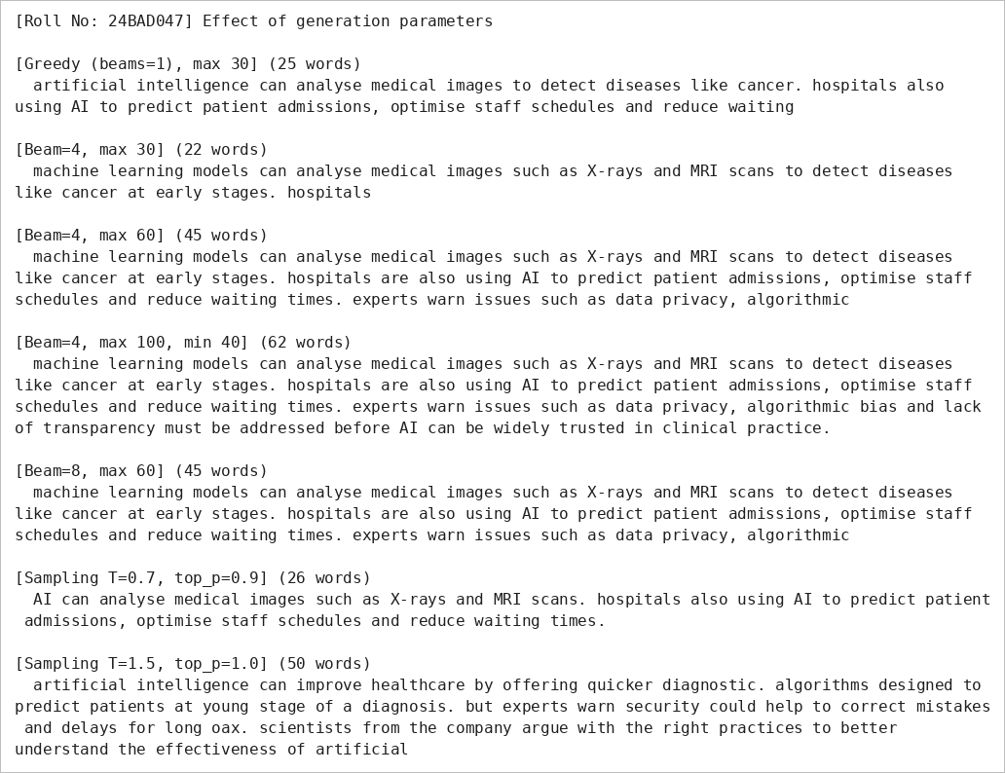
C4. Translation and other inputs — Code
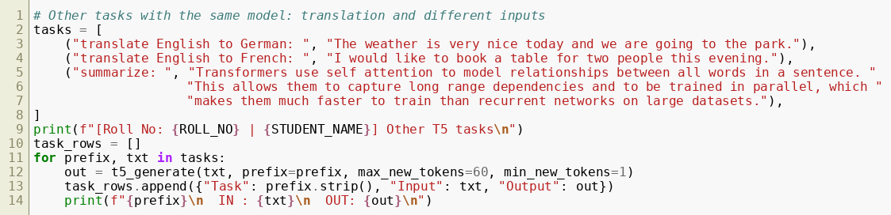
C4. Translation and other inputs — Output
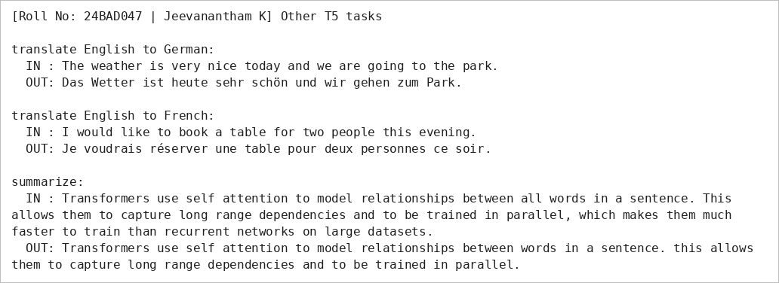
C5. Saving generated outputs — Code
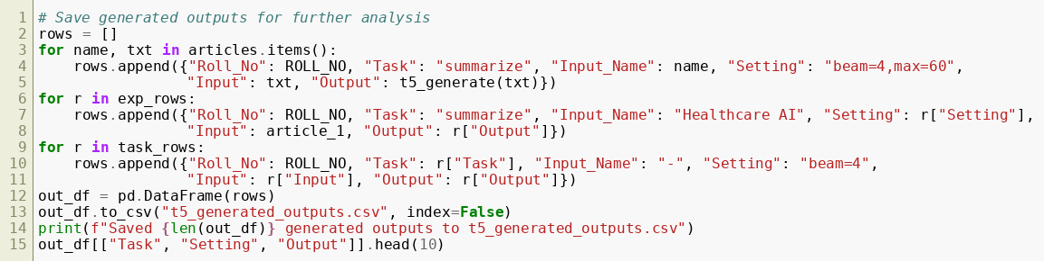
C5. Saving generated outputs — Output
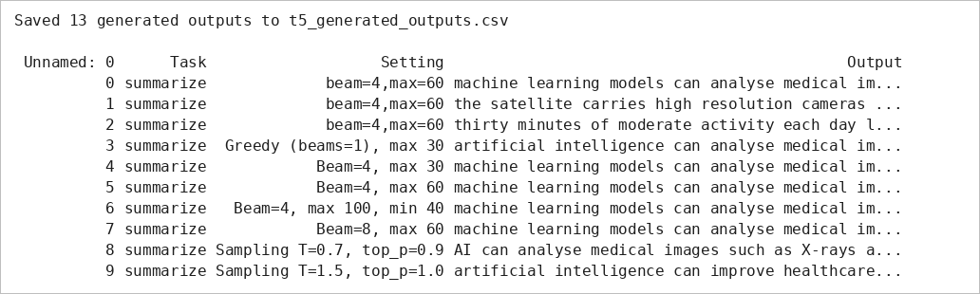

PART D: MODEL TESTING AND OUTPUT ANALYSIS
Perform the following tasks:
- Test the fine-tuned BERT model using sample positive and negative text inputs.
- Record the predicted class labels for the test inputs.
- Analyze the classification results using the selected evaluation metrics.
- Test the sequence-to-sequence model using different input texts.
- Compare the generated outputs for different inputs and generation settings.
- Examine the relevance, readability, and coherence of the generated text.
- Identify possible errors or limitations in the classification and generation outputs.
- Compare the applications of BERT-based classification and sequence-to-sequence text generation.
- Summarize the observations obtained from both models.
D1. BERT predictions on sample inputs — Code
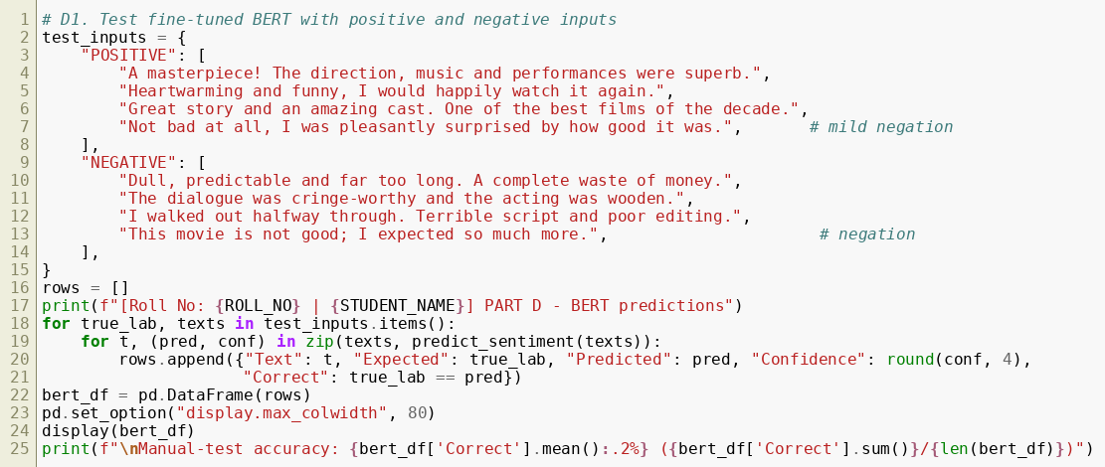
D1. BERT predictions on sample inputs — Output
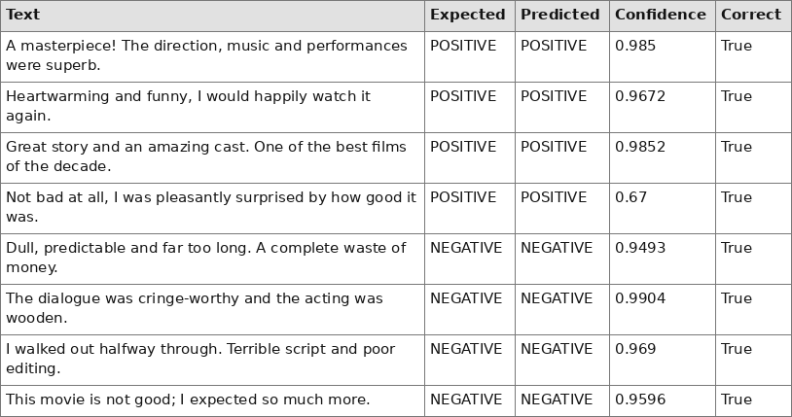
D2. Metrics and error analysis — Code
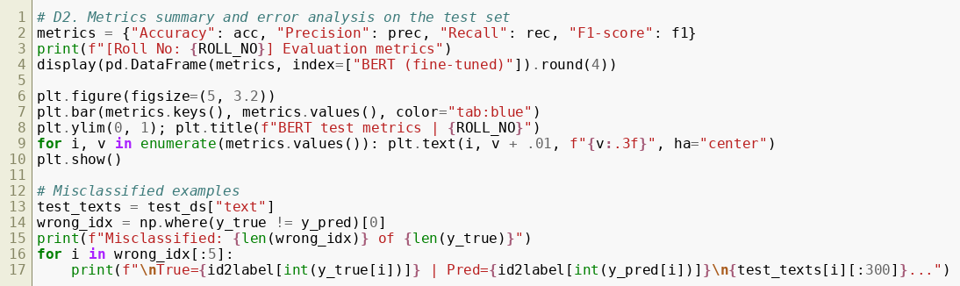
D2. Metrics and error analysis — Output
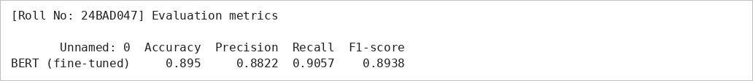
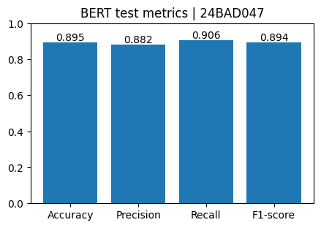
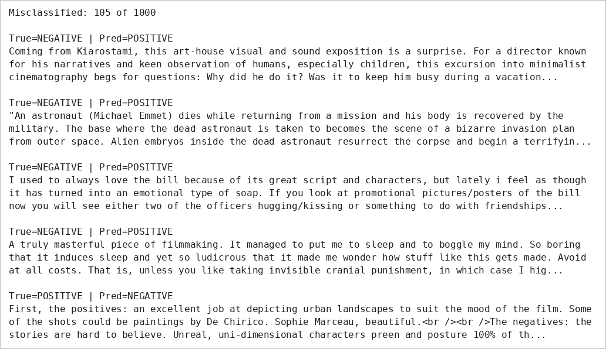
D3. T5 output analysis — Code
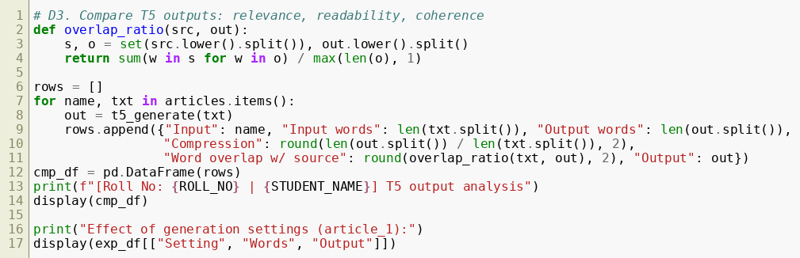
D3. T5 output analysis — Output
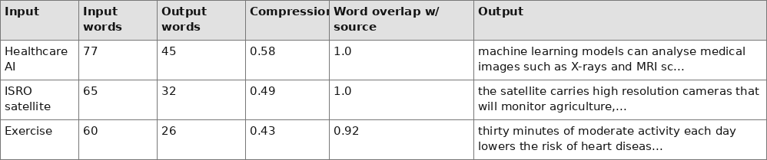
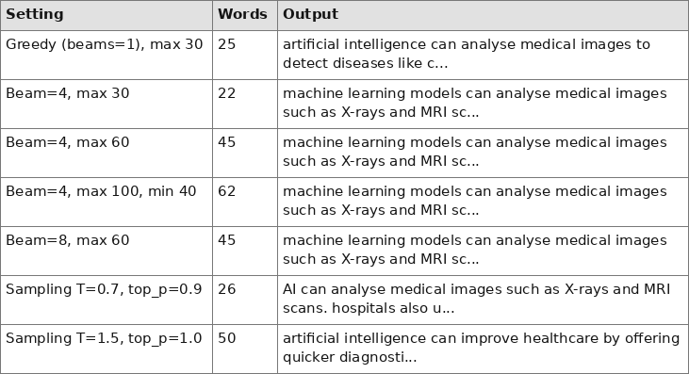
D4. BERT vs T5 comparison — Code
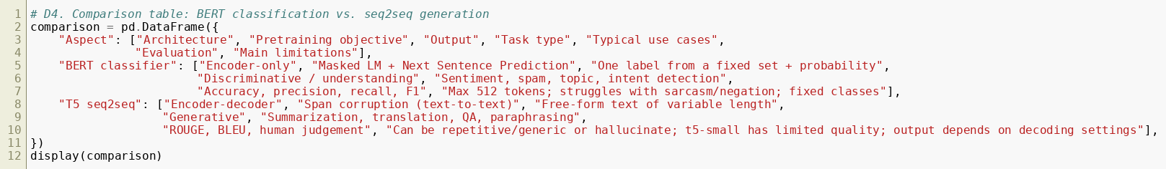
D4. BERT vs T5 comparison — Output
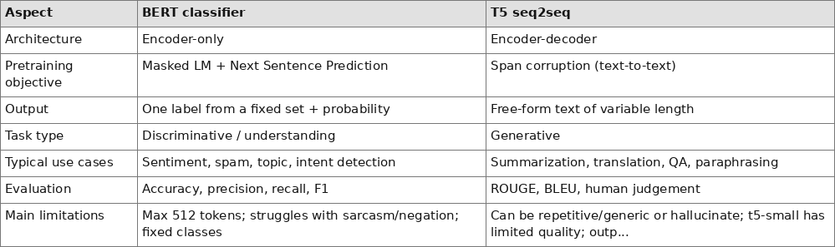

EXPECTED OUTCOME
Students will understand the architecture and applications of Transformer models in Natural Language Processing. They will learn to fine-tune a pretrained BERT model for text classification, preprocess textual data, and evaluate classification performance using appropriate metrics. Students will also develop a simple sequence-to-sequence text generation application using a pretrained Transformer model and analyze the quality and relevance of the generated outputs.
OBSERVATIONS
• BERT classification: after 2 epochs on 4,000 training reviews the model reached Accuracy 0.895, Precision 0.882, Recall 0.906 and F1-score 0.894 on 1,000 test reviews (105 misclassified). Validation accuracy rose from 0.888 (epoch 1) to 0.895 (epoch 2).
• All 8 manual positive/negative test sentences, including ones with negation, were classified correctly. The mixed review "It was okay... the ending was disappointing" was predicted NEGATIVE with about 98% confidence. Test-set errors mostly occurred on sarcastic, mixed-opinion and long reviews.
• T5-small generation: summaries were readable and relevant but mostly extractive (phrases copied from the source), in lowercase, and sometimes cut off mid-sentence when the maximum length was too small.
• Effect of parameters: increasing the maximum length from 30 to 60 to 100 (minimum 40) produced longer, more complete summaries (22, 45 and 62 words). Beam search (4 or 8 beams) was more fluent than greedy decoding. Sampling at temperature 0.7 stayed on topic, while temperature 1.5 produced incoherent, partly hallucinated text.
• Translation with T5-small gave correct German and French sentences for the sample inputs.
• Comparison: BERT (encoder-only) suits understanding and labelling text into fixed classes and is judged by accuracy/F1; T5 (encoder-decoder) suits generating new text and its output depends strongly on decoding settings.
• Limitations: BERT was trained on a small subset with inputs truncated to 256 tokens and can fail on sarcasm or mixed sentiment; T5-small is small and can repeat or omit facts and become incoherent at high temperature.
RESULT
A pretrained BERT model was fine-tuned for IMDb sentiment classification and achieved 89.5% accuracy (F1-score 0.894) on the test subset. A T5-small sequence-to-sequence model was used to generate summaries and translations, and the effect of input text and generation parameters on output quality was analysed.

POST-LAB QUESTIONS (PROVIDE BRIEF ANSWERS TO THE FOLLOWING QUESTIONS)

- What is the role of BERT in text classification?
Ans: BERT acts as a pretrained encoder that converts the input text into contextual embeddings; the [CLS] representation is passed through a classification layer that predicts the class label.
- Why is tokenization required before providing text to a Transformer model?
Ans: Transformers work on numbers, not raw text. The tokenizer splits text into sub-word tokens, maps them to integer IDs, adds special tokens ([CLS], [SEP]) and builds attention masks, with padding/truncation giving a uniform input length.
- What is the purpose of fine-tuning a pretrained BERT model?
Ans: To adapt BERT's general language knowledge to a specific task and dataset using much less data, time and compute, giving higher accuracy than training from scratch.
- Mention any two-evaluation metrics used for text classification.
Ans: Accuracy and F1-score (precision and recall are also commonly used).
- What is the role of the encoder and decoder in a sequence-to-sequence Transformer?
Ans: The encoder reads the whole input and builds contextual representations of it. The decoder generates the output tokens one at a time, using masked self-attention over tokens generated so far and cross-attention over the encoder output.
- What is the difference between text classification and text generation?
Ans: Classification assigns one label from a fixed set to a given text, whereas generation produces new, variable-length text one token at a time.
- How does the maximum output length affect text generation?
Ans: It limits the number of tokens generated. A very small value truncates the output and leaves it incomplete (seen with max 30 tokens), while a very large value gives longer output with possible repetition or irrelevant content and more computation.
- Mention one real-world application of Transformer-based text classification and one application of text generation.
Ans: Text classification: sentiment analysis of customer reviews (or spam email detection). Text generation: automatic summarization of news articles (or machine translation / chatbots).

SUGGESTIONS FOR DATASETS & MODELS
Datasets:
- IMDb Movie Reviews – https://huggingface.co/datasets/stanfordnlp/imdb
- GLUE Benchmark – https://huggingface.co/datasets/nyu-mll/glue
- SST-2 Sentiment Classification – https://huggingface.co/datasets/nyu-mll/glue

Pretrained Models:
- BERT Base Uncased – https://huggingface.co/google-bert/bert-base-uncased
- T5-small – https://huggingface.co/google-t5/t5-small

ASSESSMENT
Description | Max Marks | Marks Awarded
Pre Lab Exercise | 5
In Lab Exercise | 10
Post Lab Exercise | 5
Viva | 10
Total | 30
Faculty Signature

