**Date:** 23-11-2024  **Aspirian Name:** JEEVA ARAVINTH J V

**STEP 1:** Search for the Storage account and create the storage account and enter the account detail.

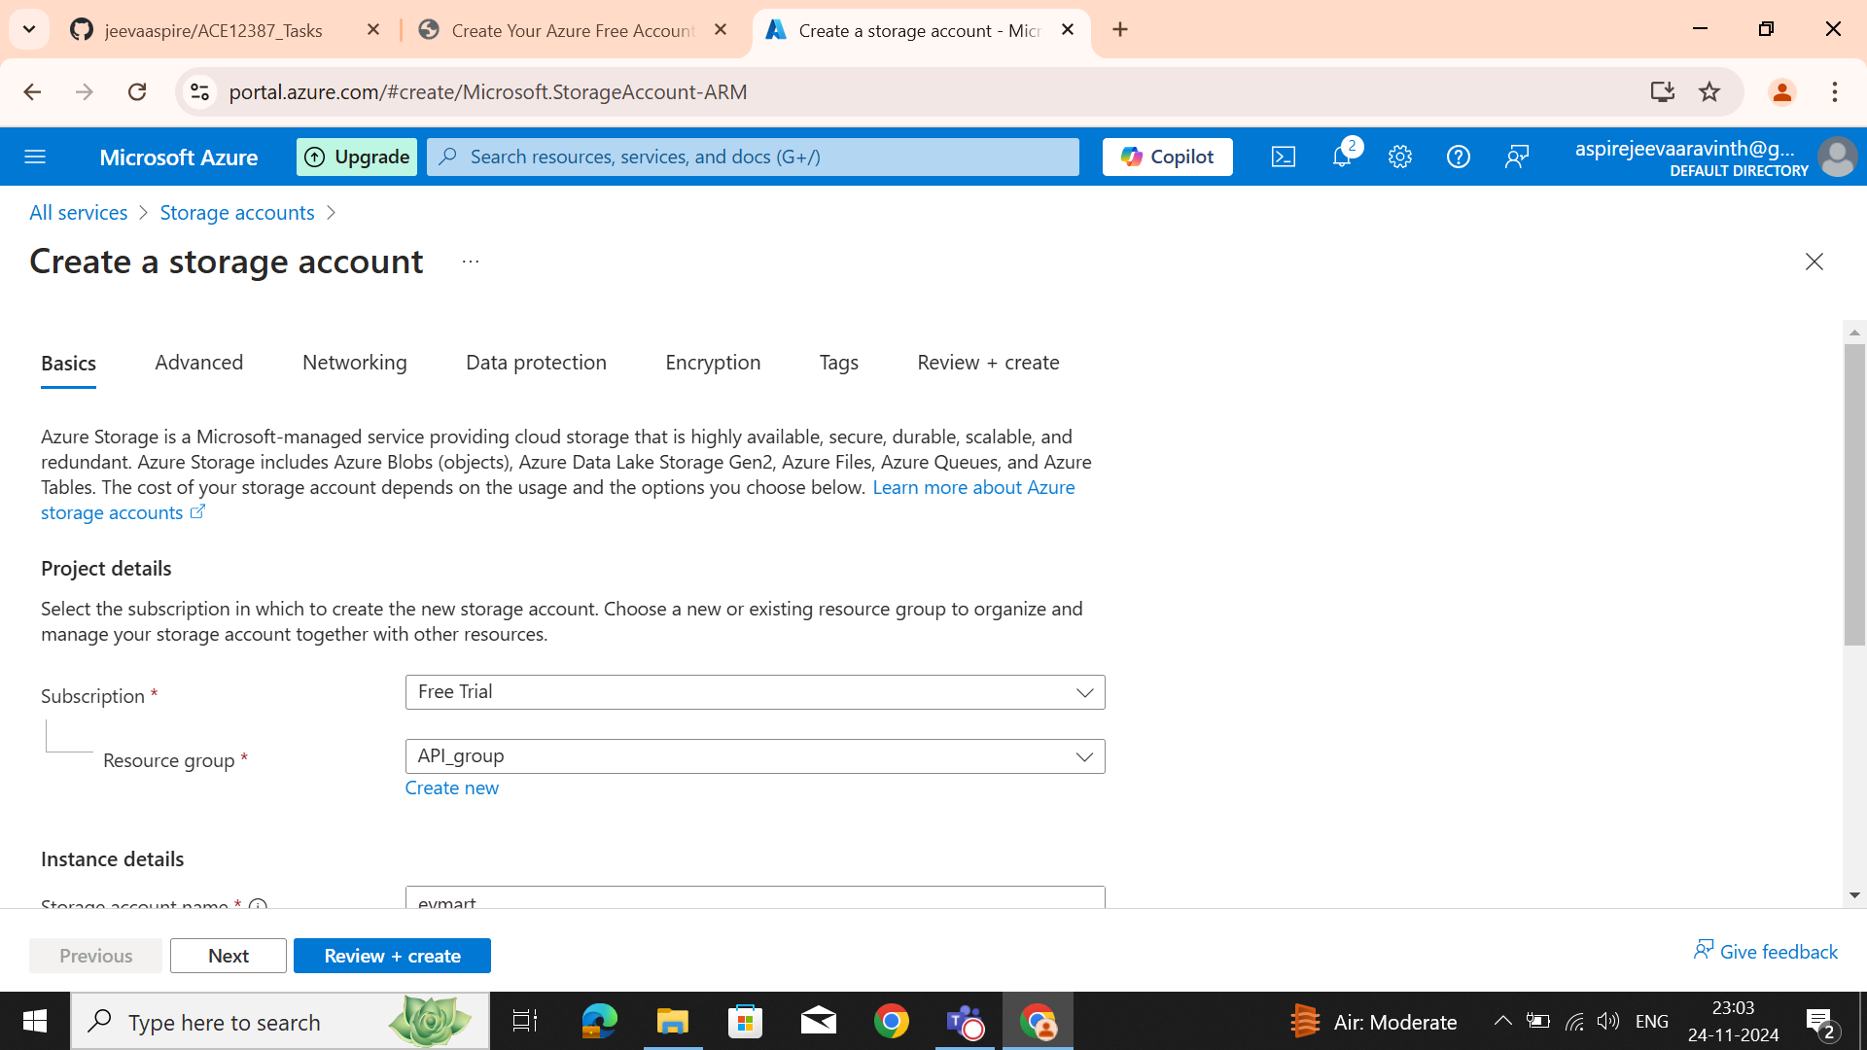**STEP 2:** Then in the networking, enable public access and click next.

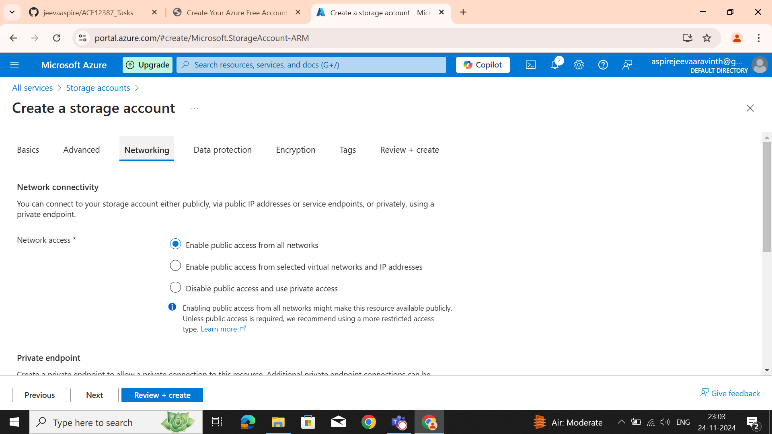

**STEP 3:** In the Data protection, ensure all the options enabled in the default for the Data protection.

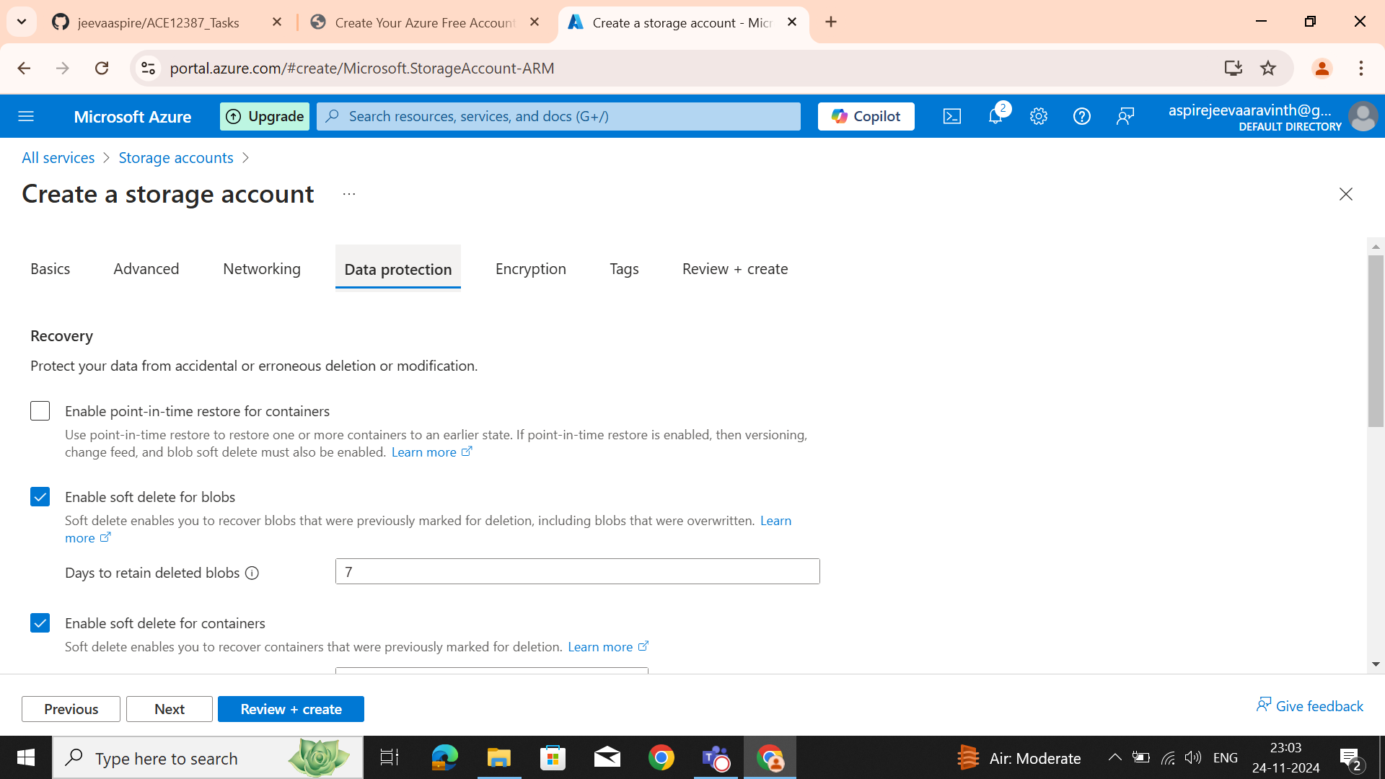**STEP 4:** In the Encryption, we can select All the services used like blobs, files, tables and queues. Ensure all the services are enabled.

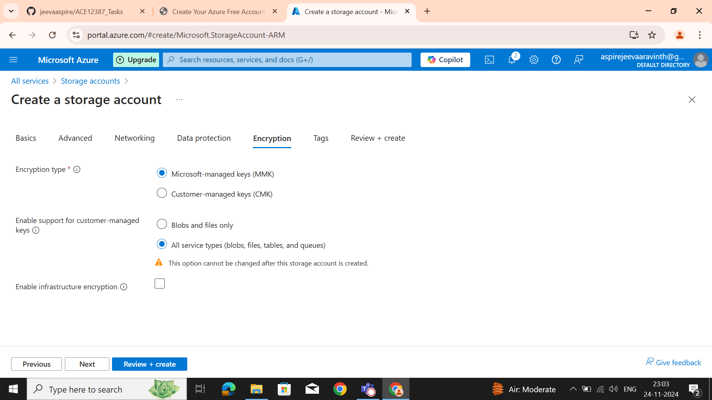

**STEP 5:** Then review + create to create a storage account. Finally, the storage will be processed to create.

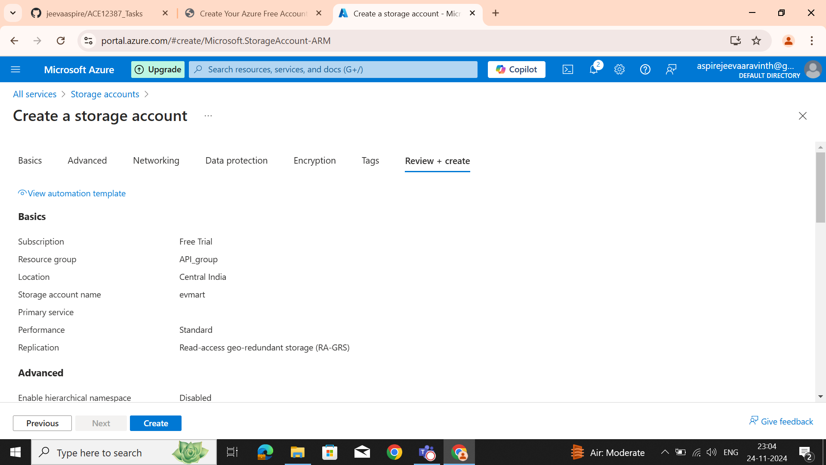**Deployment is in Progress to create storage account**

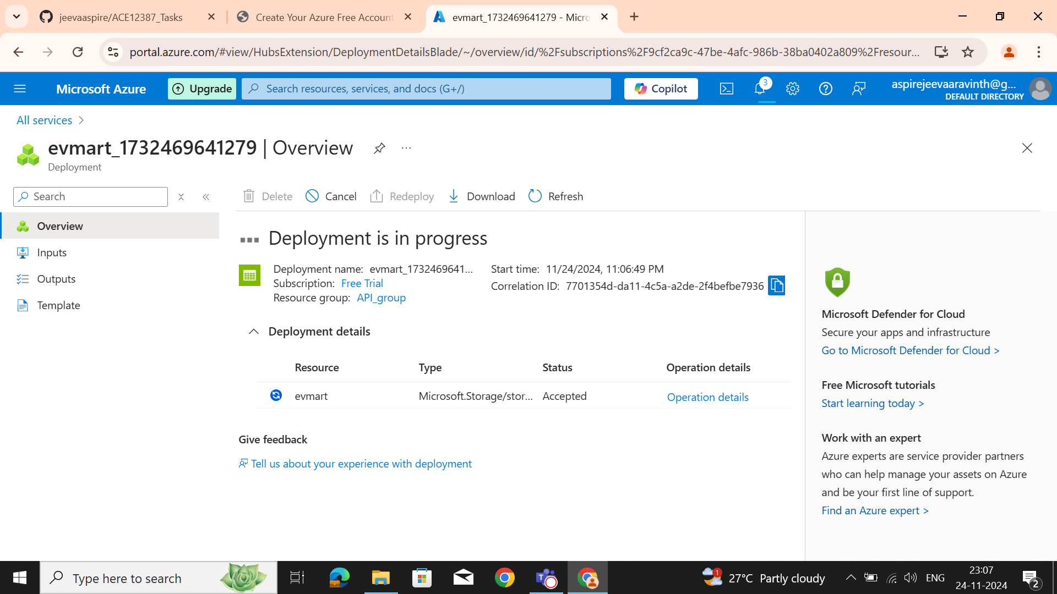

**Deployment done**

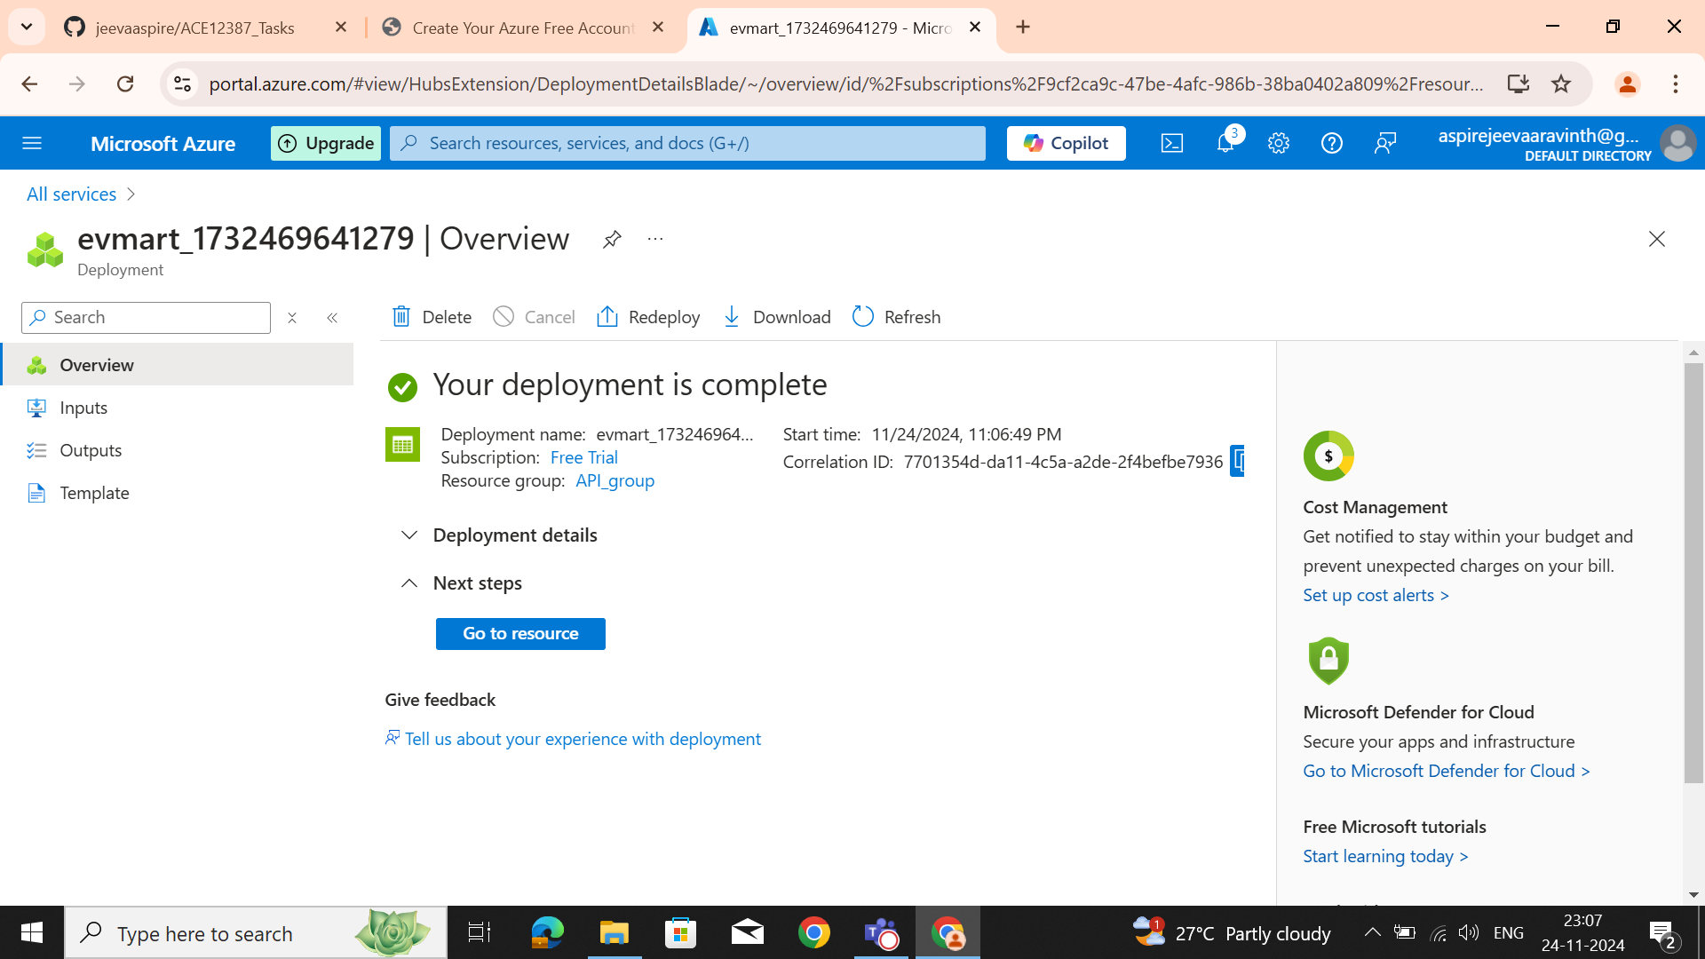**Storage account created**

