EXPT NO: 2 | COMPARATIVE STUDY OF ACTIVATION FUNCTIONS AND OPTIMIZATION ALGORITHMS IN DEEP LEARNING
DATE: 27:07:2026

PRE-LAB QUESTIONS (PROVIDE BRIEF ANSWERS TO THE FOLLOWING QUESTIONS)

- What is the purpose of an activation function in an Artificial Neural Network?
An activation function introduces non-linearity into a neural network, enabling it to learn and model complex patterns. Without activation functions, a neural network would behave like a linear model.
- Differentiate between the Sigmoid, Tanh, and ReLU activation functions based on their output range and mathematical properties.
Activation Function | Output Range | Characteristics
Sigmoid | 0 to 1 | Smooth curve, used for binary classification, suffers from vanishing gradients.
Tanh | -1 to 1 | Zero-centered, converges faster than Sigmoid, but also suffers from vanishing gradients.
ReLU | 0 to ∞ | Simple and computationally efficient, reduces vanishing gradient problem, widely used in deep learning.

- Why is an optimization algorithm required during neural network training?
An optimization algorithm updates the network's weights and biases to minimize the loss function, helping the model learn from data and improve prediction accuracy.
- What is the difference between Batch Gradient Descent, Stochastic Gradient Descent (SGD), and Mini-Batch Gradient Descent?
- Batch Gradient Descent: Uses the entire dataset to update weights once per epoch.
- Stochastic Gradient Descent (SGD): Updates weights after every training sample, making learning faster but noisier.
- Mini-Batch Gradient Descent: Uses a small batch of samples to update weights, balancing speed and stability.
- Explain the role of Google Colab and GitHub in deep learning experiment management.
- Google Colab: Provides a cloud-based Python environment with free GPU/TPU support for running deep learning experiments.
- GitHub: Stores project code, tracks version history, and enables collaboration and reproducibility.

AIM
To analyze the impact of different activation functions and optimization algorithms on the performance of Artificial Neural Networks (ANNs) and to learn best practices for managing deep learning experiments using cloud-based tools and version control.

SOFTWARE REQUIREMENTS
- Python
- TensorFlow or PyTorch
- Google Colab
- GitHub
- Matplotlib

OBJECTIVES
Students will be able to:
- Understand the role of activation functions in neural networks.
- Visualize and compare commonly used activation functions.
- Evaluate the performance of different activation functions in ANN models.
- Analyze various gradient-based optimization algorithms.
- Compare optimizer convergence and model accuracy.
- Learn experiment management using Google Colab, Google Drive, and GitHub.
- Maintain reproducible deep learning experiments using version control.

PROCEDURE
PART A: VISUALIZATION OF ACTIVATION FUNCTIONS
Implement and plot the following activation functions:
- Sigmoid
- Tanh
- ReLU
Compare their:
- Output range
- Saturation regions
- Gradient behavior
- Computational efficiency
- Typical applications
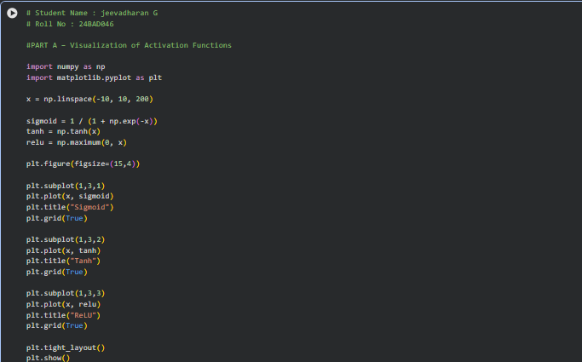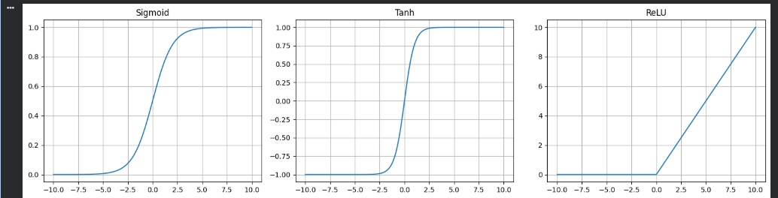
PART B: PERFORMANCE COMPARISON OF ACTIVATION FUNCTIONS
Train identical ANN architectures using:
- Sigmoid
- Tanh
- ReLU
Record and compare:
- Training accuracy
- Validation accuracy
- Training loss
- Validation loss
- Number of epochs required for convergence
Analyze which activation function performs best and justify the observations.

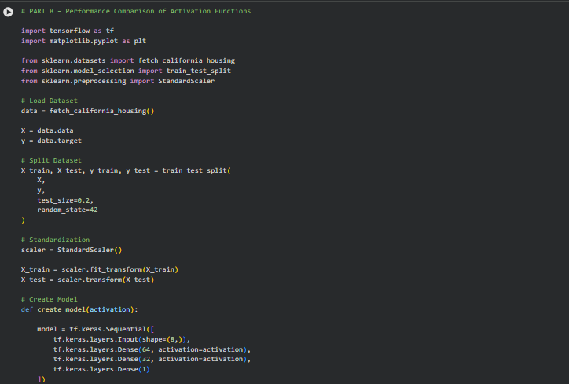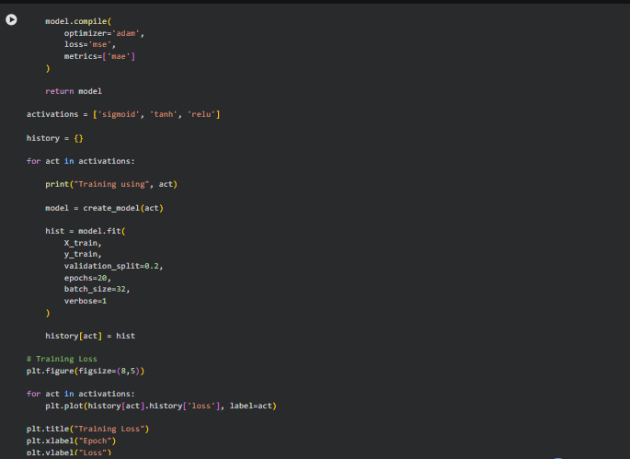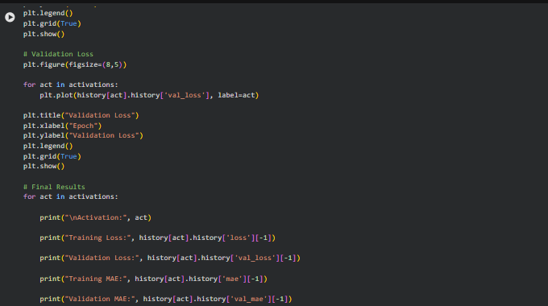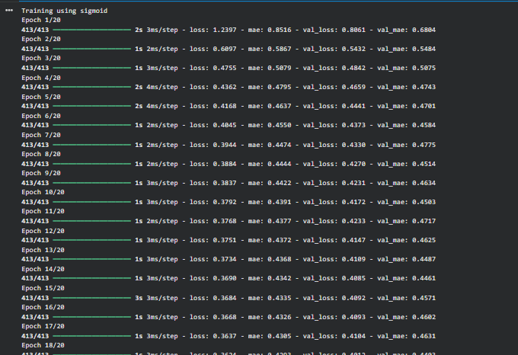

Output:
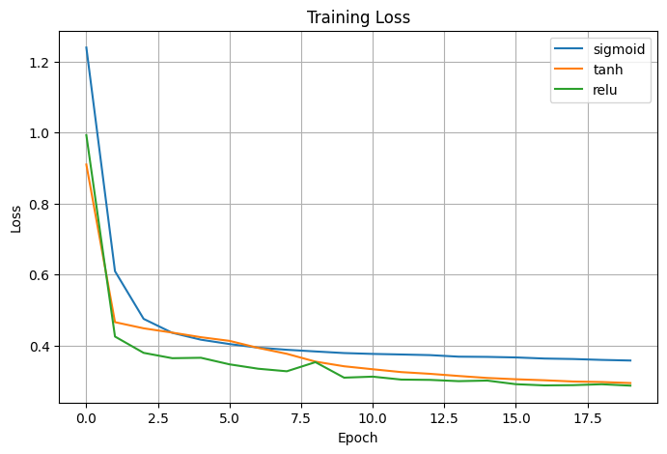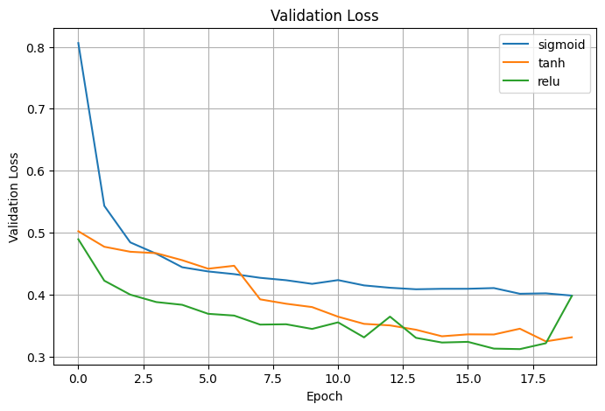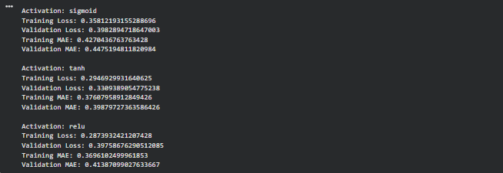
PART C: COMPARISON OF OPTIMIZATION ALGORITHMS
Train the same ANN using:
- Stochastic Gradient Descent (SGD)
- Momentum
- RMSProp
- Adam
Compare:
- Training loss
- Validation loss
- Convergence speed
- Final training accuracy
- Final validation accuracy
Visualize:
- Loss vs Epoch
- Accuracy vs Epoch
Discuss which optimizer converges faster and produces better generalization.
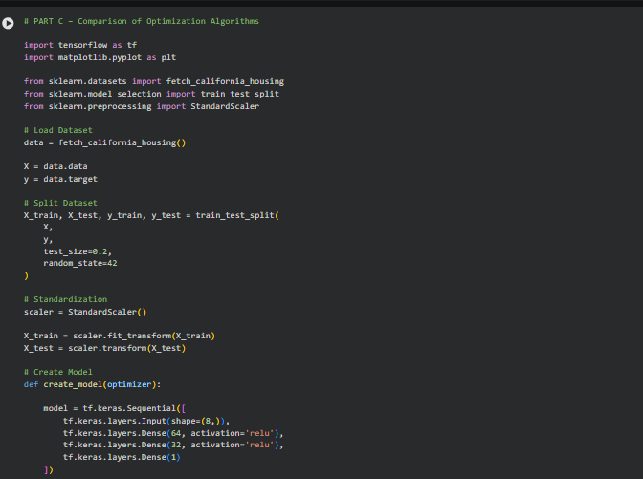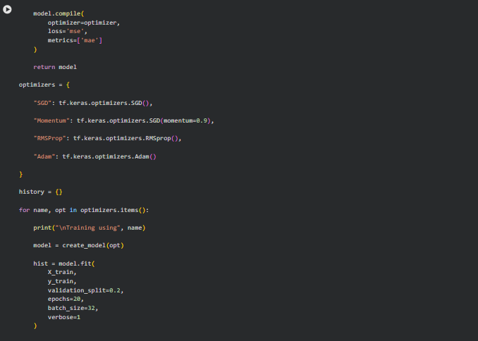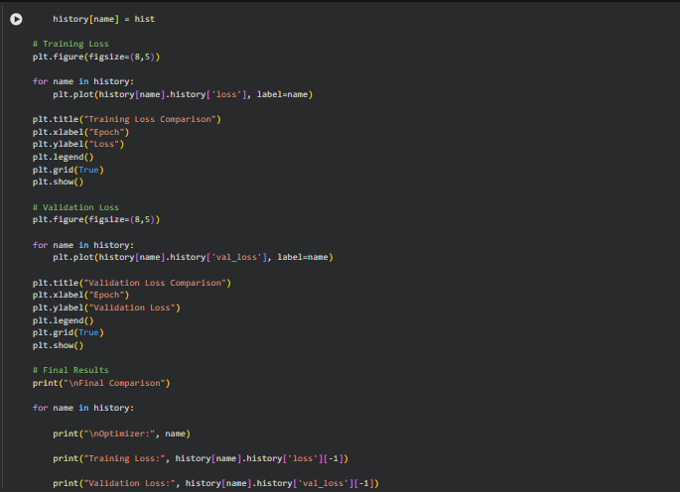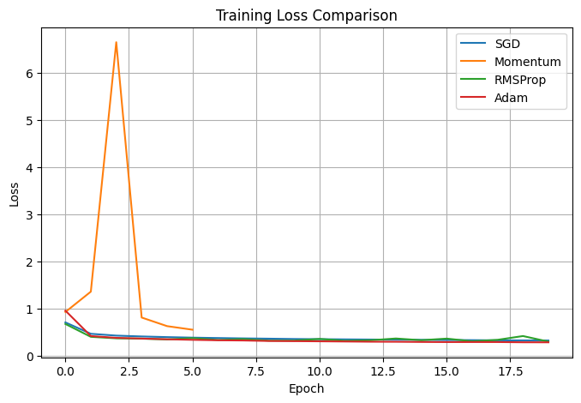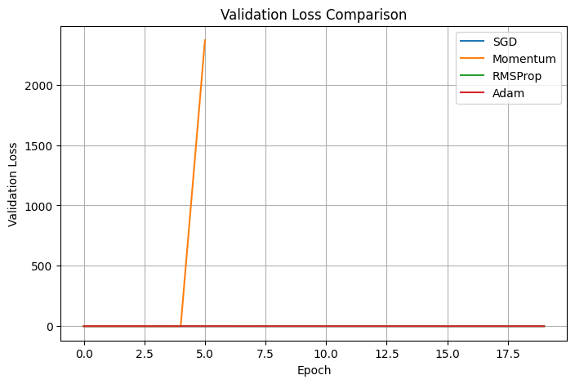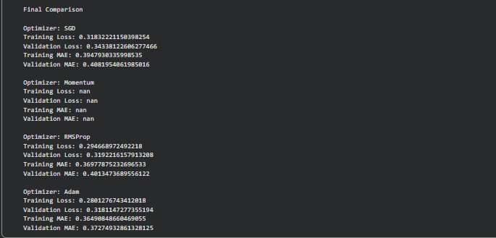

PART D: DEEP LEARNING EXPERIMENT MANAGEMENT
Perform the following tasks:
- Create a Google Colab notebook.
- Mount Google Drive.
- Save notebooks and trained models.
- Create a GitHub repository.
- Upload notebooks to GitHub.
- Commit changes and maintain version history using Git.
- Document the experiment using a README.md file.

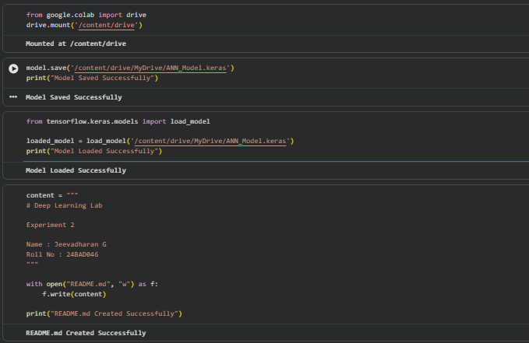

EXPECTED OUTCOME
Students will understand how activation functions and optimization algorithms influence neural network learning and performance. They will also gain practical experience in organizing, documenting, and maintaining reproducible deep learning experiments using cloud platforms and Git-based version control.

POST-LAB QUESTIONS (PROVIDE BRIEF ANSWERS TO THE FOLLOWING QUESTIONS)

- Which activation function achieved the best performance in your experiment? Justify your answer using the obtained results.

ReLU achieved the best performance because it converged faster, produced lower training and validation loss, and achieved higher accuracy compared to Sigmoid and Tanh.

- Compare the convergence behavior of SGD, Momentum, RMSProp, and Adam based on the training graphs.
- SGD: Slow convergence and more oscillations.
- Momentum: Faster than SGD with smoother convergence.
- RMSProp: Faster convergence by adapting the learning rate.
- Adam: Fastest convergence with the best validation performance due to adaptive learning rates and momentum.

- Why does the ReLU activation function generally train faster than the Sigmoid activation function?
ReLU is computationally simple and avoids the vanishing gradient problem for positive inputs, allowing gradients to propagate effectively and resulting in faster training than Sigmoid.

- How does version control using GitHub improve the reproducibility and collaboration of deep learning projects?
GitHub maintains version history, tracks changes, allows multiple developers to collaborate, and enables experiments to be reproduced by storing code, documentation, and model versions.

- If you were asked to train a deep neural network for an image classification task, which activation function and optimizer would you choose? Justify your selection based on the experimental observations.
I would choose ReLU as the activation function and Adam as the optimizer because ReLU provides faster learning and better feature extraction, while Adam offers faster convergence, stable training, and high validation accuracy. These together generally produce the best performance for image classification tasks.

ASSESSMENT
Description | Max Marks | Marks Awarded
Pre Lab Exercise | 5
In Lab Exercise | 10
Post Lab Exercise | 5
Viva | 10
Total | 30
Faculty Signature

