**Topic : Library Management System**  
You are going to build a project based on Library Management System. It keeps track of all information about books in the library, their cost, status and total number of books available in the library.  
  
Create a database named library and following TABLES in the database:   
  
1. Branch   
2. Employee   
3. Books  
4. Customer  
5. IssueStatus  
6. ReturnStatus

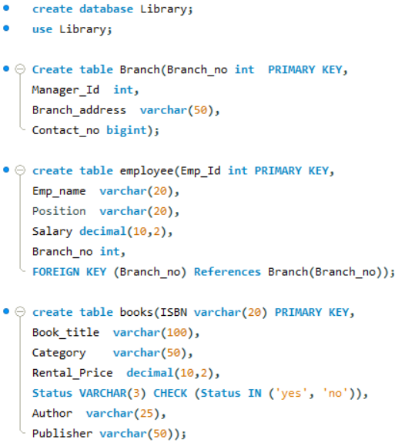

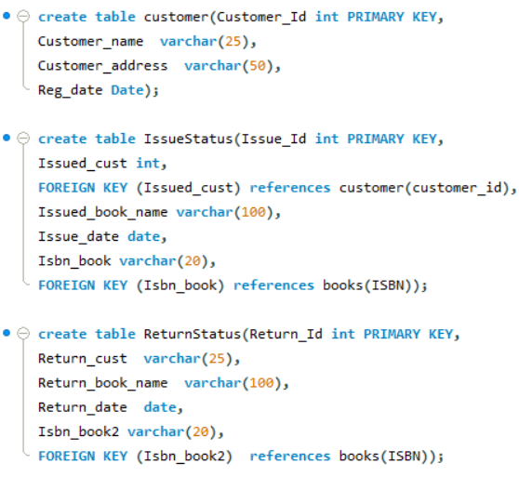

1. Retrieve the book title, category, and rental price of all available books.

Query:



Output

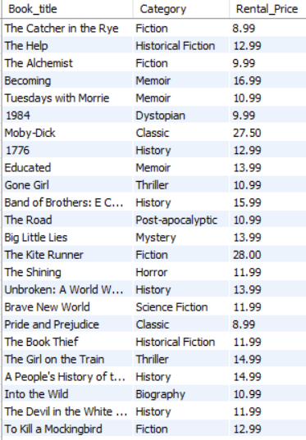

2. List the employee names and their respective salaries in descending order of salary.

Query:



Output:

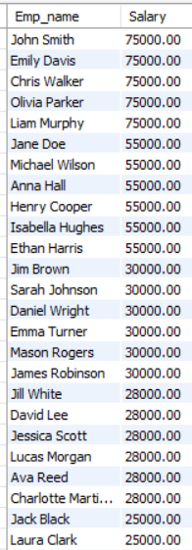

3. Retrieve the book titles and the corresponding customers who have issued those books.

Query:

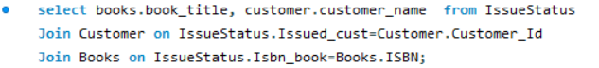

Output:

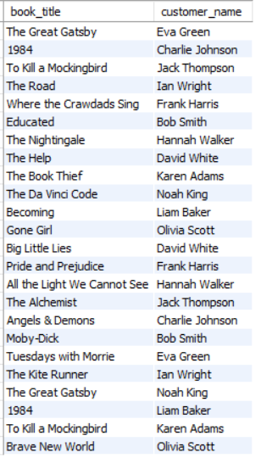

4. Display the total count of books in each category.

Query:



Output:

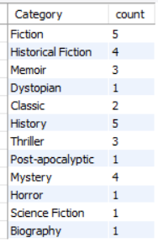

5. Retrieve the employee names and their positions for the employees whose salaries are above Rs.50,000.

Query:

Output:

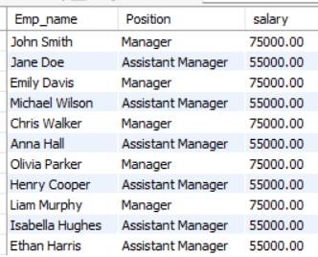

6. List the customer names who registered before 2022-01-01 and have not issued any books yet.

Query:

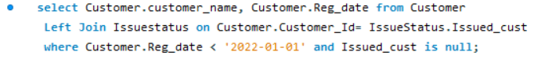

Output:

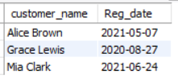

7. Display the branch numbers and the total count of employees in each branch.

Query:



Output:

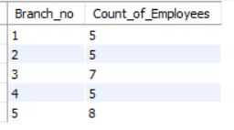

8. Display the names of customers who have issued books in the month of June 2023.

Query:

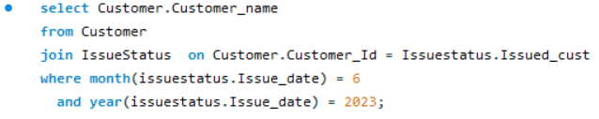

Output:

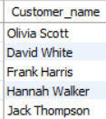

9. Retrieve book_title from book table containing history.

Query:



Output:

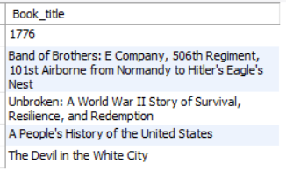

10.Retrieve the branch numbers along with the count of employees for branches having more than 5 employees

Query:



Output:

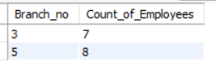

11. Retrieve the names of employees who manage branches and their respective branch addresses.

Query:

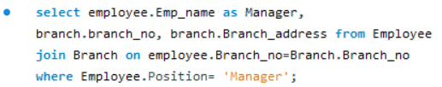

Output:

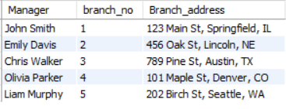

12.  Display the names of customers who have issued books with a rental price higher than Rs. 25.

Query:

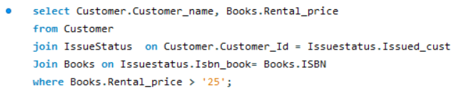

Output:

