TUC – Email Drupal Content to Group Contacts

**Assigning Weight for Each Group**

Administrator creates groups in CiviCRM and assigns weight to each group, which is used as display order for the groups, when displayed in user registration screen. For already exiting groups, the weight can be assigned in the group settings.

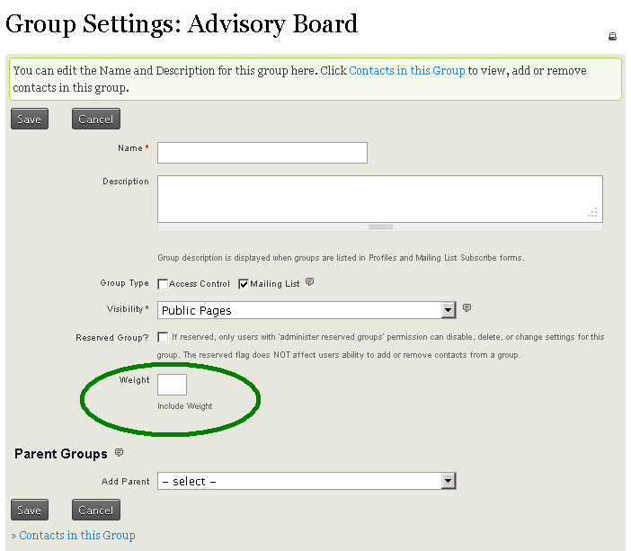

**Group - Drupal Terms mappings**

Administrator sets the groups and drupal terms mapping in UI provided in CiviCRM. This settings also has a flag 'Send Email?' for each mapping, so that it gives the administration the option to avoid sending email to some groups, if needed.

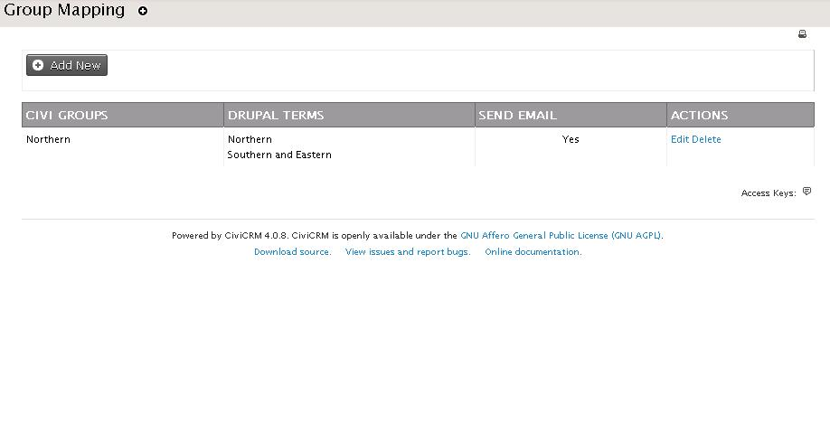

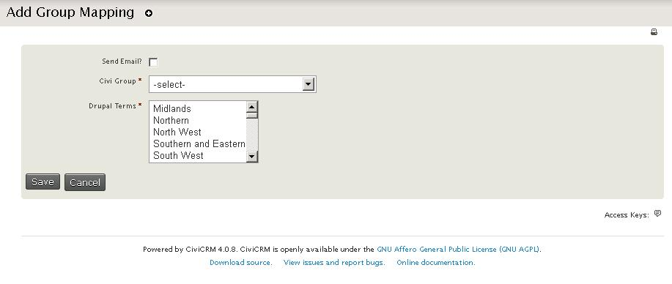

**User Registration - Group display order**

Groups are displayed in the user registration screen according to the 'weight' assigned for each group.

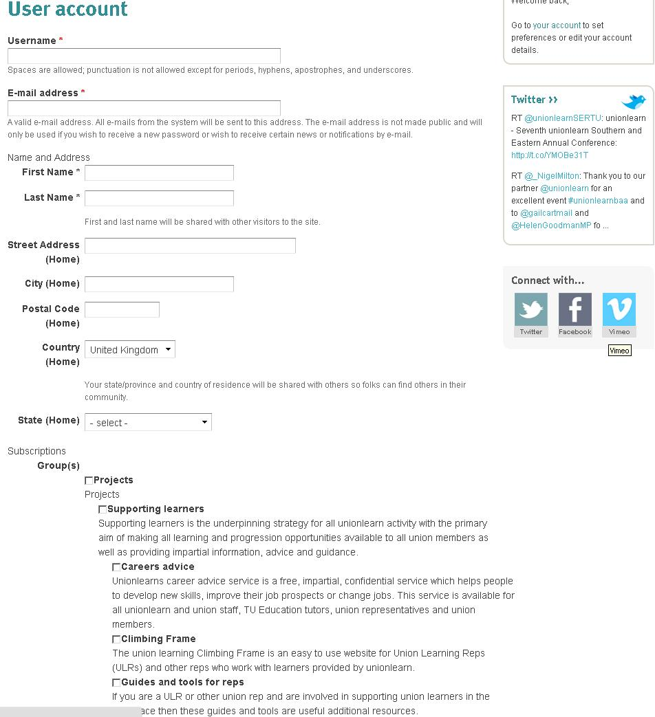

**Custom Cron Job**

The custom cron job runs every day to send the newly created drupal content to the contacts in each group, which are set for the emails to be sent out.

The cron job checks the 'Send Email?' flag set in the 'Group - Drupal Terms mappings' and gets the groups where 'Send Email?' flag is set to 'Yes'.

For each 'Group - Drupal Terms mapping' record , the associated Drupal Terms are used to fetch the content created on that day, which are assigned that drupal terms. After fetching the content created using those drupal terms, the cron job uses a standard CiviCRM template, programmatically assigns the list of drupal contents (content summary and link to the drupal node for each drupal node fetched) to the template and sends out the email to the contacts in the group.