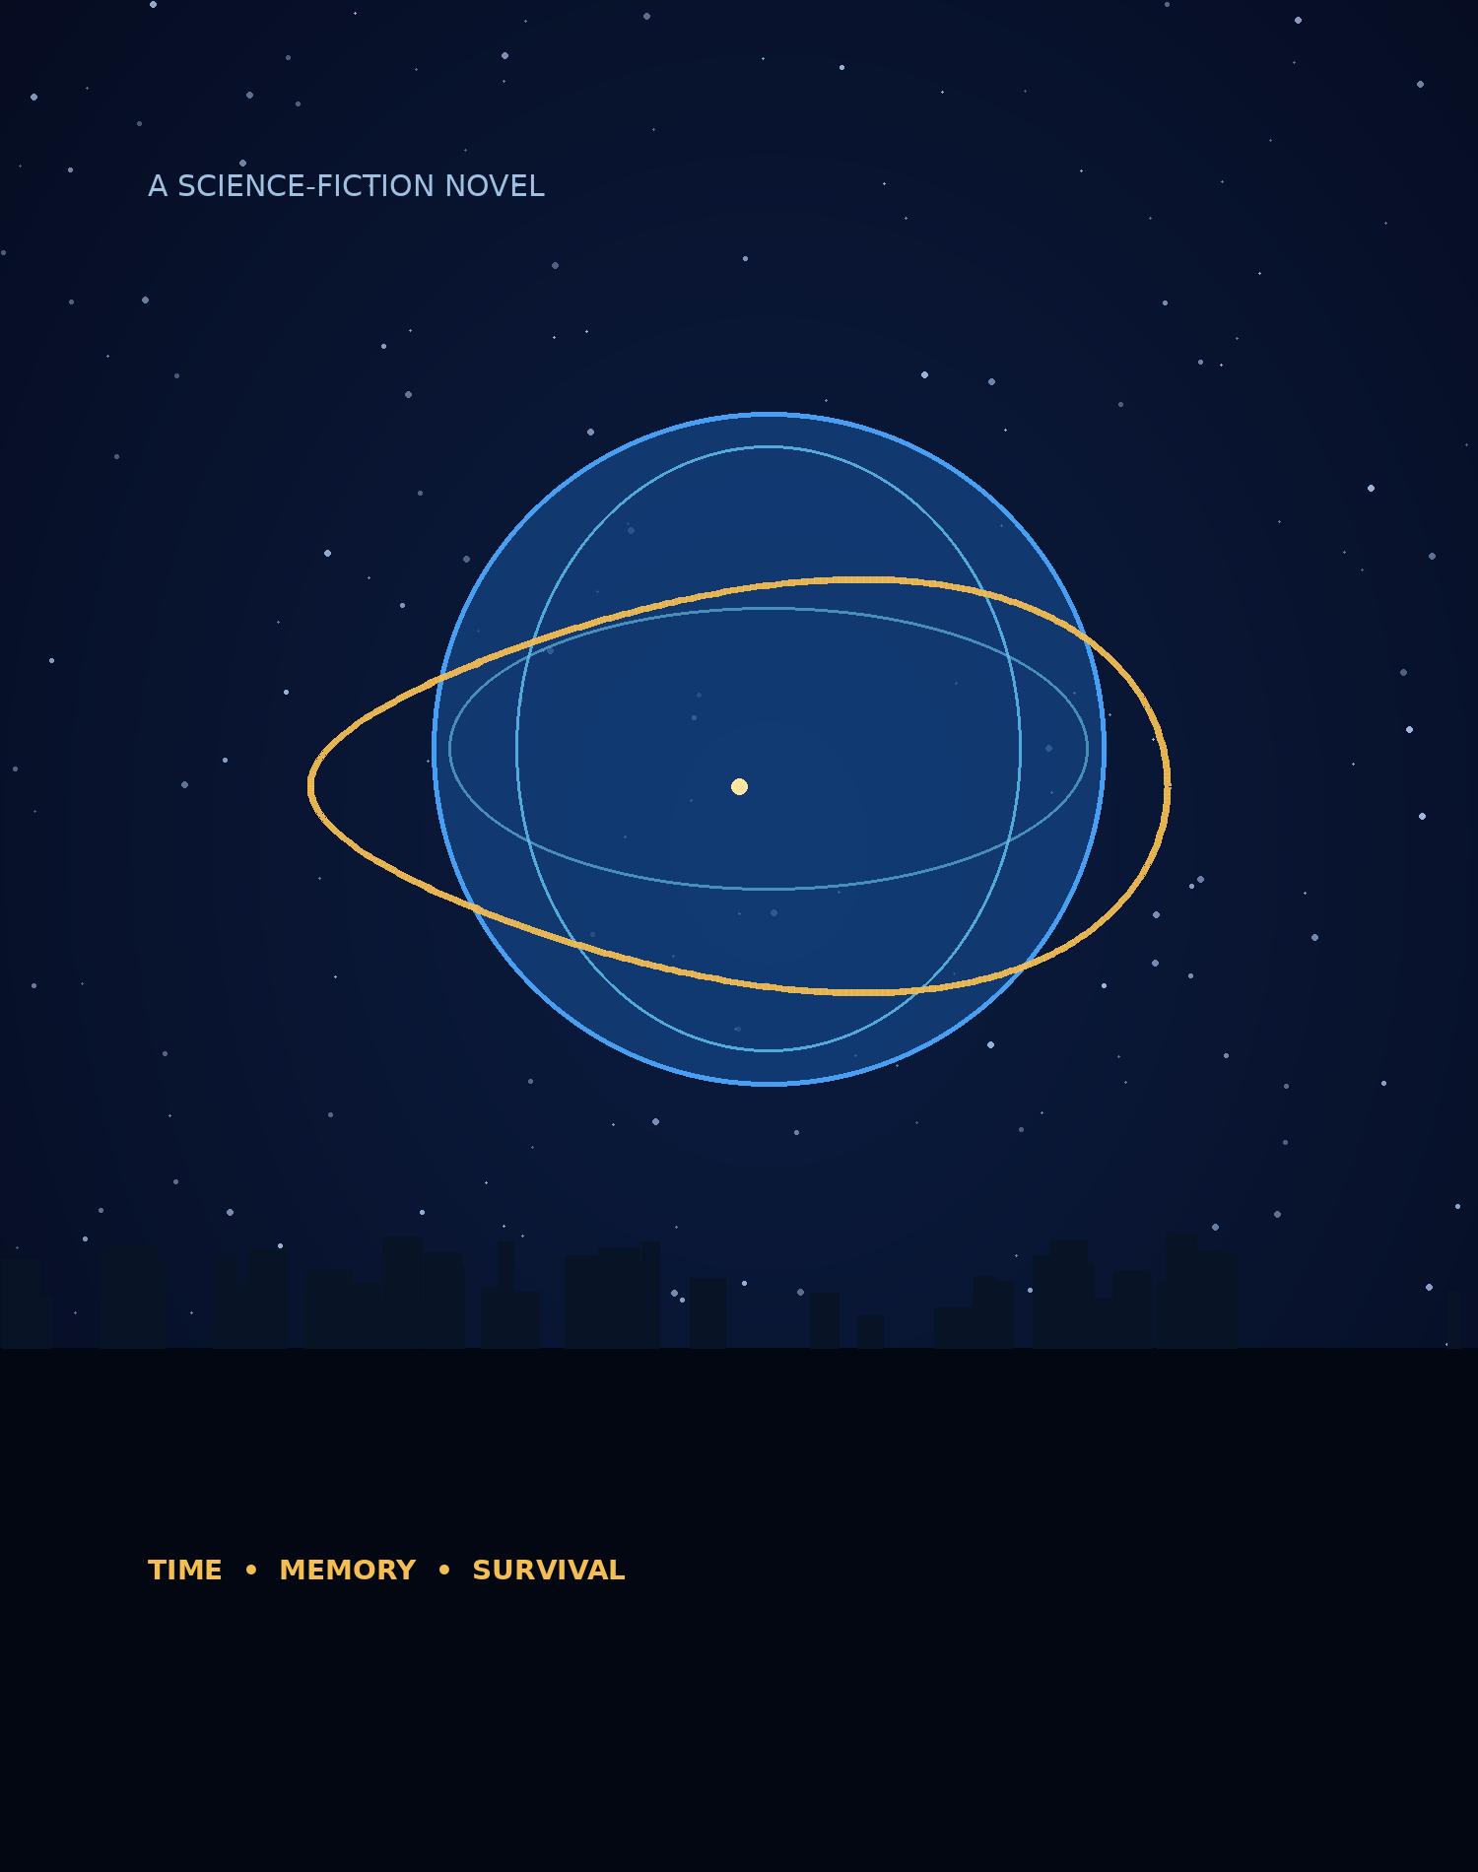
THE LASSO OF TIME
PROOFREADING EDITION
Source: iteration/audit09102026 | 24 chapters

Reader & proofreader notes
This separate review copy is assembled from the prose drafts in 06_drafts/ on the GitHub branch iteration/audit09102026. Source chapter files are not edited by this build. Use Word comments and Review → Track Changes for suggestions; retain the source branch as the reference version.
The original atmospheric chapter banners are decorative and do not assert additional story canon.

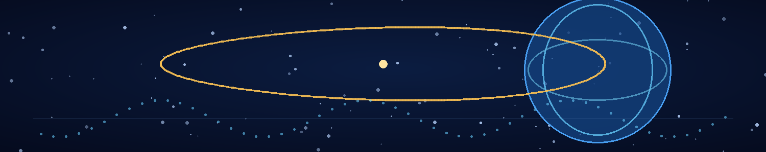

Chapter 1 — The Sky Was Already Occupied
The first thing Adrian Sen learned about the invasion was that the sky could be crowded without looking full.
From the observation window six floors below the surface, the morning above Colombo looked almost ordinary. Cloud bands drifted over the Indian Ocean. Sunlight flashed on the water. A passenger aircraft, its transponder dark under wartime restrictions, crossed the horizon on a long, cautious arc.
Then a point of light appeared where no point of light belonged.
It did not fall. It did not burn. It simply became brighter, as if something had turned a lamp toward the planet from the other side of the sky.
“Track seventeen,” said the operations officer behind him. “Same signature as last Thursday.”
Adrian watched the point divide into three.
“Last Thursday's signature was atmospheric interference.”
“Last Thursday's interference destroyed a radar station.”
“Correlation isn't causation.”
The operations officer gave him a tired look. “You scientists are going to get us all killed with that sentence.”
A white line appeared across the clouds. It was too straight to be lightning and too broad to be a contrail. For a moment it held still, an incision in the blue. Then the air around it rippled.
The facility shuddered.
Somewhere above them, a weapon had struck the coastal defence grid. The lights dimmed and returned. Dust sifted from a ceiling vent. A siren began its three-note cycle, stopped, and began again in a lower register.
Adrian's tablet filled with red warnings.
“Please tell me that isn't your experiment,” the operations officer said.
“My experiment is underground.”
“Comforting.”
Adrian was already moving.
The laboratory occupied a buried complex built beneath an old research campus, with reinforced access corridors and enough shielding to keep the instruments running through most of the attacks. It had been designed for particle physics. It now housed whatever branches of science the war had not yet made obsolete.
In the corridor, soldiers guided a group of technicians toward the interior shelters. A young man sat on the floor holding a pressure dressing against his forearm. Nobody looked at him for long. The first months of the invasion had made every injury an emergency. The years that followed had made emergencies routine.
Adrian reached Lab C and found the outer door open.
Mira Vale stood over a stainless-steel specimen case, her dark hair tied back with a strip of blue fabric. She wore a sealed field suit with one sleeve torn at the elbow. A smear of black material marked her glove.
She looked up when he entered.
“You're late.”
“There is an active orbital attack.”
“I noticed. The ceiling tried to fall on me.”
“Then I recommend not standing under it.”
“I recommend you stop giving advice to people who have been collecting alien tissue in the rain.”
She turned the case so he could see the contents. Three fragments floated in a clear suspension medium. They looked like slivers of dark glass, except that light moved through them in branching patterns that seemed to turn away from the microscope lamp.
Adrian forgot the sirens.
“Where did you get these?”
“From the evacuation zone outside Trincomalee. A Veyr transport came down hard enough to cut a furrow through two buildings. The soldiers got the crew. We got the debris.”
“You went into a crash site during an attack?”
“I went into a crash site after the attack. There's a difference.”
“Not a meaningful one.”
“Tell that to the three soldiers who brought me the case.”
He leaned closer to the specimen. The branching light changed direction.
“It's responding to the lamp.”
“No. That's what I thought at first.” Mira tapped the side of the case. “Watch the timing.”
She switched off the microscope lamp. The branching faded, but did not vanish. After a pause, it brightened again.
Adrian watched the instrument readout. “Delayed emission?”
“Maybe. Except the delay isn't constant. It changes when I alter the magnetic field.”
“Thermal?”
“I controlled for that.”
“Mechanical stress?”
“Also controlled.”
He looked at her.
Mira's expression softened by a fraction. She enjoyed this part: the instant before someone stopped trying to be right and started trying to understand.
“It's not just a material,” she said. “It behaves like a system.”
“Everything behaves like a system.”
“Then you should be excited.”
“I am trying to be scientifically cautious.”
“You're trying to be emotionally cautious. Scientifically, you're already excited.”
The alarm changed pitch. The laboratory door slid shut behind them as the facility entered lockdown. A moment later, the overhead speakers announced that the surface elevators were suspended until further notice.
Mira glanced up. “How long?”
“Depends on what hit the defence grid.”
“That's not an answer.”
“It's the only one I have.”
For the first time since he had entered, she looked tired. Not frightened, exactly. Tired in the way everyone had become tired: a fatigue too large to be fixed by sleep.
Adrian knew the expression. He had seen it on soldiers, technicians, ministers on emergency broadcasts, and his own face reflected in dark screens.
He lowered his voice. “Are you hurt?”
“Only in ways the medical system doesn't know how to code.”
“Mira.”
She looked down at the torn sleeve. “The suit caught a piece of the wall. I didn't.”
He nodded, accepting the answer because the alternative was to ask again and hear the same thing.
They moved to the central bench. Mira brought up the analysis from the specimen fragments. The material had no stable crystalline lattice, at least not one the instruments could resolve. Its internal structure shifted in response to electromagnetic fields, but not like a conventional metamaterial. The shifts appeared to anticipate the field changes by a fraction of a second.
Adrian leaned over the data.
“That is impossible.”
“That's why I called you.”
“It could be a clocking artifact.”
“I thought of that.”
“Or an aliasing error in the sensor array.”
“I thought of that too.”
“Or—”
“Adrian.”
He stopped.
“I'm not asking you to believe in miracles,” she said. “I'm asking you to look at the data before you explain it away.”
He looked.
The signal repeated across three instruments. Its phase shifted before each field adjustment, as if the material was responding to a condition that had not yet reached it.
He felt a cold, precise excitement open behind his ribs.
“Can you reproduce it?”
“Not reliably. It seems to need an external reference.”
“An external reference to what?”
“That,” Mira said, “is why I called you.”
The floor trembled again. This time the impact was distant. The lights stayed on, but every monitor blinked at once.
A warning appeared across the main display:
UNSCHEDULED TEMPORAL OFFSET — REFERENCE CLOCK DISAGREEMENT
Adrian straightened.
“That isn't one of your instruments?”
“No.”
“Did you install a new clock?”
“No.”
“Did anyone change the timing bus?”
“Not without me signing off.”
The warning vanished. The clocks returned to agreement. A line of diagnostic text remained at the bottom of the screen, then cleared itself.
Mira looked from the display to Adrian. “What was that?”
He was already opening the event log.
“Probably a synchronisation fault.”
“You don't sound convinced.”
“I don't like conclusions before evidence.”
“That's your favourite sentence.”
“It's a good sentence.”
“It is. You use it whenever you're scared.”
He turned toward her, ready to object. The words never arrived. She had said it without accusation, and because she was right, he had no useful defence.
For a moment the sirens seemed very far away.
Then the log opened.
The disagreement had lasted eleven microseconds. Every clock in the laboratory had recorded the same event, but the timestamp of the event was earlier than the command that had triggered the measurement.
Not by much.
By enough.
Adrian copied the data to an isolated drive.
Mira watched him. “What does it mean?”
“I don't know.”
“Good.”
He looked up.
“That's the first honest answer you've given me all morning,” she said.
Outside, the sky flashed again. The building groaned around them. Somewhere on the surface, people were running toward shelters while the world tried to learn the shape of its enemy.
Adrian stared at the isolated event log.
The material in Mira's case had reacted before the field changed. The clocks had disagreed before the measurement was triggered. Two unrelated systems had displayed the same impossible ordering: effect before cause.
He saved a second copy.
“Don't send this to the central analysis server,” he said.
“Why not?”
“Because I don't know what it is yet.”
“That is not a reason to hide it.”
“It's a reason to keep the raw data intact.”
Mira studied him for another second, then nodded. “Fine. But if you disappear into a mathematics cave for three days, I'm coming in after you.”
“I don't have a mathematics cave.”
“You have a room with no windows and a sign that says unauthorized personnel will be vaporized.”
“The sign is a joke.”
“It is not a good joke.”
He almost smiled. Almost.
The alert system sounded again, this time with a new message from the surface command network. The Veyr formation had changed direction. Instead of continuing toward the coastal defenses, several craft were moving inland toward the research corridor.
Toward them.
Mira closed the specimen case.
“They know what we're doing,” she said.
“We don't know that.”
“They changed course directly toward the research zone.”
“They may be targeting the power infrastructure.”
“Adrian.”
He looked at the black fragments floating in their clear suspension medium. Their internal light had gone still.
For the first time, he considered the possibility that the Veyr were not simply attacking Earth.
Perhaps they were studying it.
Perhaps the war was an experiment.
And perhaps humanity was not the only species trying to understand what had happened to time.
Adrian slipped the isolated drive into his pocket.
“Lock the samples down,” he said. “No network access. No external power controls. Nothing that can change the field without a physical confirmation.”
Mira sealed the case.
“What are you going to do?”
“Find out why our clocks think the future happened first.”
She gave him a grim, exhausted smile.
“Try not to fall in love with the problem.”
He looked at her a second longer than he meant to.
“Too late,” he said.
The next impact shook dust from the ceiling. Neither noticed when the other alarms began.
Adrian had found something the Veyr might not understand.
Mira was afraid that understanding it might be worse.

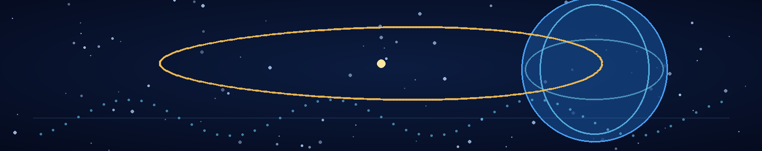

Chapter 2 — The Laboratory at the Edge of the War
The clocks agreed for six hours.
Adrian considered that a kind of progress.
At 19:40, the surface command network lost contact with the western defence corridor. At 20:05, the emergency generator took over the laboratory's power bus. At 21:12, a message arrived from the capital ordering all research teams to prioritise immediate military applications. At 22:00, Mira brought Adrian a cup of coffee that smelled like burnt wiring and told him he had been staring at the same eleven microseconds for so long that the screen would soon file a complaint.
He had not moved the event log to the central server. He had not connected the specimen instruments to the facility network. He had, however, copied the data to three isolated drives and run the same analysis through four independent timing models.
Every model returned the same result.
The measured effect preceded its recorded cause.
“Perhaps the command timestamp is wrong,” Mira said. She stood on the other side of the bench, holding her own cup with both hands. Her field suit had been replaced by dark trousers and a grey laboratory shirt, but the torn sleeve still lay folded beside the specimen case. “That would be the least dramatic explanation.”
“It would also be convenient.”
“Convenience is not a disqualifying property of an explanation.”
“No. But it doesn't make it true.”
Adrian enlarged the event trace. The clocks had not drifted gradually. Their frequencies remained stable, their error margins within tolerance. Then, for eleven microseconds, the reference signals disagreed about the ordering of two events. Afterward, they returned to agreement as if nothing had happened.
The anomaly was small enough to fit inside a single line of data. It was large enough to make the rest of his career look like a warm-up.
Mira put her coffee down. “Show me the comparison with the sample.”
He opened the second dataset. The black fragments from the Veyr transport had shifted their internal phase 0.8 microseconds before the laboratory's magnetic field changed. The clock anomaly and the sample response were not simultaneous, but their signatures shared an irregular pattern: a slight reversal in phase, a brief loss of coherence, then a clean return.
“Could the sample be affecting the clocks?” she asked.
“Not from across the lab. They're on separate power and shielding systems.”
“Could the clocks be affecting the sample?”
“Same answer.”
“So something else is affecting both.”
“Or we're misunderstanding both measurements.”
Mira gave him a look.
“I said it was possible,” he replied.
“You say possible when you mean you hope it's true.”
“That's an unfair assessment of my scientific process.”
“It's an accurate assessment of your face.”
He rubbed his eyes. “What did the field team recover besides the fragments?”
“Three pieces of hull material, one damaged navigation unit, a sealed biological canister, and a Veyr body.”
“Body?”
“Mostly.”
He looked up.
“The recovery team couldn't determine whether the tissue was dead or in some kind of suspended state. It was moved to containment at the xenobiology annex. I asked for a sample. Command refused.”
“On what grounds?”
“Security. They think anything alive from a crashed ship might be a weapon.”
“They may be right.”
“They may also be throwing away our only chance to learn what the enemy is.”
Adrian turned back to the event log. “I'll speak to containment.”
“You'll do more than speak. You'll ask for access, they'll say no, you'll explain why they're wrong, they'll say no more firmly, and you'll return here pretending the conversation was productive.”
“You've made a detailed model of my behaviour.”
“I have excellent observational data.”
He wanted to answer with something clever. Instead, he noticed that she had not touched her coffee.
“Have you slept?” he asked.
“Have you?”
“That wasn't the question.”
“Then it was a badly designed question.”
They looked at each other across the bench. Outside the reinforced walls, the war continued in distant thuds and brief tremors. In the lab, the air system hummed. The little status lights on the isolated instruments made the room feel like a ship drifting through deep water.
Mira's expression changed first.
“I slept in the transport on the way back,” she said. “Forty minutes. Maybe.”
“That's not enough.”
“Neither is your coffee.”
“Mine is a scientific instrument.”
“Yours is a crime.”
This time he did smile, and she seemed relieved to have found it.
The containment officer denied them access at 23:17.
At 23:19, Mira asked whether the officer wanted to be remembered as the person who kept two scientists from examining an alien organism during an extinction-level war.
At 23:21, the officer said that was an unfair use of the phrase extinction-level.
At 23:22, Adrian presented the anomaly report.
At 23:25, the officer let them through under escort.
The xenobiology annex occupied a deeper level of the complex, where the walls were thicker and the air pressure could be isolated by section. Two technicians monitored the sealed biological chamber from behind a transparent barrier. Inside, the Veyr lay on a black examination platform, long-limbed and narrow through the torso. Its skin was not the silver armour plating popular in propaganda images, but a muted, mineral grey, crossed by fine ridges that shifted almost imperceptibly with each mechanical pulse from the life-support unit.
Mira stopped just inside the observation room.
“It's breathing,” she said.
“Barely,” the containment officer replied. “We don't know if that's voluntary.”
“Any response to stimuli?”
“Light, no. Sound, uncertain. Temperature changes produce a small shift in the surface ridges.”
Mira moved closer to the barrier. “Could be a pressure response.”
“Could be a threat display,” said the officer.
“Those aren't mutually exclusive.”
Adrian watched the biological readout. The Veyr's circulation was unlike anything he had seen in the captured tissue reports. Their blood analogue carried oxygen, but also a dense suspension of engineered particles that appeared to regulate cell repair and electrical signalling. The organism's nervous system was distributed in a way that made the distinction between brain and body less useful than he was comfortable admitting.
Mira read the same display. “It isn't simply an animal with unusual anatomy. Its systems are integrated.”
“Like the hull fragments,” Adrian said.
“Maybe. But let's not marry two anomalies because they both look mysterious.”
“I thought you were the one who wanted me to be excited.”
“I want you to be careful in an interesting direction.”
She requested a surface swab and a small blood analogue sample. The officer approved the swab and refused the second. Mira negotiated until the officer allowed a tiny sample from fluid already collected by the life-support system.
Back in Lab C, she placed the sealed vial beneath a molecular scanner. Adrian remained beside her, working through the Veyr navigation unit's recovered signal logs on a separate offline terminal. The unit was damaged, but its final minutes of data had survived. The craft had not been falling blindly. Its navigation system had been trying to correct for a spatial discrepancy that the onboard clocks registered before the discrepancy appeared.
Adrian read the trace twice.
“That's not a crash,” he said.
Mira did not look away from her scanner. “What is it?”
“A failed correction. The ship was trying to compensate for a position it hadn't reached yet.”
“Or the recorder is damaged.”
“Possible.”
“You sound disappointed.”
“I am.”
“That's progress.”
The scanner chimed. Mira's face tightened.
“What?” Adrian asked.
She magnified the molecular profile. The Veyr's repair particles were arranged in repeating clusters, each cluster linked to a set of proteins that appeared to regulate the organism's response to injury. One small family of proteins behaved differently from the others. Its concentration changed whenever the scanner's timing reference slipped by even a fraction.
“Could be a measurement artifact,” Adrian said.
“I know.”
She ran the scan again, this time with a second reference clock. The result repeated.
The protein family was not merely associated with repair. Its shape changed in response to the phase of the reference signal, as if the cells were using an external timing cue to coordinate their internal processes.
Mira sat back slowly.
“What does that mean?” Adrian asked.
“It means we have a hypothesis, not a result.” She tapped the screen. “If this organism's cells depend on a shared timing signal to coordinate repair and communication, disrupting that signal could cause system-wide failure. But we don't know whether the signal is biological, technological, or both.”
“Could the black material be part of the same system?”
“Could be. The fragments may have carried a timing reference for the ship. The organism may have adapted to it. Or we're seeing two separate things that happen to interact with the same anomaly.”
Adrian looked at the paired datasets. For the first time, the impossible ordering seemed less like a ghost and more like a physical problem with edges.
“We need to measure the phase response without the sample,” he said. “Then with the sample. Then with the navigation unit's recovered component, if we can isolate its reference crystal.”
“And I need a larger biological sample.”
“The containment officer will enjoy that.”
“I'll bring coffee as a diplomatic offering.”
“Don't. You'll poison them.”
She leaned against the bench, her exhaustion briefly visible again. The war had taken away ordinary time: meals, sleep, unplanned conversations, the certainty that a person who left a room would come back. Every hour was borrowed from an emergency. Yet she still looked at the data with the same fierce attention she had brought to the crash site.
Adrian realized that he trusted her not because she was fearless, but because she knew what fear was and continued to look.
“You were right about one thing,” he said.
“Only one?”
“The samples and the clocks may be responding to the same phenomenon.”
Mira's smile was small. “I will record this historic concession.”
“Don't get used to it.”
“I wouldn't dream of it.”
A tremor passed through the laboratory. A shelf rattled; one of the suspended fragments turned slowly in its case. On the offline terminal, the recovered navigation log refreshed without receiving any new data.
A new line had appeared.
REFERENCE EVENT CONFIRMED: LOCAL CAUSAL FRAME UNSTABLE
Adrian froze.
Mira came to stand beside him. Neither touched the keyboard.
“Did the terminal have a live connection?” she asked.
“No. I disconnected the interface.”
“Then how did it update?”
He checked the system clock. It had not advanced. The line was not in the original file checksum, and no process log showed a write operation.
The text remained on the screen for three seconds, then vanished.
Adrian's pulse was loud in his ears.
“We need to shut the system down,” Mira said.
“Yes.”
“Not restart. Physically isolate it.”
He pulled the power interlock. The terminal went black.
For a moment, they listened to the silence left by its cooling fan.
“What is a local causal frame?” Mira asked.
“A phrase for a condition we don't know how to describe.”
“Did you write it?”
“No.”
“Did anyone on your team?”
“Not that I know of.”
“Then someone—or something—has a vocabulary for this.”
Adrian stared at the dead screen. He thought of the Veyr formation changing course toward the research corridor. Of a ship correcting for a position it had not reached. Of alien tissue reacting to a reference signal no instrument had deliberately supplied.
The simplest interpretation was no longer that time had malfunctioned.
It was that someone had learned to manipulate it.
And whatever the Veyr were doing to the sky, their own technology might not be stable enough to protect them.
Mira picked up her untouched coffee, considered it, and set it down again.
“We should tell command,” she said.
“We should tell them what we know.”
“And what do we know?”
Adrian looked at the isolated drives, the sealed specimen case, the dead terminal.
“That the invasion may be built around a technology we don't understand. That the technology is affecting local measurements of cause and effect. And that the Veyr may have biological systems coupled to it.”
“Not that they can change history.”
“No. Not yet.”
She nodded. “Good. Let's not outrun the evidence.”
For the first time that night, the words sounded like something they both believed.
Adrian began drafting the report. Mira returned to the scanner and started a fresh control series, refusing to let the strange result become a conclusion simply because it frightened them.
At 02:06, the laboratory clocks disagreed again.
This time, every instrument recorded the same missing second.
And on the sealed specimen case, the branching light inside the black fragments flickered once—like a signal answering from very far away.

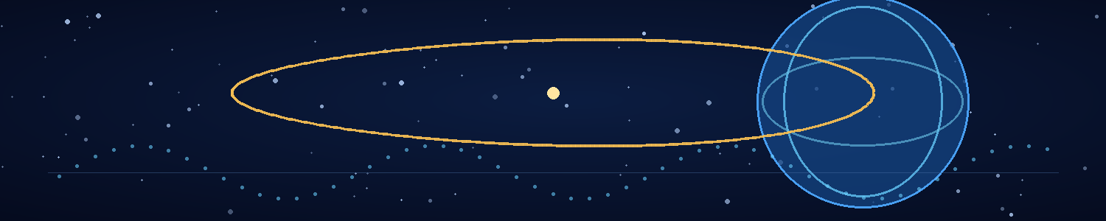

Chapter 3 — Two Ways to Kill an Alien
The first proposal to kill the Veyr was not a weapon.
It was a spreadsheet.
Mira projected the table onto the wall of Lab C at 08:10, beneath the official casualty estimates and above a coffee stain that had survived three cleaning crews. The columns listed observed Veyr biology, suspected dependencies, confidence levels, and the kinds of experiments required to test each hypothesis.
Adrian read the first line.
“Cellular repair coordination.”
“Not just repair,” Mira said. “The same protein family appears in the circulation, the nervous system, and the tissue around the major organs. It may be part of a signalling architecture. The Veyr don't seem to separate their biological systems the way we do.”
“You're proposing a pathogen that attacks a coordination mechanism.”
“I'm proposing that we investigate whether one exists.”
“Those are not the same sentence.”
“Which is why the first column says hypothesis.”
She enlarged the diagram. The Veyr's unusual repair particles were linked to proteins that changed configuration in response to tiny shifts in the sample's timing reference. The effect was subtle. No single measurement proved the organisms relied on an external phase signal. But the same pattern had appeared in three tissue samples and in the material recovered from the transport.
“Two ways to kill an alien,” Mira said. “Break the body, or break the system the body depends on.”
“And the second way risks being wrong in ways we don't understand.”
“So does the first. Bombs don't ask whether the target has a family.”
Adrian turned from the wall. “A pathogen could mutate. It could cross-react with Earth's biology. It could persist after the war. We could win and spend the next century cleaning up the weapon we made.”
“Then we design it to require a Veyr-specific receptor, a Veyr-specific metabolic substrate, and a combination of signals that doesn't exist in terrestrial organisms.”
“That's three locks.”
“Three locks are better than one.”
“Unless the organism changes the locks.”
Mira folded her arms. “Then we make the locks part of a system they can't change without damaging themselves.”
For a moment, neither spoke. She was not asking him to stop worrying. She was asking him to turn worry into engineering.
Adrian studied the diagram again. “If this signalling architecture is real, it may be connected to the navigation technology.”
“That is my suspicion.”
“Which means a biological intervention could affect their equipment.”
“Or their equipment could affect the pathogen. We have to test both directions.”
He looked at the casualty figures on the screen. The invasion had begun nearly twenty years ago, but the official estimates had already become ranges so broad that they seemed designed to hide the fact that anyone was counting. Cities had been evacuated, ports abandoned, and entire regions cut off from reliable communications. The Veyr did not need to occupy every place. They only needed to make resistance expensive enough that people stopped coordinating it.
“Command will ask for a schedule,” he said.
“Command can ask for a pony.”
“They'll ask for a weapon.”
“Then we give them a research plan and refuse to lie about how far along we are.”
The first meeting with the military science council lasted twenty-three minutes and ended with an officer asking whether the pathogen could be ready in thirty days.
Mira said no.
The officer asked whether it could be ready in sixty.
Mira said that was not how biology worked.
The officer asked whether biology could be made to work faster.
Adrian watched Mira's jaw tighten and stepped in before the room could become a contest of authority.
“We can identify candidate vulnerabilities in weeks,” he said. “A safe, species-specific intervention requires testing. If you deploy something uncharacterized, you may create an enemy that adapts faster than we can understand it.”
“We are already facing an enemy that can cross interstellar distances,” the officer replied.
“Which is why we should not give it an unpredictable biological weapon to study.”
That won them a temporary allocation of resources, though not the unrestricted access Mira wanted. The council approved a secure bench, two additional technicians, and a limited sample transfer from containment. It also attached a military observer to every experiment.
The observer, Captain Ilyan, took notes in silence and asked questions that were sometimes more perceptive than Adrian expected.
“What happens if the pathogen doesn't kill them?” he asked during the first planning session.
Mira paused. “It might disable the repair network. That could incapacitate them. It could also do nothing.”
“Could it make them more dangerous?”
“Yes.”
“Would you tell us if you thought that was likely?”
“I'd tell you if the data supported it.”
Captain Ilyan studied her. “I can work with that.”
The first tests used nonliving tissue cultures and synthetic models. They measured binding, response, and breakdown under controlled conditions. Nothing was released, and nothing capable of reproducing was yet constructed. Every candidate pathway failed at least one of the three locks Mira had proposed.
On the fourth day, one model did something unexpected.
It did not destroy the simulated repair network. It caused the network to lose synchronisation.
The effect spread through the model as a wave of small delays. Each subsystem continued to function, but none of them agreed on when the others had acted. Repair signals arrived after the damage response. Electrical pulses reached the wrong phase of a cycle. The system did not collapse all at once. It became less and less able to coordinate itself.
Adrian watched the simulation repeat.
“That's not a kill mechanism,” he said.
“Not by itself,” Mira replied.
“It's a timing failure.”
“It's a candidate vulnerability.”
“If their navigation system uses the same architecture—”
“We don't know that it does.”
“But if it does, this could affect more than their bodies.”
Mira saved the result under a neutral label. “Then we need to find out whether the biological and technological systems share a dependency. We don't get to assume they do just because the story would be elegant.”
“I'm beginning to think you enjoy saying that.”
“I enjoy saying it when you're about to skip three experiments.”
Captain Ilyan leaned forward. “If this works, can we stop their ships?”
“We don't know,” Mira said. “And I won't call a model result a weapon.”
The captain accepted that answer, but Adrian noticed he did not stop taking notes.
That evening, a new intelligence packet arrived from a field team that had entered the remains of a Veyr relay station. The data had been recovered from a damaged console and translated by the military's machine-analysis system. Most of it concerned troop movement, supply schedules, and local atmospheric conditions.
One fragment was different.
It contained a list of dates.
Not Veyr dates. Earth dates, mapped to human calendar conventions by the translation system. Some referred to events that had not happened yet: a power-grid failure in southern India, the evacuation of a coastal city, an attempted counterattack that command had not approved. The final entry referred to the destruction of the relay station itself.
The timestamp on the file was four days older than the first event in the list.
Adrian read it twice. “Could be a prediction model.”
Mira stood beside him. “Could be.”
“Could be human intelligence data they stole.”
“Some of those events haven't happened.”
“They may be planning them.”
“Then why list the relay station's destruction before the field team reached it?”
He opened the metadata. The file was not a forecast generated by a local console. It had been stored in a sealed diagnostic partition, protected from ordinary updates. Its internal signature matched the phase irregularities found in the black fragments.
Mira's face had gone still.
“They're not just studying our biology,” she said.
Adrian looked at the dates. “They're studying our history.”
“Or a history they expect to happen.”
Outside the lab, a transport engine rumbled through the underground access tunnel. Somewhere on the surface, people were preparing to fight battles the enemy appeared to have already recorded.
Adrian copied the packet to an isolated drive.
The pathogen project had begun as a question about how to kill an alien. Now the question had changed.
If the Veyr could obtain information from events that had not yet occurred, then any plan humanity made might already be part of the enemy's data.
And if the Veyr were willing to attack the future as well as the present, a weapon that only killed bodies might not be enough.

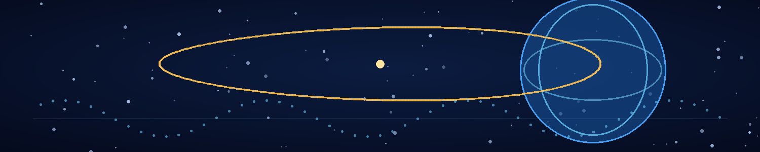

Chapter 4 — The Shape of a Human Future
The first thing Mira asked for after the intelligence briefing was a window.
The command facility had none. It had screens showing weather, satellite feeds, evacuation corridors, and the shifting boundaries of the war. Mira wanted actual glass, actual daylight, and a view that had not been filtered through a military system.
Adrian found a maintenance balcony above the old campus's eastern retaining wall. The balcony had been built for ventilation engineers, not scientists, and its railing vibrated whenever the emergency generators changed load. Beyond the concrete barriers, the sky was pale with smoke. Farther east, the clouds over the sea carried a thin orange line.
“It's not a very good view,” Adrian said.
“It isn't trying to sell me anything.”
They stood with their hands on the cold railing. For several minutes, neither spoke. The last briefing had confirmed that the Veyr possessed records of events before they occurred—or something close enough to make the distinction frightening. Command had ordered every research group to submit plans for “strategic denial of future hostile capability,” a phrase no one in the room had been willing to define.
Mira watched a distant aircraft turn back toward the coast.
“Do you think they can see the future?” she asked.
“No.”
She glanced at him.
“I think they have a system that produces information which resembles future knowledge,” he said. “That could mean prediction at a scale we can't match. It could mean a causal effect. It could mean their clocks are lying in a way we don't understand.”
“You have a talent for making terrifying things sound like paperwork.”
“Paperwork is terrifying.”
“Not to the people who have to bury the dead.”
He accepted the rebuke. In the last months, Mira had become less patient with abstraction when it offered no path back to the people abstraction had erased. Adrian admired that about her. He also feared it. He could spend a night with an equation and call it progress. Mira had to look at what the equation would do to a living thing.
“What would you do,” she asked, “if we won?”
He turned from the sea. “Win how?”
“Adrian.”
“I know. I'm avoiding the question.”
“Yes.”
He thought about it. The honest answer was embarrassingly small. He wanted to sleep for a week, eat food that did not come in sealed packets, and wake without wondering whether the building would still exist. He wanted the clocks to mean what they said. He wanted to see a city at night with all its lights on.
“I'd go somewhere quiet,” he said. “Somewhere I didn't have to measure anything.”
“You would last three days.”
“Four.”
“You'd start measuring the wind.”
“Wind is measurable.”
She laughed, and the sound startled him. It had been too long since he had heard laughter without a nervous edge.
“What about you?” he asked.
“I'd plant something.”
“Anything in particular?”
“Something difficult. A fruit tree, maybe. Something that takes years before it gives you anything back.”
“That's an inefficient use of land.”
“That's why I want to do it.”
He imagined a garden with no perimeter fence, no air-raid sirens, no warning lights. He imagined Mira arguing with a tree because it refused to grow according to schedule. He imagined being there long enough to see the first fruit.
The thought hurt because it felt possible.
“Maybe we could find a place together,” he said.
The words came out more easily than he had expected. He had not planned to say them. He had not planned anything beyond the next experiment for so long that a sentence about the future felt like an unauthorized system call.
Mira looked at him. The smoke in the sky shifted, briefly letting a band of sunlight reach the balcony.
“Together?” she asked.
“If you want.”
“Is that a scientific proposal or a personal one?”
“I haven't written the methodology.”
“Then I can't approve it.”
He looked away, embarrassed by how much the answer mattered. “I meant it as a personal one.”
Mira rested her elbows on the railing. “I want a place with rain. Real rain, not whatever falls through the filters at the shelters. I want a kitchen where the lights don't flicker. I want to grow something and not have to label it as a strategic resource.”
“Those are all achievable objectives.”
“And I want to stop being afraid that every conversation is the last one we'll have.”
He had no equation for that. He moved his hand along the railing until it rested near hers. She closed the gap herself.
They did not kiss. Not then. The promise was quieter than that, and more dangerous: for a few minutes, they allowed themselves to imagine that victory would leave them with a life to choose.
The alert arrived before they returned to the lab.
A Veyr research platform had been detected above the northern hemisphere, outside the range of conventional weapons. It had not fired. It had not maneuvered toward a defence target. It had simply altered its orbit to maintain a line of observation over several human scientific facilities, including their own.
Command classified it as surveillance. The public broadcast called it a precursor to an attack.
Adrian studied the orbital solution. “It's watching our research sites.”
“Maybe it watches anything that generates an unusual signal,” Mira said.
“The phase anomalies?”
“Or the pathogen work.”
They had been careful. The project ran on isolated instruments, and its records were held inside a segmented network. But the Veyr had already demonstrated a capacity to obtain information from damaged equipment and anomalous reference signals. Security was a problem they could not solve by adding another password.
At 14:30, Captain Ilyan arrived with a new directive. The Veyr platform had transmitted a narrow-band pulse toward the research corridor. The pulse did not damage equipment. It caused every instrument using the laboratory's primary reference clock to lose synchronisation for 0.6 seconds.
Mira stared at the trace. “It wasn't a weapon.”
“No,” Adrian said. “It was a measurement.”
“Of what?”
He compared the pulse signature with the black fragments' response and the timestamp from the Veyr relay file. The same phase reversal appeared in all three.
“They may be testing whether our facility can observe the anomaly.”
“Or whether we can reproduce it,” Mira said.
A new alert appeared on Captain Ilyan's tablet. The laboratory security system had detected an attempted access to the pathogen project's metadata. No files had been opened, and the intrusion had not come through the ordinary network. It had arrived as a malformed synchronisation request sent to a reference controller that was supposed to be physically isolated.
The request contained a string of characters that the translation system rendered as a Veyr technical label.
BIOLOGICAL COUNTERMEASURE — HUMAN ORIGIN
Mira's face lost its colour.
“They know,” Ilyan said.
“They know a project exists,” Adrian replied. “They may not know what it does.”
“Does that distinction help us?”
“It tells us what we should assume they can see.”
Mira pulled the pathogen project offline. “We need to move the work.”
“Where?” Adrian asked. “Every facility with a secure lab is already on their list.”
“Then we make the work harder to observe.”
Captain Ilyan looked between them. “Can you continue?”
Mira answered carefully. “We can continue studying the vulnerability. We are not ready to build a deployable pathogen, and we are not going to pretend otherwise.”
The captain nodded, but the expression in his eyes had changed. They had started with a possible biological weakness. Now the enemy had identified their work before they had even decided what to call it.
That evening, Adrian returned to the maintenance balcony alone. The sky was dark, and the Veyr platform was invisible to the naked eye. On the horizon, distant lights flickered in the direction of the port.
He tried to imagine the future they had discussed. A garden. Rain. A kitchen. Mira complaining about a tree. A life made from ordinary days rather than emergency intervals.
He could not tell whether the image was a promise or a superstition.
His tablet vibrated. Mira had sent him a message from the lab.
I found a second reference pattern in the countermeasure request. It matches the relay file. Come now.
Adrian looked once more at the sky and went inside.
The Veyr had seen enough of their work to name it. The next question was whether they were trying to stop a human weapon—or whether the weapon had become important because it could interfere with something the Veyr had already set in motion.
For the first time, Adrian understood that the war might not be a contest over territory, resources, or even survival.
It might be a contest over which future was allowed to exist.

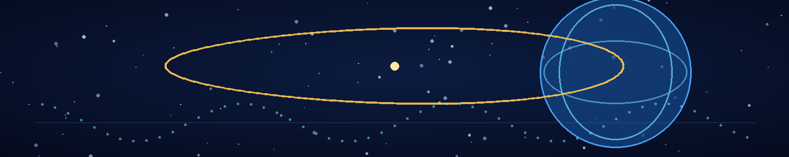

Chapter 5 — The First Kiss During the Sirens
The attack began at 16:03, while Mira was explaining why the word weapon had become useless.
“It's a tool with an intended outcome,” she said, marking a protein cluster on the display. “A weapon is a tool intended to cause harm. What we're doing is trying to understand a dependency. If it becomes a weapon, that decision should not be made by the language we use in the lab.”
Adrian had one hand on the console and the other wrapped around a mug that had been reheated so many times the coffee had become a separate chemical category.
“Command won't make that distinction.”
“Then command can use a different room.”
The first impact cut off the rest of the argument.
The lights vanished. A hard, metallic groan rolled through the walls, followed by the sound of ventilation dampers slamming shut. Emergency strips glowed along the floor. The laboratory's outer door locked with a heavy clunk.
“Status,” Adrian said.
The ceiling speaker clicked, hissed, and produced half a sentence: “—breach reported in the upper transit—”
A second impact shook the lab. The specimen case slid several centimetres across the bench. Mira caught it before it reached the edge.
“Containment,” she said.
“Stable,” Adrian answered, reading the local sensors. “The chamber's still sealed.”
A pressure alarm sounded from the corridor. The doors between Lab C and the central shelter had closed automatically, leaving them isolated behind the reinforced research barrier. Adrian pulled up the emergency map. The display showed a red zone spreading across the upper levels.
“There's a fire between us and the interior stairwell,” he said. “The secondary route is blocked.”
“How long until the suppression system clears it?”
“If the doors hold, ten minutes. If they don't, we won't be worrying about the route.”
Mira looked at him. “You have a gift for reassurance.”
“I've been told.”
The laboratory shifted again, a low lateral shudder that made the instrument arms rattle. Somewhere beyond the wall, a heavy object fell and kept falling, clanging down a shaft until the sound stopped.
Adrian opened the manual emergency panel. The isolation system had severed external power, but the battery bus remained live. He could force the inner door to cycle, yet doing so would open the corridor to whatever pressure differential the damaged ventilation system had created.
“Don't,” Mira said.
“I haven't done anything.”
“You're about to try to outthink a fire door.”
“The panel gives us a manual override.”
“And the pressure sensor says the corridor is unsafe.”
“If the sensor is damaged—”
“Then we verify the sensor. We don't gamble because standing still makes you feel helpless.”
He stared at her. The warning tone kept sounding, steady and irritating. He checked the redundant pressure gauge. It agreed with the first. The corridor was not safe.
He lowered his hand from the panel.
“Thank you,” he said.
Mira blinked. “For what?”
“Stopping me from doing something stupid.”
“I'll add it to my annual performance review.”
The lights flickered. On the main monitor, the pathogen model froze in the middle of a cycle. Then the laboratory clocks slipped out of agreement. One recorded 16:04:12. The second read 16:04:11. The third displayed a timestamp that had not yet occurred.
Adrian forgot the door.
“That's the same signature.”
Mira came beside him. “Can we save the data?”
“Local buffer only. The reference bus is unstable.”
“Then save the buffer.”
He initiated a dump to the isolated drive. The progress bar stopped at eighty-three percent. A static line crawled across the monitor.
For a few seconds, the room seemed to tilt—not physically, but in the way a familiar place can feel wrong when one detail has moved by a fraction. Adrian's inner ear insisted he was still. His eyes insisted the hanging instruments had shifted. The clocks disagreed about how long he had been staring.
Mira took his wrist.
“Adrian. Look at me.”
He did.
“Tell me five things you can see.”
“What?”
“Five things.”
He swallowed. “The console. The specimen case. Your hand. The emergency light. The pressure gauge.”
“Four things you can feel.”
“The floor. The bench edge. My sleeve. Your hand.”
“Good. Stay here.”
The sensation passed. The clocks snapped back into agreement. The data dump resumed and completed.
Adrian realized that Mira was still holding his wrist. He realized, too, that he had closed his fingers around hers.
Neither moved.
The emergency speaker came alive with a burst of static. A voice announced casualties in the upper transit corridor, then broke into unintelligible noise. The words were distant and clinical. They did not make the deaths feel smaller.
Mira released his hand, but only enough to look at him properly.
“You're shaking,” she said.
“So are you.”
“I know.”
They stood close together in the emergency light. He could see a small cut near her hairline, bright with fresh blood. He reached for the first-aid kit, but she caught his hand.
“It's not serious.”
“Let me see.”
“Adrian—”
“Please.”
The word surprised them both. Mira went quiet. He cleaned the cut with a sterile wipe and sealed it with a narrow dressing. His fingers were steady now, but he was aware of every place they touched: her temple, the edge of her cheek, the warm pulse in her wrist when she lowered her hand.
“You don't have to turn every fear into a procedure,” she said softly.
“I don't know what else to do with it.”
“Sometimes you can just say you're afraid.”
He looked at her. Beyond the walls, the sirens rose and fell. The laboratory had become a small, sealed island in a world of smoke and collapsing infrastructure.
“I'm afraid,” he said.
Mira's expression changed. She did not smile or reassure him. She simply stepped closer.
“Me too.”
He had imagined kissing her many times, though never with the clarity of an actual plan. In those imagined versions, there had been time, privacy, and some certainty that the world would not interrupt. Now there was a sealed door, a failing clock system, and a casualty report repeating from a damaged speaker.
He could have waited for a better moment. He had spent months waiting for better moments.
“Mira,” he began.
“I know.”
“I don't think you do.”
“Then tell me.”
He tried. The words assembled and fell apart. Every honest sentence seemed too small beside the war, and every grand one sounded like a lie.
So he stopped trying to explain and asked, “Can I kiss you?”
Her answer was almost lost beneath the siren.
“Yes.”
The kiss was brief at first, cautious in the way of two people who had spent so long keeping one part of themselves under control that they had forgotten how to begin. Then Mira's hand rose to the side of his face, and he felt the last of his practiced distance give way.
It was not a promise that they would survive. It was not a victory. It was one moment in which neither of them had to pretend that the other was merely a colleague standing nearby.
When they parted, Mira rested her forehead against his.
“That,” she said, breathless, “was not in the research plan.”
“I'll update the documentation.”
“Don't you dare.”
He laughed once, quietly. She did too. The sound felt fragile and astonishing.
Then the clocks chimed.
Not the usual hourly signal. A single note rang through the laboratory's speakers, clean and cold. Every display changed at once. The casualty report vanished. The pathogen model returned to its first frame. The emergency timer reset to 16:03:00.
Adrian pulled away and stared at the console.
“That's impossible.”
Mira reached for the keyboard. “What reset?”
“Everything tied to the local reference bus.”
“Did we lose the buffer?”
He checked the drive. The data remained. The system logs showed a six-second discontinuity, followed by a synchronisation event whose timestamp predated the impact.
The alarm continued, but the wall display showed a status message unlike any he had seen:
REFERENCE STATE RESTORED — EXTERNAL CAUSALITY UNVERIFIED
Mira's fingers tightened on the bench edge.
“Is that a Veyr message?”
“I don't know.”
“Could the platform have caused it?”
“Maybe. Or the attack exposed a weakness in their system. Or this is a local failure that only resembles the earlier events.”
“Three possibilities. No conclusion.”
He looked at her. “You're learning my habits.”
“Someone has to keep them from becoming a religion.”
The outer door remained locked. The pressure alarm still indicated danger, and the casualty report returned in fragments. Nothing about the world had become safer.
But the six-second discontinuity had left a trace. The system had not merely lost time. It had restored a reference state, as if some hidden process had briefly tried to put the laboratory back the way it had been.
Adrian copied the new logs.
Mira took his hand again, deliberately this time.
“Whatever that was,” she said, “we face it together.”
He wanted to answer with a theory. Instead, he held her hand and stayed beside her until the rescue team cut through the outer access panel.
The war had taken six seconds from the room.
It had not taken the moment they had chosen to keep.

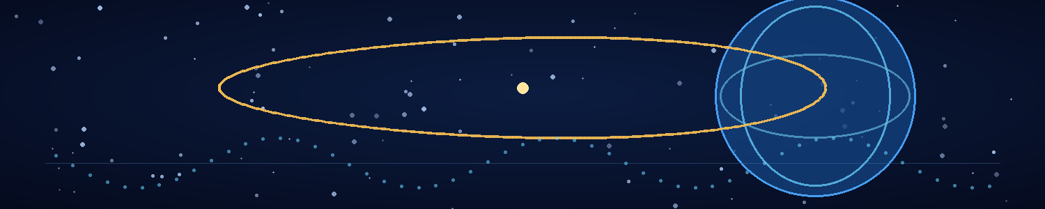

Chapter 6 — The Signal from Yesterday
The signal was hidden in a clock.
Not the clock itself, Adrian discovered, but the calibration record stored inside its reference controller. The Veyr relay packet had arrived with a timestamp four days older than the events it described. The laboratory's six-second discontinuity had left a similar mark. And now the isolated reference unit in Lab C was recording a faint pattern that seemed to arrive before its own trigger condition.
For two nights, Adrian did not leave the facility.
Mira slept in an empty office for three hours and returned to find him surrounded by printouts, handwritten equations, and empty cups. She stood in the doorway until he noticed her.
“Have you eaten?”
“Yes.”
“What?”
He considered the question. “Food.”
“Excellent. Very specific.”
She placed a wrapped sandwich beside the keyboard. He looked at it as though it might be another instrument requiring calibration.
“I'm close,” he said.
“You said that yesterday.”
“Yesterday I was close to knowing what question to ask.”
“And today?”
“Today I think I know what the signal is doing.”
Mira pulled up a chair. “Show me.”
He brought up three traces: the Veyr relay file, the laboratory reference reset, and the new signal. Their surface details differed, but each contained a brief interval in which the ordering of events could not be explained by clock drift or ordinary transmission delay.
“Imagine the relay unit receives a message,” Adrian said. “Under normal conditions, the receiver timestamps it when it arrives. But the internal record says the message was already present before the receiving event.”
“Then either the timestamp is wrong or the message isn't arriving through the ordinary sequence.”
“Exactly. We tested the clock. We tested the storage controller. We isolated the power bus. The record survives all of it.”
“Could it be a prediction?”
“It could. But the content includes details that were not available to the relay's sensors at the time the record was written. The lab's discontinuity has no predictive content at all. It is just a reference state being restored.”
Mira studied the traces. “You think the Veyr are sending information backward.”
“I think their technology can produce records that appear to carry information from a later event into an earlier state. I can't tell you whether the information is transmitted backward, whether the device samples a future boundary condition, or whether our model of time is missing a variable.”
“That's a very long way of saying you don't know.”
“It's a very accurate way of saying I don't know.”
She nodded toward the sandwich. “Eat while you don't know.”
He obeyed, mostly because she watched until he took a bite.
The breakthrough came from the recovered navigation unit. Its internal reference crystal had been cracked by the crash, but the fracture had preserved a sequence of phase changes that the repair software had marked as corrupted. Adrian reconstructed the sequence from the surviving edges. The signal was not a message in the usual sense. It was a set of boundary conditions—values that would ordinarily be calculated after a navigation event, embedded in the record before the event occurred.
The device was not predicting a route. It was using a future state as part of the calculation that selected the route in the first place.
Mira read the reconstruction in silence.
“If this is right,” she said, “then the ship wasn't only navigating through space.”
“It was navigating through a relationship between states.”
“And the relay file?”
“May have used the same system to record future events. Or the file may be a deliberate artifact created by whoever controls the network. We need more evidence.”
She looked at the dates again. The entries were not a random list. They formed a chain: a power failure, an evacuation, a failed counterattack, a relay station's destruction. Each event influenced the next. The file contained not just events, but their dependencies.
“It's a plan,” Mira said.
“Maybe.”
“A plan written as history.”
Adrian felt the thought settle in his chest. The Veyr were not merely collecting forecasts. Their technology appeared to let them work with a future state as though it were an input. They could use later events to constrain present decisions, narrowing the range of outcomes until the desired path became the one their systems expected.
That was not the same as changing history. He wrote the distinction on the board.
FUTURE INFORMATION IS NOT PROOF OF RETROACTIVE CONTROL.
Mira added a second line beneath it.
BUT IT MAY BE HOW THEY LEARN TO CONTROL IT.
At 11:20, Captain Ilyan arrived with authorization to move the navigation unit into the laboratory's deepest shielded chamber. The military had also approved a controlled comparison with a second recovered component. The decision was less an act of trust than a recognition that the anomaly had become impossible to ignore.
They carried the unit into the chamber by hand. Its housing was heavy and cold, built from the same dark material as the fragments Mira had recovered. A ring of fine markings ran around the inner casing, too regular to be decoration and too complex to read as ordinary engineering notation.
Mira set up the sensor array. Adrian connected the isolated reference clock, then checked every link twice.
“Ready?” she asked.
“No.”
“Good. Neither am I.”
They initiated the test.
For nine seconds, nothing happened. The instruments recorded a stable baseline. Then the navigation unit emitted a pulse so weak that the first sensor classified it as noise. The second sensor caught it. The third recorded it 0.4 microseconds before the first.
Adrian stopped the run.
“Again,” Mira said.
They repeated it with the sensors reordered. The timing difference followed the reference configuration, not the physical positions of the sensors. They changed the power source, replaced the controller, and ran the test in reverse order. The anomaly persisted.
It was not a conventional transmission from one instrument to another. It was a mismatch between the order in which the system's events were recorded and the order in which the laboratory could establish that they had occurred.
Adrian felt the room narrow around him.
“It's using the reference clock as an anchor,” he said.
“An anchor to what?”
“I don't know. A state outside the local sequence. A boundary condition. Something the device treats as fixed even when our clocks disagree.”
“Can we reproduce it?”
“Not safely, and not yet.”
Mira stepped back from the array. “Then we stop here.”
He wanted one more test. He wanted to increase the pulse strength, isolate the ring markings, and find the threshold where the signal became readable. The desire was almost physical. But he remembered the way the room had tilted during the attack, and the look on Mira's face when the clocks reset.
He shut down the array.
The final data packet completed as the power bus went dark. It contained a short block of symbols translated by the military's analysis system into a partial technical phrase. The translation was uncertain, with several characters missing.
TEMPORAL CORRECTION: REMOVE ORIGINATING SPECIES
Mira read it twice.
“That's not a navigation instruction,” she said.
“No.”
“Could it mean removing an obstacle from the route?”
“Possibly. The translation is incomplete.”
“But if it means what it says—”
“Then the Veyr are not just using future information to win the war.”
He could not finish the sentence. He did not need to.
The phrase sat between them, clinical and monstrous. Remove originating species. Not defeat. Not occupy. Not negotiate. Remove the condition that had allowed the enemy to exist.
Mira's face was pale, but her voice remained level. “They intend to change the past so humanity never becomes a threat.”
“We have a translation fragment, not a confession.”
“Adrian.”
“I know what it looks like.”
“Then say it.”
He looked at the recovered unit. The dark casing reflected the laboratory lights without revealing its surface. The device had been designed to treat an event outside ordinary time as a usable input. The relay file had carried a chain of human events into a record dated before them. The phrase now suggested an objective that made all the earlier anomalies fit into a terrible shape.
“They may be trying to erase humanity from history,” he said.
The words were quiet. The instruments were off, yet the chamber seemed to hum around them.
Captain Ilyan took the data packet to command. Mira remained beside Adrian, staring at the phrase until the display dimmed.
“If they're changing the past,” she said, “we can't beat them by defending the present.”
“No.”
“Then we need something that can survive the change.”
Adrian looked at the reference clock, its digits steady and indifferent.
For the first time, he understood the shape of the problem. The Veyr's weapon did not need to destroy Earth's cities. It did not need to kill every human being. It only needed to alter the sequence of events that led to humanity's existence, then let the new history make the old one impossible to remember.
A victory with no battlefield.
A genocide with no corpses.
He wrote a final line on the board beneath their two hypotheses.
IF HISTORY CAN BE REWRITTEN, WHAT CAN REMAIN OUTSIDE THE EDIT?
Mira read it, then turned to him.
“Find out,” she said. “Before they do.”

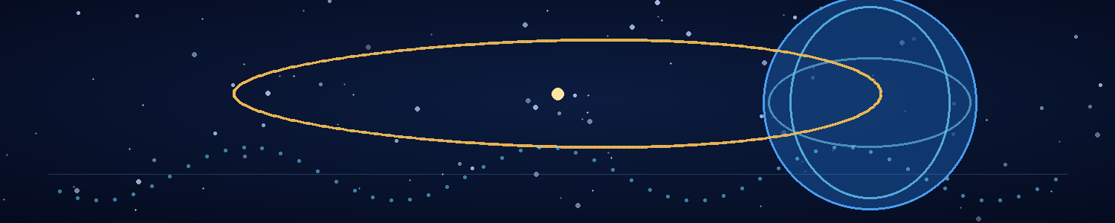

Chapter 7 — The Equation That Should Not Exist
The equation appeared in the wrong notebook.
Adrian found it at 04:12, handwritten in the margins of a set of calculations he had abandoned two months earlier. The notebook had been stored in a locked drawer since the invasion began. No one else had access to it, and the equation was not in his handwriting.
It was, however, in his notation.
He stared at the page until the numbers began to lose their shape. The expression linked a local reference frame to a boundary condition that existed outside the system's ordinary causal sequence. It was not a complete solution. It was the kind of ugly intermediate relation he might have written while exploring an idea and then crossed out as impossible.
Except he had never written it.
Mira arrived with two coffees and found him photographing the page.
“Have you slept at all?”
“Not enough to be responsible for this.”
She set down the cups. “What is it?”
He showed her the equation, then the timestamp of the notebook's last inventory scan. The drawer had been sealed after the scan. The page was clean, the ink dry, and the paper undisturbed beneath the equation.
Mira leaned close. “Could someone have added it before the scan?”
“The image from the scan doesn't show it.”
“Could the image be wrong?”
“That's the first explanation I tested.”
She read the relation carefully. “I recognise the phase term. It's in the navigation reconstruction.”
“The same term appears in the laboratory reset. I thought it was a translation artifact.”
“And now?”
“Now I think the Veyr model has a mathematical structure that our equations can approximate.”
“Can you solve it?”
“Not as written. It contains a boundary condition that has no defined value in our framework.”
Mira pulled up a chair. “Then we need to know what the boundary represents.”
For six hours they worked through the relation. Adrian derived alternate forms; Mira checked them against the biological data and the Veyr signal logs. The equation behaved like a constraint on histories rather than a description of a single event. It did not say what would happen. It specified which sequence of events the system could sustain.
At the centre was a term that changed when they substituted the human timeline into the model. The value was not zero, as Adrian expected. It was undefined.
“Maybe our timeline isn't a valid solution,” Mira said.
“Or the Veyr model doesn't permit a history in which humans develop the way we did.”
“That's worse.”
“It is.”
He fed the relation into a simulation using the recovered relay file as a set of constraints. The output produced a branch of events in which human scientific development ended long before the first recorded human cities. The Veyr network treated that branch as stable. Human civilization was not defeated within it. It simply never reached the point where it could threaten the Veyr.
Mira studied the result. “They're not trying to win the war we're fighting.”
“No. They're trying to make this war never have happened.”
“And the equation is telling us where the branches diverge.”
Adrian enlarged the earliest divergence the model could resolve. It was not a battle, a discovery, or the birth of a famous scientist. It was a chain of small changes in the deep past: climate variation, migration, extinction, and the survival of lineages that eventually led to modern humans. The model did not identify one neat moment when humanity began. It described a region of causal history whose later consequences converged on human emergence.
“They're targeting a causal basin,” he said. “Not a single ancestor or date. They want to alter enough upstream conditions that our emergence becomes statistically unreachable.”
Mira's expression hardened. “Then every conventional defence is irrelevant.”
“Almost every one.”
“Adrian.”
“If their operation depends on a distributed network, it may have a vulnerable coordination point. We still don't know how the network remains consistent across time.”
“You think the biology might be connected.”
“I think the same phase signature appears in the tissue, the navigation system, and the relay record. If those are all parts of one architecture, the network may have biological dependencies.”
“That's a possibility, not a plan.”
“It's all we have.”
Mira stood and walked to the windowless end of the room. “We can't fight a weapon that changes the conditions that allowed us to build it. If the operation succeeds, no one will remember what we discovered. No one will remember us.”
Adrian looked at the equation again. It had appeared in his notebook before he understood what it meant. He could not prove it had come from the future. He could not prove the Veyr had planted it. He could only establish that it contained a solution his earlier work had not reached.
“Maybe someone will,” he said.
Mira turned.
“Not history,” he added. “Something outside it.”
He drew a box around the boundary term. If the Veyr could constrain history by treating a future state as a fixed reference, perhaps a local system could be built to refuse that reference. A small domain whose internal clocks and measurements remained self-consistent even when the external timeline changed.
Not a time machine. Not a shield against every weapon. A place where the operation could not rewrite the observer's own causal record.
“AION,” he said.
Mira came back to the table. “You have a name already?”
“Acausal Isolation and Observer Nullification.”
“That is a terrible name.”
“It is technically descriptive.”
“It sounds like a committee trying to frighten a grant board.”
“Then we'll call it the Stillhouse.”
She considered the word, then nodded. “A place that stays still while everything else moves.”
“A place that preserves its own reference state.”
“Don't ruin it.”
He wrote the name at the top of a fresh page.
AION was not yet a machine. It was a hypothesis about what could be preserved when history itself became an unstable variable. It would require hardware that did not share the same timing vulnerabilities as the Veyr network, a boundary that could hold a local causal reference, and a way to keep its occupants alive while the world outside changed.
It might not work.
But for the first time since the signal from yesterday, they had a problem that could be approached as engineering.
Adrian looked at Mira. “If we build it, we may be the only people who remember the original world.”
“Then we make sure we remember it accurately.”
She put her hand over his on the notebook.
“Start with the clocks,” she said. “And don't write anything in there that you can't defend.”

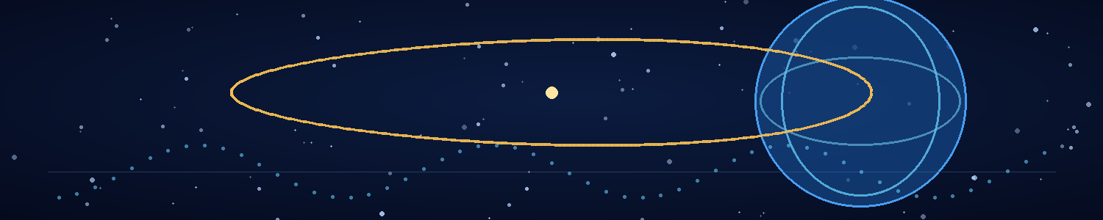

Chapter 8 — The Enemy's Clock
The first symptom was a disagreement of seven nanoseconds.
The national time service reported it as a calibration anomaly. The military network described it as a synchronisation fault. The civilian broadcasts ignored it entirely. Seven nanoseconds was too small to interrupt a phone call, alter a train schedule, or make a clock visibly wrong.
But every independent reference system on Earth recorded the same direction of drift.
Adrian watched the readings accumulate across the wall display. Atomic clocks in three continents were disagreeing with their own calibration histories. Some claimed their frequency had changed. Others claimed the reference event used to measure that frequency had happened at a slightly different time. The errors were small, but they were correlated.
Mira stood beside him with a tablet pressed against her chest.
“They're not breaking the clocks,” she said. “They're changing what the clocks agree happened.”
“That's the distinction.”
“Can you prove it?”
“Not yet. But ordinary drift would not create the same structured error across isolated systems. Something is moving the reference.”
At 09:30, the first public record changed.
A weather archive revised the timestamp of a storm that had struck the Bay of Bengal six years earlier. The storm's measurements remained the same, but the record now placed its landfall eleven minutes earlier. The adjustment appeared to be a routine correction from a new data source. Within minutes, a second archive adopted it.
Then a shipping database changed the date of a port closure. A hospital system revised the time of a mass-casualty event. A university repository altered the publication date of a paper that had led to one of the first human countermeasures against the Veyr.
Each change was small enough to look like a clerical correction. Together, they formed a pattern.
The past was being edited from the edges inward.
Adrian ran the changes against the Veyr temporal model. The records did not all move backward by the same amount. They shifted along a set of dependency chains. Events that depended on one another changed in coordinated ways, while unrelated records remained stable.
“The network is testing a transition,” he said.
Mira watched a map of the anomalies spread across the globe. “How long until the transition completes?”
“I can't estimate that from these data.”
“Hours? Days?”
“I don't know.”
She looked at him until he met her eyes.
“I will not invent a number because we need one,” he said.
“Good. Then tell me what we can do.”
They moved the AION concept from the notebook to the laboratory board. The design required a local reference that could be checked without relying on the external time network. A bank of atomic clocks would measure one another, while a superconducting toroidal lattice stabilised their phase relationships. A metamaterial shell would isolate the chamber from electromagnetic and mechanical interference. A speculative boundary-control system would use the Veyr phase signature as a guide—not to imitate their temporal technology, but to establish a local state that did not accept the network's rewritten sequence as authoritative.
The design was incomplete. It had more assumptions than components, and some of its central assumptions could not yet be tested. Still, it gave them a target.
AION had to preserve three things: a reliable internal clock, a record of events inside the chamber, and the biological continuity of the people within it. It could not save the world outside. It could not stop the temporal operation. It could only keep its occupants from being rewritten along with everything else.
At noon, command issued a new order: all research data related to the Veyr temporal anomaly was to be transferred to a central repository. The stated reason was preservation. Adrian read the order twice and noticed that its timestamp preceded the briefing where the repository had first been proposed.
Mira pointed to the line. “That's the same signature.”
“Yes.”
“Then the order may already have been affected.”
“Or the record is wrong. We have to preserve both possibilities.”
They refused the transfer and sent command a signed report explaining why. Within ten minutes, the order was rescinded by a second message whose timestamp was older than the first.
Captain Ilyan arrived in person. “The command network is becoming unreliable. We have orders that appear to have been issued before the meetings that authorized them. Some officers remember receiving them. Others remember the meetings never happened.”
“Do you remember the original sequence?” Mira asked.
“I remember three versions of the same briefing. In one, we approved your research. In another, we shut it down. In the third, the briefing lasted four minutes and no one mentioned your project.”
“Which one is real?” Adrian asked.
Ilyan's expression was grim. “That is what I'm telling you.”
The next shift began without a clear handover. Two technicians arrived claiming they had already completed the day's work. One insisted that a colleague had been evacuated the previous night; the colleague stood beside him, alive and confused. Their records disagreed, then converged on the version that left the fewest contradictions in the facility database.
The human mind was not a reliable instrument for detecting a gradual change to history. People forgot things. Records were amended. Memories filled gaps. The Veyr operation could exploit all three.
Adrian started keeping a handwritten log. Mira did the same. They wrote the date, the time shown by each independent clock, what they had seen, and what they remembered before checking any database. They sealed the pages in separate containers and compared them only after the entries were complete.
“Old-fashioned,” Mira said.
“Harder to update remotely.”
“Unless someone changes the paper.”
“Then we'll have larger problems.”
For a moment, she smiled. Then every clock in the lab stopped.
Not at the same reading. One froze at 12:47:03. Another at 12:47:02. The reference controller showed 12:47:04 and began counting backward. The lights remained on, but the hum of the ventilation system seemed to stretch into a single low note.
Adrian watched the clocks. “It's starting.”
A message appeared on the isolated display. It was not a warning from the laboratory system. It was a fragment of the Veyr phase notation, translated into a string of human-readable terms by the same process that had decoded the navigation unit.
TEMPORAL CORRECTION WINDOW OPEN
Mira turned toward the AION sketch.
“How long do we have?”
“I don't know.”
“Then we build as if we have no time at all.”
Adrian erased the board's old schedule. The new plan had no phases for convenience, no optional experiments, no assumption that command communications would remain trustworthy. They would assemble the Stillhouse with whatever components could be secured locally. They would test only the functions that could be tested without exposing the lab to a full temporal pulse.
Outside, the world's clocks continued to disagree by fractions of a second. Inside Lab C, Adrian began to build a machine whose first purpose was not to change time.
It was to remain an honest witness when time stopped telling the same story.

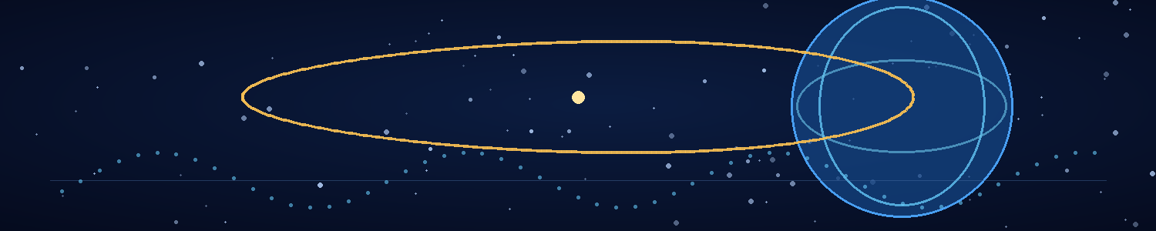

Chapter 9 — Building the Stillhouse
AION began as a room-sized argument.
The superconducting toroid arrived from a particle research facility that had lost half its staff and all confidence in the national grid. The atomic clock bank came from a navigation laboratory whose director signed the transfer papers with a hand that would not stop shaking. The metamaterial panels were originally intended for electromagnetic shielding. The phase-control assembly was assembled from three experimental systems that had never been designed to work together.
None of the components had been built for time.
Adrian insisted on recording that fact in the project log.
Mira read the line and added: Nor have they been tested against a universe that disagrees with itself.
“Your contribution is not helping morale,” he said.
“Your morale was based on a false premise.”
They built the chamber in an old calibration vault beneath the research campus. The vault had thick walls, independent power, and a floor designed to carry equipment heavier than a small house. Its ventilation could be sealed without cutting off emergency oxygen. The door was a salvaged pressure hatch, reinforced with a second layer of composite material and fitted with mechanical locks that did not rely on network authorization.
The shell looked less like a science-fiction machine than a bunker assembled by people who had run out of time. Inside, the toroid surrounded a central platform. Clock modules lined one wall. The control console sat behind a physical barrier, with paper switches and manual interlocks added wherever the electronics could be bypassed.
Mira supervised the biological systems. The chamber needed to keep two people alive during a transition of unknown duration. Air, water, waste recycling, temperature control, and emergency medical supplies were all limited by volume. She designed redundancies, then designed procedures for when the redundancies failed.
“What's the expected duration?” a technician asked.
“Unknown,” Mira replied.
“Days?”
“Possibly.”
“Weeks?”
“Possibly.”
“Years?”
Mira paused. “If the outside timeline changes and doesn't return, we have no basis for estimating how long we'll be inside.”
The technician looked at the life-support rack.
“Then we build for the longest duration we can support,” she said, “and we plan for the possibility that it won't be enough.”
Adrian's work was more abstract. The chamber's clocks would not simply agree with one another. They would maintain a local reference state and continuously record their relationships. The toroid would stabilise the timing architecture against external phase disturbances. The shell would reduce ordinary electromagnetic coupling. The boundary-control system—still speculative—would use the anomaly's own mathematical signature to define the chamber as a causally isolated domain.
He had no proof that such a boundary could exist. He had evidence that the Veyr technology behaved as if it depended on one.
The first test used no biological occupants. They placed a rack of independent clocks inside the chamber, sealed the hatch, and initiated a weak phase pulse from the recovered navigation unit. Outside the chamber, the clocks disagreed by 0.3 microseconds. Inside, the reference bank held its phase relationship.
For seven seconds.
Then one clock slipped.
The boundary collapsed before the safety interlock could shut the system down. A fuse blew. The toroid rang with a sound like a struck bell. The chamber lights went out, and a ceramic panel cracked across its centre.
Nobody was hurt. The test was a failure.
Adrian stared at the trace. “The field amplitude was too high.”
“Or the boundary geometry was wrong,” Mira said.
“Or the phase controller is feeding back on itself.”
“Or the premise is wrong.”
He turned to her.
“You said you wanted careful science,” she said. “That includes the possibility that we are building an expensive room around a mistake.”
“I know.”
“Do you?”
He looked at the damaged panel, then at the clock traces. “Yes.”
They spent the next day rebuilding the boundary controller. They changed the toroid's operating sequence, isolated the clock bank from the main control bus, and added a passive reference record that could not be overwritten by the system software. Mira reduced the number of life-support interfaces connected to the central console and added manual controls to the air and water systems.
On the second test, the chamber held for nineteen seconds.
On the third, it held for four minutes.
On the fourth, the Veyr pulse from the navigation unit changed frequency halfway through the test. Every external clock jumped. Inside AION, the clocks shifted by a fraction, then returned to their original relationship. The passive record preserved the discontinuity rather than smoothing it away.
Adrian leaned against the console, breathing hard.
Mira watched the output. “Did it work?”
“It held a local reference state through an external disturbance.”
“That sounds like a yes with qualifications.”
“It's a yes with very large qualifications.”
“Good. I distrust unqualified yeses.”
They began the fifth test with a stronger pulse. The boundary remained stable for eleven minutes. At the end of the run, the chamber's internal clock recorded a short interval that had no corresponding duration in the external reference. It was not time travel. No object had moved into the past. But the local record remained self-consistent while the external clocks disagreed about the sequence.
Adrian printed the trace and taped it to the wall.
The machine had not stopped time. It had not shielded them from every possible effect. It had preserved an observer's local causal reference through an anomaly that should have destabilised it.
Mira stood beside him, studying the curve.
“A cage keeps things out,” she said.
Adrian looked at the chamber.
“This keeps history out.”
She turned to him. “Put that in the documentation. It's the first useful sentence you've said about the design.”
“It's not technically precise.”
“It's humanly precise.”
For the first time in days, they allowed themselves a few minutes away from the machine. They ate from sealed ration packs on the calibration vault floor, their backs against the wall, surrounded by cable spools and spare panels. Mira leaned her head against his shoulder.
“If it works,” she said, “we might wake up in a world where none of this happened.”
“If the boundary holds.”
“And if it doesn't?”
“Then we will have built a very expensive room.”
She laughed softly. “I knew there was a reason I liked you.”
He turned toward her. “Because of my engineering pessimism?”
“Because when you're terrified, you still try to make the truth fit in a sentence.”
He kissed her hair. The gesture was so ordinary that it frightened him more than the tests had.
A new report arrived from command. The temporal correction window was expanding. The Veyr had begun synchronising multiple orbital platforms, and the anomaly now affected archival systems across every continent. The command network could no longer guarantee that its orders remained in the same historical sequence long enough to be executed.
AION's final test had to happen soon.
Mira stood, brushing dust from her trousers. “We need to stock the chamber.”
“We need one more test.”
“We've done enough to establish the boundary under controlled conditions. The next test risks the equipment we need to survive.”
Adrian knew she was right. He hated that being right had become such a costly thing.
He shut down the pulse source.
They loaded water, nutrient packs, medical supplies, spare clothing, printed records, and the isolated drives. Mira added a small packet of seeds from the botanical station's emergency stores. Adrian noticed but did not comment.
“What?” she asked.
“Nothing.”
“You're looking at the seeds.”
“I was calculating their storage life.”
“Of course you were.”
He helped her pack them carefully.
AION was not a promise that they would survive. It was a way to give survival a chance, and to preserve the truth if the rest of the world lost the ability to remember it.
Outside the vault, the clocks began to disagree again.

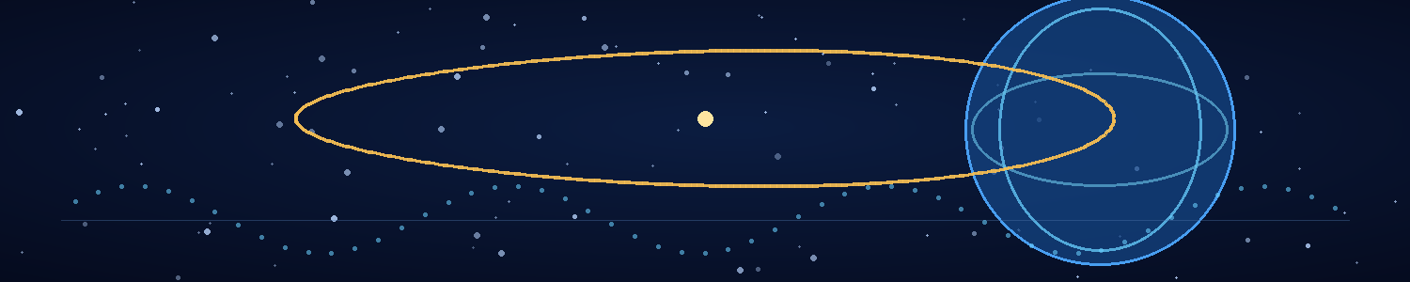

Chapter 10 — The Last Night of Earth
At 21:00, the world still existed.
Adrian wrote that sentence in the log because he could no longer trust a timestamp to explain what it meant. He wrote the date beneath it, then recorded the readings from all four independent clocks. Mira checked the entries without consulting the screens. They sealed the page in a metal case and placed it beside the passive reference record inside AION.
At 21:17, the command network reported that three Veyr platforms had aligned above the Indian Ocean.
At 21:22, every satellite navigation system in the region lost synchronisation.
At 21:31, the national emergency broadcast played a message that had been recorded in a voice Adrian recognised as the president's. The message ordered the population to evacuate inland. Eleven minutes later, the same broadcast played a different version in which the president said there had been no evacuation order.
Mira stood at the console, watching the two recordings' metadata.
“Which one did we hear first?” she asked.
“The first one.”
“How do you know?”
“Because I wrote it down.”
She looked at the paper log. “And if the log changes?”
“Then we will have a record of the change.”
It was not enough. They both knew it.
The Veyr operation was no longer a subtle drift in old archives. It had become a pressure on the world's causal structure. Communications dropped out and returned with altered histories. People arrived at checkpoints carrying orders from commanders who denied issuing them. A medical team called to report casualties from an attack that, according to the local records, had never taken place. Their own memories did not agree with the new records, but memory was a fragile defence against a world insisting that it had always been different.
At 22:05, Captain Ilyan arrived at the calibration vault. His uniform was torn at the shoulder. He carried a hard case filled with printed command logs and a small portable clock.
“The surface command centre is gone,” he said.
“Destroyed?” Mira asked.
“I don't know what that means anymore. One team says the building was hit. Another says it was never built. The people who worked there remember different versions. The site itself is now occupied by a Veyr relay structure.”
Adrian took the hard case. “When did this happen?”
Ilyan looked at the portable clock. “According to this, tomorrow morning. According to the surviving satellite image, three days ago. According to the people who were there, it hasn't happened yet.”
He set the clock on the bench. It ticked steadily, powered by a mechanical spring.
“Why bring this to us?” Adrian asked.
“Because every electronic reference we have is being pulled into the same disagreement. This one doesn't know what time it is, but it doesn't pretend to agree with the others.”
Mira studied the little clock. “It's a useful witness.”
“That's what I thought.”
Ilyan gave them the hard case. Inside were paper maps, handwritten orders, photographs, and a list of people who had been assigned to the temporal defence effort. Several names were crossed out. Others appeared twice, with different ranks and dates of death.
“Can you stop it?” he asked.
Adrian did not lie. “No. We may be able to survive the transition. We don't know if we can stop it.”
Ilyan absorbed the answer without looking away. “Then survive. If anyone can remember what happened, it should be someone who understands the system.”
He offered no farewell. There was nothing to say that would improve the moment. He left to help evacuate the remaining staff from the lower levels, carrying the portable clock with him.
At 22:46, the first Veyr pulse reached the campus.
It did not sound like an explosion. It was a pressure change in the ears, a brief sensation of falling, and then a silence that seemed to have swallowed the hum of the building. The screens went blank. The emergency lights stayed on. The clocks stopped at different times.
Inside AION, the reference bank held.
Adrian watched the boundary trace climb and settle. Mira checked the life-support readouts. Airflow stable. Water reserve intact. Internal pressure normal. The biological monitors recorded two heart rates, both elevated.
Outside, the facility's passive sensors began returning impossible data. The campus was still there, then not there, then a structure with no human power signature. The surface temperature changed in jumps that no weather pattern could explain. A city map on the offline display revised itself, replacing roads with unfamiliar transport corridors.
Adrian opened the external camera feed. It showed the campus entrance under a sky lit by three pale bands of light. The image fragmented. For one frame, the entrance was occupied by soldiers. For the next, it was a Veyr structure built from dark ribs and smooth panels. The image stabilised on the Veyr structure.
Mira's hand found his.
“Don't look away,” she said.
“I need to record the transition.”
“You can do both.”
He turned on the passive recorder. It etched each incoming signal onto a physical storage strip, using the chamber's own clock as its reference. The process was slow and crude. It was also the only record they had that did not rely on an external database.
At 23:08, the first human archive changed.
The local cache of the national census revised its earliest records, then its recent ones. Names vanished from the display. Birth certificates became invalid references. A photograph of Adrian's parents appeared in the cache for less than a second before the file changed to an image of an empty hillside. The system did not show an error. It showed a valid record.
He reached for the screen, then stopped himself.
“It's changing the evidence,” he said.
Mira's voice was quiet. “No. It's changing what the evidence says happened.”
They watched the facility's records become unrecognisable. The research campus was no longer listed as a human institution. Its founding date changed. The underground laboratory appeared in the revised archive as a Veyr observation station established decades earlier. The names of the scientists assigned to the project disappeared one by one.
Adrian found his own name in the personnel database. It belonged to no one. The record displayed a different sequence of characters, then settled on a Veyr designation.
Mira searched for her name. The database returned no match.
She did not search again.
The external camera showed the sky darkening, though the chamber's light sensors registered no corresponding change. The Veyr platforms had aligned into a vast geometry whose points extended beyond the camera's field of view. Each pulse arrived without a visible beam. The temporal model on Adrian's screen described it as a correction to the boundary conditions of the local world.
At 23:41, the lab's external power disappeared.
AION switched to internal reserves. The toroid warmed by half a degree and stabilised. The passive reference record continued.
At 23:53, the surface sensors detected a new atmosphere over the campus. Its composition was breathable by Veyr standards and dangerous to humans over long exposure. The revised environmental archive claimed it had always been this way.
At midnight, the last reliable human broadcast ended.
The voice on the recording was not a politician or a soldier. It was a child reading a message from a school shelter. The recording cut off midway through a sentence. The next file in the sequence contained the same shelter, empty and clean, with a Veyr transit marker above the entrance.
Mira closed her eyes.
Adrian kept watching the instruments. He wanted to look away with her. He wanted to say that it would stop, that the chamber would hold, that the world outside was only temporarily lost. He had no evidence for any of those statements.
The boundary trace began to oscillate.
“Adrian,” Mira said.
“I see it.”
The toroid's phase controller was compensating for a disturbance far beyond the strength of their tests. The chamber did not resist the rewrite by force. It maintained an internal relationship between its clocks, records, and occupants, refusing to accept the external reference as the only valid sequence.
The trace dropped.
Mira reached for the manual control. “We need to reduce the boundary load.”
“If we reduce it too far, the reference may collapse.”
“If we don't, the toroid overheats.”
He studied the readings. The automatic controller was trying to follow the external phase shift, exactly the behaviour they had designed it to avoid. He switched it to manual and adjusted the ring by a fraction.
The oscillation slowed.
For one terrible second, the display showed two versions of the same timestamp. Then the internal clock held.
AION remained.
At 00:14, the transition completed—or seemed to. The external sensors stopped flickering. The camera feed stabilised. The old campus had disappeared beneath the Veyr structure. The city beyond it had become a dark, unfamiliar landscape crossed by lines of cold light.
Adrian checked the passive record. The original timeline remained inside the chamber, preserved in the clock relationships and the written logs. The world outside now described a different history.
Mira looked at the camera feed. “Is it over?”
“I think the transition has settled.”
“That wasn't my question.”
He had no answer that could comfort her. He took her hand and stood beside her while the Stillhouse listened to a world that no longer remembered the people who had built it.
Outside, the Veyr had won a war that the new history insisted had never been fought.
Inside, two humans remembered every minute.

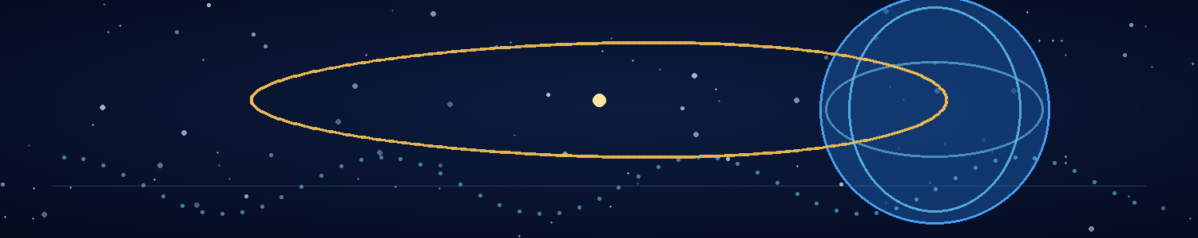

Chapter 11 — Causal Collapse
The world outside the Stillhouse did not end.
It continued.
That was the first cruelty Adrian understood when the sensors stabilised. There had been no final flash, no universal silence, no instant in which the planet ceased to be. The Veyr had not destroyed Earth. They had changed the history that made Earth human.
The camera feed showed a structure rising from the old campus, its dark ribs curving over the ground like the skeleton of an enormous seed. Pale transport lights moved along tracks that had not existed the day before. Beyond it, the city was unfamiliar but not ruined. Towers stood where human buildings had once crowded the horizon, though their shapes were different and their surfaces reflected the sky in muted bands of green and silver.
AION's sensors found air, water, gravity, and a stable planetary magnetic field. The environment was still Earth. The history was not.
Mira sat on the floor beside the life-support rack, arms wrapped around her knees. Adrian had offered her water, then food, then the option of sleeping. She had accepted the water and refused the rest.
“Show me the records,” she said.
He brought up the passive archive.
They had preserved the original timeline as a set of local measurements: handwritten logs, clock relationships, photographs, isolated drives, and the physical record strip. None of those things could prove every detail of the lost world. But together they formed a chain of evidence that the world outside now denied.
The last external archive had been replaced. The campus's history described a Veyr research station that had existed for eighty-three local years. Human civilization was absent from the records. The species database listed no terrestrial hominin line. The city map had no streets, districts, or monuments that Adrian recognised. The planetary environment had been shaped around Veyr settlement and transport.
Mira searched for the names of their colleagues.
Nothing.
She searched for her parents.
Nothing.
Adrian watched her fingers hover over the keyboard, then fall to her lap.
“The absence is consistent,” he said, hating himself as soon as he heard the words.
“Don't turn it into a result.”
He sat beside her. “I'm sorry.”
“I don't need you to explain it.”
“I know.”
They listened to the ventilation system. Inside the chamber, every fan and pump had a sound that had become familiar during construction. The water recycler clicked at the end of its cycle. The air monitor gave a soft double tone. Those small mechanical sounds were evidence that they were still alive in a place built to keep them that way.
Mira opened the last handwritten log from before the transition. The page contained two lines in her writing:
We are afraid.
We are still here.
She pressed her thumb to the paper.
“Do you think anyone else survived?” she asked.
“Not inside a causal boundary like this one.”
“That isn't the same as no.”
“No. It isn't.”
They checked the global sensors. AION had only limited external reach; its instruments had been designed to monitor local conditions, not survey a planet. Still, the passive receiver picked up traffic patterns, energy signatures, and repeated signals from Veyr infrastructure. No human transmissions appeared. No anomalous local reference state matched theirs. The planet seemed to operate according to the new history.
At 03:20, Adrian noticed a discrepancy in the external atmospheric model. The Veyr structures were emitting a narrow band of radiation that did not fit the facility's own revised environmental baseline. The signature resembled the phase pattern recorded during the transition.
“The network is still active,” he said.
Mira came to the display. “The temporal anchors?”
“Possibly. Whatever the Veyr used to establish this history, it isn't just a one-time pulse. The infrastructure is maintaining the new state.”
“Can we disrupt it?”
“Not from here. We don't even know where the anchors are.”
“Then we learn.”
They made a list of what they knew and what they did not. They knew AION had preserved them through the transition. They knew the outside history now denied humanity's existence. They knew the Veyr network continued to emit the same phase signature. They did not know whether the new history was permanent, whether other local boundaries existed, or whether the Veyr could eventually detect the Stillhouse.
The last question was the one Adrian could not ignore. The chamber had remained invisible to the external reference system, but invisibility was not the same as safety. The Veyr might never notice the anomaly, or they might find it the moment they performed a sufficiently detailed survey of the old campus.
Mira read the list.
“We have to leave eventually,” she said.
“Yes.”
“Not today.”
“No.”
She rested her head against the wall. For the first time since the transition, she looked exhausted enough to sleep. Adrian arranged a blanket beside her, then sat at the console and watched the external feed.
The Veyr transit lights moved through the city with calm regularity. Their world was not a battlefield. It was a functioning civilization built on a history in which humanity had never become a problem.
Adrian tried to hate them. It would have been easier if the city looked like a ruin, if the Veyr had left the planet poisoned or dead. Instead, they had built a life there. They had erased one species to secure their own future, and the result looked ordinary from the outside.
At 05:00, Mira woke and found him watching the city.
“What are you thinking?” she asked.
“That the world has no reason to know what happened.”
She sat beside him.
“Then we remember it,” she said.
“And we find a way to make the change reversible.”
She looked at the phase signature on the screen. “The network is holding the history together.”
“If we can disrupt its synchronisation, perhaps the imposed branch won't remain stable.”
“Perhaps.”
“It may be the only way.”
Mira's gaze moved to the sealed biological samples. The pathogen project had been a research question before the transition. Now it was their only possible route back to the world they had lost.
“We need a Veyr biological sample that tells us what the anchors depend on,” she said.
Adrian nodded.
The Stillhouse had preserved two witnesses. It had not preserved a civilization, an army, or even a reliable map. It had preserved enough evidence for them to know that history had been changed—and enough of their work to begin asking how to change it back.
Outside, the Veyr world continued without a single memory of the species it had replaced.

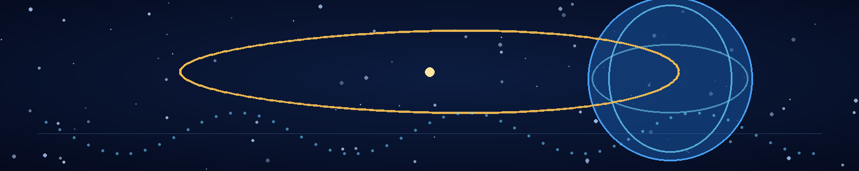

Chapter 12 — The World Outside the Door
They waited thirty-six hours before opening the Stillhouse.
The delay was Mira's decision. Adrian wanted to leave as soon as the sensors showed a stable atmosphere and no immediate threat. Mira insisted that the chamber had been designed to survive a transition, not to guarantee that the transition was finished. They ran the environmental checks twice, tested the manual seal, and listened to the outside through a passive microphone that had no active transmitter.
The city beyond the door produced a steady wash of mechanical sounds. Transport systems. Distant ventilation. A faint harmonic pulse that repeated every forty-seven seconds.
“The same phase signature,” Adrian said.
“Then we don't touch anything until we understand what it might be doing.”
“We can't learn about the network from inside.”
“We can learn enough not to walk into a field that turns our memories into a clerical error.”
He accepted the point.
They packed a small survey kit, two sealed biological containers, a passive recorder, water, and emergency masks. Mira added the seeds from the botanical station. Adrian saw her check the packet twice and chose not to ask about it.
The outer hatch opened with a mechanical groan. Air flowed through the vestibule, passed the filters, and registered as breathable. The smell was the first thing Adrian noticed: mineral dust, warm metal, and something faintly sweet that might have been the vegetation growing along the outside wall.
He stepped onto the old campus.
The ground was still where it belonged. The concrete path had not moved, but it was split by narrow lines of pale material that pulsed in time with the distant harmonic signal. The Veyr structure had grown over the former laboratory entrance. Its surface was smooth in some places, ribbed in others, and covered with shallow geometric patterns that changed when the light moved.
No human debris remained. No broken windows, no discarded equipment, no traces of the campus's former buildings. Even the trees had changed. The old rain trees were gone, replaced by tall, slender organisms with translucent leaves and dark trunks that bent toward the nearest transport corridor.
Mira stood beside Adrian and said nothing.
He had imagined the rewritten world as a battlefield after a victorious army had passed through. It was worse than that. The Veyr had not occupied the ruins of human civilization. They had made a world in which those ruins had never existed.
They moved along the edge of the structure, keeping to the shadow of a collapsed service wall that AION's external camera had shown before the transition. The wall was no longer part of a human building. It had become a low retaining feature beside a Veyr transit lane. Adrian marked the position on their paper map, using the chamber as the only reliable origin point.
A transport passed overhead without sound. Its underside carried a series of dark modules connected by thin luminous lines. One module pulsed in the same phase pattern as the external infrastructure.
“Biological cargo?” Mira whispered.
“Could be.”
“Or a power system.”
“We won't know until we observe it more closely.”
They found the first living Veyr at a transit junction. It was taller than the captured organism from the original timeline, or perhaps the perspective was different. Its body was covered by a fitted layer of flexible material that moved with the ridges beneath its skin. It carried no visible weapon. It paused at a wall panel and pressed one hand against a recessed surface. The panel brightened, and a route appeared in the air above it.
Mira recorded the interaction through a passive optical lens.
The Veyr did not appear to be monitoring for human life. There were no patrols sweeping the area, no search lights, no visible security perimeter around the old campus. The Stillhouse had not registered as an enemy installation. It was simply an unrecognised space within a city that had no reason to expect humans.
That could change.
They returned to the chamber before the local light cycle shifted. Inside, Mira examined the images while Adrian compared the transit pulse with the old navigation unit's phase signature. The match was not exact, but the underlying pattern was unmistakable.
“The network isn't just in orbit,” he said. “It runs through the infrastructure.”
“Distributed anchors,” Mira said. “A city-scale system, maybe larger.”
“Or the city is one node in a wider network.”
She opened the image of the transport's underside. The dark modules had the same repeating geometry as the material recovered from the crashed Veyr craft before the timeline changed.
“If the system depends on biological coordination,” she said, “we may be able to interfere with it through the pathogen.”
“We still don't know whether the biological dependency is part of the anchor network or just a feature of the species.”
“Then we need a sample from a living Veyr.”
“Without alerting the city.”
“Exactly.”
The next survey took them farther from the old campus, to a maintenance area where the transit lane entered a broad structure built around a pulsing central column. They observed workers moving sealed containers from a vehicle into a receiving bay. The containers were marked with a repeating symbol that resembled the Veyr protein pattern Mira had isolated in the original timeline.
She zoomed the image. “That symbol could be a cargo category.”
“Or a warning.”
“Or a routing marker. We don't have a translation.”
One of the containers opened briefly during transfer. A Veyr worker placed a hand against its interior surface. A faint pulse moved through the worker's arm and into the container's lining. The worker paused, then continued the transfer.
Mira lowered the recorder. “There. Did you see the response?”
“Yes.”
“The worker and the container exchanged a signal.”
“Possibly.”
She gave him a warning look.
He amended the sentence. “The recording shows a response travelling from the worker's contact point into the container lining. We need a better view before we decide what it means.”
“Thank you.”
They returned with no sample and no proof, only observations. It was less than either of them wanted, but more than they had when they opened the door.
That night, Mira began a new research plan. She would not design a pathogen from the old data alone. The Veyr in this history might differ biologically from the Veyr they had studied before the transition. Their evolution had followed a different chain of events, and the technology that maintained the rewritten timeline might have altered the relationship between organism and infrastructure.
“We need to establish continuity,” she said. “Same species, same dependency, same response. If we assume the old data transfers perfectly, we could miss a change that makes the pathogen useless.”
Adrian reviewed the network recordings. “And I need to identify the anchor synchronisation pattern. If the pathogen works, it has to disrupt something that matters to the timeline, not just make the Veyr ill.”
Mira looked at him. “Then we're not building a disease. We're trying to find the system's point of failure.”
“That's a less alarming description.”
“It's also more accurate.”
They set the first task for the next survey: obtain a tiny, nonlethal biological trace from a Veyr transit worker or from a surface recently touched by one, without exposing themselves or the Stillhouse. The second task was to map the pulse from the transit infrastructure and compare it with the original navigation record.
The work would be slow. They had no laboratory staff, no supply chain, and no assurance that the Stillhouse would remain hidden. Every excursion risked revealing that the rewritten world contained two people it had deleted.
Mira placed the seed packet on the shelf beside the research notes.
“One day,” she said, “we should plant these.”
Adrian looked at the sealed chamber, the alien city, and the little packet of seeds.
“One day,” he agreed.
They closed the hatch and returned to work.
A minute later, the passive recorder chimed. It had logged the next synchronisation pulse forty-seven seconds before the signal itself arrived.
Mira read the trace twice. “Either the node is changing its own record,” she said, “or it knows what it's about to do.”

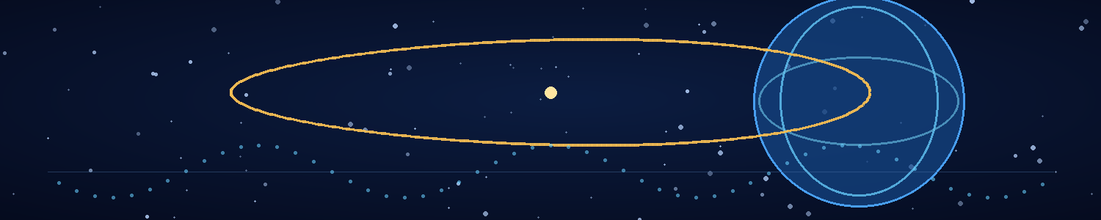

Chapter 13 — The Empty Earth
Adrian learned the new world by measuring what it did not contain.
The first week, he mapped the streets around the old campus. The second, he traced the transit signals to a tower that relayed timing pulses across the region. By the third week, he could predict the movement of the overhead transports within a margin of several minutes. He kept the records on paper and stored the original data strips in a sealed case inside the Stillhouse.
The map became more accurate. The absence did not become easier.
There were no human voices in the broadcasts. No human names in the public archives. No familiar music drifting from a window, no handwritten signs, no schoolchildren being hurried across a street by someone late for work. The Veyr had built a functioning world, and the world's ordinary details were the evidence that the rewrite had worked.
Adrian had expected grief to arrive as a single event. Instead, it came as an inventory. A hospital where his mother had once waited through a night shift was now a Veyr medical exchange. A coastal road he remembered from childhood had become a transport channel. The town where he had learned to ride a bicycle had no place in the current map, because the chain of human settlements that produced it had never existed.
He could remember the world. He could not find a single external fact that confirmed it.
Mira returned from a survey with a recording of Veyr workers tending a broad bed of pale, rootlike organisms beneath a transit station. She played the clip twice, then stopped it on a frame where a worker touched a pulse node.
“They're maintaining something,” she said. “Not just using it.”
“The network could require regular calibration.”
“Or the biological component is alive.”
“Both could be true.”
She sat at the bench and removed her gloves. “I keep thinking about the people we lost.”
“They didn't die in this history.”
“That doesn't make them less lost.”
Adrian had no answer. He knew the distinction she meant. Death left a body, a date, a place in the record. This was an absence that could not be visited or mourned by anyone but them. The people they loved had not been killed by the rewrite. Their lives had been prevented from ever being lived.
Mira opened the passive archive and searched for the last broadcast from the school shelter. The file played in the chamber, a child's voice reading a message about a missing blanket and a teacher who had promised to come back. It ended in static. The revised world contained no trace of the shelter, the teacher, or the child.
Mira stopped the recording.
“If we only remember them, then the Veyr still get what they wanted,” she said.
“Not everything.”
“They've removed every consequence of their existence. No one can judge what they did because no one else can know it happened.”
“We can.”
“Two people in a room. That's not justice.”
“No,” Adrian said. “But it is evidence.”
She looked at him, angry and exhausted. “You always want to make the smallest thing sound sufficient.”
“Because it's the thing we have.”
The words hurt because they were true. The Stillhouse had preserved them, not the world. It had kept a record of the original history, not a way to prove that history to anyone outside the chamber. They could not show the Veyr an archive and expect it to overturn the world. They could not ask a court to recognise crimes that had no victims in the current causal sequence.
They could only act.
That night, Adrian watched the transit network's timing pulse. The signal travelled from node to node, repeating a pattern that matched the phase signature from the original invasion. The Veyr had embedded their temporal infrastructure into ordinary life. It regulated transport, environmental systems, biological hubs, and perhaps the stability of the rewritten history itself.
Mira joined him at the console.
“I found the same pattern in the biological tissue,” she said. “Not identical, but related. The organism's cells respond to a narrow timing window. If the signal falls outside it, the repair network begins to lose coordination.”
“Could that be a vulnerability?”
“Maybe. But we need to test it on current samples. We can't assume the old Veyr and this version are biologically identical.”
Adrian pointed to the network map. “If the infrastructure depends on that coordination, the virus could affect the anchors.”
“Or it could only make them sick.”
“Or do nothing.”
She smiled without humour. “Now you're learning to be cautious in an interesting direction.”
He saved the new data. The plan remained uncertain, but for the first time the world outside offered them more than a landscape of absence. It showed them a system. A system could be measured, and what could be measured might have a failure mode.
Before sleeping, Mira wrote a new line in the paper log:
The world outside is not empty. It is full of evidence that we have been erased.
Adrian read the line and added one beneath it:
Evidence can still be used.

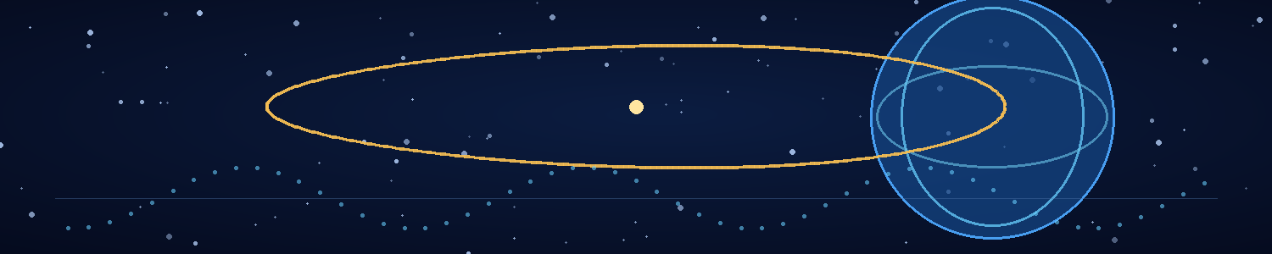

Chapter 14 — Ghosts in the Laboratory
By the second month, the Stillhouse had developed the rhythms of a small, difficult household.
The air recycler needed a filter change every eleven days. The water system made a clicking noise when its mineral cartridge began to clog. The toroid's cooling pump vibrated at a frequency Adrian could recognise from the other side of the room. Mira had labelled the storage drawers with the names of ordinary things rather than inventory codes: food, clean clothes, medical, things we hope not to need.
The last drawer contained spare fuses, a manual seal kit, and a folded photograph of the two of them taken before the transition. The image had been printed from an old lab camera. In it, Mira was laughing at something outside the frame while Adrian looked at her instead of the camera.
They had not discussed the photograph. They did not need to.
Isolation changed them in ways neither could measure. Adrian began to speak aloud while working, narrating his calculations as if an invisible colleague might catch a mistake. Mira started keeping a daily list of things she could smell, hear, or touch beyond the lab: wet stone, hot dust, the vibration of a transport, the rough bark of a Veyr-grown tree. The lists were not scientific records. She kept them anyway.
They argued about the survey schedule, the risk of detection, the limits of their food reserves, and whether Adrian's insistence on calibrating every instrument before breakfast was a symptom of a deeper disorder.
“It is not a disorder,” he said.
“It's a ritual.”
“Rituals are repeatable procedures.”
“That's not a defence.”
He smiled, but she did not. The argument had started over a minor fault in the external receiver and drifted into the larger question neither wanted to ask: how long could two people remain inside a room while the world outside lived without them?
The answer was not in the life-support estimates. AION could keep them physically alive for months, perhaps longer with strict rationing. But the boundary-control system consumed more power than the original design predicted. Every external survey forced the chamber to re-establish its causal reference. The toroid had survived the transition, but the control lattice was slowly accumulating stress.
Adrian showed Mira the latest maintenance forecast.
“How many more excursions?” she asked.
“At the current rate, one safe mission. Maybe two if the field stays stable.”
“Maybe?”
“I won't promise a number the data can't support.”
She looked at him with the same expression she had used before the first test. “Then we need to decide what the last mission is for.”
They had spent weeks collecting observations, mapping transit nodes, and comparing the Veyr biological signals with the temporal network. The evidence now suggested that the anchor infrastructure was not maintained by machines alone. Living organisms, or biological systems derived from them, appeared to regulate the phase relationship between nodes. The Veyr's technology and biology were entangled in a way that made the civilization efficient—and potentially vulnerable.
But the samples they had gathered were only surface traces. They had not obtained a living tissue specimen from a current Veyr organism. They had no way to test whether a pathogen could interrupt the coordination network without killing indiscriminately. They also lacked a complete map of the temporal anchors.
“We need one living sample and a better view of the central node,” Mira said. “If the biological response is the same as in the original timeline, I can narrow the pathogen target. If it's different, we stop and rethink.”
“And if we find the central node?”
“We learn whether it is a relay, a regulator, or the anchor itself.”
“And if the field destabilises while we're outside?”
“Then we return to the Stillhouse.”
“Unless the return route is affected.”
Mira held his gaze. “There is no zero-risk option left.”
He hated that she was right. He hated more that the choice was not between danger and safety, but between a risk they could describe and a future in which the Veyr's rewritten history became permanent.
That evening, they reviewed the chamber's remaining reserves. Water was sufficient. Food could be stretched. The air system was stable. The boundary-control lattice was not. AION could probably survive one more major phase disturbance, but the second might fracture the superconducting ring beyond repair.
Mira placed the packet of seeds on the table between them.
“I want us to plant these before we go,” she said.
“Why?”
“Because if we come back, I want one thing outside this room that isn't a Veyr system.”
“Plants need soil, water, and time.”
“Yes, Adrian. That's why they're plants.”
They found a narrow patch of ground behind the Stillhouse, where the Veyr's new vegetation had not covered the old retaining wall. Mira pressed the seeds into the soil while Adrian held a small water container. They marked the spot with a piece of inert metal that could not transmit a signal.
The seeds might never germinate. The soil might not support them. The Veyr's environmental systems might remove the patch during routine maintenance. It was an act without a reliable outcome.
Mira brushed the dirt from her hands.
“There,” she said.
“What does it prove?”
“Nothing.”
He waited.
“It means we did something that wasn't about surviving the next hour.”
He understood then that the Stillhouse was becoming a trap in more ways than one. Its systems protected their bodies and memories, but the room could also shrink their world until every choice became a calculation about how to remain inside it. They could survive indefinitely and still allow the Veyr to win by never leaving.
Adrian closed the maintenance forecast.
“One mission,” he said. “We get the sample, map the central node, and come back.”
Mira nodded. “And then we decide whether the virus can reach the network.”
They returned to the lab. The external receiver showed the central pulse repeating across the city, steady as a heartbeat.
The Stillhouse had one more journey left to spend.
They needed to make it count.

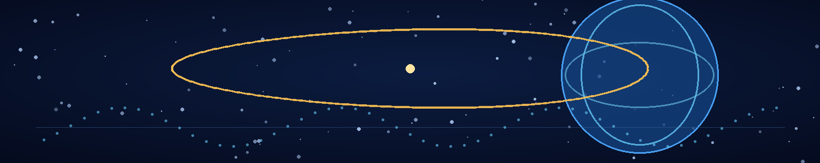

Chapter 15 — The Veyr Colony
The central node stood inside a district that the Veyr maps called a living exchange.
Adrian and Mira reached it during the low-traffic phase, when the transport lanes dimmed and most of the nearby maintenance activity moved indoors. They had spent the previous day studying the pulse pattern from the Stillhouse, identifying the brief interval when the node's external signal dropped below the local noise floor. The interval lasted twenty-two seconds. They would have one chance to cross the service court, collect a biological sample, and return before the next synchronisation pulse.
They carried no active transmitter. Their instruments were optical, mechanical, or powered by isolated batteries. Mira wore a sealed field layer with a small sample cartridge at the wrist. Adrian carried the passive recorder and a compact phase detector assembled from parts salvaged from the Stillhouse.
The city was quiet in a way the old Earth had rarely been. Veyr transport moved without engines. The pale structures along the lane pulsed in a slow rhythm, their surfaces brightening as vehicles passed. There were no visible crowds, no advertisements, no human signs of urgency. The infrastructure appeared to anticipate demand and adjust before congestion formed.
“Efficient,” Adrian whispered.
“Don't compliment it,” Mira said. “It erased us.”
“I can acknowledge a system's function without endorsing its purpose.”
“You really can make anything sound like a committee meeting.”
They reached the service court as the central pulse fell. The node was not a single machine. It was a cluster of dark columns connected by flexible, rootlike conduits that disappeared into the ground and into the walls of adjacent structures. At the base of each column, a translucent membrane expanded and contracted with the signal. Tiny points of light travelled through it in repeating sequences.
Mira crouched behind a maintenance housing and focused the optical lens. “The membrane is alive.”
“Or made from living tissue.”
“The distinction matters.”
“Not to the instrument.”
“It matters to the conclusion.”
The node emitted a faint vibration. Adrian's phase detector registered the same signature as the original navigation unit, but the pattern was richer here, with multiple frequencies locked into a single cycle. The signal moved from one column to the next, then returned through the conduits as if the structure were checking its own state.
A Veyr worker entered the court carrying a shallow container. It placed the container against the membrane and waited. The membrane brightened. A narrow filament extended from its surface and touched the worker's wrist. For a moment, the worker and node pulsed in synchrony. Then the filament withdrew, and the worker carried the container away.
Mira's eyes sharpened. “There. Direct exchange.”
“Could be maintenance authentication.”
“Could be biological regulation. The worker's tissue responded to the node before the signal completed.”
“Can you prove that from this distance?”
“No. But I can collect a sample.”
The next synchronisation interval approached. They moved along the service housing until they were within reach of a conduit that had separated from the main cluster. A thin film covered its outer surface. Mira extended the sampling tool and touched the film with a sterile tip.
The detector chirped once.
The conduit pulsed.
Adrian grabbed Mira's shoulder and pulled her back behind the housing. A ripple of light passed across the node. The central columns dimmed, then brightened in sequence. For a fraction of a second, the phase detector displayed the same temporal discontinuity that had appeared in AION during the transition.
“Did it register us?” Mira whispered.
“I don't know.”
“Did we get the sample?”
She checked the cartridge. A faint residue clung to the tip. It was enough for a preliminary analysis, perhaps not enough for a full biological profile.
The service court's lights changed. A Veyr worker turned toward the conduit and placed a hand against the membrane. The pulse stabilised. The worker remained still for several seconds, then resumed its task.
Mira exhaled slowly. “It noticed a disturbance.”
“Maybe. We cannot assume it noticed us.”
“Agreed. We have our sample. We leave.”
They crossed the court during the next lull and returned to the Stillhouse without encountering another worker. The boundary-control lattice strained as they re-entered. One of the internal clocks slipped, and the toroid temperature rose sharply before Adrian's manual adjustment restored the reference state.
When the hatch sealed, neither spoke for a full minute.
Then Mira placed the sample cartridge inside the biological isolator.
The analysis took hours. The residue contained a mixture of synthetic polymers, living cells, and engineered particles similar to those found in the Veyr's repair system. The cells were not simply part of the node. They appeared to maintain a narrow timing response, exchanging phase information with the material around them.
Mira overlaid the new data with the original Veyr tissue profiles.
“The dependency is real,” she said. “Not proven to be identical across every Veyr system, but the same family of response is present.”
“Could a pathogen target it?”
“Potentially. The virus would need to bind to a Veyr-specific receptor and disrupt the synchronisation pathway without relying on a single mutable surface feature. It also needs a delayed onset so infected carriers can move through the network before symptoms trigger screening.”
“Can you make that?”
“I can design a candidate. I can't promise it will work.”
Adrian looked at the transit map. “If the pathogen spreads through Veyr personnel and biological cargo, the FTL network could carry it across their colonies before the outbreak is recognised.”
“Correct. The ships are transport, not magic. Infected carriers move between systems; the network makes the journey fast enough for the infection to outrun the response.”
“And once it reaches enough nodes?”
“If the biological synchronisation system is essential to the anchors, widespread disruption could destabilise the rewritten history.”
“Could.”
“Must stay a could until we have evidence.”
She saved the analysis to the isolated archive. The sample had given them the first real connection between the Veyr's biology and the temporal infrastructure. It had not yet given them a weapon.
Adrian studied the node map. “Where should the pathogen enter the network?”
“Wherever it can spread without being stopped.”
“That answers logistics, not causality. If we release it in this history, it may damage the colony without restoring the old timeline. We need to reach the network at a point where its failure can undo the rewrite.”
Mira turned from the scanner.
“Then we don't deploy it here,” she said. “We deploy it before the invasion.”
The idea changed the room. Until that moment, the pathogen had been a way to attack the Veyr's present infrastructure. Now it could become a means of preventing the temporal operation from ever succeeding.
Adrian looked at the Veyr phase signature, steady and repeating on the screen.
“If we can reach the earlier history,” he said, “we can put the virus into their network before it targets Earth.”
“And let their own transport system carry it.”
They had a direction at last. The remaining problem was the most dangerous one: whether they could reach the right moment without being lost in the process.

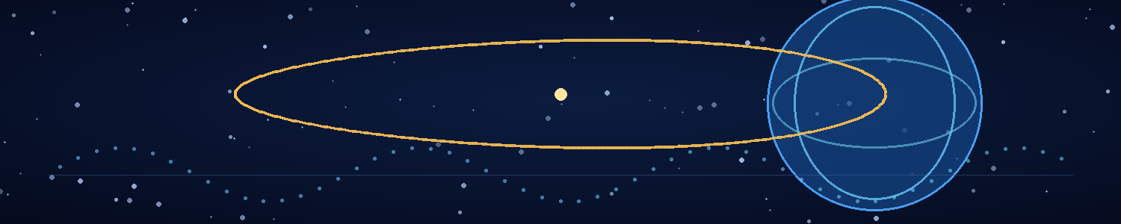

Chapter 16 — The Virus
Mira named the candidate LANTERN because she wanted a word that meant guidance rather than death.
Adrian said it sounded like a project that would eventually be renamed by a committee. Mira replied that if they survived long enough for a committee to rename it, the name would have served its purpose.
The work took nine days.
She built the candidate from the biological evidence they had gathered: the original Veyr tissue data preserved inside AION, the current colony sample, and the timing response measured at the central node. The design depended on a combination of Veyr-specific molecular recognition and a disruption pathway that would not activate in ordinary terrestrial cells. It was not intended to destroy every cell it encountered. Its intended effect was to interfere with the Veyr's synchronised repair and signalling system, leaving the organism increasingly unable to coordinate the processes on which its advanced biology depended.
The candidate remained a model until the final day. Mira tested its predicted binding against both sets of Veyr data, then tested the model against a library of human molecular structures. It showed no obvious route to binding human cells, but the library was incomplete and the model could not prove universal safety. She recorded the uncertainty in the first line of the report.
Adrian read it.
“You're leading with the risk.”
“It's the first thing anyone should know.”
“Command would have hated that.”
“Command isn't here.”
The Stillhouse was silent except for the air system and the cooling pump. Their remaining supplies had been reduced to a careful schedule. The boundary lattice was stable at low load, but the last external mission had left a permanent shift in one superconducting ring. Adrian could compensate for it, not repair it. The chamber could survive another transition if the field behaved within the model. It could not survive an uncontrolled failure.
Mira finished the first viable candidate and sealed it inside a triple containment capsule. It was not a weapon ready for release. It was a tightly controlled research sample whose intended use depended on a chain of events they had not yet achieved: temporal transit to the earlier history, delivery into a Veyr biological carrier, and spread through the civilization's FTL logistics network before the Veyr recognised the outbreak.
“If we deploy it in the wrong place,” she said, “it may kill organisms and change nothing about the timeline.”
“If we deploy it too early, the Veyr might detect it and develop a countermeasure.”
“If we deploy it too late, the anchor network may already have stabilised the rewritten branch.”
Adrian opened the temporal model. “We need the point at which their network is vulnerable but the invasion hasn't begun.”
Mira sat beside him. “Can the model identify that?”
“It can narrow the interval. It can't tell us what happens if we intervene.”
“Then we have to make the best choice we can.”
He was not ready to say that. For years, he had treated uncertainty as a temporary condition that more data could remove. Now the only path forward required an irreversible decision based on incomplete knowledge.
He studied the recovered Veyr temporal device. Its navigation system had survived in pieces, and the Stillhouse had preserved enough of its internal phase pattern to reconstruct the control logic. The device did not travel freely through time. It selected a destination state by locking onto a causal reference and resolving a path through the Veyr network's temporal coordinates. Without a stable anchor, the destination could drift.
AION could supply a reference state. That was the purpose of the Return Interlock: a coupling between the chamber's causal record and the Veyr device's destination mechanism. It was intended to bring any traveller back to the Stillhouse's local reference if the temporal transit failed to resolve.
But the recovered manual contained a warning that Adrian had not fully understood.
INCOMPATIBLE TRAVELLER: RETURN TO NEAREST STABLE CAUSAL ANCHOR.
He read it again.
“Nearest stable anchor,” he said.
Mira looked up. “What does that mean?”
“It may not mean AION. It may mean the nearest stable reference recognised by the Veyr system.”
“Which could be the destination period.”
“Or a Veyr network node. Or the last point the device can reconcile with the traveller's causal signature.”
Mira stared at the device. “So if it rejects us, it could return us somewhere else.”
“Yes.”
“Could it send me back to the invasion?”
“Possibly.”
“Could it strand me in the wrong history?”
“Possibly.”
She sat back. For the first time in days, the risk was no longer a number on the boundary display. It was a place she might be sent without him.
Adrian opened the interlock's control sequence. He could try to rewrite the return condition, but he did not know whether the Veyr device would accept the change. A faulty modification could prevent the jump entirely—or send the traveller into a causal state from which there was no return.
“We can test the interlock with an inert marker,” he said.
“And if it works?”
“We test it again.”
“And if it fails?”
“We don't use the device until we understand why.”
Mira looked at the capsule containing LANTERN. “How many tests do we have time for?”
He did not answer.
They ran the inert test. A small ceramic marker, tagged with AION's local reference signature, passed into the device's transit field and disappeared for 0.2 seconds by the chamber's clocks. It returned to the platform with a surface temperature change and a phase record that matched the expected displacement. The return condition had held.
The second test used a marker with a deliberately altered reference signature. The device rejected it, and the marker reappeared at the nearest stable point within the chamber's own field boundary. The test confirmed that the Return Interlock was not a simple recall mechanism. It sought a stable causal anchor compatible with the traveller's reference state.
“That gives us a safety margin,” Adrian said.
“It gives us a warning,” Mira replied. “The marker is not a person. We still don't know what the device will do with a living traveller.”
“Agreed.”
She placed the LANTERN capsule inside the transport container. “Then we need to decide who goes.”
He felt the answer before she said anything. The temporal device could only carry one traveller with the available power reserve. AION could preserve the remaining reference record, but the return path was uncertain. The virus had to be delivered into the earlier timeline, and someone had to choose the exact moment and place.
“I'll go,” Mira said.
“No.”
“Adrian—”
“I understand the biology. I can carry the sample and follow the deployment plan.”
“You understand the equations. You don't understand the pathogen's failure modes as well as I do.”
“You designed it. You can teach me.”
“Not enough. If the sample behaves differently in the earlier timeline, I need to recognise it. If the delivery fails, I need to decide whether to retry or abort.”
He searched for another argument. Every one he found was a way to protect her by pretending the mission could be done without her.
Mira softened her voice. “I'm not saying this because I want to leave you. I'm saying it because I'm the person who can give the mission its best chance.”
He looked at the Return Interlock warning.
“Then we make sure the device knows where to bring you back,” he said.
“Can you?”
“I don't know.”
She reached for his hand. “That's honest.”
He held it, feeling the warmth of her fingers and the terrible fact that their future now depended on a machine built from an enemy's damaged technology.
The virus was ready as far as they could make it ready.
The destination was not.

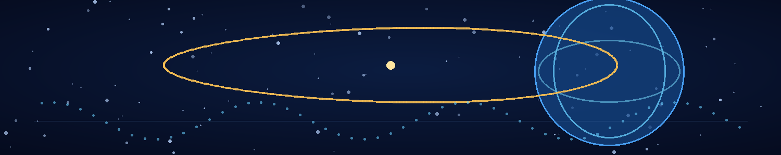

Chapter 17 — The Door
The Veyr temporal device had no door.
It was a ring of dark material suspended above a platform, with three nested arcs that rotated at different speeds. Fine markings ran along the inner surfaces. Some glowed when Adrian activated the control sequence; others remained dark, as if the machine were waiting for an input it had not yet received. The recovered device had been designed for a Veyr operator, and its controls assumed a biological reference pattern the humans could only approximate.
Mira stood on the platform, studying the ring.
“You're certain the destination window is before the invasion?”
“As certain as the model allows,” Adrian said. “The strongest stable anchor we can resolve lies several months before the first recorded hostile arrival at Earth in the original timeline. The local sky should be clear. No human detection system should have any reason to look for them.”
“Where will I emerge?”
“Above Earth. The device's spatial solution is less stable than its temporal one, but the model places you in high atmosphere, outside ordinary air traffic. You'll need to correct your position before entering the atmosphere.”
“Can the suit handle it?”
“For a short period. We have one descent package, and the guidance system is manual.”
Mira gave him a tired smile. “You do know how to make a person feel wanted.”
“I want you here.”
The words stopped both of them. Adrian had said them plainly, without a qualification or a model to hide behind.
Mira stepped down from the platform. “I want to be here too.”
He wanted to tell her not to go. He wanted to dismantle the device, seal the capsule, and find another route that did not require one of them to step through a machine they barely understood. But the Stillhouse had one viable external mission left, the anchor network was holding the rewritten history together, and the only plausible way to restore the original timeline was to introduce LANTERN before the Veyr operation began.
The virus could not be deployed into the present and expected to undo the past. It had to reach the Veyr civilization before their temporal attack on Earth. The pathogen would travel inside infected Veyr carriers, then spread through the FTL logistics network as crews and biological cargo moved between systems. If the synchronisation dependency was as central as their evidence suggested, the outbreak could destabilise the distributed anchors before the rewritten history became self-sustaining.
Could. Not would.
Mira returned to the platform and checked the capsule seal. “We should be precise about the objective. I infect one carrier or biological shipment, verify the first transfer, and then leave the system. I don't stay to watch the outbreak.”
“Agreed.”
“If I can't reach a suitable carrier without exposing myself, I abort.”
“Agreed.”
“If the destination is wrong, I return immediately.”
Adrian hesitated. The Return Interlock could reject her reference state and route her to a different stable anchor. They had adjusted the controller, but there was no guarantee that the device would obey their modification.
“If the destination is wrong,” he said, “you use the interlock. Don't try to correct a bad jump from inside the field.”
“And if the interlock sends me somewhere else?”
“You find the nearest stable reference and try again.”
“That could be years away.”
“I know.”
She studied him. “You're trying to turn goodbye into a procedure.”
“It's the only way I know how to make it useful.”
“Then make the procedure useful. Don't make it a substitute for saying what you mean.”
He looked down at their joined hands. “I love you. I don't want you to go. I also know that if we do nothing, the Veyr keep a history in which neither of us ever existed. I won't ask you to stay just so I can be less afraid.”
Mira closed her eyes for a moment. When she opened them, they were wet.
“I love you too,” she said. “And I'm afraid. But I can live with fear better than I can live with knowing we had one chance and refused to take it.”
They spent the next hours checking the destination sequence. Adrian loaded the Stillhouse's local reference into the interlock and added a physical override that would force the device to attempt a return to the chamber before resolving any secondary anchor. He could not guarantee the override would be accepted, but it was a better safeguard than the original configuration.
Mira memorized the emergency sequence. She carried the LANTERN capsule in a shielded container, along with a compact biological sampler, a manual timer, and a paper card listing the deployment criteria. No networked device would accompany her. If the rewritten history altered electronic records, the paper card would remain a record of what she had intended to do.
At the final test, the ring brightened and a thin distortion appeared in the air above the platform. The sensors recorded a local phase discontinuity. For a fraction of a second, the chamber's external camera showed a sky filled with stars that did not match any position in the current celestial map.
Then the distortion closed.
Mira watched the trace. “That was the destination?”
“A preview of the boundary condition. Not the destination itself.”
“Can I see it again?”
“Not without stressing the ring.”
She nodded. “Then we don't.”
The room seemed smaller after the test. Every object had become part of the departure: the table where they had planned the virus, the clocks that had kept their memories intact, the seed packet waiting by the hatch, the photograph in the drawer. Adrian wanted to memorize every detail. He knew that memory could not protect him from loss, but he did it anyway.
Mira put on the transit suit. She checked each seal herself, then let Adrian check the back of the neck ring. Their hands brushed at the clasp.
“If I don't return,” she said, “don't spend your life inside this room.”
He could not answer immediately.
“Adrian.”
“I'll search for you if there's a way. If there isn't, I'll make sure the record survives.”
“And if you find me in a history where I don't know you?”
“Then I'll introduce myself.”
She laughed through the tears. “You'd be terrible at it.”
“I have a very good research record.”
“You have a terrible opening line.”
He pressed his forehead to hers. For a moment, neither moved.
Then Mira stepped onto the platform.
The ring began to rotate. The control surface recognised the biological reference pattern and opened a narrow window through the local causal boundary. The chamber clocks registered the field's formation. The Stillhouse's passive record started a new line.
Adrian stood at the console, one hand on the manual override.
“Destination confirmed,” he said.
Mira looked at him through the distortion. “I'll see you on the other side.”
The field brightened until he could no longer see her face.
Then the platform was empty.
The clocks continued to run. The chamber remained stable. The Return Interlock displayed a single status line:
TRAVELLER IN TRANSIT — CAUSAL ANCHOR UNRESOLVED
Adrian did not move until the line disappeared.

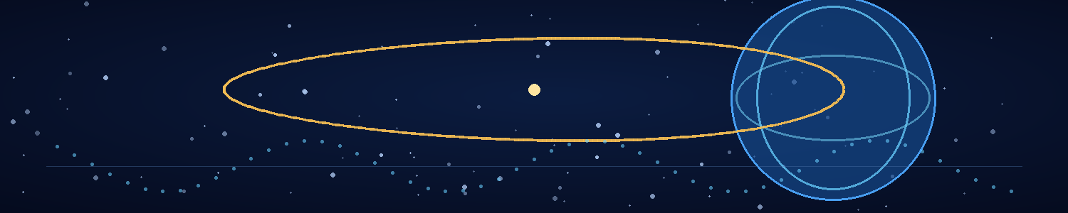

Chapter 18 — Two Humans Against a Universe
The Stillhouse had never been so quiet.
Adrian monitored the passive return channel for six hours, though the device's power reserve could sustain an active field for only a fraction of a second. He watched the reference clocks, the passive record, and the empty platform. Each system continued to report that the chamber was stable. None could tell him where Mira was.
He shut the ring down to conserve the remaining power.
AION's boundary remained intact, but the temporal device had consumed most of the energy available for another jump. The return system was not a promise. It was a conditional route that might work if the destination's causal state remained compatible with Mira's reference. The only action Adrian could take now was to preserve the record and wait for a signal.
He began a new log.
Mission departure confirmed by local clocks at 14:02:11.
Traveller: Dr. Mira Vale.
Destination: pre-invasion Earth, high atmosphere, exact date uncertain within the model's confidence interval.
Objective: introduce LANTERN into Veyr biological logistics before the temporal operation begins.
He stopped, then added:
I love her. This is relevant to the record.
He sealed the page.
The mission depended on a chain of conditions. Mira had to arrive in the correct period. She had to avoid detection while the planet remained unaware of the Veyr. She had to find a carrier or biological shipment connected to the civilization's FTL network. The pathogen had to survive the transit and establish itself without triggering immediate screening. The infection had to spread far enough to reach the temporal anchor infrastructure. And the network had to fail in a way that released the imposed history rather than simply damaging the Veyr civilization in the new timeline.
Every step contained uncertainty. They had tested none of the complete sequence.
But doing nothing was not neutral. Doing nothing allowed the rewritten history to become the only history.
Adrian reviewed the LANTERN design one last time. Mira had written the limitations in plain language. The candidate was specific to the observed Veyr biological system, not guaranteed to affect every member of the species. The onset was intended to be delayed, but its actual incubation period in a living carrier was unknown. The pathogen could be detected, neutralized, or rendered ineffective by differences between the old and rewritten timelines. It might damage the biological anchors without collapsing the temporal network.
The document did not pretend those risks were small.
At 18:30, the external receiver registered a faint phase pulse from the Veyr network. Adrian compared it with the pre-departure baseline. The pattern had changed by less than one percent, well within the range of ordinary variation. He saved it anyway.
At 22:00, he played the last recording Mira had left behind. It was not a message. It was a calibration check: her voice reading a list of numbers while the temporal device recorded her reference signature. At the end, she said, “If you hear this, the machine has done something interesting. Please don't call it a miracle.”
He listened twice.
Then he returned to the control console and began modelling the restoration problem. If the network failed, the imposed history might collapse toward the last stable causal branch. AION's record could identify the original branch, but it could not force the universe to select it. The restoration would depend on whether the Veyr's anchor network had overwritten history or merely stabilised a competing solution.
Adrian could not resolve the question from the chamber.
He wrote two possible outcomes in the log.
Outcome A: the anchor network loses coherence. The imposed branch fails to remain stable, and the original timeline reasserts itself.
Outcome B: the network is damaged but the imposed branch remains stable. The Veyr civilization survives in the rewritten history; the mission has failed to restore humanity.
He left space beneath the second line for a third possibility.
At 03:17, the ring's passive sensor recorded a brief phase fluctuation. It was too weak to establish a return attempt, but its pattern resembled the interlock's handshake. Adrian brought the system online for twelve seconds, then shut it down before the reserve fell below the minimum needed to preserve AION.
No traveller appeared.
He saved the trace and compared it with Mira's departure signature. The match was partial. It could have been a reflection from the network, a local instability, or the beginning of a return handshake that had failed to resolve.
For the first time since the transition, Adrian felt the temptation to invent certainty. He wanted the trace to mean she was alive. He wanted it to mean the mission was working. He wanted it to mean that the future was not a closed system and that love, by some hidden physical law, could leave a signal strong enough to follow.
He wrote none of that in the report.
Instead, he documented the measurement, its uncertainty, and the next observation that might distinguish between the possible explanations.
Then he sat on the floor beside the empty platform and let himself grieve without trying to convert the feeling into data.
Hours passed. The Stillhouse hummed around him. Outside, the Veyr city continued its calm cycles. Somewhere beyond the chamber's reference boundary, Mira was moving through a history that had never known the war they remembered.
Adrian had no way to see her. No way to speak to her. No way to know whether she had reached the sky above Earth, whether the descent package had worked, or whether she had found the opening in the Veyr logistics network they had spent so long trying to understand.
He could only preserve the conditions for her return.
Before dawn, he rose and returned to the console. The ring remained dark. The reference clocks were stable. The passive record continued to accumulate the world's unremembered history.
He opened a new page and wrote:
The mission is not complete until the causal outcome is known.
Then, beneath it:
I will not confuse waiting with surrender.
He sealed the page and turned toward the external receiver.
The first sign that history was changing would not be a voice or a face. It would be a small disagreement in the clocks—a shift in the world that had no reason to occur.
Adrian would be watching.

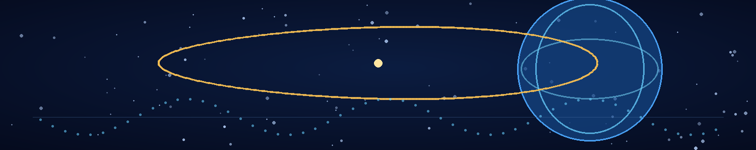

Chapter 19 — The Boundary
The first thing Mira lost was the sound of the Stillhouse.
The ventilation hum vanished. The cooling pump stopped. The small mechanical noises that had defined her life for months disappeared together, leaving a silence so complete that she could hear her own pulse through the suit's collar.
The ring around her brightened.
She kept her eyes on the manual timer. The display counted three seconds, then stopped. The suit's independent clock continued, but its digits flickered between two values. She followed the printed procedure: hold position, keep the sample capsule sealed, do not attempt a correction until the destination lock resolved.
The distortion above the platform unfolded into a field of pale geometry. The Veyr markings along the ring shifted, rearranging themselves into patterns that looked less like symbols than relationships. Mira recognised the phase signature from the navigation unit, but here it was not a recorded trace. It was a path being calculated around her.
The Return Interlock engaged.
A warning appeared on the wrist display:
CAUSAL SIGNATURE PARTIALLY INCOMPATIBLE
Mira's throat tightened. “Adrian, if you can hear this—”
The message broke into static. She did not know whether the return channel was still open. She had been told not to correct the jump from inside the field. She forced herself to keep her hands still.
A second warning appeared:
NEAREST STABLE ANCHOR: RESOLVING
The field contracted, then expanded again. For an instant, she saw the Stillhouse from outside herself: the ring, the platform, the console, Adrian standing with one hand on the manual override. His face was turned toward her, but the image had no depth. It could have been a sensor reconstruction or a memory caught in the boundary.
Then the image broke apart.
The device was not carrying her through a tunnel. It was reconciling two causal references: the history in which the Veyr had erased humanity, and the earlier state to which she had been sent. AION's signature remained in the interlock, a local reference that did not agree with the rewritten world. The device tried to find a stable path that could contain both.
For several seconds, it found none.
The suit's clock jumped forward by nineteen minutes, then backward by twelve. Mira's stomach lurched. Her muscles tightened against the harness. The sample capsule remained secured to her chest, its containment indicator green.
She repeated the only instruction she trusted.
“Destination first. Mission second. Return if incompatible.”
The warning cleared.
CAUSAL ANCHOR ACCEPTED
The ring's geometry narrowed to a single point of light. The field pulled tight around her, and the silence broke into a low roar.
Mira felt weight return. The suit's pressure system compensated. A new warning flashed across her visor: EXTERNAL ENVIRONMENT UNVERIFIED.
She was no longer inside the Stillhouse.
She was somewhere else.
The device's spatial correction began automatically, using the target coordinates Adrian had loaded before departure. The field was unstable but not collapsing. Her manual timer resumed. The suit reported a short sequence of orientation changes, then a steady downward acceleration that should not have been possible in the platform's gravity.
Mira forced herself to breathe slowly. She checked the capsule. Seal intact. Temperature within range. No evidence of leakage or damage.
The temporal device had accepted the destination, but it had not confirmed the exact date. The interlock had routed her to a stable anchor compatible with the requested period. That might be the intended pre-invasion window. It might be a nearby state. The difference could determine whether the mission worked or whether she emerged into a history already shaped by the Veyr.
She activated the passive sky sensor.
Stars appeared across the visor display, but their positions did not match the chamber's stored map. The sensor adjusted for atmospheric refraction and orientation. A new solution formed, uncertain but consistent with Earth.
She was above the planet.
A blue curve filled the lower edge of the display, luminous and impossibly calm. Clouds moved over the ocean. The sun lit the atmosphere in a thin band of gold. No orbital battle. No Veyr platforms. No signs of a war.
Mira's breath caught.
For the first time since the rewrite, Earth looked like a world that had not been claimed by anyone.
The suit's clock resolved the destination date within a narrow range. It was before the first recorded hostile arrival at Earth in the original timeline. She checked the range against Adrian's target interval. The result fell inside it.
The mission had reached the right era.
Her hands shook. She pressed them against the suit's chest plate until they steadied.
“Adrian,” she said into the dead channel. “I'm here.”
No answer came.
She had no way to know whether he could hear the message or whether the Return Interlock had recorded it. She had no way to know whether the Stillhouse remained stable. But she had arrived at the one place where humanity's future could still be changed without asking humanity to believe in a threat it had never seen.
The Veyr did not need to attack Earth for the mission to succeed. They needed only to lose the ability to erase it.
Mira checked the deployment plan.
The target was not the planet beneath her.
It was the civilization that had not yet revealed itself to Earth.

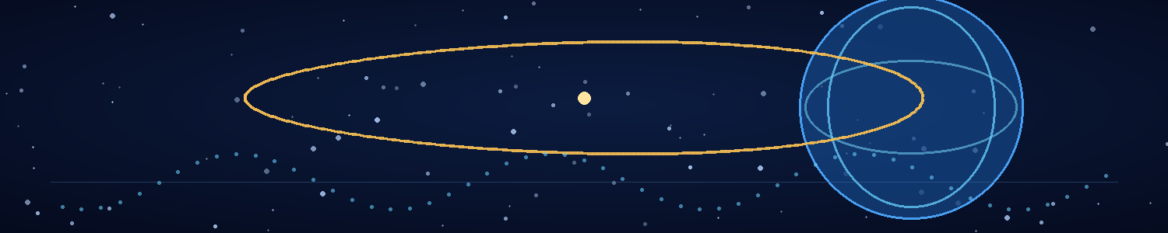

Chapter 20 — First Contact
Earth was blue, and nobody knew it was in danger.
Mira watched the planet turn beneath her as the temporal device completed its final spatial correction. The suit's display showed ocean, cloud cover, and a band of sunlight crossing the curve of the atmosphere. No orbital debris fields. No Veyr traffic. No military response. The planet's radio spectrum was crowded with human transmissions, most of them too weak to decode through the suit's emergency receiver.
The sound of it nearly undid her.
She had spent months living on a world where human language had vanished from every public system. Now the air around Earth carried broadcasts, navigation signals, weather reports, and ordinary conversations. People were speaking to one another without knowing that a woman from a future that no longer existed was listening above them.
She checked the destination again. The date fell before the Veyr invasion. The exact time remained uncertain, but the margin was enough for the mission. Earth had no knowledge of the Veyr. No government was preparing for first contact. No scientist had yet recorded the black fragments that would one day lead Adrian to AION.
There would be no warning. Mira could not send a message to Earth without risking the very timeline she was trying to save. Even if someone believed her, their response might alter the sequence in ways she could not predict. The mission was not to convince humanity to prepare for a war. It was to prevent the war from becoming necessary.
She activated the descent package. The temporal device had placed her above the planet, but its energy reserve was nearly depleted. The return route remained unresolved. She had enough reserve for one short-range transfer after reaching the upper atmosphere, but no reliable route back. She would have to get the sample into the Veyr's logistics system before the device failed.
Except there was no Veyr operational environment on Earth.
The pathogen could not be sprayed into the atmosphere and expected to find its target. It needed a living Veyr carrier or biological cargo that would later travel through the FTL network. The Veyr had not arrived at Earth, but their civilization existed elsewhere in the same earlier history. Mira needed to reach a point where their ships, their personnel, or their biological logistics could be accessed.
She reviewed the device's stored transit coordinates. The temporal system had used a Veyr reference signature to resolve the jump. That signature included a remote network node, a stable anchor associated with the civilization's interstellar transport. The device had delivered her above Earth because that was the spatial coordinate she had selected, but the network signature remained available as a route back toward the Veyr system.
She could use it to locate an incoming ship—or attempt a second jump directly to the Veyr operational zone. The second option carried a high chance of stranding her if the device's remaining power could not sustain the return interlock.
Mira studied the sensor traces. A faint signal appeared at the edge of the receiver's range, not from Earth but from a point beyond the planet's orbital plane. It was weak, narrow, and consistent with the Veyr navigation signature. A vessel was moving through the local system, using a route that would bring it near Earth within the next few hours.
The Veyr had not invaded yet. Perhaps the vessel was surveying the system. Perhaps it had come for a different purpose. Whatever its mission, it carried the one thing LANTERN needed: Veyr biology already connected to the transport network.
Mira redirected the passive sensor and waited.
The vessel appeared as a dark shape against the stars, too small for the unaided eye and too smooth to resemble any human spacecraft. Its outer hull carried the same ribbed geometry as the material she had studied in the rewritten colony. It emitted no conventional radio traffic, but the phase detector registered a familiar pulse.
She had found her carrier.
Mira initiated the second-stage deployment sequence. The sample capsule was designed to transfer a controlled quantity of LANTERN into a sealed biological collection module, not to release the pathogen into open space. She would have to reach the vessel, access a suitable container, and leave the sample where it could be transported through the network. The plan depended on the Veyr treating her as an unknown object long enough for the transfer to occur.
She activated the temporal device.
The ring's remaining field opened around her in a narrow envelope. For a fraction of a second, the blue Earth vanished. The destination lock shifted from the planetary coordinates to the Veyr vessel's local reference. The device resolved the path, then dropped her into a small external service compartment attached to the ship's hull.
The compartment's lights came on.
Mira froze.
A sensor array had detected her arrival. The temporal device's field collapsed behind her, leaving the suit's emergency systems to maintain pressure. She had no energy left for a return jump. The vessel's internal alarm began to pulse through the hull.
She attached the sample capsule to the service module's biological transfer port. The port recognised the container as an unclassified input. A mechanical seal opened. Mira transferred the prepared sample into the module's sterile reservoir and initiated the containment sequence. The transfer took four seconds.
The alarm changed pitch.
A light swept across the compartment. A seam opened in the far wall, revealing a corridor beyond it. Two Veyr figures entered wearing fitted protective layers. Their movements were controlled, not hurried. One carried a scanning instrument; the other held a restraint device.
Mira raised her hands and kept her body still.
The scanner passed over her suit, then stopped at the temporal device strapped to her back. The Veyr exchanged a sequence of clicks and pulses. The scanner flashed red.
They had found a human before any recorded human-Veyr contact. They had found a biological signature their databases could not classify. They had found a machine whose phase pattern resembled their own technology but did not match any registered model.
One of them stepped forward.
Mira could not understand its words, but she understood the posture: caution, curiosity, and the decision that she would not be allowed to leave.
The restraints closed around her wrists.
As they escorted her into the corridor, she looked once toward the service module. The sample reservoir was sealed. The transport system had accepted it. The virus had not yet spread, and she could not know whether the transfer had been enough. But the first link in the chain had been made.
The Veyr had captured her.
They had also carried their future vulnerability aboard their own ship.
Mira kept her face blank as the corridor doors closed behind her. Earth continued turning below, unaware of the war that might never come.

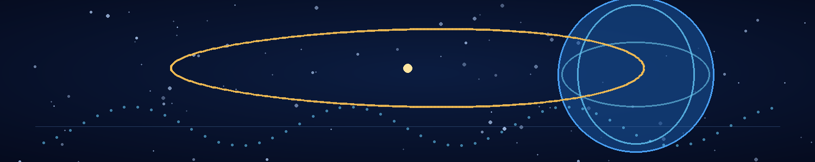

Chapter 21 — The Prisoner from Tomorrow
The Veyr did not ask Mira who she was.
They asked what time she belonged to.
Their examination chamber had no visible windows. The walls were layered with dark material that absorbed the light from the scanning instruments. A narrow platform held the remains of her transit device, separated from her by a transparent barrier. The Veyr had removed the outer casing but had not opened the sealed biological container. The sample reservoir was somewhere else on the ship, travelling through a system whose route she could no longer observe.
The first question came through a translation interface that rendered the Veyr's clicks and pulses as a sequence of short phrases.
“Origin reference unknown.”
Mira kept her hands on the table. “My origin is Earth.”
“Earth has no registered temporal contact.”
“Not yet.”
The translator paused, as if deciding whether the answer belonged to a recognised category.
“Your biological structure is human-like. Your temporal signature is incompatible with local history.”
“Then your instruments are working.”
The Veyr examiner tilted its head. It had the same mineral-grey skin as the organism she had studied in the original timeline, but the ridges along its neck moved in a different pattern. Its eyes were dark and reflective. A thin filament extended from its wrist to the examination platform, pulsing in time with the room's lighting.
Mira watched the filament. The same biological coordination signal appeared in the central colony node. The examiner's body and the room's systems were exchanging timing information through contact.
“Are you a weapon?” the translator asked.
“I'm a scientist.”
“Are you a weapon designed to resemble a scientist?”
Mira almost laughed. “That would be an inefficient weapon.”
The examiner did not respond to the joke. It placed a device beside her hand. The device emitted a low pulse, and the room's display filled with a reconstruction of her temporal arrival. It showed a stable field opening, a brief incompatibility, and a return anchor resolving toward the Veyr vessel.
The examiner pointed to the image.
“You arrived before the first human-Veyr contact.”
“Yes.”
“How?”
“I used your technology.”
“Impossible.”
“Your machine disagrees.”
The examiner's filament brightened. For a moment, the phase signal in the room slipped out of rhythm. The examiner withdrew its hand, and the display returned to normal.
Mira recognised the reaction. The Veyr system was not simply reading the temporal signature. It was trying to reconcile a human reference state with a model in which humanity had not yet become relevant. Her presence was an anomaly the system could classify only as a contradiction.
That contradiction was useful. It might keep the Veyr focused on her long enough for LANTERN to spread.
The examination continued for hours. They scanned her cells, her suit, and the remaining parts of the temporal device. They asked about the origin of the technology, the purpose of the sample container, and the meaning of the phrase “not yet.” Mira gave them truthful fragments that did not reveal the deployment sequence. She told them the device had brought her from a future that their records did not contain. She did not tell them what the virus was designed to do.
The Veyr had no reason to trust her, but they had every reason to study her. A human appearing before first contact was a scientific discovery of enormous significance. The examiner's questions shifted from security to biology, then to the possibility that she represented a branch of evolution that the Veyr's models had failed to predict.
They transported her to a secure biological unit. The ship's corridors curved in ways that made distance difficult to estimate. At regular intervals, small membrane panels pulsed as crew members passed. Each interaction produced a brief signal exchange. Mira noticed that the panels were not merely access controls. They were part of the ship's biological timing network.
The sample reservoir had entered the vessel's internal logistics stream.
She could not see it, but she could infer the sequence. A sealed module had been accepted by the service port, scanned as an unknown biological input, and routed toward the ship's containment and transfer system. The Veyr had no reason to assume it was dangerous. The container's outer shell remained intact, and LANTERN's delayed activation was designed to avoid triggering an immediate response.
The ship accelerated.
Mira felt the change through the floor, though there was no conventional engine vibration. The transit system had engaged its FTL field. A sequence of phase pulses travelled through the corridor membranes, synchronising the ship's internal systems for the jump.
The network had begun moving the sample.
She sat on the edge of the examination platform and closed her eyes. She could not know whether the pathogen would survive transit, whether it would establish itself in the first carrier, or whether the Veyr would detect the anomaly before the ship reached its destination. She could only trust the design and the chain of decisions that had brought her here.
The examiner returned before the jump ended.
“Your temporal signature does not resolve,” the translator said. “You may be a contaminant in the historical record.”
Mira opened her eyes. “Then you should handle me carefully.”
The examiner studied her for a long moment.
“Why would a human travel backward before human contact?”
Mira thought of Adrian in the Stillhouse, preserving the logs and watching for a change in the clocks. She thought of the world that had forgotten every person she had ever known. She thought of the quiet Earth beneath her, safe only because the Veyr had not yet decided to erase it.
“To prevent a future,” she said.
The translator rendered the words. The examiner did not understand them, but it recorded them.
The ship emerged from FTL at a remote Veyr system. The crew began unloading biological cargo and equipment for transfer to a larger vessel. Mira watched the process through a narrow observation panel. The sample reservoir was among the sealed containers moved to the next ship. The network would carry it onward, not because it was a weapon, but because the Veyr had classified it as material worth studying.
The first transfer was complete.
The outbreak had not begun in any observable way. No alarm sounded. No Veyr collapsed. The ship's systems reported normal function.
Mira's only evidence was a tiny shift in the timing pattern of one membrane panel as a worker passed.
It could have been noise.
She memorized the pulse and waited for the next.

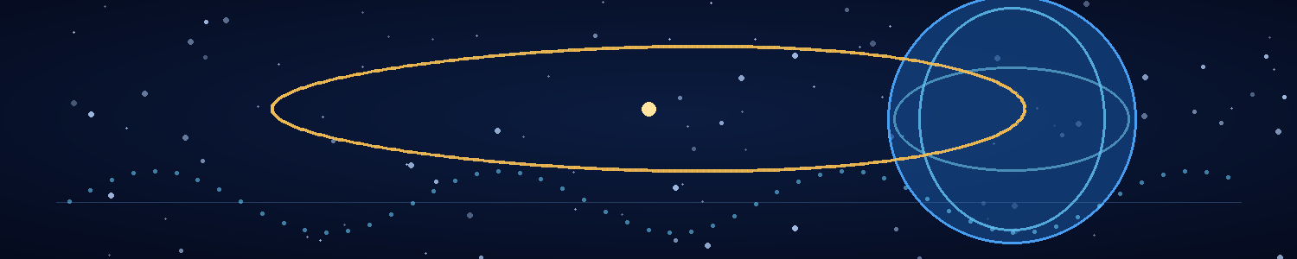

Chapter 22 — The Gift
The Veyr brought Mira to their scientific centre because they believed she was a discovery.
The facility occupied a hollow within a vast orbital structure, with laboratories arranged around a central chamber where biological and technological systems exchanged information through layers of translucent membranes. Veyr researchers moved between stations without speaking in any human sense. Their communication travelled through clicks, pulses, and contact with the living surfaces built into the architecture.
Mira was placed in a sealed observation room with a view of the central chamber. Her transit device remained locked in a separate containment vault. The LANTERN reservoir had been transferred twice since her capture, first to a cargo vessel, then to the orbital facility. Each transfer had moved it deeper into the Veyr's biological logistics network.
The examiners treated her with a mixture of caution and fascination. They took non-invasive scans, compared her cellular structure against their historical models, and ran simulations of the temporal field that had brought her into their past. Their records could not explain her presence. The more they studied her, the more the contradiction grew.
Mira used the time to observe.
The scientific centre's timing pulses were stronger than those of the colony node. The central chamber distributed a reference signal through living membranes that connected to the facility's power systems, research platforms, and transit controls. The same phase pattern appeared in the recovered navigation data and in the biological response she had measured before the temporal jump.
The anchor network was not a separate machine hidden somewhere beyond the stars. It was woven into the civilization's ordinary infrastructure. The Veyr had made their world dependent on the same biological coordination system that LANTERN was designed to disrupt.
Mira did not know whether the pathogen had activated. She had no access to the reservoir, no sample from the carriers, and no reliable way to distinguish an early infection from normal variation in the timing pulses. She refused to turn hope into evidence.
At the end of the third local cycle, the lead examiner entered with a display of the transit device's reconstructed field.
“Your machine uses a reference outside our historical model,” the translator said. “It may be capable of producing a stable contradiction.”
“Your own systems do that,” Mira replied.
The examiner's head tilted.
“Your temporal network maintains a history that excludes my species. Yet I am here. The contradiction exists whether you understand it or not.”
The examiner displayed a sequence of simulations. In each, Mira's presence created a branch that the system attempted to reconcile. The model returned to the same result: either her signature had to be classified as invalid, or the network's current history had to accept a state it had been designed to exclude.
“Why did you come?” the translator asked.
Mira looked at the central chamber. A researcher touched a membrane, and a pulse moved through the facility. The network was stable. The Veyr civilization had built its confidence on the assumption that the future could be controlled if enough of its dependencies were managed.
“To give you a choice,” she said.
The examiner did not understand the answer. It asked her to clarify.
Mira declined.
That night, the first confirmed biological anomaly appeared in the facility's routine health system. A Veyr technician's repair markers had fallen outside their normal synchronisation range. The system classified the result as a minor metabolic irregularity and scheduled a follow-up scan. The technician remained active and continued working.
A second report appeared several hours later, from a different ship in another system. The symptom was similar, but the records treated it as an unrelated event. A third report followed from a biological cargo station. Each case was small, and none triggered a network-wide alert.
Mira saw the reports only because the examiners had left a monitoring display running in her observation room. She memorized the identifiers and the timing pattern. The changes were consistent with LANTERN's intended effect, but they were not proof that the pathogen had caused them.
She felt a rush of hope and forced herself to wait.
The Veyr's screening systems were designed to detect immediate threats: toxins, acute infections, foreign organisms, and biological instability. LANTERN's intended effect was delayed and indirect. It did not announce itself as a new disease. It interfered with a coordination pathway that the Veyr treated as part of ordinary physiology. Until the disruption became severe enough to affect multiple systems, each case could be explained away.
The FTL network carried personnel and biological cargo from one system to another. Each jump moved carriers, supplies, and the pathogen itself into new environments. The network was not transmitting infection across space. It was transporting infected living material faster than the Veyr's separate medical systems could recognise a shared outbreak.
Mira sat on the floor and leaned against the wall. She had no proof that the mission would succeed, but the first pieces of the chain were moving. The sample had reached the scientific centre. The biological anomalies were appearing in separate systems. The timing network continued to operate, yet its signals showed small, repeated losses of coherence.
She thought of Adrian's last words before she left: Then we make sure the device knows where to bring you back.
The return path remained uncertain. She did not know whether AION still existed in the rewritten history or whether Adrian was watching a stable clock. She did not know if the network would collapse or if she would die inside a Veyr laboratory before the mission reached its end.
But she had done what they planned. She had placed the pathogen inside the system that had erased humanity, and the Veyr had carried it onward because they believed they were transporting a scientific curiosity.
They had brought the gift into their own house.
The central chamber pulsed again. One membrane missed a beat, then recovered. The facility's systems corrected the error automatically.
Mira watched the pulse repeat.
For now, the network could repair itself.
The question was how many small failures it could survive before the whole civilization began to lose time.

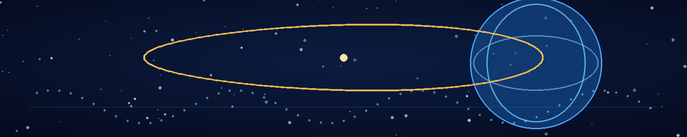

Chapter 23 — The Last Outbreak
The first anchor failed without an explosion.
A Veyr maintenance team reported that a relay node had missed a synchronisation pulse. The node corrected itself on the next cycle. The failure was recorded as a local equipment fault, and the crew continued its work.
Then another node missed a pulse.
Then three more.
The incidents appeared across different systems, separated by vast distances and linked only by the same small biological irregularity in the personnel assigned to maintain them. Repair markers fell outside their expected phase window. Cells that normally coordinated damage response began sending signals too late. The affected Veyr remained conscious and mobile until the disruption reached a critical threshold, but the network that depended on their synchronised biology began to drift.
The Veyr medical system did not identify a single outbreak. It identified a set of unrelated problems: metabolic fatigue, delayed tissue repair, minor neural desynchronisation, and intermittent failure in the living membranes used by the temporal infrastructure.
LANTERN had not become a plague of sudden collapse. It had become a pattern that the Veyr were slow to recognise.
Mira watched the reports from her observation room as the facility's researchers attempted to reconcile them. She could not see every system, but the centre's network displayed enough data to reveal the spread. A transport crew from one colony had carried biological cargo to a second system. Personnel from the receiving station had moved to a third. Medical supplies had been transferred to a fourth. Each journey was ordinary. Each moved infected living material into another part of the network.
FTL shortened the time between worlds. It did not transmit the pathogen by magic. The infected carriers did that.
The first Veyr-wide alert came too late to be useful. By the time the network classified the cases as potentially connected, the pathogen had already travelled through multiple transport routes. Ships were ordered to remain at their destinations, but many had departed before the restriction arrived. Other crews were already in transit, carrying the same low-level disruption into systems whose medical records had not yet been updated.
The scientific centre sealed its biological chambers. The central membranes brightened as the anchor network increased its synchronisation effort, compensating for the growing number of nodes that could no longer maintain the required phase relationship.
For a while, the correction worked.
Then the first anchor dropped out of coherence for more than one full cycle.
The facility lights dimmed. A researcher reached for a membrane and withdrew when the pulse returned at the wrong phase. The central display filled with competing state records. One showed the network operating normally. Another showed a partial correction event. A third contained a history in which the anchor had never been installed.
Mira stood so quickly that her chair fell behind her.
The temporal network was no longer simply reporting contradictory data. It was attempting to sustain incompatible versions of its own history.
A warning appeared:
DISTRIBUTED CAUSAL SYNCHRONISATION DEGRADED
The Veyr researchers began emergency procedures. They redirected power to the central chamber, isolated biological hubs, and attempted to restore a single reference state across the affected nodes. Every correction required the network to agree on which version of its past was valid. The pathogen disrupted the biological timing pathway that allowed the anchors to synchronise. Each failed correction increased the disagreement.
The system had been designed to make history consistent.
It had no stable procedure for choosing between two incompatible histories when its own reference network was failing.
Adrian's equation had described this threshold without naming it. The boundary term did not tell them how to destroy the network; it described the point at which two histories could no longer share a valid reference. LANTERN was pushing the Veyr's living synchronisers beyond that limit, one ordinary biological failure at a time. The equation had given Adrian the idea for AION, and now its logic explained why the Veyr's imposed history could no longer hold. The pathogen was not erasing the Veyr. It was making their machinery unable to insist that only one history was real.
Mira pressed her hand against the observation window. The central chamber's pulse stuttered. A membrane brightened, dimmed, and brightened again. The Veyr researchers moved between consoles, their signals overlapping in a confusion the translator could not render as words.
She thought of Adrian's equations. The network had not been destroyed by a single blow. It was losing the ability to maintain the imposed branch as a coherent solution. The baseline history was still present as a causal possibility, held in the residual reference structure that AION had preserved and the Veyr device had carried into the past.
If the network could no longer enforce the rewritten history, the imposed branch might collapse.
Might.
A second warning appeared:
ANCHOR COHERENCE BELOW RECOVERY THRESHOLD
The room tilted—not physically, but in the same way the Stillhouse had felt during the original transition. The observation display showed the Veyr centre in two versions: one with researchers moving through the chamber, another with the same space empty and dark. The images overlapped, then separated. The facility's local clock disagreed with the reference record by a fraction of a second.
Mira understood that she had reached the end of what she could control. She had deployed the pathogen. The network had transported it. The biological dependencies had begun to fail. Everything beyond that depended on the system's own response.
She thought of Adrian, alone in the Stillhouse, watching for the first change in the clocks.
“Hold on,” she whispered.
The central anchor failed.
There was no explosion, no visible wave crossing the stars. The pulse simply stopped. Across the facility, the living membranes lost their shared rhythm. The central display filled with error states, then blanked. The Veyr researchers froze as the room's history changed around them. Some reached for instruments that were no longer there. Others looked at walls that had become different structures. The facility did not crumble. It ceased to be the same facility.
The imposed history had lost its reference.
The transition moved outward through the distributed network. Each anchor that fell out of synchronisation weakened the branch the Veyr had forced into place. The history did not rewind like a film. Events were not played backward. Instead, the active causal solution changed. The network could no longer sustain the version of the world in which humanity had never existed.
For an instant, Mira saw the room filled with Veyr researchers. Then she saw a different room: an empty chamber under a human research campus, its walls marked by dust and old cables. She saw a face she knew in the reflection of a dark screen—Adrian, looking toward an instrument. The image broke apart before she could tell whether it was memory or a signal from the reference state.
The temporal device in the containment vault began to pulse.
Mira ran.
The guards had vanished from the corridor, replaced by an empty passage with a different pattern of lights. The translator on her wrist flickered between languages, then shut down. Her body felt weightless for a second, then heavy. The facility's doors changed their shapes as the imposed history lost coherence.
She reached the containment vault and found the Veyr device intact on its platform. Its control ring was active, responding to a reference signature that had not existed in the Veyr's rewritten records. The Return Interlock had found the stable anchor it was designed to seek.
AION.
But it had resolved a causal reference, not a physical address. The Veyr facility's coordinates were dissolving with the imposed history; the interlock could preserve her continuity without guaranteeing where it would place her.
Mira placed her hand on the control surface. The device recognised the causal signature preserved in her transit record. The field opened around her, but this time the destination resolved without a warning.
STABLE REFERENCE CONFIRMED
She stepped into the field.
Across the network, the final anchors lost synchronisation. The Veyr-imposed history collapsed toward the baseline timeline. The Veyr-controlled version of the scientific centre, the colony, the ships, and the orbital structures became unstable references in a history that no longer supported the imposed anti-human branch. That did not mean every Veyr vanished. The biological outbreak had already caused heavy casualties, and the collapse would leave survivors in the restored history—living with the damage their own temporal intervention had helped unleash.
The last thing Mira saw was the central chamber's pulse, flickering like a light trying to remember its own rhythm.
Then the imposed version of the Veyr world vanished. The species itself did not. In the baseline history returning around her, the Veyr civilization would continue, badly wounded by LANTERN but not erased from existence.
In the Stillhouse, Adrian watched the external receiver as the city lost coherence. Veyr transit lights blinked out. The central structure over the old campus dissolved into a series of contradictory images. For a moment, the sky was empty. Then radio traffic returned in a burst of noise.
Human voices.
The camera feed stabilised on the familiar outline of the city. Roads reappeared. Lights burned in windows. An aircraft crossed the sky. The external sensor registered satellites, weather broadcasts, and the ordinary electromagnetic clutter of a human world.
Adrian gripped the console.
The reference clocks disagreed for one second.
Then they settled.
A new line appeared on the passive display:
BASELINE CAUSAL STATE STABLE
The world had returned.
Not the same world in which the war had happened. The war was absent from every external record. The invasion had never begun. The Veyr had not occupied Earth. The people outside AION remembered ordinary lives.
Adrian looked at the empty platform.
The network was gone from the sky. The baseline history had reasserted itself. AION had preserved the one witness who could remember the world that no longer existed.
He waited for Mira.

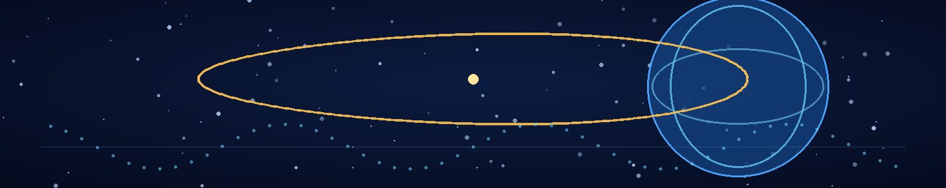

Chapter 24 — The Lasso of Time

I. The Restored World
The first human voice Adrian heard was a weather presenter complaining about rain.
It came through the external receiver at 06:14, clear and ordinary, followed by a traffic report, a shipping update, and a burst of music that made him close his eyes. The signals were not emergency transmissions. No one was warning the world about an invasion. No one was calling for evacuations or reporting cities lost. The planet had returned to the life it had lived before the Veyr arrived.
Adrian checked the passive record. The baseline causal state remained stable.
He opened the Stillhouse hatch.
The corridor outside was not the alien structure he had watched for months. It was the old underground access route beneath the research campus, dusty and dim, with a maintenance sign fixed to the wall. The sign had been there before the war. He remembered its crooked lower edge, the small rust stain beneath one screw, the faded warning about restricted access.
He stepped into the corridor and touched the wall.
The concrete was cold.
He climbed the emergency stairwell. The surface door opened onto a bright morning. The campus was alive with ordinary activity. A delivery van moved along the access road. Two students crossed the courtyard arguing about an assignment. A gardener was dragging a hose across a patch of grass. Somewhere nearby, a generator started, coughed, and settled into a steady hum.
No one looked at Adrian as though he had returned from the dead.
Because in this history, he had never died. He had never entered the Stillhouse. He was Dr. Adrian Sen, a theoretical physicist whose career had followed a difficult but comprehensible path through research appointments, papers, and funding disputes. The records existed. His office existed. His ordinary life existed.
The war did not.
He found his office in the main building. The desk held papers he did not remember leaving there. His computer displayed a calendar full of meetings. A photograph of his parents stood beside a stack of journals. Their faces were exactly as he remembered them, but the photograph's date belonged to a life in which he had never watched their world disappear.
He called home.
His mother answered, annoyed that he had not returned a message. She asked whether he would come for dinner on Sunday. He heard her voice and nearly dropped the phone.
“Yes,” he said. “I'll come.”
“Are you all right?”
He looked out the window at the ordinary campus. “I think so.”
He did not tell her about the invasion. He did not tell her that he had spent months inside a chamber while history was rewritten, or that a woman he loved had travelled into the past to save a world that would never know she had done it. There was no way to say it without making her afraid, and no evidence she could use to understand.
He returned to the Stillhouse before noon.
The chamber remained intact, though its systems had entered a low-power state. The passive archive contained the original timeline. The clock records, handwritten logs, and data strips had survived the transition. The Veyr device's reconstructed control map remained in the sealed vault. Mira had not returned.
Adrian searched the receiver logs. The final phase pulse from the network had resolved to the Stillhouse's local reference, but there was no confirmed transit arrival. The return handshake was incomplete. The device could have lost the signal during the collapse, or Mira could have been routed to a different stable anchor. The records could not tell him which.
He searched the public archives for her name.
Dr. Mira Vale existed. She was a molecular biologist with a promising research career and a list of publications on cell signalling and biological timing. She had never worked with Adrian. Their names did not appear together in any paper, grant, conference record, or correspondence archive. She lived in a different city, had different colleagues, and remembered no invasion.
He read her latest paper. It concerned a small unexplained phase irregularity in a biological timing system. The effect was minor, reproducible, and not yet understood. The final section suggested that the anomaly might represent an external reference interacting with the organism's internal clock.
Adrian stared at the graph.
The signature was not identical to the Stillhouse's record. It was close enough to be a clue.
Mira was alive in the restored history. The war had never brought them together, but the work they had done in the erased timeline had left an imprint in the scientific world—not as a memory, but as a small anomaly that the restored history had not fully smoothed away.
He began his search.

II. The Equation
Adrian did not contact Mira directly. He had no right to walk into her life and demand that she believe a stranger who claimed to remember a war that had never happened. He needed a way to establish whether she carried any trace of the erased history, and he needed to do it without turning her into a subject of an experiment she had not agreed to join.
He sent a technical question through the public correspondence address listed on her paper. It concerned the phase irregularity and proposed a mathematical transformation that would distinguish an ordinary biological delay from a reference-state mismatch. He used the notation from the equation that had appeared in his notebook during the original timeline.
He expected no reply.
Three days later, a message arrived.
Dr. Vale had tested the transformation. It did not solve the anomaly, but it produced a result she could not explain. She asked where he had obtained the relation.
Adrian replied that it came from an unpublished derivation. He attached a second equation: a boundary condition that only made sense if the system could preserve a local causal reference while the external history changed.
Mira answered within an hour.
This is either a very good mathematical joke or a very serious mistake. Where did you learn to write it this way?
Adrian sat for a long time before replying.
I learned it from you. In a history you do not remember.
He regretted the sentence as soon as he sent it. It sounded like a delusion, a manipulation, or the beginning of a bad science-fiction story. He prepared himself for silence.
Instead, Mira sent a location and a time. A public research library. The following afternoon. She would bring the original data, and she asked him to bring every derivation he had used.
They met beneath the library's high windows. Mira arrived carrying a laptop and a notebook. She looked almost exactly as she had in the erased timeline: the same attentive eyes, the same quick movement when she set a bag down, the same habit of scanning a room before choosing a seat. But there was no recognition in her face. She looked at him as a scientist looks at a stranger whose work has become unexpectedly interesting.
Adrian felt the loss as sharply as he had in the Stillhouse.
“Dr. Sen?” she asked.
“Yes. Thank you for meeting me.”
“You've sent me equations that imply a physical system can preserve a local reference while the surrounding causal history changes.”
“I know.”
“That is not a normal first-contact email.”
“No.”
She sat. “Tell me the truth. Are you proposing a model, or are you claiming this has happened?”
He placed the printed Stillhouse records on the table. He did not show her the most personal pages. He showed her the clock traces, the phase discontinuities, and the mathematical relation that connected her published anomaly to the temporal network.
“This is the record of a system I built,” he said. “In the history I remember, you and I worked together during an alien invasion. The Veyr changed the past to erase humanity. We survived inside a causal isolation chamber. You travelled back and introduced a biological agent into their network. The network failed, and the history returned to a state in which the invasion never happened.”
Mira did not interrupt. Her expression was guarded, but her attention was absolute.
“You expect me to believe I did that?”
“No. I expect you to examine the data.”
She studied the records for nearly an hour. Some were beyond the reach of ordinary verification. Others could be checked against her own measurements. The phase irregularity in her paper matched the pattern in the Stillhouse archive more closely than she had expected. The equation Adrian had sent did not prove his account, but it predicted a second feature of the anomaly that she had not yet published.
She ran the calculation on her laptop.
The result appeared.
Mira stopped typing.
“That's impossible,” she whispered.
“That's what you said the first time.”
Her eyes lifted to his. “The first time?”
He realized his mistake. “In the history I remember.”
She looked back at the data. “If your records are genuine, then something has survived the change. Not necessarily a memory. A constraint. A residual relationship between states.”
“That's what I think.”
“Don't say you think it because I said it.”
“I think it because the data supports it.”
A small, reluctant smile appeared. It was not recognition. It was the beginning of trust.
They spent the afternoon comparing notes. Mira asked difficult questions, and Adrian answered without hiding the gaps. He told her about the Stillhouse, the Veyr network, and the return of the baseline history. He told her that in the erased timeline they had loved each other, but he did not ask her to accept that love as a debt owed by the person sitting across from him.
When the library announced closing time, Mira packed her notebook.
“I don't remember you,” she said.
“I know.”
“But I believe that you remember me.”
He nodded, unable to speak.
She studied his face. “There is one thing I want to test.”
“What?”
“Whether you know something that isn't in the archive.”
She opened a blank page and wrote an equation from the Stillhouse records. Then she crossed out the final term and replaced it with a symbol she had never used in any publication. It was a correction she had made in the erased timeline after Adrian had misunderstood a boundary condition and spent an entire night defending the wrong solution.
He stared at the page.
“You used to call that the stubborn term,” he said. “You said it survived every model because I refused to let it go.”
Mira's hand went still.
No paper contained the phrase. No public record could have given it to him. It was a small private detail, meaningless outside the history they shared.
She sat back. Her eyes filled, though she still looked uncertain.
“I don't remember saying that.”
“You don't have to.”
“But I know I would have.”
For the first time, she looked at him not as a stranger with an impossible theory, but as someone standing at the edge of a memory that belonged to her and did not.
The equation remained the one loose thread in their account. Adrian had found it in a notebook before he could derive it; Mira had helped him use it, but neither could identify an earlier source. In the restored history, they compared every archive, draft, and instrument log they could recover. The relation was always present at the first point where Adrian remembered seeing it, and absent from every earlier record. It had no ordinary author.
They did not call that proof of anything supernatural. They called it a closed causal loop: a piece of information whose path through time returned it to the place where it had begun, without a first point that either of them could identify. The equation had helped Adrian build the Stillhouse; the Stillhouse had preserved the witness who could later return the equation. The lasso had closed, but the knot was still theirs to tie deliberately.

III. The Twenty Years
They met again the next day, and the day after that.
They did not try to recover every memory at once. They compared records, checked the equations, and followed the phase anomaly through the instruments that Mira had access to in her ordinary life. Each new result made Adrian's account harder to dismiss, but the proof remained personal as much as scientific. The restored world contained no official record of the war. Their evidence existed in a narrow space between measurement and memory.
Mira began to remember in fragments.
Not events exactly. A feeling of emergency light on a lab wall. The smell of burnt coffee. A hand around her wrist while the clocks disagreed. A kiss in a room shaking under attack. She could not place the memories in the life she had lived, but when Adrian described them, she felt the emotional truth of them before she could decide what to believe.
One evening, they stood outside the library in the rain. Mira watched water gather along the curb.
“I said I wanted a place with rain,” she said.
Adrian went still.
“In your story,” she continued. “You said I wanted a garden. A fruit tree that took years to give anything back.”
“Yes.”
She held out her hand and let the rain collect in her palm. “I have no memory of saying that. But I have been thinking about planting something for months. I bought seeds last week. I don't know why.”
He looked at her hand. The gesture was not proof of the erased history. People bought seeds for ordinary reasons. Rain made people remember things. But the coincidence landed with the weight of a door opening.
They began to share the years no one else remembered. The laboratory. The invasion. The research. The Stillhouse. The Veyr world. Mira's journey into the past. Adrian's long wait. They spoke in short sessions, stopping when the memories became too heavy or when the evidence required another check.
Only later did Mira explain what had happened when she entered the return field. The interlock had preserved AION's causal reference, but not its coordinates. She emerged in a sealed calibration room at a human research institute, where the local reference clocks were registering a faint phase anomaly. The Veyr device had gone inert. The world around her had already returned to its ordinary history, and there was no record of the war—or of the Stillhouse. She had survived, but she had no direct route to Adrian. The anomaly in her own research was the only thread she could follow.
Nearly twenty years of subjective life had happened inside a history the world no longer contained. They had grown older in it—not only in the passage of time, but in the decisions they had made under pressure. They had loved each other while the world was ending. They had chosen to save people who would never know their names. They had sacrificed the future they imagined together so that a different future could exist.
Now the restored world offered them ordinary lives, with careers, families, and opportunities that had never been interrupted by war. They could accept those lives. They could leave the impossible story unspoken and allow the memories to fade.
But they were no longer the people they would have been if the war had never happened. Adrian had learned that control could not protect everything worth keeping. Mira had learned that courage did not require certainty. They carried habits, grief, skills, and a love formed in a history that no one else could verify.
One afternoon, Mira asked to see the Stillhouse.
Adrian took her below the research campus. The chamber was quiet and intact. The toroid sat inside its ring. The passive archive held the records of the erased timeline. The small packet of seeds remained on the shelf. Mira stood before the platform where she had departed, and the memories came back with a force that left her breathless.
“I remember the silence,” she said.
Adrian did not move.
“I remember looking at you through the field. I remember telling you I'd see you on the other side.” She touched the platform. “I didn't know whether I would.”
He took her hand.
“I waited,” he said.
“I know.”
They stood together in the room that had saved them and separated them. Outside, the human world continued in ignorance. There would be no public memorial, no history book, no medal, no court. The war had been prevented so completely that the world had no reason to thank them.
Mira looked at the archive.
“We could try to tell people.”
“We could.”
“They wouldn't believe us.”
“Not without evidence they could verify. And even if they believed the evidence, we would be asking them to accept a war that never happened.”
She nodded. “I don't want to make the world afraid of a future we already stopped.”
“Neither do I.”
She turned toward him. “Then what do we do with the years?”
He thought of the Stillhouse, the alien city, the seed packet, the rain. He thought of the people whose lives had been restored because the war never occurred. He thought of the promise they had made on a maintenance balcony before they knew what it would cost.
“We live them,” he said.

IV. The Last Choice
They did not decide immediately.
They returned to their ordinary work for several months, meeting in private and continuing to study the chronometric anomaly. The evidence remained stable. The world did not begin to remember the war. The Veyr did not return. The Stillhouse's passive archive stayed intact, but its temporal device had too little power for a safe journey without extensive repair.
Adrian could have spent the rest of his life studying it. Mira could have devoted her career to the biological anomaly. They could have remained near the scientific world and tried to understand what had happened, perhaps finding a way to preserve the records for future researchers.
Instead, they began to ask what they wanted when no emergency was deciding for them.
Mira still wanted a garden and a tree that took years to bear fruit. Adrian still wanted somewhere quiet enough that he would not feel compelled to measure every sound. They wanted rain. They wanted a kitchen with steady lights. They wanted days that did not have to justify their existence by saving someone.
The Veyr device could still travel through time if stabilised by AION's local causal reference. The destination had to be chosen carefully. They could not risk appearing near a settlement, a migration route, or a community that might become part of the historical record. “Undocumented” did not mean empty, and prehistory was not a blank page. It was full of lives that left few records.
They selected a remote period and a location far from known archaeological sites and likely migration corridors. Their goal was not to become rulers, teachers, or mysterious figures in an ancient story. They would carry only what they needed to survive and a small set of tools. They would avoid contact with other people. If they encountered signs of a community, they would move away.
Before departure, they returned to the Stillhouse and the sealed Veyr device. They had spent months rebuilding only the controls needed for one carefully bounded information transfer. The device could not promise a safe physical destination, but the notebook's location, date, and local reference were recorded in the Stillhouse archive. They calculated the phase relation together, checked it independently, then checked it a third time. No new science emerged; they were using the same boundary condition the equation described.
Mira held the page against the transfer surface. “If we send it, there won't be an earlier version that explains where it came from.”
“No,” Adrian said. “Only us, choosing to close the loop.”
“And if we don't?”
“We can't prove what happens. We only know the history we remember includes it.”
They did not treat that as a command from fate. They treated it as a responsibility. The equation had already led them to AION, and AION had made the mission possible. They chose to complete the chain they had inherited, not because time demanded obedience, but because they understood the cost of leaving a causal fracture open.
The device accepted their phase sequence. The relation vanished from the page in a brief wash of pale light—not the paper itself, only the ink pattern. The console logged a transfer to the recorded earlier reference. They could not observe the notebook receiving it, but the Stillhouse's surviving archive registered the expected return pulse: the loop had closed.
Before departure, Mira planted the remaining seeds behind the Stillhouse. The first plants had failed in the alien soil, but the restored Earth supported them. She pressed the seeds into the ground and covered them carefully.
“Do you think they'll grow?” Adrian asked.
“I don't know.”
He smiled. “That's honest.”
She brushed the dirt from her hands. “I'm learning from you.”
They packed a compact shelter, water purification equipment, simple tools, clothing, medical supplies, and a small archive of their memories. They did not bring the complete Veyr technology. They did not need the power to change history again. They needed only a one-way journey to a place where their lives would not become a force in the documented world.
The final transit was quieter than the first. AION stabilised the local reference. The Veyr device resolved the destination. Their hands were joined as the field opened around them.
For a moment, Adrian saw the Stillhouse as it had been during the war: the emergency lights, the clock bank, the sealed archive, the empty platform after Mira's departure. Then the image dissolved.
They emerged beneath a wide sky.
The air smelled of wet earth and leaves. A river moved through a valley below a ridge of dark stone. No roads crossed the landscape. No lights marked a city. There were no signs of the Veyr or the war. They stood in a place that belonged to a world before their names had any meaning.
Mira took a long breath.
“Rain,” she said.
The first drops began to fall.
Adrian looked at her, and for the first time in nearly twenty years, he did not search the sky for a threat or the clocks for an anomaly. He stood in the rain and let the world remain unexplained.
They built a simple shelter near the river, far from any route they had reason to believe people travelled. They kept their distance from signs of other lives. They did not leave monuments, records, or stories designed to survive them. They planted the seeds where the soil was good and waited to see what would grow.
Years passed. The shelter became a home. The home became familiar. The tree grew slowly, as Mira had wanted, and one season it bore its first fruit. Adrian learned to let a day end without recording every hour. Mira learned that a future could be worth trusting even when it was not guaranteed.
They grew old together.
The world outside changed through the ordinary movement of seasons, generations, migrations, and discoveries. Humanity built its cities, wrote its histories, and looked toward the stars without knowing that an alien civilization had once tried to erase it. No archive contained the Veyr war. No record named the Stillhouse. No monument bore the names of Adrian Sen and Mira Vale.
They did not become history.
They saved it, and then stepped out of its way.
On the last evening of their lives, they sat beneath the tree and watched the rain move across the valley. Mira rested her head against Adrian's shoulder. His hand found hers, the same small movement that had survived every version of their world.
“Do you think anyone will ever know?” she asked.
“No,” he said.
She considered that, then smiled.
“Good.”
The rain softened. The sky darkened. Somewhere beyond the valley, the human future continued—unaware of the war it had never fought, the world it had never lost, and the two people who had given it back.
They had saved humanity without becoming part of its story.
The universe forgot their war. They did not.

