PROGRAM 1: INSURANCE DATABASE

Person (driver_id: string, name: string, address: string)
Car (reg_num: string, model: string, year: int)
Accident (report_num: int, accident_date: date, location: string)
Owns (driver_id: string, reg_num: string)
Participated (driver_id: string,reg_num: string, report_num: int, damage_amount: int)

SCHEMA DIAGRAM

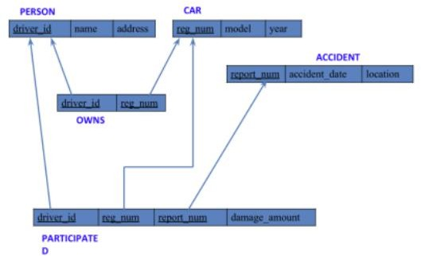

i. Create the above tables by properly specifying the primary keys and the foreign keys.

CREATE DATABASES
Query:
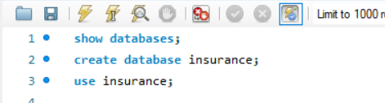

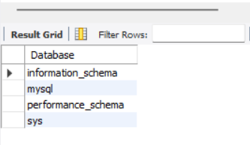

Create Tables:
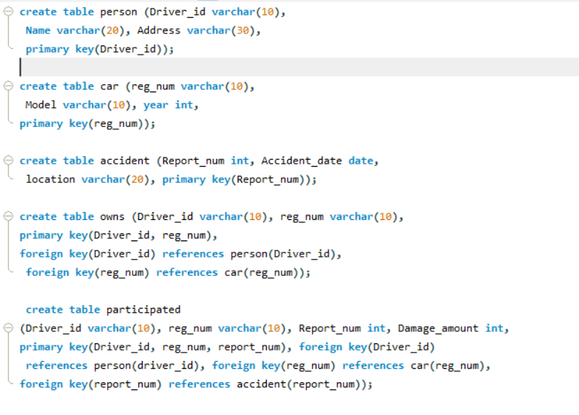
STRUCTURE OF THE TABLES:
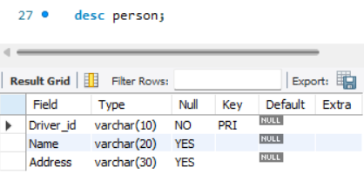
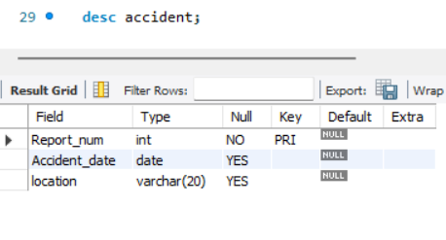
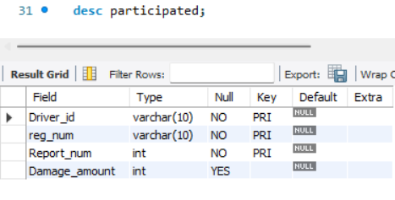
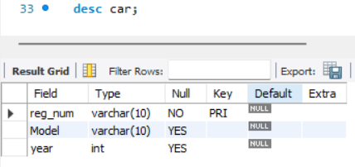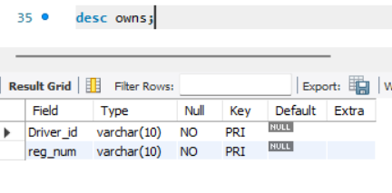

INSERTING VALUES TO THE TABLE:
ii. Enter at least five tuples for each relation.
Person table:
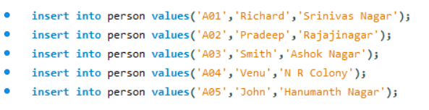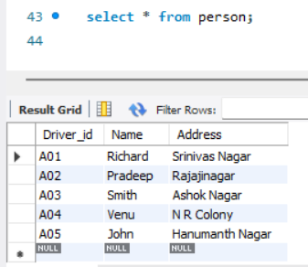

Car Table:

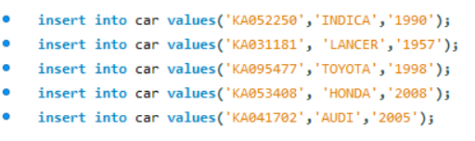
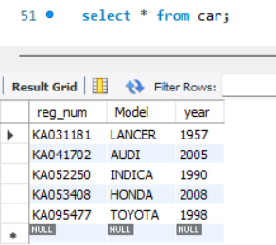
Accident Table:
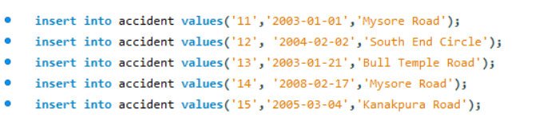
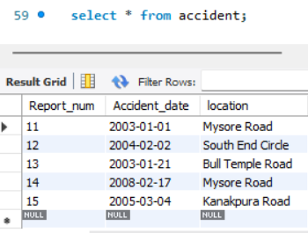

OwnsTable:
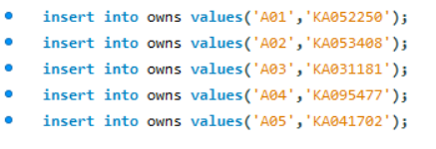
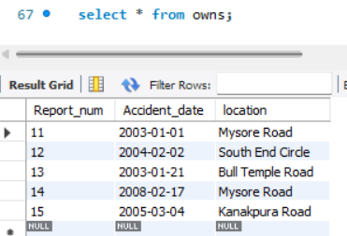

Participated table:
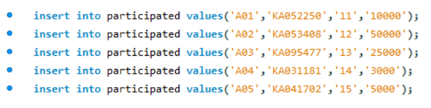
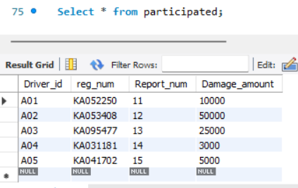

iii. Display Accident date and location

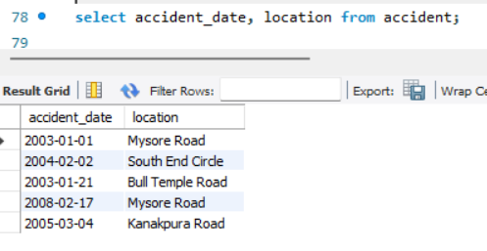
iv. Update the damage amount to 25000 for the car with a specific reg-num for which the accident report number was 12.
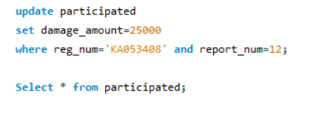
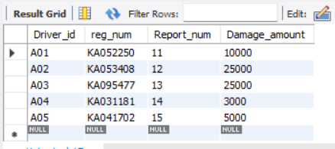
v. Add a new accident to the database.
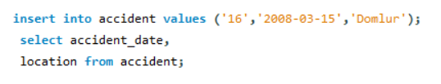
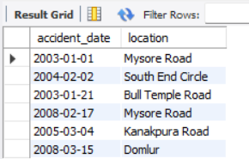

vi. Display driver id who did accident with damage amount greater than or equal to Rs.25000
