Program 2. More Queries on Insurance database
i. Display the entire CAR relation in the ascending order of manufacturing year.
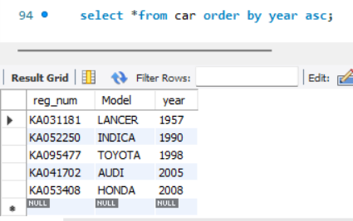
ii. Find the number of accidents in which cars belonging to a specific model (example 'Lancer') were involved.
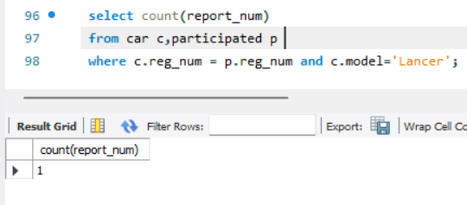
iii. Find the total number of people who owned cars that were involved in accidents in 2008.

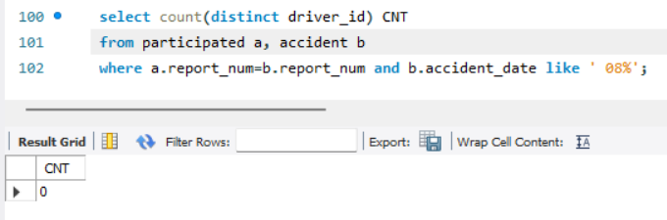

iv.List the entire participated relation in the descending order of damage amount.
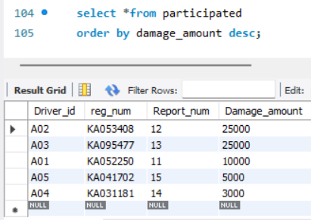

v.Find the average damage amount

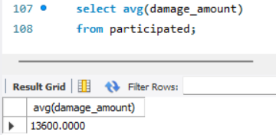

vi.Delete the tuple whose damage amount is below the average damage amount

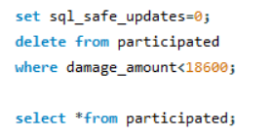

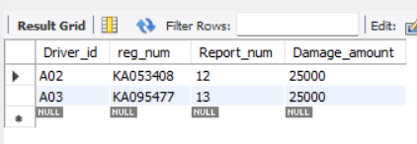

vii. List the name of drivers whose damage is greater than the average damage amount.

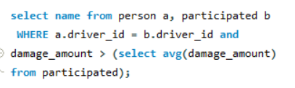
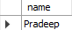

vii. Find maximum damage amount.
