Program 3:bank database

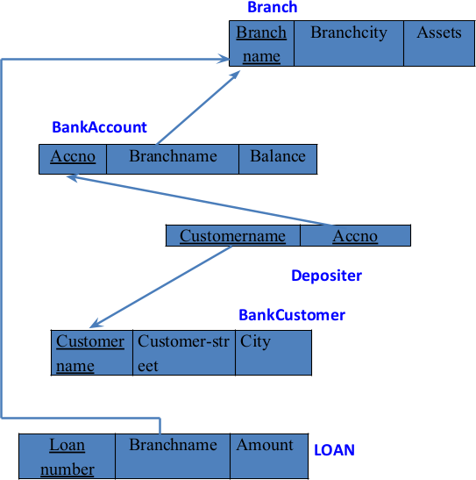
Shema Diagram:

Branch (branch-name: String, branch-city: String, assets: real)
BankAccount(accno: int, branch-name: String, balance: real)
BankCustomer (customer-name: String, customer-street: String, customer-city: String)
Depositer(customer-name: String, accno: int)
Loan(loan-number: int, branch-name: String, amount: real)

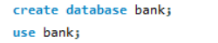

CREATE TABLES:

i. Create the above tables by properly specifying the primary keys and the foreign keys.

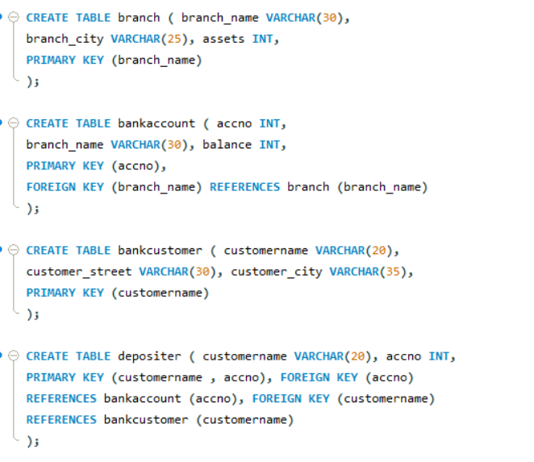
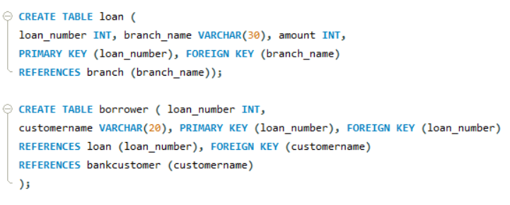

STRUCTURE OF THE TABLES:
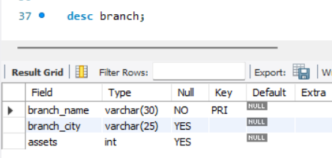
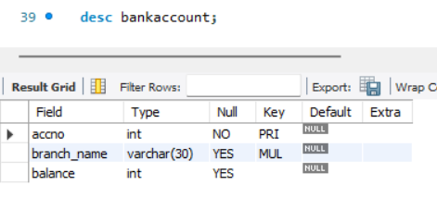
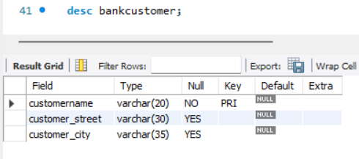
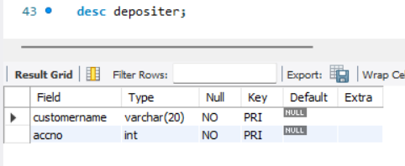
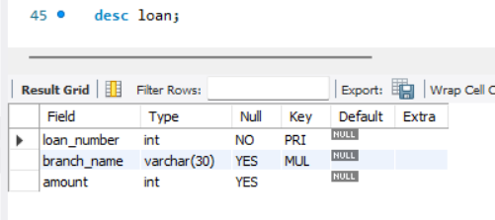
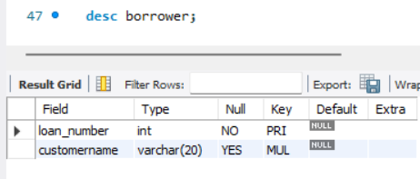
INSERTING VALUES TO THE TABLE:
ii. Enter at least five tuples for each relation.
Branch table :
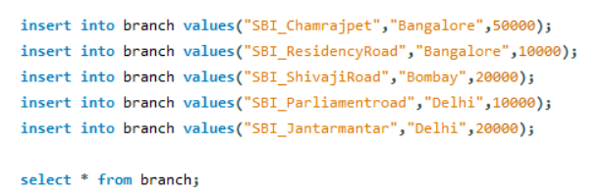
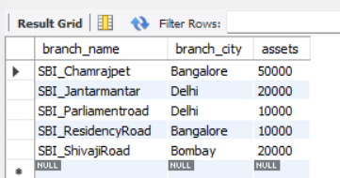

Bankaccount Table:
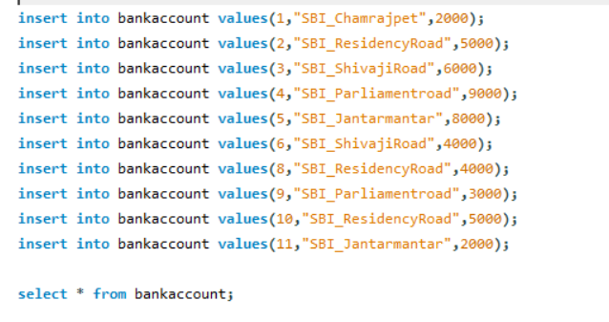
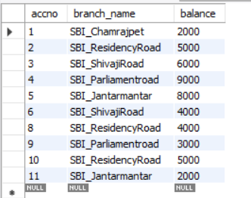
Banckcustomer Table:
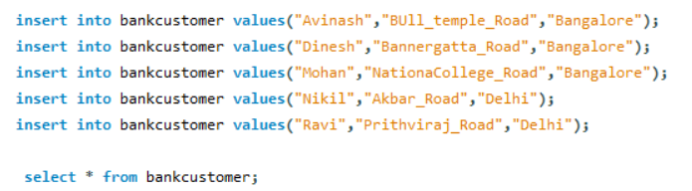
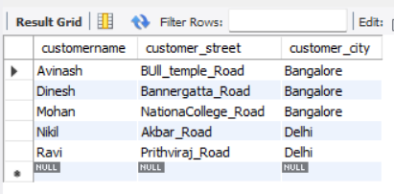
Depositor Table:
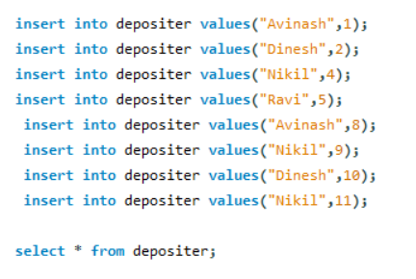
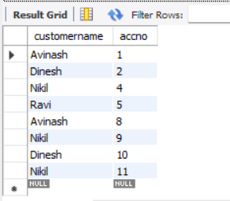

Loan Table:
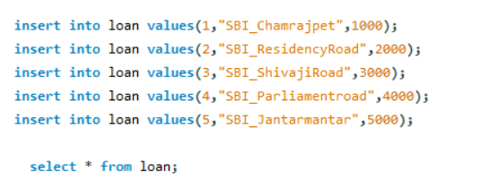
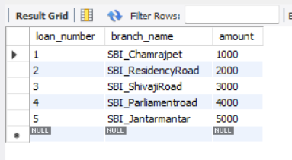
Borrower Table:
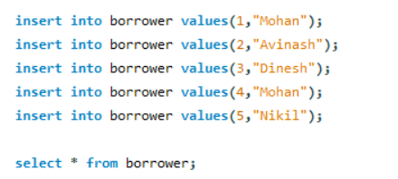
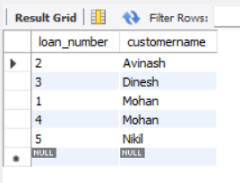
iii. Display the branch name and assets from all branches in lakhs of rupees and rename the assets column to 'assets in lakhs'.
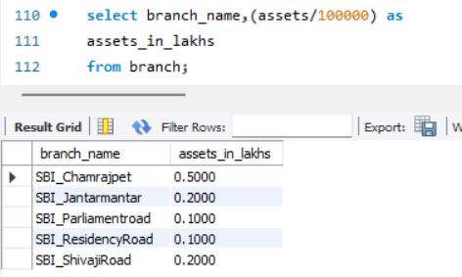
iv. Find all the customers who have at least two accounts at the same branch (ex. SBI_ResidencyRoad).
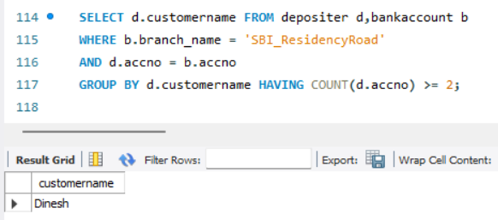
v. Create a view which gives each branch the sum of the amount of all the loans at the branch.
